THE UNITED NATIONS
TAKING ITS POWER TO REIGN AS LEADER AND PROMOTER OF WORLD GOVERNMENT AND RELIGION UNDER THE 8TH BEAST

This is part III of the series on the U.N. Take each part and do your own research, always taking it to Yahuwah in prayer to guide you into all Truth.
I take this article from Des Griffin’s Fourth Reich of the Rich, copyright 1976, and “The 17 Principles of UN Martial Law as Per the Kigali Principles.”
The two previous articles, and this one, have been inspired by Yahuwah to my astonishment. I certainly had no intension of writing them until He led me to expose these things. In a previous article under the Mikvah of Present Realty, “and the loss of 21 trillion dollars” I expose how America is infiltrated by U.N. troops already.
I have studied these things on and off for years, yet never put it together like He has shown me in these three articles. The Greco-Roman religious tags put on scriptures from western-thinking and reasoning leaves us out to sea on a lot of reality that is firmly establish on land. Most Christians are waiting for things to happen that are not going to happen, at least not as their teachers have taught them. And, also, the churches of today are not teaching current world events in a context of Scripture and the return of Messiah. Everyone reasons what appears to be right in their own eyes, for the most part.
Take all the information from the last two articles and this one and see the reality of what is actually happening before our eyes, which has been planned, and now being implemented. We actually have a world government – it is just now showing its ugly head.
The first Beast out of sea, “Leviathan,” the Beast of Revelation 13 has 7 heads. People are bowing their knees to it – yielding to it, obeying it. Many Christians are bowing and obeying. And what is the attitude of most all who are bowing to its edict via its W.H.O.? Pride, arrogance, haughtiness and an underlying loathing, despising, even hate for those who are not bowing to obey it. Here we have the warning of Messiah – that it will be our own families, natural and spiritual, who will turn us into the Beast rule, children turning in parents, parents turning in children, pastors of the enormous “Clergy First Response Team” of F.E.M.A., turning in their parishioners to be taken to the death camps.
7 heads 10 horns! One of the heads is wounded. Most translations say it is “healed.” However, the Aramaic uses the word for “resurrected” which is the proper understanding. These 7 heads of Revelation 13 are the 7 heads of Revelation 17 – 7 empires that have ruled earth. On the 7 heads of this Beast sit 10 horns, or the 10 regions of earth under the power of the final Beast – the 8th Beast who rules earth with the authority, power, and throne of Satan.
Revelation 17:9-11: “Here is the mind of wisdom: The seven heads are seven mountains on which the woman sits (Rev. 17:1-7). And there are 7 kings: five have fallen, and one is, and the other has not yet come. And when he comes, he has to remain a little while. And the Beast that was, and is not, is himself also the 8th, and is of the seventh, and goes into destruction.”
At the time of Yochanan’s/John’s writing, there had been 5 great empires of the past that had ruled earth under the leadership of Satan: 1) Assyria, 2) Egypt, 3) Babylon 4) Media-Persia, and 5) Greece. In Yochanan’s day Rome ruled. Rome was the 6th. The 7th was an empire that did not come into being until the 20th century AD/CE – an empire so recent that the world’s people will be in awe of a recognized empire/Reich and its ruler. Out of this 7th empire will come the Beast ruler of the 8th. The empires are called “beasts” and represented by Beasts both in Daniel 7 and Revelation 13, because of their brutality and control over all the world. The Greek actually designates them as “wild beasts,” beasts that devour and destroy. All of these world empires under Satan have worshipped him in some manner.
Since 1945, America has hosted a world-controlling organization, a “Behemoth,” as described in the 2nd article of December 7th, which rose out of the earth – out of the dirt and rocks of earth which was once the Rockefeller’s slaughter house land, to rule the nations of earth. They are a band of Satanists who rule earth for Satan’s plans for all humans. The evidence for the student of truth is just there in our face.
I don’t say “this is that” except in looking carefully at details and seeing things come into focus that religion has labelled wrongly. I just share what Abba is sharing with me. I you to take the responsibility to go to Him to hear from Him. He teaches by peace and assurance. I never ask anyone to analyze things in their mind and come up with their didactive reasoning. If we don’t think like Yahuwah thinks, we won’t see things as He sees them.
I did not plan to write a third article on the United Nations. I had no intention of writing articles 1 and 2 this last week. I just write and Podcast as Abba leads. He directs my “steps.”
On the eve of December 6th, I posted the second article about the U.N., America’s 70 years, and the false prophet, under the Mikvah of Present Reality. After posting it, I was walking into my bedroom with the intent of reading a little and going to sleep. My eyes fixed on a book in my book rack as I entered. I thought “I’ve not read that before.” So, I picked it up. It was Des Griffin’s book Fourth Reich of the Rich, written in 1976. The title held no interest for me. I had bought a used copy about 5 years before. As my usual, I opened the book to the middle of it. I looked down and gasped. Only 2 words jumped out at me: “December 7.”
Abba’s calculation of days goes from sunset to sunset. That evening, it was already December 7th. Why was I shocked? This happens to me all the time – things related to timing. The shock was that the information on December 7, 1941, was encased in information about the United Nations.
Here are quotes from Griffin’s which build on the first two articles: “The Foundation and the Building of Nimrod’s Final Tower,” and “The United Nations, America’s 70 Years, and the False Prophet.”
Page 144: Speaking of 1945, “The American public was deluged by a flood of misinformation regarding the aims and purposes of the new organization the American government Officials instrumental in the founding of the UN kept from the pubic the fact that, from its inception, the UN was designed to promote the cause of socialism. The Soviet Union insisted that the headquarters of the United Nations be located in the United States.
The 17-acre site for the United Nations headquarters in New York, was donated by, of course, the Rockefellers! It cost them $8,500,000. The cost of the UN building, $65,000,000, was taken care of by an interest-free loan from American taxpayers.
Ratification of the UN Charter was bulldozed through the Senate in a wave of oratorical praise, and so the United States became committed to a New World Order which subverted its constitution.”
“In 1952, communist, backer of Hitler, and head of the CIA, John Foster Dulles, said in an April 12, 1952 speech: `The Treaty making power is an extraordinary power, liable to abuse. Treaties make international law and they also make domestic law. Under our constitution, treaties become the Supreme Law of the Land. They are indeed more supreme than ordinary laws, for Congressional laws are invalid if they do not conform to the Constitution, whereas treaty law can override the Constitution.’
Treaties, for example, can take powers away from Congress and give them to the President. They can take powers away from the States and give it to the Federal government, or to some international body, and they can cut across the rights given to the people by their Constitutional Bill of Rights.”
Now we can see what is happening. The U.S. is under the law of the United Nations, which supersedes the laws of our once-free nation. The United Nations, therefore, has become the government of the world. The “one world government,” or “the new world order.” It was given that power since 1945, but not is the time for it to take its position and be a forerunner of the Beast himself. It is a forerunner of the worship of the Beast system and the son of Satan himself. The U.N. is the voice of the Beast, and we’re hearing it get stronger and stronger, as the world’s people submit to its proclamations.
Page 145: “The fact that treaties could place all Americans at the no-so-tender-mercies of a world government (New World Order) was so clearly recognized by the legal profession following the ratification of the UN Charter, that, in 1952, the American Bar Association passed a resolution recommending a Constitutional Amendment which would state: `A provision of a treaty which conflicts with any provision of this Constitution shall not be of any force of effect…” Their resolution was rejected, as is obvious.
“In 1950, the State Department published a very illuminating official report “Post War Foreign Policy Preparation 1939-1945, which named the men in the U.S. government who did the planning and shaping the policies that led to the creation of the United Nations: … (list of names) … All the above, with the exception of John Foster Dulles, were later identified in sworn testimony as Communist agents. Why not John Foster Dulles? It was well known where his sentiments lay: he had been hired by Joseph Stalin to act as Russia’s legal counsel in the United States. He was closely associated with J.P. Morgan.”
I might add that in the over-a-year Abba had me studying on Hitler and the U.S. involvement with him, (2017-2018), I learned how America funded, worked with, and supported Hitler and the Nazis – Dulles being a main player in that, all the way back to Henry Ford, IBM, and other corporations.
“The few Americans who took the time to read the constitution of both the USSA and the United Nations came to the (page 146) spine-chilling realization that the latter is nothing less than a copy of the former…In addition the seals of both the UN and the USSR are also very similar.”
“The founders of the United Nations Organization and their successors, have proven to be masters of deceit.”
Page 147: “One of the false pictures being projected by the U.N. is that it is a `peacekeeping organization,’ determined to save succeeding generations from the ‘scourge of war, and to reaffirm faith in fundamental human rights, in dignity, and worth of the human person, in the equal rights of men and women and of nations large and small’ (Preamble to the Charter of the U.N.)
…so much pious cant – devoid of any truth or purposeful meaning. The simple truth is that never in history has there been a similar period so filled with war, terrorism, and moral corruption. Since 1945, the world has seen more than 70 major outbreaks of violence….
The `collapse of communism’ in the East opened the way for still further massive western economic and financial investments into those countries which were behind the Iron Curtain. It also begins to pave the way for the planned integration of East and West into the New World Order.”
All the while, Americans enjoyed TV, bigger and better technology for life’s convenience, more time for pleasures, more to entertain and control the minds and emotions of humans – and all the while, as American’s coasted along on a river of good-times and fun, prosperity, and new exciting challenges to get what they wanted, the evil of the fallen ones who returned at the end of Enoch’s 70 generation prophecy in 1896, with substantial proof of it, for their 120 years to set up their final kingdom, as per Genesis 6:1-4, with the Spirit’s striving, we come to 2016, which also ends the 70 years of America’s super power status, and the compacting of Bible prophecy into one small package being implemented right now!!!
All the while, Americans, and most of the “First World” of affluence, have been acting on the mind programming that began seriously in 1944, and are totally ignorant of all that has been set up to bring us to this point. In their carnal wallowing, their satiating themselves with their own desires, they have thrown out the Bible and most all responsibility to the Kingdom of heaven. Very few are even interested in the return of Messiah. All is well in their estimation, and He might come back in 40-50 years. Most large churches are now working with the new world order via F.E.M.A. to turn in all of their members who do not comply with the orders of world government. Their sermons are to comfort people that all is well.
Yes, America is under the new world order, and so are all nations. Yes, we are in rising Beast system that will become more and more brutal.
From pages 146 to 151, Griffin tells how the U.N. supplied money for the taking down of several nations and people groups, all hidden in pious rhetoric or preserving peace. The “peace-keepers” mostly all overseen by Chinese and Russian generals and soldiers, are infamous for rape and murder and pillage wherever they go. Well, along with Russia, China, Iran, ISIS, etc. inside the U.S. by the hundreds of thousands, we have loads of U.N. Peacekeepers ready to do their “job.” Russian U.N. soldiers patrol the 30-mile buffer zone between the southern border of Texas and Mexico, as I found out when I was stopped by one who asked if I was a U.S. citizen. That was “chilling” to say the least.
Because of the often-savage treatment by the U.N. soldiers in third world nations, Griffin says “As a result, nation after nation is reverting to its primitive, savage ways – the law of the jungle.”
Page 156: “Every agency of the United Nations Organization carefully orchestrates its efforts towards the same goal – the establishment of a New World Order.” He goes on to talk about UNESCO “Communism’s Trap Our Youth” giving Paul Harvey’s article on UNESCO.
They are definitely Satan #1 organization to unite the world around his plans! While religion keeps looking for a religious leader, Behemoth, with his two horns of peace (Revelation 13:10-18), is beginning to speak louder and louder with orders that destroy humankind.
One last comment from page 159 by Griffin: “The United Nations = with its headquarters in the Tower of Babel in New York City – is clearly playing a major role in the Satanic Conspiracy to once again enslave all peoples of the earth in a gigantic concentration camp, with the elitist International Bankers in total and unquestioned control. One final word about the United Nations Organization: There are two highly significant religious symbols in the UN Headquarters in New York. As you walk through the main entrance, you are greeted with a large naked male statue, this is Zeus – the supreme god of the pagan pantheon. He is representative of Satan, or Lucifer, “the god of this world. (II Corinthians 4:4).”
Today, a picture was released of a statue put in front of the main entrance to the United Nations recently. It represents the Jaguar god of the ancient Aztecs.
On pages 161 and 162, he shows this statue (from the back that is) and also the “black stone” in the Meditation Room at the U.N., truncated pyramid laid on its side.” It is a room of occultism and rituals to Satan.
The EU Parliament Building is shaped to look like Nimrod’s tower. A spokesman for the EU said: “What Nimrod started we will complete.” They have statues outside many main buildings which represent “the woman riding the beast.” In one article I put lots of pictures of these statues in it, and of the Parliament building.
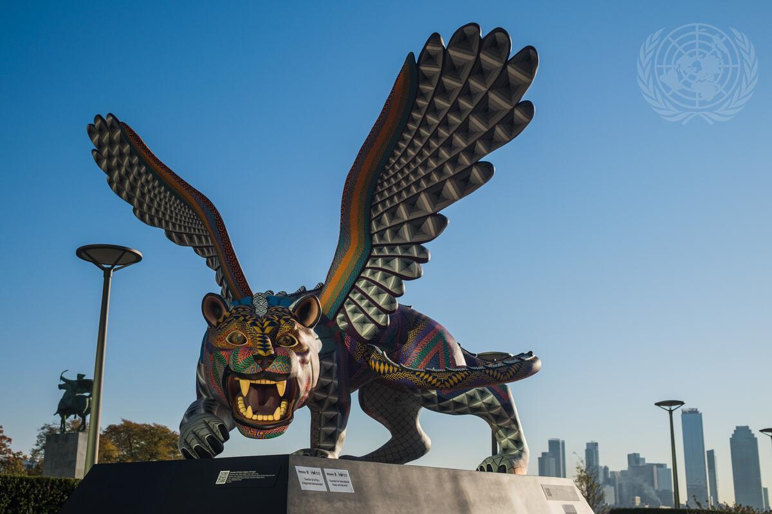
A sculpture that was created by artists Jacobo and Maria Angeles called the “guardian for international peace and security” sits on the Visitor’s Plaza outside the UN Headquarters
In closing I want to share with you the 17 principles of the United Nations
https://www.globalr2p.org/wp-content/uploads/2015/05/KP-Principles-13-April-2020.pdf
https://thecommonsenseshow.com/martial-law/17-principles-un-martial-law-kigali-principles
From an article by Dave Hodges “The 17 Principles of UN Martial Law as per the Kigali Principles” May 5, 2018
“The signing was initiated by John Kerry, on behalf of Obama in December of 2016.”
From Fox News: UNITED NATIONS – The United States is announcing its support for a set of principles that give a green light for U.N. peacekeeping troops and police to use force to protect civilians in armed conflicts. U.S. Ambassador Samantha Power told a high-level U.N. meeting Wednesday focusing on the responsibility to protect civilians that the United States was "proud" and "humbled" to join 28 other countries that have pledged to abide by the 18 pledges. U.N. peacekeepers from these 29 countries are now required to act in cases where civilians are in danger. "The Kigali Principles are designed to make sure that civilians are not abandoned by the international community again," she said…
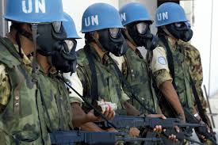
The 17 Principles
The Kigali Principles on the Protection of Civilians
We, as member states endorsing the Kigali Principles on the Protection of Civilians, and in line with our commitment to the effective implementation of Protection of Civilians mandates in peace operations, hereby pledge:
1. To train all of our troops on the protection of civilians prior to their deployment to missions.

2. To ensure that our sector and contingent-commanders, as well as our nominees for mission leadership positions, have a high level of training and preparedness on peacekeeping operations and, in particular, the protection of civilians.

3. To be prepared to use force to protect civilians, as necessary and consistent with the mandate. Such action encompasses making a show of force as a deterrent; interpositioning our forces between armed actors and civilians; and taking direct military action against armed actors with clear hostile intent to harm civilians.

4. Not to stipulate caveats or other restrictions that prevent us from fulfilling our responsibility to protect civilians in accordance with the mandate.

5. To identify and communicate to the UN any resource and capability gaps that inhibit our ability to protect civilians.

6. To strive, within our capabilities, to contribute the enabling capabilities (e.g. helicopters) to peacekeeping operations that facilitate improved civilian protection.

7. To avoid undue delay in protecting civilians, by investing our contingent commander with the authority to use force to protect civilians in urgent situations without the need for further consultations with capital.

8. Not to hesitate to take action to protect civilians, in accordance with the rules of engagement, in the absence of an effective host government response or demonstrated willingness to carry out its responsibilities to protect civilians.

9. To demand clarity from the UN and mission leadership on our rules of engagement, including under which circumstances the use of force is appropriate. 10. To seek to identify, as early as possible, potential threats to civilians and proactively take steps to mitigate such threats and otherwise reduce the vulnerability of the civilian population.

11. To seek to enhance the arrangements for rapid deployment, including by supporting a full review of the UN’s standby arrangements, exploring a system in which earmarked units from troop and police contributing countries could be placed in readiness in order to ensure rapid troop deployment, and encouraging the utilization of partnerships with regional organisations such as the African Union and its RECs.

12. To be vigilant in monitoring and reporting any human rights abuses or signs of impending violence in the areas in which our personnel serve.

13. To take disciplinary action against our own personnel if and when they fail to act to protect civilians when circumstances warrant such action.

14. To undertake our own review, in parallel to any after-action review, in the event that our personnel are unable to protect civilians, and identify and share key lessons for avoiding such failures in the future.

15. To hold our own personnel to the highest standard of conduct, and to vigorously investigate and, where appropriate, prosecute any incidents of abuse.

16. To better implement protection of civilian mandates and deliver on our responsibilities, we request better, regular and more extensive consultations on the mandating of peacekeeping missions. When mandates of peacekeeping missions are under review and may change, it should also be mandatory for the Security Council to consult all troop and police contributing countries deployed to the mission. We commit to bring our own ideas and solutions to these consultations that can strengthen the implementation of protection of civilian mandates.

17. To urge the Security Council to ensure that mandates are matched with the requisite resources, and to commit to support a process that addresses the current critical resource gaps in several missions. We support a more phased mandating process that can ensure a better alignment of resources and mandates.

Well, there you have it. To get the whole presentation, cut and paste the link above into your browser.
I’ve been writing about “what’s coming” for a very long time. In these three articles, you have enough information to prepare yourself in mind, emotions, spiritually, and practically in the physical realm.
These “principals” are not for the distant future, but for now.
They have been signed into US law. The enemy is within our borders in so many ways, we’ve already been set up for Jeremiah 50-51, Isaiah 13, Isaiah 47 and Revelation 18, the “shoe is just waiting to be dropped.”
Please pass on these three articles to those whom you are led to share with … men, and women too. His people wallowing in their own will, must re-program their minds in the whole of Yahuwah’s Word, asking His Spirit to teach them, so that their eyes are opened to reality and they are not hiding behind fear, man’s opinions, or personal desires for the future – and enter “the final stage of preparation” before it all comes down quickly – and it will.
Shalom, always maintain His Shalom! Yedidah
December 9, 2021

