THE WHOLE RING OF FIRE IS ON ALERT!
Deadly Serious Earthquake and Volcano Eruption Danger

Luke 21:10-11, 25-26: “Then He said to them `Nation shall rise against nations and kingdom against kingdom. And there shall be great earthquakes in various places, and scarcity of food and deadly diseases. And there shall be horrors and great signs from heaven….And there shall be signs in the sun, and moon, and stars, and on the earth anxiety of nations, in bewilderment at the roaring of the sea and agitation, men fainting from fear, and for the expectation of what is coming on the earth, for the powers of heaven shall be shaken.”
Revelation 16:20-21: “And every island fled away and the mountains were not found. And great hail from the heaven fell upon men, every hailstone about the weight of a talent. And men blasphemed Elohim for the plague of the hail because the plague was exceedingly great.” [Note: “talent,” or a “talent weight,” from the Greek “talantiaios,” is estimated at 100 pounds]
Revelation 6:12-14: “And I looked when He opened the sixth seal and saw a great earthquake came to be. And the sun became black a sackcloth of hair and the moon became as blood. And the stars of the heaven fell to earth as a fig tree drops its unripe figs being shaken by a strong wind. And the heaven departed like a scroll being rolled up, and every mountain and island was moved out of its place…”
Isaiah 24:1, 6, 19-21: “See, Yahuwah is making the earth empty and making it waste, and shall overturn its surface and shall scatter abroad its inhabitants…Therefore a curse shall consume earth and those who dwell in it be punished. Therefore the inhabitants of the earth shall be burned, and few men shall be left…The earth shall be utterly broken, the earth shall be completely shattered, the earth shall be fiercely shaken. The earth shall stagger like a drunkard. And it shall totter like a hut, and its transgression shall be heavy upon it, and it shall fall and not rise again. And in that day it shall be that Yahuwah punishes on high the hosts of the exalted ones, and on the earth the kings of the earth…And the moon shall blush and the sun shall be ashamed, for Yahuwah of hosts shall reign on Mount Zion, and in Jerusalem, and before His elders in esteem!”
Haggai 2:6-7 and 3:21: “For thus says Yahuwah of hosts, `Once more, in a little while, I am shaking the heaven and the earth the sea and the dry land. And I shall shake all nations and they shall come to the Delight of all the nations…I am shaking the heavens and the earth…”
Hebrews 12:25-29: “Take heed not to refuse the One speaking. For if those did not escape who refused the warning on earth, much less we who turn away from Him from heaven, whose voice shook the earth then, but now He has promised saying `Yet once more I shake not only the earth, but also the heavens.’ And this `Yet once more,’ makes clear the removal of what is shaken, as having been made, that the unshaken things might remain. Therefore, receiving an unshakable Kingdom, let us hold the favor through which we serve Elohim pleasingly with reverence and awe for indeed, our Elohim is a consuming fire!”

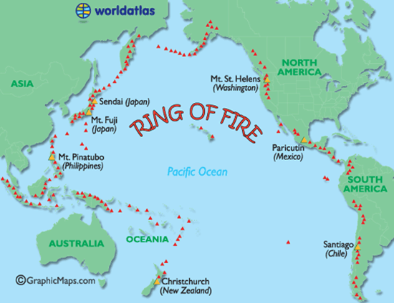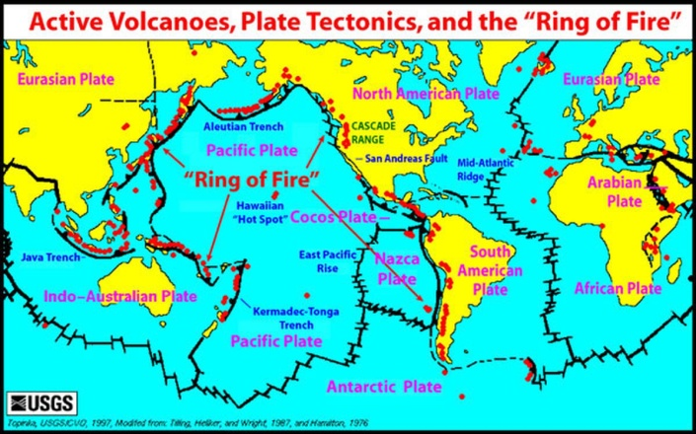
Look at all those red-marked volcanoes! Hawaii marked as a “Hot Spot”

With all the emergency “Danger, Danger” reporting going on about the “Ring of Fire” coming to life as a whole, I could have written much more. But, this article will hopefully encourage you to KEEP UP with this daily. And, it’s not just the Ring of Fire – there is danger in the Canary Islands, too, that could send a tsunami and wipe out the east coast of America! Yahuwah, controlling man’s use of His technology, or by Himself from His throne room, He is definitely shaking!

“Earthquakes Volcanoes Ring of Fire on Alert After Philippines Earthquake - California is Warned” - by Tyler Durden - 05/14/2018 – Zero Hedge
“After a 5.2 magnitude earthquake struck the Philippines, the Ring of Fire was put on alert. After dozens of earthquakes rocked Hawaii this month, followed by a volcanic eruption, many fear the Ring of Fire has become much more active, which has prompted scientists to warn California. The recent and strong Philippines earthquake struck 113 miles from Davao, which is home to about 1.2 million people…The lack of a tsunami warning has slightly calmed the fears of those living in the vicinity of the quake, but those who reside near the Ring of Fire are on alert…“According to The Express UK, the Pacific Ring of Fire volcanoes are more explosive than the ones located in the island state of Hawaii. With Hawaii experiencing widespread devastation at the hands of the volcano, geologists are now warning that California could be the next in line for an explosive eruption… California, which sits on the volatile Pacific Ring of Fire, and is well overdue for a massive and devastating earthquake. The state is also now on volcano alert.
“18th Fissure Opens and Lava Bombs Fly as Kilauea's Eruption Shows No Sign of Slowing Down” CNN News May 14, 2018: “Scalding, black lava crept out of the largest fissure ripped open by Hawaii's Kilauea Volcano, consuming the lush, green landscape around it and lobbing balls of magma known as "spatter bombs" 500 feet into the air, according to footage and reports from the US Geological Survey. Fissure No. 17 split the Earth near Leilani Estates, near the eastern point of Hawaii's Big Island, and the USGS published footage of the lava running like a river -- and then a lake -- past three structures in the area.
While authorities reported an 18th fissure opening Sunday, the Hurricane Volcano Observatory walked that back, saying the latest crack in the Earth -- near Halekamahina Loop Road -- was actually part of Fissure 17. On Monday morning, Fissure 18 officially opened, according to the USGS…”
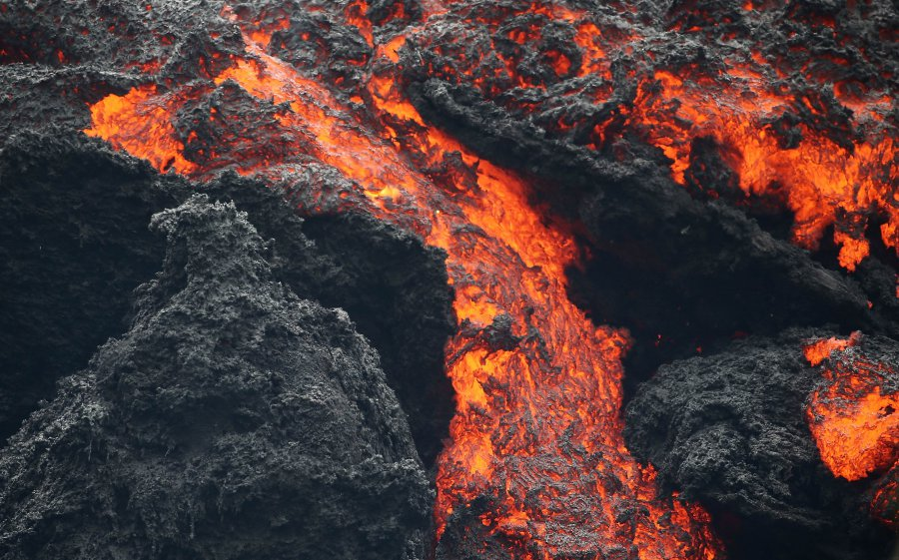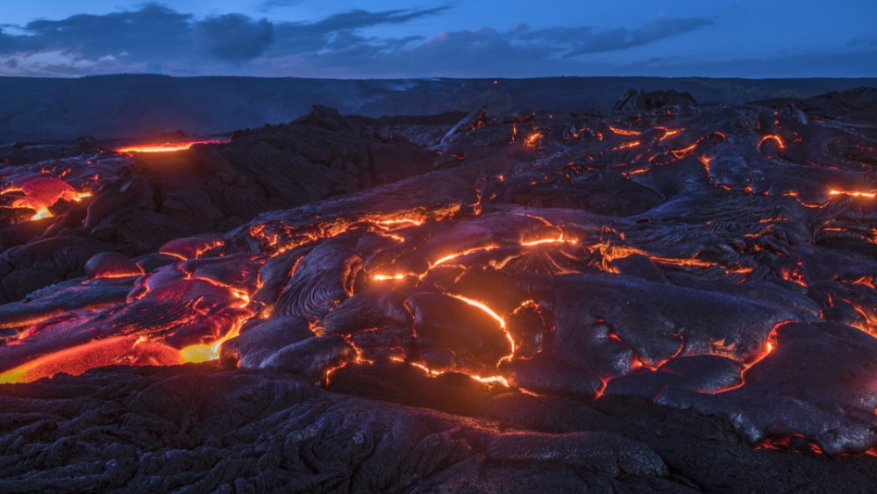
New lava flow – May 14, 2018 – “roaring like jet engines”
WSVX: “Huge Fissure Opens On Hawaiian Volcano As More Eruptions Expected”
YourNewsWire: “Hawaii tells its citizens to prepare for catastrophic eruption”
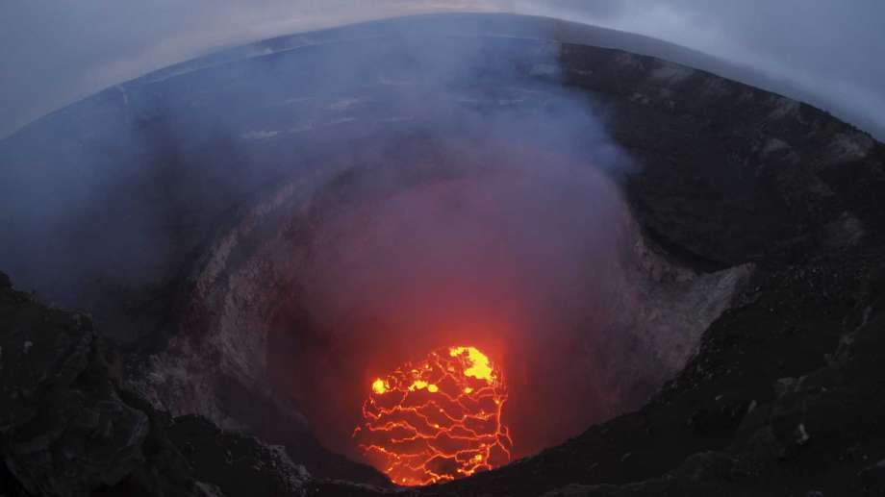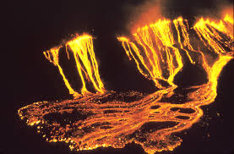
San Antonio Express News: Kilauea Volcano rim: “This May 6, 2018 photo provided by the U.S. Geological Survey shows the lava lake at the summit of Kilauea near Pahoa, Hawaii. Hawaii's erupting Kilauea volcano has destroyed homes and forced the evacuations.”
“The People of Hawaii Are Facing a Growing and Ominous Threat,” The Common Sense Show – Dave Hodges - May 14, 2018: “The Kilauea volcano first erupted April 3, sending toxic gases into the Big Island’s atmosphere and eventually leading to more than a dozen cracks opening in the neighborhoods of Leilani Estates and Lanipuna Gardens. Even if the volcano does not fully explode people with respiratory issues are already suffering because of the great increase of pollutants in the air.
Nearly 2,000 people were evacuated from the neighborhoods last week. Many more evacuations are being contemplated…The lava is spewing out of enormous cracks in the ground, which are increasing by the moment, thus enhancing the danger. The lava has also enveloped homes and cars, by starting massive fires and encasing what was left in molten rock. This is what happened to the people at Pompeii.
An Increasing Threat: The Lava Table Is Falling: Most people would think that shrinking lava table would mean the threat is diminishing. However, the opposite is true. We see that now is that the level of lava inside the main crater of Kilauea, is falling. This is bad--very bad for the people of Hawaii because as lava levels fall inside the volcano, sea water from the long volcanic tunnels which lead to the ocean, allows the sea water to pour into these open cracks. When that sea water reaches the main volcanic chamber and contacts the molten hot lava, the water will instantly boil into steam, and that is when very bad things will begin to happen.
Another complicating factor consists of the consideration that as the lava level has fallen, giant rocks, dirt and other debris from the volcano walls has broken off and fallen into the volcano, blocking the main crater. Subsequently, the steam created from the ocean water flowing-in from lava tubes, could become trapped and build-up pressure. Staggering levels of pressure will develop and eventually, the steam pressure build-up could cause the volcano to literally explode, hurling all the rocks, dirt and other material miles into the air. The volcano could then eject “ballistic rocks” of lava up to several feet in diameter, as large as refrigerators, stated the USGS.
The following diagram shows how explosive eruptions occur at Kilauea: 1) lava column drops below the water table; 2) groundwater comes in contact with magma or hot rocks, 3) the flash boiling of water causes violent steam explosions.
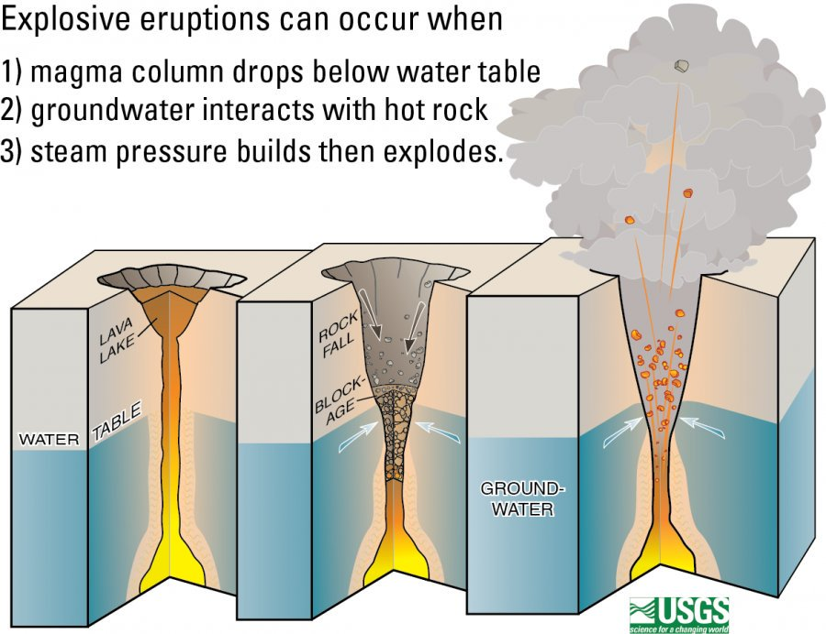
More Danger
There is another grave threat facing the people of Hawaii. Lying between two separate neighborhoods, is a geothermal plant that houses thousands of gallons of flammable chemicals and deep wells that pose serious risks if they overheat or are breached by lava flow or by seismic activity.
In the past, local residents expressed grave concerns and actually filed law suits challenging the placement of this plant on an island with an active volcano. The name of the facility is the Puna Geothermal Venture (PGV) has now become a major safety issue concern as result of the awakening volcano. As it turned out, the people were correct regarding the placement of the plant, and the government adopted the attitude “to hell with the people and their concerns”.
Local authorities are very concerned that the subsequent seismic activity could cause gas leaks or explosions at the plant, which is near fissures that have broken the surface. And seemingly more fissures are being discovered all the time. The risk of suffocation is high for the locals in the immediate vicinity.
Conclusion: Local government officials are telling their locals, on the other Hawaiian Islands that they have nothing to worry about...It smells like this is a means to preserve the tourist trade…America has never faced a threat such as this and we are in uncharted territory. We are in a wait and see mode.”
The Creators of heaven and earth are furious that the life support systems of Their perfect earth, designed to protect and preserve us and our planet, are being destroyed by wicked men. His image and likeness, His people, are being destroyed--the DNA of true humanity is being destroyed to create the hideous spirit-less monsters of the pre-flood atrocity. Therefore Yahuwah is already shaking the earth! The islands will flee, the mountains collapse, the oceans die (they’re dying now), and the earth and the cosmos will revolt against the sin of mankind. It is time for the wise to fear Yahuwah more than ever before. “Our Elohim is a consuming fire.”
Just as I was going to post this article, I saw this article from All News Pipeline that fits right in, May 14th, 2018. It has some good charts and graphs – please see the whole article: “Seismic Symphony of Mayhem Happening Now is a Wake Up Call As We Enter A Tumultuous, Perilous And Ominous Future. - 'When It Comes To Our Existence on Earth, Nothing Will Ever Be The Same As The Words 'Normal' And 'The Good Old Days' Pass Away'” by Stephan Sanford:
“While the mainstream media completely ignores the potential of billions of tons of Earth crashing into the Pacific Ocean and causing a widespread tsunami as we hear in the first video below from videographer MrMBB333, Kilauea isn't the only thing now 'heating up' seismically. As we reported in detail back on May 9th in this ANP story in which we warned that experts say the Mount Teide volcano on Tenerife in the Canary Islands is 'awakening' as well, an eruption they warn "would be cataclysmic…
In this new story over at Zero Hedge titled "'We Are Telling People To Plan For The Worst'": Hawaii Braces For Explosive New Eruptions" they report that authorities in Hawaii are expecting "a series of explosive eruptions" which could happen over the next several days or weeks, "hurling boulders the size of small cars, creating a giant ash cloud, and oozing even more of the hot magma" which we've seen destroying homes, cars, trees and forced thousands to evacuate.
As this new story over at the Daily Mail reports, "it's not over yet" with more and more new fissures forming in the land, spewing lava and causing President Trump to declare the region a disaster area as lava piles up in some places as high as a 4-story building...
And as Zero Hedge reports in their new story this morning, more evacuations have been ordered for residents of the Leilani Estates and surrounding areas of the Puna district after lava was hurtled several hundred feet into the air in new eruptions, spewing massive chunks of lava in an ominous jet-engine sound that once again proves to us the amazing power of our planet...
While nearly half-a-world-away from Hawaii, as we reported on ANP back on May 9th, the Canary Islands may be 'awakening' too with a series of nearly 300 earthquakes within just over a week happening in the region between the islands of Tenerife and Grand Canaria in the Canary Islands…
As Steve Quayle tells us, "when it comes to our existence on Earth, nothing will ever be the same again as the words 'normal' and the 'good old days pass away into a very tumultuous, perilous and ominous future"...
With the eruption of Kilauea causing 'ring of fire fears' for California as well as Eyewitness News 7 reports in this new story, we see why as Mac Slavo reports in this new story over at SHTFPlan: "after a 5.2 magnitude earthquake struck the
Philippines, the Ring of Fire was put on alert. After dozens of earthquakes rocked Hawaii this month, followed by a volcanic eruption, many fear the Ring of Fire has become much more active, which has prompted scientists to warn California.
With California and the entire 'Ring of Fire' now on alert and cluster sets of earthquakes and a volatile volcanic situation seemingly firing up this 'seismic symphony of mayhem', sets of earthquakes and a volatile volcanic situation seemingly firing up this 'seismic symphony of mayhem', Steve Quayle warns us that what is happening around the planet is truly a 'wake up and ponder' call, ready to take everybody by surprise.” Read the article: It has good graphs and charts.
Keep watch! Review important articles like: 1) “Earth is Cracking Like an Egg--Historic Earthquakes and Volcano Eruptions Plus Chunks of Earth’s Mantle Are Peeling Off,” 2) “70 Years of Weather Geo-Engineering – 70 Years of Man’s Destroying Earth’s Life Support Systems,” 3) “Volcanoes - The Magna is Happening in Human Nature”/1-3--Mikvah of Present Reality, and 4) “Terraforming the Earth,”/Mikvah of the Heart of Elohim.
Using Yahuwah’s technology, stolen from Him and given to wicked men once again in a post Flood world, man is manipulating the life support systems of earth’s outer layers, warming the oceans and killing the sea life, manipulating weather, and shaking the tectonic plates of earth’s surface, even rattling the core of the earth.
But, Yahuwah is also demonstrating His rage at the destruction of His Creation. He will step in and cut short the reign of the fallen ones. Let’s put it this way: IF He doesn’t step in, our earth will return to its Genesis 1:2 condition of chaos and ruin.
Prepare, and prepare more. Strengthen you spirit, soul, and body!
In His love for us, His children, Shalom,
Yedidah
May 15, 2018

