The Hidden Agenda Behind the Pope’s Visit
My report on the Pope’s visit to Israel May 25-26, 2014

Current events and Scriptural prophecy are coming together lightning-fast! We of the “last generation” are so highly privileged to see events in the culmination of the ages that are leading to the return of our Beloved One, Messiah Yahushua. After much study in the Word of Yahuweh about the events that will precede the return of Messiah Yahushua, beginning around the early 1960s, I am overwhelmed now at what I am finally seeing with my eyes. Everything is coming together to pave the way for the return of Yahushua. My worship is focused on His coming. Do you realize how privileged you are? Are you consumed with a passion for His Word--proclaiming it, living it, and preparing for what is soon to come? Are you consumed with a passion for His Presence? Are you allowing Him to show you things to come? It is our privilege – John 16:13: ”But, when He comes, the Spirit of Truth, He shall guide you into all truth…and He shall announce to you what is to come.” Are you seeking Him with all your heart? Are you obeying Him without compromise? Are you becoming more and more set apart unto Him? He is becoming more and more personal with His faithful, trustworthy servants, for His servants have their ears close to His chest, to hear His voice, and feel what He feels. (i.e. Yochanan in John 13:21-26)
Abba had me stationed in Israel for 2½ months this last trip--March 22-June 5, 2014--for the purpose of watching things take place, to proclaim His Word, open portals for His entrance, interceded for His people, and understand His heart more completely, so that I could report accurately. Current events are aligning to His Word before our eyes. I am filled with excitement that my Master, my Beloved, my Melek Zadok, is soon to return. I hope you are feeling this excitement too, even though we know that much suffering lies between now and then!
In Israel this time, for about 6 weeks before the pope’s visit, He had me studying hours a day in Scripture and current news about the pope, the Vatican, the Beasts of Revelation 13, the Day of Yahuweh, the “abomination that lays desolate,” and the events to take place when the pope arrived in Israel, so that I would be keenly aware of the fulfillment of the Scriptures. And, everything I saw was fulfillment of Scriptures!
Yet, with all this studying, the last thing I wanted to do was go to Rome. Before the London Olympics of 2012, I felt I had to get back to Patmos. While looking at a map of the Greek Isles, my eye fell to my left and I saw “Rome.” Instantly, He spoke in my spirit, “I want you to go to Rome.” My response: “OH NO!” His response was “OH YES!” He gave me an intercession assignment there in 2012, and another in 2013, that topped anything He had ever given me to do before. I was glad to have my son and daughter-in-law with me in 2013! So, for those trips, we did a lot of studying. My studying for a long time has been focused on the Jesuits – the hidden rulers, not only of the Vatican, but of the world. I have even recently learned how the top Jesuits, the most powerful people on earth, created doctrines at the time of the Counter Reformation, and introduced them into fundamental Christianity, which most of us have believed--doctrines that have purposely kept people from understanding the true nature of the 7th Beast through the past 1700 years.
I love the books of Daniel and Revelation! I found out that in creating rabbinic Judaism, and canonizing the Tenach, Rabbi Akiva considered seriously leaving the book of Daniel out of the cannon. Then, when Constantine ordered a re-write of the “New Testament,” Bishop Eusebius considered leaving out the book of Revelation. Both Daniel and Revelation point directly to the papacy, from its inception in 325 CE and throughout history to these last days. After the Reformation, the Bible was being translated into the languages of the people. To stop people from seeing the power of the papacy in the Word, the pope ordered a new “translation” of the “New Testament” to be done by Jesuits. He ordered them also to write a commentary to be written on the book of Revelation to hide any references to the papacy. When you know the nature of Yahuweh, and the culture of the East, it is easy to see what was twisted, and added, to fit the doctrines of a western mind. One example is the giving of exact time periods that are not in the Tenach. The Tenach is our guide for the accuracy of the “New Testament!” Recently, it has come to my attention that the American Bible Society presented the pope with a new translation, to his pleasure, and they are considering an international translation that leaves out the book of Revelation.
To visualize this study, I highly recommend that you watch the documentary DVD: A Lamp in the Darkness by Chris Pinto, honing in on the section “Enter the Jesuits.” It brings our future into focus and presents reality that should cause all to take action now. The Jesuits were outlawed in 83 countries during their history for their infiltrations, deceptions, manipulations, hidden agendas, assassinations, slaughtering of the true believes, and extreme disruption throughout nations. Today, they do the same only covertly. They don’t leave fingerprints except in third world nations that can’t cry out for themselves and be heard. They are accomplishing the same things fast and worldwide, by using hidden manipulation on a platform of peace, love for the poor, and the uniting all religions into one to bring peace and unity. Daniel 8:25, KJV: “…by peace he shall destroy many.” The gate to hell has opened wide! [Refer to: “False Unity – Stand Firm for the Truth”/March 3, 2014]
The Vatican’s message of unity in the name of peace is the deception that will “deceive, if possible, even the elect.” (KJV) Matthew 24:24, The Scriptures: “For false messiahs and false prophets shall arise, and they shall show great signs and wonders, so as to lead astray, if possible, even the chosen ones.”
Since the 1960s especially, we have seen many false prophets arise and be embraced by born-again believers as wonderful men. They indeed have performed many signs and wonders before us. Because they have awed the Christian world, they were given power by the people--authority, and honor, even worship. People did not question them – they just joined with them. These false prophets have grown in overwhelming wealth. Their names have become big and important. But, in the last 20 or so years, many have been exposed for the deceivers they are, and for their sexual immorality, even homosexuality. In 1994, several big-name Evangelical and Charismatic leaders of America made a pact with the Vatican to deny the Protestant Reformation and join with the pope, in an official document entitled “Evangelicals and Catholics Together.” The Protestant Reformation was declared revoked at that point. Men like Paul Crouch of TBN mocked the Protestant Reformation saying that he didn’t understand why we didn’t reunite with the Vatican a long time ago, and added that he wasn’t protesting anything. Before his death, he was exposed for carrying on a long-term homosexual relationship. Many of the false prophets so honored by American Christians have proved to be immoral people, and most of them have unity with the Vatican at some point. Yet despite their immorality, they are still honored, still raking in the big money. They wow people with their boldness and their signs and wonders.
In early 2014, a big move was made by false prophets in America to unite with the Vatican. To so easily renounce the Protestant Reformation, and denounce our freedom to be taught by the Spirit in the Word, guided and directed by the Spirit in our daily lives, to guard His Torah of Yahuweh with joy, and know Elohim as the Elohim of Israel, in order to embrace demonic slavery to a system that has its roots in Nimrod, the sun gods, and the Nephillim, is to be in league, even in worship, with Satan/Lucifer.
These false prophets are powerful because their followers are in the multi-millions. They have damned themselves and all who follow them.
This is the deception that will cause many sincere people to fall for the “mark of the Beast,” and lose their eternal salvation. The set-up for this delusion began with the Jesuits as early as 154o. They were leaders of the Counter-Reformation. Their schemes worked because they were so demonically deceptive. I have documented research that they created the “pre-tribulation rapture” theology in order to keep everyone looking at a last 3½ year period and a political world ruler, instead of realizing that from 325 CE and the Council of Nicaea, the Roman Catholic Church has been the trampling and devouring 7th Beast of Revelation 17, and the 4th Beast of Daniel 7.
It is just now that we are watching the Roman Empire come to life and rise to world power. It has been hidden, and had its problems through the centuries, but in studying its history, especially Jesuit history, we see that the 4th Beast of Daniel 7 has been seeking world domination since the days of Constantine. It is just now that they have all their “ducks in a row” to pull it off!
Before our eyes, we are seeing the rise of the 7th Beast of history, the 7th head of the Beast, the 4th Beast of Daniel 7, and the 1st Beast of Revelation 13.
Please note: At this point, you might want to read Appendix A, which is “The Extreme Oath of the Jesuits.” Then finish the article, and re-read Appendix A. This is Revelation 17 in real time. The whore of Babylon has been drunk with the blood of the set-apart ones--from Constantine to this day. And we have not seen anything yet in their cruel evil. The fulfillment of Part III of the Mazzini/Pike Plan of 1871 is near, which is to pit Arabs against Jews to set off WW III. Guisipi Mazzini was the leader of the Illuminati at that time, and founder of the Mafia. Albert Pike was the Grand Master of the Scottish-Rite Masons, in league with the Illuminati. [For details on the Mazzini/Pike Plan, refer to “Launching the Chaos”/February 2011]
Ruler of the Vatican, and silent ruler of the world, is the “Black Pope. He, and the Jesuit Order as a whole, is dedicated to enthroning the pope on the Temple Mount in Jerusalem, to cause the world worship him, and to bring all world commerce and economy together to force all to identify with him, or die. As a Catholic Order, they were founded to be the pope’s military--to force the world to bow to the pope, obey him, and come totally under his control, or be killed. This is their one express goal! (Revelation 13:11-18 is clear)
All of this been under our noses all this time, but we have been deceived in believing the lies perpetrated by the Jesuits through the centuries. Now that all of this is coming to the surface so fast, we know we are near the coming of Messiah.
My son said that things were definitely getting worse and worse in the world, but if they didn’t Messiah would not be coming. How true! The signs of the tribulation, the time of “Ya’cob’s troubles,” cause us to “look up for our redemption draws near.”
I am not going to be dogmatic as to how these things will unfold. We will learn as things progress. But, since the Protestants Reformation, once true believers got hold of the Scriptures to read for themselves in their own languages, most have come to the same conclusions I have.
I want to present startling documented facts, and let you do your own research, watch, hear Abba, and pray, to get your own questions answered. But, what I present here will give you a good start. The final puzzle picture is coming together. There are still a few places that need filling in, but Abba teaches those that ask Him.

Yahushua Messiah said this regarding the timing of His return, in Matthew 24:27-34: “As the lightning comes from the east and shines to the west, so also shall the coming of the Son of Adam be…and immediately after the tribulation of those days, the sun shall be darkened and the moon shall not give her light, and the stars shall fall from heaven, and the powers of heaven shall be shaken. And then the sign of Adam shall appear in the heavens, and all the tribes of the earth shall mourn, and they shall see the Son of Adam coming on the clouds in the heaven, with power and great esteem. And He shall send His messengers with the sound of a great trumpet, and they shall gather together His chosen ones from the four winds, from one end of the heaven to the other. And learn the parable of the fig tree: When its branch becomes tender and puts forth leaves, you know that summer is near. So you also, when you see all these things, know that He is near--even at the doors. Truly I say to you that this generation shall by no means pass away until all these things are fulfilled.”
Notes: The word “heaven” in context in Matthew 24:27-34 refers to the area of the sky that we see above us. Revelation 1:7: “Behold! He is coming with the clouds, and every eye shall see Him, even they who pierced Him…”
When He says “all these things” please read in context to find out what things. The “Promised Land” of Israel is the fig tree - refer to Joel 1:9, Hosea 9:10, and Jeremiah 24.
The fig tree began to put forth leaves November 29, 1947, when the United Nations proclaimed the state of Israel for the Jewish people. That state became an official reality on May 14, 1948. Yahushua said “this generation shall not pass” until all is fulfilled--concluding with His return.
A Biblical generation is 70 years (i.e. Psalm 90:10) Adding 70 years to 1947, we get 2017. Adding 70 years to 1948, we get 2018. Thus, 2018 will not pass until all is fulfilled!
On Yom Teruah 2015, (2015 is a Smittah year), entering into 2016 on His Creation calendar, we begin a new 7-year cycle. In “The Shmittah Year Prophecy”/2007, you see that the final 7-year cycle, of the final three cycles, ends on Yom Teruah 2015 as we go into 2016 on the Creation calendar. Ten days after the Yom Teruah on which Messiah returns is Yom Kippur. That Yom Kippur will begin the official Yobel--Jubilee year-- (Leviticus 25).
The actual beginning of the blossoming of the fig tree began on November 29, 1947 by edict of the United Nations. But, since, on the Creation Calendar, a new year begins on Yom Teruah, November of 1947 was really 1948 in His actuality. Thus, no matter how you figure it, the generation that was alive in 1948, whether on His calendar of the Gregorian calendar in May, will see the return of Messiah! I was born in 1944, so I am part of that “seeing,” but so are you, no matter when you were born!
“Look up, lift up your head, for your redemption draws near!”
We’re in the final stages of the fast-moving strategy of the evil ones--agents and worshippers of Lucifer/Satan--to set up a one world government in which the son of Zeus, Apollyon, son of destruction, one who sits in the place of “God,” demanding worship as “God,” will rule the world from the Temple Mount in Jerusalem. How interesting that the Muslim Wafts want to put a throne for the pope on the Temple Mount, which they control for the Vatican.
Only one religion brought forth the entire ancient pagan religions of sun god worship from Nimrod, Semiramis, and Tammuz, and hid it in full view before the eyes of the world--Roman Catholicism. Its founder, Constantine, the 1st pope, was a worshipper of Sol Invictus Mithra – the unconquerable sun--the sun god Mithra of Persia. He, as the Greek Apollo/Apollyon, son of Zeus--Revelation 9:11--is called the “son of destruction,” or “the destroyer,”--the “apolia” in Greek: Revelation 9:11, 11:7, 17:8; II Thessalonians 2:3.
We are watching “the great falling away,” and the magnifying of the 1st Beast of Revelation 13, promoted by the 2nd Beast. The 1st Beast is described throughout the Tenach, especially by the Prophets. I have referenced all the Scriptures in the entire Word that deal with this man of sin. The second Beast is hidden within the 1st Beast in the Tenach, as “echad,” -- two in unity as one. In Revelation the two are separated – to show their incredible alliance.
Actually, the first Beast of Revelation 13 gives the second Beast the power to carry out his will – to cause the world to worship him, and to control the world through economic unity. The Roman Catholic Church now controls 1.2 billion Roman Catholics. But, they actually control everyone on earth through their control of world economy, commerce, (buying and selling), the intelligence organizations, chief nations and international organizations of the world. There is very little on earth that is not controlled by the Jesuits. By infiltration, they have covertly placed their non-priest Jesuits in about every high position on earth--in governments, top international organizations, the largest banks and commercial institutions, universities, seminaries, intelligence organizations, churches, and public schools. Is this power real? It sure is! It’s well known and documented by those that refuse to look at life on a surface level. Have you ever questioned by the world news media gives the pope’s activities, and events at the Vatican, so much publicity? Why, at the funeral of Pope John Paul II, do we see former U.S. Presidents kneeling by his casket?
I knew in my spirit that after Pope Francis I came to Jordan, Bethlehem, which the Vatican referred to as part of “the Palestinian state,” and Israel, that things would speed up lightning fast! I will give you some examples below, just since May 26th 2014.
My focus of study, and prayer, is in three areas: 1) Israel 2) the Jesuit Vatican under the Jesuit General, and Jesuit Pope Francis I, and 3) the backlash that is being unleashed on America in judgment as a result of America’s betrayal of Israel.
The terrible Beast of Daniel 7, the two feet and the ten toes of Nebuchadnezzar’s statue in Daniel 2, is with us. It is growing in power, and, like a black hole, sucking in all religions, and the world’s people under is guise of peace.
I love Daniel 7 because, side by side are the prophecies of the Beast and the prophecies of the mighty coming of Messiah in power and great esteem.
Daniel 8:25: “…and by peace he shall destroy many.” Those that do not love Truth enough to seek it from the Spirit of Yahuweh, the giver of all Truth, will fall prey to the deception of this peace, damning themselves. It is Yahuweh who is sending this delusion on all, so that He might separate His people from everyone else. (II Thessalonians 2:8-12)
Recently a friend told me about talking to some Australian Messianic people about the real Shavu’ot on June 8th, referencing Leviticus 23:9-21 and Yahuweh’s detailed instructions. Their comment to her was, “thank you, BUT we have decided to follow the rabbis.” The rabbis have changed the law of Yahuweh to suit themselves. For the truth about rabbinic Judaism, please read “Exposing Rabbinic Judaism and Its Link to Rome.” It is amazing how it aligns to Vatican thinking and doctrine in many things.
This is a tiny example of attitudes that rebel against Yahuweh’s Word in favor of man’s manipulations. People who run after man’s teachings, without studying the Word with the Spirit as their Teacher, and obeying only Him, will be led into greater deception like a lamb to the slaughter.
The Scriptures tell us that there will only be two categories of true believers in these days: 1) the martyrs, and 2) those that will be alive and remain, overcome, and do “exploits” for Him. (Revelation 7 clearly describes both groups)
From the time of the Reformation and way into the 1800s, the true believers knew that both Beasts would come from the Vatican.
The Roman Empire controlled a great portion of the world at one time. It appeared to die, but didn’t. The ancient Roman Empire was the 6th head of the Beast. The term “Beast” refers to both a world system--political, economic, military, and religious--and to a man who would rule the world before the return of Yahushua Messiah.
The system and the man are a composite of the cultures and characteristics of six empires that have ruled in history, and ruled over Yahuweh’s land at some point – Assyria, Egypt, Babylon, Medo-Persia, Greece, and Rome.
Daniel 7 hones in on the last four, showing the 4th one to be a revived Beast of all beasts.

One of the seven heads was wounded. It was the 6th head that was wounded – ancient Rome, and appeared to die. Six is the number of man. The seventh head is the revived Roman Empire, which shocks the world as it rises to world power. Seven is the number of completion – the completion of the empires of the world that have come against Yahuweh, His people, and His Land.
Historians know that the worship of the Emperors, and the power of the Roman Empire appeared to die, but it didn’t -- it just reincarnated into the Roman Catholic Church, with its pope as the ruling Emperor, sitting as the “Vicar of Christ,”--the one who sits as “God,” demanding worship as “God.” Constantine united his failing Empire by creating a composite religion of several types of sun god worship – including Greek Gnostic Christianity. His plan worked. This same plan is being implemented by Pope Francis I and it is working well! The Roman Catholic Church, from 325 CE, became the perfect façade for the hiding of the ancient Roman Empire until the time for it to be revived--the sixth head to become the 7th-- to conquer the world! You are watching the reviving and empowering of world-conquering final Beast with your own eyes! And this time, the conquering is being through a deceptive peace and unity. And, as with Constantine, it will be very successful!

In the days of the Roman Empire, the Caesars demanded worship, believing themselves to be gods--just like the Pharaohs of Egypt thought they were incarnations of the sun god Ra. Constantine demanded worship as the Pontifex Maximus of his Roman Catholic religion. The Jesuit Order, the Society of Jesus, came on the scene years later (1540) as a militant force to make sure the world bowed to the pope. It was an occult organization from the beginning. Their god has always been Lucifer. Loyola was an occultist in league with Lucifer. Their express goal in the “Jesuit Extreme Oath,” is to put a pope of their own on the Temple Mount to be worshipped as “the god who sits in St. Peter’s chair.” This “god” of theirs--the pope--is considered infallible, God on earth. Pope Francis I is the first-ever Jesuit pope in history! This is beyond significant.
[To see the “supernatural” surroundings of this pope, refer to: “The Deceptive Pope: Mister 13”/March 2013] Israel embraced Pope Francis as a man of peace.

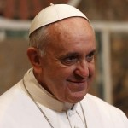
Pope Francis I

I saw things in Jerusalem that were numbing, i.e. the papal flag flying at the same height as the Israeli flag over the Old City of East Jerusalem.
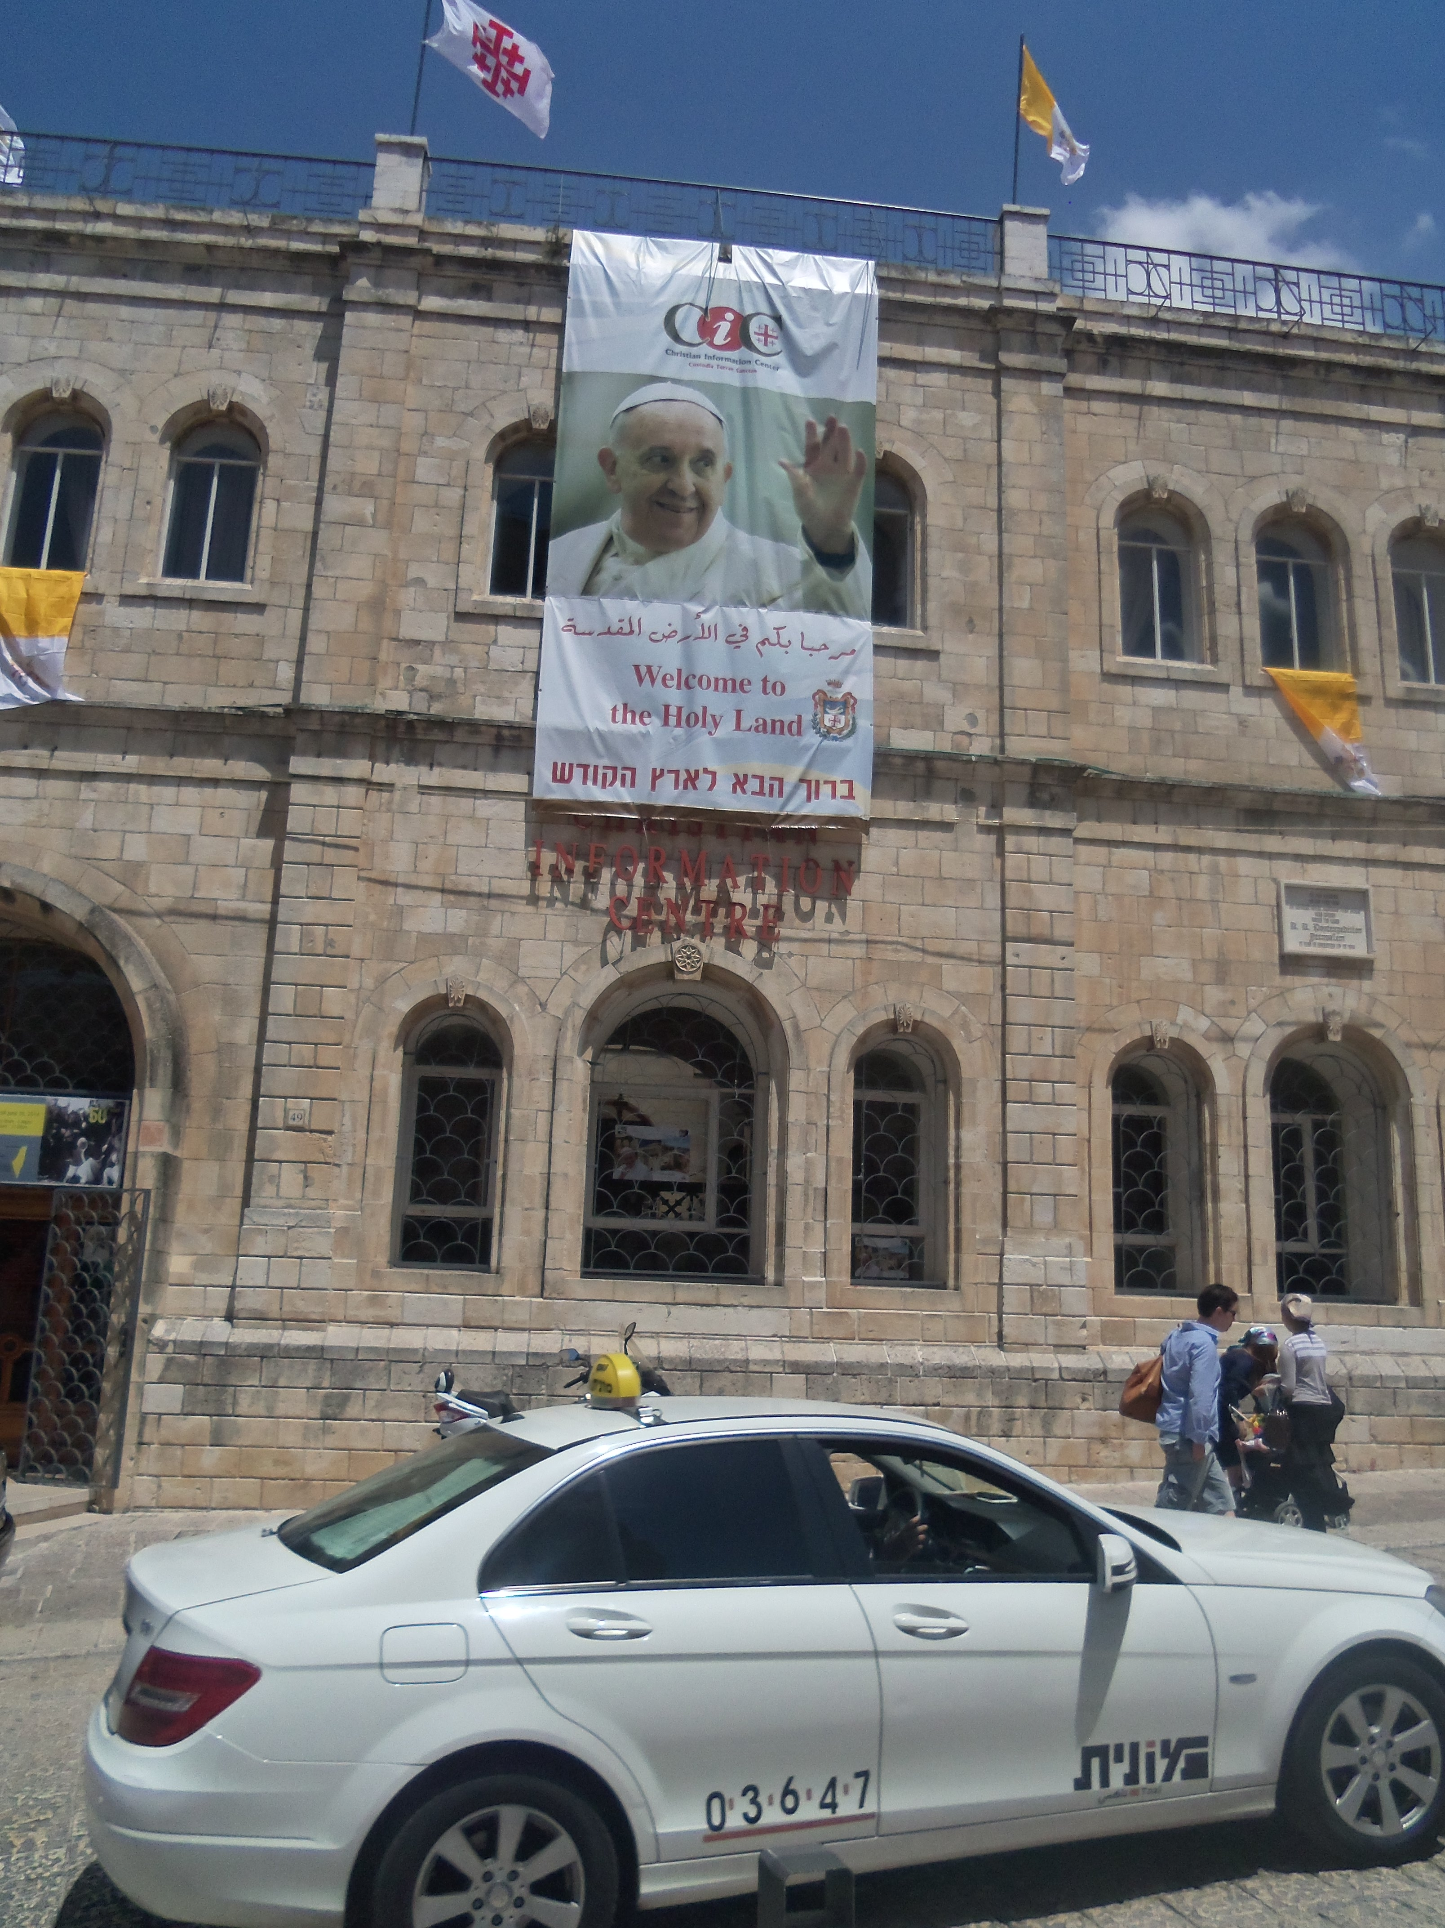
Photo by Yedidah May 24, 2014, Jaffa Gate area of the Old City of Jerusalem – note the yellow and white flags with the papal crest on the white side, and the banner welcoming the pope

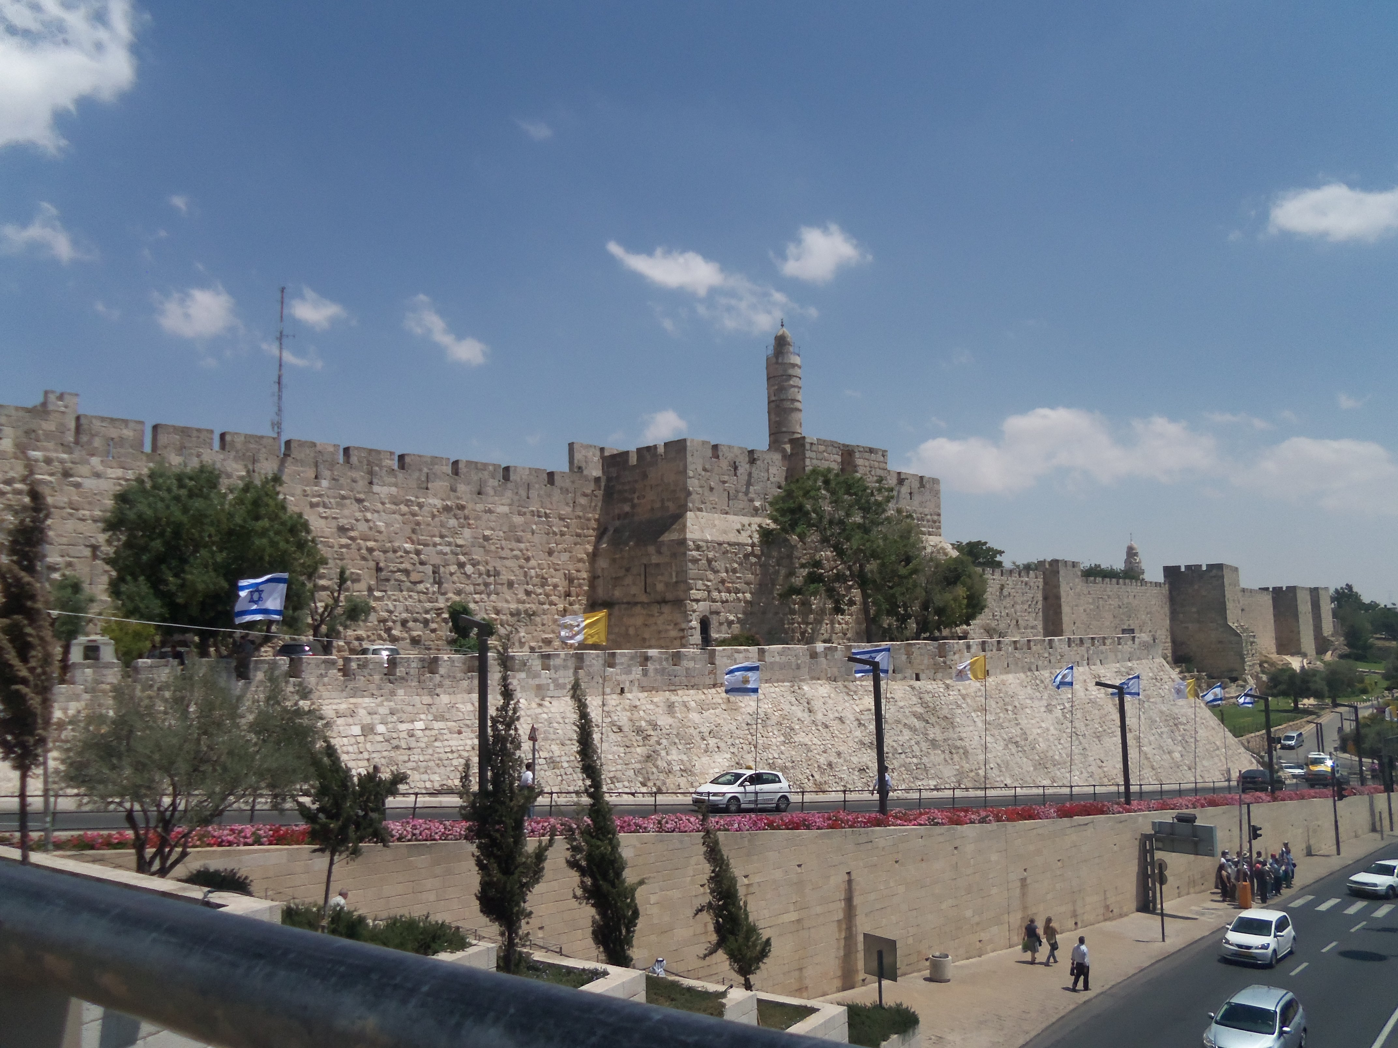
Papal flags flying outside the Jaffa Gate entrance to the Old City along with Israeli flags

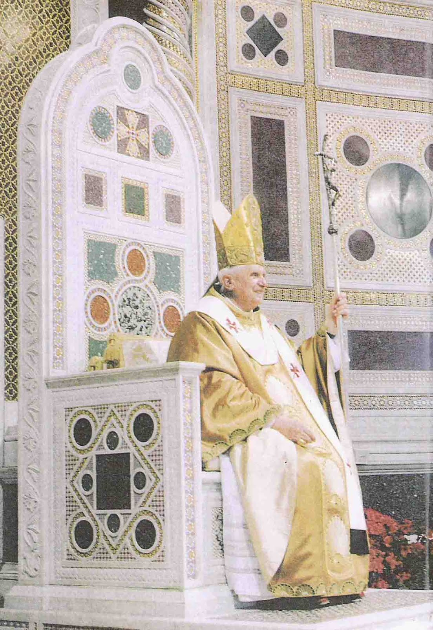
November 12, 2012: Pope Benedict sits on his throne at the Lateran Basilica
From this throne, the popes can speak “ex cathedra,” of as infallible, as God

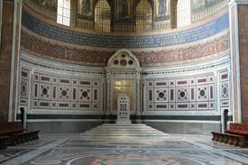
The throne in the apse of the Lateran Basilica--photo by Yedidah 2013

Revelation 13:2: “And the Beast which you saw was like a leopard, and his feet were like the feet of a bear, and his mouth as the mouth of a lion, and the Dragon (Revelation 12:7-17) gave him his power, his throne, and great authority.” (Daniel 7:17-28)
Here’s what we’re watching--Revelation 13:3: “And I saw one of his heads, having been slain to death, and his deadly wound was healed. And the earth marveled after the Beast.” The world is marveling! The deadly wound has been healed. It is about to reach its goal – of world conquest. It has slowly been taking over the powers of the earth for centuries, and has succeeded well despite ups and downs. The Jesuit Order was brought on the scene by Satan/Lucifer to bring his plans to their fruition. Thus the Dragon and the dark rulers of the Jesuit Order are united as one in their goal and their methodology.
The “Extreme Oath of the Jesuits” in Appendix A will answer many questions.
Constantine began in 325 CE, at the Council of Nicaea to change the “mo’edim” (the appointed times of Yahuweh for His Festivals and His day of worship) to match the holidays and day of worship of the sun gods: Sun-day worship, Christmas, honoring the birthdays of the sun gods, and Easter, to honor the resurrection of the sun gods at the spring equinox. (Isaiah 14:13) [Please refer to: “The Sunday Laws and the Returning Inquisition”/July 31, 2013] You need to know the information in this article!
The desire of Lucifer/Satan has been to sit on the Temple Mount and be worshipped as “God,” -- to sit where the Ark once sat. He will change times and seasons again to raise himself up above Yahuweh. He has just needed a body to inhabit.
The United Nations, the Vatican, the E.U., and now America, are openly dedicated to making East Jerusalem the capitol of a Palestinian state! Yet, at this same time, Hamas, now in unity as a government with the PA/Fatah, has kidnapped three Israeli teenagers. Look at this picture, from Arutz Sheva, June 15th. Over 30,000 Jews gathered at the Wall to pray for their return. The nation of Israel is uniting more and more.
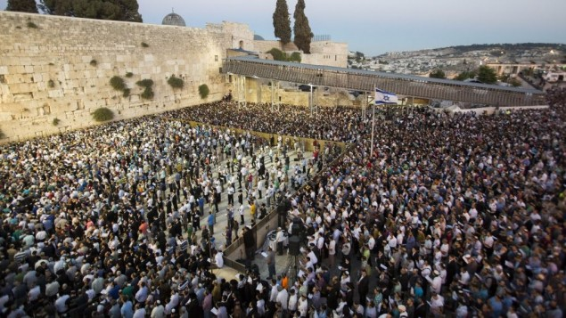

The Vatican’s itinerary for the pope’s visit said that the Pope would fly from Rome into Amman, Jordan on May 24th. Then on May 25th, he would take a helicopter to the “state of Palestine” (which is Bethlehem) to meet with the “President of Palestine” (Mahmoud Abbas), before flying into Israel later that day. On May 26th, he was in Israel, but first he visited with the Muslim Waft and other Muslim leaders on the Temple Mount before going to the Western Wall at 9:15, and other Jewish places. The Israeli leaders and news media prostrated themselves before him, even though the whole time he was in the “Palestinian state” he indicated their right to have East Jerusalem as their capitol. It was definitely a political trip to set things up. Jordan is not only the overseer of the Temple Mount, but of the PA itself.
Yet, Israel proclaimed the Pope a man of peace, while the pope proclaimed Mahmoud Abbas, head of the PA and Fatah, and an arch enemy to Israel, to be a man of peace.
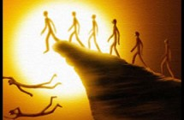
People are becoming so dulled to reality that most are falling off a cliff into destruction.

A recent dream by a friend in Australia:
“There was a very large stadium filled to the brim with people, all seated. I knew I was in America, but I was receiving a message for all humanity. There was no action on the field, not even a goal post or anything to indicate what might have drawn the people to this place. I was down at ground level, inside the stadium, observing the people from one of many ‘tunnels’ which opened onto the field. Suddenly a blast, a bomb went off in one of those tunnels. I moved to a place of safety outside the complex, expecting a stampede of people trying to exit. There was nothing, just silence. I waited awhile then went back through the tunnel to see where the people were. Every single person was still sitting in their seats and I saw through spiritual eyes that they were as though dead.
…this message is about the state of consciousness and lack of awareness of the masses. Critical, independent thinking and responsibility has been so dumbed-down that now they wait to be told what to do. Even when they are in danger, they wait for someone ‘in authority’ – to tell them what to think, believe and how to react. They have no internal voice, no discernment. In the dream there was no evacuation order, but I was moved to get out of harm’s way, the people in the stands did nothing. After the bomb went off it appeared no one had been injured, but I wondered if there were more, perhaps bigger bombs waiting to be triggered. Thousands had come to this place with their family and friends to be entertained, now they just sat waiting for the entertainment, even though there was nothing on the field but green grass. They were slaves to their expectations, and blind to reality.” Awesome picture of present-day reality!

From another Australian friend regarding timing: “In the first segment of the dream I see myself rushing to reach a pedestrian crossing before the light changes from green to red. In the second segment while I am in the safety of the crossing, I note that the green light shows the number 58, and I know that I have but fifty eight seconds to complete the crossing. Thus we are no longer in the last hour, or even the last minute. We are now, I believe, in the last seconds before our Beloved Yahushua returns--HalleluYah!”
Yes, HalleluYah!!!

Both these ladies are submitted to the Master, so He is sharing His heart with them. I have heard from several on my list who are feeling that something massive and urgent is about to happen, some are hearing sounds in their spirit from the heavens. The battle in the planetary/star system of Revelation 12 is in full sway. There is a new awareness in those that are close to His heart, who are feeling what He is feeling. He is coming ever closer to those who have died to “self” and are hanging onto His every Word to do what He says – the true servants of the Elyon (the Most High). The great separation is taking place! The great gulf is forming between the true servants of the Master, and the religious pretenders. (Matthew 10:34-39)
The Spirit of Yahuweh is withdrawing from the earth – leaving it to the will of man, who is choosing the will of Lucifer over the will of Yahuweh and Messiah Yahushua. He will allow earth’s people to have their way without Him for a very short time. Then will come “the Day of Yahuweh” as Messiah descends with the wrath of His Father. Then the Kingdom will be given to the few.
Matthew 7:13-14: “Enter through the narrow gate! For the gate is wide and the way is broad that leads to destruction, and there are many who enter in through it. Because the gate is narrow and the way is hard-pressed (“the way is afflicted”) that leads to life, and there be FEW who find it.”
Isaiah 1:9: “Unless Yahuweh of Hosts had left us a small remnant (“a precious few”), we would have become like Sodom, and we would have been made like Gomorrah.”
Revelation 3:1-5: “And to the messenger of the assembly in Sardis write, He who has the seven spirits of Elohim and the seven stars says this, `I know your works, that you have a name that you are alive, but you are dead. Wake up and strengthen that which remains and is about to die, for I have not found your works complete before Elohim…watch and repent! If, then, you do not wake up, I shall come to you as a thief…He who overcomes shall be dressed in white robes and I shall not by any means blot out his name from the Book of Life, but I shall confess his name before My Father…’ ”
In Revelation 14:9-20 we read the fate of those that submit to the “mark of the Beast,” the identification ID that separates a person unto the Beast, to worship and obey Him. Tragically, multi-millions of Christians, Messianics, and Jews, in the illusionary “free world,” are already so dulled by their allegiance to man, their lusts of the flesh, their love of the world, their allegiance to their own goals, and their comfortable surroundings, that for them to receive the promises, and submit to what they are told to do by an international ruler will seem the right thing to do to maintain their lifestyle. Most so-called believers are not submitted to Yahuweh, but to their own beliefs that they have chosen which please them. Most are now sinking in a mire of deep mud, not even noticing that they are sinking--even being pulled downward into an eternal pit, and thinking they are all right with God.
Apathy rules in most people to some degree. “Apathy” is not a passive condition! It denotes willful rebellion and stubborn resistance to taking responsibility for their thoughts, words, and actions. Few are allowing the Spirit of Yahuweh to transform them into the nature, ways, and thinking of Yahuweh. That is true freedom! But, the Illuminati mind-programming and the DNA-changing elements that we have been bombarded with for so long, has left people in a self-satisfied zombie state, with little to no desire to change – not even to save their eternal life. People are becoming near incapable to change. Those that lean towards following intellectuals who look good and sound good, do not realize that the leaders of the Illuminati are considered the “intellectuals” of Roman Catholicism, and the Jewish rabbis that are in league with them have been led astray by glorying in their intellect and their demonic Kabala.

In Matthew 18:1-3, Messiah says: “Unless you become as a little child, you cannot enter the Kingdom of Elohim.”
In I Corinthians 1:27-29, Sha’ul says: “Elohim has chosen the foolish things of this world to put to shame the wise, and Elohim has chosen the weak of this world to put to shame the strong. And Elohim has chosen the low-born of this world and the despised, and the ones that are not, that He might bring to nothing the ones that are--that no flesh should boast in His Presence.”
Beware! Whatever you see the world running after and embracing: Yahuweh is not in it!

And who is behind the mind-programming? -- The mysterious “Illuminati.”
Ignatius Loyola, founder of the Jesuit Order, occultist, warlock, Luciferic/Satanist, and first Jesuit General, created the Illuminati, which was first called the “Alumbrados,” as a means of conquering the world’s people for the pope to rule them. That’s their founding goal! The term “Illuminati” comes from their god Lucifer (Latin), or Helel in Isaiah 14:12-14, which mean the “light-bearer,” or the “illumined one.”
Their methods of mind-programming are all designed to open portals for the entrance of their gods to inhabit the minds of the world’s people, so that they will, like robots, submit to the pope, and think they’re doing right – a hypnotic programming. This has been accomplished well through mass media – especially the T.V., but also through video games, the world wide web, books, and public schools.
Loyola’s “Spiritual Exercises” are a disciplined methodology for reaching their goals by deceiving the people. Pope Francis is a master in using these “exercises,” having even taught them to Jesuits in Argentina.
I wrote about the methodology of the Illuminati, quoting from their own handbook, in “Quiet Wars and Silent Weapons.” Because we have been bombarded, especially in America, by this mind-programming from birth to death, we are watching people becoming more and more zombie-like, yet masking a hidden nature like Lucifer’s. Dead bodies inhabited by demonic spirits that make them appear to live are called “Zombies,”--the living dead. They may appear passive, but once grouped together with an agenda they become ravenous beasts, as so well portrayed in the movie “I Am Legend”/2009. It is horrifying that so many young people today, even children, think of the zombies as “cool.” Many new cults of youth are turning to Satanism and witchcraft, and identifying with Dracula.
Man is rapidly aligning to the will of Satan’s/Lucifer. The great deception is happening before our eyes. (II Thessalonians 2:8-12) Deception is being sent from Yahuweh upon those who refuse to submit to His Truth and obey it. Truth is only real Truth if it is taught by the Spirit of Truth to our re-born spirit. Only those who are Spirit-taught unite as the early disciples united – “echad” as Yahuweh and Yahushua are “echad.” (John 17) “Echad” is a Hebrew word denoting two in unity as one – a family word, like husband wife who are one flesh. (Genesis 2:24)
Take sides! Make your stand firm! Else you will be washed away in the powerful current of delusion that is now washing multi-millions of people down into the pit of destruction. The “great deception” has now manifesting. We knew it intellectually, but to watch it is numbing.
Following the leading in my spirit, I planned to be in Jerusalem May 23-26, to cover the pope’s visit. I was excited. I knew this was a big assignment. I did at least 2 months of intense research, 8 hours a day in preparation for it. So, I made reservations at a guest house in the Old City within the Jaffa Gate. But, a few days later Abba surprised me to add a day--not to stay through the 26th, but to go on May 22nd. He reminded me of my intercession over the G-8 Summit in Evian, France in 2003. I did my intercession days before the G-8 Summit was to begin. But, a couple of days before, they shut down the ferry from Lausanne, Switzerland to Evian, and closed off Evian for the arrival of the dignitaries. So, I was obedient to go early to Jerusalem--and was I ever thankful!
By going on Thursday the 22ned, I was able to go into the Cenacle, (what the Catholic Church calls the “Upper Room”), where the Pope would be saying Mass on the evening of the 26th. I got to see some of the IDF (Israeli Defense Force) preparations for securing the area. If I had kept to my original schedule, I would have missed so much. Abba wants to guide us in fine-tuned ways! I had questioned why He wanted me to leave Jerusalem the morning of the 26th, when that is the day that he was in East Jerusalem until that evening. But, I obeyed, and on the morning of the 26th I learned why I had to leave early.
Constantine’s mother visited the “Holy Land” to find things that would support her son’s new religion. The hill above the real Zion, the City of David, she named Mount Zion.
Catholicism has supported all she found, which was all fake, and made her a saint. Yet, her son was so crazy she later had to hide out in fear of him. After supposedly becoming a Christian, Constantine had his wife and son murdered. Truthfully, he was really a worshipper of Sol Invictus Mithra until his death.
I knew in my spirit that the pope’s Mass at the Cenacle would open doors for harm to the Orthodox Jews who have a yeshiva there in the same area, and for those who pray at the symbolic, or literal, tomb of David. I have gone to pray with His people on the women’s side of the tomb for many years and have been blessed to be with them! But, with the Mass being said inside the Cenacle--the Roman Catholic “upper room” where “Jesus” and his disciples supposedly had their last supper--under rabbinic, and Torah law, the Mass defiled the whole building. The “tomb of David” is on the bottom floor, the Cenacle is just above it and on top of both stands an ancient mosque. More and more Muslims are going up to see that mosque, and also coming into the “tomb of David” prayer area.
The Orthodox Jews have been very tolerant. They have not said anything about the Christians going into the Cenacle to say their personal prayers, because they don’t organize to bring in pagan defilement (idolatry) that would affect the Jewish place of prayer below. But, with the Mass, the door was opened for pilgrims to bring in huge crosses, light candles, sing and worship, and hear the Mass itself, from which Satanists formulated their “black mass.” Yes! I learned that from a very powerful warlock, ex-Satanist, who was dramatically born again. Satanic “black masses” are performed under St. Peter’s Basilica by the Jesuits. There are miles of catacombs beneath the Vatican that go out from the center under St. Peter’s like spokes in all directions.
Around June 1st or 2nd, brief footage was taken by a Jewish man of a Mass being said in the Cenacle. It was reported by Artuz Sheva, and proved by videos, that since the pope’s mass there, the Franciscan priests who oversee the Catholic sites on the false “Mount Zion” are actually celebrating masses there. Because of this defilement, the Orthodox Jews cannot go and pray at the “tomb of David.” I also saw a video taken by an Orthodox man who was approaching the steps to go up to the Cenacle. He was stopped by Israeli police. Christians and Muslims could go up, but not a Jew. I was also stopped by police from going up to the Cenacle on Friday morning, the 23rd. It had already been set up for the Mass. I saw part of the setting up from below.
I also learned recently that the deal Israel made with the Vatican, which opened the Cenacle for regular masses and prayer--a deal which the Jews feared was real--was indeed a reality!
Israeli Jews Protest at King David's Tomb Over Christian Prayers
By AFP and Arutz Sheva Staff - First Publish: 6/9/2014
“…on Monday, witnesses revealed to Arutz Sheva that the status quo had changed with Christians flooding the site for Mass, which is now a weekly service. It should be noted that the institution of regular Catholic prayers at the site constitute a severe breach of Jewish prayer rights. Rabbi Avraham Goldstein, dean of the Diaspora Yeshiva, told Arutz Sheva in May that Jews will be prevented from entering the holy site altogether due to the Mass services, given that Jewish law forbids using a building used for idol-worship - a category which Catholic worship, with its use of effigies, falls under according to Jewish law.
Rabbi Dvir Tal, dean of the King David Yeshiva, reports that during the Mass service on Sunday, incense was burned, the scent of which spread throughout the Compound--engulfing the Tomb of King David on the ground floor as well. Christian visitors brought massive crosses to the prayers, and placed them in the `Room of the Last Supper’ for the service.
Additional testimony was given to Arutz Sheva by Rabbi Yaakov Sevilia, an activist for King David's Tomb. Rabbi Sevilia reported that lit candles were placed in the floor of the room in the shape of a cross. `There's a great pain here; it is hard to describe the depth of our frustration over the reality in which right above the Tomb of King David - David who every Jew is connected to and who the full redemption is dependent upon - they let idol-worship happen, which is more severe than murder and sexual indecency,’ said Rabbi Tal, noting Jewish law's position on the three cardinal sins.”

Vatican and Israel reach agreement on taxes and the Cenacle
May29, 2013 – Catholic World News

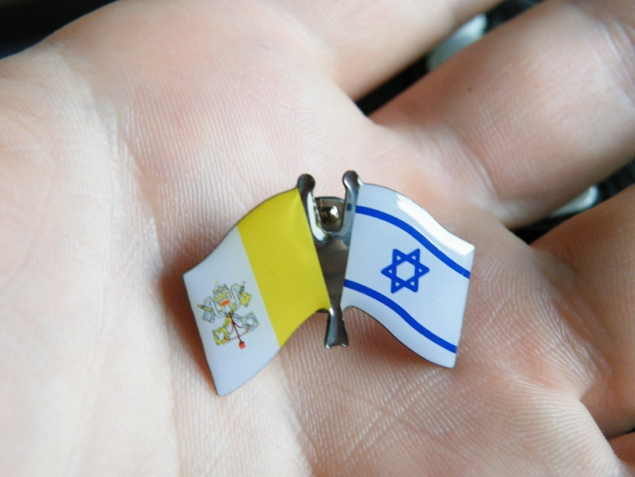
“The Cenacle on Mount Zion where, according to Christian tradition, the Last Supper was held, will become a Catholic place of worship once again.
According to the “Protocol Activity” – a permanent protocol between the Holy See and the State of Israel which both sides have agreed on, it will now be possible to celebrate Mass in the Cenacle. The room will be managed by the Franciscan Custody, but will remain the property of the State of Israel and will not be handed back to the Franciscans who owned it in the past.

Perhaps you in the West wonder why the Jews are so unrelenting in this situation. Western culture tolerates, condones, and even calls “good” what the Torah says is idolatry, blasphemy, wickedness, and immoral. “The Word of Yahuweh is not an American document,” to quote a Torah-guarding Jewish Messianic friend in Israel. It was written to the children of Ya’cob in their culture, in their Land, regarding their Covenant with their Elohim. Yahuweh is intolerant of paganism trying to mix with what is undefiled. He will have no other gods in His face! (Exodus 20:3-5)

Here is a picture I took of the web of the pope celebrating mass in the Cenacle, the evening of May 26th. The prayer area of the “tomb of David” below was closed off, and Jews were not permitted into that area. All for “security” reasons of course…
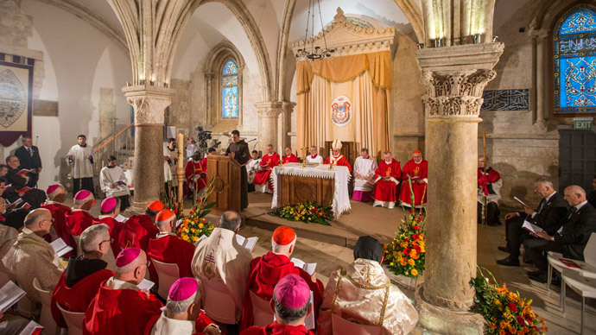

[Refer to this article: David’s Tomb Status Quo Breached by Catholic Mass Services - Footage shows David's Tomb Compound has been handed over to fixed Catholic worship, endangering Jewish prayer rights... By Shimon Cohen, Ari Yashar - 6/9/2014 israelnationalnews.com] In this article you can see the short video clips.Refer also to this article: Israeli Jews Protest at King David's Tomb Over Christian Prayers - by AFP and Arutz Sheva Staff - First Publish: 6/9/2014]

Just since the pope was in Jerusalem, things have accelerated to a mind-bogglingly high degree. On June 1 and 2nd, there was a huge “Charismatic Renewal” revival held in a large stadium in Rome.
Pope to Inaugurate Charismatic Convocation in Rome's Olympic Stadium
Vatican City, May 29, 2014 (Zenit.org) Deborah Castellano Lubov
“Organizers Ready to Welcome Francis to Event, Expected to Draw 50,000 Worldwide
For the first time in history, a pope will visit the Rome Olympic Stadium for an International Charismatic renewal convocation, the Vatican has announced.
This Sunday, Pope Francis will attend and meet members of the Catholic Charismatic Renewal Movement in its 37th National Assembly. The June 1-2 gathering is expected to draw some 50,000 people from over 50 countries. The theme of the event, comprising prayer, testimonies, and dialogue, is “Repent! Believe! Receive the Holy Spirit!” The Holy Father is expected to arrive at 5 p.m.”

I’m sure many of you remember the “Charismatic Renewal” in the Roman Catholic Church in the 1960s. I went to meetings at Loyola University in California. We all thought that was wonderful. And through it, Catholics were exposed to the true new birth, and some began reading the Bible for themselves. Abba always brings good out of evil intent. But, it also carried a very high spirit of Mary-worship, since Mary and the “Holy Spirit” are so interlocked in traditional trinity teaching from the pagan world. Now this “renewal” has surfaced, and its real purpose has been exposed. Bishop Tony Palmer is doing a fantastic job of drawing Evangelical and Charismatic churches, organizations, and denominations, into re-uniting with the Vatican. The basis of this deception is: “We are one in the `Spirit,’ so our doctrinal differences do not matter. Differences have to be put aside. We must embrace diversity, and remember that we are all brothers and sisters in the `Spirit.”
But, I ask: What “Spirit?” Certainly not Yahuweh’s Spirit! He has nothing to do with the wicked religions of man – for all are rooted in Lucifer/Satan. The Scriptures teach that Yahuweh is the Spirit--the Spirit is Yahuweh. There are two – a Father and a Son – the Father is Spirit, the Son, Yahushua Messiah, has a human form. Upon this platform of unity in the false deceptive “spirit,” this pope is leading former Protestant denominations into his lair.
[Please refer to: “False Unity,” which I wrote March 3, 2014. Watch the video from Kenneth Copeland’s meeting of big-name charismatic leaders, in which Tony Palmer introduces a video made of the pope giving a message to this meeting]
I also highly suggest that you read Joseph Herrin’s recent article entitled “Deception – Exposing False Unity by the Vatican,” May 26, 2014 -- website: parablesblog.blogspot.com
On March 27, 2013, Herrin published an article on his blog spot about the pope, the Jesuits, and the evil of this man. Some from Argentina are going to the Haag World Court with proof of this pope’s involvement in torture, murder, slaughtering, with pedophile groups, and other hideous things while aligned to the dictator of Argentina. This man is evil, yet Israel and the world are falling at his feet, as well as major denominations of former Protestantism. What type of hypnotizing power is drawing the world to his feet? -- The same power that drew Americans to the feet of Obama. The Dragon’s chief agents in both end-time Rome, and end-time Babylon, are united as “echad” in purpose to bring in the new world order. Remember also, that “St.” Augustine called Rome “the second Babylon.” The early believers called Rome, “Babylon.”
America, from its inception, united with Rome through the Jesuits and their Masonic agents. America wanted to call their capitol “Rome.” Its obelisks and domes are as those in Rome. Washington D.C. is filled with symbols and “art” of Egypt, Greece, and Rome. America is known as the Vatican’s sister country. Vatican State is the world’s smallest country, but it wields world power, and controls the U.N., NATO, the U.S., and on and on through its Jesuits. Most Jesuits are not priests. Their chief methodology has always been “infiltration.” Non-priest Jesuits are stationed in high positions in all countries, in all major corporations, in banking, in commerce, in intelligence organizations, like the FBI, the CIA, and the Israeli Mossad. Vice-President Joe Biden is a Jesuit, for example.
Beginning officially with Vatican Council II, which basically reinforced the wicked Jesuit Coutner-Reformation Council of Trent, this pope is concentrating on drawing all into the Vatican – all Christendom, Islam, Jewish rabbis, Hindus, witches, new age cults, and etc. The Jesuits are astute to destroy anything and anyone who does not cooperate with the pope’s edicts. Do you realize what happened on March 13, 2013? For the first time in the history of the Roman Catholic Church, a Jesuit pope was elected, to join with the Jesuit General who runs the Vatican for the pope. These two are indeed “echad,” – two in unity as one.
A few testimonies of Cardinals who were present in the Sistine Chapel for his election, admit that something “supernatural” took place. No pope was ever elected that fast. It had to be a pre-arranged deal, or a demonically-controlled deal.
The express job of the militaristic Jesuit Order is to make sure that anyone not bowing to the pope will be tragically wiped out.

Recently famed Pastor Joel Osteen went to visit the pope.
meets with Pope Francis at Vatican
By Carol Christian | June 6, 2014 | The Houston Chronicle - Texas News
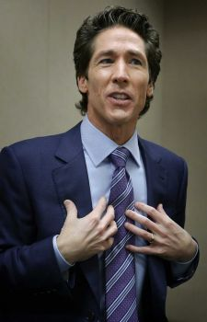 “Osteen said Friday it was a great honor to represent the pastors of America in the meeting with the pontiff, whom he described as warm, personable and full of joy. `I like the fact that this pope is trying to make the church larger, not smaller,’ Osteen said. `He's not pushing people out but making the church more inclusive. That resonated with me.’

So much has happened since the pope’s visit to Israel. I knew that his visit was a turning point. He spent a lot of time with King Abdullah II of Jordan, overseer of the PA and the Temple Mount. From there, he went to spend most of a day with the “president of Palestine,” Mahmoud Abbas, and other PA leaders, throwing in a Mass at the Church of the Nativity in Bethlehem, and a visit to a separate wall – political intrigue for sure. From there he flew into Israel to meet with the Patriarch of Constantinople, on the 50th anniversary of the reuniting of the Roman Catholic Church with the Eastern Catholic Church – a very historic event! But, after a brief meeting with the Patriarch, he went to the Church of the Holy Sepulcher, which is down in the heart of the Arab Quarter. On the morning of the 26th, he first went to the Temple Mount to meet with Muslim leaders. Then he paid token visits to places and people in Israel, before defiling a place of prayer for Jews. The pope said it was an ecumenical trip – a trip to unify. But, unify what? I believe it was a trip to unify the plans of the Vatican with the Muslim leaders, to commence with Psalm 83!
Psalm 83:1-5: “Oh Elohim, do not remain silent! Do not be speechless, and do not be still, O El! For look! Your enemies make an uproar, and those hating You have lifted up their head. They craftily plot against Your people, and conspire against Your treasured ones. They have said, `Come, let us wipe them out as a nation and let the name of Israel be remembered no more! For they have conspired together with one heart. They have made a covenant against You.”

I have known for years that the “us” was the Roman Catholic Church and Islam, which they created as their sword to obtain Jerusalem for the pope. They have been conspiring for many years, but now, they are formulating their final plans. In my study “Exposing the Real Agenda of Mary Worship/April 10, 2013, you will read that Muslims are very loyal to the pope, believing in and worshipping Jesus as a prophet, and worshipping Mary as the Queen of Heaven. Muslim men even finger a type of rosary prayer beads.
I lived in a Muslim nation for 8 years, and learned a lot about their friendship with Roman Catholics and the Greek Orthodox priesthood.
Proclaim Psalm 83 and Psalm 2, and declare the victory of Yahuweh and Yahushua over all of their enemies!

On June 2nd, the unity government of Mahmoud Abbas, and the PA (Palestinian Authority), with its terrorist attachment, Fatah, (which America supports with weapons and money) and Hamas, were officially joined in unity. Hamas is considered a terrorist organization worldwide. Western media has portrayed the PA as good guys, but they are responsible for the murder of many Jews inside Israel. The Jewish teenagers that were kidnapped in Samaria a few days ago were kidnapped by Hamas. This unity agreement between these two terrorist organizations began before April 29th, the deadline for America’s peace with Israel to be finalized. But, it was after the pope’s visit that it was finalized. Supposedly, the initial Hamas government is to be represented by lawyers and other professional people. President Obama, the EU, and many other nations of the earth, have endorsed this unity as GOOD. America defended its position to Israel, saying that there were no terrorists involved in the new unity government. Does America consider Israel to be that stupid!

For June 3rd, the eve of rabbinic Shavu’ot, the state of Israel passed a law that Jews could go on the Temple Mount to pray for that day only. The Wafts have forbidden Jews to go up there. Jordan, overseer of the Temple Mount and the PA, has forbidden Jews to go up there. Jordan was furious that they were allowed up on their own Temple Mount. The U.S. and the E.U. decried this also.
Here is a picture of Jews on the Temple Mount, carefully guarded by the IDF and Israeli police on June 3rd. How terribly sad that the enemies of Israel are not only on the inside, but are dictating policy to the Israeli government about their rights to their own, our own, historical Mount Moriah.

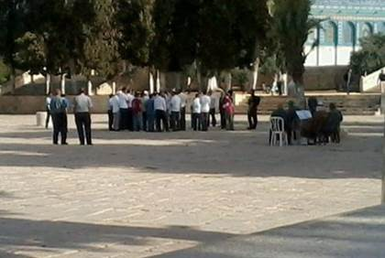

Except from: Temple Mount is Jewish for a Day
By Gil Ronen -- First Publish: 6/3/2014 israelnationalnews.com
“In a letter to the Prime Minister, Moshe Feiglin (Deputy speaker of the Knesset) branded the string of riots over the Pesach (Passover) holiday as a "Hamas takeover on the Temple Mount." He described how "Hamas flags were flown on the Mount", as Islamists succeeded repeatedly in blocking Jews and tourist groups from visiting the holy site, and said the "sheer helplessness of the Israeli Police" marked a security failure so severe that it was impossible to overlook. `We are talking about a loss of sovereignty in the heart of hearts of the capital of Israel, in the holiest place for the Jewish people, and the handing over [of sovereignty] to a terrorist movement which inscribes [calls for] the destruction of the State of Israel on its flag.’ "
My note: On the Thursday after Pesach I took a new friend with me to see the Ophel archeology park at the base of the south wall of the Temple Mount. But, when we got to the gate into that part of the park, it was locked. I asked a police guard why it was locked, and he said that the Arabs were throwing stones down on the tourists below in the Ophel. Later I found out it was more than that--there had been a riot on the Temple Mount that morning, and yes they were throwing stones, but also the police had to stop a riot. So, I personally know what Moshe Feiglin was talking about.

US Promises PLO Unity Elections in East Jerusalem
By Dalit Halevy, Ari Yashar - 6/3/2014 - israelnationalnews.com
“According to new reports, the American administration has promised the new Fatah-Hamas unity government, which was sworn in this Monday, that it will convince Israel to allow that new government's elections to be held in the eastern part of Jerusalem. `A source that knows things,’ apparently from within the Palestinian Authority (PA) or Hamas, was quoted in the Jordanian paper Al-Arab Al-Youm, reporting the American promise to work for parliamentary and presidential elections for the new unity government to be held in the Israeli capital… Netanyahu responded to the American decision on Tuesday, saying he was "deeply troubled" that the US would work with the new government backed by Hamas, a group that has murdered "countless innocent civilians."
As “punishment” for Israel’s not going along with Kerry’s ridiculous “peace deal,” the U.S. is doing some strange things to spite Israel. They have been, and continue to, support Iran’s nuclear build-up, and new rockets that can hit Israel. America has encouraged the European sanctions and boycotts of Israeli goods.
The backlash on America for siding against Israel and for her enemies will be horrendous. Genesis 12:3 is in motion! But, America is an idolatrous nation to the core – a pagan nation, worshipping the gods of mammon (money, fame, materialism, power, control, ease and comfort), sacrificing their children to the god of this world to fit in with their idolatrous culture. In the name of religion, Americans prostrate themselves before humans to teach them, lead them, tell them what to do, and give them comfort, as the ancients used to prostrate themselves to idols.
As a nation, America has committed the ultimate crime against Yahuweh--not only abandoning His people, His Land, and His Covenant, but is the leader behind dividing His land, giving it to His enemies. (Joel 3:2; Daniel 11:39) America has set itself against Yahuweh! The prophetic words regarding America, who is in bed with the Vatican, and has been since its inception, will be fulfilled. The 8th Beast of Revelation 17 is the revived Roman Empire, coupled with end-time Babylon, to bring in a new world order under one central world authority.

Soon, the U.N., under the authority of the Jesuit Black Pope, will enforce a division of the Land, giving East Jerusalem over to the Palestinian “state,” for their capital. Luke 21:20 is close. Jews will be restricted completely from entering into this Palestinian zone. I have seen the U.N. diagram for the buffer zone around the Palestinian capital. If Israel goes back to the pre-1967 borders, as they are now being forced to do to make peace, that will mean that the whole Old City, including the Western Wall, will once again be off limits to them, as it was before 1967 under Jordanian rule.
Seeing, with my own eyes, how the Jews were treated on May 23rd, seeing the door to the tomb of David prayer area locked, and guarded by police as a precaution against demonstrating Jews, it is obvious that those who love the Land, love the Torah, love the Elohim of Israel, are being shut out in favor of the enemies of Israel. Muslims are all over that area now, going up to the old mosque on the top of the building, above the “tomb of David,” and the Cenacle. America and the Vatican are leading the pack of wolves. Woe to you who stay in America because you fear losing your ease and comfort – you will die in America.
Some will be martyrs, but many will deny their Savior to align to the Beast. Revelation 13:4, 8: “…the world will wonder after the Beast; who can stand against the Beast.”
Americans naturally jump on band wagons. They justify their friendship with the world, but Ya’cob said it well, in Ya’cob 4:4, and Yochanan said it well in I John 2:15-17. You cannot be a friend of the world and a friend of Yahuweh at the same time – darkness and light do not mix! He calls us to be “more set apart” than ever before – set apart unto Him! You are either 100% solidly loyal to Yahuweh, or you’ll fall prey to the great deception that is now filling the earth.

“The” False Prophet comes out of the sea. Refer carefully to the wording of Ezekiel 26, 27, and 28 with Revelation 13:11 and following. The False Prophet is echad with the 1st Beast. The 1st Beast has two horns like a lamb. (Revelation 13:1) The pope has two given powers: 1) temporary power (political power over the earth, and 2) spiritual power. In Scripture “horns” denote power.
Under the Vatican are literally miles of secret hidden information – carefully organized and categorized, including at least a mile of Inquisition Files. Former Pope Benedict was the guardian for the Inquisition Files under Pope John Paul II. These “roads” underneath the Vatican with row after row of files, form a circle around the Vatican itself. It is in these secret tunnels that the treasures taken from the second Temple are stored. One rabbi was very verbal to the pope before he came, saying he didn’t want the pope to come unless he brought the temple treasures with him – like the menorah. In 70 CE, when Titus raided and burned the Temple, he took the menorah.

I sat in the Arch of Titus in the Forum in Rome, and saw the famous carving in the arch of the menorah, with other treasures, and Jews taken as slaves.
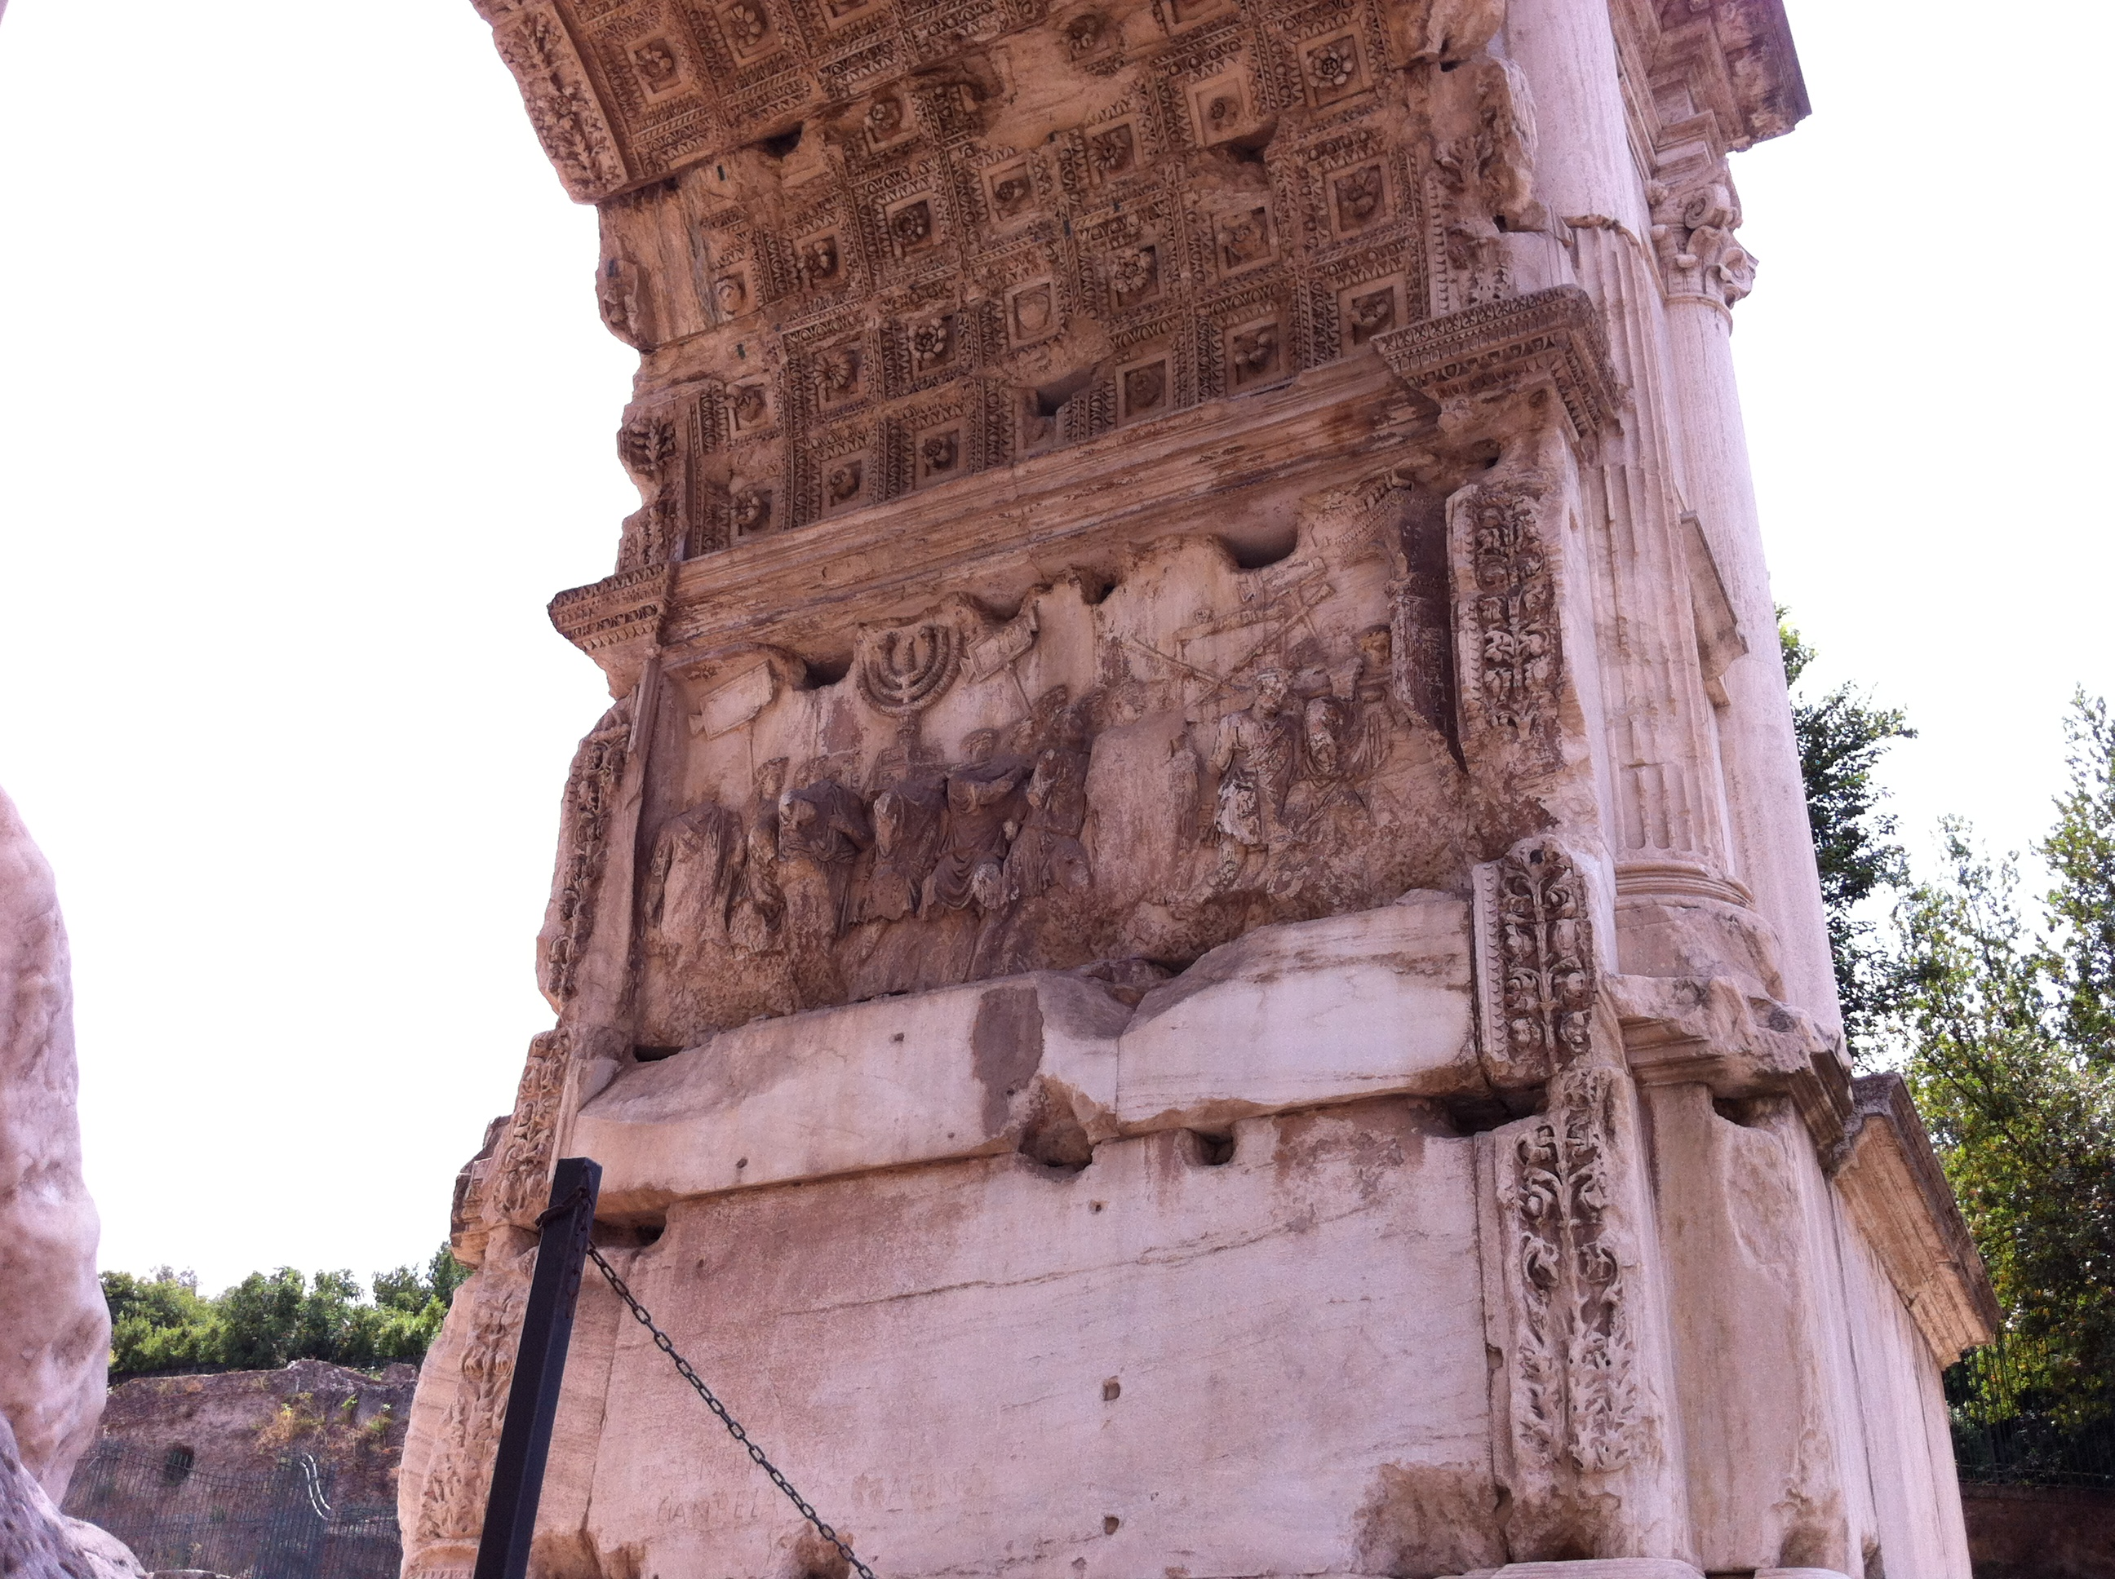
Photo of the Arch of Titus in the Roman Forum, Rome, 2013, by Yedidah
The lighting on the marble makes it look lavender, but it is white marble
Note the menorah …

As said earlier, in those underground tunnels, black masses are conducted by Jesuits. In 1963, a black mass was conducted where the Vatican was dedicated to Satan. [Refer to Malachi Martin’s truth-filled report in novel form: Windswept House. This really happened]
The “white pope,” and the “black pope,” the Jesuit General, are “echad” – two working together as one in perfect unity - to reach their goal of world rule, and for the world to worship the “Vicar of Christ” enthroned in Jerusalem. The word “vicar” means one who sits in the place of, representing, acting as Christ. It is similar to the word “anti” in Greek, as in “antichrist,” which means “one who sits in the place of,” as well as one who stands “against” Christ. The word “Christ” comes from the worshippers of Serapis in Alexandria, Egypt, and is a name-title of a god that was renounced throughout the pagan world. In India its name became the Hindu god Krishna. The English translation of the Hebrew “Machiach,” is “Messiah.”
I am not a “Christian.” I do not follow the god Christ. I have no religion. All religion is rooted in Lucifer’s schemes, propagated by his loyal or unsuspecting servants.
I am a worshipper of the Elohim of Israel – YahUweh and YahUshua. The foundation of all my belief is found in the Scriptures from Genesis to Revelation, taught to me by the Spirit of Yahuweh. I stand before Them. Yet, I am not alone. Eliyahu said to Ahab, “As the Elohim of Israel lives, before whom I stand…” (I Kings 17:1) In the Presence of Yahuweh, we either stand, or fall.
But, as the pope who dubbed Henry VIII the defender of the faith, once said: “It has served us well, this myth of Christ.” The religion of Roman Catholicism has always been a myth from ancient paganism--only a manipulation tool to hide the real agenda of its rulers, which is world domination in the power of the ancient Roman Empire under Jupiter/Zeus-Apollo, and all the gods of Greece and Rome. This is why they hate the Jews, and true believers, because their gods are enemies of Yahuweh.

In II Corinthians 11:13-15, the Apostle Sha’ul speaks of deceivers whom he, and the other Apostles were battling: “For such are false apostles, deceptive workers, masquerading as apostles of Messiah. And no wonder! For Satan himself masquerades as a messenger of light! It is not surprising, then, if his servants masquerade as servants of righteousness…” The world is now being deceived by this mask of righteousness!
The Jesuits enforce their oath: “He who will not accept the pope as the Vicar of Jesus, and his vice-regent on earth, let him be accused and exterminated.”
An example is the St. Bartholomew’s Massacre of 1572, led by the Jesuits. 70,000-100,000 perished in this massacre in France, which targeted Protestants who would not bow to the pope. King Louis XIV of France revoked the Edict of Nantes, which allowed freedom for Protestants. The Bible was outlawed. The Jesuits took over, and ½ million at least were slaughtered.
At the end of this article, in Appendix A, I include the Jesuit Extreme Oath. I also encourage you to read truthful books like Jesuits by former Jesuit Malachi Martin, and/or Secret History of the Jesuits by Edmond Paris. Also, if you want the information concentrated in an easy form to read, I recommend Jack Chick’s Alberto comics series, volumes 13-17, and 20. You can get them on Amazon.com. The information is correct-- documented by many sources for many years. Also, I recommend the classic, written in the mid-1800s by Alexander Hyslop, which is entitled The Two Babylons.
Alberto Rivera was a real Jesuit priest who had taken the extreme oath, and was a spy among Protestants. Infiltration into major arenas of all countries, into governments, cultures, corporations, financial institutions, churches, synagogues, Messianic congregations, universities and other houses of study for the purpose of turning people to the pope is the main maneuver of the Jesuits. Alberto was a disciple of the famed Cardinal Bea. Everything he reports can be substantiated by many researchers and writers. Jon Eric Phelps’ Vatican Assassins is also a masterpiece of information.
These people are not against Catholic indiviudals, and neither am I! But, for the sake of saving them, the truth has to be told. Many priests and nuns and Catholic laity are getting out, because they know something is very wrong. But, if they give testimony to why they got out, well … many have been found dead.
Our job is not to condemn individuals, but to expose the traps they are in to help loose them. Our job is one of rescuing the perishing …
From their inception under occultist Ignatius Loyola, their express purpose was to cause the whole world to worship the pope, or die. Thus, these people are masters of torture, and murder. The Jesuits, and the Roman Catholic Church as a whole from its inception, has caused the deaths of more people than people who have died in all the wars of history. Well, the fact is that most of the wars in the last nearly 500 years have been orchestrated by Jesuits to gain some goal for the pope, including World War I and World War II. Now they’re working on World War III.
Here is what Abraham Lincoln said about their involvement in the Civil War between the North and the South in America: “It is not against the Americans of the South alone that I am fighting…It is more against the pope of Rome, his perfidious Jesuits, and their blind and blood-thirsty slaves that we have to defend ourselves.” From former Jesuit Charles Chinique page 496 of his classic “Fifty Years in the Church of Rome.” It has also been exposed that the Jesuits were behind the murder of Lincoln.
Infiltrating, manipulating, betrayals, deceptions, wars, and assassinations, are “normal” activities of Jesuits worldwide still today. They are more covert now, but they have not changed.
The Jesuits launched the Counter Reformation in 1540. The Council of Trent was instituted, which lasted for 18 years. Vatican Council II under Pope John XXIII was no more than a revision of the Council of Trent, which launched the “Ecumenical Movement.” Today that movement is gathering Protestants back under the pope quickly through a very deceptive guise.
The Jesuits hate the Bible with venomous fury. During the Council of Trent they reasoned that if the people could read Bibles in their own language they would turn against the pope, for the Bible spoke against the teachings of the pope. So, they had the pope ban the laity from reading the Bible. In 1848, Abbate Leone wrote about a meeting that he attended with the Jesuits in 1825, entitled: The Jesuit Conspiracy – The Secret Plan of the Order. Here is a portion of his notes from the meeting: “At this meeting in Chieri, France, the Jesuit General boldly proclaimed: “We shall know how, by marvelous stories and gorgeous shows, to exorcise heresy from the heads and hearts of the multitudes; we shall know how to nail their thoughts upon ours, so that they shall make no stir without our good pleasure. Then the Bible, that serpent which, with head erect and eyes flashing fire, threatens us with its venom, whilst it trails along the ground, shall be changed again into a rod as soon as we are able to seize it; and what wounds will we not inflict with it upon these hardened Pharaohs and their cunning magicians! What miracles will we work by its means! Oh, then, mysterious rod, we will not again suffer thee to escape from our hands, and fall to the earth! For you know but too well that, for three centuries past this cruel asp has left us no repose; you well know with what folds it, entwines us, and with what fangs it gnaws us!”

The Word is a “cruel asp,” with “fangs it gnaws us.” Truly, the Word is as a two-edged sword, but sharper--it divides the righteous unto Yahuweh, and it divides the evil unto Satan. (Hebrews 4:12)
In capsule form, here are words of former Jesuit priest Charles Chinique about the Jesuits: “The Jesuits are a military organization, not a religious order. Their chief is the General of an army, not a mere father abbot of a monastery. And the aim or this organization is power. Power is the most despotic exercise--absolute power, universal power, power to control the world by the volition (will) of a single man. Jesuitism is the most absolute of despotism (dictatorship); and at the same time the most enormous of abuses. The General of the Jesuits insists on being master, sovereign, over the sovereign. Wherever Jesuits are admitted, they will be masters, cost what it may. Their society is by nature dictatorial. Therefore it is the irreconcilable enemy of all constituted authority. Every act, every crime, no matter how atrocious, is a meritorious work, if committed in the interest of the Society of the Jesuits, or by the order of its General.” From Fifty Years in the Church of Rome by Charles Chinique, quoted from The Big Betrayal, a Jack Chick comic on the life of Charles Chinique

The Roman Catholic Church is most definitely the great whore of Revelation 17. Even her clothing is that of Cardinals and the pope – purple and scarlet. She is drunk with the blood of the set-apart ones from her inception to this day. She is also drunk with the blood of 6 million Jews and thousands of true believers under Hitler, and millions more under Stalin.
Revelation 17:1-6: “And one of the seven messengers who had the seven bowls came and spoke to me saying, ‘Come, I shall show you the judgment of the great whore sitting on many waters, with whom the kings of the earth have committed fornication, and the inhabitants of the earth were made drunk with the wine of her whoring.’ He carried me away in the Spirit into the wilderness. And I saw a woman sitting on a scarlet beast covered with names of blasphemy, having seven heads and ten horns. And the woman was dressed in purple and scarlet, and adorned with gold and precious stones and pearls, holding in her hand a golden cut filled with abominations and the filthiness of her whoring, and upon her forehead a name written, MYSTERY, BABEL THE GREAT, THE MOTHER OF THE HARLOTS AND OF THE ABOMINATONS OF THE EARTH. And I saw the woman drunk with the blood of the set-apart ones, and with the blood of the witnesses of Yahushua. And having seen her I marveled, greatly marveled!”
This whore has ridden the political system to power since the days of Constantine. The Vatican is the most wealthy institution on earth. They control the economies of nations and world commerce (Ezekiel 26, 27 and 28). The woman symbolizing the faith of Roman Catholicism is Fides. Her statue stands outside St. Peter’s Basilica. She is holding up a wine goblet. The woman, the Roman Catholic Church, is the mother of harlots, or whores. Some of her daughters are Islam, Communism, Nazism, Fascism, and most factions of Protestantism, beginning with the “high state churches” of European countries. To be bluntly honest, all that is represented by the religion of Christianity is a daughter of hers, for Yahuweh puts the word “whore” on anyone who has turned from Him as their Elohim, rebels against His Covenant given to His people – His Torah (teachings and instructions for right-standing in the Kingdom of Elohim), and serves another God by another name. The very foundation of Christianity is a rejection of the marriage Covenant of Yahuweh, given at Sinai. Yet the reason Yahushua died and rose again was to redeem His whoring children of the House of Israel back to it. (Matthew 15:24; 10:5-6) The twisting of the Scriptures to create a Greco/Roman religion had to do away with anything Hebrew, including the Hebrew Messiah.

Edmond Paris, The Secret History of the Jesuits, page 164: “The SS origin (Hitler’s secret service) had been constituted according to the principles of the Jesuit Order.” Hitler referred to Heinrich Himmler as his “Ignatius Loyola.” The swastika symbol was taken from a Jesuit Abba, overseen by Fr. Hagan. Hitler designed his whole attack force after the pattern of the Jesuits. The Vatican signed a concordant with Hitler, and priests and nuns helped murder Jews and Bible-believing Christians through their infamous Ustachi.
The Crusades, the Inquisitions, the Holocausts in Germany and Russia, the wars they’ve started in many countries, including America, and the slaughter of the innocents in Central and South America, Mexico, Africa, and Asia, because people would not bow to the pope’s rule, is sure proof of what we are seeing today, and will see.
When Revelation 13 and 14 talk about the slaughter of those who will not bow to the Beast, it is talking about the slaughter of those who will not bow to the pope! [Refer to: “The Sunday Laws and the Returning Inquisition”/July 31, 2013]
This is how the Catholic Church has risen to power through the centuries, politically, economically, and power over nations, and will soon in the future over the whole world.
Anyone standing in the way of the now-present striving for unity is in danger. Jesuits, in the name of “Liberation Theology” in Latin America has caused the deaths of thousands of true believers. Constantine saw a vision of a cross, or a Chi Ro, and heard the words “in this sign conquer.” Yahuweh did not speak to him.
In July of 2013, I stood with my son and daughter-in-law on the Milvan Bridge, where Constantine supposedly saw his vision to conquer in the name of the pagan “crux.”
What a lovely place it is now. But, just a short distance away stands St. Peter’s Square and St. Peter’s Basilica--the headquarters of Vatican State. They have conquered, using the symbol of the cross, an ancient fertility symbol, holding it over the heads of the Jews, calling them “Christ killers.”
The Jews didn’t kill “Christ,” nor has God forsaken His promises to them, as the Catholic Church contends. The High Priest, Caiphas, and his assistant Annas, and all on the Sanhedrin council were puppets of Rome. King Herod was an Idumean, an Edomite. The Edomites migrated into Rome, and took the hate of Esau for Ya’cob (Jacob) with them. This is just an example of the extreme manipulation of truth that was done by the Roman Catholic popes as an excuse to kill Jews and born-again believers.
By this sign of the crux, Constantine united his Empire under sun gods. The symbol of the State of Israel is the menorah. When Iran, Hezbollah, Hamas, and all the other Muslim nations cry out for the extermination of the Jews, it is the cry of the Vatican also, who persuaded them in the 6th century that the Jews were their enemies. The Islamic world is friends with their Roman creator.
Daniel 9:26: “And the people of a coming prince shall destroy the city and the set-apart place. And the end of it is with a flood. And wastes are decreed and fighting until the end.”
“The people” under Roman Emperor Titus destroyed Jerusalem and the Temple in 70 CE. But, the “coming prince” will also come from Rome to Jerusalem to rule. He is in the process of “coming!” He is the ruler from the 7th Beast – the 7th head – the revived and empowered Roman Empire of Daniel 7.
Throughout the ages, Jews have been the target, in Europe especially, for the cruelty of the pope and kings. But, also true Christians have also been slaughtered by the Roman Church through the centuries for refusing to bow to the pope, and/or for helping to rescue Jews from the evils of Rome. The Jesuits know no boundaries. They kill anyone who won’t submit to the pope, using their own army, or wars. They are the ones with the “spirit of the Medes” in Isaiah 13:12-18. Their cruelty is infamous. They have no mercy on the innocent. They delight in slaughtering babies, tearing them from the womb, or grabbing them from their mother’s arms to slice them to pieces. They have the sadism of Satan himself. Yet, this passage and others state that this is part of the wrath of Yahuweh as He allows man and Satan to do as they will for a short time, and then He will step in with the full fury of His wrath against the wicked on the “Day of Yahuweh.” Chris Pinto’s DVD, “A Lamp in the Darkness” under the section “Enter the Jesuits,” shows some of the violence in the methods of the Jesuits to make people submit. They targeted whole groups for slaughter, like the Waldensians.
Now they work by deception in front of the world as peace-lovers, all the while carrying on their slaughtering in third world nations among true believers, especially in Catholic countries. They are taking over Africa, and a lot of Asia.
I John 5:4-5 tells us that we overcome and conquer by our faith. II Corinthians 10:3-6 tells us that the “weapons of our warfare are not carnal, but mighty to the pulling down of strongholds.” Ephesians 6:10-18 says that we stand strong in the power of His might, wearing the armor of the High Priest--Messiah Yahushua.
Pope Francis was a part of this type of slaughtering of the poor in Argentina!

On June 8th, in response to the invitation given on May 26th to President Shimon Peres of Israel, and President Mahmoud Abbas of the “State of Palestine,” these two men came to the Vatican to pray together with the pope for the peace of the Middle East.
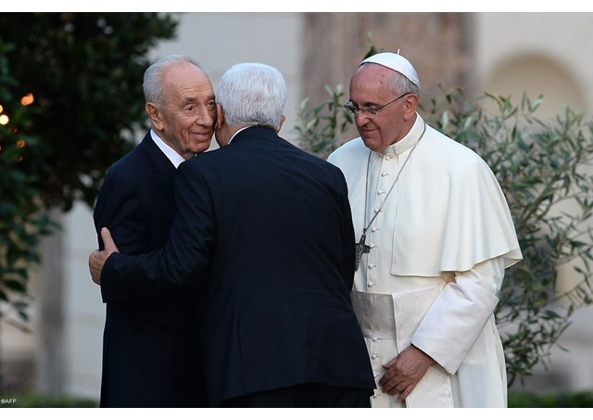
After this historic “prayer meeting” between a renegade Jew, a billionaire Muslim, and a deceptive pope--head of 1.2 billion Catholics worldwide, ruler of Vatican State, and world ruler in disguise, a picture was taken that shows the absolute hypocrisy to this whole fiasco. The look on Shimon Peres’ face is a classic, as Abbas hugs Peres. The pope looks either embarrassed, or humored. Shortly before coming to the Vatican, Peres went into a fit over the evils done to Israel by Abbas.
Photo taken by Vatican news.va
I wrote the article “Exposing Kim Clement and Other False Prophets.” I did this from a personal angle, as I did in my article regarding Kenneth Copeland and the Pope, “False Unity.” Kim has done it again! Here is his prophecy about Pope Francis, which was picked up by the horrendous Elijah List group and promoted. This false unity is drawing people together like the tail of the Serpent that whips together the stars in the last days.

Kim Clement says Pope Francis is God’s Chosen
April 29, 2014 by Kevin Kleint - thehonorofkings.org
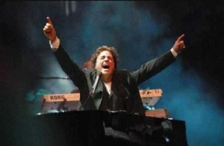
Kim Clement giving his false prophecy

“God” is supposedly speaking: “As I stand at this cross, there is one that I have chosen who has kneeled at this cross many, many times. I speak of the one who calls himself after St. Francis of Assisi. The Spirit of the Lord spoke for him to come and stand at the head, but this man is not like any other, says the Lord. This man has been appointed to join the hearts of Protestant faith – Catholic – those who are Spirit-filled. And I will do something so unique and so different, says the Lord, because of his acknowledgement of My power. There is a renewal that will take place that will far surpass what took place in the 60’s and in the 70’s. My Spirit will not be confined; neither will it be arrested only for one or two groups of people. My eye is on the globe; My eye is on the earth. My eye, says the Lord, is upon planet Earth, to pour out of My Spirit. And I have chosen Pope Francis as one of the voices that will speak, and he will command and they will try and assassinate him three times. They will try within to damage him. God says, they will even try to poison him, but his voice will not be stopped, says the Lord. I will cause people to run to the cross, people to cling to the cross. Many souls shall come. And then, God says, there will be a change in the entire system. I will make a change, for what Martin Luther did 500 years ago, and when he nailed a thesis to the door and said “this is it – we believe that by faith we are saved, which is a gift of God, saved unto works, not by works.” God’s Spirit says so it shall be that this man shall pronounce that as well and there shall be fire that shall ignite in the southern part of America, in the central part of America. There shall be criminals that shall be brought to justice. And God says this man shall change laws and there will be creeds that will come forth and the Catholic people shall rejoice and they shall smile again for I will fill them with light. I will light the candles of My incense in the buildings that were once built for My glory but were taken and used as stone, as a place of refuge, as a place of religion. I will take those same buildings throughout the earth and I will raise them up. And in Italy, I will do something that is so anointed and strange they shall have two earthquakes and then you will know that God has begun to do His work throughout the earth. This is My word, says the Lord. Pray for it shall come to pass, says the Lord.”

If you think this sounds like something out of someone’s demon-controlled head--you’re right, it is! However Yahuweh did choose this pope – but for His purposes to judge and separate the earth’s people.
Also note that it is the anti-messiah, the 1st Beast, who changes laws and seasons. The Roman Church was built on changing the laws and mo’ed of Yahuweh, and substituting the sun gods for Yahuweh. Constantine fills the bill perfectly in the establishment of the Roman Catholic Church.
But just know that, for sure, Kim’s accuracy record is nearly non-existent. However, he’s not worried. In this prophetic movement, as leader Mike Bickle has made clear: In the Old Testament God killed the false prophets, but in the New Testament we can make mistakes because now we’re under grace. HA! I know about their prophecies, which are more like the scam of a fortune teller in a carnival than anything else. Kim belongs to this group of “prophets.” Steve Schultz, founder of the infamous “Elijah List,” bastion of false prophecies, endorses Kim’s prophecy, of course.
Kevin Kleint has an excellent article about the endorsement of Kim’s prophecy by the Elijah List, recently written for thehonorofkings.org. But, the bottom line is--the world is falling at this pope’s feet.
Revelation 12:1-4: This great Dragon (Satan/Lucifer/Devil) is identified as having the same 7 heads, 10 horns, and 7 crowns, as the 1st Beast of Revelation 13. These are mentioned in Daniel 2 and 7 also. The Dragon’s aim is to destroy Israel (the woman), and Israel’s Messiah, (her child), and her offspring who guard the commandments and have the testimony of Yahushua (Revelation 12:17).
The 7 heads are 6 empires that have ruled Israel, plus the revived Rome, making the 7th. The 10 horns are the 10 economic regions of the earth, called “the ten kingdoms” by the United Nations, that are now in place and operating, the 10 toes of Daniel 2. The 7 crowns on the heads indicate authority and rule.
The intent of the Dragon and his son/Beast is, like Herod of old, to kill as many as possible in order to kill that Child. It goes back to Genesis 3:15 – that the seed of the woman would crush his head … so he is going after her seed, who are redeemed by that Child! That includes you and me!
This pope fanes love for the poor, yet helped slaughter the poor in Argentina. [For a few details of Pope Francis’ role in Argentina’s “Dirty War” see: “Washington’s Pope?” March 14, 2013, the article, and “Who is Pope Francis I,” an interview of Michel Chossudovsky with Bonnie Faulkner, KPFA Pacifica Global Research TV (GRTV) This information is very documented, with pictures]
Do your own homework. This subject reads like a mystery. Sha’ul called it “the mystery of iniquity,” which he began seeing form as early as the mid-1st century CE with Greek Gnostic Christianity.
Take a look at this picture of the pope, from Joseph Herrin’s article on the pope and the Jesuits, from March 27, 2013:
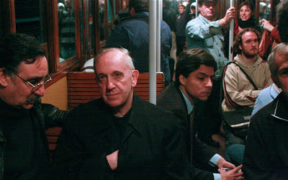
Pope Francis I – The Hidden Hand
Herrin’s Introduction quote: “When two Jesuits meet, the devil is always there to make a threesome.” - old French proverb
The “hidden hand” gesture, made so famous by pictures of Napoleon with his hand in his coat, is an Illuminati gesture.
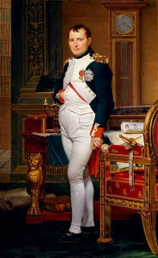
From Joseph Herrin’s article: “Those who are in league with Satan have adopted the symbolism of the unseen hand to denote their occult (hidden from sight) activities. They have signaled their true allegiance and hidden agenda through symbols. A common symbol employed to denote that one is a servant of unseen masters is to have a picture or portrait made with one hand hidden inside of their clothing...

In the mid-1800s, men like Alexander Hyslop, author of The Two Babylons, believed that the pope was the “antichrist.” President John Adams had this to say in a letter to Thomas Jefferson, 1816: “I do not like the resurrection of the Jesuits. Shall we not have regular swarms of them here in many disguises as only a king of the gypsies can assume? If ever there was a body of men who merited eternal damnation, on earth and in hell, it is the society of Loyola’s.” (cited in The Fifth Wall by O’Malley and Martin, page 58)

In 1987, writing for the Radio Bible Class, the well-known end-time prophecy writer, M.R. DeHann wrote a small booklet called What Can We Know About the Anti-Christ?
While he, like so many others, are trapped in the great deception of an un-Scriptural pre-tribulation “rapture,” based on the fallacious teachings of Jesuit-inspired Dispensational Theology, at the same time, their teachings contain quite a bit of prophetic insight. It’s like eating unfilled fish, but those that know the Word its entirety can easily detect the bones. Yet it is shocking to find out that so much of what became known as Protestant Fundamentalist Theology was taken directly from Jesuit deceptions. [Refer to the documented article: “VATICAN: JESUITS, DISPENSATIONAL THEOLOGY, AND JOHN NELSON DARBY” --
www.regal-network.com/dispensationalism]
DeHann’s words reflect the beliefs of most real Christian believers in the 1800s, and are highly prophetic: “Antichrist will seem to be a man of peace when he first appears. In Revelation 6:2, he is portrayed riding on a white horse wearing a crown, holding a bow without arrow, and having great success. He will be hailed as a great emancipator. He will be so clever that the nation of Israel will be deceived by him.”
DeHann then quoted the verse that Abba gave me from the beginning of my intercession time in Jerusalem during the pope’s visit: John 5:43: “I HAVE COME IN MY FATHER’S NAME AND YOU DID NOT RECEIVE ME. ANOTHER WILL COME IN HIS OWN NAME – HIM YOU WILL RECEIVE.”
Again, DeHann says: “Anti-Christ will gain his position through deception. He will play the role of a wise leader as he climbs his way to the top of the political ladder. He will portray himself as a man of peace and a friend of Israel…Since anti-Christ’s strategy will be deception, we should be very cautious about whom we follow. Not every man who claims to be a man of peace can be trusted. A person may pose as a friend to Israel in public statements and yet be thinking of ways to destroy her.”
This is exactly what I saw during the pope’s visit in late May. Israel overlooked all the signs of his dealings with the Arabs, to promote him as a man of peace.
We’ve sure seen the pretense friendship of President Obama. It has recently been exposed quite clearly how Obama, in dealing in international affairs, follows the strict shiria law of the Wahabi Islam of Saudi Arabia. His track record is extremely anti-Israel. He even destabilized Muslim nations that were not hostile to Israel, like Egypt and Libya. He’s put monkey-wrenches in the ability of Israel to even consider talking peace, because the Muslims don’t want peace with Israel – they want every Jew dead and Palestine as their country. Now Obama is making moves to openly turn on Israel. Revelation 13:2: “And the Beast that I saw was like a leopard, and his feet were like the feet of a bear, and his mouth like the mouth of a lion. And the Dragon gave him his power, and his throne, and great authority.” (Read in context from Revelation 12.)
DeHann goes on to make a very important point. He refers to the dream of Nebuchadnezzar in Daniel 2, in which the statue is explained. The iron legs are the old Roman Empire, which was divided into two sections: “Historically, the western part lasted until AD 476, the eastern part until about AD 1450. In the dream, the Roman Empire is suddenly destroyed. Therefore, the following prophecy cannot be literally fulfilled unless the Roman Empire is in place again at the time Christ returns to the earth.”
In Daniel 2:44-45, the whole statue is destroyed as a mighty stone hits it and topples the statue. This Stone is Messiah Yahushua! The 10 toes of the statue are connected to the feet and legs – representing the end-time 10 economic regions that unite the world under the 1st Beast--unites those that take his “mark” of identification that is. Thus the description of the toes must be the way it is now!
In Daniel 7 the same four beasts represent Babylon, Medo-Persia, Greece, and Rome. These four are part of the larger seven empires, or the seven heads, that have ruled over His Land-- 1) Assyria, 2) Egypt, 3) Babylon, 4) Medo-Persia, 5) Greece, and 6) Rome. Number 7 of the “seven heads” is a revived Rome whose empire covers the earth. This end-time Roman Empire couples with its partner, end-time Babylon, to form a world power that is unprecedented in history. This is happening before our eyes! [Refer to: “End-Time Babylon” for Scriptures showing this to be America] Yes, in the 1st century, the code name for Rome among believers was “Babylon,” as in I Peter 5:13. “St. Augustine” called Rome, “the second Babylon.” But, remember that everything that Rome was, and is, balled up in America, early on – even from the 1600s.

During my brief time in the Old City during the pope’s visit, I watched the incredible bowing and prostrating of Israel before this pope. The news media of all types had their time mocking and deriding those Orthodox Jews who know who the pope really is, and who were exposing some of the evils of Roman Catholicism. The mockery and wicked verbal jabbing of the head of the Temple Institute, Rabbi Yisra’el Ariel, who told the absolute truth about the Vatican and its pope’s supporting the Inquisitions, the Crusades, and the Holocausts of Hitler and Stalin. He pled with the nation of Israel to not let the pope “celebrate mass” in the Cenacle. Sarcastic articles and voices of the media reduced him to the level of a foolish child who needed to grow up. Yet he spoke the absolute truth, and did so with dignity.
Young zealous Jews in Israel, both in Samaria and Judea, have been doing vandalism, some very bad, against Arabs. But, before the pope’s visit this “price tag” group supposedly sprayed a Catholic building in Jerusalem with black paint, writing hate jargon. This was noted as having upset the pope and the Vatican. So, while the pope rode freely in an open car in Amman, Jordan, and in Bethlehem among Arabs, when he got into Israel, he was put in an enclosed black car with a massive amount of police and IDF protection from those nasty spray painters. Again, this was a political signal that the Palestinians are peaceful, while the Jews are hostile and dangerous. The whole thing was a propaganda smokescreen that hid the real agenda.
I found it quite interesting the two positions that many of the Jewish writers took regarding “Jesus.” Some said that since Christians were persecuted all over the world and many killed for their faith, that Jews should accept Christians and stand with them in their sufferings. Of course, in the Middle East “Christian” means Roman Catholic of Greek Orthodox primarily. Yet, the Orthodox Jews know that those who really love them and stand for them are not part of these groups.
On the other hand, in The Jerusalem Post article by Carolyn Glick, entitled “Pope Francis’ Unfriendly Visit”, May 28, 2014, she spoke of the publicly embarrassing thing the pope did to Prime Minister Netanyahu. The Prime Minister gave a welcoming speech at Ben Gurion Airport after the pope flew in from the “state of Palestine” (Bethlehem) in a helicopter.. During the speech Netanyahu said that Jesus spoke Hebrew. The pope stopped him and corrected him, saying: “Jesus spoke Aramaic.” Netanyahu then made a comment to cover up his “error.” But, Carolyn said that Jesus spoke Hebrew. She said that He was a Hebrew, and Jews get upset if Jesus is referred to as a Palestinian. I thought that was awesome!

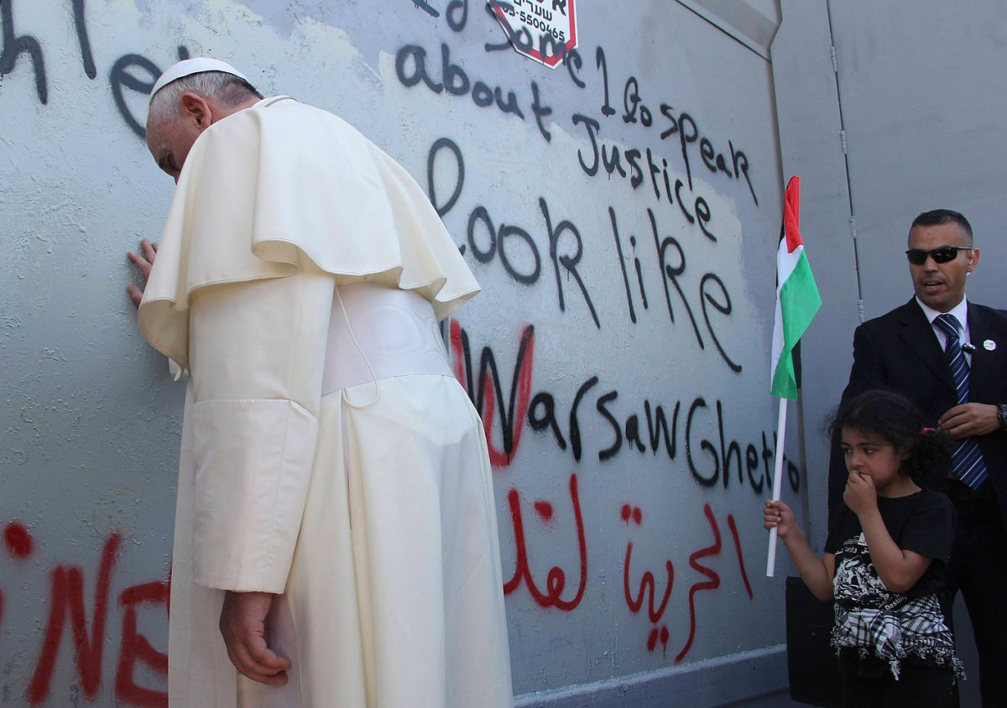
The photo of the pope praying at a separation wall on May 25th, built by Israel to protect its citizens against terrorists crossing from Bethlehem into Jerusalem, attracted the attention of the world media. The wall had been pray painted with words that made the separation wall equivalent to the Nazi wall to contain the Jews. Talk about a propaganda photo! To find out the truth about the Vatican and Israel I highly recommend the recent book, also available on Amazon Kindle, by Giulio Meotti, The Vatican Against Israel. It has one quote after another to show you the absolute facts.
Further defining how Jesuits have affected our lives: There is clear proof of the Church’s retaliation against the Protestant Reformation and its Reformers. Its invention of doctrines designed to tear the movement apart, included the Jesuit-created pre-tribulation rapture doctrine, and Dispensational Theology. The Pope commissioned Jesuits to write their own interpretation of the book of Revelation to make sure that no one connected the anti-messiah to the Roman Catholic papacy. By putting everything into a final 3½ year period in the very end times before Messiah’s return, they had people focusing on escaping in a “rapture,” and on some evil political fiend from the nations, but ignoring what was clearly visible for many centuries--the papacy, the oldest monarchy on earth, which has been anti-messiah and Beast in nature since its inception.
Throughout its history, the papacy has aligned to the Scriptures about the Beast, but, also, the Scriptures point to a final pope taking world power at the end of days before Messiah’s return. Now the united forces of the two greatest powers on earth are making their moves – the Jesuit General and the Jesuit pope/the Bishop of Rome. Behind them are powerful rulers dedicated to bringing about their goals.
As I said above, in the 1st century, Rome was known as the second Babylon. But, the spirit of Babylon, and its founder Nimrod, went west as the pope’s conquered Western Europe, then the spirit of Babylon crossed the Atlantic Ocean with Jesuits on the Mayflower, and balled up in America’s New York City, the 1st capital city of America. Thus, Revelation 18 is a continuation of Revelation 17, but at the same time Revelation 18 refers distinctly to New York, its harbor, Wall Street, and world commerce, which is controlled by the Jesuit General, the “Beast out of the sea.” Look at the wording of Ezekiel 26 and 27. In that day, Tyre was the New York of the ancient world. We have yet to see all the major players, but we will soon.
I John 4:1-4, we read that in his day the Apostle Yochanan (John) was seeing the rising of the Beasts – in Greek Gnostic Christianity. He said that many false prophets were going out in the world. He described the spirit of anti-messiah. Sha’ul described him well in II Thessalonians 2.
Time is ticking away, and Messiah set His deadline in Matthew 24. The powers of darkness know they have a short time to do all the destroying they want to do. (Revelation 12:12)

Here are just a very few quotes from Reformers and ministers since the Protestant Reformation, who labeled the popes the “Antichrist.” The term “antichrist,” or really anti-messiah, means one who sits in the place of Messiah, one who usurps His authority, His power, His right to rule, and replaces him with his own self – his own name, and his own character. Thus Messiah said to the Pharisees: “I COME IN MY FATHER’S NAME AND YOU DO NOT RECEIVE ME. IF ANOTHER COMES IN HIS OWN NAME – HIM YOU WILL RECEIVE.”
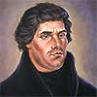
Martin Luther (Lutheran)
"We here are of the conviction that the papacy is the seat of the true and real Antichrist...personally I declare that I owe the Pope no other obedience than that to Antichrist." (Aug. 18, 1520) Taken from The Prophetic Faith of Our Fathers, Vol. 2., pg. 121 by Froom. In response to a papal bull--official decree: "I despise and attack it as impious, false... It is Christ Himself who is condemned therein... I rejoice in having to bear such ills for the best of causes. Already I feel greater liberty in my heart; for at last I know that the pope is antichrist, and that his throne is that of Satan himself." --D'Aubigné, b.6, ch. 9.
Cotton Mather (Congregational Theologian)
"The oracles of God foretold the rising of an Antichrist in the Christian Church: and in the Pope of Rome, all the characteristics of that Antichrist are so marvelously answered that if any who read the Scriptures do not see it, there is a marvelous blindness upon them." Taken from The Fall of Babylon by Cotton Mather in Froom's book, The Prophetic Faith of Our Fathers, Vol. 3, pg. 113
John Wesley (Methodist)
Speaking of the Papacy he said, "He is in an emphatical sense the Man of Sin, as he increases all manner of sin above measure. And he is, too, properly styled the Son of Perdition, as he has caused the death of numberless multitudes, both of his opposers and followers... He it is...that exalteth himself above all that is called God, or that is worshipped...claiming the highest power, and highest honour...claiming the prerogatives which belong to God alone." Taken from Antichrist and His Ten Kingdoms by John Wesley, pg. 110
Roger Williams (First Baptist Pastor in America)
He spoke of the Pope as "the pretended Vicar of Christ on earth, who sits as God over the Temple of God, exalting himself not only above all that is called God, but over the souls and consciences of all his vassals, yea over the Spirit of Christ, over the Holy Spirit, yea, and God himself...speaking against the God of heaven, thinking to change times and laws; but he is the son of perdition (II Thess. 2)." Taken from The Prophetic Faith of Our Fathers by Froom, Vol. 3, pg. 52.
John Knox (Scotch Presbyterian)
Knox wrote to abolish "that tyranny which the pope himself has for so many ages exercised over the church" and that the pope should be recognized as "the very antichrist, and son of perdition, of whom Paul speaks." Taken from The Zurich Letters, pg. 199 by John Knox
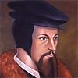
John Calvin (1509-1564) [founder of the Presbyterian Church]
“I deny him to be the vicar of Christ, who, in furiously persecuting the gospel, demonstrates by his conduct that he is Antichrist--I deny him to be the successor of Peter..I deny him to be the head of the church.” “Some persons think us too severe and censorious when we call the Roman pontiff Antichrist. But those who are of this opinion do not consider that they bring the same charge of presumption against Paul himself, after whom we speak and whose language we adopt…I shall briefly show that (Paul’s words in 2 Thessalonians 2) are not capable of any other interpretation than that which applies them to the Papacy” John Calvin, Tracts, Vol. 1, pp. 219,220. John Calvin, Institutes
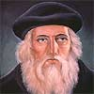
John Wycliffe (1324-1384) [Completed the 1st English translation of the Bible]
“Why is it necessary in unbelief to look for another Antichrist? Hence in the seventh chapter of Daniel Antichrist is forcefully described by a horn arising in the time of the 4th kingdom. For it grew from [among] our powerful ones, more horrible, more cruel, and more greedy, because by reckoning the pagans and our Christians by name, a lesser [greater?] struggle for the temporals is not recorded in any preceding time. Therefore the ten horns are the whole of our temporal rulers, and the horn has arisen from the ten horns, having eyes and a mouth speaking great things against the Lofty One, and wearing out the saints of the Most High, and thinking that he is able to change times and laws.” (Daniel 7:8, 25 quoted) …"For so our clergy foresee the lord pope, as it is said of the eighth blaspheming little head." Translated from Wycliffe's, De Veritate Sacrae Scripturae, vol. 3 pp. 262, 263

From Chris Pinto’s DVD “A Lamp in the Darkness”: “Former Jesuit General Michael Angelus Tamburini said: `See Sir, from these chambers I govern not only Paris but to China, and not only to China but to all the world, without anyone knowing how I do it.’ ” Quoted from Charles Chinique’s Fifty Years in the Church of Rome, page 484.
World rule has always been the goal of the Roman Catholic Church, and now they are on the verge of reaching that goal!

There are so many more quotes, but I’ll stop here. Please have a map of Israel available for you to see at all times. If you really love Israel, you must keep up with where things are taking place so that you can pray with knowledge. Love is interactive with what is loved. Check daily with israelnationalnews.com and other related websites that tell the truth about what is happening in Israel – telling things the world’s news media will never tell you. (i.e. The Times of Israel; Israel Breaking News)
Please pray and proclaim Psalm 2 and 83, Psalm 9, Psalms 96-99, proclaim the victory of the coming Kingdom of Yahushua, and the defeat of the enemies of Yahuweh and His people. Pray for the protection of His remnant among the Jews in Israel. It is amazing that nearly 2000 years ago Messiah gave signs of the time before His return, and at one point saying “flee to the mountains.” (Matthew 24:15-22) Today, the Orthodox Jews, the Karaite Jews, and others who guard the Torah, knows well, that there is soon-coming a time that they will have to flee out of Jerusalem or be killed. “The mountains,” they know are the mountains of Seir, in Edom (in southern Jordan). Except for Mount Hermon Israel has no mountains.
Below is the Jesuit Extreme Oath. Do your homework in the Word, so that you put the puzzle pieces together correctly. Watch and pray! Watch with intelligence and wisdom! Your eternity is close – prepare wisely!
Written with shalom and love,
Yedidah
June 20, 2014
--------------------------------------------------------------------------------
APPENDIX A: THE JESUIT EXTREME OATH
Taken from “The Black Pope President of the World,” from warningilluminati@wordpress.com - This is a 68-page article with pictures, showing the history of the Jesuit Order, using an interview with Jon Eric Phelps, a leading authority on the Jesuits. It is excellent information!
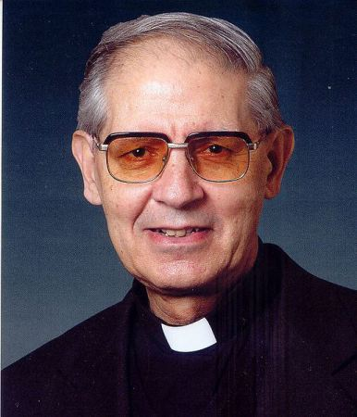
The present “Black Pope,” Adolfo Nicolas, Superior General of the Society of Jesus

This oath clarifies Daniel 11 in many ways …
Ceremony Of Induction And Extreme Oath Of The Jesuits
(Given to a Jesuit of minor rank when he is to be elevated to a position of command.)
Superior Speaks:
“My son, heretofore you have been taught to act the dissembler among the Roman Catholics to be a Roman Catholic, and to be a spy even among your own brethren: to believe no man, to trust no man. Among the reformers, to be a reformer; among the Huguenots (French Protestants) to be a Huguenot: among the Calvinists, to be a Calvinist: among the Protestants (those who protest and disagree with the Roman Catholic institution), generally to be a Protestant: and obtaining their confidence to seek even to preach from their pulpits, and to denounce with all the vehemence (violent emotion) in your nature our Holy Religion and the Pope; and even to descend so low as to become a Jew among the Jews, that you might be enabled to gather together all information for the benefit of your order as a faithful soldier of the Pope.
“You have been taught to insidiously plant the seeds of jealously and hatred between states that were at peace, and incite them to deeds of blood, involving them in war with each other, and to create revolutions and civil wars in communities, provinces and countries that were independent and prosperous, cultivating the arts and the sciences and enjoying the blessings of peace;
“To take sides with the combatants and to act secretly in concert with your brother Jesuit who might be engaged on the other side, but openly opposed to that with which you might be connected. “Only that the church might be the gainer in the end in the conditions fixed in the treaties for peace, and that the ends justify the means.
“You have been taught your duty as a spy, to gather all statistics, facts and information in your power from every source: to ingratiate yourself into the confidence of the family circle of Protestants and heretics of every class and character, as well as that of the merchant, the banker, the lawyer, among the schools and universities, in parliament and legislatures, and in the judiciaries and councils of State, and to ‘be all things to all men’, for the Pope’s sake, whose servants we are unto death.
“You have received all your instructions heretofore as a novice (one who has no training), a neophyte (a newly ordained priest), and have served as a coadjutor (worked as a helper), confessor and priest, but you have not yet been invested with all that is necessary to command in the army of Loyola and in the service of the Pope.
“You must serve the proper time as the instrument and executioner as directed by your superiors; for none can command here who has not consecrated (made secret or holy) his labors with the blood of the heretic; for ‘without the shedding of blood no man can be saved.’
The Extreme Oath of the Jesuits
“I, I……….., now, in the presence of Almighty God, the Blessed Virgin Mary, the blessed Michael the Archangel, the blessed St. John the Baptist, the holy Apostles St. Peter and St. Paul and all the saints and sacred hosts of heaven, and to you, my ghostly father, the Superior General of the Society of Jesus, founded by St. Ignatius Loyola in the Pontificate of Paul the Third, and continued to the present, do by the womb of the virgin, the matrix of God, and the rod of Jesus Christ, declare and swear, that his holiness the Pope is Christ’s Vice-regent and is the true and only head of the Catholic or Universal Church throughout the earth; and that by virtue of the keys of binding and loosing, given to his Holiness by my Savior, Jesus Christ, he hath power to depose heretical kings, princes, states, commonwealths and governments, all being illegal without his sacred confirmation and that they may safely be destroyed.”
“Therefore, to the utmost of my power I shall and will defend this doctrine of his Holiness’ right and custom against all usurpers of the heretical or Protestant authority whatever, especially the Lutheran of Germany, Holland, Denmark, Sweden, Norway, and the now pretended authority and churches of England and Scotland, and branches of the same now established in Ireland and on the Continent of America and elsewhere; and all adherents in regard that they be usurped and heretical, opposing the sacred Mother Church of Rome. I do now renounce and disown any allegiance as due to any heretical king, prince or state named Protestants or Liberals, or obedience to any of the laws, magistrates or officers.”
“I do further declare that the doctrine of the churches of England and Scotland, of the Calvinists, Huguenots and others of the name Protestants or Liberals to be damnable and they themselves damned who will not forsake the same.”
“I do further declare, that I will help, assist, and advise all or any of his Holiness’ agents in any place wherever I shall be, in Switzerland, Germany, Holland, Denmark, Sweden, Norway, England, Ireland or America, or in any other Kingdom or territory I shall come to, and do my uttermost to extirpate the heretical Protestants or Liberals’ doctrines and to destroy all their pretended powers, legal or otherwise.”
“I do further promise and declare, that notwithstanding I am dispensed with, to assume my religion heretical, for the propaganda of the Mother Church’s interest, to keep secret and private all her agents’ counsels from time to time, as they may entrust me and not to divulge, directly or indirectly, by word, writing or circumstance whatever; but to execute all that shall be proposed, given in charge or discovered unto me, by you, my ghostly father, or any of this sacred covenant.”
“I do further promise and declare, that I will have no opinion or will of my own, or any mental reservation whatever, even as a corpse or cadaver (perinde ac cadaver), but will unhesitatingly obey each and every command that I may receive from my superiors in the Militia of the Pope and of Jesus Christ.”
“That I may go to any part of the world withersoever I may be sent, to the frozen regions of the North, the burning sands of the desert of Africa, or the jungles of India, to the centers of civilization of Europe, or to the wild haunts of the barbarous savages of America, without murmuring or repining, and will be submissive in all things whatsoever communicated to me.”
“I furthermore promise and declare that I will, when opportunity present, make and wage relentless war, secretly or openly, against all heretics, Protestants and Liberals, as I am directed to do, to extirpate and exterminate them from the face of the whole earth; and that I will spare neither age, sex or condition; and that I will hang, waste, boil, flay, strangle and bury alive these infamous heretics, rip up the stomachs and wombs of their women and crush their infants’ heads against the walls, in order to annihilate forever their execrable race. That when the same cannot be done openly, I will secretly use the poisoned cup, the strangulating cord, the steel of the poniard or the leaden bullet, regardless of the honor, rank, dignity, or authority of the person or persons, whatever may be their condition in life, either public or private, as I at any time may be directed so to do by any agent of the Pope or Superior of the Brotherhood of the Holy Faith, of the Society of Jesus.”
“In confirmation of which, I hereby dedicate my life, my soul and all my corporal powers, and with this dagger which I now receive, I will subscribe my name written in my own blood, in testimony thereof; and should I prove false or weaken in my determination, may my brethren and fellow soldiers of the Militia of the Pope cut off my hands and my feet, and my throat from ear to ear, my belly opened and sulphur burned therein, with all the punishment that can be inflicted upon me on earth and my soul be tortured by demons in an eternal hell forever!”
“All of which, I, ………., do swear by the Blessed Trinity and blessed Sacraments, which I am now to receive, to perform and on my part to keep inviolable; and do call all the heavenly and glorious host of heaven to witness the blessed Sacrament of the Eucharist, and witness the same further with my name written and with the point of this dagger dipped in my own blood and sealed in the face of this holy covenant.”
(He receives the wafer from the Superior and writes his name with the point of his dagger dipped in his own blood taken from over his heart.)
Superior:
“You will now rise to your feet and I will instruct you in the Catechism necessary to make yourself known to any member of the Society of Jesus belonging to this rank.”
“In the first place, you, as a Brother Jesuit, will with another mutually make the ordinary sign of the cross as any ordinary Roman Catholic would; then one cross his wrists, the palms of his hands open, and the other in answer crosses his feet, one above the other; the first points with forefinger of the right hand to the center of the palm of the left, the other with the forefinger of the left hand points to the center of the palm of the right; the first then with his right hand makes a circle around his head, touching it; the other then with the forefinger of his left hand touches the left side of his body just below his heart; the first then with his right hand draws it across the throat of the other, and the latter then with a dagger down the stomach and abdomen of the first. The first then says Iustum; and the other answers Necar; the first Reges. The other answers Impious.” (The meaning of which has already been explained.) “The first will then present a small piece of paper folded in a peculiar manner, four times, which the other will cut longitudinally and on opening the name Jesu will be found written upon the head and arms of a cross three times. You will then give and receive with him the following questions and answers:-”
Question:- From whither do you come?
Answer:- The Holy faith.
Q.:- Whom do you serve?
A.:- The Holy Father at Rome, the Pope, and the Roman Catholic Church Universal throughout the world.
Q.:- Who commands you?
A.:- The Successor of St. Ignatius Loyola, the founder of the Society of Jesus or the Soldiers of Jesus Christ.
Q.:- Who received you?
A.:- A venerable man in white hair.
Q.:- How?
A.:- With a naked dagger, I kneeling upon the cross beneath the banners of the Pope and of our sacred order.
Q.:- Did you take an oath?
A.:- I did, to destroy heretics and their governments and rulers, and to spare neither age, sex nor condition, and to be as a corpse without any opinion or will of my own, but to implicitly obey my Superiors in all things without hesitation of murmuring.
Q.:- Will you do that?
A.:- I will.
Q.:- How do you travel?
A.:- In the bark of Peter the fisherman.
Q.:- Whither do you travel?
A.:- To the four quarters of the globe.
Q.:- For what purpose?
A.:- To obey the orders of my general and Superiors and execute the will of the Pope and faithfully fulfill the conditions of my oaths.

