THE GLOBALIST AGENDA for the NEW WORLD ORDER
UNITED NATIONS INTERNATIONAL PACT
Preparing the Nations for the Rise of the Anti-messiah to World Power

[This article is based on my research for factual knowledge from 1987 to present, up-to-date articles, and “New World Order Execute New Deal to Destroy the Borders of Every Nation…” justusaknight.com YouTube, December 11, 2018]

Ephesians 5:8, 11: “For you were once darkness, but now you are light in the Master – walk as children of light…And have no fellowship with the fruitless works of darkness, but rather expose them.”
I Thessalonians 5:3-5: “For when they say `peace and safety’ the sudden destruction shall come upon them as labor pains upon a pregnant woman, and they shall not escape. But, you brothers are not in darkness so that this day should overtake you like a thief, for you are all sons of light and sons of the day. We are not of the night or of the darkness…”
I Corinthians 4:5: “Do not judge anyone before the time, until Messiah comes, who shall bring to light what is hidden in darkness and reveal the thoughts of the heart….”
Psalm 139:12: “If I say `darkness shall cover me,’ then night would be light to me. Even darkness is not dark for You, but night shines as the day – as in darkness, so is light…”
Iyob/Job 34:21-22: “For His eyes are on the ways of man and He sees all his steps. There is no darkness or shadow of death where the workers of wickedness can hide themselves.”
The Word of Yahuwah is full of passages about the new world order that we are seeing built on an already established foundation. The Word tells us a lot about the plans, and about how Yahuwah and Yahushua will ruin their plans!

Beginning with notes on Justus’ 12-minute YouTube Broadcast of December 11:
Justus talked about “conspiracy theories.” My input here amplifies what he said: “Conspiracy” is just something planned that is hidden until it comes to light. Two or more people make plans for something – a birthday party, an engagement, a marriage, a surprise party, or a new world order. It’s so simple: Either something is planned, or it is not planned. A conspiracy is planned by two or more people with a goal for a desired effect. What is not planned is a “coincidence.” Almost all events are planned. But some things are guessed at, or surmised, in an attempt to unravel what is hidden – that is a “conspiracy theory.” A conspiracy theory has many “maybes.” They are based on partial knowledge and opinions. The theories may come very close to truth, but still not be 100% based on solid facts. But, then again, the theories may be from outer space – totally “off the wall.”
Until something is total revealed, the only real way to see through what is hidden is by the Spirit of Yahuwah, who shines the light on all things hidden. He

may convey to us the hidden things by impression to our spirit, by vision or dream,
by a personal word to us, or by showing us Scripture. But, by whatever means, Yahuwah delights in exposing the works of darkness! Yet, He only exposes the full extent of truth, the secrets that He sees, to those He trusts with it. (Amos 3:7)
People are prone to give their theories about what is being planned, yet they don’t know details, or how things will work out. It’s fun to discuss opinions with friends, but to make opinions as dogma often leads others astray into confusion, deception, and even to believing pure lies. Good researchers do not deal in theories. Good researchers find the truth about what is being planned, and if it is evil, they expose the plans openly. Good watchmen expose deceptions, and warn the people (Ezekiel 33)!
The ones making evil plans do everything they can to keep them “hush hush.”
They often hide any mention of their plans, tout fake news to the public, or even go so far as to silence those exposing their plans, shutting off their means of communication to others. This is what is happening as Google is removing YouTube programs of many truth-tellers. The globalists are ready to execute their plan, and they do not want the public to know what they’re doing, or how they are doing it.
They want to remain in secret until they rip the cover off, tear off their masks, and the plan stands naked before the world as in “accept it or your dead.”
Justus rightly says that the term “conspiracy theory” has been weaponized to suppress the truth exposed openly by those who know the truth. The Globalists want to destroy all borders, draw us together into one culture, into obedience to one leader, in one economic system, one political and religious system, one military system, with no personal rights, not even rights to our thoughts.
This move is being orchestrated by the United Nations, lackeys of Satan and his fallen angels, Nephilim, and hybrids. The global agenda is being orchestrated to bring to power a Beast—an ancient entity with a composite government of all empires that have stood against Yahuwah, and the persons of anti-messiah and his false prophet. All those disagreeing will be killed, except for a remnant and the two “witnesses.” (Daniel 7, Zechariah 4:2-3, 11-14 with Revelation 11:3-6 and Revelation 13)
Justus Knight is amazed at how the U.N. building is even allowed on U.S. soil. He says their “dignitaries should be sent home and the building condemned.” He said: “The U.N. has no place on U.S. soil. It is the antithesis of everything that is wrong around us.” The U.N.’s presence is a monument to the now-existing new world order that is making its move to expose itself to the world. It was announced in May of 1999 as having been formed, just on time as Gary Kah wrote about in Enroute to Global Occupation.
Zechariah 5:5-11 speaks of a woman who is the embodiment of “wickedness.” Her origin is ancient Babylon--not Nebuchadnezzar’s Babylon, but Nimrod’s Babel. (Genesis 10:8-10) In the last days, “she” returns to her “base” in Shinar, a symbolic Shinar - the Plain where Nimrod’s Babel stood. She is the woman who rides the Beast to power in Revelation 17, “Mystery Babylon.” Revelation 18 gives us the clue as to where the base is in modern-day Shinar/Babel.
In Revelation 18, we read that this Port is the world’s trading center - the center of the gathering of the nations. 26 commodities are traded every day on its stock exchange. Its fallen spirits enslave the souls of men to make themselves great. It is the base for this woman to rule from. Only one place in the world trades those 26 items as a whole every day, and is the International Port of the world--New York City, home of the United Nations and the World Trade Center.
America is the epitome of Nimrod’s purpose for Babel, the nation chosen before the Mayflower sailed to finish what he started with His tower to unite the world’s people around him as the world ruler. (Genesis 11) Yahuwah stopped the attempts for world government back then. America was designated back in the 1500s to be the place where Nimrod would rise to power again, be reincarnated and restored, and put in power as the ruler of all nations – in other words, the antichrist/anti-messiah.
Here are five references you can get, with excellent indisputable documentation, to learn the truth. 1) Chris Pinto’s DVD “The New Atlantis,” 2) Chris Pinto’s DVD “Riddles in Stone,” 3) Chris Pinto’s DVD “The Eye of the Phoenix” (Adullum Films, or available very cheap on Amazon), 4) The newly released from Skywatchtv.com “The Belly of the Beast,” and for foundational simplicity my article “America’s Secret Destiny”/Mikvah of Present Reality.
It is amazing how the plans for the return of the gods of the Golden Age (pre-Flood), the fallen angels and their offspring, gods and demi-gods of the nations, have been slowly brought forth in secret, but NOW they are open for the wise to understand! (Daniel 2:20-23)
Gary Kah in Enroute to Global Occupation exposed the timing of the plan in the early 1990s when he secretly infiltrated the beginning Council that was planning it out. They said their goals would be reached by the late 1990s.
In May of 1999, I had just moved to Jordan. I was in the apartment of a lady I knew from Texas. She invited the ladies gathered for fellowship, to watch CNN Europe, news, eat cookies, and drink tea. She turned on CNN on her TV. Immediately we saw James Reuben standing by the U.S. flag. He said he was there to announce that “the new world order had been established.” He proceeded to tell what it was and who was over its different arenas. At the time it was President Clinton. Another lady in our group was watching BBC Europe. She called us excited to tell what she was hearing – same thing. Europe heard the announcement, but no one in the U.S. heard it, even though it was announced from what appeared to be the White House or the Pentagon. We kept the T.V. on to see how America would react to the announcement. The U.S. News was next. We waded through 45 minutes of their telling about a new Steven Spielberg movie, and 15 minutes of a review of the Jon Bene Ramsey murder case. A year later, while in Wales, I ask my host if he had heard the announcement - He said “yes.’
The new world order, one world government, has been with us since 1999, but hidden. The plans have been with us for around 500 years. But, the nation in charge of bringing the new order to fruition did not hear of its announcement – America. Today the plans are out in the open and most of the world is content with going along with it. Angela Merkel is encouraging it – of course. We see what is happening in the U.K. and in Europe with the riots, the violence, and the migrant horrors. People are protesting against injustice, but among the demonstrators are paid criminals and violent-mind-controlled “Manchurian Candidates.”
I hope you have read the article “Hitler’s Secret Plan for World Conquest Exposed”/Mikvah of Present Reality. This article informs you about the source of what we’re seeing with the migrant invasions worldwide. It was Hitler’s plan to use the Arabs to flood Europe, and to destroy Christianity so that he could take the helm of the world in a Fourth Reich. Many Arabs became Nazis. As many have written about, America has facilitated the Fourth Reich from 1945 to present day.
The DVD, “The Belly of the Beast,” mentioned above from Skywatchtv.com spells out how America has been the “womb of the anti-messiah,” the chosen nation to bring him forth. Recently Yahuwah said that me while I was fixing dinner: “America is the womb of the anti-messiah.” (His timing to talk to us is sometimes rather humorous.)
Justus Knight said: “The U.N. is the opposite of everything our great Republic stands for…It is the destruction of the United States.” Yes, he’s right. Members of the “shadow government,” known also as “the deep state,” were chosen centuries ago to restore the fallen angels to power over a new Golden Age, the Age of Atlantis. America was chosen to reincarnate and restore Nimrod to power over the earth. Nimrod is the god of Freemasonry – the perpetrator of the tower of Babel.
Europe has the tower of Babel as its symbol in their Parliament building and in their statues of the woman who rides the Beast outside other government buildings. Europa was the goddess who rode Zeus, who had turned himself into a bull. The son of Zeus is found in Revelation 9:11--Apollo/Apollyon, which is another name for Nimrod, as is Osiris of Egypt. Nimrod founded the original Babylon, which he called “Babel.”
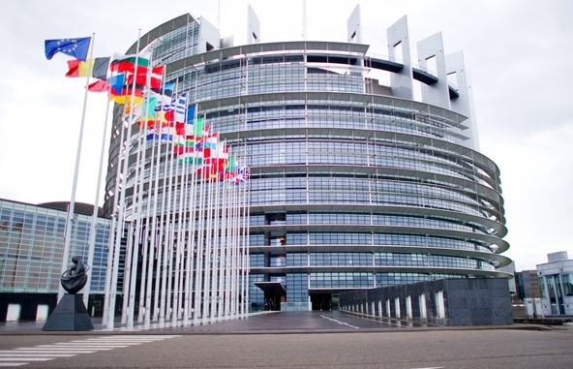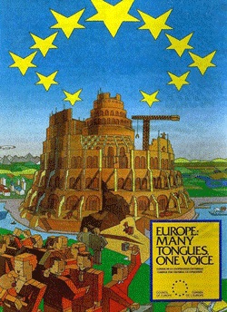
Left: E.U. Parliament Building Brussels
Middle: Replica of Nimrod’s Tower of Babel, note the globalist message
Right: An E.U. Coin with the woman riding the Beast
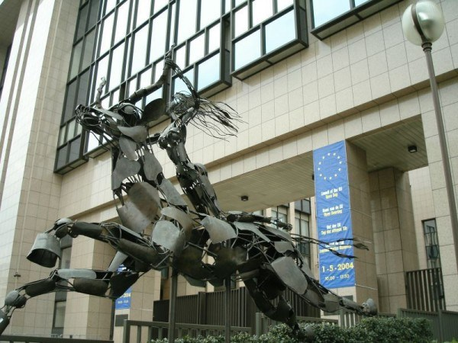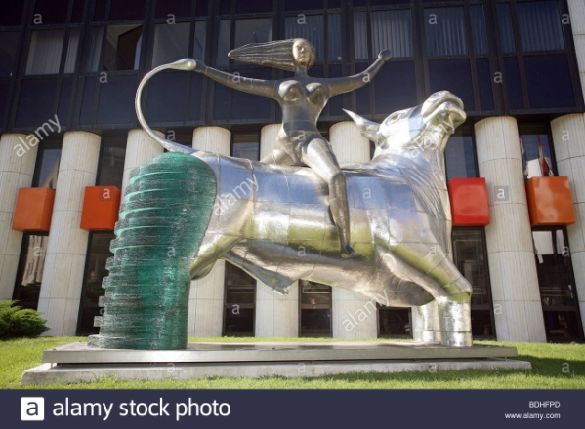
Left: Woman Rides the Beast statue outside Headquarters of the E.U.
Right: Woman Rides the Beast--EU Parliament Building Strasbourg, France
The spirit of Babel moved from the ancient area of Babel in what is now Iraq, to Pergamum, where the seat of Satan was (Revelation 2:12-17--It is now it in Berlin), then into Rome where Esau settled. By the 1st century, Rome was officially titled “the second Babylon.” Then this spirit went across Western Europe, and on to America (Jeremiah 50-51, Revelation 18). Today, as several Scriptures so graphically tell us, America is end-time Babel, political Babylon. [Refer to: “Thirty Clues…”/Mikvah of Preparation]
In order for a new world order to rise, like the Phoenix rising out of the ashes, America has to die as a nation so that out of the ashes will arise the Golden Age of the gods and demigods under one ruler--a “messiah” to the world’s people.
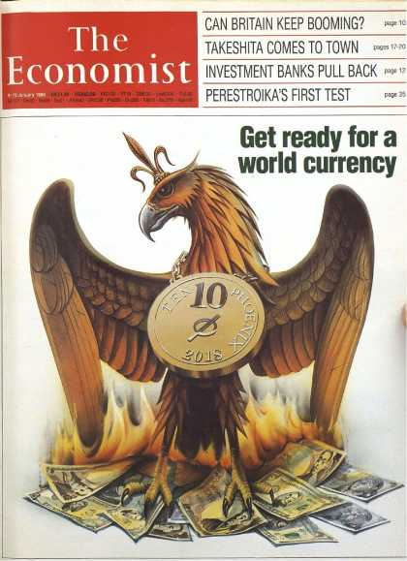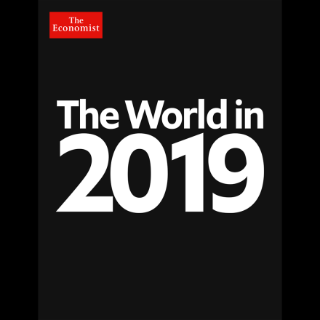
Left: The medallion on the Phoenix says 2018 – This cover is dated January 1988! Now we’re facing economic collapse and a new world currency. This shows the slogan of Globalists that the Phoenix will rise out of the ashes to begin a new world order. The Phoenix is on the right side of the back of the dollar bill.
Right: The cover for January 2019 – the world is in darkness.

The goal of the United Nations is to eliminate all national borders! My remembering: On one of my flights, which landed in Heathrow Airport, there was a holdup in exiting the plane. Upon deplaning, I asked the Captain about it. He said that I would not be in England until I left the airport, because no airport, I assumed international at least, belongs to the nation they are in. The airports are sovereign, and are not aligned to any nation. What a shock!

Newsweek, December 10, 2018, “Why is the Trump Administration so against the U.N.’s Global Migration Pact?” Notes from the article:
Justus retorted: “Because he cares about the sovereignty of our nation.”
President Trump stands for national sovereignty. He has been consistent on that. I question: Are the globalists using his fervor for nationalism to separate between nationalists and globalists in America, so that the globalists can work for the elimination of protesting nationalists. Those who stand with Trump are conservatives and nationalists, plus most are Christian. Globalists have proven themselves hostile, even violent, against “Trump supporters.”
The globalists take note of who stands with Trump, and these are the ones they want to eliminate in order to have no opposition.
“The New World Order cannot happen without U.S. participation, as we are the single most significant component. Yes, there will be a New World Order, and it will force the United States to change its perceptions.” - Henry Kissinger, World Action Council, April 19, 1994
In 1994, Henry Kissinger most likely did not know Donald Trump would be President and stand against the new world order. If Trump keeps standing against it, the “powers that be” are prepared to take him out of office or out of life.
It is possible that because Trump is a billionaire, he wants to preserve our rights in the market place. He wants to preserve Capitalism. He wants to lower the unemployment rate. He wants to raise and prosper the middle class, who has a higher sophistication in the work place. The globalists want to do the opposite, and make the world’s people slaves of a Feudalistic society. Of course, Trump is also fighting for his rights as a money-maker.
Justus says that if a person applies for residency or citizenship within America, and they are accepted, they should be let in, they are legal. Yes, that’s right. But, as he also says, we must not let in illegals who will drain our welfare system, commit crimes, and expect to be rewarded for laziness and violence. Right!
Those that want jobs can apply. However, if the country is flooded with people from other nations who are used to being paid next to nothing for their work, then their presence, legal or not, will take jobs from U.S.-born citizens or previously legalized citizens. Perhaps this is the goal, for cheap labor is cheap labor – and to hire them for a lot less more money, puts more cash in the pockets of the rich.
Texas’ oil is being uncapped, and Texas is now booming with new wells, new pipelines going everywhere. Texas used to be the 8th largest economy in the world when they pumped their own oil. Now, it is being restored. I’m a suspicious. It is possible that this all-of-a-sudden boom in Texas is to provide jobs for migrants. They’ll be paid little for their work, much less than what an America would expect to be paid. American corporations use the poor in many countries to work in their fields and factories because they are paid next to nothing, and even children as young as five work in the fields for next to nothing. Thus: “the bodies and souls of men” in Revelation 18:13.

Article from The Express, December 10, 2018: “U.N. members Sign Global Migration Pact After 10 Countries Shun Deal Over Sovereignty Fears.”
“Agreed to by all 193 U.N. countries except these 10 who are still questioning it”
Justus asks: What rights do these U.N. representatives have to make any decisions for the people of the world? They have none, except what has been given them by the public who ignorantly passive and complacent.” While apathy reigns, the enemy is taking over. But, also, in most nations the public is not told anything that would cause them to question these things.
Justus said: “Any signatures on this deal allow the new world order to win.”
But, on the other side are those gung ho Trump supporters who think that all we have to do worldwide is unite against the Globalists and the Globalists will be defeated. Ha! Chaos has broken out in protests in Europe. No matter if 7 billion people protest, the goals of the Globalists will go forward, for it is written so in the Word. It leads to Yahuwah’s judgment!
Mankind will not hold back the Kingdom of Yahushua! First comes an attempt at a kingdom of the anti-messiah. It will be a horrendous attempt, tribulation for earth’s people, but it will not last long – it will fail eternally.
Back in 1990, George H.W. Bush promoted “a new world order.” He said it over and over in speeches. Few understood what that meant. Yet, that was why America was founded – to usher in a new world order, a one world government. Look at the Great Seal of the United States on the left side of the back of the dollar bill. It says “a new order of the ages,” in Latin. It says: “He approves our undertaking,” in Latin, referring to Jupiter, chief god of the Romans. I refer you to Chris Pinto’s DVD “The Eye of the Phoenix,” and Tom Horn’s book Zenith 2016. That’s not an eagle on the right side of the back of the dollar bill – it is a Phoenix.
The planned timing for establishing the foundation of a new world order was put right there in the Great Seal – 1776. The timing for the goal to be reached begins with 1776 and goes up 13 steps to the top of the pyramid on the back of the dollar bill -- 2016 Gregorian calendar, and 2012 Mayan calendar, as well as ancient calendars all over the world—i.e. using 19.7 katum/Mayan years.
The banner board behind those heading the U.N. International meeting in Morocco reads: “Intercontinental Conference to Adopt the Global Compact for Safe, Orderly, and Regular Migration…” Justus asks: “Safe and orderly for who?”
When followed through, it will open borders for the destruction of anyone that anyone wants to destroy. The goal for the reduction of the population of earth still stands at 500 million, as on the Georgia Guide Stones #1--Maintain the population at 500 million. Ted Turner openly talked about population reduction in the 1980s.
Soon the international community will begin to enforce their plan to eliminate those who are “useless eaters,” those that are non-productive in the work place, unable to do menial jobs, physically weak people who eat but can’t labor, like the infirmed, the elderly, and children under five. The rules of China will be enacted, euthanasia will be law, “Solient Green” will come to pass. Cannibalism is already an accepted thing--human meat as a viable protein food product scientists say.
If you’ve kept up with the geoengineering of the planet, the main target for destruction is the food crops in all countries of the world. They are destroyed by what appears to be natural phenomenon – i.e. hurricanes, cyclones, tsunamis, drought, excessive heat, floods, blizzards, wildfires, volcano, and eruptions. But, these “natural phenomenon” are most all man-created.
Pope Francis has said that the world should go by birth certificates to determine who is allowed to live and who should not, based on work ability. Anyone not physically fit, or who stands against their draconian practices, will be eliminated… all “unfit” races, too - sounds like Hitler doesn’t it? But remember, America led the world in Eugenics at the turn of the 20th century, and today America is the world leader of abortions, funding them especially in third world nations.
According to Part III of the Mazzini/Pike Plan, pitting the Arabs and the Jews against each other, the goal is to let them kill each other off. Both groups of people, to the Globalists, are inferior races. They also know the DNA of the 10 tribes of the House of Israel. Primitive and /or poor tribal people worldwide will be killed off, the very poor, the ignorant, tribes in various countries who live in mud and wood huts, and, those who are Christians are included. Years ago, the World Bank army went through the Amazon River area telling the Christians to get naked again and give up Christianity, or they’d be killed. Then there was/still is “Liberation Theology” in Latin America. People Francis enforced that in Argentina.
The United Nations is demanding that America let in the thousands of migrants now at our border, and thousands that are still coming. Yet, it has been proven that a large number of the migrants, mostly all young men of military age, in good health, are violent, cruel, greedy, aggressive, domineering, and criminal in intent. They use the woman and children as their forerunners to soften the hearts of the ignorant. Trump is not allowing them in – at this point. But, if the flood gates are opened, and the illegals flood in, among them being drug cartel gangs, ISIS, other terrorist groups from the Middle East, too, we’ll be letting in murderers, rapist, thieves, drug runners, and violence like we’ve never known.
“The U.N. is the ground zero for the new world order,” Justus said. But, this has all been prophesied in the Word of Yahuwah, too. The Globalists are preparing the way for the anti-messiah! Justus and watchmen like him are preparing the way for the Messiah by telling the Truth and warning the people of Yahuwah and Yahushua!
Honestly ask yourself: “Who am I forerunning? How am I preparing the way for the return of Messiah?” How am I preparing human beings to receive Messiah?

“Leaders of 164 Nations Sign Global Migration Pact Amid Opposition” - OAN Newsroom--One America News Network - Monday, Dec. 10, 2018
“More than 160 nations recently approved a non-binding migration accord amid fierce opposition from some countries, including the U.S. Leaders of 164 nations signed the ‘Global Compact for Migration’ Monday at a United Nations conference in Morocco. While at least 10 members have pulled out, Israel and Switzerland are among those who remain undecided.
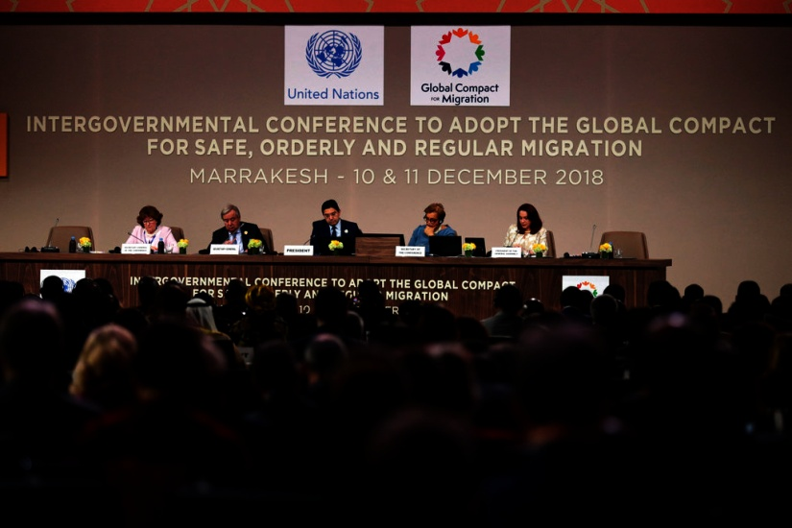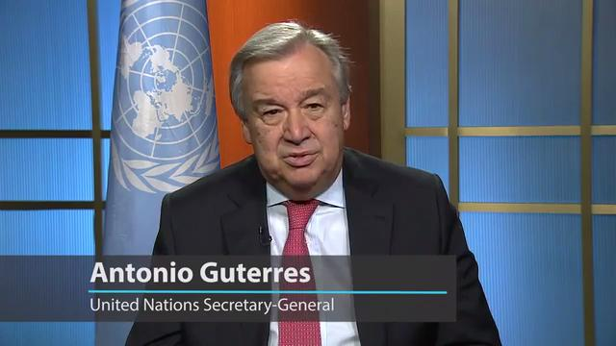
Left: U.N. Secretary-General Antonio Guterres, 2nd left, and Moroccan Minister of Foreign Affairs and International Cooperation, Nasser Bourita, center, chair the opening session of a UN Migration Conference in Marrakech, Morocco, Monday, Dec.10, 2018.
Right: U.N. Secretary-General
“…Opponents are saying the agreement could challenge national sovereignty and security for host countries, but supporters say the pact will potentially save lives and help boost economies with new labor. `With better international cooperation, it would be possible to invest much more in countries of origin, creating the conditions for people to have an option to stay in their own country and build with hope their lives in their own country,’ stated UN Secretary General Antonio Guterres. `I do believe that better international cooperation will also open the way for more opportunities for legal migration, taking into account the needs of markets, the demography and the situation of different countries in the world.’
The United Nations General Assembly is set to adopt an official resolution on the deal next week in New York.” (Revelation 18/NYC)
“UNITED Nations members have adopted a controversial pact designed to improve global cooperation on migration.” Harvey Gavin – The Express, December 11, 2018
The non-binding deal was agreed by all 193 UN countries, except the United States, in July. But in the months that followed, 15 more nations have either pulled out or expressed concerns over the impact of the agreement on sovereignty and ability to control their borders. At a signing ceremony in Marrakesh today, the deal was described by UN Secretary

General Antonio Guterres as a `roadmap to prevent suffering and chaos.’

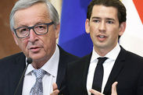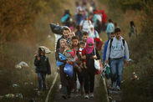
Left: EU CRISIS: Austria divides Brussels with UN migrant pact boycott
Czech Republic joins EU rebels in REJECTING UN’S refugee pact
He reiterated the pact `is not legally binding" and includes specific measures which reaffirms the principle of state sovereignty.’ Mr. Guterres also hit out at the `fear and false narratives’ surrounding the deal. The UN migration pact, officially the Global Compact for Safe, Orderly and Regular Migration, sets out a series of shared goals aimed at better managing the estimated 258 million migrants living outside their country of birth.
These goals include providing access to basic services for migrants, improving integration for new arrivals, combating people trafficking and coordinating how to send migrants home.
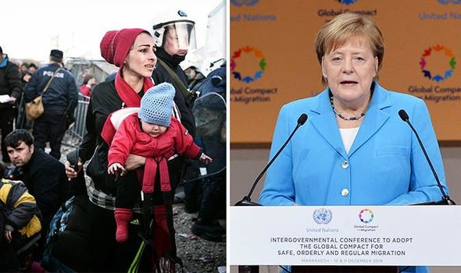
Left: Migration “compassion card” being played, often using posed pictures
Most UN members have signed up to a global migration pact (Image: GETTY IMAGES/REUTERS)
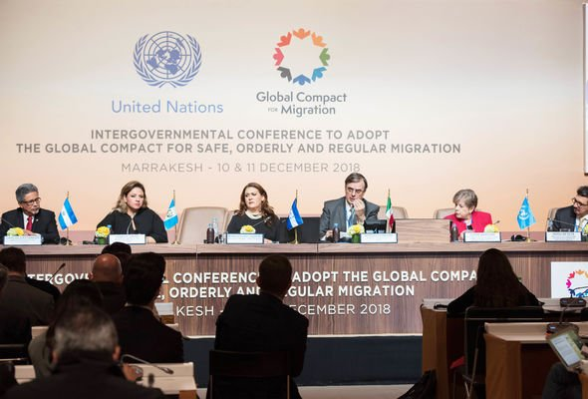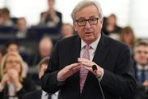
Left: The US and nine other countries pulled out of the non-binding agreement (Image: EPA) Right: Brussels blasts the Pact
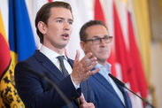
Austria to QUIT UN migrant pact in solidarity with US and Hungary
A total of 164 nations signed up to the agreement today - including the UK - but none are legally bound to make good on the goals. [i.e. Here’s some candy. There’s no poison in it--eat it, it’s good. Isaiah 5:20! In global government no one can stand up for the Word of Elohim and not be liable for death because Yahuwah’s Word goes against everything Globalism stands for]
However 10 countries, mostly in Eastern Europe, have pulled out. Six more, including Israel and Bulgaria, are debating whether to quit, a UN spokesman said after the pact was adopted.
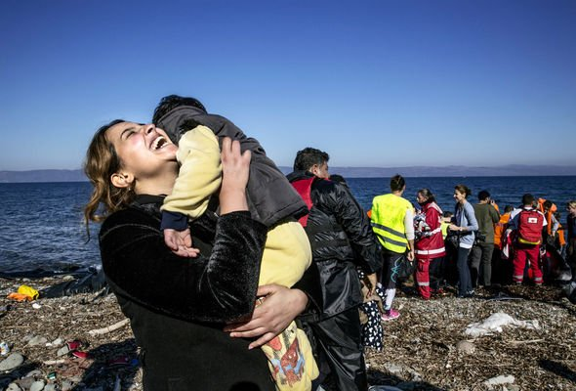
The peak of the migrant crisis in 2015 saw one million refugees and asylum seekers arrive in Europe (Image: GETTY IMAGES)
But President Donald Trump’s administration last year said it would not be taking part on the grounds the pact was not compatible with US sovereignty!
The United States on Friday had hit out at the deal, labeling it `an effort by the United Nations to advance global governance at the expense of the sovereign right of states.’
Since then, other nations have said the pact could increase immigration from African and Arab countries. Australia, Austria, the Czech Republic, Dominican Republic, Hungary, Latvia, Poland and Slovakia have already pulled out. Austria's right-wing government said it would not sign up because the pact would blur the line between legal and illegal migration.
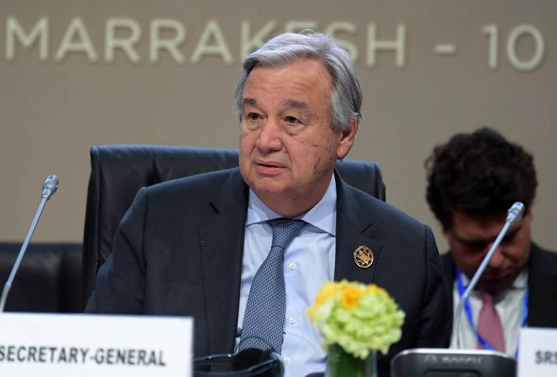
UN boss Antonio Guterres insisted the pact was not legally binding (Image: AFP/GETTY IMAGES)
Chile became the latest country to shun the deal when it withdrew on Sunday.
Angela Merkel, accused by critics of worsening the refugee crisis by opening Germany's borders in 2015, said cooperation was the only answer to tackle the world's problems. Speaking in Marrakesh today she said: `The pact is worth fighting for. It's about time that we finally tackle migration together.’
Without naming Mr. Trump or his `America First’ policy, the German leader said multilateralism is the way `to make the world a better place.’ "
Related articles: Fears grow Turkey could release millions of migrants into Europe
-----
Global Migration Pact puts Belgian ruling coalition in jeopardy
By Georgi Gotev | EURACTIV.com
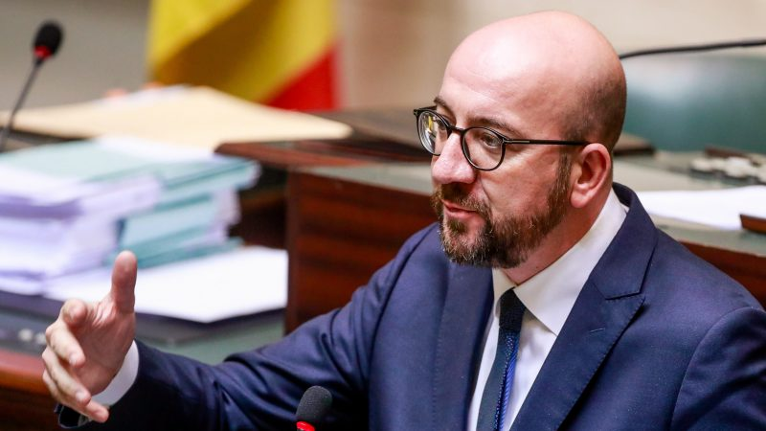
Belgian Prime Minister Charles Michel speaks during a plenary session at the federal parliament in Brussels, Belgium, 22 November 2018. The main subject of the plenary session is the U.N. Migration Pact. In Belgium, the issue of the migration pact is controversial within the federal government. [Stephanie Lecocq/EPA/EFE]
The future of Belgium’s coalition government has come under threat after Prime Minister Charles Michel said he would back the UN Global Migration Compact in Marrakesh on 10 December, despite opposition from his coalition partner, the Flemish right-wing N-VA party. The Global Compact for Safe, Orderly and Regular Migration was approved in July by all 193 member UN nations except the United States, which backed out last year, and is due to be ratified formally in December. The pact was conceived after the biggest influx of migrants into Europe since World War Two, many of them fleeing conflicts and poverty in the Middle East, Africa and beyond. But in recent months, opposition to the pact has been growing, with critics saying that it makes no distinction between legal and illegal migration. The list of EU countries pulling out from the global migration pact is getting longer almost by the day.
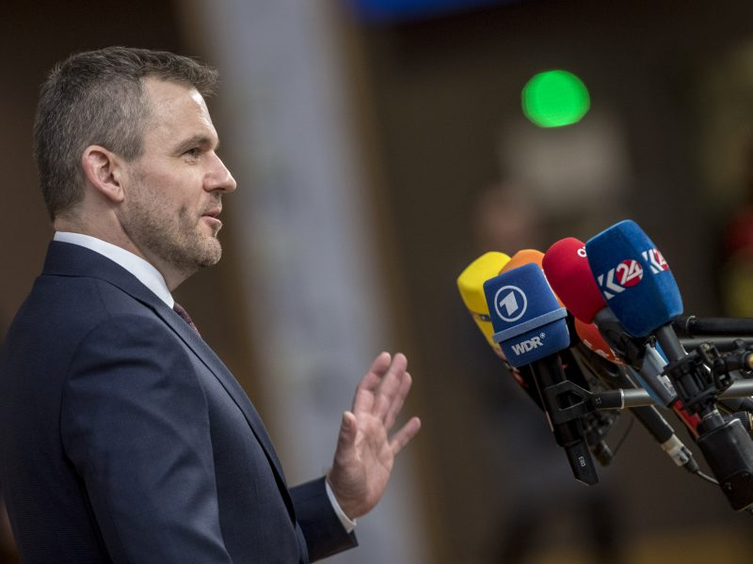
Slovakia becomes 8th EU country to oppose global migration pact
All Visegrad countries have now rejected the United Nations pact on the treatment of migrants worldwide, after Slovak Prime Minister Peter Pellegrini on Nov.25
Here is a list of links that Justus referred to for you to check out:
https://www.oann.com/leaders-of-164-nations-sign-global-migration-pact-amid-opposition/
https://www.newsweek.com/why-trump-administration-so-against-uns-global-migration-pact-1252215
https://www.express.co.uk/news/world/1056998/un-migration-pact-europe-united-states-immigration
https://mobile.reuters.com/article/amp/ca/idUSKBN1O90V5
https://www.euractiv.com/section/elections/news/global-migration-pact-puts-belgian-ruling-coalition-in-jeopardy/
Alex Jones had a program on December 7th in which he said that Globalism will be conquered and fade away because humanity is aligning against it. True, humanity is beginning to unite against globalism! Some believe Trump will run off the Globalists and they will give up. Wish on!
Nationalists in every country are protesting the rule of globalists. Humanity is protesting, demonstrating and rioting against abuses by globalists. The protests are getting more violent. Demonstrations are using more and more ways to harm police and citizens. But, what Alex does not realize is 1) the forces behind it are more powerful than any resistance, for they are fallen angels and their offspring, and 2) the Force allowing it is Yahuwah Himself. He is using it to bring His own conclusion. It is for a short time. Then He will send Messiah to shut it down forever!
But, also there is #3: It will take very little to shut down humanity altogether. Famine is already taking millions of lives, as are diseases, war, and BIG Pharma drugs. Right now, the Pentagon is using Direct Target Weapons that don’t just start fires, but when pointed at a crowd, can literally melt the skin off of people. (Zechariah 14:12)
There are weapons of mass destruction that can take out a nation as big as the U.S.A. by EMP attack followed by nuclear attack. No one dying of radiation, starvation, or disease, is going to want to protest a new world order! (Revelation 6)
Just weaken humans and let them die is the plan, and the globalists win, take over, get the wealth of the world for themselves, and the few humans left are their slaves. That’s their plan! That is Satan’s plan. It is the plan of all the fallen angels. And for a short time, Yahuwah will take His hands off in order for their plan to be attempted. But, Yahuwah has drawn “a line in the sand,” and they will not cross it. The will try, but they will not succeed. (Zechariah 14:1-5; Revelation 19)
So, noble as it sounds Alex, the great hope of throwing off the bad guys is, in essence, fallen humanity fighting against fallen angels, and humanity working together trying to overthrow Judgment by Yahuwah and prevent Messiah from returning.
The Scriptures tell us of a small band of set-apart ones as in Daniel 11:32, Revelation 7:1-8, Revelation 14:1-5. This band is unconquerable. They welcome Messiah’s return, after having declared the salvation of Yahushua and the judgment of Yahuwah into all the earth. The fallen angels, Nephilim, creatures from the deep, the giants, the hybrid monsters, the possessed robots, and Satan himself cannot win. They’ve been defeated from day one of their rebellion. Those that worship them are so deluded that they are going to win that they will kill everyone in an attempt their kingdom on earth.
“Your Kingdom come; Your will be done on earth as it is in heaven!”
Come Yahushua Come!
In His love and shalom,
Yedidah
December 12, 2018

