THE KILLING OF SOLEIMANI HAS GONE GLOBAL
AMERICA PREPARES FOR RETALIATION

IRAQ-IRAN UPDATE JANUARY 3, 2020
Refer to last night’s breaking news report: “U.S. Embassy Attacked in Baghdad – War With Iran Is Closer Than Ever”/Mikvah of Present Reality or Recent Articles
5 pictures below…

Who Was Qassem Soleimani? A Master of Iran’s Intrigue and Force
‎January‎ ‎03‎, ‎2020‎ ‎New York Times
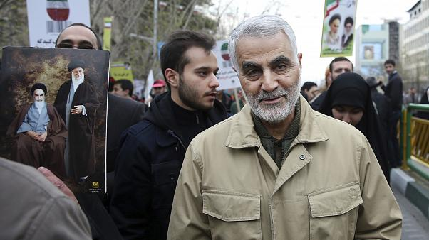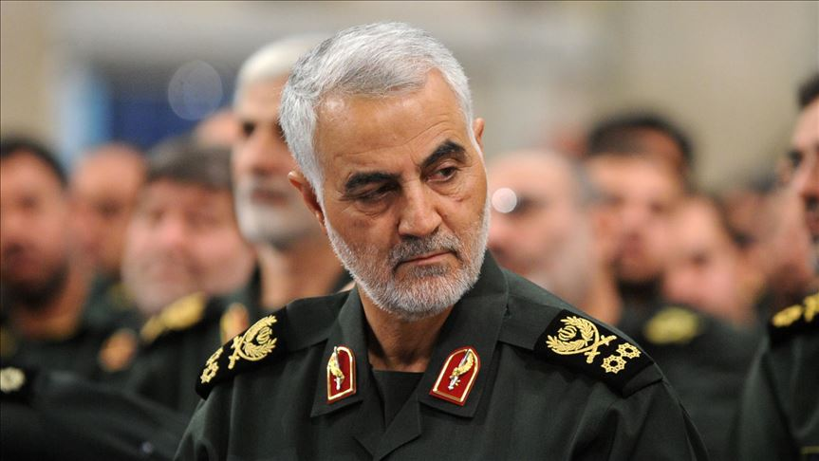

“In July 2018, after President Donald Trump warned Iran’s president not to threaten the United States, a rejoinder came not from the Iranian leader but from a military figure perhaps even more powerful. “It is beneath the dignity of our president to respond to you,” Maj. Gen. Qassem Soleimani declared in a speech in western Iran. “I, as a soldier, respond to you.”
On Friday, Soleimani was reported killed in an airstrike in Baghdad. The general, a once-shadowy figure who enjoyed celebrity-like status among the hard-line conservatives in Iran, was a figure of intense interest to people inside and outside the country.
It is not just that he was in charge of Iranian intelligence gathering and covert military operations, and regarded as one of its most cunning and autonomous military figures. He was also believed to be very close to the country’s supreme leader, Ayatollah Ali Khamenei — and seen as a potential future leader of Iran.
That Soleimani was in Iraq when he was killed at age 62, at Baghdad International Airport, was not surprising.
He was in charge of the Quds Force of Iran’s Revolutionary Guard, a special forces unit that undertakes Iranian missions in other countries. He had been named to lead it in the late 1990s.
In that role, Soleimani was believed to be the chief strategist behind Iran’s military ventures and influence in Syria, Iraq and elsewhere in the region and beyond. He was considered the most effective military intelligence official in the region.
At the height of the Iraq War, as the Quds Force under Soleimani armed and trained Shiite militias in Iraq, the general was stoking violence and then mediating the conflict so he could make himself indispensable and keep the Iraqis off balance, former U.S. officials have said…”
Another top General was also killed as the two of them were ready to enter the airport and fly back to Iran. The U.S. drone attack took place early in the morning of January 3rd. Civilians were also killed in the drone attack. This has gone global.
All News Pipeline ran this article yesterday:
“President Trump May Be Walking Into A Globalist Trap: With Iranian Sleeper Cells Across America, War Against Iran May Be A Globalist Ploy To Unleash Death And Destruction Here - Iran Running War Games With Russia And China Hints Of Trouble Ahead January 2, 2020 ANP Stefan Sanford

“Ali Kourani previously tasked with conducting surveillance of JFK & Pearson airports” - by Paul Joseph Watson | INFOWARS.COM Friday, January 03, 2020
The threat posed by Iran-backed Hezbollah sleeper cells embedded in major American cities has once again come to the fore following the killing of Iran’s Quds Force General Qasem Soleimani.
Following last night’s assassination of the Iranian military leader, authorities in both New York and Los Angeles announced that they were ramping up security in readiness for possible revenge attacks on U.S. soil.
This is because Iran is known to have placed Hezbollah terrorist sleeper cells throughout not just Europe but the United States too.
…Following the arrest of Kourani and another Hezbollah operative named Samer el-Debek, the U.S. intelligence community reversed its belief that Hezbollah was unlikely to attempt attacks within the U.S. `It’s our assessment that Hezbollah is determined to give itself a potential homeland option as a critical component of its terrorism playbook,’ said National Counterterrorism Center Director Nicholas Rasmussen.
Mayors in major U.S. cities are monitoring developments and ramping up security in preparation for any potential Iranian-backed terror attacks following the killing of Iran’s Quds Force General Qasem Soleimani.
…With the world now waiting for Iran’s response to Soleimani’s killing, we can only hope that it doesn’t come in the form of a massive Hezbollah-backed terror attack targeting a major American city.”

Steve Quayle Alert:
“…CHINA IS RAMPING UP OVER THE IRAN ISSUE AS WELL. THIS TELLS US THAT THIS `REGIONAL WAR’ COULD EASILY BECOME A GLOBAL WAR.
CHINA AND RUSSIA HAVE NAVAL ASSETS IN THE AREA ALREADY AND SUDDENLY MORE CHINESE SHIPS ARE HEADING TO IRAN AREA.
THE NEW NORMAL IS PLANET-WIDE NOT JUST IN ONE AREA.
https://www.stevequayle.com/index.php?s=33&d=2385 - Jan 2, 2020
The world’s people are reacting. Jeremiah 50-51: The attack on America comes from nations to our north, i.e. Russia, China, and North Korea. But because Germany and France have made a pact with Russia, they are also hostile to the U.S. A long time ago, Steve Quayle was saying that Germany and France would join in the attack on the U.S. Iranian sleeper cells are on alert in the U.S.
There are ISIS camps in every U.S. state. There are gangs waiting, and other terrorist groups waiting inside the U.S. Then top that with around one million U.N. troops inside the U.S. right now, many of them are Russia and Chinese. Russian and Chinese troops have been inside the U.S. for a long time by invitation of the U.S. government. The truth is, the Secret Destiny of America is about to be fulfilled, or has been, and we’re now expendable. Refer to: “The Secret Destiny of America”/Mikvah of Preparation.
Since at least 1896, the American people have been used as experimental lab-rats, and now the laboratory is about to close and the rats are expendable. The U.N. calls us “cattle.” At least that’s better than “rat.” But, scientists refer to us as “insects.” Yahuwah calls us “My children.”
I’ve been warning and writing about this since 1992. Abba has confirmed everything! Revelation 18 (Isaiah 47) is New York Harbor. Jeremiah 50-51 a about a post-1948 nation that is the super power of the world, the final end of what Nimrod started with Babel/Babylon. “Refer to: “30 Clues and More…”/Mikvah of Present Reality.

“'Depart Iraq Immediately.' U.S. Embassy Advises Americans to Leave After Qasem Soleimani Assassination” – January 3, 2020 Yahoo News
“The Pentagon said Thursday that the U.S. military has killed Gen. Qasem Soleimani, the head of Iran’s elite Quds Force, at the direction of President Donald Trump.
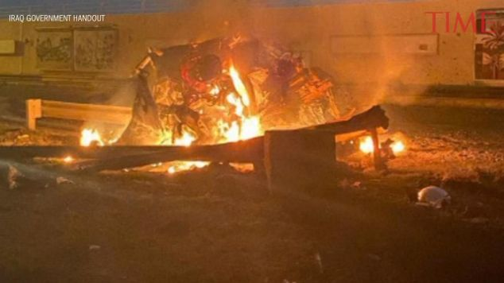
The State Department is urging American citizens to leave Iraq immediately, citing danger in the aftermath of a U.S. airstrike which killed Qasem Soleimani, one of Iran’s most senior military commanders.
President Donald Trump authorized the strike that killed Soleimani, who led the Quds Force of Iran’s Islamic Revolutionary Guards Corps, at Baghdad’s international airport early Friday morning.
American citizens were specifically warned to avoid the U.S. embassy in Baghdad, which had been besieged by Iranian-backed militias Thursday.
“Due to heightened tensions in Iraq and the region, the U.S. Embassy urges American citizens to heed the January 2020 Travel Advisory and depart Iraq immediately,” the State Department said in a statement released Friday.
Soleimani had approved the attacks on the U.S.’s Baghdad embassy in the days before his death, the U.S. Department of Defense said in a statement confirming U.S. responsibility for the general’s death. The Pentagon said Soleimani was also `actively developing plans to attack American diplomats and service members in Iraq and throughout the region.’
`General Soleimani and his Quds Force were responsible for the deaths of hundreds of American and coalition service members and the wounding of thousands more,’ the statement added.
The State Department advised U.S. citizens in Iraq to leave the country preferably by air travel, or failing that, across land borders. Across the Middle East, security has been ramped up at U.S. military bases in the expectation of retaliatory attacks.”
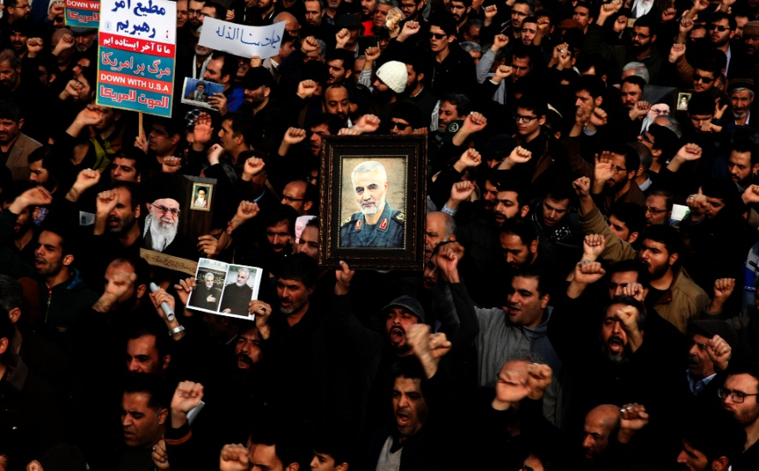

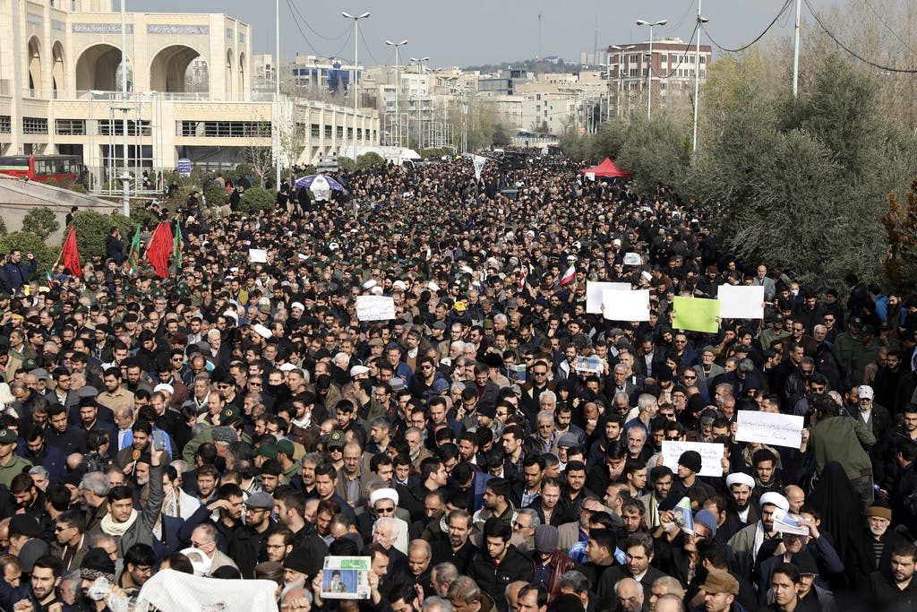
Iran demands retaliation for the killing of two top Generals
However, protests are now global. War is more realistic now than ever before. But, the great threat is within the U.S. just waiting to be unleashed. Do your own research, but to keep up easily, refer to the list of current event articles each day on stevequayle.com.
What is Abba saying to you? What has He instructed you to do?
Shabbat Shalom! Yedidah
January 3, 2020

