THE MYSTERIOUS “CITY OF LONDON,”
GOG and MAGOG, the VATICAN, and the
HUMAN and NON-HUMAN WORLD CONTROLLERS

Gog and Magog and the City of London

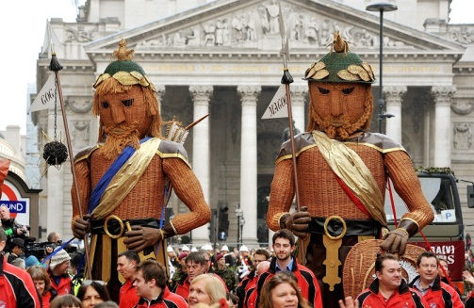
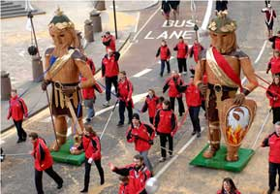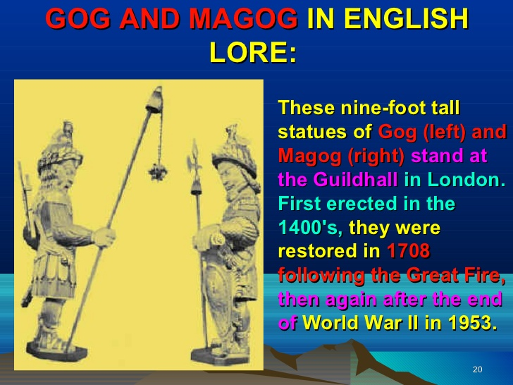
“And the word of Yahuwah came unto me saying, “Son of man, set thy face against Gog, the land of Magog, the chief prince of Meshech and Tubal, and prophesy against him, And say, Thus says Yahuwah Elohim; Behold, I am against thee, O Gog, the chief prince of Meshech and Tubal: And I will turn thee back, and put hooks into thy jaws, and I will bring thee forth, and all thine army, horses and horsemen, all of them clothed with all sorts of armor, even a great company with bucklers and shields, all of them handling swords. (Ezekiel 38: 1-4 KJV). Also refer to: Revelation 20: 7-10 – Gog and Magog at the end of the 1000-year reign of Yahushua Messiah

Gog and Magog symbolize a worldwide Satanic confederacy
From the article: “Gog and Magog are the "protectors" of the City of London!!
by His angel armies…
“Two giants named Gog and Magog are the `patron saints’ or `protectors’ of the City of London....Every year, on the second Saturday in November, they are paraded through the streets of the City. The City of London is about a square mile area of central London where the Bank of England and the financial district are located....It is very similar to Vatican City, which is a separate jurisdiction within the city of Rome...
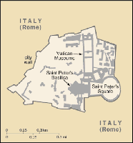  Vatican City map. |  | 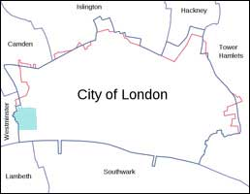  City of London map.

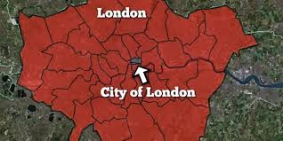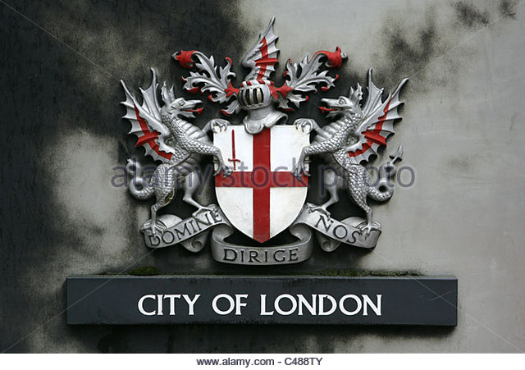

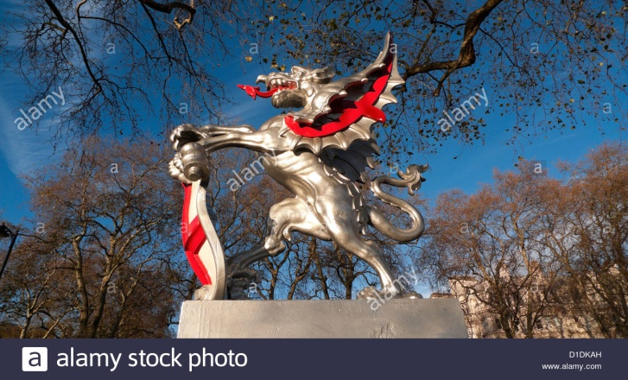
Corporation of London Griffin statue at the boundary of the City of London Square Mile Embankment England UK

“Daniel the Prophet foresaw all of this 500 years before the Messiah was born:
Thus he said, `The fourth beast shall be the fourth kingdom upon earth, which shall be different from all kingdoms, and shall devour the whole earth, and shall tread it down, and break it in pieces.’ (Daniel 7:23).
The 4th empire of Daniel's vision was the pagan Roman Empire, which did devour the whole earth, and was divided into 2 halves at the time of Emperor Constantine. The myth of the decline and fall of the Roman Empire was started by British author Edward Gibbon. “
Yedidah’s input: Historians say that the Roman Empire never fell—its power transferred to the papacy after the establishment of the Roman Catholic Church. Constantine was the 1st pope. He organized it and paganized everything. It was the true followers of the Way, the followers of the Nazarene, who were killed in the Coliseum, who were burned at the stake, who were used as living torches for the parties of the rich and powerful, who were hunted like dogs and slaughtered. Constantine continued what Hadrian began with the slaughter of true believers, while giving asylum to pagan Christianity to unify his empire and to appease the worship of his military. Constantine himself was a worshipper of Sol Invictus Mithra of Persia to his death. After his supposed conversion to Christianity he had his wife and son killed. It was all about promoting, and, at the same time hiding, the sun god worship of the nations from the time of Nimrod under a cloak of a new religion.

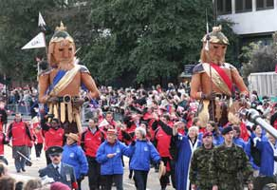
This parade through the City of London is one of the oldest in the world, going back to the 13th century, but the giants Gog and Magog were not introduced until the reign of King Henry V.
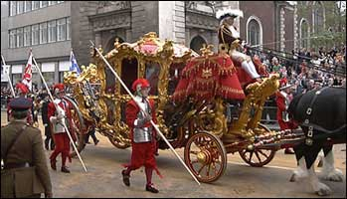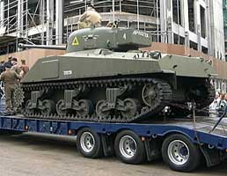
The Lord Mayor’s coach British tank in the parade also

“When the Romans invaded Britannia in 43 AD, they found that the Druids were their most implacable enemy. Druid and Roman hated each other with a passion; but like King Herod and Pontius Pilate, they became fast friends in order to destroy Christianity. Constantius was a Roman tribune and Constantine was his son by Druidess Princess Helena
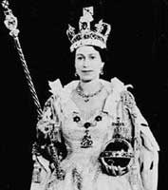 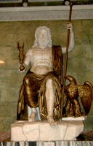
Coronation of Queen Elizabeth II Statue of Zeus with orb, Nike, and scepter

“At her coronation in 1953, Queen Elizabeth II had a scepter in one hand and a cross crowned orb in the other. The symbols are borrowed directly from pagan Greece and Rome. The orb and scepter were the symbols of Zeus and Jupiter as the supreme false gods of the Greek and Roman pantheons. The orb represents universal dominion.
The goddess Nike was called Victoria at Rome. The cross, representing the Papal Roman Empire, was substituted for Victoria or Victory by Emperor Constantine.
The visual symbolism of holding the world in one's hand was a clear message used since antiquity. Citizens of Rome were familiar with the plain round globe as a representation of the world or universe, ruled by Jupiter, and thus the Emperor's dominion and absolute dictatorial rule over the pagan Roman Empire....Obviously, the Roman eagle has been replaced by the British lion
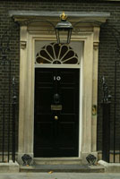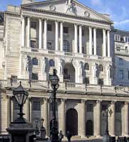
10 Downing Street Bank of England
Home of the British Prime Minister

The Tower of London is located very close to 10 Downing Street. The City of London was once a Roman city called Londinium.
The Bank of England is the heart of The City of London
The Druid/Jesuits founded Bank of England is the heart of the City of London. Since it was given a royal charter in 1694, it has totally dominated the British government, because the golden rule says that `whoever has the gold; makes the rules.’
The Bank of England was granted a royal charter by King William III in 1694. This bank took financial control of the nation out of the hands of the sovereign and parliament . . . and placed it in the hands of Jesuit bankers. Its founder was a Scotsman named William Paterson. Paterson was involved in various financial scams before he founded the Bank of England. The Bank of England is a USURY bank and issues `paper money.’ Prior to 1694, usury was considered a crime punishable with a jail sentence.
The U.S. `Federal’ Reserve is almost an exact copy of this usury paper money scam.
This bank is called a central bank and has a complete monopoly on the printing of paper money....It also sets interest (usury) rates for the nation. Many central banks around the world are modeled on this bank, especially the `Federal’ Reserve Bank in the United States. [There is nothing `Federal’ about the Feds – they are a private corporation]
The Bank of England was responsible for financing all the wars that Great Britain fought after 1694....Many of these wars were fought against the Dutch and French for the benefit of the Spanish Inquisition.
Gog and Magog on her majesty's secret service!!
Prior to 1900, spying was considered a despicable profession, but spying came out of the closet in 1908 with the founding of MI5 and MI6. When one nation spies on another, the other nation takes countermeasures, leading to an endless circle of espionage and counter-espionage. Originally, MI5 and MI6 were housed in the same building, but they eventually became separate spying bureaus.
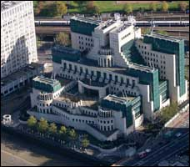 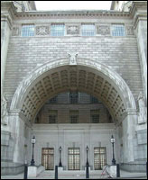
Nothing covert about M16 spy M15 headquarters at Thames Housed
headquarters in London Westminster, London

Domestic and international spying has separate headquarters in London, but they are all financed by the Bank of England, and answer to the queen!!
The CIA and FBI are their CLONES in the United States. People would be astonished and shocked if they knew that many of their great heroes in the political, financial, military, `scientific,’ and musical worlds were nothing more than British secret service agents!!
Emperor Constantine
Emperor Constantine was a British giant who conquered the entire Roman Empire, beginning from his native land.
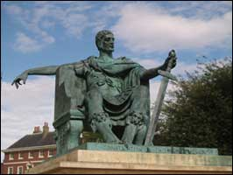 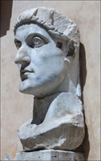
Statue of Constantine in York, England Colossus Head of Constantine in Rome

Constantine was a British GIANT or COLOSSUS who conquered the entire Roman Empire with the help of his Romano-British soldiers. He was the founder of the Roman Catholic Church, and the city of Constantinople (now Istanbul)
Constantine’s father, Constantius, was the husband of Helena, only daughter of King Coel. When King Coel died, Constantinus became the lawful king of Britannia as well as Caesar. Constantine inherited the title of king from his father, and thus he was Roman Emperor . . . and king of Britannia.

King Henry V had Sir John Oldcastle burned alive for treason!!
Gog and Magog were first introduced into England during the reign of King Henry V. King Henry was completely under the control of the Latin Druid hierarchy, and often tried to get Christians to recant and return to Rome in order to save themselves from a fiery death.
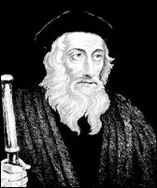 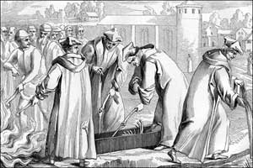
John Wycliffe Fanatical Papal clergy burning the bones
(1328-1384) of John Wycliffe 44 years after his death

In 1401, Thomas Arundel, Archbishop of Canterbury—a bitter foe of the Bible in English–had an infamous statute passed entitled De Haeretico Comburendo (Concerning the Burning of Heretics).
In 1428, John Wycliffe’s bones were dug up and burned. His "crime" was translating the Scriptures from the Latin Vulgate into English. His ashes were thrown into the nearby river Swift, which flows into the Avon.

Wahhabi Islam was established by the Bank of England!
Islam and Druidism are remarkably similar false religions. One of the revered symbols of the Druids is the crescent moon. The big difference is that Muslims do not follow the pagan Druid practice of cremation. An entire chapter in the Holy Bible is devoted to the burial of Sarah—beloved wife of Abraham (Genesis 23).
The British government and Bank of England were present at every stage in the creation of modern day Wahhabi Islam.
The original founder of the Saudi dynasty was a Bedouin Emir named Muhammad ibn Saud (circa 1748–1765). In 1744, Muhammad ibn Saud's son, Abdul Aziz, married the daughter of Imam Muhammad ibn Abdul Wahhab (1703–1792): Here in Dariya, Al-Wahhab won the support of the local chief, Muhammad ibn Saud, leader of a sub-branch of the powerful Aneiza tribe and already admired for his abilities as a warrior.
Muhammad ibn Saud became not only a convert to Wahhabism but, by marrying his eldest son Abd Al-Aziz ibn Saud to Al-Wahhab's daughter, became the founding father of the Saudi-Wahhabi dynasty–the future rulers of Saudi Arabia. (Allen, God's Terrorists, The Wahhabi Cult and the Hidden Roots of Modern Jihad, p. 52).
This marriage alliance of Emir Abdul Aziz ibn Saud with Imam Abdul Wahhab created an alliance between political and religious Wahhabi Islam . . . and remains the basis of the Saudi dynasty to this very day. “
Yedidah’s input: I know that the Roman Catholic Church created Islam as their sword to gain Jerusalem for a future the pope to rule the world from. Islam and Catholicism work together. Today the Vatican works closely with Muslim leaders. The Jesuits were founded with the goal of setting one of their own popes enthroned on the Temple Mount, in their own words “for the glory of the god that sits in St. Peter’s Chair.” Now they have one of their own with rising power over the world.
Slowly through infiltration the Jesuits have taken over the world in every aspect of control, thus they are also controlling the economy of the world, the banking system, the U.N, chief nations, especially America, international “intelligence” agencies, spy agencies, and now assimilating all religions under the Vatican. They have their own military in many countries, and are responsible for more deaths of true Bible believers than those who died in both world wars. I have studied on the underground workings and goals of the Vatican for many years.
I recommend Edmond Paris’ book Jesuits, and Malachi Martin’s book The Jesuits, and Jon Eric Phelps book Vatican Assassins.

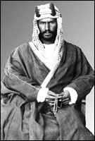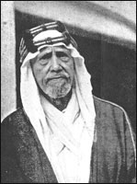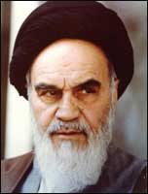
Abdul Abiz ibn Saud Haji Williamson Ayatollah Khomeini
Ayatollah Khomeini was a Rasputin-like figure with strange mesmerizing power.
His real father was a British MI6 spy named Haji Williamson. The British Druid sponsored Islamic Revolution began in that country in 1979, which was the year 1400 in the Islamic calendar.

The British invasion of the U.S. in 1812
The war of 1812 between Great Britain and the United States was financed by the Bank of England and the Jesuits. The Jesuits were determined to enforce the Bull of Pope Alexander VI and stop the new nation from expanding westward. The invasion of the eastern seaboard of the U.S. was a feint to hide their real destination: New Orleans and the Louisiana Territory
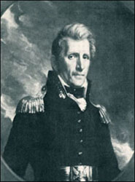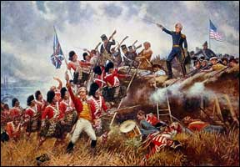
General Andrew Jackson Battle of New Orleans January 8, 1815

By December 12, 1814, a huge British armada, under the command of Sir Alexander Cochrane, with more than 15,000 soldiers and sailors aboard had anchored in the Gulf of Mexico east of Lake Pontchartrain and Lake Borgne. General Jackson sent the British lion back to Druidland with his tail between his legs. The Bank of England had to wait until the Civil War for another opportunity to break up the Union. President Jackson closed the corrupt Bank of the United States and gave all its money to the states....The closure of the bank and the redistribution of its money allowed the United States to expand to the Pacific Ocean. The U.S. was central bank free until the British `Federal’ Reserve Bank was chartered in 1913.”

The U.S. Civil War was Bank of England instigated!”
Yedidah’s Input: “More than interesting: It was the pope who backed Jefferson Davis and who funded the Civil War using the Bank of England. I really recommend Charles Chinquis’ fascinating autobiography Fifty Years in the Church of Rome to understand the incredible involvement of the Jesuit s in controlling America, even to the killing of President Abraham Lincoln. Amazon carries the full text and abridged version.
Hitler’s war efforts and the Holocaust against the Jews was set up and funded by three Elite hierarch: The Vatican/Rome, American government and leading American Corporations, and the Queen of England through the Bank of England. Israel knows this. It is now well-known history of the involvement of these three groups with Hitler.
Osama ben Lauden was a businessman in the Carlyle Group of leading American and British business people--like the Bush family, and the Queen of England. Osama was a personal friend of George W. Bush. Their families were even vacation buddies. The ben Lauden family built most of Americans military bases in the Middle East. When 9/11 happened, Osama was in Dubai dying of a kidney disease. He died shortly after 9/11. He had nothing to do with it. He was just used to cover up what the American government did to their own people, and to insure that American and British troops would protected America’s poppy crop in Afghanistan.
A personal friend of George Bush Sr. was Saddam Hussein. This inner connection of America, the Pope, and the Queen of England keeps cropping up all through the last 400 or so years – and all interlocked with the Jesuit Order. Hitler said he pattered his SS – with his inner circle of monsters – after the Jesuit Order.
Falsified American history says that America broke free of its “mother” in the Revolutionary War. NO! America still pays taxes to the Queen of England. She’s still our mother.
It all goes back to the prophecy of Ya’cob over his grandchildren Ephraim and Manasseh in Genesis 49. That prophecy was fulfilled as the two sons of Joseph mainly ended up in the area of England (Ephraim) and Manasseh in America. The Pilgrims said they were of the tribe of Manasseh. The other 8 tribes of the northern 10 migrated into different parts of Europe, and also on to the UK and Ireland and into America. So basically America is the melting pot of the ten northern tribes of Israel/Ephraim/Joseph.
I recommend Ya’ir Davidy’s classic work, The Tribes, available on his website Britam, and/or Steven Collins’ classic The Lost Tribes Found. “Brit” in Hebrew means “Covenant, “am” is people. Great Britain means “the great covenant people.”
The “god of this world” has used the pagan sun-god culture of Greece and Rome to enslave the minds of His people, to use His people for experimentation, and to control the world using His people under the guise of religion and/or fleshly lusts. America has been ruled by the Illuminati-Jesuits for its goal of reincarnating Nimrod to rule the world, and to restore the hierarchy of the pre-flood Nephilim. [Refer to the article: “America’s Secret Destiny”/January 25, 2009 and Chris Pintos’ three DVDs: “The New Atlantis,” “Riddles in Stone,” and “The Eye of the Phoenix” – all available on Amazon]

Back to the article:
“The MI6 British invasion of 1964
The most recent British invasion of the U.S. took place in February 1964....Instead of swords and muskets they carried . . . GUITARS!!
Of course, we are referring to the rock music invasion....Rock music was popularized in the U.S. by Elvis Presley, but Presley was not instrumental in the far reaching social and moral revolution that followed the British rock music invasion of 1964. The Druids were noted as bards or "musicians" and their hypnotizing drumbeats accompanied their diabolical human sacrifices.
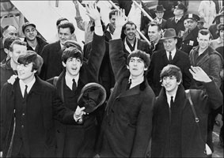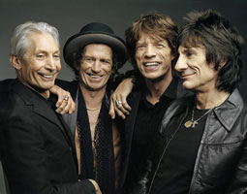
Arrival of the Beatles in NYC Feb. 7, 1964 M16’s Rolling Stones
The vast majority of rock stars died by suicide or drug overdoses.... “
-----------
From another article: The City of London
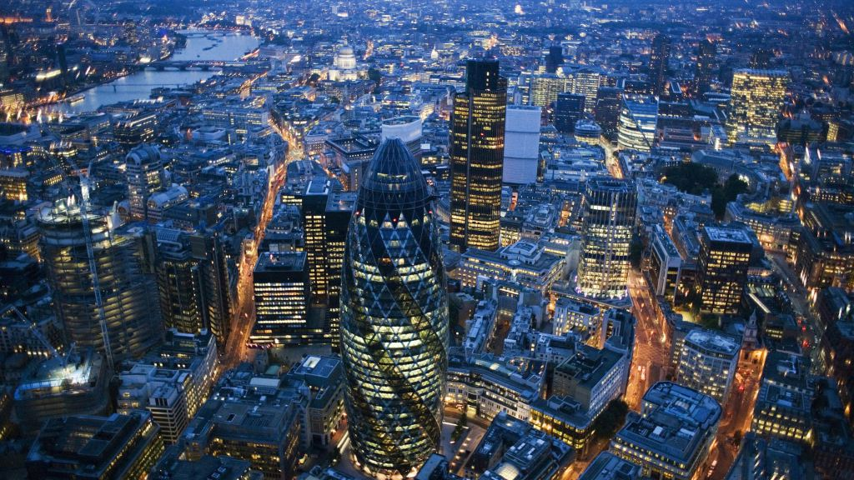
Wikipedia: The City of London is a city and county within London. It constituted most of London from its settlement by the Romans in the 1st century AD to the Middle Ages, but the agglomeration has since grown far beyond the City's borders.
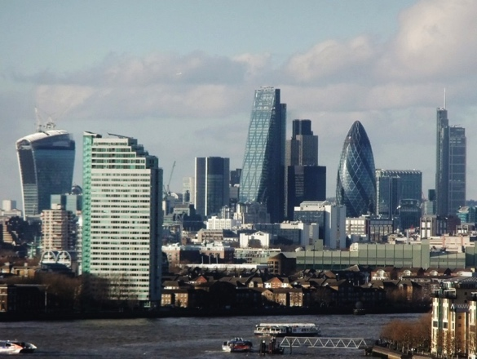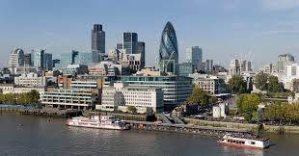
The British Crown Empire and the City of London Corporation

“World politics today is governed by the Vatican, but also by the Crown Empire. The modern world of so-called Western Civilization began at the end of the 17th century with the blossoming of the British Empire.
That empire actually began several hundred years earlier with the establishment of the City of London, which is now an 800-year corporation that controls finance from an entity called `The Crown.’
This entity is the creator and controller of the Bank of England, the US Federal Reserve, the World Bank (IMF – International Monetary Fund), The European Union, and various cartels and corporations across the earth.
The Crown Identity is kept most secret, and The Crown Bank of England took and assumed control of the United States during the Roosevelt Administration (1901-1909) when its agents, who were really Crown agents (J. P. Morgan), took over 25% of American business.
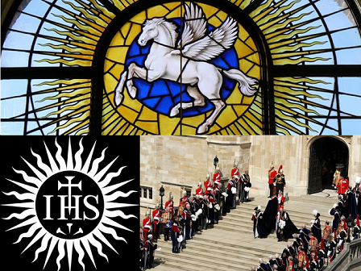
`The Crown’ has never been the King or Queen of England since the establishment of the corporate body, but the British Monarchy is a figurehead for The Crown, rules parliament in Great Britain and has authority over the Prime Ministers through a Vatican knighthood called the Order of the Garter. The Crown, however, is not the King or Queen of England – they are an established monarchy of the corporate body.
The Crown is the directorate of the corporation, and Great Britain is ruled by The Crown, the City of London which controls the Bank of England – a private corporation The City of London is a private state existing in Britain within the centre of London.
This City, located in the heart of Greater London, became a sovereign-state in 1694 when King William III of Orange privatized the Bank of England, and turned it over to the Vatican banksters who today rule the financial world.
The City/The Crown Corporation is not subject to British Law; it has its own courts, its own laws, its own flag, its own police force – exactly like the Vatican city state and Washington DC Columbia.
The Crown Corporation is also separate from the Metropolitan city; its police drive red police cars and their uniforms are different from the Metropolitan Police.
Also, The Crown in London houses the privatized Bank of England [owned by the Rothschilds] and Lloyd’s of London, the London Stock Exchange, and all British Banks. It also houses the branch offices of 385 foreign banks, 70 US banks, as well as Fleet Street newspapers and publishing monopolies. It controls the world media and world intelligence.
It is out of The Crown City of London, the headquarters of British Freemasonry overseen by the British Monarchy and the Duke of Kent, that World Freemasonry is governed. This includes the Grand Orient Masonic Order and the Washington DC Scottish Rite.
In 1945 the Bank of England was nationalized by the Labor Government, and is allegedly no longer a private bank, although it governs the US Federal Reserve. It is ruled over by the Rothschild family, who are bankers for the Pope – guardians of the Vatican Treasury.” [So the Rothschild family is subservient to the Jesuit-Vatican]
“The City of London also has its own Lord Mayor, different from the current Mayor, who has the power in The Crown Corporation.
When the Queen wishes to conduct business in the City, she is met by the Lord Mayor at Temple Bar. Temple Bar and their associate franchises come from what is called the Four Inns of the Temples of Court – the Inner Temple and the Middle Temple.
The logo of the Inner Temple is a white horse on the sunburst seal of the Jesuit Order. The white horse is a symbol of the British Empire / Order of the Garter / Crown Corporation, and is the same white horse which is the symbol of the CFR (Council on Foreign Relations).
The white horse is a Jesuit symbol – Pegasus. It is the Jesuit Order that governs the Honorable Society of the Inner Temple. The Inner Temple is the core group that governs the City of London Corporation.
The whole Earth is governed by The Crown, through Crown Colonies which belong to The City – The Crown Empire. It governs Africa and still governs China and India. The colonies of the Earth are really just Crown Colonies – The United States of America are states of The Crown. [My note: Thus, the US is subject to the Crown who is subject to the Vatican]
This being said, however, it is vitally important to remember the following. The Crown Empire uses commercial law (a.k.a. international maritime law, or law of contracts) as its means of control.
Your name, when spelled out in all capital letters – as in JULIAN WEBSDALE – is a corporation, a trust set up by the government through the treasury department at your birth. Every time a child is born, a corporation/trust is created using his or her name in all capital letters.
They do this because governments are corporations and they operate under commercial law, the law of contracts. The laws passed by governments only apply to corporations and not to living, breathing, flesh and blood sovereign-free men and women spelled in upper-lower or lower case. The living, breathing sovereign man and woman is subject to common law, not the commercial law introduced by governments through legislation.
(By Julian Websdale, HumansAreFree.com | Reference: YouTube )
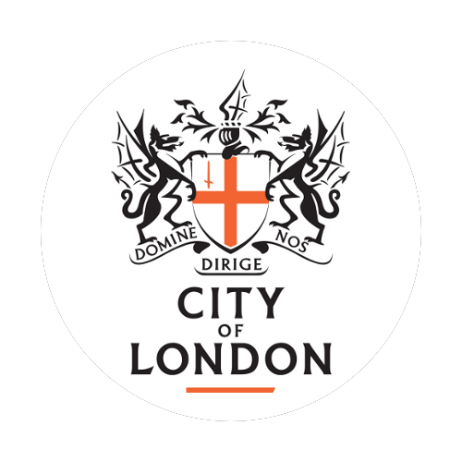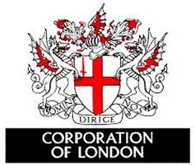

The Crown” is a committee of twelve to fourteen men who rule the independent sovereign state known as London or ‘The City.’
The City’ is not part of England. It is not subject to the Sovereign. It is not under the rule of the British parliament. Like the Vatican in Rome, it is a separate, independent state.
“The City”, which is often called “the wealthiest square mile on earth,” is ruled over by a Lord Mayor.
Here are grouped together Britain’s great financial and commercial institutions: Wealthy banks, dominated by the privately-owned (Rothschild controlled) Bank of England, Lloyd’s of London, the London Stock Exchange, and the offices of most of the leading international trading concerns. Here, also, is located Fleet Street, the heart and core of the newspaper and publishing worlds.
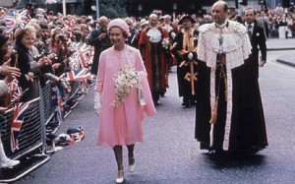“
The relation of this monarch of the City to the monarch of the realm [Queen] is curious and tells much.” When the Queen of England goes to visit the City she is met by the Lord Mayor at Temple Bar, the symbolic gate of the City. She bows and asks for permission to enter his private, sovereign State. During such State visits “the Lord Mayor in his robes and chain, and his entourage in medieval costume, outshines the royal party, which can dress up no further than service uniforms.”
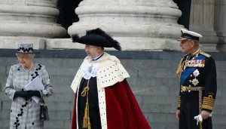
The Lord Mayor leads the queen into his city. The symbolism is clear. The Lord Mayor is the monarch. The Queen is his subject.
The small clique who rule the City dictate to the British Parliament. It tells them what to do, and when. In theory Britain is ruled by a Prime Minister and a Cabinet of close advisers. These ‘fronts’ go to great lengths to create the impression that they are running the show but, in reality, they are mere puppets whose strings are pulled by the shadowy characters who dominate behind the scenes. As the former British Prime Minister of England during the late 1800s Benjamin D’Israeli wrote:
“So you see… the world is governed by very different personages from what is imagined by those who are not behind the scenes”
(Coningsby, The Century Co., N.Y., 1907, p. 233).
This fact is further demonstrated by another passage from Menen’s book:
“The Prime Minister, a busy politician, is not expected to understand the mysteries of high finance, while the Chancellor of the Exchequer is only expected to understand them when he introduces the budget. Both are advised by the permanent officials of the Treasury, and these listen to the City. If they suspect that some policy of the government will back-fire it is of no use their calling up British ambassadors to ask if it is so; they can find out more quickly from the City. As one ambassador said, “Diplomats are nowadays no more than office boys, and slow ones at that. The City will know. They will tell the Treasury and the Treasury will tell the Prime Minister and `Woe betide him if he does not listen.’
It is important to recognize the fact that two separate empires were operating under the guise of the British Empire. One was the Crown Empire and the other the British Empire.
The colonial possessions that were white were under the sovereign – i.e. under the authority of the British government. Such nations as the Union of South Africa, Australia, New Zealand and Canada were governed under British law. These only represented thirteen percent of the people who made up the inhabitants of the British Empire.
All the other parts of the British Empire – nations like India, Egypt, Bermuda, Malta, Cyprus and colonies in Central Africa, Singapore, Hong Kong and Gibraltar were all Crown Colonies. These were not under British rule. The British parliament had no authority over them.
As the Crown owned the committee known as the British government there was no problem getting the British taxpayer to pay for naval and military forces to maintain the Crown’s supremacy in these areas.
At present names have been replaced by groups, capitalists, republicans, democrats, terrorists, corporations, NATO, UNO, NAFTA, EMI, ECB, ASEAN--names that are spewed out like confetti in an endless list of anonymity.”
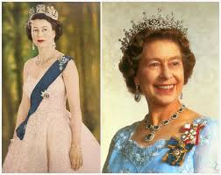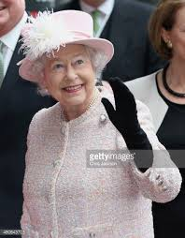

Yedidah’s Closing Input: The Queen of England, pictured here from her Coronation to her old age, is from the Tudor –Windsor family that goes back through Constantine to Nimrod …
The American Presidents, from George Washington through Barack Obama, were all related to this family, and to each other. All American Presidents are related to each other through the Tudor /Winsor line, with the exception perhaps of Martin Van Burien. All these years since the Revolutionary War, America has been under the authority of “mother” England. America still pays taxes to the Queen.
You can get one of the 30 clues from Jeremiah 50:11 as to who end-time Babylon is. It is America, described in several places in the Word. When America is destroyed, her mother is ashamed of her. (Jeremiah 50-51; Isaiah 10, 13, 18, 47; Revelation 18 for examples)
[Refer to: “Reality America…”/June 23, 2015 for the 30 clues as to who this end-time nation is that is the world’s super power during a pre-messianic era] You can read of the root lineage of the Queen and the America Presidents in: “Why the Obvious Election Manipulation”/October 25, 2016] Also refer to John Price’s book The End of America – The Role of Islam in the End Times and Biblical Warnings to Flee America, in which he gives the 30 “clues.” His three novels on the subject are also excellent.
At the top – the Illuminati Jesuits work to control the world through the City of London and world corporations. The world has been gathered together since the return of the Nephilim in 1896 for their final 120 years, and today the world is governed by the original pre-Flood hierarchy of the Nephilim once again – a reptilian race that has modified itself so that it can inhabit human bodies and not be detected.
The original Nephilim that Yahuwah had been bound in Tartaros after the Flood (II Peter 2), having returned, now rule in secrecy and stay hidden., at least for the time being. They have not taken humanoid bodies. They hide in underground places like tunnels, military facilities, and under the ice of Antarctica. They are now summoning the world’s political and religious leaders there for their final instructions, or their cloning and replacement. Nimrod has been cloned. I won’t go into detail about how I know that, but I know that and so do men like Steve Quayle and Tom Horn in personal ways. His reincarnation was the reason why America was founded – to resurrect and embody him to return to rule the world.
Perhaps I have bombarded you too much shocking information, but it is all scattered in many articles through the years. It’s all documented. I am not speculating. The returned original Nephilim, according to Enoch’s 70-year prophecy, began in 1896. The evidence is very clear. [I wrote some on this in “The Amazing Message Behind the Numbers 3, 7, 50, 70, and 120”/January 25, 2016, “Olympics 2016…”/April 5, 2016, and “Noah Days are Nowadays/November 14, 2015]
You can also listen to my audio messages on the days of Noah, from November 2015 in Canada, by clicking on “Audio Messages” on the main page of my website.
We don’t have to gain a lot of head-knowledge about what Satan is doing, but we must have knowledge of what Abba Yahuwah is doing to prepare for the return of His Son! We must prepare to face Yahushua!
I have shared this information with you in order to reemphasize that our only hope is in shed blood of Messiah Yahushua and in His resurrection, for the forgiveness of our sins, so that once out of our human physical body our spirit body will rise to heaven, and when Messiah comes, it will be rejoined to an immortal body so that we can live with Him on earth, forever and ever. This powerful salvation cannot be kept inside of us, for It is by His blood, and the word of our testimony, and that we love not our lives unto death that we overcome the Dragon/Satan (Revelation 12:11)
Our future is more than wonderful! But, we must know enough of what we’re up against now so that we are not deceived. I know it doesn’t make you feel good to know you’re a corporation name, and that all you have belongs to the corporation because you have a birth certificate. There’s also an Executive Order that Obama wrote emphasizing our lack of rights and the government’s powerful rights over us. [Refer to: “The New Executive Order”/ March 21, 2012]
Remember Philippians 3:20-21--“our citizenship is in heaven.” We belong to an eternal Kingdom. Let us walk as children of that Kingdom of Light, and be set-apart more than ever before unto Yahuwah and unto Yahushua. Let us love Them with all our heart and help others find Them without religion. They are Persons, not a religion…
Shabbat Shalom, blessing, in the love of Elohim,
Yedidah
February 17, 2017

