The Pergamum Altar
and the Throne of Satan

Excerpt from Revelation 2:12-17:”And to the messenger of the assembly of Pergamum write: `He who has the sharp two-edged sword says this, “I know your works and where you dwell—where the throne of Satan is. And you hold fast to My Name and do not deny your faith in me, even in the days when Antipas was my faithful witness, who was killed near you—where Satan dwells…” ’ ”

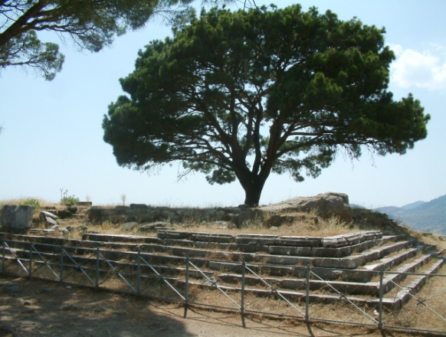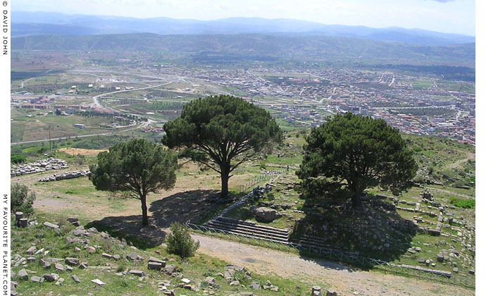
Where the altar of Zeus once stood in Pergamum, as it looks today

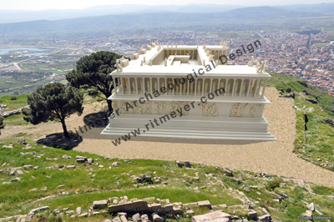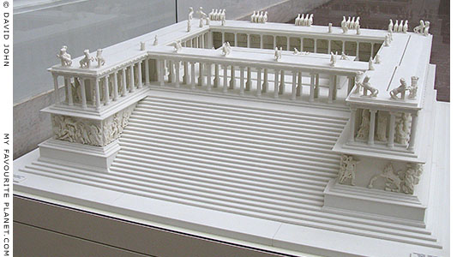
Models of the way the altar would have looked, side and front – photo on the right is a model in the Pergamum Museum, Berlin

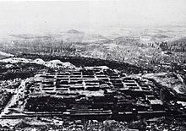
Foundation of the Pergamum Altar after excavation, c. 1880
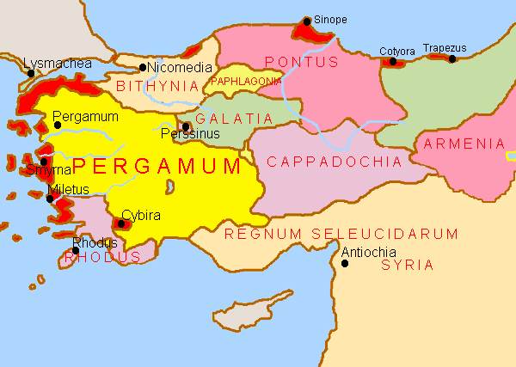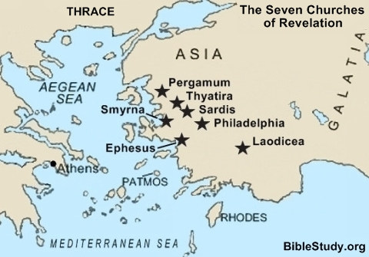
Map of the ancient kingdom of Pergamum Map of showing the 7 assemblies in
Revelation 2 and 3

Refer to: Closing the “Church Age” in Laodicea – Transition from the “Age of Grace” to the time of wrath/July 7, 2014 for amazing revelation!

Pergamum was an ancient Greek city located in the western part of what is now modern Turkey; the technique of preparing sheepskins as parchment was developed here.
The meaning of the word Pergamum is: “to be thoroughly married,” – as in thoroughly married to the world!
The text of Revelation reads: “where Satan’s throne is.” It was no mere seat. This statement stems from the fact of the extreme idolatry and demonic nature of the religious activity connected with the worship of the serpent god of Esculapius/ Asclepius, son of Apollo, the worship of the Emperor of Rome, and the persecution these Christians faced as a result. Truly Satan worship was concentrated there.
While all seven assemblies are represented today by specific characteristics in the Messianic and Christian faiths, they can also be slotted by time-periods in history. Following a historic timeline of these assemblies, Pergamum falls into the timeframe of the “Age of Constantine,” (313-600).
In His condemnation of the assembly of Pergamum, Yahushua judges two things: 1) their toleration for the teachings of Baalim, and 2) their toleration of the Nicolations. The teachings of Baalim said it was all right to mix their belief in the Scriptures and their loyalty to Messiah with their loyalty to the Roman Empire. In order to unite his Empire, Constantine created an amalgamation of “church and state.” The new world order will unite around a merging of all religions under the Vatican (Rome). Today we see that the religion of Constantine, through its Protestant daughters, has splintered into some 38,000 denominations and organizations worldwide. The majority of these groups are now rejoining with his Roman Catholic Church to form a one world religion under the Vatican’s control. The word “Nicolation” means “to conquer the laity.” The Roman Catholic Church created a pagan hierarch in a priesthood that separated priests from the “laity,” the common man – putting the cardinals, priests, bishops, and pope, above all the people they would rule over.
Fascinating that “the seat,” or “throne of Satan,” was a literal place on top of the high altar where animals and humans were sacrificed to Satan.
The anti-messiah of Revelation 13:2 will rule with Satan’s authority, power, and throne. Around 2003, I learned of an ex-intelligence officer, a former military man, from the U.S. who had gone to the Pergamum Museum many times to do intercession over that “altar” of Zeus. The altar, in the late 1800s had been moved piece by piece from Turkey to Berlin. It can be moved again. He told me that he had heard while there at the Museum that the plan was to take it apart again, and reconstruct it on the Temple Mount. This is very possible since two men with the goal of world rule have made replicas of it from which to declare their rule (Hitler and Obama).
The original altar had a place at the top of it to burn sacrifices. It was a literal altar where humans were sacrificed as an offering to the pleasure of Zeus. In history, the Greek Zeus and his son, Apollo, the Roman Jupiter, Persian Mithra, Babylonian Nimrod, Egyptian Osiris, and other sun gods, have been used as substitutes for Yahuweh. The son of Zeus, Apollo, has been used as a substitute for Yahushua…savior sun gods, sons of sun gods. The “Apollo,” Apollyon, of Revelation 9:11; 11:7, 17:8, and II Thessalonians 2:3 (“apolia”) is the destroyer--the “son of perdition.”
Apollyon, means “the destroyer,” just as the Hindu Shiva means “the destroyer.”
Shiva is CERN’s mascot. In late September, CERN plans to open the portals of Tartaros– Revelation 9 and II Peter 2:4--using its strongest force ever – beyond 13 Trillion volts-- to collide particles and open portals.

From a study entitled “Message to Pergamum” – “A Church Married to the World” -- Bible.org, July 4, 2004 – Author: J. Hampton Keathley, III
In Pergamum was the magnificent temple of Esculapius, a pagan god whose idol was in the form of a serpent. The inhabitants were known as the chief temple keepers of Asia. When the Babylonian cult of the Magians was driven out of Babylon, they found a haven in Pergamum. Pergamum was a university town with a large library of 200,000 volumes given as a gift from Anthony to Cleopatra.
The title of the Magian high priest was “Chief Bridge Builder” meaning the one who spans the gap between mortals and Satan and his hosts. In Latin this title was written “Pontifex Maximus,” the title now used by the Pope. This title goes all the way back to Babylon and the beginnings of the mother-child cult under Nimrod of Genesis 10 and his wife Sumerimus. Later, Julius Caesar was elected Pontifex Maximus and when he became Emperor, he became the supreme civil and religious ruler and head of Rome politically and religiously with all the power and functions of the Babylonian pontiff… But Satan, though a defeated foe, is still alive and well and, as a roaring lion, is carrying on his havoc in the world which is now rampant in America. We are now facing Satan’s activities as never before and many believe this is in part preparing the world for the Tribulation. Satanism, devil worship, ritual murders, sacrifices to Satan, and gross immorality are no longer unheard of, but are occurring in our cities all across America. The New Age movement with its mysticism, channeling, belief in mystical forces, etc. is rampant in book stores, in schools, in our government, on TV, in the movies, in politics; it is literally everywhere. As mentioned above, the reference here in verse 13 is a reference to Satanic power manifested in the particular religious, political, and idolatrous character of Pergamum. It became the seat of emperor worship and, according to Hyslop who wrote The Two Babylons, it also became the new home of the mother-child cult of Babylon which was moved from Babylon after the death of Belshazzar. It was later moved to Rome.
One of the prominent features we find in Revelation is a prophetic picture of the revival of ancient Babylonianism (Rev. 17-18). This means that one of the things that will occur in preparation for the events of the coming Tribulation will be a rise, not only in Satanic activity, but of his activity in the various forms of ancient eastern mysticism and occult activity that was so much a part of this cult
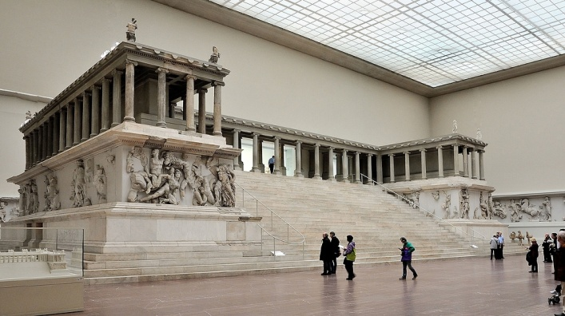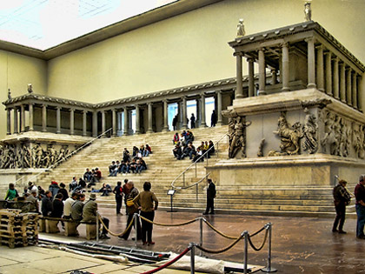
Pictures of the altar of Zeus at Germany’s Pergamum Museum in East Berlin

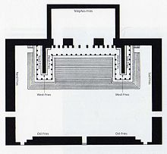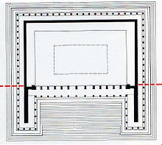
Left: Ground plan of the altar as modified for presentation in the Pergamum Museum
Right: Reconstructed ground plan for the entire Pergamum Altar

Pergamum was a city of the Roman province of Asia, and was the centre of emperor worship (Rev. 2:13); its church was listed in the Book of Revelation as one of the 'seven churches' of Asia, Rev. 1:11, 2:13ff. Pergamum today is the modern city of Bergama. The first temple of the “imperial cult” was built in Pergamum (c. 29 B.C.) in honor of Rome and Augustus. The city thus boasted a religious primacy the province, though Ephesus became its main commercial center.
The Sanctuary of Asclepius grew in fame and was considered one of the most famous therapeutic and healing centers of the Roman world. Galen, after Hippocrates, the most famous physician of antiquity, was born at Pergamon and received his early training at the Asclepeion.
Pergamon reached the height of its greatness under Roman Imperial rule and was home to about 200,000 inhabitants. The Library of Pergamon was renowned, and second only to the Library of Alexandria, although not approaching Alexandria in scholarship. Pergamum was a university town with a large library of 200,000 volumes given as a gift from Anthony to Cleopatra.
The Altar of Zeus has a 113 metre (371 feet) long sculptural frieze depicting the gigantomachy, or struggle of the gods and the giants. Genesis 6:2, 4…Zeus was a Nephlim, a giant … as was his son Apollo – gods who descended from the pre-flood Nephilim, through Nimrod and Osiris. Genesis 6:4 “There were giants in the earth in those days; and also after that, when the sons of God came in unto the daughters of men, and they bare children to them, the same became mighty men which were of old, men of renown.”
A German archaeologist, Carl Humann, began excavating the altar on Sept.9, 1878. The altar was then moved back to Germany and reconstructed. Kaiser Wilhelm II celebrated its erection in Berlin in 1902. In 1933 Adolph Hitler was elected Chancellor of Germany. In 1934 he became dictator and ordered construction of the Tribune at Zeppelin Field in Nuremberg for his Nazi rallies. The architect, Albert Speer, used the Pergamum Altar as the model for the Zeppelintribüne. The Führer's pulpit was in the center of the tribune, which was built from 1934 to 1937. Adolph Hitler, the Evil King of Germany started World War II in 1939. After the end of World War II, the Soviets took the Pergamon Altar to Leningrad in 1948 (Same year as the Rebirth of Israel) as spoils. The Alter was later returned in 1958. (from the website Former Things, “Throne of Satan”)

From: 700 Club Special The Seat of Satan: Nazi Germany - By Gordon Robertson
In the first century, it was a thriving city, but after countless wars and natural disasters, the temples of Pergamum lay in ruins. By the mid-19th century, the once-great city of Pergamum was barely a memory.
Locals used this site as a quarry, looting the marble for new buildings, until 1864, when a German engineer paid a visit to Pergamum. Carl Humann was shocked by the destruction of the priceless artifacts, so he got permission to excavate the ancient city himself. What he found was one of the greatest monuments in ancient history: the Altar of Zeus.
Stone by stone, the altar was excavated and taken to Berlin, where it was reassembled and placed in its own museum. The Pergamum Museum opened in 1930, with the altar as its centerpiece.
Eventually, the altar caught the eye of a young man named Albert Speer, the new chief architect for the Nazi Party. Germany’s new chancellor, Adolf Hitler, had commissioned him to design the parade grounds for the party rallies in Nuremberg. For inspiration, Speer turned to the Pergamum Altar. “If you read the German written by Speer, he gives all the credit to Hitler,” says Dr. Anthony R. Santoro, the Distinguished Professor of History & President Emeritus of Christopher Newport University. “I think he's like a good interior decorator that someone hires, and that client already has the ideas of what he wants to do, and the decorator agrees with him. So that's what Speer did.”
Using the altar as his model, Speer created a colossal grandstand at the rally grounds in Nuremberg. It became known as the Zeppelintribüne. After the war, only a small part of it was left standing. “If you look at the kinds of ceremonies that were on display at Zeppelin field with the reconstructed temple there patterned on the Pergamum Altar, you'll see photographs of Hitler, descending down the steps, like a tribune of the people from old Roman times,” says Santoro.
In the middle of the grandstand, where the bronze Altar of Zeus stood in ancient Pergamum, Albert Speer built Hitler’s podium. Hitler wanted to create what he called a "mass experience," and Speer came up with the perfect idea.
Most of the Nuremberg rallies were held at night, so Speer surrounded the grandstand with 150 searchlights. The columns of light extended for miles in the sky, creating the mystical effect Hitler wanted:
"The concluding meeting in Nuremberg must be exactly as solemnly and ceremonially performed as a service of the Catholic Church." This effect was known as the "Cathedral of Light,” and it became a hallmark of Hitler’s events. It was even used in the closing ceremonies of the 1936 Summer Olympics in Berlin...Inside the rally grounds, thousands of Nazi Party members marched in torchlight parades.
From his podium, Hitler mesmerized the crowds:
"Not every one of you sees me and I do not see every one of you. But I feel you... and you feel me!" Then under the Cathedral of Light, thousands of Germans swore what they called a “holy oath."
It was also in Nuremberg that Hitler used the phrase “Final Solution” for the first time in public. “Bitter complaints have come in from countless places citing the provocative behavior of Jews. This law is an attempt to find a legislative solution. If this attempt fails, it will be necessary to transfer [the Jewish problem] ... to the National Socialist party for a final solution." The Nuremberg Laws stripped the Jews of their rights as citizens.
Jewish people in Germany were subjects of the Reich, but not citizens.” Hitler's "Final Solution" is now known as the Holocaust, a word that comes from a Greek word meaning "a wholly burnt animal sacrifice."
In AD 92, the faithful martyr Antipas died, a "wholly burnt sacrifice" on the altar of Zeus in Pergamum, the place the Book of Revelation calls "the Throne of Satan." Centuries later in Nuremberg, in the center of a redesigned Pergamon Altar, the bronze bull was replaced by a podium. From there, Adolf Hitler announced his "Final Solution" to the world... and this time, the burnt sacrifice was six million Jews.
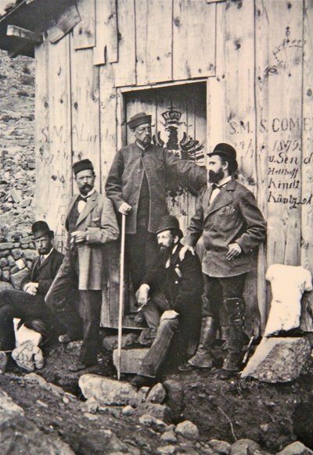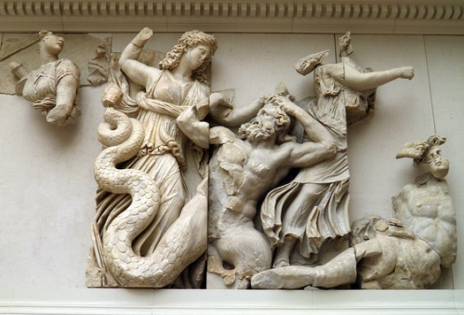
Carl Humann (second from left) Giant frieze on Pergamum altar
with fellow excavators, 1897
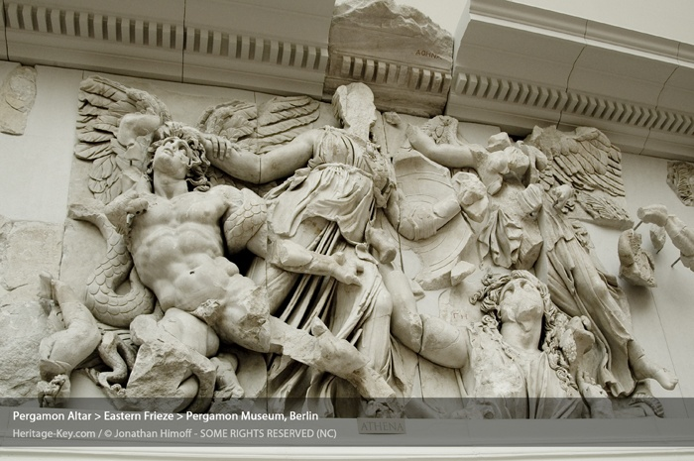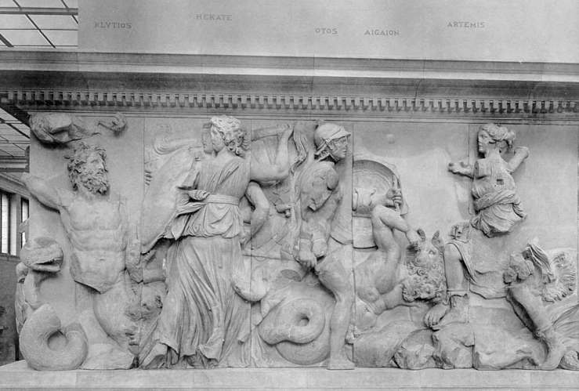
Hitler was born in Austria April 20, 1889 … In 1871, Albert Pike and Guissippe Mazzini, contrived the infamous Mazzini/Pike Plan [Refer to: “Launching the Chaos] German archeologists uncovered the altar of Zeus in 1878, and took it piece by piece to Germany where it was finally reconstructed in 1886. The first "Pergamon Museum" was built between 1897 and 1899 by Fritz Wolff and opened in 1901. It was demolished and rebuilt in 1909.
Hitler had a model of the altar built and placed at Nuremberg, from which he announced the “final solution,” the murder of the Jewish people.

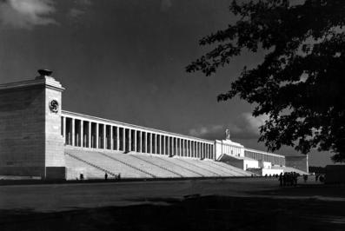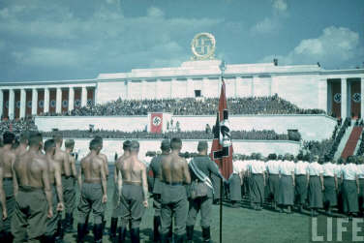
Left: Hitler’s model of the altar of Zeus, Right: Actual photos: Hitler’s Germany
Nuremberg/Photo from Watchman-Report.com
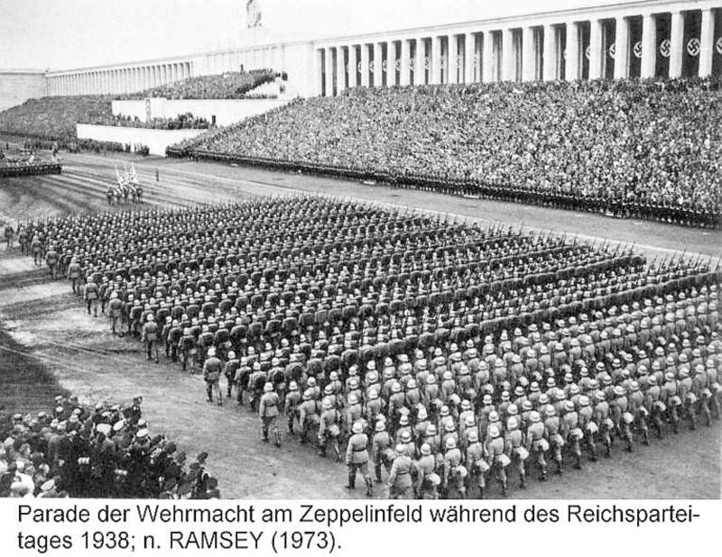
2008: Barack Obama had a replica of the Pergamum altar of Zeus built from which he gave his Presidential acceptance speech in Denver, Colorado. His goal is to create a Holocaust (a burnt offering) of 350,000,000 American people. The result – not one living person will be left alive in America when it’s all over. For over 150 years, people have had visions, dreams, and prophecies of America burning. But, it’s all there in Isaiah, Jeremiah, and Revelation, too. And, today’s watchmen of Yahuweh are also proclaiming it boldly.

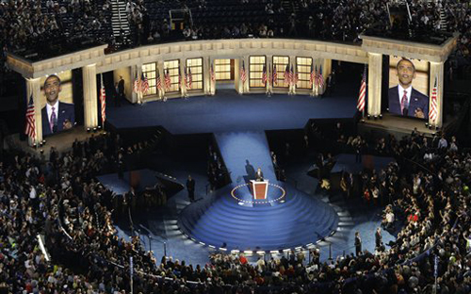

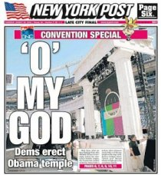It was noticed by quite a few people that Obama’s platform for his speech was a replica of the Pergamum Altar.

The Holocaust of the Jews during World War II was a burnt offering to Satan. Lucifer, Latin for the “light bearer,” the “Illumined one,” wants a sacrifice of over 7 billion of earth’s people and a complete annihilation of all who worship Yahuweh and Yahushua.
After World War II, from 1945, America began bringing in about 100,000 former Nazi leaders into America to be incorporated into the American Medical Association, into facets of American Psychology, scientists, military leaders, and those involved in space exploration technology, to continue the experiments they were doing on the Jews with the American people. This was called “Operation Paperclip.”

In the Greek Septuagint Version of the Tenach, the word for “whole burnt offering” is similar to holocaust in English. In Genesis 22, speaking of Abraham sacrificing Isaac, the Greek Septuagint Version reads: “offer him there as a holocaust,“ verse 3, “And split the wood for the holocaust,” verse 6. Verse 7…“where is the lamb for the holocaust?” Verse 8…“the lamb for the holocaust...”
Here is the information from the Strong’s Concordance, for a “whole burnt offering.”
#3646. Holokautóma – Strong’s Concordance
holokautóma: a whole burnt offering
Original Word: ὁλοκαύτωμα, ατος, τό
Part of Speech: Noun; Transliteration: holokautóma
Phonetic Spelling: (hol-ok-ow'-to-mah); Definition: a whole burnt offering
3646 holokaútōma (literally, "an offering that is completely burned up") – a whole burnt-offering. 3646 (holokaútōma) is used three times in the NT, each time for a "whole burnt offering," i.e. a sacrifice burned in its entirety. Compare Leviticus 5:12, 23:8 with Mark 12:33; Hebrews 10:6, 8 (see also Strong’s OT #5930).
Strong's Exhaustive Concordance: whole burnt offering, from a derivative of a compound of holos and a derivative of kaio; a wholly-consumed sacrifice ("holocaust") -- (whole) burnt offering.

The word “Auschwitz,” or Oświęcim in Polish, means “a holy place.” A “holy place” is a place of worship, a place of sacrifice to one’s god. Here it was a place where Jews were burned (“holocaust) as an offering to Satan, on his altar--his “holy place” of sacrifice.
"One more thing--Oświęcim is an old Polish name that means 'enlightened place or place which is made holy.'" From The Heathen Learns, October 31, 2011, marleytheheathen.blogspot.com/2011/10/auschwitz-one.html

World War I and World War II were both great sacrifices of millions of people to Satan. The great sacrifice planned by World War III is designed to exterminate nearly 7 billion people. Even the Vatican has come out with the need to “depopulate” the earth by about 6 billion people. A few years ago I heard Ted Turner say in a TV interview, “we need to reduce the earth’s population down to 500,000,000. This depopulation goal was listed as #1 of 7 on the Georgia Guidestones “for an Age of Reason.”
Six million Jews were led as sacrificial lambs to the slaughter during World War II. Sixty million people were killed in battle in World War II. It was as if the Jews were a tithe to Satan. Among the Jews thousands of Christians were also killed for trying to help them.
The spirit of Babylon moved to Pergamum, where emperor worship was at its height. Then it moved to Rome, which, by the 1st century, was known as “the second Babylon.”
Then the spirit of Babylon moved across Europe, finally resting in America… particularly in what became New York City, as we see in Revelation 18.

Pergamum’s altar is alive and well. Lucifer/Satan is calling for a great holocaust of nearly all the world’s people. It has been planned, and will be carried out. The chief targets are those who believe in the Elohim of the Scriptures, those who are loyal to the Elohim of the Scriptures – whether Jews, of Christians, or Messianic believers.
Remember Obama’s speech in Berlin, the Heil Hitler salute, the location of the speech…
Holocaust survivors feared when they saw this, for he began acting like Hitler before he took absolute power. [Refer to: “It’s All About Worship”/ March 11, 2013]
[Refer to Jonathan Cahn’s DVD: “The Dark Angel’s Sacrifice – The Mystery of Pergamum.” (#1961) The Jerusalem Center, Wayne, New Jersey]

The Pergamon Altar – Its Rediscovery, History and Reconstruction

Written by Verlag Philipp von Zabern, Mainz , c 1995, published by and for the Staatliche Museen zu Berlin – contents: history and pictures, sold at the Pergamum Museum, Berlin. Purchased by Yedidah at the Museum in Berlin, April 29, 2010...

The year 1871…
This was the year that Albert Pike, head of the American Scottish Rite Freemasons, author of the Freemason’s guidebook, Morals and Dogmas, buried in a pillar in the House of the Temple, Washington DC, and teacher of “pure Luciferian doctrine,” wrote
to Giuseppe Mazzini, head of the Bavarian Illuminati, founder of the Mafia (M is for Mazzini, the other letters for what they do to kill and destroy), with the plans for three world wars, three new governments, three mass murderers of Jews and Christians, to bring the chaos that will bring the order – the new world order.
Part I of the plan was put into effect in 1917, with the overthrow of the Czar of Russia, the creation of communism, and the rise of Stalin, who murdered multi-millions of Jews and Christians. Part II was put into effect in the late 1930s with the rise of Hitler, Fascism, and Nazism, culminating in World War II and the destruction of six million Jews and thousands of Christians – funded, backed, and supported by America, England, and the Vatican, just like Part I. Now see clearly the rise of Part III, set in place, supported and funded, by America, the UK, and the Vatican to bring the world into such chaos that the world will cry for a new world order under one ruler. In the process the goal is to eradicate between 6 and 7 billion people – as before during World Wars I and II, to achieve a massive global sacrifice to Satan/Lucifer.
1871 was the ground zero year for organizing what is about to be set in motion in September of 2015. [For more details on the Mazzini/Pike Plan of 1871, refer to the article: “Launching the Chaos,”/February 2011]

Here is what the booklet, The Pergamon Altar, has to say about 1871:
“After his first visit, Carl Humann did his best to protect the antiquities to the point where he temporarily moved his residence to Pergamon. He knew, however, that only an excavation could really offer satisfactory protection by safeguarding the entire area. His hopes for winning the Berlin Museums for such an excavation appeared to materialize in 1871.
In that year a group of Berlin architectural researchers and archeologists traveling in Turkey accepted the invitation to visit Pergamon. They gave him the chance to show them the boldly carved reliefs he had found built into the Byzantine wall. At the end of the same year, he sent those first reliefs to Berlin.”
“Thanks to Prussia’s military success the German Empire had been proclaimed in 1871. Understandably the new imperial capital of Berlin called upon its research institutions and museums to help establish a worthy cultural legitimacy.”
“On the 9th of September 1878, Carl Humann began the search for the famous altar on the Acropolis of Pergamon.”
“For many contemporaries, the discovery of Pergamon’s High Hellenistic Art was just as exciting as Heinrich Schliemann’s controversial excavation since 1871 underway at Troy.”
“The Pergamon Altar was reconstructed in the Altes Museum in the center of Berlin.
…to its admirers, Pergamon had been an `ambitious center of power and culture where one had the means to attract the finest craftsmen.’ Its splendid altar was seen as the `proudest monument of monarchist self-confidence,’ a role which it was also to fill in Berlin. The fledgling German Empire had adopted the Pergamon Altar, and its symbolic meaning, which whether ancient or modern, was practically identical. The historical parallels were close at hand. Just as the Hellenistic Empire of Pergamon superseded the classical city culture of Athens, so were the small states of Germany swallowed into the empire under Prussia’s leadership.”
Ancient Pergamon: “The astute kings of Pergamon understood quite well the long-term advantage of linking themselves to Roman political power and how to take advantage of that link…The rulers of Pergamon, indulged and encouraged by Rome…was soon the strongest military and economic power in Asia Minor, and because it was an important harbor, the coastal city of Ephesus was at its disposal. Pergamon also ranked as a maritime power to be reckoned with. Thanks to the socio-economic system the royal house of Pergamon had more than substantial means with which to develop their splendid city. Attention was, of course, centered on the Acropolis, whose terraced terrain was gradually developed into an impressive grouping of cult and official buildings. The finest architects and artists were brought to Pergamon where all they built and created was intended to demonstrate how firmly the artistic heritage of their royal emperors was rooted in Greek culture. In effect, they were creating a `new Athens,’ a new center of Greek art, literature, and science, most visibly expressed in its buildings in its buildings and art.” “Pergamon’s short but glorious history spans barely 150 years.”

In 1906, following the great Welsh revival of 1904, the Spirit was poured out, like a second Pentecost, at Azusa Street in Los Angles, and the gifts of Yahuweh’s Spirit began to be restored. The book of Acts became alive again! News of the baptism into the Spirit by Messiah (Luke 3:16; Acts 2) reached Germany in short order. But, as a nation, the leaders of Germany formally rejected the message and forbid anyone to spread it. They, in truth, rejected the Spirit of Yahuweh, and Hitler was their reward!

In Greece, the greatest of the gods was Zeus. His son was Apollo. There is a frieze of Apollo that adorns the altar of Zeus--“Apollo is at the head of a family of Olympian gods. Apollo’s mother, Leto, fights at his side…” In Greece, Zeus was the substituted for Yahuweh, and Apollo the substituted for Yahushua. Leto, Isis of Egypt, mothers of gods, are cultural names for the original “mother of god,” “Queen of heaven”--Nimrod’s mother/wife Semaramis, mother of Tammuz. Today, the elite world leaders are calling for the return of Apollo (Apollyon), the destroyer, the “son of perdition,” to rule the world – as the incarnation of Nimrod.
In these last days, what part will the Roman Catholic “Mary” play in her role as the “mother of God” and “Queen of heaven?”

The altar depicts wars between giants and Greek gods and demigods. Yes, the artwork and magnitude of the altar is amazing. But, it is an altar. In the same area of the Acropolis was the Temple of Athena, and the Temple of Dionysus.
The Temple of Athena housed some 200,000 scrolls, second only to the famous library
of Alexandria. A theater, dedicated to Dionysus, was built on the steep western slope of
the Acropolis, and could seat 10,000 people.

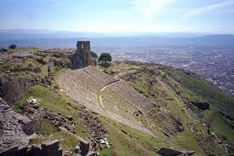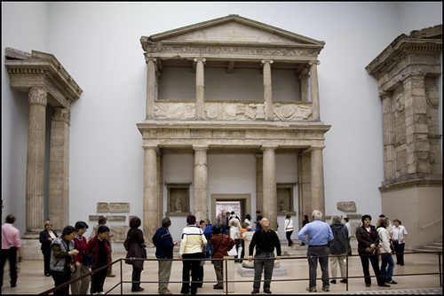
Ruins of the theater of Dionysus Reconstruction of ruins of the temple of
Green tree in center--where the Athena in the Pergamon Museum
Altar of Zeus once sat

Under Rome, there were temples built for the worship of the Roman Emperors, who demanded worship, believing they were gods. The popes have always demanded worship--quoting the Jesuits, as “the god that sits in St. Peter’s chair.”
In review, Pergamum was the major center of pagan idol worship! History shows that the spirit and beliefs of Babylon came and rested in Pergamum, and from there went into Rome. Rome was called “the second Babylon” by the 1st century. From there “Babylon” and all it stands for moved west across Europe and the British Isles, then came to rest in what became America. Washington DC is a city filled with idols of gods and goddesses of Egypt, Babylon, Greece, and Rome. The city is dedicated to the goddess Virgo.
Why was a symbolic Pergamum altar reconstructed for Hitler in Nuremberg, from which he declared “the final solution?” Why was the Pergamum altar symbolically reconstructed in 2008 in Denver, Colorado, from which Barack Obama delivered his acceptance speech for the Presidency, running on a platform of “change?”
Denver is the “second capital” of the U.S., and is also a major headquarters for extreme paganism and the worship of Satan, the Nephilim gods of old, and death of the innocent.

The year 1871 set in motion the return of Nimrod/Osiris/Apollo (Apollyon, Revelation 9:11). America was founded to bring about the resurrection, reincarnation, and reign of the Nephilim, Nimrod, god of the Freemasons, first King of Babylon. This gives more credence than ever to the fact that America is end-time Babylon of the Scriptures
(Jeremiah 50-51, Isaiah 13, 18, 47, Zechariah 2; Revelation 17-18). [Refer to: “America’s Secret Destiny”]
But, what are the odds that the same year when parts of the throne of Satan began to be sent to Berlin, and Berlin received this altar with such esteem, that the plan that would bring Hitler to power was set in motion? It was no coincidence – the planning was done by Satan, and his agents played their parts well.
The message of Pergamum to us is found in Revelation 2:16-17: “Repent, or else I will come to you speedily and fight against them with the sword of My mouth. He who has an ear, let him hear what the Spirit says to the assemblies. To him who overcomes, I will give some of the hidden manna to eat, and I shall give him a white stone, and on the stone a new name written who no one knows except him who receives it.”
Who is “them?” -- Those that operate in the spirit of Lucifer, the spirits of Baalim and of the Nicolatians. We must repent so that we are not caught up in their judgment. Revelation 18:4 is a similar word to us. A sword goes out of the mouth of Yahushua as He descends on the “Day of Yahuweh.” (Revelation 19; Isaiah 63:1-6, and 34)
The white stone is the acquittal stone. He will set apart those who are pure to Yahuweh!

Conclusion: I was in Pergamum in October of 2001. I stood in front of the place where the altar of Zeus once stood. In April of 2010, I saw the altar and the Ishtar Gate in the Musem in Berlin. But, why has Yahuweh’s Spirit so impressed me to study about Pergamum now? Why has it become a driving passion to me? -- The spirit from Pergamum has moved end-time Babylon, America, now into the whole earth, headquartering once again in Vatican Rome--America’s sister city, sister country.
The two together, end-time Babylon, and end-time Rome, make up the 8th Beast of Revelation 17. America, like ancient Pergamum, is a land of idolatry, a land filled with the worship (submission to) of what man has created, what man has achieved, and what man says. Pergamum was a political power-center, a center of commerce and economics, and a military power--so is today’s America. Its culture was the fullness of both Greece and Rome, as is America’s culture.
On Pergamum’s high altar, the martyr Antipas was slowly roasted alive, wrapped in a cow hide. Today, in America, attacks on Christians and Messianic people (born again people) have begun in a severe way. Now true believers who stand for truth are being arrested, and others threatened with arrest if they don’t do what the government says. We’re following China’s pattern – the Communist pattern. Persecution will only increase. Those who overcome, keep His commandments, and have the testimony of Yahushua’s salvation, will eat of the tree of life, and be allowed through the gates of the city. (Revelation 22:14)
The conclusion of what Nimrod started in Babylon will be utter destruction forever (Jeremiah 50-51; Revelation 18).
Revelation 18:4: “Come out of her My people, lest you share in her sins, lest you receive of her plagues.”
II Corinthians 6:17-7:1: “`Come out from among them and be separate,’ says Yahuweh, `do not touch what is unclean, and I will receive you. And I will be a Father to you, and you will be sons and daughters to Me,’ says Yahuweh the Almighty. Having then these promises beloved let us cleanse ourselves from all defilement of the flesh and spirit, perfecting set-apartness in the fear of Elohim.”
Whether in America, Canada, the UK, Europe, Australia, New Zealand, or anywhere else that Greek-Roman culture has taken root and grown, He is calling us to come out of it – for its mother is Nimrod and Babylon. He is calling us to make a clean break with the world system that is governed and ruled by Satan and his agents – those hiding in religion, in politics, in economics, and in military might.
In western religious culture, the idolatry is hidden. Evil is whitewashed to appear tolerable, or even good. But, idolatry is simply the breaking of the 1st commandment: “You shall have no other gods in My face.” (Exodus 20:3) He will not be usurped by any gods of man’s creation. If He is not held as Supreme Master of your life, He is not in your life. There can be no mixing of the love of this world, with belief in Him.
Ya’cob 4:4: “Adulterers and adulteresses! Do you not know that friendship with the world is enmity with Elohim. Whoever, therefore, wants to be a friend of this world makes himself an enemy of Yahuweh.” We use what we need of this world, but we use it loosely. Shut it off in your house … give yourself and your family to seeking Yahuweh with all your heart.
From I Corinthians 7:29-31 -- excellent advice from Sha’ul: “This I say brothers, the time is short, … those that weep as though they did not weep, those that rejoice as though they did not rejoice, those who buy as though they did not possess, and those who use this world as not misusing it, for the scene of this world is passing away.”
America will look like the ruins of Pergamum before long … He has warned us.
Shalom,
Yedidah
September 4, 2015, a research report

