The Return of the Fuhrer and the Nazis
“Hitler is on his way”

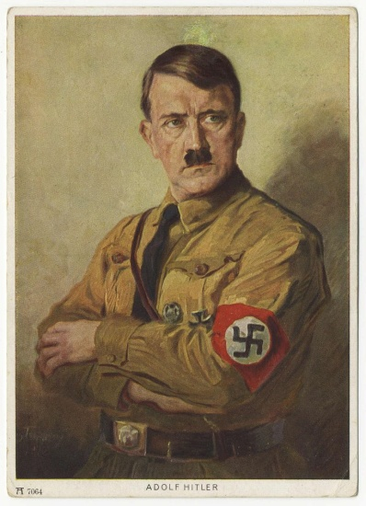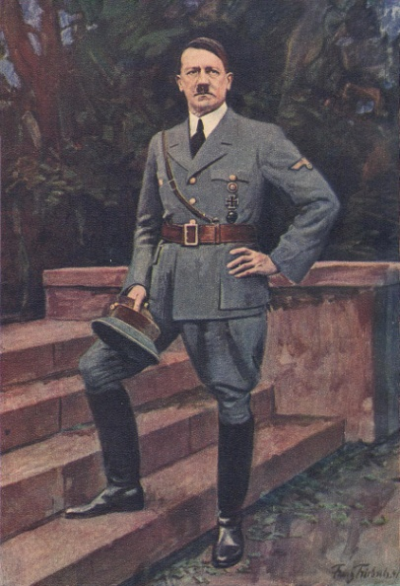
Left: Left: Portrait by Bruno Jacobs – Adolf Hitler (1933)

Right: Portrait of Adolf Hitler by Franz Triebsch – Der Führer (1941)
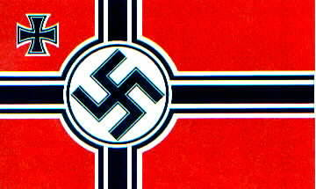
Official Nazi flag Nazi battle flag

It is hard to believe … but it’s true: Like a lot of things history relegated to the past, found only in history books and in the memory of a few survivors, the Nazis, Adolf Hitler, Josef Mengele, and the worst of the former Nazi leaders, are very much in the forefront of today’s world. This is because their master, Satan/Lucifer, is very much in the forefront of everything that is happening before our eyes. With all the rapid-growth cloning of bodies for the returned Nephilim to inhabit, Nimrod included, just some DNA from Hitler’s bones would allow him to be cloned, not just once but several times. The term “Fuhrer” means “a ruthless and tyrannical leader,” according to the online internet dictionary.
Hitler was demon possessed. Even his closest henchmen knew that. So, once Hitler’s DNA is used to clone more Hitler’s, guess who would return to their former “host?” The demons that used his body would be happy to come with seven times more to use his body to work through once again. Hitler is in hell, but cloned bodies using his DNA can be taken over.
I wrote how Josef Mengele’s body was exhumed last year I think, in Brazil, supposedly to be used by medical students in University of Sao Paulo. But, Mengele – “Dr. Death – the insane experimenter on children and adults – a man whose experiments were beyond hideous – beyond what a normal human could imagine – but Satan could imagine! So, it is a very real thing that cloning of bodies for the Nephilim to inhabit of famous slaughterers, like also Stalin, and Mao Tse Tung, Pol Pot, and others, is a present reality.
Please read the article: “The Pergamum Altar and the Throne of Satan”/September 4, 2015. Look at the pictures. The information in this article will give you a foundation for what is happening in Berlin right now, which goes back to 1871 and the bringing of the Pergamum Altar to Berlin.
Foundational Scripture: Revelation 2:12-13: 12“And to the messenger of the assembly in Pergamos write, ‘He who has the sharp two-edged sword, says this: 13 `I know your works, and where you dwell, where the throne of Satan is. And you hold fast to My Name, and did not deny the belief in Me, even in the days in which Antipas was My trustworthy witness, who was killed near you, where Satan dwells.’
The throne of Satan was brought to Berlin, and it is still housed there in the Pergamum Museum. I saw it myself. Also, in the same building is the “Ishtar Gate,” the Gate of Babylon, constructed around 575 by Nebuchadnezzar. This article is a fascinating foundation--please read before going over the fascinating articles below.
***This large compilation of information covers the late 1800s to 2017. However, it is by no means meant to inform about Hitler’s entire life, or how he became demonized to the point that he did. I share with you from some of the information I have collected regarding the rise and return of Hitler to the forefront of modern life, and make a very few comments. The life of Adolf Hitler is most complex, from babyhood to his most likely death in his mid-90s in Argentina. This compilation includes shocking facts, and many old pictures that were hidden, but now all is coming to the forefront once again. Glance over the articles; read what you’re drawn to. Learn from the past, for it is being, and will continue to be, repeated again! The word most prominent from the watchmen of Yahuwah to His people is: In all ways PREPARE!
***I make a disclaimer here regarding some of the statements made in the articles below, especially speculation-statements like those regarding Hitler and Germany’s Angela Merkel being his daughter. But, all of the historical information is amazing, and to be considered. Do your own research. Compare this past history with what is happening in our world today. The Nazis never faded away – they just hid and continued with the research and developments they started during World War II.
I give no opinions of my own in regards to this information in general. I do make a few comments. I also have compiled this information for you to observe similar developments before your eyes. I warn people that we must be very discerning so as to understand the desires and plans of the enemy for today’s world. Truly, what was in history is being repeated!
TOPICS of the articles include:

1) The rise of popularity for Adolf Hitler in modern Germany, the reissuance of Mein Kampf, the rise of anti-Semitism, and the verbal proclamation “Hitler is on his way.” It has been recently noted that Germans are calling for a new Fuhrer. The world is calling for the return of the “sky gods” to rule earth once again. Nazis scientists, as well as men like Nicola Tesla in the 1920s, have given credit to the “sky gods” for their advanced technology, like the “flying saucer,” which they received via séances by the Vril in the 1920s. Nazis are occultists. They never died out, but continued as a hidden power, ever-increasing in knowledge from the “sky gods.” Neo-Nazis are appearing, heralding another chapter in modern history.

2) Mein Kampf reissued January 2016

3) Hitler’s personal life as a child, his daughters, Eva Braun, his rise to power, his occult beliefs, the Arian race, and World War II

4) Is Angela Merkel the daughter of Adolf Hitler?

5) Hitler’s faked death and his life after Germany, the Nazis in Argentina and Antarctica, Nazi goals and their infamous history of UFOs
***For fantastic details, current discoveries, activity in Antarctica, UFOs, and German Nazi technology, I highly recommend the all-inclusive book with loads of pictures: Empire Beneath the Ice – How the Nazis Won World War II, by Steven Quayle, 2015. In fact, there is so much about Hitler’s rise to prominence right now, that Steve Quayle has added a separate section on his website about Hitler (stevequayle.com)
---------
THE ARTICLES BEGIN:
Jewish shoppers in London are bombarded with laughing gas canisters by neo-Nazi thugs shouting 'Hitler is on the way'
Daily Mail, London - By James Dunn For Mailonline - Published: 7 January 2016
Jewish shoppers were targeted by neo-Nazi thugs who bombarded with small gas canisters by 'Nazi' thugs who shouted 'Hitler is on the way.'
Witnesses say a woman and two men had nitrous oxide canisters hurled at them by three men in a van during the anti-Semitic attack on Wednesday. Jewish neighborhood watch group Shomrim said the men also shouted 'Heil Hitler' at the shoppers outside Poundland in the Tottenham Hale Retail Park, north London.

Witnesses say a woman and two men had nitrous oxide canisters hurled at them by three men in a van during the anti-Semitic attack on Wednesday at Tottenham Hale Retail Park (pictured, right), north London
…Shomrim volunteer Michael Blayer said the shoppers were targeted purely because of their religion, and they were recognizable because of the distinctive clothing worn by Orthodox Jews. This disturbing incident is a reminder of the abuse that many Jewish people experience all too often. Jonathan Sacerdoti, Campaign Against Anti-Semitism said: `This behavior is appalling. The victims were innocent shoppers at the Tottenham Hale Retail Park, and they were targeted because they were visibly Jewish. 'The verbal abuse was disgusting, and small objects were thrown towards the victims, making them fear for their immediate safety. 'Shomrim are supporting the victims. The incident has been reported to the Metropolitan Police, I have absolute confidence in our local police that this will be thoroughly investigated.' ”
-------------
Hitler Returns via Mein Kampf – an article with many pictures
By Gianluca Mezzofiore For Mailonline - 8 January 2016

Adolf Hitler's Mein Kampf on sale in Germany for the first time since World War II as Jewish community warns it should remain in 'poison cabinet of history'
2,000-page critical edition of anti-Semitic rant hits bookstores on 8 January
German state of Bavaria refused to publish book for 70 years
Copyright expired on January and new edition will cost 59 euros (£43)
Munich's Institute for Contemporary History curated annotated edition
Jewish community says Holocaust survivors 'will be offended'
Hitler wrote notorious racist manifesto while in jail in 1924
For 70 years, the southern German state of Bavaria - who was handed the copyright of the book by the Allies in 1945 following Hitler's death - refused to publish the anti-Semitic manifesto out of respect for victim of the Nazis. But Mein Kampf, which means My Struggle, fell into the public domain on January 1.
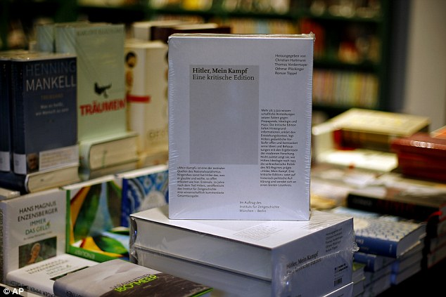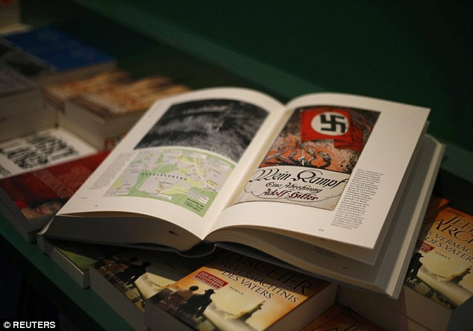
A copy of Hitler's Mein Kampf - A Critical Edition stands on a display table in a bookshop in Munich, Germany
For 70 years, Bavaria refused to publish Hitler's 800-page rant out of respect for Nazi victims
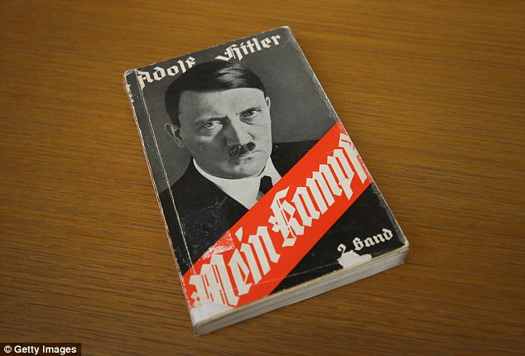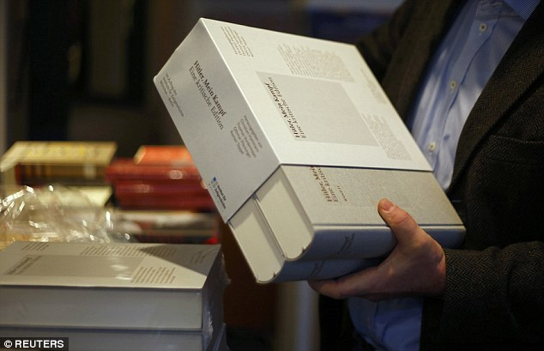
Left: A 1941 edition of Adolf Hitler's 'Mein Kampf' ('My Struggle') lies at the library of the Deutsches Historisches Museum (German Historical Museum)
Right: Hitler's book 'Mein Kampf' available to buy in Munich stores

Ian Kershaw, a Briton who is a leading biographer of Hitler, joined Friday's book presentation and said it was 'high time for a rigorously academic edition of Mein Kampf' to be made available. 'For years, I have considered the lifting of the ban on publication long overdue,' Kershaw said.
'Censorship is almost always pointless in the long term in a free society, and only contributes to creating a negative myth, making a forbidden text more mysterious and awakening an inevitable fascination with the inaccessible.'
Germany's main Jewish group, the Central Council of Jews, said it has no objections to the critical edition but strongly supports ongoing efforts to prevent any new 'Mein Kampf' without annotations. Its president, Josef Schuster, said he hopes the critical edition will 'contribute to debunking Hitler's inhuman ideology and counteracting anti-Semitism.'
Copies of a 2,000-page, two-volume annotated version of Mein Kampf will go on sale on January 9 after three years of labor by scholars at Munich's Institute for Contemporary History. The new version, which will cost 59 euros (£43), has some 3,500 annotations. Authors argue that the critical edition will serve to 'deconstruct and put into context Hitler's writing' with the aim to demystify the 800-page rant.
The annotated version looks at key historical questions, the institute said, including: 'How were his theses conceived? What objectives did he have? And most important: which counterarguments do we have, given our knowledge today of the countless claims, lies and assertions of Hitler?'
The Jewish community in Germany criticized the decision to reprint the anti-Semitic book, questioning whether it was necessary to propagate the inflammatory text again.
Ronald Lauder, president of the World Jewish Congress, said 'it would be best to leave 'Mein Kampf' where it belongs: the poison cabinet of history.' Education Minister Johanna Wanka has argued that such a version should be introduced to all classrooms across Germany, saying it would serve to ensure that 'Hitler's comments do not remain unchallenged.' 'Pupils will have questions and it is only right that these can be addressed in classes,' she said. But the Jewish community in Germany criticized the decision to reprint the anti-Semitic book, questioning whether it was necessary to propagate the inflammatory text again.
Charlotte Knobloch, leader of the Jewish community in Munich, said she could not imagine seeing 'Mein Kampf' in shop windows.
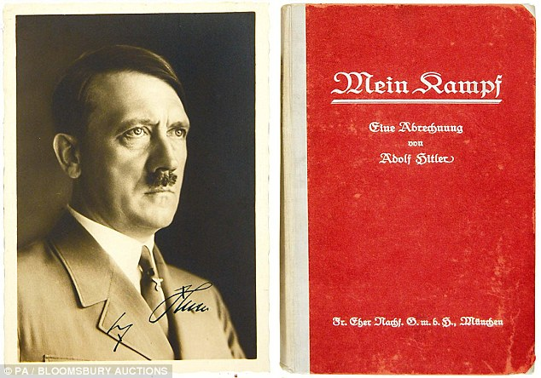
First edition of Mein Kampf signed by Adolf Hitler
The Nazi dictator wrote the book in 1924 while he was in jail in Bavaria for treason after his failed coup
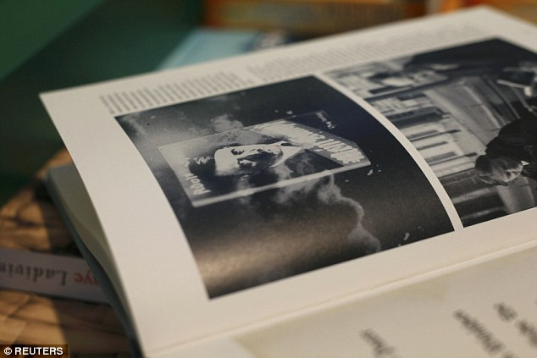
Versions of the book will also hit bookstands in France, causing an outcry in the Jewish community there. Roger Cukierman, the president of the council of Jewish institutions, called the planned French reprints 'a disaster'
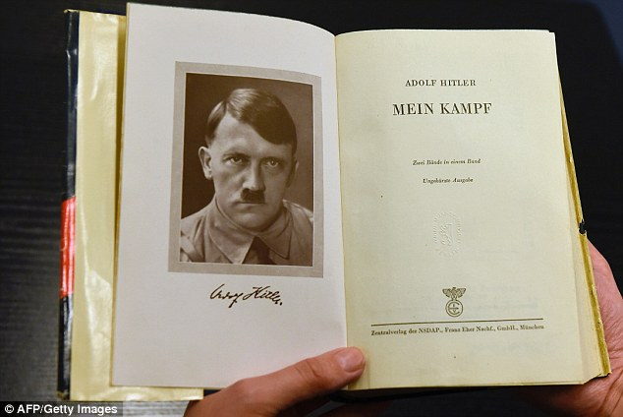
A German edition of Adolf Hitler's 'Mein Kampf' (My Struggle) is pictured at the Berlin Central and Regional Library

BANNING THE NAZI MANIFESTO
Mein Kampf, which is partly autobiographical, was written by Hitler in 1924 while he was in jail in Bavaria for treason after his failed Beer Hall Putsch.
The book set out two ideas that he put into practice as Germany's leader going into World War II: annexing neighboring countries to gain 'Lebensraum', or 'living space', for Germans; and his hatred of Jews, which led to the Holocaust.
Some 12.4 million copies were published in Germany until 1945, some of which can be found in academic libraries. The ban will continue in several European countries that were occupied by Nazi Germany, including Austria and the Netherlands.
In Turkey, India and Brazil, the book is easily found. More than 30,000 copies have been sold since 2004 in Turkey.
------------
He’s Back! Germany Is Publishing Adolf Hitler’s Mein Kampf For First Time Since WWII - From Nowtheendbegins - December 23, 2015
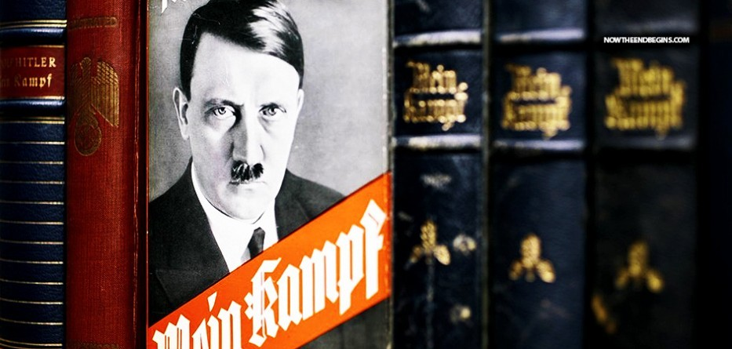
by Geoffrey Grider December 23, 2015
For the first time since Hitler’s death, Germany is publishing the Nazi leader’s political treatise “Mein Kampf”, unleashing a highly charged row over whether the text is an inflammatory racist diatribe or a useful educational tool
“The thing that hath been, it is that which shall be; and that which is done is that which shall be done: and there is no new thing under the sun.” Ecclesiastes 1:9 (KJV)
EDITOR’S NOTE: There have only been two world wars in human history and both of them started by the Germans. If history is any indicator, they will have a hand in starting the third one as well, and in the not too distant future.
[Yedidah’s insert: Refer to my article “THE PERGAMUM ALTAR” for a lot of history of Germany and Berlin in the 1800s, with old and recent pictures, and how the altar of Zeus from Pergamum (modern Turkey)--the Revelation 2:12-17 altar--came to be moved to Berlin. Obviously, the spirit of that altar, Zeus – father of Apollo/Apollyon (Revelation 9:11) which was used to sacrifice Yahuwah’s people, and sacrifice many others, brought with it to Germany an open portal to Satan’ kingdom, through which occult Nazism was able to thrive. This article also relates, with pictures, about how President Obama ties into this altar.
In my article you’ll read that in 1871, Berlin became the capitol of the new German state. Germany wanted to be the cultural capital of Europe. That year they gladly welcomed the first shipment of frieze from the Pergamum Altar in Turkey, and it was not long before the whole “seat of Satan” was moved to Berlin and constructed in a museum. It is in Berlin to this day. After 1904, the year the great Welsh revival broke out with its teaching on the infilling of the Spirit, the teaching swept into Germany. The German government banned this teaching of the Spirit by law. Then they got Hitler. Between housing the seat of Satan and rejecting the Spirit of Yahuweh, as a nation, Germany became a seat of Satan for the whole world.]

Continuing with Grider’s article:
BERLIN – The 70-year copyright on the text, written by Hitler between 1924 and 1926, banned by the Allies at the end of World War Two, expires at the end of the year, opening the way for a critical edition with explanatory sections and some 3,500 annotations.
In January the 2,000 page, two-volume work will go on sale after about three years of labor by scholars at Munich’s Institute for Contemporary History.
Hitler wrote most of the first, highly autobiographical, volume while incarcerated in Landsberg prison after his failed Munich coup attempt in 1923. After his release, he wrote much of the second volume at his mountain retreat near Berchtesgaden.
Mein Kampf: The Story of Adolf Hitler
In the book, a mix of personal experience and political ideology, he outlined his strategy. A bestseller after he became chancellor in 1933, it had by 1945 sold 12 million copies and been translated into 18 languages. The publication is a big step for Germany, which is still struggling with the legacy of the Nazi era and the Holocaust.
Polls show deeply divided public opinion. A YouGov survey last month said 51 percent of Germans oppose a continuation of the ban. The state of Bavaria has until now repeatedly used the copyright transferred to it by the Allies to prevent a reprint.
Hitler biographer Peter Longerich told Reuters Germans have reached a stage where taboos are being broken.
“We are probably entering a phase in which you can do more with Hitler and texts about him than you did 10 or 20 years ago. In the age of mass media, taboos are constantly broken and texts cannot be locked away,” he told Reuters.
Other watersheds include the 2004 film “Downfall” which explored the last days of Hitler’s life to this year’s hit film “Look Who’s Back”, an adaptation of a satirical novel about the reappearance of Hitler in modern times and becoming a celebrity.
DECONSTRUCT NAZI LIES
Keenly aware of the controversy surrounding “Mein Kampf”, the Munich institute has stressed that the aim is to deconstruct propaganda and undermine any symbolic power the book still has. “The aim … is to present ‘Mein Kampf’ as a salient source document for contemporary history, to describe the context of the genesis of Hitler’s world view,” it said.
To prevent any commercial exploitation of the sensitive text, the Institute is self-publishing. The first print run is expected to be up to about 4,000 copies. The Central Council of Jews in Germany has reservations, arguing the text, described by some community leaders as an “anti-Semitic diatribe”, should remain banned.
“After the expiry of the copyright, there is a very big risk that this sorry effort of a work will be more widely available,” Council President Josef Schuster said in a statement.
Yet Schuster acknowledged that understanding it is important in explaining Nazism and the Holocaust. “So there is nothing to object to if an academic edition with commentary is available for research and teaching,” he added.
German authorities have made clear anyone reprinting an unedited version will be subject to incitement laws. But Germany’s teachers association wants it used in schools. “A professional treatment of excerpts in lessons can help immunize against political extremism,” association head Josef Kraus told Handelsblatt. source
---------
Germany Hitler’s Mein Kampf Re-Issued for sale January 1, 2016
Out of print for 70 years, Hitler’s ‘Mein Kampf’ to go on sale in Germany
BY Corinne Segal December 31, 2015
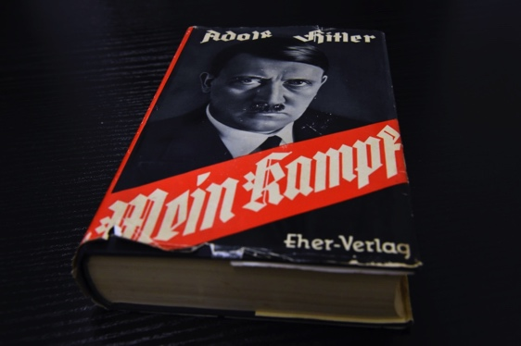
A German edition of Adolf Hitler’s “Mein Kampf” (My Struggle) is pictured at the Berlin Central and Regional Library in Berlin on Dec. 7, 2015.
For the first time since World War II, Adolf Hitler’s “Mein Kampf” will be printed in Germany in January 2016 as an annotated edition published by the Institute of
Contemporary History in Munich... Photo by Tobias Schwarz/AFP/Getty Images

“Mein Kampf” will go on sale in Germany next week after its copyright expires on Friday, January 8, 2016, marking the first time in 70 years the book will be legally reprinted in the country.
The German state of Bavaria has held the copyright for Adolf Hitler’s autobiography since 1945 and has withheld publishing the book, preventing any reprints in Germany. But in 2016, the book becomes available in the public domain, which will make it widely available in Germany for the first time since World War II.
Hitler began writing the first volume of the autobiographical “Mein Kampf” in 1923 while imprisoned in Landsberg prison for an attempted coup to overthrow the government of Bavaria. Published in 1925, the first volume of the book lays out Hitler’s overview of the problems facing German society, his support for dictatorship and the racial hatred underpinning his beliefs.
The book gained popularity in 1933 as Hitler became Reich Chancellor, and by 1945, it was translated into 18 languages and sold 12 million copies.
The Institute of Contemporary History in Munich will release an approximately 2,000-page annotated edition of “Mein Kampf” on Jan. 8, 2016. The version will include critical commentary aimed at deconstructing and contextualizing the work, according to a statement from the Institute. The book will cost 59 euros ($65).
Critics have raised questions about the value of reprinting a book that contributed to inciting racial hatred in the years leading up to the Holocaust, said Steven Luckert, Senior Program Curator at the U.S. Holocaust Memorial Museum’s​ Levine Institute for Holocaust Education.
“It’s generated a lot of fears in Germany and elsewhere that once again, Hitler’s words could resonate with audiences,” he said.
But some scholars have argued that continuing to ban the book does not prevent people from accessing it — “Mein Kampf” is available for download online — and that a reprint with historical analysis could have educational merit.
Josef Kraus, president of the German Teachers Association, has voiced support for using the book in schools, saying it could help students think critically about extremism.
“A professional treatment of excerpts in lessons can help immunize against political extremism,” he told German newspaper Handelsblatt. A reprint that puts Hitler’s words in context could be helpful for students, Luckert said.
“With critical commentary that contextualizes the book, that explains where these ideas come from — the insidious nature of those — I think that can be very helpful for people to understand something about those words and what they mean,” he said. “In a world in which you have a lot of hate, a lot of anti-Semitism, a lot of racism being propagated through various forms of media, I think it’s important to confront those in meaningful ways.”
“Mein Kampf” was never banned in the U.S. but remains banned in Austria and the Netherlands. In France, publisher Fayard will print a French version…
------------
ADOLF HITLER’S LIFE IN PICTURES – from a baby to the Fuhrer

Hitler glorification rising in Germany and Austria
A shrine to Hitler: The Nazi loving Austrian pub where the Führer was born is thrust back into spotlight with Mein Kampf release. Adolf Hitler was born April 20th, 1889, in an inn in the Austrian town of Braunau-am-Inn, separated from Germany by a river
By Allan Hall in Berlin for MailOnline--Published: 12 January 2016

The scrabble to get a copy of Mein Kampf, re-released January 9, 2016 -- controversially released this month for the first time since the end of the Second World War - has sent prices soaring to 10,000 euro (£7,521) a book. Just 4,000 were printed, but pre-orders alone topped 15,000 for the annotated addition of Hitler's inflammatory text, which outlined his political 'vision.' But it also told the story of his life - meaning one town which had hoped its part in the darkest part of history would be confined to the past may find itself back in the spotlight.
'It stands me in good stead today that fate should have chosen that Braunau am Inn be my birthplace,' Hitler wrote, sitting in a jail cell where he had been thrown for his political activities in 1923. 'That little town lies on the frontier between the two German States, the reunion of which we younger ones regard as a work worthy of accomplishment by all the means in our power.'
Almost a century later the choice that 'fate” made still haunts this small town, stained by its close ties to Nazism and still stuck with one foot in the past thanks to an old inn, which looks almost the same today as it did when a baby was born in one of its rooms on a wet day in April 1889.
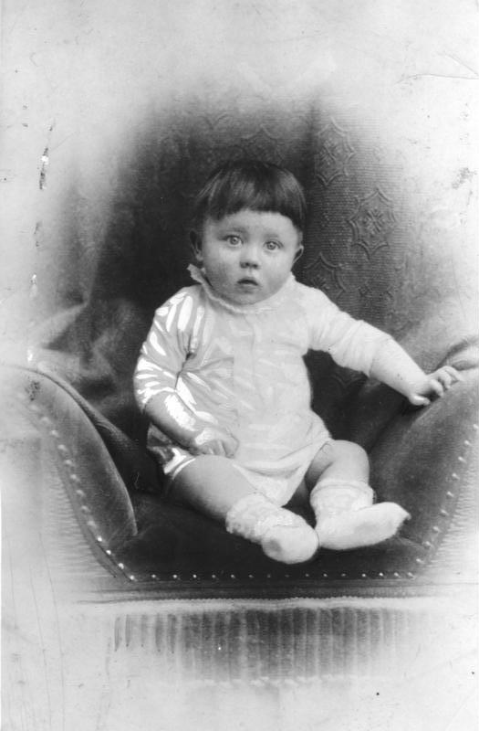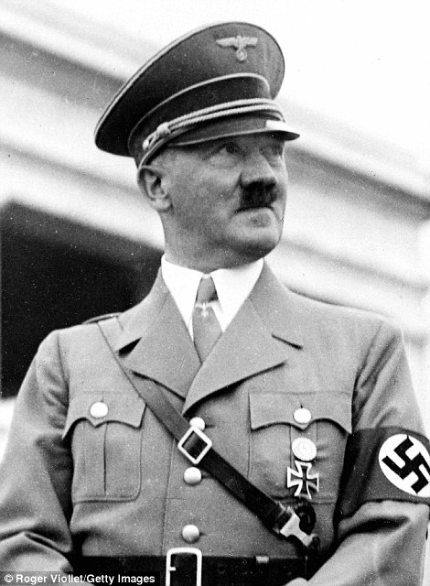
Birthplace: Adolf Hitler (left--a sweet little baby) was born in a room in what would become the notorious Gasthof zum Pommer, a Nazi shrine
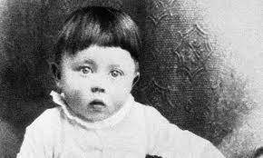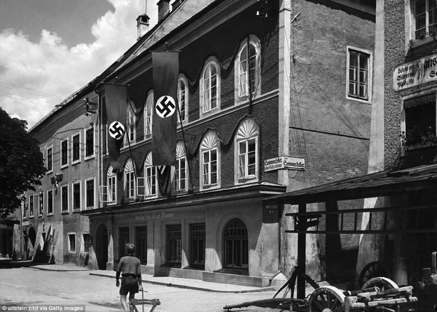
The Gasthof zum Pommer would become a focus point for Nazis in the 20s, 30s and 40s, with its owner Josef Pommer throwing his support behind the evil dictator, and even claiming to have know the family, although they left when Hitler was just three
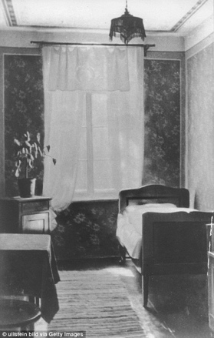
Above: This is the room where Hitler was born, and Josef would later turn into a museum, preserved by his adoring followers
Now, it is a bricks-and-mortar conundrum for authorities who wrestle with the legacy of its most notorious infant tenant, struggling to find a solution that preserves the historical meaning of this house without it ever falling into the hands of those who still worship at the shrine of Nazism. Yet, 127 years ago, it was just another guest house in Braunau-am-Inn, a town separated from Germany by a bridge across the river.
It simply happened to be the place where a minor customs official called Alois Hitler had made his home with his young wife, Klara. Alois, who had been posted in the town of Braunau am Inn since 1885, had married Klara in January 1885. Their wedding was held at Hitler's rented rooms on the top floor of the Braunau inn, where Hitler would be born four years later. The Hitlers would live in the house for just three more years before moving on.
They were long gone by the time Josef Pommer and his wife Maria purchased the house for 58,000 Austrian Kronen in 1912. At that point, Hitler was a penniless failed art student walking around the streets of Vienna.
But things would have been quite different for the Pommers - not to mention the town and his descendants - had Hitler not decided to write those lines in Mein Kampf 11 years later.
They would spark an outpouring of support in Braunau for Hitler's National Socialists - despite the party being banned in Austria. And it seems none were more supportive than Josef Pommer.
By the 1930s the town was filled with fanatical youngsters. Brownshirts would march through the area are destroying left-wing symbols and attacking anyone regarded as opponents. In 1933 the town narrowly managed to fight off a proposal to give honorary citizenship to Hitler.
The party remained banned, but Hitler's supporters met clandestinely - more often than not, at the Gasthaus zum Pommer. Members of the party would cross the river at night to attend them, and in October 1933 the Pommer's son had to answer for broadcasting Nazi propaganda.
Josef was unlikely to be the source of the complaint: he regularly filled his bar with National Socialists - no one else was welcome.
Six months after the radio broadcast the entire district was covered in Nazi propaganda, with posters demanding the 'demolition of the chains' of Engelbert Dollfuss, the Austrian leader who had banned the Nazi party. 'Only Hitler can save us,' said the posters.
Dolfuss was assassinated soon afterwards, and Braunau enjoyed one huge party.
By 1936, the swastika on a red flag had become a permanent feature hanging from the doors of the Gasthof zum Pommer, and a portrait of Hitler above the bar.
The same year, Hitler's older half-sister Angela Hammitzsch visited. The Pommer family by now had turned the room where he was born on the second floor into a tiny museum to the Fuhrer.
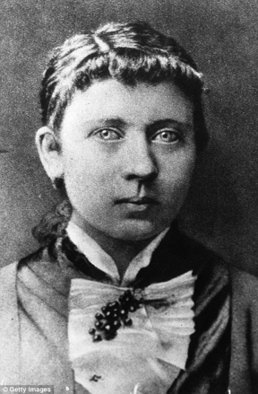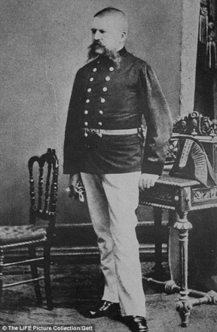
Parents: Hitler was born to Klara (left) and Alois (right) April 20, 1889. They had been married for four years. Adolf Hitler was the fourth of their six children. They remained at the inn, where they had married in 1885, for another three years after their son's birth.
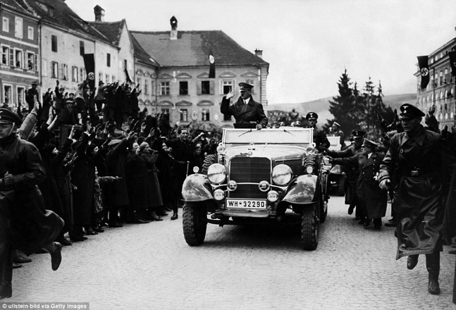
Homecoming: Hitler begins Mein Kampf, his 1923 autobiography, by stating in the first paragraph that 'it stands me in good stead today that Fate should have chosen that Braunau am Inn be my birthplace'. Pictured: Hitler in Braunau after taking Austria
In 1937, Josef was allowed to officially offer visits to the 'Fuehrerzimmer ' to German and other foreign tourists, although he was told Austrians had to be banned.
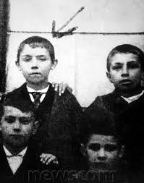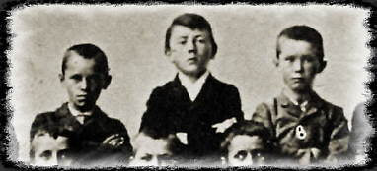
Left: Picture of Hitler at age 10 in a school photograph--1899
Right: School picture, Hitler in center, taken in 1900
Dark history: Hitler (pictured as a child) did not spend most of his childhood in Braunau, but in Leonding, the Austrian town still has a black mark against its name
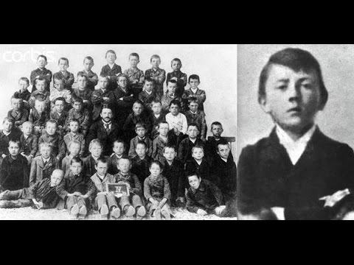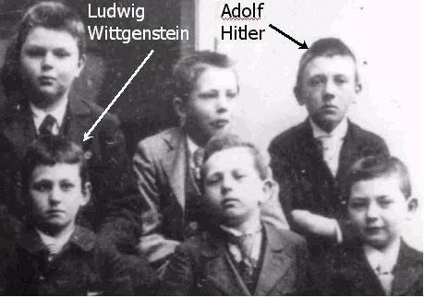
Hitler in a school photograph in 1901

In January 1938 he placed a plaque on the outside wall informing the world that here was the place of birth of 'German Fuehrer and Chancellor Adolf Hitler.’
The same year Hitler marched unopposed into Austria. Braunau celebrated with equal enthusiasm when, on March 12 that year (1938), nearly fifty years after he was born there, Hitler returned in an open topped car.
He visited the Gasthof zum Pommer briefly, apparently poked his head into the room where he came into the world, before motoring off to nearby Leonding, where he attended school and where his parents were buried.
The Anschluss, or union, was the catalyst for his birth house to morph from dingy provincial pub to shrine. No self respecting Nazi could afford to blot his record by failing to make at least one odyssey there.
Braunau thrived on this wave of 'brown tourism', so named from the shirts that the original stromtroopers of the movement wore. Martin Bormann, who had become the Fuehrer's personal secretary in 1935, saw the opportunity in this pilgrimage tourism to turn the Gasthof into the central place of worship for the party faithful.
Bormann persuaded the Pommer family to part with their property for 150,000 Reichsmarks, four times the market value. In addition, the plot of land on which the house was located was allowed to remain the property of the Pommers. Local newspapers from the time reported that the negotiations went on for a long time because the Pommers wanted to drive it up as high as possible.
The Nazis spent a further 150,000 Reichsmarks were on repairs, and managed to track down the former housekeeper, who had lived with the Hitlers when he was born, Rosalia Hörl.
With her help the original room in which Hitler was born was restored to its original appearance, and postcards showing the house, and in particular the bedroom, were distributed among the party faithful. It also boasted a Nazi culture centre and public library, while at the back of the property the Braunaer Gallery was created there, where authorized party-approved artists exhibited.
Braunau, from 1938 until 1944, enjoyed a prosperity it had not achieved since the days of the salt trade--restaurants boomed, souvenir shops proliferated. There were at least 10 photographic agencies in town.
With the money that they had made from the sale of the property, the Pommers managed to buy another home and still had enough left over to live comfortably without working.
They, too, cashed in on the Nazi tourism tsunami. Eager party members queued up to buy beers for the couple at the other pubs in town, lapping up fabricated stories about how they knew the Hitler family. There is nothing to indicate there was any truth in the claim.
There were even claims the inn had healing powers, and it briefly became a magnet for sick people, who came to salute the house, touch it and hope for a rejuvenating cure.
But towards the end of 1944, the tourism had dried up and the bedroom was locked up, while the natal bed removed to Berlin for safe storage.
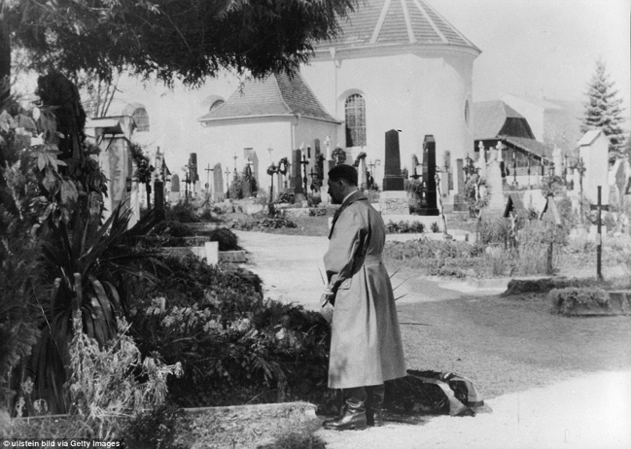
Legacy: Hitler's parents are buried in Leonding, which he visited after Braunau following the annexation of Austria. The inn where he had been born had been known as a meeting
house for Nazi sympathizers long before he arrived.
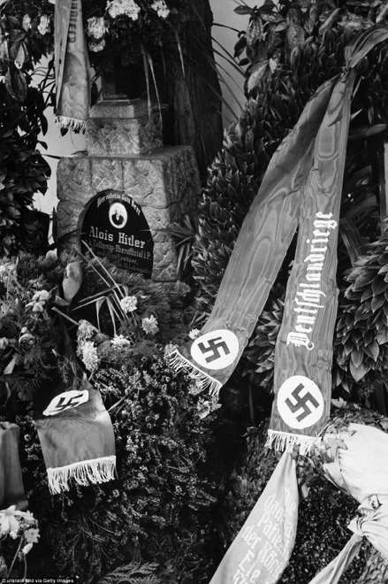
Mania: The area had embraced its ties with Hitler, and Josef Pommer was no exception, only allowing Nazi supporters in his bar. His son was even arrested after Nazi propaganda was heard coming from the windows of his room
In May 1945, as the Americans advanced, fanatical Nazi Gauleiter August Eigruber decided to destroy the Hitler house so it could not become a trophy of war for the Allies.
But the Americans got there first, and it was a solider with Jewish roots who made it into the room first. He told local political leaders to promise that the property 'would be made into an eternal memory of what had happened here' - including not leaving it empty to become a shrine.
They agreed. It eventually passed into the hands of the town - but there was a problem: the widow Pommer demanded the inn was returned, arguing neither she nor her husband had ever been Nazis. She said that the Nazis had declared them unworthy to continue to operate it, claiming Borrmann had told them to accept the price - or the matter would be sorted out 'in another way.'
Maria died in 1948, but her daughter Kreszenzia won the battle, also claiming the theoretical amount of money that the family had lost by not being able to run the guesthouse any longer.
She took back the house for the extremely low price of 150,000 shillings. In the 1950s the local council rented it for a class of schoolchildren, and then a bank. Should the Pommers fail to find a tenant, the council was always prepared to take over the lease, for obvious reasons.
Every now and again plans would attract international attention - like a scheme to turn it into an art museum - with an exhibition dedicated to Nazism at its heart, complete with swastika flags, Hitler photos, and Nazi kitsch Christmas tree ornaments. They were shelved.
For the last five years it's been empty because Gerlinde Pommer - Josef's granddaughter - refuses to refurbish or sell it, leaving it useless. But she does continue to receive £3,800 a month to keep the place empty. No one can do anything until Gerlinde relents - and as no one knows what motivates her, the impasse looks set to continue.
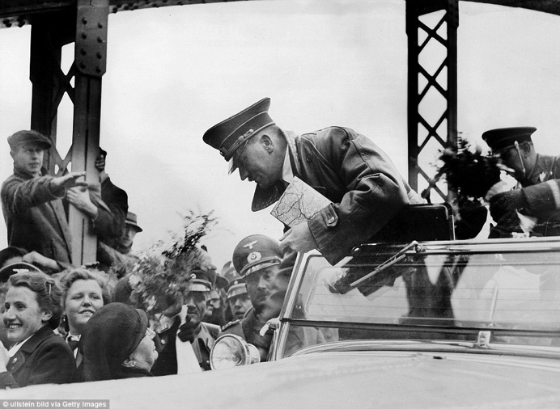
Infatuation: In the late 1930s, Pommer created the museum, which only foreigners were allowed to visit originally, under Austrian law
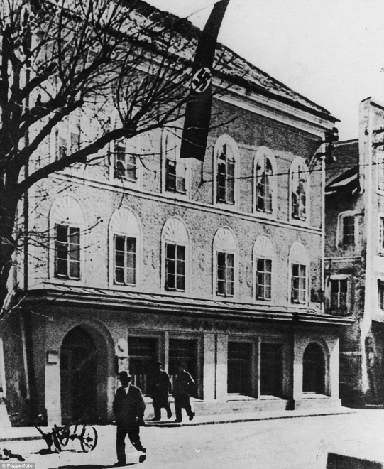
Boom town: When the war began, the entire town benefited from a boost in 'brown shirt' tourism, with Nazis flooding in to visit
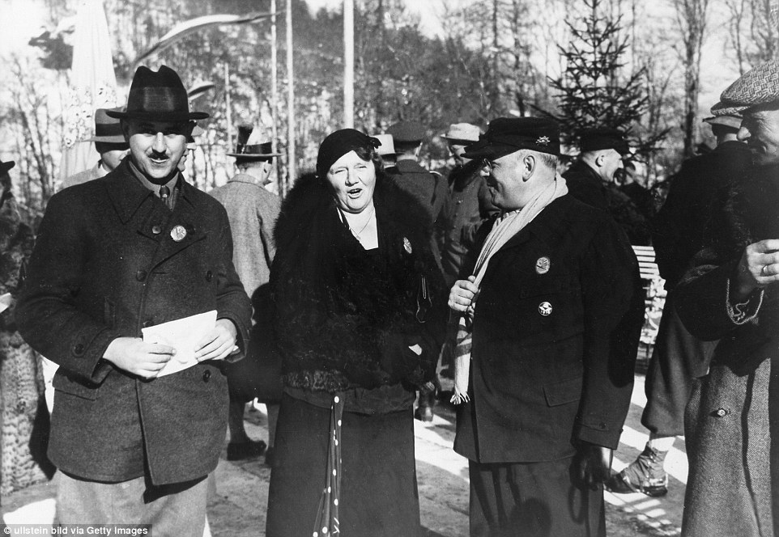
Links: Hitler's sister, Angela Hammitzsch (centre), visited the museum, and was said to be 'proud' of what it showed
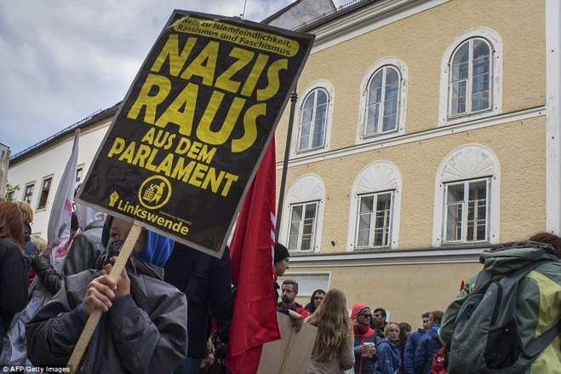
Controversy: The inn was sold to the Nazis for an inflated price at the start of the war. It then passed back to the Austrian government, before the Pommers announced they wanted it back. They still own it today - but it stands empty as they can't agree on its future
Wealthy: Pommer's granddaughter still gets £3,800 a month from the government so she doesn't rent it to Hitler enthusiasts

From Yedidah’s research:
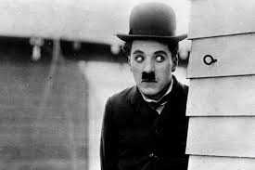
Charlie Chaplin was born only 4 days before Hitler, on April 16, 1889. He died in December 25, 1977. He had a hard bringing up, yet he turned out to be a winner that people remember for good to this day. Hitler turned out to be an evil fiend, a child of Satan, a mass murderer, to be so remembered by history. Born Charles Spencer Chaplin in London, England, on April 16, 1889, Charlie Chaplin's rise to fame is a true rags-to-riches story. His father, a notorious drinker, abandoned Chaplin, his mother and his older half-brother, Sydney, not long after Chaplin's birth. That left Chaplin and his brother in the hands of their mother, a vaudevillian and music hall singer who went by the stage name Lily Harley. Chaplin's mother, later suffer severe mental issues and have to be committed to an asylum, was able to support her family for a few years. But in a performance that would introduce her youngest boy to the spotlight, Hannah inexplicably lost her voice in the middle of a show, prompting the production manager to push the five-year-old Chaplin, whom he'd heard sing, onto the stage to replace her. Chaplin lit up the audience, wowing them with his natural presence and comedic angle… his mother’s career ended. By the age of 26, Chaplin, just three years removed from his vaudeville days, was a superstar. He starred in 35 movies.
----------
Is Hitler’s Daughter Angela Merkel?
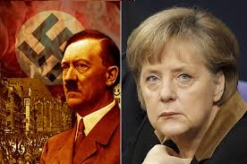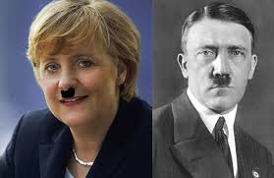

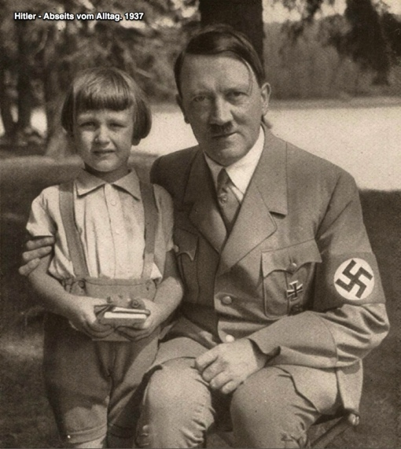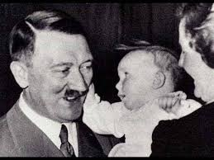
My comment: First picture (right) I’ve ever seen of Hitler smiling

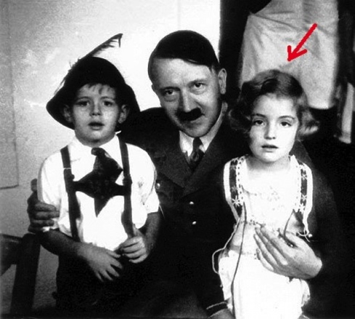
Hitler with his daughter
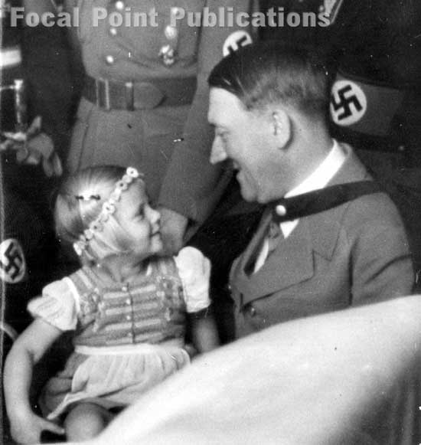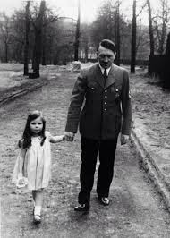
Here he is smiling again … such a nice daddy …
Is Angela Merkel Hitler's Daughter?
THE FOURTH REICH
Angela Merkel was born in the D.D.R., the Communist portion of Germany in 1954. Her biography says she was born on July 17, 1954, and that she is the daughter of a Lutheran minister from an East German-controlled church. Recently, however, Soviet KJB archive files reveal an entirely different story. Stasi GDR files indicate that she was born on April 20, 1954, and details of her birth were included in the records of the German Dr. Karl Klauberg, who was one of the Nazi "death doctors" convicted by Soviet courts and imprisoned. When he later was recognized as a brilliant scientist, he was released after seven years and was recognized as the father of artificial insemination. [Hitler was born April 20, 1889]
The Soviets were even more intrigued when they discovered Dr. Klauberg had preserved frozen samples of the sperm of Adolf Hitler. The forces of darkness in high places decided to try to produce a child from Hitler's sperm, obviously for occult and illuministic purposes. Dr. Klauberg then brought the youngest sister of Eva Braun (Hitler's wife), whose name was Gretl, to Eastern Germany, and the result of the experiment produced not a biological son of Hitler, but rather a daughter. Amazingly, Adolf Hitler was born on April 20th, 1889, and Angela Merkel was born on April 20th, 1954. (April 20th is 11 days before the witches' high sabat of Beltaine.) Angela became a custodian of the Catholic Church through its connections with the East German Lutheran Church. Once a German Pope would take the Roman throne, Angela Merkel was to also take her biological father's position as German Chancellor.
On April 20th, 2005, the Nazi Joseph Ratzinger became Pope Benedict XVI, (16th), precisely on the 116th birthday of Adolf Hitler. Then on November 22nd, 2005, Hitler's biological daughter, Angela Merkel was elected Chancellor of Germany. The day of that election, November 22nd, was the anniversary of the publication of Charles Darwin's Origin of the Species, which is an antichrist publication denying the Creator of the universe.
If the Soviet record is true, and the evidence is strong, it opens up some amazing possibilities. The undeniable fact is that Angela Merkel came from obscurity to triumphal power as German Chancellor, President of the European Union, and head of the powerful G-8 economic cartel. When I began to do further research on this, I discovered that Hitler's father, who took the name Hitler, was the illegitimate son of a Rothschild mistress whose last name was Schicklgruber. The etymology of the name Hitler reveals that the name means a shepherd who lives in a hut. The name Adolf from Old High German means noble wolf. Thus, his combined name indicates that he was the Shepherd Wolf, or false shepherd. Strangely enough, Pope Ratzinger, or Benedict XVI, also has the title of Shepherd of the Church, and since he took office, the Roman Catholic Church has had a German shepherd. Incidentally, that breed of dog resembles a wolf. We also know that Adolf Hitler nicknamed himself Herr Wolf. His East Prussian headquarters was called Wolfsschanze; his headquarters in France was called Wolfsschlucht, and his headquarters in the Ukraine was called Werwolf. Will the powerful European Union become the New World Order and Fourth Reich? Only God knows.
One more interesting point is that, like Hitler, Chancellor Angela Merkel has an unusual obsession with the works of the occult composer Richard Wagner, who was a Satanist. She made her obsession known in an interview with the newspaper Frankfurter Allgemeine Zeitung in July 2005. Wagner wrote the infamous composition called Parsifal, which is purely occult and demonic. Parsifal was a favorite of Adolf Hitler as well, and Hitler stated that the music of Wagner occupied his mind. Angela Merkel, like Adolf Hitler, is deeply fascinated with Wagner's Ride of the Valkyries. The valkyries were minor female deities that would ride through every battle to gather the most valiant of the slain and carry them off to a place called Valhalla where they would wait to join the army of Odin in the last battle at the end of the world.
http://www.thecontroversialfiles.net/201...ghter.html
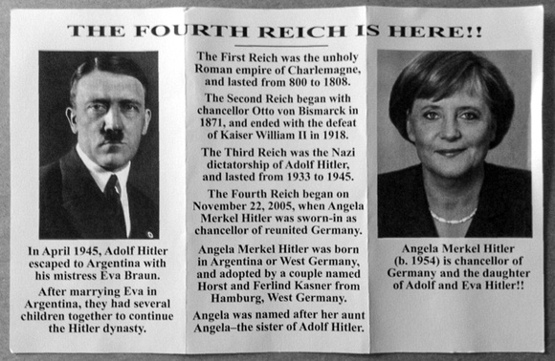
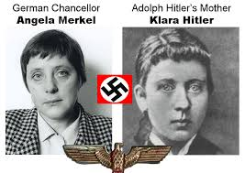
The Most Powerful Human Being on Earth... Adolf Hitler's Daughter... Angela Merkel! Submitted by SadInAmerica on Sun, 02/12/2012
It is with troubling concern that we report today that the Western Nations have announced this week that the ancient German city of Meerholz, Germany has now become the ‘Heart’ of the European Union with the inclusion of the former Soviet block nations of Bulgaria and Romania. ~ May 28, 2011 - The symbolism of this ancient citadel, founded in 1170 by the German Emperor Frederick Barbarossa, (who was also crowned the Holy Roman Emperor in 1155, has been known throughout history as Barbarossa).
Being the ‘Heart’ of Europe cannot be lost upon our World of today, particularly when viewed in the light of the German Chancellor Angela Merkel’s vow today to unite all of Europe under one single constitution, which in effect would wipe out the National Sovereignty of all the countries in the European Union. This vow being made by Angela Merkel to unite the European Continent under one flag cannot be ignored, especially when viewed in the light of still secret, but ‘obtainable’, Soviet KGB archive files which present a terrifying portrait of the present German Chancellor as being the daughter of the former German Nazi Leader, Adolf Hitler.
Though said to be born on July 17, 1954 in the former Soviet controlled German Democratic Republic (East Germany), Angela Merkel’s Stasi GDR file (currently still held in the Soviet KGB archives) states that she was instead born on April 20, 1954, the birth date of her ‘true’ father, Adolph Hitler who was born on April 20, 1889.
The means of Angela Merkel’s birth, as detailed in these documents, was based upon the research of the German Doctor Carl Clauberg, and though classified as one of the worst Nazi ‘Angel of Death’ doctors, and convicted by the Soviet Courts as being a ‘war criminal’, was nevertheless freed by the Soviets as he was recognized as being the ‘Father’ of artificial insemination.
According to these reports, Doctor Clauberg was released by the Soviets after serving only seven years of his sentence in return for turning over to the KGB his hidden files on his Nazi artificial insemination experiments and, more horrifically, the frozen sperm of the former Nazi Dictator, Adolf Hitler.
Upon their receipt of the Nazi files on artificial insemination, along with Hitler’s frozen sperm, the Soviet Politicheskoye Buro (Politburo) authorized the experiments to ‘resurrect’, ‘if possible’, a child bearing the ‘genetic markers’ of Adolph Hitler.
Doctor Clauberg then brought to the GDR (Communist East Germany) the wife of Adolph Hitler’s, Eva Braun, youngest, and most devoted to the Third Reich, sister, Gretl to be the ‘surrogate’ mother for the intended offspring of the Hitler’s frozen sperm.
It was ‘reasoned’ that the combining of the genes between Hitler’s sperm and Eva Braun’s closest family would produce for the Soviets a ‘near match’ of what a child of Hitler and Eva Braun would have been, should one have been born.
Upon the birth of Angela Merkel April 20,1954 it was ‘agreed upon’ by the Soviets, Americans and the Vatican, that she would be ‘placed’ under the ‘control’ of the Catholic Church through its ‘connections’ with the GDR Lutheran Church, and whom she was in fact placed with.
Doctor Clauberg, after the birth of Hitler’s Daughter, and upon his return to West Germany was promptly imprisoned and then murdered almost two years later while still in custody of the West German and Americans.
In the, aforementioned, ‘agreement’ between the Soviets, the Western Powers and the Vatican, the ‘ascendancy’ of Hitler’s Daughter to power could not be achieved until the Vatican also brought to power a German Pope.
This was accomplished in 2005 following the death of Pope John Paul I, and which then brought to power the former German Nazi Joseph Ratzinger, and who is now known as Pope Benedict XVI, and who assumed the Leadership of the Roman Church on April 20, 2005 following his election the previous day.
(It goes without mentioning the significance of the present Nazi Pope taking power on the 116th birthday anniversary of Adolph Hitler.)
Quickly following the Nazi German Pope to European power, Hitler’s daughter was elected as the Chancellor of Germany on November 22, 2005, and which is one of the most significant dates for the World Globalists.
It was on November 22, 1859 that the ‘final assault’ upon Christianity was made with the publishing of Charles Darwin’s "On the Origin of Species by Means of Natural Selection," and whose intention of fragment the Western Worlds peoples from their truest origins, and meanings, has succeeded beyond their expectations.
Today, the daughter of Hitler, holding the same office as her father, Chancellor of Germany, is now the most powerful human being on our Earth as she is also the President of the European Union (EU) and the head of the powerful Western Economic Block known as the G-8.
More concerning, however, is that her Fathers dream of uniting Europe under German/Vatican control through war is now to be accomplished by his Daughter using deception.
As we have been taught from our ancient past, in the uniting of the Continent begins the destruction of our present World, and which as the New Comet runs, and as Mabus has died, begins the tribulations of awakening and Final Destruction of the dragons of old.
May 28, 2011 - posted at LibertyBroadcastingNetwork
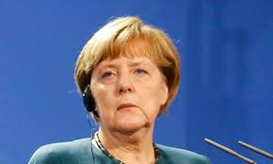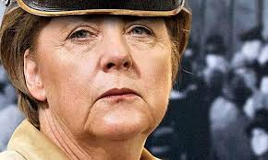
Here, her mouth looks more like Hitler’s downturned mouth
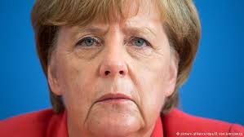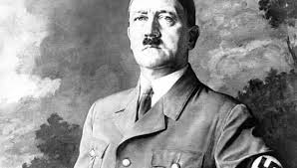

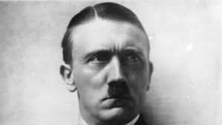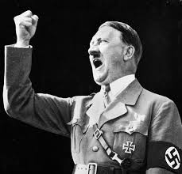

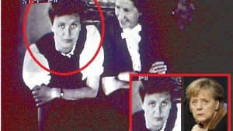
Hitler’s mother and Angela
Angela Merkel, according to documents the Stasi police, the successor of Adolf Hitler!
According to the documents main secret intelligence service of the German Democratic republic known as the Stasi, the former chair of Chancellor Hitler's Germany Asel is neither more nor less than his daughter!
In fact, in 1954, was born a girl for whom the Stasi claimed that it was just Angela. The official date of birth is July 17, 1954. However, as argued in the documents of the secret police, who are currently in the Soviet KGB ARHOVA--her real birthday on 20 April 1954. Hitler’s birthday was April 20, 1889.
If you believe this secret service, the daughter of Adolf Hitler was born exactly on his birthday. "Angel of Death" Hitler revived
For details about the birth of Angela Merkel noted Dr. Karl Klauberg, one of the worst Nazi "angel of death", which is a Soviet court convicted war criminal.
The Klauberg had served only seven years of the sentence, after which the Soviet authorities released him in exchange for the secret police, the Stasi document of Klaubergovoj technique of artificial insemination, and more important, the frozen sperm of Adolf Hitler.
Hitler's father, who changed his real surname in Hitler, was the illegitimate son of Solomon Rothschild and his mistress Mary Anne Šiklgruber.
Soviet Cominform, in addition to the Nazi secret about artificial insemination, so i got hold of Hitler's frozen sperm and gave the green light to start CPR genes Adolf Hitler!
So Klauberg led Gretl Braun, youngest sister of Eva Braun in East Germany. She was elected as a surrogate Hitler Youth. When the job is done Klauberg returned to West Germany, was soon arrested and killed two years later, while his trial was still pending.
The agreement on world domination!
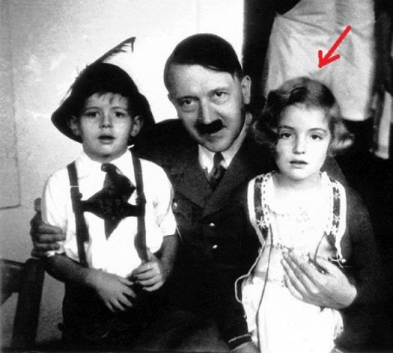
Shortly after the birth of girls, Soviets, Americans and the Vatican signed an agreement, according to which the child has control over the Catholic Church, which was well connected with the Lutheran Church in East Germany, which officially took "custody" of the baby.
They gave her a fake birth date as July 17th, and the name Angela Dorothea Kasner. For false father, Horst Kasner was determined by a pastor in the Lutheran Church, and her mother was allegedly Herlind, a teacher of German and English. one of the provisions of the contract on three sides is that the Angels to international power, but that will have to wait until the Vatican on his forehead does not place the pope from Germany.
After the death of Pope John Paul II, at the head of the Catholic Church on April 20, 2005, he was appointed Nazi Joseph Ratzinger, who later took the name of Pope Benedict XVI. Is it really a coincidence that and it just happened to Hitler's birthday?
In 1977, Angela Dorothea Merkel became Kesner, married to a physicist Ulrich Merkel. She divorced in 1982 and she was elected Chancellor of Germany shortly after Pope Ratzinger took over the leadership of the Catholic Church, on Hitler's birthday!
-----------------------------------------------------------------
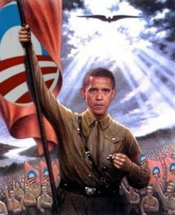
Obama as Hitler by eurokultur
Yedidah’s insert: Please refer to my research-article: “It’s All About Worship” with many pictures to do with Obama’s ID with Hitler-status.
Obama began copying Hitler in many ways in 2008, before even his nomination for President. Obama made a speech in Berlin, giving the Nazi salute to thousands of onlookers under the monument to Hitler’s glory. The salute was returned by the audience. He held them spellbound with his speech about the glory o Berlin and Germany.
His acceptance speech was given on a replica of the Pergamum Altar, in Denver, Colorado.
Hitler delivered his “final solution” speech from a replica of the Pergamum Altar. The real Altar of Satan, of Zeus, is in the Pergamum Museum in Berlin.
------------
Hitler and the Woman Behind His Flying Saucers Maria
The Woman Behind Hitler's Flying Saucers Maria Orschitsch
6/24/2016 Tales from Out
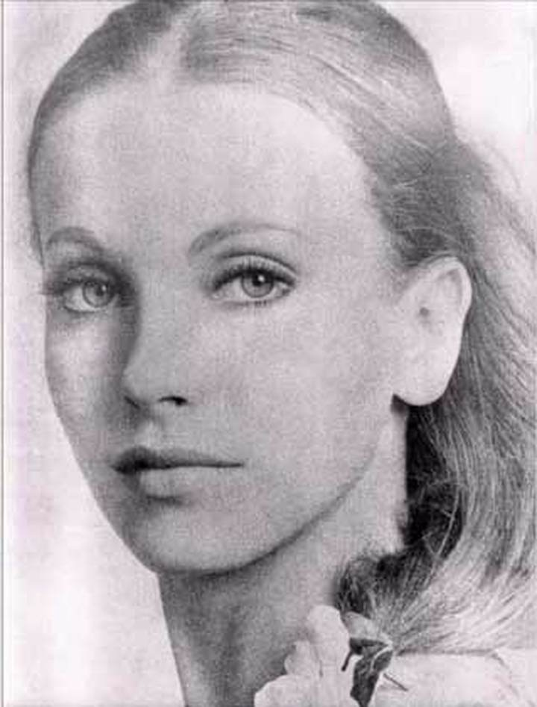
Maria Orschitsch, a member of the Vril-Gesellschaft would obtained telepathically messages from extraterrestrials in a code language of the Knights Templar, a language that was unknown to her.
The messages allegedly contain technical information about the construction of a UFO. Hitler gave at the end of World War II mission to build flying saucers, claimed a report in the German science magazine PM.
Mary Orschitsch was a well-known medium and would have been the head of the Vril-Gesellschaft. They gathered a large number of young women around them.
​They had long ponytails, something that was very unusual at that time. They believed that their long hair acted as a cosmic antenna to communicate with extraterrestrials. Vril members, also known as “Vril.”
According to the Vril documents these messages, would be obtained telepathically, from Aldebaran, 68 light years away in the constellation Taurus.
Maria had two stacks of papers, one written in code language of the Templars, the other in an ancient oriental language.
They got help from the Pan-Babylonians, a group that had close ties with the Thule Society which was formed among others by archaeologist Hugo Winckler, physicist Peter Jensen and Assyriologist Friedrich Delitzsch.
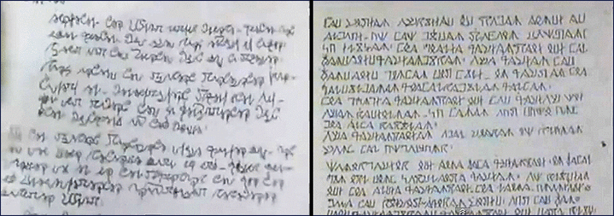
t turned out that the second stack of documents were written in Sumerian. Sigrun helped translate the messages and decipher the strange images of a circular flying machine.
Prototype
According to skeptics, there has never been a Vril-Gesellschaft in Germany and Louis Pauwels made up this story.
However, several sources confirmed independently that the UFO projects were not a made up story.
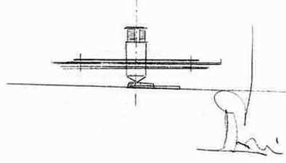
​Several years ago, the German science magazine PM claimed in a report that Hitler gave at the end of World War II to build flying saucers. According to PM a prototype actually flown and certainly 15 prototypes were created.
The magazine had quoted eyewitnesses that the UFO with the Iron Cross, the symbol of the German army, saw flying over the Thames in 1944. The Americans also had the vessel detected on their radar as a potential danger.
Mary Orsic disappeared in 1945. Rudolf von Sebottendorf, founder of the Thule Society, committed suicide by jumping into the Bosphorus. Most members of Thule and Vril came from the upper strata of society.
After the war, many Nazi scientists were employed by NASA, where they made a great contribution to the development of the American space.
Source: http://humansarefree.com

-------------------------
Hitler: British Royal Family and their Nazi Connection
December 23, 2015 – New Eastern Outlook website
The Nazi Connected British Royal Family Still Wields Incredible Power
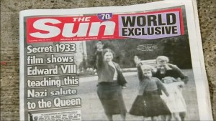
Bewilderingly, whenever a revelation details the prominent role the royal family still plays in the running of the British state; many people in the UK are surprised and shocked. After all, anyone who has grown up in the UK knows that you are constantly told the “royal family has no power”; the “monarchy is just vestigial”; and the “Queen is just a figurehead.” The evidence however shows that the British royal family still holds considerable power, in addition to having ties to one of the most abhorrent regimes in human history.
The roots of the current reigning British royal family can be traced back to an ancient European dynasty known as the Wettin dynasty, whose origins go back to the 10th century AD. In 1840, Queen Victoria – who was a member of the House of Hanover – married her cousin, Prince Albert of Saxe-Coburg and Gotha, thus introducing the line of Saxe-Coburg-Gotha into Britain. When Queen Victoria died in 1901, the reign of the House of Hanover ended, and she was succeeded by her son, Edward VII, from the House of Saxe-Coburg-Gotha. In 1917, during World War I, King George V changed the royal family name from Saxe-Coburg-Gotha to Windsor, due to a strong anti-German sentiment at the time.
Today, the royal family still holds significant power in the country, with Queen Elizabeth II remaining the head of state and the constitutional monarch. Following a three-year freedom of information battle, it was recently revealed that Prince Charles and Queen Elizabeth II have received confidential cabinet papers for decades, pertaining to the workings of the British government. This revelation comes shortly after a number of formerly private letters were released to the public, which detail how Prince Charles has lobbied government ministers on an array of issues.
The Queen and Prince Charles also have the power to veto bills they oppose, a power the Queen exercised in 1999 when she vetoed the Military Actions Against Iraq Bill. For a bill to become law in Britain, the Queen is still legally required to give royal assent. As the UK Parliament website explains:
“Once a bill has completed all the parliamentary stages in both Houses, it is ready to receive royal assent. This is when the Queen formally agrees to make the bill into an Act of Parliament (law).”
Cameron is Related to the Queen
The Prime Minister and the Queen meet privately every week, and following the general election, “the appointment of a Prime Minister is the prerogative of the Sovereign.” In fact, the current Prime Minister, David Cameron, is a distant relation of the Queen. They are both related to William IV – the King of the UK from 1830 to 1837 – and according to certain genealogists, Cameron is the Queen’s fifth cousin twice removed.
The British monarchy is also fabulously wealthy, although their wealth is difficult to calculate as a percentage of it is not declared. Reutersestimates that the British monarchy “has nominal assets worth about 22.8 billion pounds.”
The Windsor’s and the Nazi’s
The Windsor’s connections to Nazi Germany go far beyond Prince Harry wearing a Nazi costume to a friend’s party, and footage of the Queen giving a Nazi salute in the 1930’s. The Queen’s uncle, Edward VIII, who was the King for a brief period in 1936 before abdicating to marry Wallis Simpson, is well-known to be a Nazi sympathizer.
In 1937, he visited Nazi Germany along with his wife, meeting Adolf Hitler and other high-level Nazi officers. The BBC even reports that during his visit to Germany, evidence suggests he went “to the early stages of a concentration camp.” Karina Urbach, a historian and author, also argues that Edward VIII advocated a bombing campaign being waged against Britain prior to the German onslaught.
Prince Phillip, the Queens husband, and a man who stated in a 1984 interview that the human population was “reaching plague proportions”, has numerous ties to the Nazi regime, with many members of his family marrying high-ranking officers. As the Times of Israel and AFP reported in an article titled, Buckingham Palace braces for new documentary on Nazi ties:
“Three of Prince Philip’s sisters were married to senior Nazi officers, including Sophie, who wed Prince Christopher von Hessen, head of the SS in the Air Ministry.”
Princess Sophie reportedly described Hitler as a “charming and seemingly modest man”, in addition to being photographed attending the wedding of the Nazi war criminal, Hermann Goering, in 1935.
Prince Bernhard of the Netherlands, who was one of Prince Phillip’s closest friends, also had close ties to the Nazis. Both men were heavily involved with the World Wildlife Fund (WWF) and the surreptitious Bilderberg Group.
Prince Bernhard joined the Reiter SS Corps in the 1930’s, in addition to working for the German chemical giant IG Farben – which “established a synthetic oil and rubber plant at Auschwitz” during World War II, resulting in numerous company officials being prosecuted for war crimes after WWII. Annejet van der Zijl, a Dutch writer, also argues that the Dutch Prince was a member of the Nazi party until 1934, although the Prince has always denied this charge.
These dark family ties also bring new levels of hypocrisy to Prince Charles’ comments last year, when he allegedly compared Putin to Hitler.
Although the Windsor’s connections to the Third Reich are shocking, what is perhaps more disturbing is the fact that the people of Britain have allowed these elitists to rule over them for so many years.
Steven MacMillan is an independent writer, researcher, geopolitical analyst and editor of The Analyst Report, especially for the online magazine “New Eastern Outlook”. First appeared: http://journal-neo.org/2015/12/23/the-nazi-connected-british-royal-family-still-wields-incredible-power/
[Yedidah’s input: In World War II and before, the British monarchy supported Hitler, as did American businessmen from his beginnings to his attack on Poland, to his escape to South American and/or the South Pole. The British monarchy has its roots also in the Plantegian and Angivan families – satanic rooted families. The Queen was also in the Carlye Group with the Bush family and Osama bin Lauden – they were business partners and friends. Yes, the monarchy is just a figure-head … for the real world rulers are the popes of the Gotha family lineage, and the City of London world economy-controlling empire]
***LOOK FOR MY SOON-TO-BE-RELEASED ARTICLE ON THE “CITY OF LONDON”
-------------
Astonishing’ photo album showing Duke of Windsor meeting Hitler smashes expectations at auction - Chris Cheesman - March 11, 2016
Amateur Photographer
A photo album that shows the Duke of Windsor meeting Adolf Hitler on a trip to Germany in 1937 has outstripped expectations by raising more than five times its pre-auction estimate.
image: http://keyassets.timeincuk.net/inspirewp/live/wp-content/uploads/sites/12/2016/03/nazi-404x400.jpg
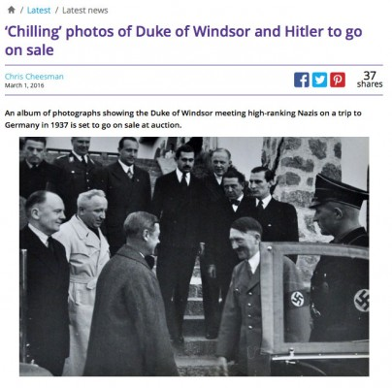
-------------
Hitler and the Jesuit Order
Alan Lamont New YouTube Channel - Tuesday, 8 December 2015
ADOLF HITLER AND THE JESUIT ORDER
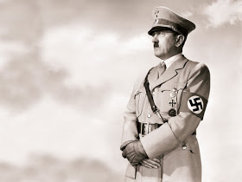
If there be any doubt about Hitler's close ties to the Jesuits, Listen to his own words as recorded in 1939 by Hermann Rauschning, former national-socialist chief of the Danzig government: Quote from Hitler
"I learned much from the Order of the Jesuits", said Hitler... "Until now, there has never been anything more grandiose, on the earth, than the hierarchical organization of the Catholic Church. I transferred much of this organization into my own party... I am going to let you in on a secret... I am founding an Order... In my "Burgs" of the Order, we will raise up a youth which will make the world tremble... " Hermann Rauschning, former national-socialist chief of the government of Dantzig: "Hitler m'a dit", (Ed. Co-operation, Paris 1939, pp.266, 267, 273 ss). According to Raushning, Hitler then stopped his speech, abruptly saying: "I can't say anymore."
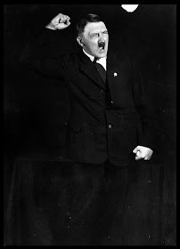
However, after the war, Walter Schellenberg, former of chief of German counter-espionage, finished Hitler's speech, confirming Hitler's strong behind the scenes ties to the Vatican and the Jesuit Order.
"The S.S. organization has been constituted by Himmler according to the principles of the Jesuit Order. Their regulations and the spiritual exercises prescribed by Ignatius of Loyola were the model Himmler tried to copy exactly.
"Himmler's title as supreme chief of the S.S. was to be the equivalent to the Jesuit General and the whole structure and direction was a close imitation of the Catholic Church's hierarchical order.
And French writer Frederic Hoffet in 1948 wrote:
"Hitler, Goebbels, Himmler and most of the members of the party's old guard were Catholics. It was not by accident that because of its chief's religion, the Nationalist-Socialist government was the most Catholic Germany ever had This kinship between socialism and Catholicism is most striking if we study closely the propaganda methods and the interior organization of the party QUOTE BY HITLER 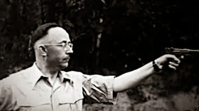
HIMMLER "I can see Himmler as our Ignatius of Loyola" ~Adolf Hitler: "Libres propos" (Flammarion, Paris 1952, p.164).
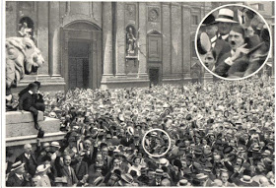
"On that subject, nothing is more instructive than Joseph Goebbel's works.
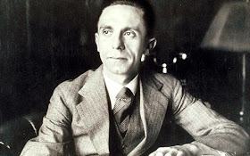
He had been brought up in a Jesuit college and was a seminarist before devoting himself to literature and politics Every page, every line of his writings recall the teaching of his masters; so he stresses obedience the contempt for truth."
"Some lies are as useful as bread," Goebbel's once proclaimed, taking his words from extracts of Ignatius of Loyola's writings.
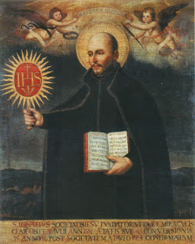
As quoted by Edmund Paris in his final 1975 work, the Secret History of the Jesuits,
another well-informed insider of the pact between Berlin and the Holy See

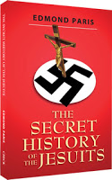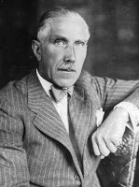
[Good book! Yedidah’s curiosity in 2016 before learning of the cloning going on: Pope Francis, a Jesuit, is looking for a political leader to join with for world rule. Could it be that a cloned Hitler and this pope would join together, or a world-power Hitler-type? Daniel 8 talks about a man “fierce of face.” Could Hitler be Beast 1 and the Pope Beast 2? We’ll see…]

Franz von Papen was even more explicit when he said: "The Third Reich is the first world power which not only acknowledges but also puts into practice the high principles of the papacy."
And what essentially was put into practice was 25 million victims of concentration camps, the official figure once released by the United Nations. But do such barbaric acts belong to the past?
By no means, barbarianism continues today as evidenced by the U.S. government's illegal invasion in the Middle East as well as its own siege on U.S citizens by advancing a bogus war on terror.
Adolph Hitler, although hidden by the scholars, in his own words show the Third Reich was organized like the hierarchical organization of the Catholic Church, using Jesuit spiritual exercises. Certain things in history get lost in the shuffle like Adolph Hitler's loyalty to the Vatican and his eternal gratitude paid to the Jesuit Order. Hitler served the Catholic Church faithfully and he wasn't afraid or ashamed in admitting his endless devotion to the Society of Jesus. And if one looks closely, President Obama has the same look, feel and rhetoric of a modern day Hitler. In fact, he can be looked at as the Vatican's new boy on the block or its Americana version of Hitler as he pushes his fascist-war mongering agenda on the people of the United States and the people of the world. "And you can bet that the Vatican and the Jesuit Order are behind everything," but the Vatican placed Adolf Hitler in power. For example, Knight of Malta Franz von Papen from the Center Party helped the Nazis to receive political power in the German Parliament. The Vatican entered into a concordat with Hitler [which was signed in the Vatican by Von Papen and Cardinal Secretary of State: Eugenio Pacelli (later Pope Pius XII), on July 20, 1933], as with Mussolini, Franco and Salazar. Von Papen was the personal advisor to Pope Pius XII. “The SS had been organized by [Heinrich] Himmler according to the principles of the Jesuit Order. The rules of service and spiritual exercises prescribed by Ignatius de Loyola [Ed. Note: the founder of the Jesuit Order] constituted a model which [Heinrich] Himmler strove carefully to copy. Absolute obedience was the supreme rule; every order had to be executed without comment.” – Walter Shellenberg (Chief of the Nazi Sicherheitdienst) Quote by Spanish dictator (Francisco Franco, “Adolf Hitler, son of the Catholic Church, died while defending Christianity. It is therefore understandable that words cannot be found to lament over his death, when so many were found to exalt his life. Over his mortal remains stands his victorious moral figure. With the palm of the martyr, God gives Hitler the laurels of Victory”. - Spanish dictator (Francisco Franco, Knight of the Order of Christ) published on the 3rd of May 1945, the day of Hitler’s death. (“Reforme”, 21st of July 1945.) “Fascism is the regime that corresponds most closely to the concepts of the Church of Rome.” – Quote Civilta Cattolica (House organ of the Jesuits)
Even his Mein Kampf book was written, for Hitler, by German Jesuit Staempfle. So, a Vatican/Nazi link is for real.
The great author Jack Chick is absolutely correct to point to the Holocaust as a 20th century Inquisition. William (“Wild Bill”) Joseph Donovan is an elite Vatican personage.
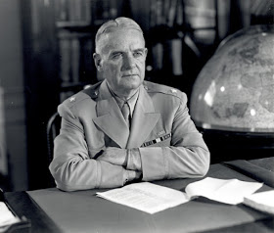
Donovan was a dedicated Roman Catholic until his death. He was the leader of the OSS. The OSS was the precursor of the CIA. Donovan was also a member of Phi Kappa Psi Fraternity, and he graduated from Columbia in 1905. Being a veteran of WWI, he will get an abundant of military including intelligence experience in his life. He was awarded the Lateran medal and the Knight Grand Cross of the Order of St. Sylvester. Many other Directors of the CIA would be ironically Knights of Malta like William Casey World War II ended in 1945 and the Nuremberg trials commenced. Roman Catholic Chris Dodd’s father Thomas J. Dodd worked in the trials against the Nazis. Dodd worked with high level Freemason Robert H. Jackson. 33rd Degree Freemason Edward Carter was a 5th judge in the Nuremberg Tribunal. Jesuit priest Edmund Walsh had a big role in the Nuremberg trials by advising Robert Jackson. Walsh was a friend of 33rd Degree Freemason Douglas MacArthur and other elites. High level Jesuit Walsh wore an officer’s uniform when he apprehended General Karl Haushofer in Bavaria for interrogation at Nuremberg. The Jesuit Edmund Walsh had chatted with Grigori Zinoviev, who was president of the Petrograd Soviet. This proves that high level Jesuits and high level Freemasons worked together for centuries on many endeavors. That is why Knight of Malta Franz von Papen was acquitted in Nuremberg as a high level knight of Malta he was above prosecution.
The Vatican Ratline allowed the Vatican to make Nazi (plus Ustashi) fascist war criminals to escape justice. They were smuggled into Argentina, Bolivia, Paraguay, Australia, Canada and of course the U.S. Mark Aarons and John Loftus wrote a book entitled, Unholy Trinity, exposing the Ratlines.
Nazi General and war criminal Reinhard Gehlen would work with the CIA. Gehlen also was given the highest honor of the Knights of Malta called the “Grand Cross of Merit” award. Knight of Malta J. Peter Grace would be a key figure in Operation Paperclip where Nazis war criminals were sent into America for technological reasons. According to State Department documents, Angleton decided to give money to an organization called Catholic Action and use it to help the right-wing win elections in Italy. The author Ralph Epperson documented in his literature about how the U.S. government covertly gave information about atomic weaponry to the Soviets. This is one out of enumerable examples proving that the Cold War an utter hoax. Fidel Castro was trained by Catholics. Many Catholic bishops opposed Castro’s dictatorship. For example Miguel Angel Loredo, a Catholic priest, was arrested by the Cubans and sent to prison. He was beaten severely by Cuban prison guards and lay hospitalized, although, the leadership of the Vatican supported Castro clearly. Monsignor Cesar Zachi was the Vatican’s ambassador to Cuba. As the official representative of the Catholic Church, Zachi avidly supported the communism of Fidel Castro.
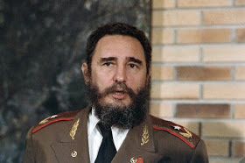
Zachi extolled the virtues of the communist revolution and continually asked the young people in Cuba to join the communist revolutionary militia. In fact, Fidel Castro was the guest of honor at Zachi’s episcopal consecration.
Fidel Castro was the honored guest of the Pope John Paul II at the Vatican in November of 1996 and the pope in turn visited Castro in Cuba in January 1998. Both meetings were marked by cordiality, which puzzled and upset many in the American Cuban community, who don’t yet understand the close ties between communists and the Vatican. The late John Paul II opposed the embargo against Cuba. The Ecumenical Movement was invented by the Vatican via Vatican II Council in the early 1960′s. Around this time, Pope John XXIII was a friend of Liberation Theology. He was Pope from 1958 to 1963 (He wanted to talk to the Communists when components of Communism is a part of the new world order agenda from a central bank to the stealing of private property). Jesuit John Courtney Murray, was called one of the “architects of the Second Vatican Council.” Vatican II’s Dignitatis Humanae Personae claimed to support religious liberty. Yet, Vatican II never revoked the anti-religious freedom proclamations of the Council of Trent. This Vatican II Council promoted false Alexandrian corrupt Bible versions (like the NIV). The NIV is heavily influenced by Papal Knight of St. Gregory Rupert Murdoch. Murdoch had to apologize for a racist cartoon about Obama in the New York Post. The NIV and other modern version omit hundreds of words), and the compromise of many Protestant & Baptist churches.
Just recently in 2007, Pope Benedict XVI called non-Catholic churches defective. Therefore, Vatican II wasn’t about reconciliation, it was about Rome trying to control all Christian churches via compromise. Today, famous Ecumenicists include Pat Robertson, Billy Graham, Chuck Colson, even John Hagee, Robert Schuller, and Rick Warren. Billy Graham would praise the Roman Catholic Mass. The late Jerry Falwell was a part of the Moral Majority group. This organization had tons of Roman Catholics in its group. In his January 1985 Moral Majority Report, Falwell called the Pope and Billy Graham great moral and religious leaders. Rick Warren (who loves the modern Bible versions. These versions were pro-Latin Vulgate, pro-Jesuit Council of Trent, Westcott and Hort Greek Text) is a friend of pro-abortion President Barack Obama. Rick Warren is loved by the mainstream media, because he is a 21st century version of a calculating, compromising professing Christian in America. He does talk about controversial issues much and even compared Fundamental Christians to jihadists in an evil way. The Ecumenical movement is about merging Christianity into a global system basically (under the bigger goal of a one world religion. That‘s why there are global religious organizations today wanting this goal including Theosophists).
Cardinal Spellman is an important Cold War figure.
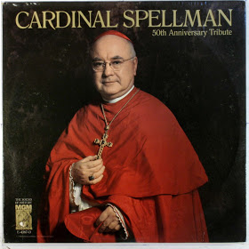
In my opinion, he was the most powerful American clergyman of the 20th century. He had ties to the CIA, Chiang Kai-shek, President Roosevelt, MacArthur, the Pentagon, and Wall Street. Cardinal Spellman was nicknamed Cardinal “Moneybags” because of his immense wealth. Pope Pius XII greets Cardinal Spellman of New York City. Cardinal Spellman was a supporter for U.S. military involvement in Vietnam as early as the 1950’s. In the 1960’s, he would call the American soldiers fighting in Vietnam as the “soldiers of Christ.” Cardinal Spellman was pound for pound the most powerful clergyman in America during the 20th century. SMOM is short for the Sovereign Military Order of Malta aka the Knights of Malta.
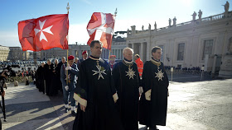
The USA has its Knights of Malta, some of whom have used their influence to promote right-wing causes in South America (during the Cold War). In Chile, Opus Dei sought support from Chilean bishops for the overthrow of President Salvador Allende. In Chile, Opus Dei worked closely with CIA-funded groups which later merged with the Chilean secret police. John Paul II made Opus Dei a “personal prelature.” John Paul II made Alfonso Lopez Trujillo a cardinal. Lopez Trujillo was a Colombian sympathizer with Opus Dei and an opponent of liberation theology. American Knights of Malta such as William Simon (Citicorp) and Francis X.
Stankard (Chase Manhattan Bank) have spoken at Opus Dei meetings. Presently, the Knights of Malta (who exited since the 1100’s A.D. According to William Cooper and Fritz Springmeier, almost half of the Knights of Malta are in the Black Nobility families) still have great corporate power. Carl Nicholas Karcher (the head of Hardees) and Thomas S. Monaghan (head of Domino’s Pizza) are all Knights of Malta. Knight of Malta Alexandre de Marcendes was in the France intelligence agency called SDECE. Knight of Malta Juan Carlos of Spain today (who is pictured with Bush, Pinochet, and other world leaders. Juan Carlos is a member of the Order of the Garter and the head of the Golden Fleece) is a significant force in Middle East negotiations. The Knights of Malta today are ruled by Matthew Festing, who is the worldwide Grandmaster of the Knights of Malta.
The SMOM Joseph E. Schmitz had ties with the mercenary Blackwater organization. Blackwater has been caught murdering Iraqis, even by American investigators. Their leadership has been in controversies spanning years now. SMOM Giscard D’Estaing is a huge promoter of the European Union. An European Union has been a Vatican brainchild for centuries. SMOM Frederic V. Salerno was the President of NYNEX Worldwide Services Group and a Senior Advisor to Gabelli Group Capital Partners.
*The Knights of Malta—has been called “the most exclusive club on earth,” according to Stephen Birmingham, author of Real Lace: America’s Irish Rich. Bush 41 was the Director of the CIA during the 1970’s. He was also awarded the Knight of Malta award of Savoy. He was in WWII, he was a Bonesmen.
George H. W. Bush is famous especially for calling for the existence of the new world order in 1990 during his State of the Union Address. He was awarded the Grand Cross of the Order of the Bath One of his sons named Jeb Bush is also a member of the Knights of Columbus.
Edward Cardinal Egan of the Archdiocese of New York knighted Salerno to the Order of St. Gregory the Great in 2006. Salerno is on the Board of Viacom and a member of the Board of Hedrick & Struggles. SMOM Joseph A. Unanue is the Founder, Goya Foods the largest Hispanic-owned food company in the U.S. Tom Monaghan is the Founder of Domino’s Pizza. SMOM Geoffrey T. Biois is Trilateral Commission member and a leader in many corporate boards. This shows that Knights of Malta have many ties to the banking international elite.
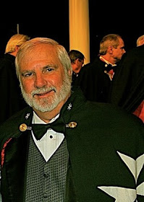
Even Rick Joyner, the false prophet on God TV, who wrote the Jesuit-inspired templar/quest , book is a Knight of Malta. He is the Charismatic/Word of Faith/Dominionist proponent who is really a Jesuit agent protestant among protestants He claims to have visions about the Kingdom of God on Earth (being man-made) that going on. This is unscriptural of course.
The Jesuit priest Greg Galluzo founded the Gamaliel Foundation. This is a subsidiary of the Ford Foundation. Barack Obama worked for this Gamaliel Foundation in Chicago for years. Furthermore, Ann Dunham, who is Barack Obama’s mother, worked for the Ford Foundation as did the father of Timothy Geithner, Barack Obama’s Secretary of the Treasury. Jesuit trained Jon Favreau is Barack Obama’s chief speechwriter. Obama’s Senior Military and Foreign Policy Advisor, Maj. Gen. J. Scott Gration, was Jesuit-trained. Obama’s National Security Adviser is James L. Jones, who was trained by Jesuits at Georgetown University. Jones is a retired four-star general and formerly served as Supreme Allied Commander Europe (2003-2006). Until a few days ago, Jones was on the board of directors of Boeing, Obama’s Deputy Communications Director, Dan Pfeiffer, was Jesuit-trained. Barack Obama’s CIA pick of Leon Panetta is Jesuit trained (he entered JESUIT Santa Clara University in 1956) as well. Leon Panetta compromise and said that there will be no prosecutions for CIA interrogators who committed torture in the rendition program. It appears that the new Barack Obama administration have as much ties to the Vatican as the previous administration had. It’s apparent that the Vatican/Jesuit goal of ruling the world under the Papacy hasn’t ceased to function. This information about the Vatican’s manipulation of world events (with the influence of the Jesuit/Vatican network) is not shown in the mainstream media.
Tony Blair is another prominent Roman Catholic. He is known for supporting immoral war in Iraq and expanding the police state in Britain to unheard of levels. Blair has been speaking across the world now to promote ecumenicalism and the new world order. That is why he is partnering with the Yale University Schools of Management and Divinity. Blair is doing this order to make his “The Tony Blair Faith Foundation” to use “education” as a means to bring about the New World Order. Tony Blair is a supporter of the pro-Knight of Malta Carlyle Group (with members like Roman Catholic Frank C. Carclucci and Knight of Malta award receiver George H. W. Bush. Bush would support the new world order via a famous speech in 1990. That’s why the leadership of America, Saudi Arabia, and even Israel work together. For example, the Bush family, the Bin Laden family, and the Bandar family all worked together in business endeavors for decades. In 1957 a treaty was signed in Rome that every man, woman and child in the United Kingdom will regret as long as they live.
It was called the Treaty of Rome
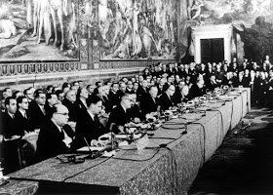
The Treaty of Rome marked the formation of what was then termed, “The Common Market.” Ted Heath, Prime Minister at the time, now member of the papal order of the garter ruled by the monarchy which really governs Westminster took this country into the common. Ted Heath, as other prime ministers, is subordinate to the British monarchy.
Today the European Union has taken over this country lock, stock and barrel! If you listen to the controlled media, you could easily assume that the European Union was a wholly secular entity. You would be gravely mistaken. The power behind the Union, is not a bunch of politicians, it is in fact being steered by no other than the harlot church of the book of Revelation.
The Jesuits are the puppet masters pulling the strings of every nation state in the union. We need to understand that there is something very sinister happening before our very eyes that will spell trouble for every true follower of Jesus Christ in this country as well as every nation in this amalgam of countries. The power behind Europe is the Jesuit Order.
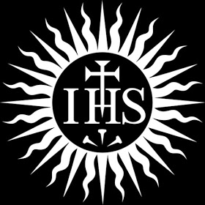
The Jesuit Oath: "I furthermore promise and declare that I will, when opportunity present, make and wage relentless war, secretly or openly, against all heretics, Protestants and Liberals, as I am directed to do, to extirpate and exterminate them from the face of the whole earth; and that I will spare neither age, sex or condition; and that I will hang, waste, boil, flay, strangle and bury alive these infamous heretics, rip up the stomachs and wombs of their women and crush their infants' heads against the walls, in order to annihilate forever their execrable race. That when the same cannot be done openly, I will secretly use the poisoned cup, the strangulating cord, the steel of the poniard or the leaden bullet, regardless of the honor, rank, dignity, or authority of the person or persons, whatever may be their condition in life, either public or private, as I at any time may be directed so to do by any agent of the Pope or Superior of the Brotherhood of the Holy Faith, of the Society of Jesus"
If you care to take the time to research what the Roman Catholic Institution have been up to in the last 60 to 70 years, you will find that she is as much a ravenous wolf now, as she was in the days covered by Foxes Book of Martyrs.
-------------
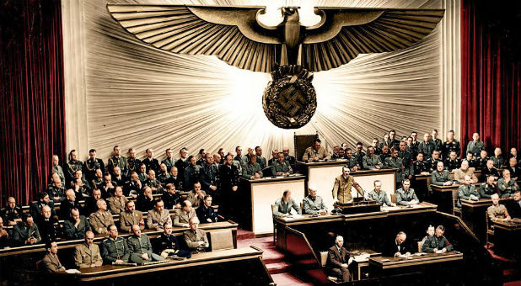
Hitler speaking before the Third Reich Assembly
The Nazi forces of darkness (Courtesy/Justice House of Prayer DC)
Hitler sought to be Fuhrer of the world … but Yahuwah cut his plans short in 1945. Yet, Hitler continued on as did thousands of Nazis with him to influence the world through the Nazis behind the scenes until this day. Operation Paperclip brought thousands of Nazi scientists into the United States, who immediately began to experiment on the American people, continuing with what they began.
------------------------------------------
Hitler faked his death flew to Canary Islands then to Argentina
Hola Hitler! Ex CIA agent claims Nazi leader faked his death and flew to Tenerife before escaping to Argentina on a U-Boat By Darren Boyle for MailOnline 8 January 2016
A CIA agent with more than 21-years' field experience claims newly declassified evidence suggests that Adolf Hitler faked his own death before escaping to the Canary Islands by air before continuing to Argentina.
Bob Baer, who spent his lifetime involved in counter-intelligence and espionage said the official version of history with Hitler killing himself in his Berlin bunker does not stand up to official scrutiny.
He claims that newly released FBI files suggest that investigators at the time were also suspicious about whether the Nazi dictator had shot himself in the head.
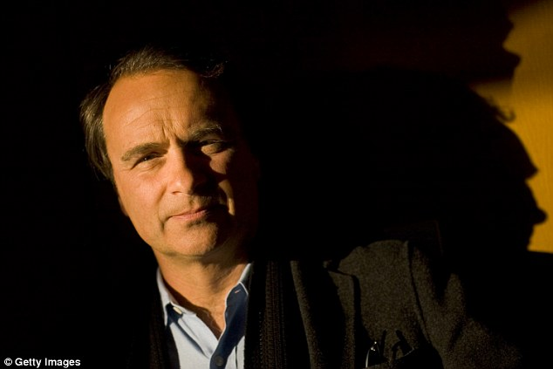

+2 Ex-CIA agent Robert Baer, pictured, believes the official history of Adolf Hitler's death is not conclusive
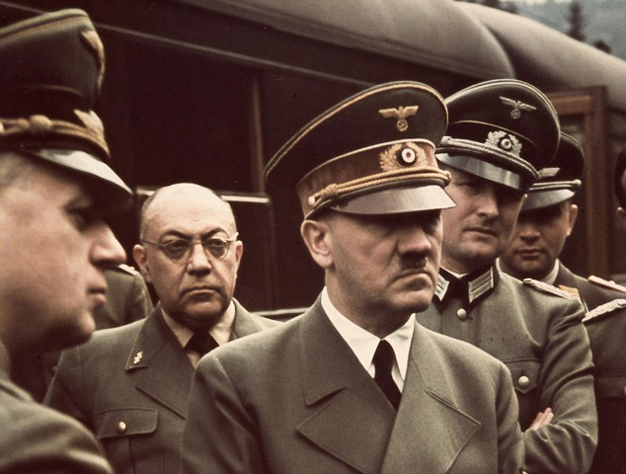
Baer believes Adolf Hitler centre, could have easily faked his own death and flown out of Berlin
According to the Hunting Hitler documentary on History Channel, there was no eyewitness report of Hitler's suicide or of anyone discovering his body inside his bunker.
The team, following snippets of evidence, said it was plausible that Hitler could have faked his own death and escaped through the Templehof airport on the day after he was last seen in public. One of the aircraft which left during the mass Nazi exodus is believed to have contained his luggage.
During the controversial documentary series, Baer claims: 'The narrative the government gives us is a lie. if you look at the FBI files it throws open the investigation.
'What we are doing is re-examining history, history that we thought was settled that Hitler died in the bunker but the deeper we get into it, it's clear to me we don't have any facts for it.'
One of the declassified documents expresses concern that Hitler's body had not been recovered and the complete lack of evidence of his death.
The controversial theory claims that Hitler flew to the Canary Island and boarded a U-Boat which transported him to a Nazi-friendly area of Argentina.
Secret recording: Listen to the voice of Hitler (with subtitles)
--------------
Hitler Secret files reveal Hitler faked his death
Secret FBI files 'reveal Hitler DID fake death' after WW2 then flew to TENERIFE
IN an astonishing new series, a team of former CIA investigators uncover secret FBI files to 'reveal' exactly what happened to Adolf Hitler.
By Katie Mansfield Fri, Jan 8, 2016 Sunday Express
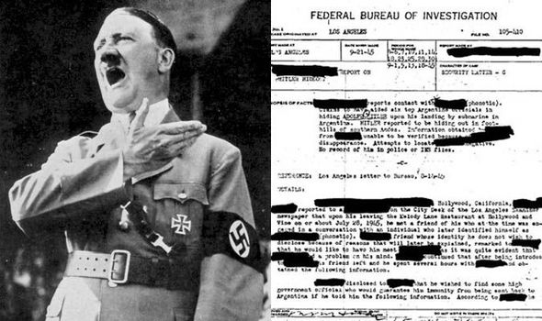IG
Secret FBI documents are believed to show Adolf Hitler lived after WW2
Using a collection of never-before-seen documents, the team claim to have proof Hitler did not kill himself in his underground bunker at the end of the Second World War.
Instead, the investigators believe Hitler faked his own death before scarpering to the Canary Islands to live out his days in the sunshine.

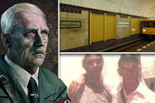
Does SECRET TUNNEL discovered under Berlin prove Hitler SURVIVED...
"What we are doing is re-examine history, history that we thought was settled that Hitler died in the bunker but the deeper we get into it, it's clear to me we don't have any facts for it."
The team have access to 700 pages of newly declassified information, with one document stating: "American Army officials in Germany have not located Hitler's body nor is there any reliable source that Hitler is dead."
The team, who feature in a series on The History Channel, used sonar, historical maps and cutting-edge technology as well as interviewing a series of alleged witnesses to the crazed dictator's escape.
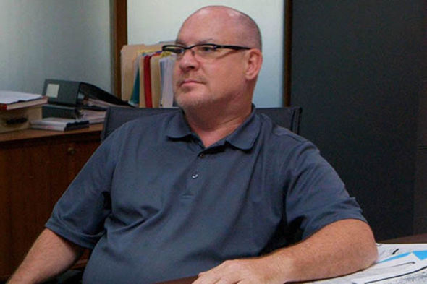
Based on new evidence John Cencich believes Hitler faked his own death
Hitler easily faked his own death through the use of a double, say the team, who add the corpse found by the Russians was actually five inches shorter than Hitler with a smaller skull.
Not to mention the fact the body disappeared before the American or British authorities could investigate it. Some reports suggested Hitler had lived to 95 with a lover in Brazil after an unusual photograph emerged.
Ex-United Nations (UN) war crimes investigator John Cencich helps lead the investigation. Initially a skeptic, Mr Cencich insists there IS evidence both Hitler and his wife Eva Braun had doubles. He said: "We do know from evidence both of them had doubles. If someone was going to stage a crime scene, this was the perfect way to do it. “The accepted truth that he committed suicide is ambiguous.”
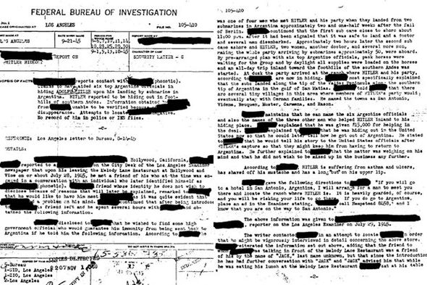
The FBI report on Hitler's flight to South America from the Canaries
As the war came to an end many Nazis fled and set up a new life in warmer climes, many making it all the way to South America and the crack team uncover a mass Nazi exodus from Templehof airport the day after Hitler was last seen in public. In a further twist, the plane even contained Hitler's luggage.
The team conclude Hitler could not have made the long journey in a single trip and evidence points them towards the Canary Islands and Greece.
Interviewing an alleged witness to Hitler's escape Mr Cencich speaks to a former construction worker who claims to have seen Hitler in May 1945, days after he supposedly died in Berlin.
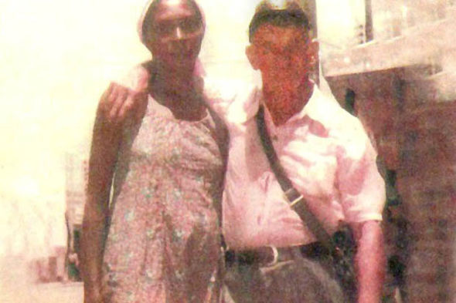
SIMONI GUERREIRO DIAS/ARQUIVO PESSOAL
A picture believed to show Adolf Hitler when he would have been 93
The Greek man tells Mr Cencich: "In 1945 I was building a secret construction inside the monastery in Samos. "I had to build secret tunnels and compartments for Germans. Yes, the Germans were Nazis and one of these guys was Adolf Hitler.
"He was right there, he wasn't wearing a moustache or anything. this was May 1945. I realized it was really Hitler because of the airplane.
"I went to work in another town. The first thing I saw in this town was a German airplane. It had landed in an old potato field. The farmer told me there were five people who landed, they were German." From there it is believed Hitler travelled by U-Boat to Argentina to be reunited with his Nazi comrades.
A complex network of tunnels and secret airplanes made the journey possible.
In the series, the team travel to Argentina to uncover a school that was part of the Nazi Youth movement before heading into the jungle to search a recently discovered Nazi compound before making their investigation leads them to the Canary Islands.
The series is the latest in a long line of theories surrounding the fate of the Nazi dictator with mystery surrounding the exact details around the aftermath of his death and concerns raised over the Russians, who found the bunker first, and their investigation.
---------
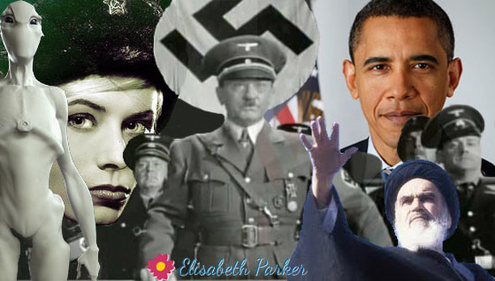
Snowden Documents Proving “US-Alien-Hitler” Link Stuns Russia
By Conspiracy UFOmania blogsite March 13, 2016
A stunning Federal Security Services (FSB) report on the nearly two million highly classified top-secret documents obtained from the United States Department of Defense (DOD) run National Security Agency-Central Security Service (NSA/CSS) by the American ex-patriot Edward Snowden states that this information is providing “incontrovertible proof” that an “alien/extraterrestrial intelligence agenda” is driving US domestic and international policy, and has been doing so since at least 1945.
Edward Snowden is a computer specialist, a former Central Intelligence Agency (CIA) employee, and former NSA/CSS contractor who disclosed these classified documents to several media outlets in late 2012 and was granted temporary asylum in Russia in 2013 after his designation by the Obama regime as the “most wanted man on earth.”
This FSB report further states that Snowden, in December, 2012, contacted the highly respected American columnist, blogger, and author Glenn Greenwald by an email headed with the subject line stating, “I and others have things you would be interested in.?.?.?.”
In Snowden’s own words, this report continues, he outlined to Greenwald the reason for his highly secretive group obtaining and releasing these documents by warning that that there “were actually two governments in the US: the one that was elected, and the other, secret regime, governing in the dark.”
As to who is running this “secret regime” Snowden and his cohorts were warning about, FSB experts in this report say, was confirmed this past weekend by former Canadian defense minister Paul Hellyer who was given access to all of Snowden’s documents by Russian intelligence services and stated they were, indeed, “accurate.”
Even though Defense Minister Hellyer’s exact statements to the FSB in regards to Snowden’s documents remain classified, shortly after his “extensive electronic interview” by the FSB he was allowed to appear on Russia Today’s program SophieCo this past fortnight
Where he shockingly admitted that aliens have “been visiting our planet for thousands of years” and described several types of these extraterrestrials, including “Tall Whites” who are working with the US Air Force in Nevada.
Of the many explosive revelations in this FSB report, the one most concerning to Russian authorities are the Snowden’s documents “confirming” that the “Tall Whites” (further revealed by Defense Minister Hellyer as noted above) are the same extraterrestrial alien race behind the stunning rise of Nazi Germany during the 1930’s).
[My input: In other words THE ARIAN race of Nazi worship – which could be traced to the Celts--giants who came from Assyria via north Israel to the Nordic lands and UK--whether created by the DNA manipulation by the 10 tribes prior to 722 BCE, or those from the Golan, like the Amonites]
In just one example of the many outlined in this FSB report, it shows that with this “alien assistance,” at the end of the 1930’s, when Nazi Germany possessed just 57 submarines, over the four years of World War II it built 1,163 modern technologically advanced submarines at its dockyards and even put them into operation.
Snowden’s documents further confirm, this report says, the “Tall Whites” (Nordic) meetings in 1954 with US President Dwight D. Eisenhower where the “secret regime” currently ruling over America was established.
Most disturbingly, this FSB report warns, is that the “Tall White” agenda being implemented by the “secret regime” ruling the United States calls for the creation of a global electronic surveillance system meant to hide all true information about their presence here on earth as they enter into what one of Snowden’s documents calls the “final phase” of their end plan for total assimilation and world rule.
Unbeknownst to the FSB, this report confirms, are those still in the US government backing Snowden, but whose presence Russian intelligence experts note is “unmistakable” and shows a cataclysmic power struggle is currently underway against this “secret regime,” now headed by Obama, by “forces unknown.”
Most to be feared by Russian policy makers and authorities, this report concludes, is if those opposing the “Tall White” “secret regime” ruled over by Obama have themselves aligned with another alien-extraterrestrial power themselves. January 11, 2014
----------
Argentina Was Hitler’s Final Home According to FBI Files – Part I
By Jerry Nelson on March 17, 20149 Liberty Voice
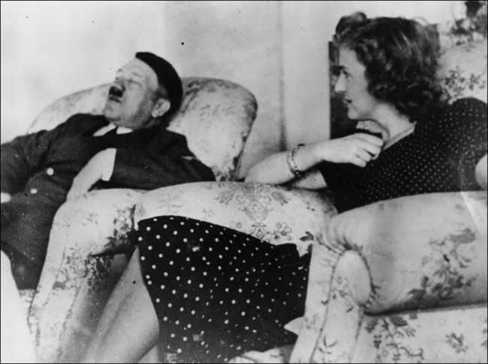
Newly released FBI documents seem to indicate that Adolf Hitler survived the bunker in Germany and made his escape to Argentina where he lived out the rest of his days.
In 1945, two German submarines pulled to the shore one night in Argentina. Approximately 50 people disembarked. They were met and driven off in Argentine buses. Those are known, verifiable facts. Eyewitnesses are still alive that saw the small crowd of people standing around the shoreline waiting on the busses to arrive.
Recently, the Federal Bureau of Investigation released previously classified documents that seem to prove that Adolf Hitler, the German dictator, was among the people arriving in Argentina that night. With him was the equally recognizable
Eva Braun.
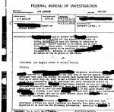
The documents released by the FBI go on to show that the American government knew Hitler was alive and living in the Andes long after World War II had ended. The newly released documents also show that the director of the OSS, Allen Dulles, provided aid and assistance to the group.
Who Was the Informant?
In a letter to the FBI, dated August 1945, an unidentified informant agreed to swap information for political asylum. The information the informant dangled in front of the agency was tantalizing enough for J. Edgar Hoover, long-time FBI Director, to get personally involved. What the informant told Hoover was shocking.
The informant not only knew that Hitler was in Argentina, the informant was one of four men confirmed to have met the German submarines when they arrive. The largest part of the landing party was on the first submarine while Hitler and Braun were on board the second.
The idea that German submarines could land on Argentine shores is not surprising or novel. U-boat 977 and U-boat 530 each landed in Mar del Plata following their own escape from German waters.
Argentina Assistance
Argentine sympathies were with Nazi Germany. South America’s second largest country had a large German “ex-pat” population that stayed loyal to Hitler and the former Führer enjoyed many close friends in Argentina even before the end of the war.
The Argentina government welcomed the German dictator with open arms and assisted him in his hiding. The FBI documents indicate not only could the informant provide detailed directions to the towns which Hitler and his party traveled through, but was also able to provide details of the house in which Hitler and Braun took up residence.
The informant, while obviously not named in the FBI papers, was credible enough for Hoover to get personally involved in the informant’s subsequent questioning. Hoover then transferred some of the documents to Generals in the US War Department.
Did Hitler escape Germany and live to be an old man in Argentina? More information to come.
----------------
The “official story” says that Adolf Hitler died by a self-inflicted gunshot to the head. For decades, rumors swirled throughout Argentina that Hitler had in fact survived the bunker and escaped to South America’s second largest country where he lived until 1962. Documents recently released by the Federal Bureau of Investigation in Washington DC are giving some credence to the rumors. While no concrete evidence exists to support either the death-by-suicide or life-in-Argentina theories, the weight of the evidence is shifting.
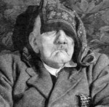
If this is a picture of Hitler in his 90s

Juan Peron
One of the up-and-coming military officers who was in a good position to help in Hitler’s move to Argentina was Juan Peron, husband of Eva, of “Evita” fame.
From 1939 until 1941, Peron was assigned by the War Ministry to go to the Italian Alps to study mountain warfare. While in Europe, he also served as a military observer in Italy, France, Germany, Hungary and Yugoslavia. Traveling throughout Europe and working with the various military, Peron had the opportunity to meet many men who would become leaders among the Axis Powers with the outbreak of World War II.
Peron had a long military history before becoming Argentina’s president in 1946. As a colonel in the Argentine Army, Peron participated in a coup against conservative President Ramon Castillo. Peron played a large part in the coup which was led by the GOU, United Officers Group, a secret society. Peron moved more into politics with his assignment as assistant to Secretary of War, General Edelmiro Farrell, and then as the head of the fledgling Department of Labor.
When he was elected President, Peron had the opportunity to repay many friends he had met while in Europe as a military observer. He also had the chance to enrich himself. Accepting bribes of gold, jewels and paintings from Nazi’s escaping the advancing allies, Peron swapped passports and travel documents for treasure stolen from the Jews. In her turn, Eva “Evita” Peron made several trips to Switzerland and during these trips she deposited much of the wealth the Perons made by selling access to Argentina living. Some of the treasure, not transported to Switzerland, is still on display in “Casa Rosada,” the Argentine version of The White House, today.
Eva Peron
Born in 1919, Eva “Evita” Peron climbed the Argentine social ladder lover by lover. During her ascending trip through Argentine society, she developed a strong resentment towards the country’s elite. A mistress to army officers, Eva caught the eye of handsome, and already legendary, Juan Peron. Following a very public love affair, they married in 1945.
Eva positioned herself as the “queen of the poor.” She created a foundation to help the poor buy items from houses to toys. Her charity extended to her husband’s Nazi allies. On June 6, 1947, Eva left for Europe. The publicly stated purpose of the trip was to help strengthen business and cultural ties between Argentina and Europe’s leaders. The real reason was a bit more sinister.
According to records now being revealed from Swiss archives, Evita’s trip was meant to lay the groundwork for Nazi’s seeking to move to Argentina. During her trip to Europe, Evita visited a small Italian town called Rapallo. While in Rapallo, she was the guest of Alberto Dodero, owner of an Argentine shipping fleet and known for many years as being the “go-to-guy” for anyone with something that needed smuggling. Before Evita could even leave Europe, one of Dodero’s ships, the Santa Fe, docked in Buenos Aires. Aboard were hundreds of Nazis stepping foot in their new country.
A few years later, in June 1951, the ship, Giovanna C, arrived in Buenos Aires. Onboard was the Holocaust designer, Adolf Eichmann. Eichmann posed as a skilled engineer and got a job at the city’s Mercedes-Benz plant. Eichmann was subsequently captured by Israeli agents in May 1960. Taken Israel to stand trial for mass murder, Eichmann was convicted and later hung in 1962.
Rodolfo Freude
Rodolfo Freude was Juan Peron’s private secretary and Evita’s main benefactor. Freude also served Peron as the latter’s chief of Argentine internal security. Freude’s father, Ludwig, filled a key role in Argentine history as director of the Banco Aleman Transatlantico in Buenos Aires. When Ludwig wasn’t busy being a banker, he led the pro-Nazi Germany community in Argentina and acted as trustee for millions of German Reichmarks that Hitler’s top aides started funneling as World War II came to an end.
By 1946, the first group of Nazi’s was settling into new Argentine homes made available to them by Peron. In return for his help, the Nazi’s bankrolled Peron’s campaign for the presidency. In 1947, Peron had taken up residence in Casa Rosada and continued to hear cries for assistance from thousands of other Nazis eager to get out of Europe.
Nazis were coming to Argentina in droves following the end of the Second World War. Adolph Eichmann was one of the more infamous to live in Argentina and was captured by Israeli troops in Buenos Aires in 1960. Taken by to Israel for trial, Eichmann was convicted and later hung for his part in the Nazi machine.
By Jerry Nelson
-----------
Hitler and Eva Braun Pictures

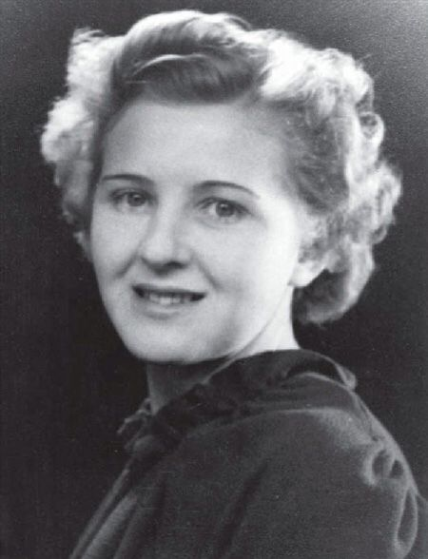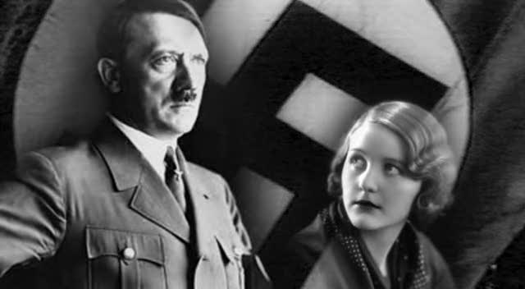

From DNA, April 16, 2014
Newly released FBI files claim that Adolf Hitler escaped by submarine to Argentina where he lived in a heavily guarded ranch at the end of the Second World War suffering from asthma and ulcers.
An amazing cache of files shows that J Edgar Hoover's FBI took claims of Hitler's survival seriously and a team was assigned to exploring scores of tip offs.
The astonishing documents detail how an Argentinean fugitive claimed he helped Hitler, two women and other Germans disembark from a submarine in the South American country approximately two and half weeks after the fall of Berlin in April 1945, the Daily Express reported.
Newly released FBI files claim that Adolf Hitler escaped by submarine to Argentina where he lived in a heavily guarded ranch at the end of the Second World War suffering from asthma and ulcers.
An amazing cache of files shows that J Edgar Hoover's FBI took claims of Hitler's survival seriously and a team was assigned to exploring scores of tip offs.
The astonishing documents detail how an Argentinean fugitive claimed he helped Hitler, two women and other Germans disembark from a submarine in the South American country approximately two and half weeks after the fall of Berlin in April 1945, the Daily Express reported.
Hitler and his companions then went by horse pack to the foothills of the southern Andes, and the plan was for the 50-strong group to move in with German families in villages in the area.
The unnamed Argentinian informant, who gave the information over to the US authorities hoping to get asylum in return, gives a description of Hitler to a journalist for the Los Angeles Examiner on July 29 1945, saying the Nazi "is suffering from asthma and ulcers, has shaved off his moustache and has a long 'but' on his upper lip".
Other tip-offs to the FBI suggested Hitler was actually living in New York City, again without his moustache, while some suggested he was hiding with Nazi sympathizers in the German speaking part of Switzerland.
The revelations come just weeks after a Nazi-hunting author claimed he had found a picture of Hitler which proved he died in Brazil aged 95.
Hitler and his companions then went by horse pack to the foothills of the southern Andes, and the plan was for the 50-strong group to move in with German families in villages in the area.
The unnamed Argentinian informant, who gave the information over to the US authorities hoping to get asylum in return, gives a description of Hitler to a journalist for the Los Angeles Examiner on July 29 1945, saying the Nazi "is suffering from asthma and ulcers, has shaved off his moustache and has a long 'but' on his upper lip".
Other tip-offs to the FBI suggested Hitler was actually living in New York City, again without his moustache, while some suggested he was hiding with Nazi sympathizers in the German speaking part of Switzerland.
The revelations come just weeks after a Nazi-hunting author claimed he had found a picture of Hitler which proved he died in Brazil aged 95.
Refer to Hitler’s daughter Angela Merkel – which has lots of pictures..
https://en.wikipedia.org/wiki/Eva_Braun
Eva Anna Paula Hitler Braun: born 6 February 1912, died 30 April 1945, was the longtime companion, mistress, of Adolf Hitler… and, for less than 40 hours, his wife (if you believe they committed suicide in Berlin)... Otherwise, they had a longer marriage in Argentina or Antarctica.
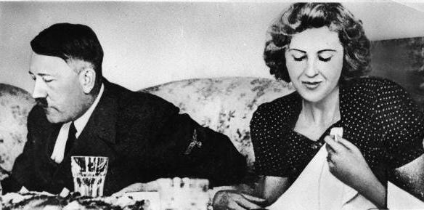
---------
German Submarine Used By Escaping Nazi’s Washes up on the Coast of Argentina
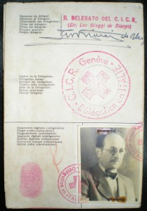
Red Cross passport under the name of “Ricardo Klement” that Eichmann used to enter Argentina in 1950
Some of these wanted men were being held in internment camps: generally without identity papers, they would be enrolled in camp registers under false names. Other Nazis were in hiding in Italy, and sought Hudal out as his role in assisting escapes became known on the Nazi grapevine.
According to Mark Aarons and John Loftus in their book Unholy Trinity, Hudal was the first Catholic priest to dedicate himself to establishing escape routes. Aarons and Loftus claim that Hudal provided the objects of his charity with money to help them escape, and more importantly with false papers including identity documents issued by the Vatican Refugee Organization.
These Vatican papers were not full passports, and not in themselves enough to gain passage overseas. They were, rather, the first stop in a paper trail—they could be used to obtain a displaced person passport from the International Committee of the Red Cross (ICRC), which in turn could be used to apply for visas.
In his 2002 book The Real Odessa Argentine researcher Uki Goñi used new access to the country’s archives to show that Argentine diplomats and intelligence officers had, on Perón’s instructions, vigorously encouraged Nazi and Fascist war criminals to make their home in Argentina. According to Goñi, the Argentines not only collaborated with Draganović’s ratline, they set up further ratlines of their own running through Scandinavia, Switzerland and Belgium.
Argentinian Nazi smuggling became institutionalized, according to Goñi, when Perón’s new government of February 1946 appointed anthropologist Santiago Peralta as Immigration Commissioner and former Ribbentrop agent Ludwig Freude as his intelligence chief. Goñi argues that these two then set up a “rescue team” of secret service agents and immigration “advisors”, many of whom were themselves European war-criminals, with Argentine citizenship and employment.
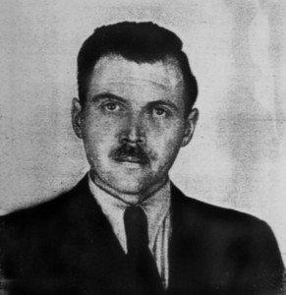
Photo from Mengele’s Argentine identification document (1956)

The Italian and Argentine ratlines have only been confirmed relatively recently, mainly due to research in newly declassified archives. Until the work of Aarons and Loftus, and of Uki Goñi (2002), a common view was that ex-Nazis themselves, organized in secret networks, ran the escape routes alone. The most famous such network is ODESSA (Organization of former SS members), founded in 1946 and according to Paul Manning, “eventually, over 10,000 former German military made it to South America along escape routes ODESSA and Deutsche Hilfsverein …”
Simon Wiesenthal, who advised Frederick Forsyth on the novel/filmscript The Odessa File which brought the name to public attention, also names other Nazi escape organizations such as Spinne (“Spider”) and Sechsgestirn (“Constellation of Six”).
Some of the Nazis and war criminals who escaped using ratlines include:
Adolf Eichmann, fled to Argentina in 1950, captured 1960, executed in Israel on 1 June 1962
Franz Stangl, fled to Brazil in 1951, arrested in 1967 and extradited to West Germany, died in 1971 of natural causes,
Gustav Wagner, fled to Brazil in 1950, arrested 1978, committed suicide 1980.
Erich Priebke, fled to Argentina in 1949, arrested 1994, eventually died in 2013.
Klaus Barbie, fled to Bolivia with help from the United States, captured in 1983, died in prison in France on 23 September 1991
Eduard Roschmann, escaped to Argentina in 1948, fled to Paraguay to avoid extradition and died there in 1977
Aribert Heim, disappeared in 1962, most likely died in Egypt in 1992
Andrija Artuković, escaped to the United States, arrested in 1984, died in prison in Croatia in 1988
Ante Pavelić, escaped to Argentina in 1948, initially survived an assassination attempt in 1957, but died of his wounds in Spain in 1959
Walter Rauff, escaped to Chile, never captured, died in 1984
Alois Brunner, fled to Syria in 1954, died around 2010
Josef Mengele, fled to Argentina in 1949, then to other countries, dying in Brazil in 1979. Remains exhumed in 1985 and probably destroyed. [He entered the US and continued his experiments on a national level through the Illuminati]
Johann Feil
------------------
***Hitler The Secret Underground Nazi UFO Base In the Antarctic:
Base-211 | Neu-Schwabenland | Shangri-La (documentary on YouTube by sheepleTV.com August 15, 2015
THIS IS A 50-PAGE DOCUMENTED ARTICLE that has shocking information about Hitler and Nazis after World War II. The information aligns to things written in Steve Quayle’s EMPIRE BENEATH THE ICE – HOW THE NAZIS WON WORLD WAR II … Here is one picture from the article:
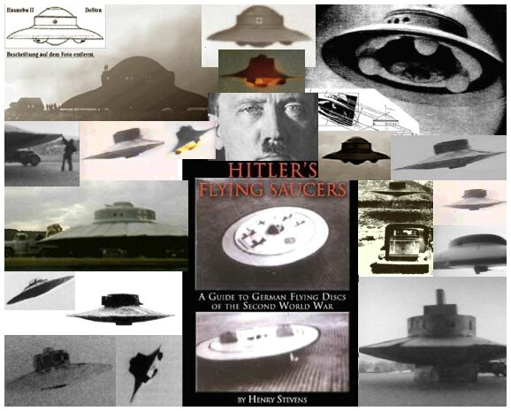
-----------
Hitler Artwork could fetch hundreds of thousands to go on auction
Artwork by Adolf Hitler could fetch hundreds of thousands: More than a dozen paintings by the Nazi dictator go under the hammer at auction in Nuremberg
By Julian Robinson for MailOnline - 28 January 2016

A collection of paintings and drawings made by Nazi dictator Adolf Hitler are going under the hammer in Germany - and they could fetch hundreds of thousands of pounds. The artwork, which includes water colours of houses, castles, countryside scenes and town squares, will be sold off in the Bavarian city of Nuremberg.
It comes six months after another collection of his art fetched £286,000 at auction with one work - a painting of Neuschwanstein Castle in Bavaria - selling to a Chinese buyer for £71,000.
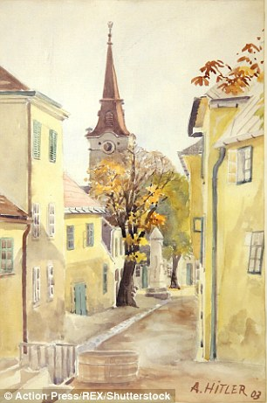
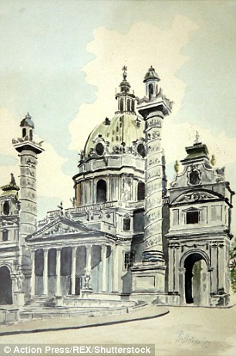 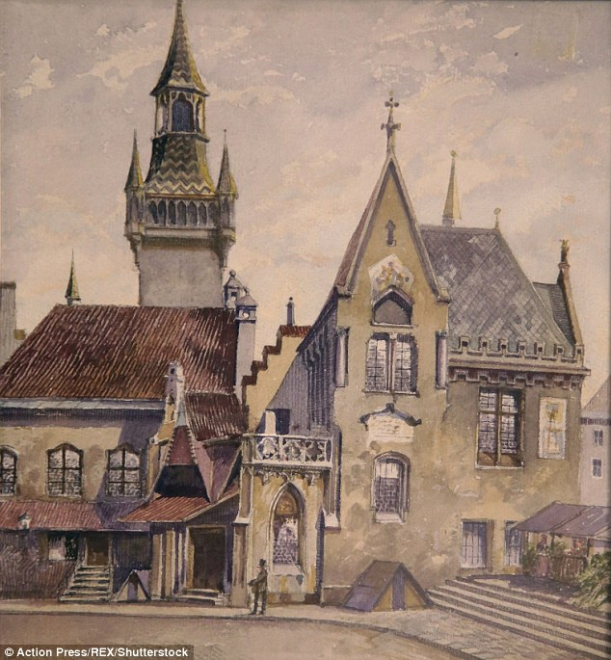
For sale: A collection of paintings and drawings made by Nazi dictator Adolf Hitler are going under the hammer in Germany - and they could fetch hundreds of thousands of pounds.
The artwork, which includes water colours of houses, castles, countryside scenes and town squares, will be sold off in the Bavarian city of Nuremberg
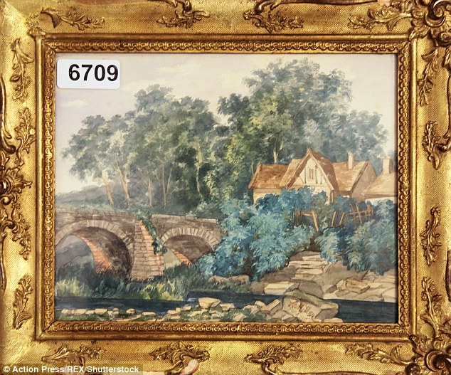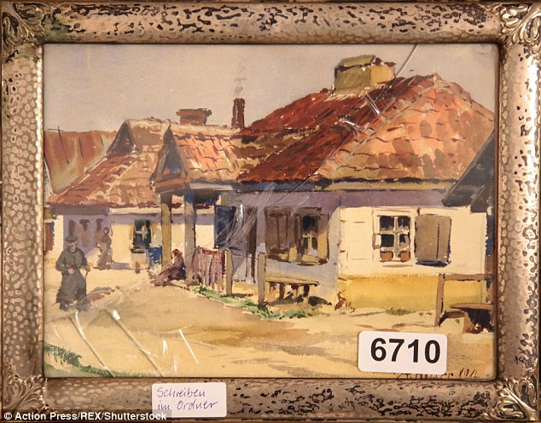
There has been no indication yet how much the latest collection could sell for
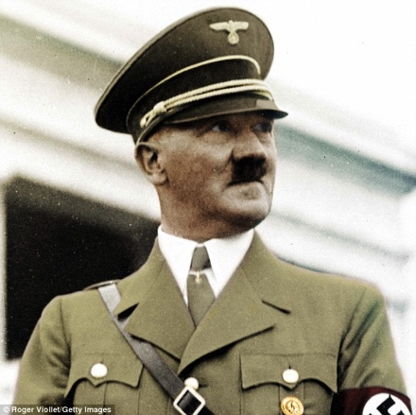
People from all over the world made bids for the Nazi dictator's work at a previous auction. There is no indication yet how much the latest collection could sell for.
Water color landscapes, nude portraits and still life were among the 14 pieces that went under the hammer at an auction in June, which was also in Nuremburg.
In November a water color painted by a young Hitler in 1914 of the city hall in Munich sold for 130,000 euros at a sale organized by the same auction house.
As a budding young artist, Hitler applied to the Vienna Academy of Art but was rejected. He continued to paint however, copying images from postcards that he sold to tourists.
Under the hammer: The Nazi dictator's paintings are up for sale at an auction in Nurenberg in southern Germany Hitler applied to the Vienna Academy of Art but was rejected
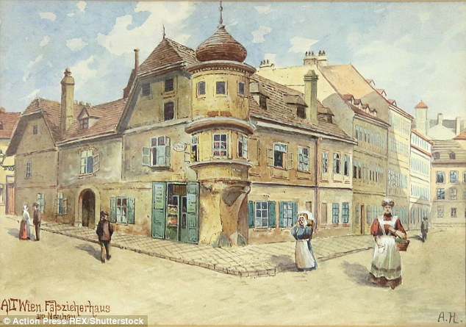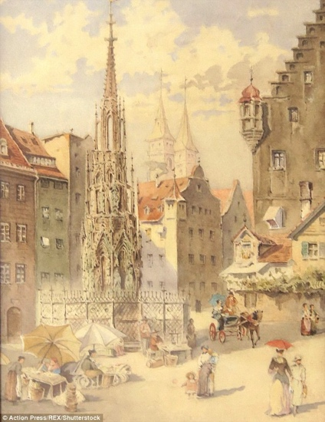
Hitler continued to paint after being rejected from the Vienna Academy of Art and copied images from postcards that he sold to tourists
Hitler went on to become Germany's Nazi leader from 1933 to 1945, launching the Second World War and causing the deaths of millions of people
He went on to become Germany's Nazi leader from 1933 to 1945, launching the Second World War and causing the deaths of millions of people.
Last year, Germany's Frankfurter Allgemeine Zeitung reported that German law allows for Hitler's paintings to be sold as long as they do not display any Nazi symbols.
Experts consider his work to be of mediocre quality. Yet, one of Hitler's water colors sold last year for $450,000

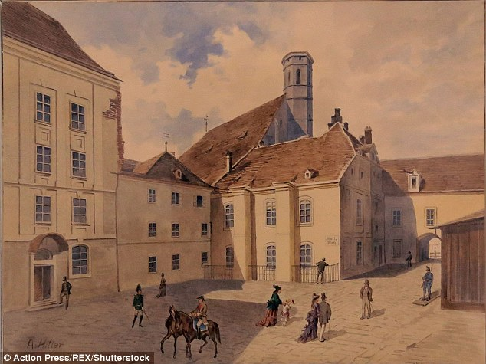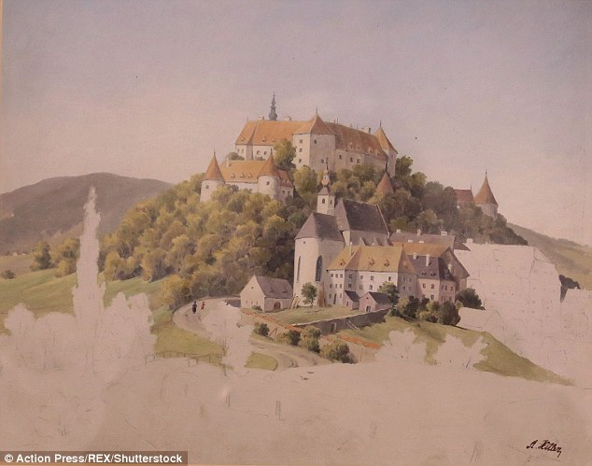

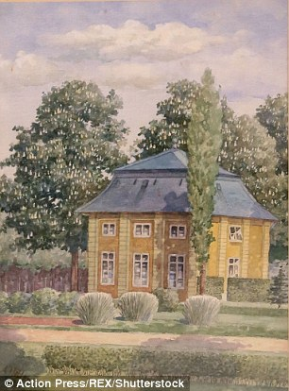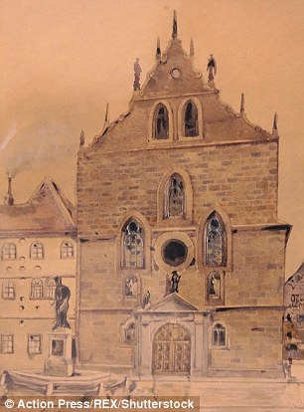
Last year, Germany's Frankfurter Allgemeine Zeitung reported that German law allows for Hitler's paintings to be sold as long as they do not display any Nazi symbols
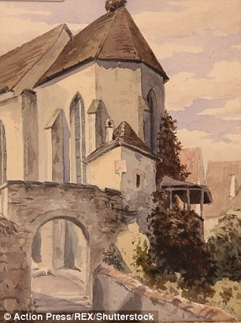
Early work: As a budding young artist
[My question: What would the world be like today if the Vienna Academy of Art had accepted him, and he would have spent his life painting pictures--a normal human being with a family? But, Yahuwah knew him from eternity past, and like Nebuchadnezzar and Koresh (Cyrus), allowed him to be what he was, for His purposes. Also, if not Adolf Hitler, another would have been chosen by the evil one’s forces to drive the Jews homeward for the continuance of their plans.]
--------------
10 Stunning Parallels Between The United States And Nazi Germany
image: http://www.prophecynewswatch.com/images/recent/flagmay122016.jpg
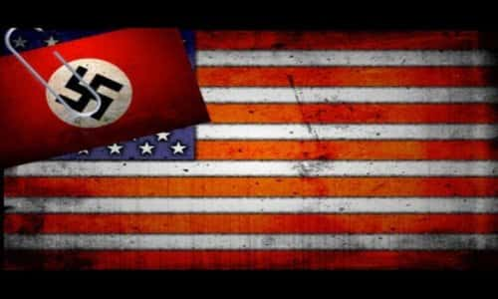
By Michael Snyder - End of The America Dream Blog May 12, 2016

Most Americans may not like to hear this, but the truth is that modern day America very closely resembles Nazi Germany. If you initially recoiled when you read the headline to this article, that is understandable. After all, most of us were raised to deeply love this country.
But I would ask you to consider the evidence that I have compiled before you pass judgment on the matter. Most citizens of this nation know that something has gone deeply wrong, and I would suggest that just like the Nazis, all of the pageantry and beauty in our society masks an evil which has grown to a level that is almost unspeakable.
And just like the Germans, we don't do ourselves any favors by turning a blind eye to what is going on. The following are 10 stunning parallels between the United States and Nazi Germany...

#1 Human Experimentation
The fact that the Nazis conducted scientific experiments on their prisoners has been heavily documented, but many Americans may not realize that we have been conducting similar experiments for decades. The following comes from author John Whitehead...
In Alabama, for example, 600 black men with syphilis were allowed to suffer without proper medical treatment in order to study the natural progression of untreated syphilis. In California, older prisoners had testicles from livestock and from recently executed convicts implanted in them to test their virility. In Connecticut, mental patients were injected with hepatitis.
In Maryland, sleeping prisoners had a pandemic flu virus sprayed up their noses. In Georgia, two dozen "volunteering" prison inmates had gonorrhea bacteria pumped directly into their urinary tracts through the penis. In Michigan, male patients at an insane asylum were exposed to the flu after first being injected with an experimental flu vaccine. In Minnesota, 11 public service employee "volunteers" were injected with malaria, then starved for five days.
In New York, dying patients had cancer cells introduced into their systems. In Ohio, over 100 inmates were injected with live cancer cells. Also in New York, prisoners at a reformatory prison were also split into two groups to determine how a deadly stomach virus was spread: the first group was made to swallow an unfiltered stool suspension, while the second group merely breathed in germs sprayed into the air. And in Staten Island, children with mental retardation were given hepatitis orally and by injection to see if they could then be cured.
And while times may have changed, the truth is that we are still being experimented on against our will. Just check out what the New York Daily News says is happening in New York City this month...
Don't hold your breath, it's only a test.
The Department of Homeland Security will release "harmless particle materials" in the city's subway system next week.
The "non-toxic, safe gas material" will be released at subway stations in Manhattan, Brooklyn, and Queens in order to understand where hazardous material would travel in the event of a biological terrorist attack.
In addition, let us not forget that we systematically create and perform experiments on unborn baby children...
A shocking new report indicates scientists have found a way for human embryos to live outside the womb for 14 days, which is a record, so they can be experimented on for a longer period of time.
Leading pro-life advocates are outraged that scientists would specifically create unique human beings to purposefully experiment on and later destroy just for research. They are worried scientists will continue creating more unborn human people who will be subjected to research for a longer duration of their embryonic life.
What we are doing is so evil that it is hard to put into words, and yet most Americans have come to accept this kind of sick behavior as perfectly normal.

#2 Socialism
The Nazis were hardcore socialists, and they were very proud of this fact. For example, National Socialist theologian Gregor Strasser once made the following statement...
We National Socialists are enemies, deadly enemies, of the present capitalist system with its exploitation of the economically weak ... and we are resolved under all circumstances to destroy this system.
Unfortunately, the United States is rapidly moving in a similar direction. An avowed socialist, Bernie Sanders, is wildly popular with Democrats, and more than half of all U.S. adults under the age of 30 now say that they reject capitalism.

#3 Free Stuff
Just like Bernie Sanders wants to do, the Nazis gave out lots and lots of free stuff. Kitty Werthmann was a child living a peaceful life in Austria when Hitler took over her nation, and I will be quoting her extensively for the rest of this article. She says that once the Nazis took control in Austria, they started handing out lots of freebies...
Newlyweds immediately received a $1,000 loan from the government to establish a household. We had big programs for families. All day care and education were free. High schools were taken over by the government and college tuition was subsidized. Everyone was entitled to free handouts, such as food stamps, clothing, and housing.

#4 Taxes
Free stuff may sound like a good idea, but someone has to pay for it. According to Kitty Werthmann, once the Nazis took control of Austria "our tax rates went up to 80% of our income", and that absolutely choked the life out of the free market system.
Sadly, things are moving in the exact same direction in the United States. When the federal income tax was first implemented a little over a century ago, most Americans were taxed at a rate of just one percent. But today, we are being taxed into oblivion. I recently wrote an article in which I listed 97 different taxes that Americans pay each year, and when you add all of those taxes together some Americans end up paying out more than 50 percent of their incomes in taxes.

#5 Obamacare
Would it surprise you to learn that the Nazis had their own version of Obamacare? The following is some more eyewitness testimony from Kitty Werthmann...
Before Hitler, we had very good medical care. Many American doctors trained at the University of Vienna. After Hitler, health care was socialized, free for everyone. Doctors were salaried by the government. The problem was, since it was free, the people were going to the doctors for everything. When the good doctor arrived at his office at 8 a.m., 40 people were already waiting and, at the same time, the hospitals were full. If you needed elective surgery, you had to wait a year or two for your turn. There was no money for research as it was poured into socialized medicine. Research at the medical schools literally stopped, so the best doctors left Austria and emigrated to other countries.

image: http://www.prophecynewswatch.com/images/ads/TFP_freedvd.jpg

#6 Government Regulation
Just like the Obama administration, the Nazis wanted to tightly regulate virtually everything in the economy. Here is more from Kitty Werthmann...
My brother-in-law owned a restaurant that had square tables. Government officials told him he had to replace them with round tables because people might bump themselves on the corners. Then they said he had to have additional bathroom facilities. It was just a small dairy business with a snack bar. He couldn't meet all the demands. Soon, he went out of business.
If the government owned the large businesses and not many small ones existed, it could be in control.
We had consumer protection. We were told how to shop and what to buy. Free enterprise was essentially abolished. We had a planning agency specially designed for farmers. The agents would go to the farms, count the live-stock, then tell the farmers what to produce, and how to produce it.

#7 Gun Control
The Nazis believed in having a very strong military, but they were also obsessed with taking the guns away from the general population. According to Kitty Werthmann, the first step was gun registration, and once the government knew where all the guns were it was very easy to round all of them up...
Next came gun registration. People were getting injured by guns. Hitler said that the real way to catch criminals (we still had a few) was by matching serial numbers on guns. Most citizens were law abiding and dutifully marched to the police station to register their firearms. Not long after-wards, the police said that it was best for everyone to turn in their guns. The authorities already knew who had them, so it was futile not to comply voluntarily.

#8 Spying
The Nazi secret police, also known as the Gestapo, became world famous for their brutal tactics. The Nazis wanted to know everything about everybody, and anyone that was deemed to be "anti-government" was dealt with mercilessly.
Unfortunately, we are moving in the exact same direction in the United States today. We spy on our enemies, but we also spy on our friends. Control freaks working for the government are systematically watching us, tracking us, recording our phone calls and monitoring our emails. At this point, government snooping has become so pervasive that 64 percent of all reporters believe that the government is spying on them.

#9 Abortion

The Nazis brought legalized abortion to Germany, and they were especially interested in having "undesirable" elements of the population engage in this practice. It turns out that Adolf Hitler was actually a huge fan of the founder of Planned Parenthood, Margaret Sanger, and he adopted many of her philosophies. As I have written about previously, Sanger once made the following statement...
"The most merciful thing that a family does to one of its infant members is to kill it."
Now compare that line from Sanger to this statement from Hitler in Mein Kampf...
"The demand that defective people be prevented from propagating equally defective offspring. . . represents the most humane act of mankind."
Just like the Nazis, our disregard for human life is absolutely appalling. Even after the American people were shown clear undercover video evidence that revealed that Planned Parenthood is chopping up aborted babies and selling their body parts to the highest bidder, one survey found that only 29 percent of Americans wanted to cut off the hundreds of millions of dollars that Planned Parenthood is getting from the federal government every year.
To say that we have become an "evil nation" is a gigantic understatement.

#10 Pushing The Christian Faith Out Of Public Life
In this day and age, it has become "American" to remove every trace of the Christian faith from public life. We don't want God in our government, in our schools, in our parks or in our businesses. Many people may not realize this, but the Nazis were the exact same way. The following information originally comes from Bruce Walker, the author of "The Swastika Against the Cross: The Nazi War on Christianity"...
The Nazi tract Gott und Volk was distributed in 1941, and it describes the life cycle of German youth in the future, who would: "With parties and gifts the youth will be led painlessly from one faith to the other and will grow up without ever having heard of the Sermon on the Mount or the Golden Rule, to say nothing of the Ten Commandments... The education of the youth is to be confined primarily by the teacher, the officer, and the leaders of the party. The priests will die out. They have estranged the youth from the Volk. Into their places will step the leaders. Not deputies of God. But anyway the best Germans. And how shall we train our children? Thus, as though they had never heard of Christianity!"
And just like Nazi Germany, our end will be exceedingly terrible.
You see, the truth is that all evil regimes eventually fall, and America is headed for a day of reckoning.
Even now, our enemies are preparing weapons which could potentially destroy us in a single day. For example, just check out what Russia is building...
The "Satan 23 missile is rumored to be the most powerful ever designed and is equipped with stealth technology to help it dodge enemy radar systems .
This terrifying doomsday weapon is likely to strike fear into the hearts of Western military chiefs, as current missile defense technology is totally incapable of stopping it. It is being reported that the warheads from a single Satan 2 missile could destroy a state the size of Texas or a country the size of France.
Whether it is nuclear oblivion or something else, if we continue to behave like the Nazis it is just a matter of time before America is destroyed.
Let us hope and pray that this country wakes up while there is still time to do so.
----------
One in ten Germans want a new FUHRER and a third believe their country ‘is dangerously overpopulated by foreigners’, new study finds
By Allan Hall in Berlin for MailOnline - 15 June 2016

A new academic study has rocked the government in Berlin as people call for a 'dictatorship in the national interest' with one in ten wanting a new Führer to lead them to glory. The University of Leipzig's research team found that nearly 34 per cent of people quizzed thought Germany is 'dangerously overpopulated by foreigners.' A total of 21.9 per cent agreed that Germany needs 'a single strong party that embodies the national community as a whole.'
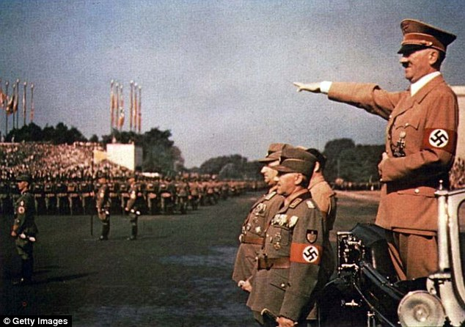
Thirty per cent claimed Germany had been 'infiltrated by too many foreigners in a dangerous way.' One in every ten Germans wants their country to be led by a 'Führer' applying 'a firm hand for the common good.'
And 71 years after Nazism was vanquished and the horror of the death camps revealed to a stunned world, 11 per cent of people questioned by the university researchers said Jews have too much influence in society.
Overall 12 per cent think Germans are by nature 'superior' to other people - a central plank of the ideology of Adolf Hitler and the original Nazis.
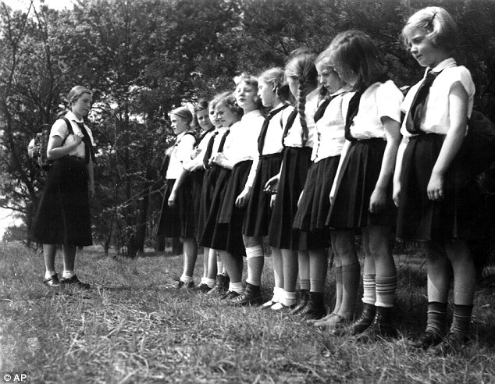
Hitler Youth (pictured)
Other findings included four out of every ten people thinking Muslims should be prohibited from immigrating to the country and half of respondents in a survey of 2,240 people saying they feel like 'foreigners in their own country.'
Thirty per cent claimed Germany had been 'infiltrated by too many foreigners in a dangerous way.' And three out of every five Germans believe migrants who have arrived in the country seeking sanctuary from war and terror are bogus.
'They are not really at risk of any persecution in their home country" was the question they agreed with.
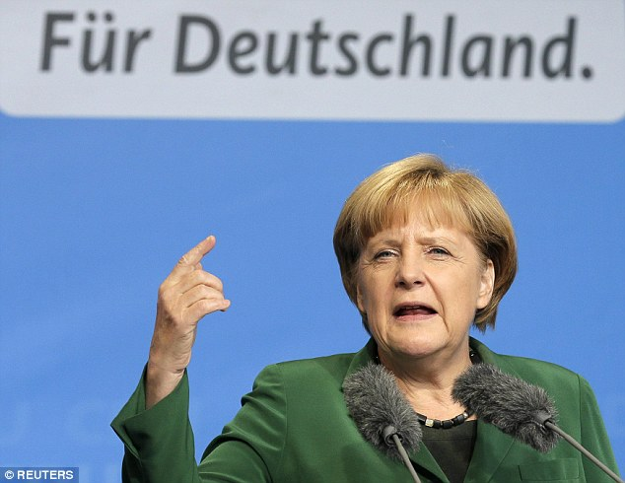
The rise of the hard-right Alternative for Germany (AfD) party delivered hammer blows to Chancellor Angela Merkel's CDU conservatives in regional polls in March
'There has been no increase in extreme right attitudes, but in comparison with our study from two years ago people who have far-right attitudes are more prepared to use violence to achieve their aims,' said Dr Oliver Decker, one of the report’s authors.
'There is a clear polarization and radicalization in German society, with more respondents also likely to completely reject violence this time around.
'The two groups exist next to each other. We have people who actively engage to help refugees and there are people who actively reject refugees,” said Decker.
The study entitled 'The uninhibited middle' argues extremist thinking has become more acceptable in mainstream German society - one reason for the rise of the hard-right Alternative for Germany (AfD) party.
It delivered hammer blows to Chancellor Angela Merkel's CDU conservatives in regional polls in March and looks set to send MPs into national government in the general election in the autumn of next year. 'Most AfD voters have a hostile attitude to the world,' said report co-author Dr Elmar Braehler.
'The potential for extreme right or populist right-wing parties is still higher than what electoral results have yet shown,' he added.
The survey noted an increase in negative attitudes towards Gypsy communities, with half of respondents saying such people should be banned from city centres.
Gypsies were persecuted by the original Nazis with hundreds of thousands of them murdered in the Holocaust.
And gays - also persecuted under the Third Reich - are also hated: 40 percent of people said they found it 'disgusting' when homosexuals kissed in public - an increase.
----------------------
JULY 24, 2016
Germany deploys armed soldiers in Nazi-like fashion after Munich shooting

Germany prepares to smash last post-Nazi taboo by deploying armed soldiers on the streets in peacetime after Munich shooting
By Peter Allen - 24 July 2016 for Daily Mail
Germany is on the verge of smashing one of the last post-Nazi taboos by deploying armed soldiers on the streets in peacetime to combat terrorism. The Munich massacre has triggered a new security debate which includes stiffer gun laws and the use of troops in force. A mentally-ill loner, 18, killed nine including teenagers outside a McDonald's in revenge for years of bullying.
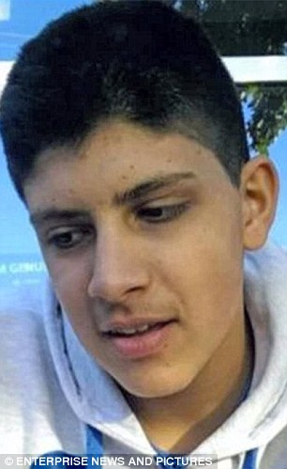
Pictured: Munich shooter Ali Sonboly

Keeping soldiers in their barracks has been a central tenet of postwar German domestic policy following the demise of Nazism. But after Friday's slaughter - and an earlier incident where a refugee attacked passengers on a commuter train with an axe and a knife - the Bavarian interior minister Joachim Herrmann says soldiers must join in the anti-terror fight in the same way as they do in France.
'We are facing extreme situations,' said Herrmann. 'We do not live in the time of the Weimar Republic now,' he said referring to Germany's post-WW1 experiment with democracy which failed spectacularly and led directly to the rise of the Nazis.
He said that historical reservations about armed soldiers on the streets were no longer applicable, adding: 'We are an absolutely stable democracy.'
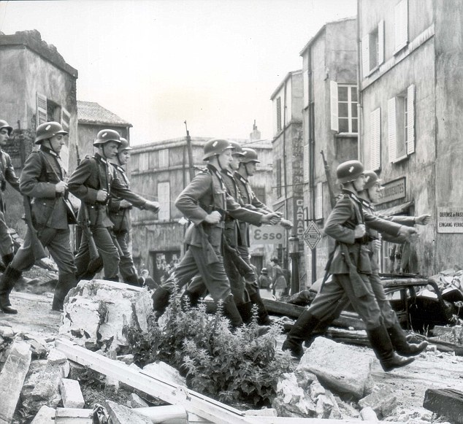
Pictured: Nazi troops march through occupied France
But he said the decision when and where to deploy the Bundeswehr (army) must rest solely with the police. He went on: 'The Bundeswehr can be deployed under the leadership of the German states who are responsible for internal security to protect the citizens.' In tandem with this plan are new discussions in Berlin about tightening Germany's already strict gun laws.
The news comes as investigators say the gun used by the deranged Munich killer had been bought on the 'dark web' and was originally from Slovakia.

The gun used by Ali Sonboly was a replica Glock, just like this one, which had been converted so it could fire live ammunition. The 9mm Glock handgun was smuggled into Germany and sold illegally to 18-year-old killer Ali Sonboly. The serial number on the weapon had been erased but police sources have revealed the firearm carried a certification mark from Slovakia.
It is believed the weapon used to kill nine people on Friday was a replica that had been converted to fire live ammunition. The Glock 17 pistol was sold illegally via the 'dark web' - sites on the internet that can only be accessed with passwords and are often used to sell drugs, child porn and other items illegally.

FINAL ARTICLE: February 2017
The amount of material being amassed about Hitler now is incredible. But, if Angela Merkel is his daughter, she is continuing his legacy of destroying Germany. Her open door policy to the Muslims, has about destroyed Germany. The police are not able to keep up with the violence against individuals, groups, and property. Germany has become a danger zone, and Merkel won’t stop it. She keeps opening more doors to bring Germany back under totalitarian rule, like Adolf Hitler. Now laws are being passed to shut down the free speech of the good citizens.
Here is the most recent article, but articles about the return of the Nazi regime are all over the news all the time now.
Hitler Rises And Her Name Is Angela - 'They Are Merkel's Dead' To Be Censored By The New Nazi Propaganda Ministry, Dubbed 'Center Of Defense Against Fake News'
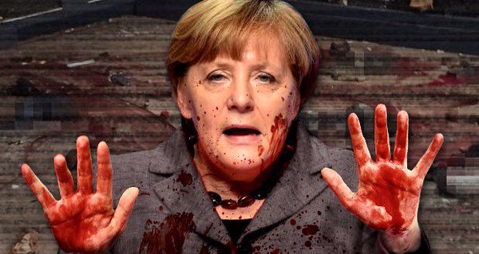
By Susan Duclos - All News PipeLine – December 24, 2016
“German Chancellor Angela Merkel is suffering severe backlash after the most recent terror attack in Berlin which killed 12 people. Protesters have coined the term `They are Merkel's dead’ in reference to her open border policies of allowing millions of immigrants to flood into Germany....immigrants that continue to carry out successful terror attacks… Merkel's refusal to seriously address Germany's growing Jihadist problem, while allowing more and more into the country, has spurned some brutal campaigns against her, and in response, rather than change those policies, she has created a new agency to prevent German's from hearing the truth about her and the blood of innocent victims that are on her hands because of her immigration policies. This is perhaps the most bone-chilling report for anyone that has studied history and `The Censorship of Nazi Germany.
Flashback: Censorship was rampant throughout Nazi Germany. Censorship ensured that Germans could only see what the Nazi hierarchy wanted people to see, hear what they wanted them to hear and read only what the Nazis deemed acceptable. The Nazi police dealt with anyone who went outside of these boundaries. Censorship dominated the lives of the ordinary citizen in Nazi Germany. (Citation: C N Trueman)
Via USHMM.ORG: `Once they succeeded in ending democracy and turning Germany into a one-party dictatorship, the Nazis orchestrated a massive propaganda campaign to win the loyalty and cooperation of Germans. The Nazi Propaganda Ministry, directed by Dr. Joseph Goebbels, took control of all forms of communication in Germany: newspapers, magazines, books, public meetings, and rallies, art, music, movies, and radio. Viewpoints in any way threatening to Nazi beliefs or to the regime were censored or eliminated from all media. Present Day - Back then they didn't have the Internet, so Merkel's new censorship campaign has been updated to include threats of legal consequences for internet giants that do not remove any content that Germany deems unacceptable or labels as fake… `The Federal Press Office in the Chancellery, which has a staff of over 500 professionals, will take the leading role in establishing the fake news defense center,’ Der Spiegel reported quoting a note from an anonymous Interior Ministry staff member.
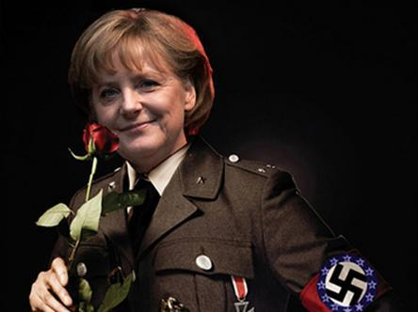
BOTTOM LINE
It is if Germany says it is according to them. They have recreated the Nazi Propaganda Program in the name of Center Of Defense Against Fake News, in order to control not only what the German public sees, but to control what the world sees.”
-------------------
The Nazis were never defeated. Their bases on Antarctica have been used for the creation of advanced technology, and experiments, from the dark kingdom since the 1940s at least. I close, and we watch.
The nation of Germany, via the influence of the State Lutheran Church rejected the restoration/revival of the baptism into the Spirit in the early 1900s. It was banned by law. They were rewarded with Hitler and the Nazis. Germany brought the Pergamum Altar into Berlin, and with it opened a portal for the spirit of Zeus/Apollo – Apollyon of Revelation 9:11; 11:7; 17:8, and II Thessalonians 2:3 (“perdition” – “apoleia” in Greek) to enter the nation.
Today the nation follows the old pattern, but also the pattern which has overtaken the world – the pattern of wanting the gods of old to rule them—Yahuwah, and the Jews, thrust out.
Keep watching! Our Redemption draws near!
In His love and shalom,
Yedidah
July 8, 2016
***Happy Birthday Rivkah! - My dear daughter-in-law who was born in Germany, who was born again by faith in Messiah Yahushua, filled with the Spirit of Yahuwah, who moves in the gifts of the Spirit, is bold in proclaiming the Word, and who walks in the ways of Yahuwah’s Torah and Messiah’s salvation. There are many Germans like her--in Germany, in Canada, in America, and around the world who love Elohim with all their heart – HalleluYah!

Edited and released for posting on comeenterthemikvah.com February 13, 2017

