THE U.S. PENTAGON’S BIO-LABS
EXPERIMENTS IN BIOLOGICAL and CHEMICAL WARFARE
The Rider on the Pale Horse Carries Human-Created Death – Part 3

The First Two Foundation-Articles: 1) “The Worldwide Flu Epidemic 2018 PART 1 – What is the Real Agenda …?” and 2) “The Satanic Global Agenda of `BIG PHARM’ and the Deaths of 84 Courageous Doctors - Part 2” both under the Mikvah of Present Reality.

Revelation 6:1, 7-8: “And I saw when the Lamb opened one of the seals, I heard one of the four living creatures saying, like the sound of thunder, `Come and see’…And when He opened the fourth seal, I heard the voice of the fourth living creature saying `Come and see.’ And I looked and saw a pale horse. And he who sat on it had the name `Death.’ And the grave followed with him. And authority was given to them over a fourth of the earth to kill with the sword, and with hunger, and with death, and by the beasts of the earth.”
How do you kill with death? That is possible if “Death” is created in a test tube, kept in air-tight storage vessels, then used by doctors or by other means to distribute the pathogens into human beings, as well as into animals, birds, fish, food crops, etc.
Famine is also taking over the earth. Man-made geoengineering of weather storms, floods, and droughts etc. worldwide has caused the eradication of major crops and edible animals. The evil ones seek to kill mankind by scientific-created means of death!
The rider of the pale horse is named “Death.” This rider IS the virus, the bio-weapon, the radiation, the pathogens, the vaccines, and the deadly elements of chemicals and chem.-trails. The rider is Death personified! What is the meaning of “pathogen?” -- Online dictionary: “a bacterium, virus, or other microorganism that can cause disease.”
That means that what is being created by scientists in test tubes is being spread abroad via the air (airborne pathogens), spread by chem.-trails, via personal contact with the virus, bacteria, and various pathogens put in food, drinking water, vaccines and medicines. The rider uses all means to spread what kills the body.
The origin of the deadly disease may be a military post like Fort Detrick, Maryland, who created AIDS, or a University laboratory like Texas A & M, or the Pentagon’s secret underground laboratories, along with many other such laboratories all over the world
“Death” may also be put on the tips of rockets – chemicals that kill, biological weapons that kill. There are many ways for “Death” to ride the globe. And along with new disease inventions, old diseases are being revived.
Revelation says that “Death” mainly rides over 1/4th of the earth, at least at his beginnings. Once Death is released into the air, it spreads on its own. It doesn’t need the rider anymore.
Ezekiel 14:12-23 describes the “four evil judgments” that Yahuwah sends: 1) famine 2) pestilence 3) war and 4) beasts of the earth. “Pestilence” is disease.
Ezekiel 14:19: “`Or, if I send a pestilence into that land and I shall pour out My wrath on it in blood, to cut off from it man and beast, even though Noah, Dani’el, and Iyob were in it, as I live,’ declares Yahuwah `they would deliver neither son nor daughter. They would deliver their own lives by their own righteousness…’ ” If His own people won’t listen to His warnings, He has to let them suffer with the wicked.
I asked Yahuwah once why He especifically mentioned these three men. His answer was immediate. He said that Iyob overcame the wrath of Satan. Dani’el overcame the wrath of man. Noah overcame the results of His wrath on the wicked. Today, the truly born again children of Yahuwah and Yahushua in our day will face all three at once. But, as with Noah, we won’t be overcome by His wrath, but will “sail through” it by His ark of mercy! HalleluYah!
Ezekiel 21:3-5, 7: “And you shall say to the land of Israel, Thus says Yahuwah, `See I am against you and shall draw My sword out of its sheath and cut off from you the righteous and the wicked. Because I shall cut off from you the righteous and the wicked, therefore My sword shall go out of its sheath against all flesh from south to north, and all flesh shall know that I, Yahuwah, have drawn My sword out of its sheath, not to turn back again…And it shall be when they say to you “why are you sighing?” That you shall say to them, “Because of the report that is coming. And every heart shall melt and all hands shall go limp, and every spirit shall faint, and all knees will be weak as water. See it is coming and it shall be,’ declares the Master Yahuwah.”
Like so many prophetic passages, in this we see two levels of prophecy, i.e.: 1) The attack on Jerusalem by Nebuchadnezzar, and 2) the events to come in our day on a global basis.
We’ve seen the horrors of chemical warfare in Syria. When you learn even a little about the horrors of biological and chemical warfare, the use of microscopic germs, viruses, etc., the words “beasts of the earth” becomes not only clearer but terrifying. A few years back, I wrote an article entitled “The Beasts of the Earth,” (use the search menu to find that one) telling how dangerous beasts of varying kinds, i.e. animals, reptiles, insects, etc., were being purposely seeded into key areas around the U.S., like the Florida Keys and the wooded areas of America’s Northwest.
Using the beasts of the earth, which include microscopic bacteria, all forms of death can happen. “Death” is being prepared in so many ways by scientists in our day, that Yochanan could only say in Revelation 6:8 “And authority was given to them over a fourth of the earth to kill with sword, and with hunger, and with death, and by the beasts of the earth.”
And where did this scientific knowledge come from that is being used on mankind? In the early 1930s, in Germany, the Nazi doctors and scientists worked on various the means of “death” in underground laboratories. Some of the chemical warfare, like the gas used on the Jews in the death camps came from huge companies like I.G. Farben, as well as other companies within Germany. Pope John Paul II, Karol Józef Wojtyła, as a young man in Poland, worked in these chemical factories to produce this gas for the Nazis. From murderous wolves and huge alligators, to the Pentagon’s D.A.R.P.A.’s disease-carrying mosquitoes, to microscopic diseases, the evil ones work in underground secret facilities to produce “Death.”
Strong’s Greek Concordance #2288 “Death”: “thanatos” means “danger of death,” “death,” “deadly,” “fatal,” or “pestilence.” It is a word speaking of physical death, but not by sword or famine.
So “Death” is a general way of uniting the basics of Yahuwah’s judgment pattern – famine, pestilence/disease. Refer to: “Yahuwah’s Pattern of Judgment”/Mikvah of the Heart of Elohim.
Microscopic pathogens are injected into insects, reptiles, rats, bats, birds, and larger beasts, but also nanobots, to infect humans. Yochanan might have seen some of the inventions of death in our day, but either he could not describe what he was seeing or he was not given liberty by Yahuwah to tell what he saw.
The targeting, isolating, and mutating, of human DNA, transforming human DNA, mixing it with other species, is happening in secret laboratories all over the world. These secret labs house “black-op” projects. Billions, even trillions, of dollars go into these projects each year. Globalists and their think tanks are working hard to mix human DNA all sorts of other life forms, thus the Dr. Moreau chimera, and also human DNA with robots, creating cyborgs (cybernetics), attempting to erase humanity totally.
[Refer to: “Chimera – Turning Men Into Monsters on Earth’s Island of Dr. Moreau – 1896, 1996, and 2016/Mikvah of Present Reality – the pictures speak loudly]
Humans are unique in that they have a body, a mind, emotions, reasoning, and a will. However, humans were created in the image and likeness of our Creators, with not just a body and mind, but with an eternal spirit. Thus we have the distinctive “spirit man” within our body – the united soul and spirit. No other creation has this type of spirit, which, if activated by the true new birth becomes an actual portal into the third heaven of the Creator. It is our “star gate.” [Refer to: “Living From the Eternal Mind”/Mikvah of the Spirit, and “Beyond This Dimension - Through Your Own Portal”/Mikvah of The Great Adventure]
Without correct activation of the re-born spirit, the carnal flesh-appeasing soul will dominate. But, when activated by the Spirit of Yahuwah -- when one puts faith in Messiah’s death and resurrection, submits to Him as Master, and begins to walk in obedience to Him, being transformed through the Spirit into His nature, with His thinking and understanding, -- a human has the possibility of becoming like Adam before the fall into sin. [Refer to: “Accessing the Third Heaven”/Mikvah of the Heart of Elohim.]
Thus the evil ones of the dark kingdom, angelic or human, work on the mind to take it over so that the mind dismisses any responsibility to the spirit. In this way, mankind is transformed into nothing more than an animal, their spirit dark and dead, the mind controlled and darkened. Transhumanists want to end humanity as we know it, and replace moral humanity with an indestructible body or a replaceable body so that man can have immortality without Elohim. The mixing of the DNA of man with robotics, Artificial Intelligence (A.I.), the merging of man with machines, mixing human DNA with animals, birds, fish, reptiles, even plants, is the goal, to return the ancient gods of old who were also hybrids. Look at the gods of Egypt, part man part all kinds of things. But, in 2018, and forward, this is a reality. Man is an “endangered species.”
The Creator has reached a point where either mankind turns to Him or mankind will be wiped out. Man is destroying the very life-support systems of earth itself!
Yahuwah’s Spirit has stopped striving with “those who are also flesh,” the Nephilim (Genesis 6:2-4; Number 13:30-32). The 120 years of the returnees ended in the spring of 2016. Please know: Yahuwah will not allow His image and likeness to be erased from the earth! He has a remnant that He will transform and use in the face of the Dragon before Messiah comes. Please know that if you can’t face your daily problems with His power and might, you won’t be able to face the tangible powers of darkness when they openly manifest!
Here is the background behind the use of the word “Pentagon” from the days of the Philistines, from Jim Wilhelmsen’s book Beyond Science Fiction, page 132ff: “Allen Dulles would later become the head of the newly formed C.I.A. composed of ex-Nazi SS officers which he helped bring into this country…SS General Reinhard Gehlen, on May 22, 1945, surrendered to an American Counter-intelligence Corp. Gehlen immediately asked for an interview with the commanding officer and offered the United States his intelligence staff, spy apparatus, and files for future service. Not only did the United States take the bait, our intelligence community was assisted by Gehlen in the redevelopment of our own intelligence system. Gehen was sent back to Germany and worked with Allen Dulles to set up the Germany branch of the newly developed C.I.A. Hundreds of Army and SS officers were quietly released from internment camps…later many of these were given U.S. citizenship and became a part of our newly formed Central Intelligence Agency in Washington D.C. under Operation Paperclip…A new building was already in progress to help facilitate the new branches of the C.I.A., the N.S.A, and other re-organized defense departments called the `PENTAGON.’ [I also add the DoD and the DoJ]
Why is America’s military headquarters shaped like a pentagram? Is this name an innocent coincidence, or is it a prophetic re-awaking of the Philistine presence? Remember the Philistines had the Pentapolis; a five city fortification for defense of their land….the five point plan signified by the Pentagram. This is more than a coincidence. Could this be a sign of Satan’s infiltration into the U.S.?” Wilhelmsen adds that the Pentagram/Pentagon/or the Philistine Pentapolis, has the five pointed star shape, “Both are a reminder of Satan’s pentagram and his five--`I will plan.’ ” (Isaiah 14:13-14)
From a study and an article 1) U.S. Biolabs and 2) US Rider on Pale Horse carries Human Created Death from Pentagon
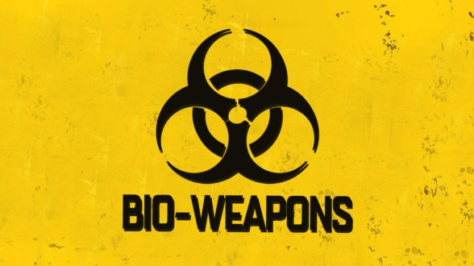Explosive Article: The Pentagon Bio-weapons
January 16, 2018 - Natural Health News

by Dilyana Gaytandzhieva
“The US Army regularly produces deadly viruses, bacteria and toxins in direct violation of the UN Convention on the prohibition of Biological Weapons. Hundreds of thousands of unwitting people are systematically exposed to dangerous pathogens and other incurable diseases. Bio warfare scientists using diplomatic cover test man-made viruses at Pentagon bio laboratories in 25 countries across the world. These US bio-laboratories are funded by the Defense Threat Reduction Agency (DTRA) under a $ 2.1 billion military program– Cooperative Biological Engagement Program (CBEP), and are located in former Soviet Union countries such as Georgia and Ukraine, the Middle East, South East Asia and Africa.”
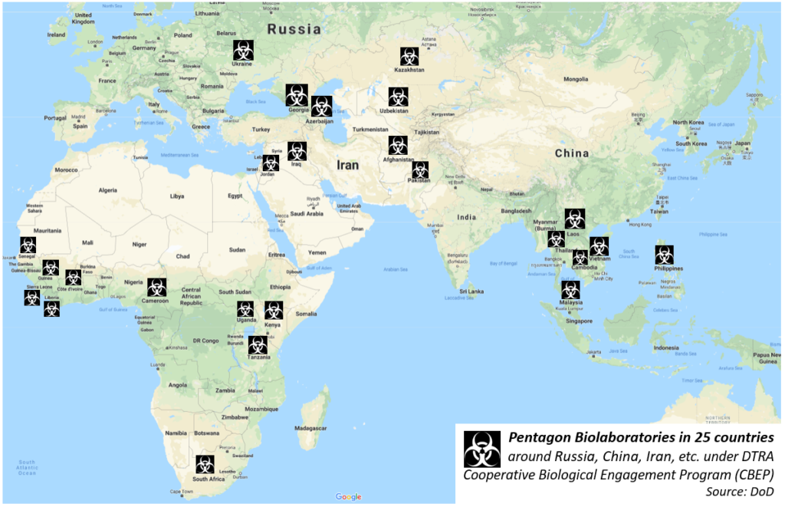
From The Lugar Center, Republic of Georgia - Source: fbo.gov
“Genetically engineered humans: Besides gene editing in insects and in the viruses they transmit, the Pentagon wants to engineer humans as well. DARPA Advanced Tools for Mammalian Genome Engineering Project seeks to create a biological platform inside the human body, using it to deliver new genetic information, and thus altering humans at the DNA level.”
“DARPA wants to insert an additional 47th artificial chromosome into human cells. This chromosome will deliver new genes that will be used for engineering the human body.”
“A Plague Has Been Unleashed On America and We May Not Be Able To Survive It - Colossal Red Alert Issued As Globalists Prepare 'Final Event' To Complete Their 'Take Down' Of America – ANP – March 5, 2018
Why would so many alternative health practitioners meet their untimely and, in many cases 'mysterious', ends within such a short period of time? Certainly such people are on the front lines in our battle against disease, most of them uncontrolled by 'Big Pharma' and 'corporate medicine', thorns in the sides of 'Big Pharma' and the deadly poisons that they peddle. With evidence that the flu virus has been deliberately weaponized for widest transmission…another sign is that it is well within the potential range of evil of these people who've long used the American people as 'guinea pigs' for their diabolical experiments, we remind you of this July 4th of 2007 story from Science Daily which reported upon efforts to find preserved samples of the 1918 influenza virus.
`The 1918 influenza pandemic was the most devastating single disease outbreak in modern history, and examining the virus that caused it may help prepare for, and possibly prevent, future pandemics. When the complete sequence of the 1918 virus was published in 2005, it represented a watershed event for influenza researchers worldwide.’
It also put the 1918 virus back into laboratories and while at this moment there is no way that we can be sure that the globalists are ready to unleash a deadly pandemic upon America and the world to finish their goals of 'culling the masses' and get our planet down to the 'more manageable' 500 million engraved upon the Georgia Guidestones as their population goal for our planet, history has proven that anybody who still thinks that 'government' has our best interests in mind is gravely mistaken.”
“Why I believe a killer flu pandemic is lurking just beyond the corner, and it could kill 33 MILLION people in the first 200 days,” by Dr. Jonathan D. Quick - 6 March 2018 - Daily Mail [Note: The Illuminati/Masonic signature in the numbers 33 and 300. Daily Mail writes: “Warning: Dr. Quick is Chair of the Global Health Council.” It is obvious that he “prophesies” because he knows the plans and their timing!]
Dr. Quick wrote: “`The big one is coming: A global virus pandemic that could kill 33 million victims in its first 200 days. Within the ensuing two years, more than 300 million people could perish worldwide. As a medical doctor and a health chief who has led global programmes at the World Health Organization (WHO), I believe that the world is at risk of a viral pandemic that will be at least as deadly as anything we have ever known before. The most likely culprit will be a new and unprecedentedly deadly mutation of the influenza virus. The conditions are right. It could happen tomorrow. We are just as vulnerable now as we were 100 years ago, when the 1918 Spanish flu pandemic infected a third of the world’s population and wiped out up to 100 million people. It remains the deadliest flu outbreak in history. A century on, the history and biology of the influenza virus tells us that we should expect another major global pandemic soon. Experts say it is already overdue. Human influenza usually starts with wild aquatic birds, because avian flu is very common in waterfowl.’
Wipeout: He fears a major influenza outbreak could kill 300 million people in two years. Somewhere out there, a flu virus is boiling up in the bloodstream of a bird, bat, monkey or pig, preparing to jump into a human being. When that combination from birds and beasts finds its way into a person, the resulting new human strain can kill us more easily because it is unknown to us and our bodies have zero immunity to it. This is most likely how the Spanish flu took hold.
`We have inadvertently developed a powerful way of helping influenza to kill us, 100 years on. This is our addiction to cheap chicken and pork — and the factory farm industry that supplies it. Factory farms present one of the greatest potentials for catastrophic disease because they pack animals together by the million in conditions that can be fetid incubators of disease. These giant industrial farms were the birthplace of H1N1 swine flu that emerged in 2009 and killed up to an estimated 575,400 people worldwide. Scientists traced the virus’s genes to a massive North Carolina pig farm in 1998. Pigs eat almost everything, so their guts are the perfect mixing bowls for flu strains. When pigs eat droppings of sick wild birds or the chickens living near them, the flu viruses in their digestive systems can swap their genetic material to create new strains.’
`…Food for thought: Factory farms could very likely be the birthplace of the next killer pandemic. Pig guts can add multiple germs from the humans that the pigs come into contact with, too. When new flu strains acquire their genes, it makes it easier for them to infect people. Factory farms could very likely be the birthplace of the next killer pandemic. The renegade influenza viruses they spawn could one day annihilate the people they feed.’ ” Dr. Quick goes on to give more. Read the article if you want to.
It is a fact that the WHO and the CDC, Pentagon/military, universities, and underground black-op labs are working feverishly to develop diseases to kill us. The rider on the pale horse is named “Death.” The varieties of ways to kill human and all biological life are very many, so as not to appear connected. While the rider rides to destroy 1/4th of the earth. Yet, the effects of the rider “Death” are spread into the air, and so will cover the globe. Mixed in with this is the incredible release of radiation in the oceans and the air due to Fukushima. Our oceans and Gulfs are dying, our rivers, our water systems of earth are being polluted.
Bottom line: 2018 is a break-loose year for many things that will speed up timing.
There is always Abba’s flip side to bad news! Wait for His input! I want to remind you of my last article: “What About Billy Graham’s Passing? Was It a “Sign?”/Mikvah of the Great Adventure. Be sure to read it for encouragement! Everything is accelerating, and the 223 prophecies of Messiah’s second coming are all converging now. The “hidden ones,” as in the prophecy by Pastor Chironna in that article about Graham, are being prepared for their release. The “hidden ones” proclaim defeat to the kingdom of darkness.
There is excitement in the spirits of those who understand the release of the hidden ones of Yahuwah--the Daniel 11:32 company, children of Light. We’ve entered the final days, and our assignments from our Master are being laid out for us. Be sure you are truly born of the Spirit, filled with His Spirit as in the Book of Acts pattern, and are moving forward in His perfect will. He can only use those who are already moving by His Spirit. Hang on to simple faith, peace, joy, and love--our Redeemer is on His way!
Shalom, in His love,
Yedidah
March 7, 2018

