Tornadoes of Judgment Descending
What Authority Do You Have To Stand Against Destructive Storms?

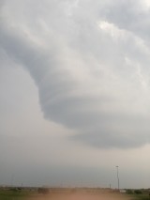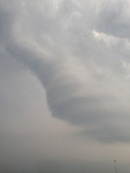
Photos taken by Derek evening May 10, 2016 Fort Worth, Texas
Derek’s comment: “Rebuked this thing and shortly afterwards it went up and dissipated into the clouds.”
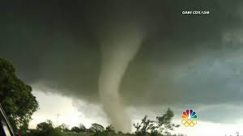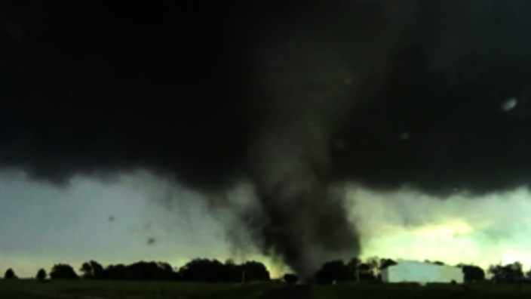

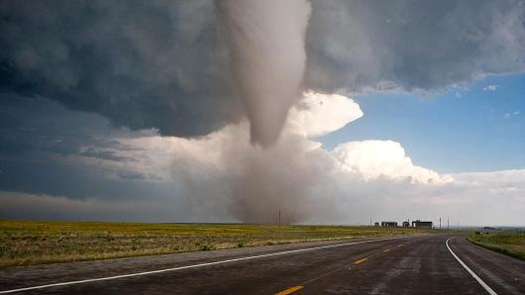
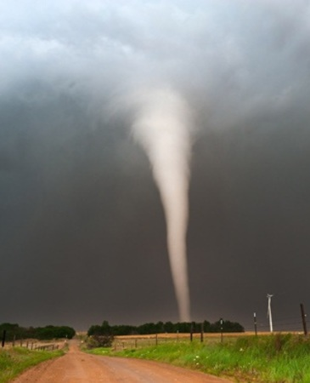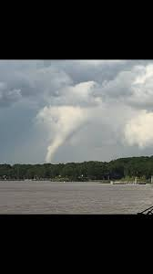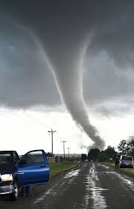
Funnel tornado clouds – their roar sounds just like a freight train moving fast
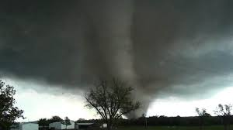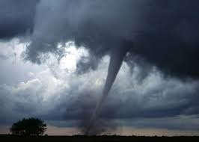

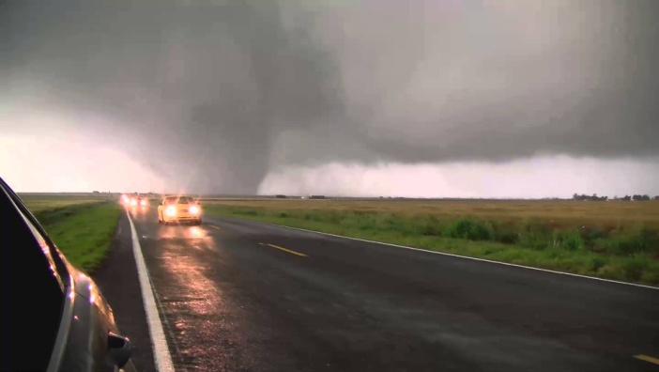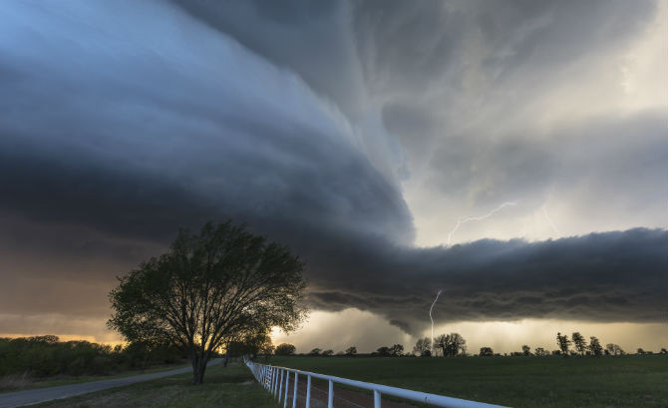
These are internet photos taken in Texas, Oklahoma, and Kansas of Tornadoes 2015 and 2016 …

This article shares a lot more Truth than just reporting on tornadoes! It contains things you must know in order to be prepared spiritually for the severe days ahead. I write from my own experiences, too.
Please look up these Scriptures and read in context

Isaiah 66:15-16: “Look, Yahuwah comes with fire and with His chariots like a whirlwind to render His displeasure with burning, and His rebuke with flames of fire. For by fire, and by His sword, Yahuwah shall judge all flesh, and His slain shall be many.”

Jeremiah 23:19-20/Jeremiah 30:23-24: “See, the storm of Yahuwah shall go forth in a rage, a whirling storm! It whirls on the head of the wicked. The displeasure of Yahuwah shall not turn back until He has done, and established the purposes of His heart. In the latter days you will understand it perfectly.”

Jeremiah 25:31-33: “…a great whirlwind is raised up from the farthermost parts of the earth. And in that Day the slain of Yahuwah shall be from one end of the earth even to the other end of the earth...”

Amos 1:14 “the day of the whirlwind”

Nahum 1:2-7: “Yahuwah has His way in the whirlwind and in the storm…”

Zechariah 9:14: “…His arrow goes forth like lightning, and the Master Yahuwah sound the ram’s horn. He shall go with whirlwinds from the south.”

The above Scriptures refer to the “Day of Yahuwah,”—at the coming of Messiah Yahushua! [Article: “The Day of Yahuwah/November 14, 2014] The whirlwind here is symbolic of His wrath.
My increasingly passionate alignment with the Creators of heaven and earth, Yahuwah and Yahushua, stands in the face of a world that has openly rejected Elohim--a world that adheres to Charles Darwin and his “Theory of Evolution,” and ideas like the “Big Bang Theory.” Man’s corrupted intellect from demonic sources has turned him from faith in “Intelligent design,” and loving Creators, to scientific speculation. The same corrupters have convinced man to create hybrid and robotic beings in their own image and likeness, to become the new creators.
Along with this, it is estimated statistically that over 40% of Evangelical Christians do not believe the “Bible” account of creation, and/or that the “Bible” contains the inspired Word of “God.” The rejection of Elohim and Their right to rule Their own creation has turned earth’s people to beliefs like the “Green Religion” (Mother Earth worship), Pantheism, Buddhism, Hinduism, or even Satanism or Luciferic worship.
The rising voices of earth’s people, including the rich and powerful, are calling for the return of the “sky gods,” i.e. the Nephilim/Rephaim. Their calling, since the 1800s at least, has been heard by the kingdom of darkness and its response has been swift. The ancient religions of the Incas, Maya, Aztec, and many native American Indian tribes, as well as those of Egypt, Greece, and Rome—religions that believed sky gods came to earth to bring man knowledge, who also promised to return, are now seeing their return.
In Mexico, Central and South America, even in North America, too, the “gods” who came to bring knowledge, promising to return, were said to have come from the East. They were described as giant white men with reddish blond hair and blue eyes, who had beards. These giants are returning and being seen by many. I have a belief as to who they were, since the same description fits the original giant Celts. But, from recent reports of tribal people today, they know the blond blue-eyed giants came from the Middle East. The Nazis were greatly influenced by the teachings of Darwin, and also great believers in the return of the perfect Arian race of blond, blue-eyed, Nordic people, their having tapped into demonic sources from their earliest predecessors. Refer to: “The Ancient Giants of the New World” April 17, 2016, by Primus Getarum: https://arcodabara.wordpress.com
As I sat at the dining room table drinking my jasmine green tea, I looked at the clutter Abby left on the table after doing her artwork. I thought of questions to ask my 10-year old grandson: “What holds all these things on the table?” “What keeps them from flying around the room? What keeps them from dissolving? When he came downstairs, I asked him the questions and asked him to read Colossians 1 for the answers. These questions baffle physicists to a large degree, especially “what holds everything together; what is the `gluon?’ “They are also baffled by the elusive “field of gravity.” Yet, the simple answer is found in Colossians 1:16-17.
Before the foundation of the world, Yahushua, the Son, the exact representation of His Father, was brought forth out of the loins of Yahuwah.
(Psalm 2; John 3:16, etc.) He was brought forth like a woman delivers a baby from her womb – out of the midst of her – the area of the eternal spirit. The Eternal Spirit brought forth Yahushua Yahuwah from the same area of His being. Later Elohim would create a man and a woman in their likeness and image that would also be able to bring forth out of their loins – the area of their spirit! I get cold chills thinking about it.
In Psalm 2, Daniel 7, Philippians 2, and Revelation 4 and 5, we see the exaltation of this Son – the “right hand” and “arm” of Yahuwah who has “brought Him the victory.” He is exalted and His Name praised to the esteem and honor of His Father.
He was brought forth after the angels were created. He was brought forth before the “foundation of the earth.” They are the “Us” of Genesis 1:26, 11:7 and Isaiah 6:8. Yahushua is the Living Word who spoke creation into existence. All things were created by sound waves emanating from His mouth. (Genesis 1; Colossians 1:12-17; Hebrews 1)
He appeared many times before His incarnation into flesh to pay the blood sacrifice required to redeem the lost sheep of the House of Israel and anyone else who received His substitute sacrifice. (Leviticus 17:11; Hebrews 9:14, 22) Abraham referred to Him as “Yahuwah,” as did Ya’cob and Sampson’s parents.
What type of “God” would give a commandment, or commandments, which if not obeyed carry the death penalty, and then a few centuries later stop His children from being able to obey the commandment at all? Not a “God” any sane person would want to worship! From the days of Adam and Eve, the shedding of innocent blood of a pure and spotless animal for a substitute to atone for one’s sins to today 2016, the Elohim of Israel has made sure that His people had a “lamb” to offer! Yahuwah never left His people without a blood sacrifice!!! Therefore, a “god” that leaves His children to resort to “good works” for salvation, thus defying His own eternal Word, is not the “God” of the Scriptures. He is a made-up God in the minds of men. Think about it: All these deceived people throwing away the Lamb of Elohim for a religion of good works--No logic in it at all! It is a mighty deception of Satan’s forces on the minds of people who have no personal relationship with Father and Son.
Cain offered the works of his hands, and though I’m sure his vegetables were top quality, Yahuwah didn’t accept his sacrifice. So, out of anger and jealousy, Cain killed his brother because Abel brought a lamb and was accepted. Cain was jealous of Abel’s relationship with Yahuwah! Isn’t this religion – get rid of the true in order to protect the false?
This mighty Creator-Savior, Son of Yahuwah, is returning with the wrath of His Father. His judgment will come like a whirlwind as He moves from south to north as the Scriptures foretell. He comes like lightning from East to West, touching base with Mount Sinai, moving over the Gulf of Aqaba to Mount Paran, then rising up over Mount Seir (Petra), then turning in wrath towards Bozrah, north of Mount Seir, then on to Jerusalem. (Deuteronomy 33:2-3; Isaiah 63:1-6; Habakkuk chapter 3, Matthew 24:27-31)
He alone will sit in judgment over all mankind at His coming. (Matthew 25:31-46; Luke 12:30-48) You and I will stand before the “bema,” the judgment seat, of Messiah to receive rewards according to what we have done for the Master. (Matthew 25:1-1-30; Romans 14:10; I Corinthians 3:11-15; II Corinthians 5:9-16; II Timothy 2:19-21)
For a short time now, Yahuwah is allowing the rebellious fallen angels, their leader, Satan/Lucifer, and humans subject to Satan, to test and purge mankind to see who is loyal to the control of the fallen ones, and who is loyal to Them.
Hebrew Matthew translates Matthew 24:22 like this: “…“unless those days be few no flesh will be saved, but for the elect’s sake those days will be few.” From the Greek, it is translated as “…days be shortened.” I believe “few” is more accurate. The judgment by Flood was a mere 6 weeks, not months or years. Yahuwah is swift in His judgment, and thorough.
Man is made of dust. So, eliminating nearly 7 billion people won’t take long. But, now we see the push for what is called a “post human” world--the creation of hybrid beings via the trans-human and transgenic scientific experiments--the creating of artificial intelligence and cyborgs, etc., joined with the increasing destruction of the earth.
Satan wants to take earth back to Genesis 1:2 --“And the earth was without form and void, and darkness covered the deep.” He hates Light! Thus, at his bidding, his human servants are quickly destabilizing the balance of earth’s delicate ecosystem, using technology he gave them, releasing fire at earth’s core that is surfacing onto the earth-- causing earthquakes, volcano eruptions, tornadoes, cyclones, tsunamis, hurricanes, blizzards, fires, drought, and floods to destroy the earth’s food crops. The Word tells us that the earth will be covered with “great famine.”
HAARP was capable of heating the Ionosphere in order to do weather “modification,” – “weather warfare,” against mankind. It was closed down for a couple of years, so it was said. Here is a quote that is most fascinating, showing that the destruction of earth is going forward with or without HAARP, from the article: Mysterious Weather Radar Anomalies Over Switzerland (Video) A strange phenomenon appeared on the weather map last Sunday, May 8, 2016. A perfect circle of rain moved across Lausanne, Vallorbe a few kilometers to the south of Geneva in Switzerland, however at that time it was not raining! UFO Hotspot May 11, 2016: “Weather modification system – HAARP: A military US defense program created to control the weather, using electromagnetic energy focused on our Ionosphere to heat it.
“`In a Senate hearing in 2014, David Walker, a deputy assistance secretary of the Air Force, answered a question by Lisa McCroskey (? spelling) about the dismantling of HAARP – a 3 billion dollar program. (It was “dismantled for about 2 years) Walker said: *** “It’s not an area we have any need for in the future. It would not be a good use of Air Force funds to keep HAARP going. We’re moving on to other ways of managing the Ionosphere, which is what HAARP is really designed to do, which was to inject energy into the Ionosphere to actually be able to control it. But, that work has been completed.’ In the public eye HAARP closed down, but many people believed it did not. It was controlling weather, for sure, but now we are seeing a stronger repeat of what HAARP did before – or at least a repeat of intense and strange storms, tsunamis, hurricanes, cyclones, tornadoes, blizzards, floods, droughts, fires, etc. – using Nicola Tesla’s technology as well. Weather seems to be artificial in many places …”
Yedidah is one of those that does not believe it was shut down (smile). If it did, a much more powerful technology took its place. I am trying to keep up with all the weather anomalies, and now there are many! The word “anomaly” means: something that deviates from what is standard, normal, or expected i.e. oddity, peculiarity, abnormality, irregularity, inconsistent, incongruity, a `quirk’ or a rarity.”
This strange “rain,” spoken of in the above article happened over Switzerland in the area of CERN. I believe that CERN is also doing its own brand of destruction of earth.
But, the Creators will only let it go so far before They step in. The earth will not be destroyed, though as Isaiah 10, 13, and 24 tell us, it will come close to being destroyed. Are you calling for Messiah to come! Are you honoring the Creators by proclaiming Their Word about Creation? It is a major theme throughout the Word. In fact, look at Revelation 14:6-7. I wrote an article that Derek said influenced him, entitled “Just Acknowledge Me As Creator”/August 2008. It is the final plea of Yahuwah before He sends judgment on the earth.
Revelation 14:6-7: “And I saw an another angel flying in the mid-heaven holding the Everlasting Good News to announce to those dwelling on the earth, even to every nation and tribe, and tongue and people, saying with a loud voice: `Fear Elohim and give esteem to Him because the hour of His judgment has come. And worship Him who made the heavens and the earth, the sea, and the fountains of water.”
Most people today think Genesis 1 is a myth. One day, when I was in my mid-teens, I sat in a Seminary class on a field trip with my American Baptist Church. The professor told us that the book of Genesis was a myth. I couldn’t believe what I was hearing. I was furiously outraged. I went to the Dean of the Seminary about what he said. Two weeks later, I heard the professor had been fired. I felt bad about that, but I was not going to let him get away with tearing down the Word. That’s Yedidah to this day…
The final judgment of mankind is based on the acknowledgement of Elohim as Creator. But, mankind won’t acknowledge Him, so Yahuwah sends Yahushua to take back the earth!
If Yahushua finds no guarding of the Kingdom instructions (Torah), no representation of His nature, no one crying “Come Yahushua Come,” no one grieving with Him, then Yahushua Messiah will have to destroy the earth. (Malachi 4:5-6, Luke 18:7-8) He created the universe with His voice, spoken forth at the command of His Father to fulfill His Father’s will, so He can destroy it if that creation gives Him no fruit at His coming. However: HalleluYah! There will be a remnant!
Tornadoes are a destructive force, like flood, hurricanes, cyclones, tsunamis, drought, snow, ice, and hail, extreme heat, wild beasts, disease, famine, and war. They are signs of judgment. All of these plagues will be on the earth before Messiah comes. But, those who huddle under His talit in the “secret place of the Most High” will be sheltered in “the shadow of the Almighty.” They are the “few.” So, for the sake of the “few,” the days of judgment will be “few.” Thank you Abba!
Meteorologists have said for a long time that there are no natural weather patterns on earth. Man has been purposely and systematically destroying Yahuwah’s perfect balance since the return of the Nephilim in 1896. The 120 years of Abba’s striving with man is over!
When in Canada the last time, I mostly stayed south of Winnipeg, Manitoba. Recently, the local newspaper ran an article telling the people to buy generators and other survival equipment because Tornado Alley, which generally has run from Kansas to Oklahoma to Texas, was turning northward into Manitoba. Recently, we’ve seen the terrible destruction of a mysterious fire in Alberta that seems to have a mind of its own, refusing to be put out.
Destructive Weather was not part of the blueprint of Creation!
All over the world, people are seeing very strange things in the sky, from new types of clouds never before seen, new cloud shapes never seen before, recent hail streaks not seen before, bizarre circles of rain shown on radar over Switzerland that are baffling meteorologists, people hearing booming under the earth and in the skies, and strange trumpet sounds in the skies.
I have been collecting one article after the other with the word “historic” in it i.e. historic fire, historic earthquake, historic volcano eruption, historic drought, historic flood, and historic tornadoes, etc.
Weather manipulation is being used to bring famine, spread disease, to herd human beings like animals, to destroy a nation’s infrastructure and kill its citizens, to collapse economies of nations, and to control the thinking of people by creating fear, into which lies can be interjected and believed.
The increase in powerful tornadoes is just another sign of judgment on mankind who has rebelled against Elohim. He is allowing His own laws to be breached for a short time to separate unto Himself His true children.
Look at Jeremiah 5:22-25. Man no longer fears the Creator who set boundaries for the seas. Therefore, the Creator will allow the seas to also be a means of judgment. The seas are roaring not because of “global warming” but because of the purposed melting of ice caps at the two poles to make it look like global warming. The nations rush like the raging seas in these last days. (Isaiah 17:12-13; Luke 21:25-27)
As I wrote in the Withdrawal trilogy/January 2016, Yahuwah has withdrawn in order to give His enemies their final chance … then He will send Messiah with His raging wrath to take control of His earth once again. (Revelation 11:15-18) He will destroy those destroying the earth!
The earth was created in peace, and its balance set up for the good of His creation. These storms are not Him. So, a question for you: Did Elohim leave us with any power over the power of the “prince of the air,” the “god of this world,” and over the works of evil men who have used the stolen technology of Yahuwah to bring destruction? Or, has He left us as helpless victims of circumstances?
Look again at the two photos Derek took, page 1, and read what he wrote me about them. When he was a little boy of 4, his favorite story in the Bible was Mark 4:35-5:1.
Read that story! You, yes YOU, as a born-again believer, have the right to rebuke weather when it is a danger to man, animals, and property, and especially when it is an obstacle/a hindrance to the work of Yahuwah’s servants. You have the right to stand against evil with the spiritual weapons of our warfare. Adverse weather must obey the command in the mouth of those with “authority backing” from Yahuwah. [Refer to: “Authority Backing” and “It’s In Your Mouth”/April 28, 2016]
Man’s sin in the Garden negated the authority mankind was originally given over the world system of nations and the earth itself. Our rebellion snuffed out our rights and turned our power over to the “prince of the power of the air,” to the “god of this world,” to the principalities and powers over nations. But, Messiah died to restore that authority to those that would align to Him, and to the boundaries of His Father. If we have no authority against destruction by the fallen angels, “the prince” himself, or their human agents, then we are indeed “at the mercy” of the evil ones who have no mercy. Does our Father leave us helpless against these forces? The answer is: NO!
I first commanded a storm to stop when I taught at a Christian school in Sun Valley, California. I was in my early 20s. I had written a program about salvation to be presented on a certain night to parents of 700 school children. I was the director of it, and played the piano for the children’s singing. The children had to stand outside and walk into the auditorium. It had been storming all morning. The storm kept on all day into the early evening. I was on my knees in prayer all afternoon. I remembered Mark 4:35-5:1. That evening, as the children arrived, the rains stopped, the storm went away, and the program was a big success. After everyone got home later that evening, the storm started up again.
In the story in Mark 4:35-5:1, Yahushua Messiah had a mission at the end of the Lake to heal and deliver the man at Gadera. A storm came in between his leaving the north of Lake Kinneret to His arriving at His destination. The disciples panicked. Yahushua remained asleep in the back of the boat. The disciples were good swimmers, but when a storm whips around that Lake, no one can swim because of the violence of the waves. I know. I was at the marina in downtown Tiberias when one came up suddenly. So, in panic, the disciples woke up Messiah. He was not happy. In fact, He was angry at them for not rebuking the storm. That must have been a shock to them. He rebuked it. They arrived at their destination.
One evening, in 1992, in Fort Worth, Texas, I was up about midnight praying over a serious situation in our family, doing spiritual warfare. All of a sudden I saw one lightning bolt after another flashing, with one loud thunder roll after another. It was a sudden storm, and a powerful one. It got louder and louder. I boldly rebuked it, telling it to stay away from our house and dissipate. I kept on praying a while longer. It reached a very loud pitch, then faded. The next morning, I looked down our street. Obviously, a tornado has set down and moved straight down our street. We were on the corner at the head of the street. I drove my car down the street. I saw roofs that had been ripped off, trees uprooted, people’s possessions thrown all over the place. Yet, we had a few leaves knocked off a tree.
In 2000, I was visiting from Jordan, staying in Derek’s home in a suburb of Fort Worth, Texas. His little boy, my precious grandson, was scared. We were watching TV footage of a tornado ripping through downtown Fort Worth. He turned and asked me if the tornado was going to get us. I told him “no.” That twister went right down the 820 loop near us. At Calvary Cathedral in downtown Fort Worth, the tornado took off their prayer tower, but the pastor boldly ran out in the face of that tornado and rebuked it, and it lifted up and did not destroy the church.
In 1995, a powerful hail storm ripped through Fort Worth. It was so bad that cars were beaten in by it, mine included. My 2nd daughter had been working at Discovery Zone that night. She had driven my car. The youngest daughter was staying with her, and was at home. My daughter had to drive from Discovery Zone down Hwy 20 to get to the east side of the city where she lived. I did much spiritual warfare for her protection. The hail was golf-ball size. It hit some people on the head and gave some concussions.
In 1977, my husband was bold enough to go into the tower of the main local radio station where he worked, during a tornado that was ripping through that area of Murphy, North Carolina. He was alone. He felt it was his duty to keep the radio station proclaiming the condition of the storm. I lay on the couch in our living room about 10 miles away. The year before, the station’s tower had been blown to the ground by a powerful tornado. They had put up a new tower, the one he was in that night. I was praying hard. I kept the radio on, listening to his reporting. I was so proud of him! I heard what sounded like a freight train approaching. It was very loud. It passed high over our area. It was the tornado. I get chills just writing this. But, Abba lifted it up, and my husband came home a hero in the community.
In Africa, I rebuked many storms that stood in my way of reaching my destination in small villages where I taught and preached. I have never had a problem with rebuking a storm that was threatening my work for Abba, or my family. Abba always backed me.
Fear cancels faith. Fear removes Abba’s protection from us! The “gift of faith” in I Corinthians 12:4-11 is not the “measure of faith” that we get with the true new birth. (Romans 12:3 KJV) The “gift of faith” is a miracle-working faith that bypasses the reasoning of the mind. I have seen this in action several times, and used it myself. That’s the faith that acts without the mind in operation--faith that comes from the re-born spirit within us, located behind our naval. This is the bold faith that obtains the victory in all situations. Without it, man is left to his puny reasoning, fear, and anxiety, which accomplishes nothing, and brings down disaster.
So, as in Mark 4, why disturb Yahushua with panic, fear, crying, anxiety, fretting, worry, and all that silly stuff, when we have all the power from Him to speak to the storm and have it obey us?
But, one word of caution: Bold proclamation of the Word against the forces of the evil ones requires faith that bypasses human reason, that which has the backing of Yahuwah, for it to be effective. It’s like using a sword against an enemy who has invaded your house. Who stops to reason when someone is about to destroy your family? The reason shuts down. “Self-preservation” and “species preservation,” which is innate in human beings, takes control. So, whether adverse weather, disease, beasts or the earth, or sword, His children are equipped with “weapons that are not carnal, but might to the pulling down of strongholds.” (II Corinthians 10:3-6; Ephesians 6:10-18)
People are prone in panicky situations to scream at the devil and fear. But, only bold proclamation in faith, from peace in our re-born spirit, tells the enemy you have Yahuwah’s backing!
Tornadoes of His judgment are descending in many different ways. But, we can be victorious, remain in peace, and go forth to meet the coming Bridegroom.
Shalom, in His love,
Yedidah
May 17, 2016

