U.N. Peacekeeper TROOPS in America
Violence, Covert Agendas, and the Disappearance of 21 Trillion Dollars

In 1996, I drove from Fort Worth, Texas to Southern California with my daughter-in-law and grandson to attend a Voice of the Martyrs Conference. Driving back, I wanted to take them to Carlsbad Caverns in New Mexico. Driving the lower route from California through Arizona, I drove towards El Paso, Texas. Upon getting to El Paso, I saw that, since it was on the border with Mexico, I had to go through a check-point. From there I could go into Northwest Texas and then turn north into New Mexico, and on to Carlsbad. As I approached the El Paso check-point on the border with Mexico, one thing immediately stood out – there was no American flag, and no Mexico flag. We got through that easily, and I began climbing up the road out of El Paso heading towards New Mexico on Hwy 62/180.
As we left “civilization” and I began driving up the hill from El Paso, we were the only car on the road. We had not gone far before I saw a tall young man standing by the road to my right, dressed in a dark green military uniform I had not seen before. He stepped out of a wooden guard-shack. He put up his hand to stop me. I pulled over to the side of the road. He came to the driver’s side, and I saw he was wearing a United Nations uniform. He spoke with a Russian accent and asked coldly: “Are you a U.S. citizen?” I told him “yes.” He waved me on. As I drove on, my daughter-in-law and I were silent for about 15 minutes. Then it was “ohmagosh – what happened!”
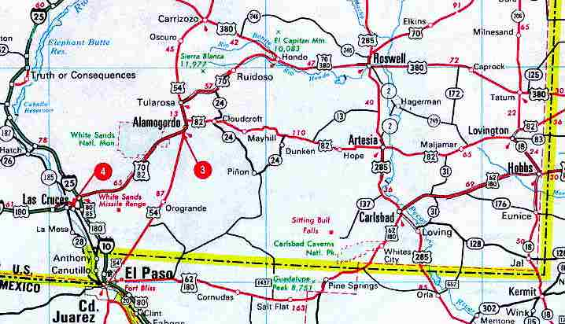
After leaving Carlsbad, we headed home, back into Texas, on to Fort Worth. Later I learned from a young man in the army, the son of a friend of mine who was also patrolling that border from the New Mexico side, that the U.N. had troops all along the Texas/Mexico border in a 30-mile buffer zone. I later learned that all U.N. Peacekeeper Generals were Communist Russians, or from some other Communist country. Now I know that included China, as we saw in 2006 after the U.N. helped Hezbollah in Lebanon to “win” the war against Israel--using very dirty tricks!
OH yes – the U.N. has their facilities in Lebanon just a few miles from Hezbollah headquarters. I saw it myself as I road along the border of Lebanon inside Israel. Going towards Mount Hermon, there is a place in the Druid town of Majdal Shams, where you can stand at the fence that separates Israel from Syria. I’ve stood there a few times, and there in front of me not far away stood U.N. headquarters inside Syria. I also saw them from inside Israel along the Syrian border crossing the Golan Heights. U.N. troops swam all over Israel like a plague of locusts from top to bottom.
President Obama invited Interpol (International Police) into America a few years ago. Of course, the U.N. headquarters stand in New York City! Black-ops, i.e. “Black Water” mercenaries, are inside America, also, waiting for instructions in case of martial law, a plague quarantine, an EMP attack, famine, war, civil war, etc whatever real or false flag event that comes first. Real plagues inside America, besides many Muslim terrorist Jihad camps, are foreign troops like Russian and Chinese--not only with the U.N., but their militaries that occupy U.S. bases at the invitation of the U.S. government.
And where are America’s “good ol’ boys,”--our soldiers, our Army, Air Force, Navy, Marines, Coast Guard, and National Guard? Most are in over 100 foreign countries.
In Aqaba (Jordan), a couple of friends and I talked to a few American military men at a restaurant one night. Their U.S. Coast Guard ship was docked in the port of Aqaba. It was a gorgeous ship. It looked like a huge yacht. Having drunk too much beer, the men were all too ready to talk freely with fellow Americans. I asked why they were in Jordan when they were supposed to be guarding the American Coast. One of their chief officer said that they were on a two-year mission sailing around the world to arrest pirates. They were the ones who accosted pirates where the Gulf of Aden enters the Red Sea in Yemen. The story made national news. Nice friendly young fellows! One wore a UTA t-shirt. I asked him if he went to that college. He said “yes.” I told him my daughter had recently graduated from that same college. Small world huh …
The U.S. Army is in over 100 countries, our Navy in various places, our Air Force, too. Recently we’re learned that approximately 44,000, or more, of our military abroad are “missing”--the records of where they went are missing. Refer to: “Dude Where's My Troops? Pentagon Loses Track of 44,000 Soldiers by Tyler Durden – Zero Hedge - Dec 9, 2017.
We learn that the Air Force is having problems getting plane parts, and the Navy is having trouble getting parts for their ships and for the planes on their ships.
We learned that Obama reduced our military down in size to an even lower number of soldiers than we had on December 7, 1945, the day of the Pearl Harbor attack. Obama removed many top military leaders of our nation, even Generals, in all branches of our military. So, who is here protecting us! Oh, a few of our own troops I suppose, but now we’re asking the help foreign troops with the U.N. who have no love or mercy for Americans. Are the words of Isaiah 13:17-18 and Jeremiah 51:11, speaking of America, more understandable now? The spirit of the Medes indeed!
About five years ago, two of the Russian troops on motorcycles told my friend Michelle they were here to kill Americans. Others have heard them say that, too. The personality of the Russian who stopped us out of El Paso was as “cold as ice.” The chief Chinese General recently commented to one of our military Generals that he’d like to kill all the Americans, but his army wouldn’t go along with it. It is amazing how many bases and how much land has been given to the Chinese in America and Canada.
So, here we are like “sitting ducks” with President Trump doing all he can it seems, and I must say doing a decent job with what he can do, even thought he is fought “tooth and nail” by the Deep State. But, he’s also letting important things slip past him, and he’s doing a few things that make us question “…whose side are you on?”
Last night, in reading Doug Woodward’s Power Quest Book II, he went into detail about the Executive Order that I wrote about in --“The New Executive Order.” Isn’t Abba great to confirm what He is showing us? Comparing it to what happened in Nazi Germany, here is what Woodward wrote about America: “…we can distinctly mark a steady move towards Fascism. One only needs to recognize the erosion of liberty implied through the National Defense Authorization Act (NDAA) of 2012, quietly and strategically signed on New Year’s Eve by President Barack Obama…Writing on behalf of Forbes Magazine, Erik Kahn conveyed its essential significance and implication (January 2, 2012): `The National Defense Authorization Act greatly expands the power and scope of the federal government to fight the War on Terror, including codifying into law the indefinite detention of terrorism suspects without trial. Under the new law the U.S. military has the power to carry out domestic anti-terrorism operations on U.S. soil.’ In regards to personal liberty, the NDAA comprise the single greatest threat to our Constitution’s Bill of Rights...the NDAA goes so far as to allow authorities to arrest citizens (identified as terrorists) for literally doing nothing more than appearing suspicious…Anyone can be held indefinitely – for any reason the Federal Government chooses.”
This confirms what Tom Horn wrote in Blood on the Altar. One of the main groups that are targeted by this authorization are Christians,--or all Bible believers in general.
Bottom line: In case of martial law, all of our rights are GONE! The government, or their proxy friends, like the Russian troops, can take anything we have – property, money, possessions, our children, and our lives. This is the bottom line of all socialist governments, whether Communist, Fascist, Nazi, Feudal, or just plain old Dictator – there are two classes – poor and rich – and the rich have the right to take whatever the poor have to give it to other poor, or keep it for themselves. There is no “middle-class.”
All this time, the governments of earth have been playing a mind-game with earth’s people--supposedly pitting Communists against National Socialists/Nazis, Fascists, and Feudalists, even in wars. But, all this time, they’ve been on both sides, for there is little difference--all are anti-middle class, anti-Capitalist, anti-rights of the people. It is a Jesuit trick also using all of these forms of government in various countries to be on both sides, so no matter who wins the spoils, they win. America played this game in World War II and successfully banks and corporations raked in multi-billions of dollars.
For our good, of course, in case of some national catastrophe, we may be herded into FEMA camps, separated into distinct areas for “women,” “men,” and “children.” I’ve written about these “camps” and the three-story boxcars ready to transport people to them. I got confirmation on all of it from a top-insider, a retired military man highly respected as a Colonel in the Army. This is very real. Old military bases have been turned into “detention camps.” You can right now be arrested for being a “suspected” terrorist, detailed without trial indefinitely. That’s on the law books of America. This one law will be used against Christians primarily. [Refer to the important book: Blood on the Altar, by Tom Horn and other authors]
I want to tell you a dream I had in 2007 about being in Chicago. The dream symbolized the collapse of America. I was staying with friends in Pine Hills, East Texas, during a time of teaching in meetings in that area. One night, I had just fallen asleep, when I had a very clear dream from Abba. I was evidently in an extra dimensional state in the dream. I was in a very big city without any ID or money – no purse, no wallet. I looked up and saw high skyscrapers. I knew in my spirit that I was in Chicago. I was standing on a sidewalk by a large park area. The road by me had two lanes going to my left, and two lanes going to my right. There was no traffic. But, I saw one car going about 30mph along the road to my right. It kept going until it hit a barrier that was across the road, like a check-point barrier, and the car exploded. I put my hands over my ears. I was not hurt, even though I was about a block from it. Another car came faster and hit the barrier and exploded. I started to go towards the barrier to see if anyone was still alive in the cars. But, then, I saw an old rusty jalopy heading towards the barrier. The diver had the window down and his arm up on the window frame. He was wearing a dirty t-shirt. He was fat and “greasy” looking, a cigarette hung from his mouth. He was driving very slowly. But, as he neared the barrier, he sped up to a very fast speed. I saw a hotel across the park, and thought I should run to it. But, just then, he hit the barrier, the car blew up, and the hotel fell down like “building 7” next to the twin towers on 9/11/01. I saw a strip-mall to my right, and thought I could run there, but immediately it all came tumbling down in an instant. I was totally unscathed, and I maintained peace, but everything was collapsing around me.
In 2009, as I learned that Obama, a former Senator from Chicago, gave his election speech in a Chicago Park. I did some research as to where it was. I was numbed to see that the park where Obama gave his speech was the same park I had seen in the 2007 dream. Later I realized that the driver and his old car chugging along slowly represented TIME. But, when it is time for everything to blow up and collapse, the events of time will speed up. Those “under the shadow of the Almighty” will be “unscathed.”
COVERT Agendas are being carried out, and public news is assisting it, while hiding the truth from the American people. “Covert” means: “not openly acknowledged or displayed, secret, clandestine, stealthy, cloak-and-dagger, backroom, hidden, under-the-table, concealed, private, under-ground, hush-hush.” Get the idea?
Here I begin to share articles about U.N. troops in America’s inner cities. Keep watch on how this progresses! Violence is increasing, and just a few days ago, violence erupted in Chicago again, and in Charlottesville, Virginia, and in Washington D.C.
Notes from Dave Hodges, The Common Sense Show, YouTube video: “U.S. Government Money: Where Did 21 Trillion Dollars Disappear to?” December 17, 2017: Between 1998 and 2015, the Army was found to have “unsupported adjustments, un-authorized expenses,” for which they got 6.5 trillion from the Pentagon, when the Army “only” gets 120 billion a year normally…so we’re looking at some 6X over normal budgeting.’ This is about secret armies, covert black-op projects.
Hodges got some undercover info. Remember, his dad was a government Intelligence officer. He learned that some of the missing money ended up with HUD for urban projects. They are buying up and refurbishing homes that have been repossessed and making them livable. The amount of money spent is not recorded. Former Green Beret John Moore told Dave Hodges and Paul Martin that his daughter went shopping for puppies for sale. She followed up on one advertisement. She went to an upscale home to hopefully get the puppy. She got the puppy, and in conversation she asked the man at the house: And what do you do?” He replied: “I am an UN Peacekeeper.”
In Chicago authorized U.N. Peacekeepers have been asked to patrol the streets to catch people carrying guns. Hodges said he thought that maybe HUD was refurbishing homes to house U.N. Peacekeepers in style. Afterwards, he learned these houses were being refurbished for especially Russian and Chinese U.N. Peacekeepers in America.
This money has also gone to military projects that are top-secret, which we refer to as “Black-op” (Black operation) Projects. The government has cut off “public access to government funding.” It used to be open, but no more. Hodges said that if the 21 trillion used for Black-ops projects and U.N. housing of their peacekeepers, was put back into the U.S. economy, there would be NO NATIONAL DEBT - or almost no national debt. However, the Banks want a debt-based economy, so the national debt continues to rise.
Yet, under President Andrew Jackson, as a nation, America was debt-free. The credit system and a Central Bank were created at Jekyll Island, Georgia in the early 1900s purposely to enslave us with debt so that the elite bankers could get richer on our interest paid on our debt. Hodges said: “The Federal Reserve System is our Central Bank.” From online info: “Jekyll Island was the location of a meeting in November 1910 in which draft legislation was written to create the U.S. Federal Reserve.”
Oh what a mess we get ourselves into because we don’t obey the simple directives of Yahuwah! His opinion: “Owe no man anything but love.” Going into debt is willfully submitting to slavery, creating for ourselves a continual struggle to pay for what we don’t need to go into debt for.
Hodges: “The U.S. government is committing fraud against the American people. They are engaged in a fallacious cover-up of their spending of 21 trillion dollars.”
The conspiracy to commit the crime is one thing, the conspiracy to cover it up is another, plus obstruction of justice. Hodges said he talked to two people in the news media who had elements of this in their knowledge, so “it’s not speculative, it is for real.”
“The true-life X-Files: As the Pentagon admits it secretly spent tens of millions to combat UFO attacks, the spooky close encounters U.S. pilots are convinced were aliens” - by Tom Leonard in New York for The Daily Mail, 18 December 2017. It’s near laughable, but it exposes the deeply hidden corruption that is seeking our ruin.
Here are excerpts from a few articles I’ve collected. Google the articles and read them for yourself to learn more…
“BREAKING: Military Martial Law Bill Sneaked Through by Senate Bill gives Obama power to deploy military anywhere - including on U.S. soil, Kit Daniels, Infowars.com, Jan. 22, 2016: “Senate Majority Leader Mitch McConnell is attempting to fast track a “war powers” bill that will allow President Obama nearly unlimited power to deploy the military anywhere in the world for any length of time – including on U.S. soil… In other words, the authorization allows the president to deploy the military anywhere at his discretion – both foreign and domestic – for as long as he wants.” This bill has not been revoked!” These Executive Order powers are now in the hands of Donald Trump. He has not revoked them!

Obama and Interpol (International Police)
“Terror, the U.N., Interpol, and Power!” By David J. Smith - Editor Newswatch Magazine 1/9/10: “…Barack Obama, an illegal president, has cast aside the U.S. Constitution like a rag doll…He has agreed to allow an international police authority to overrule the U.S. government. Barack Obama signed an Executive Order giving express permission for Interpol to supersede the laws and police authorities of the U.S.A. (Barry Napier, Wednesday, December 30, 2009)….
“In 2005, Interpol briefed members of the U.N. Security Council Counter Terrorism Committee on its work to combat terrorism AND its `growing cooperation with the U.N. in a range of anti-crime areas.’ What is considered to be ‘crime?’ Whatever the U.N. decides it will be! Interpol has an office in the U.N.’s New York building. The links between Interpol and the U.N. are very strong, if not interwoven…
…Another AIM of Interpol is to provide support for U.N. peacekeeping missions. Anyone who has studied these peacekeeping missions knows they are killing sprees, with U.N. troops at the helm, making sure Marxist regimes STAY in power, or gain power! How can Interpol claim neutrality when it assists U.N. troops in murderous ‘peacekeeping?’ ”
Why do I report what Obama did when he’s no longer President? – Because, Obama set things in motion during his Dictatorship that has set us on a course for destruction. NBC news published a video-interview December 27, 2017 showing Prince Harry talking to Obama. The caption: “Prince Harry talks to President Obama,” not “former President Obama.” Obama still thinks of himself as the President. He still acts like he is the President. He has set himself up in a fortress two miles from the White House and rules over a nation-wide web of protestors against the Trump Presidency. Here’s what Wikipedia says about his organization: “Organizing for Action” (OFA) is a nonprofit 501(c)4 organization…that advocates the agenda of former U.S. President Barack Obama.” His organization was founded: January 18, 2013. I guess he got an early start by establishing his military bunker to make sure he stayed President no matter what would happen in 2016.
Check out: “How Obama is scheming to sabotage Trump’s presidency” by Paul Sperry,
February 11, 2017--New York Post. Here’s an excerpt from this article: “When former President Barack Obama said he was `heartened’ by anti-Trump protests, he was sending a message of approval to his troops. Troops? Yes, Obama has an army of agitators numbering more than 30,000 who will fight his Republican successor at every turn of his historic presidency. And Obama will command them from a bunker less than two miles from the White House.”
Obama places US under international police
“Obama Surrenders U.S. Sovereignty: His INTERPOL Executive Order”
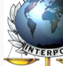 December 28, 2009 - by Bob Owens
“At ThreatsWatch.org, Steve Schippert and Clyde Middleton have dug up the bizarre and unsettling issuance of an executive order recently signed by President Barack Obama. Executive Order — Amending Executive Order 12425, signed December 16, 2009, and released a day later, grants the International Criminal Police Organization (INTERPOL) rights on American soil that place it beyond the reach of our own law enforcement agencies, such as the Federal Bureau of Investigation (FBI). Schippert and Middleton note that Obama’s order removes protections placed upon INTERPOL by President Reagan in 1983. Obama’s order gives the group the authority to avoid Freedom of Information Act (FOIA) requests — which means this foreign law enforcement organization can operate free of an important safeguard against governmental abuse. … If the president of the United States has an aboveboard reason for making a foreign law enforcement agency exempt from American laws on American soil, it wasn’t shared by the White House. INTERPOL’s senior leadership was flush with Nazis from the late 1930s all the way into the 1970s.”
In other words on American soil are INTERPOL, the U.N. Peacekeeping Troops, foreign armies of Russia, China, and others in the NATO block, a government long-ago taken over by communist and Nazi infiltrators, and before that taken over by Jesuit infiltrators from the 1600s. We’ve been the breeding ground for the return of the pre-flood gods, and the post flood Nimrod, since our inception. [Refer to: “America’s Secret Destiny”/Mikvah of Preparation] We’ve lived under an illusion of our goodness, but now it’s over.
“The U.S. Government Agrees to a UN Military Takeover In the Event of Civil Unrest on American Soil – Dave Hodges – The Common Sense Show – October 30, 2017”: “ISIS, MS-13, Antifa, the conspiratorial wing of the CIA the cover up mechanisms of the FBI, the Clinton Foundation, the Paddock family, Loretta Lynch, Eric Holder, AG Jeff Sessions, VP Mike Pence, George Soros and his communist front groups (eg Moveon.org, BLM), CALEXIT (eg. California Gov. Jerry Brown, various drug cartels), the Mexican Consulate, George Soros (2), Bank of China, the United Nations, La Raza, et al), former President Obama, Hillary Clinton, HSBC Bank, 80 Federal legislators who belong to Communist and Muslim Brotherhood front groups (eg. Franken, McCain, Pelosi, Feinstein, Boxer, Waters, Warren, K. Harris, etc.), James Comey, Robert Mueller, the Chinese government, the Russian government, and individual nations (eg Norway) of the UN Peacekeeping forces) and many others are just one big happy family. And what are they happy about? They are active and dedicated participants in the plot to destroy the Constitutional Republic of the United States and replace it with a brutal totalitarian government complete with UN troops in our streets and FEMA re-education camps. By the way, what you have read in this paragraph is just the short list.” (I love his humor!)
From Fox News: `UNITED NATIONS –The United States is announcing its support for a set of principles that give a green light for U.N. peacekeeping troops and police to use force to protect civilians in armed conflicts.’…
`The UN is not coming to an unsuspecting America, they are already here. They are waiting for enough chaos to ensue to justify taking over the country… The UN Takeover of America Has Already Been Rehearsed Under the Obama Administration… The declaration of the United States government, as published on Fox News on October 29, 2017, is merely the legitimization of what has already happened…Camp Grayling is a FEMA camp facility in Grayling, MI., and was the sight of martial law training for the Michigan National guard which commenced on July 15, 2015, during the Jade 15 Operation. This facility also houses hundreds of UN military vehicles. The foreign troops training at the FEMA Camp facility, Camp Grayling, are clearly UN troops who are undoubtedly training for the inevitable…With regard to Obama’s July 1, 2016 executive order: `United Nations peacekeepers may soon arrive and see action on American soil following the United States’ announcement of support for `a set of principles that give a green light for U.N. peacekeeping troops and police to use force to protect civilians in armed conflicts,’ Military Times.’ … On July 21, 2015, I published the following:
WNEM TV in Michigan ran a story in which they noted that 3,000 Polish troops were training in the area. We have seen live combat drills in Flint, Michigan complete with explosions and troops movements. In fact, The Common Sense Show has produced documentation that could fill a book with regard to foreign troop activity on American soil.…I have also previously covered the fact that thousands of Danish soldiers trained at Camp Grayling in April (2015).
On my Youtube Channel Paul Martin has repeatedly stated that Turkish soldiers have been reported in Northern Colorado. Paul and I have logged many hours exposing the all the foreign and UN troops in Northern Colorado and in Southern Wyoming (eg Rawlins, WY).The takeover of America has been well-rehearsed and has been underway for years…As far back as 2011, I published the account of Sherrie Wilcox of Knoxville, TN. Sherrie has seen and photographed DHS armored vehicles back in March with Russian soldiers manning the vehicles in eastern Tennessee and Western Kentucky.
A recent Q-Alert posted at Stevequayle.com, stated that the United Nations is preparing for what I have written about in the previous paragraphs…This does not come from a high level source, just an everyday average Joe…a Norwegian U.N. peacekeeper who likes Americans and is concerned for us: He states he had been fighting beside US troops over past 6-7 years. And this is why I feel I need to tell someone over here in the states. He said he was from Norway. And he would be back in 3-4 months as a part of UN troops. He said there was nothing he could do. But felt compelled that he needed to say something, just to let such good people know what is coming. He said that they were going to be going door to door taking guns, or shooting to kill. They already had the lists of names, and addresses…”
I’ll never forget standing on the dock in Aqaba, Jordan. Next to me in the water was a giant ship--a U.N. Peacekeeper ship. It flew the flags of many nations. But, its peacekeepers were all Turkish! It was on its way across the north Red Sea to the port of Eilat, Israel, to join others, even U.S. soldiers dressed in IDF uniforms, to participate in the taking out of nearly 8,000 Jews from their homes in Gaza. It was 2005!
In 2006, after the U.N. helped Hezbollah “win” the war against Israel in Lebanon, using some very dirty tricks against Israel, they sent in the U.N. Peacekeeper forces, like the Chinese, and other nations hostile to Israel. Israel is covered over by U.N. vehicles, especially in Jerusalem. A friend of mine saw the building of U.N. headquarters in Tiberias. U.N. vehicles are all over the North of Israel--their headquarters are set up just inside Muslim nations, like Lebanon and Syria.
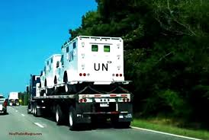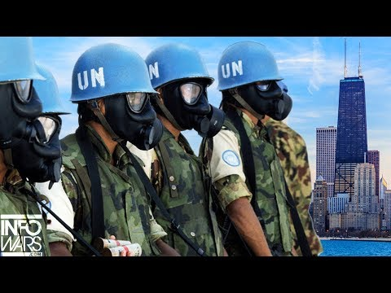
Left: Photo taken on a Georgia highway

U.N. Troops on American Soil – June 27, 2016
“Military U.N. vehicles: Why Are UN Troops on American Soil?”
Dave Hodges June 27, 2016 The Common Sense Show
“…The United Nations has no business being in rural Pennsylvania, or downtown Dallas. We are not under martial law. We have not suffered an invasion or a civil war… Or, are we about to…Is this the chest pain before the heart attack?...Wake up America! We have been in the process of being occupied for a long time and these foreign troops are merely awaiting the catalyst event to be brought into action…”
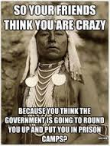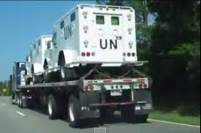
Left: The American Right: Picture taken in Georgia 2014
Indians know…
U.N. Global Police Now in America: “Has War Been Declared Upon The American People? Massive 'UN Vehicles Sighting' in Virginia Sounds Alarm Soon After Obama and UN Announce Global Police Force To Fight 'Extremism' ” June 27, 2016 All News Pipeline by Stephan Sanford
“From the October 2015 story on Breitbart: `On Wednesday, Attorney General Loretta Lynch announced at the United Nations that her office would be working in several American cities to form what she called the Strong Cities Network (SCN), a law enforcement initiative that would encompass the globe. This amounts to nothing less than the overriding of American laws, up to and including the United States Constitution, in favor of United Nations laws that would henceforth be implemented in the United States itself – without any consultation of Congress at all.’
…from Alex Jones and Infowars, `incredible news has broken as the mainstream media has come out and admitted that Barack Obama is using the United Nations to run his open borders program that the US Supreme Court recently attempted to shut down. Despite that, Obama came out and declared he's not going to follow their ruling’…Is this why the UN vehicles have been spotted on US soil, to assist running refugees around the country just in case 'counter-jihadi' forces decide to take the law into their own hands since Obama has refused to follow the Supreme Court ruling? Or has war truly been declared upon the American people by our own government? Think that's far-fetched? The Breitbart story from December 2015 warned, and then concluded: `After all, with Obama knowingly aiding al-Qaeda forces in Syria, how likely is it that he will use his “global police force” against actual Islamic jihadists? I suspect that instead, this global police force will be used to impose the blasphemy laws under the sharia (Islamic law), and to silence all criticism of Islam for the President who proclaimed that “the future must not belong to those who slander the prophet of Islam.’ What is a global police force doing in our cities?”

U.N. Imposing Martial Law in Chicago, St. Louis is Next
Dave Hodges – The Common Sense Show - December 18, 2017
“I published the following excerpt from an article on April 19, 2017: `I WANT TO BE CRYSTAL CLEAR. WHEN THE U.N. ASSUMES CONTROL.., THIS WILL MARK THE BEGINNING OF THE END OF THE UNITED STATES AND WHEN THE ECONOMY COLLAPSES THIS WILL MARK THE END OF AMERICAN SOVEREIGNTY. THE UN MUST NEVER BE ALLOWED TO HAVE A POLICING AUTHORITY ON OUR SOIL FOR ANY REASON WHATSOEVER!’
Connecting the Dots: As previously reported on The Common Sense Show in 2014:
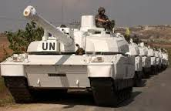
“….At a future date the UN will be responding to a `humanitarian need’ the American military will have a very difficult time objecting to and opposing the takeover by the UN. The policing of the US by the UN is merely a move to gain a foothold for control over this country…What follows will allow the UN to assume complete policing powers in all 50 states and the assumption of jurisdictional control over all state and federal agencies.
From Chicago’s CBS: `There is a quiet genocide taking place in too many of our communities. Eighty percent of those who are being killed by gun violence are African American, and often killed at the hands of another African American,” he said. “So we must protect these population groups, and that’s what the United Nations does. They’re a peacekeeping force. They know all about keeping the peace, and so we’re hopeful that they’ll hear our appeal. Boykin said Chicago must `utilize every avenue’ available to protect its people from gun violence, possibly including U.N. peacekeepers…’
IT IS ALWAYS THE SAME MANTRA- `GIVE UP YOUR LIBERTY FOR A LITTLE BIT OF SECURITY…St. Louis will follow Chicago. St. Louis is the nation’s leader in homicide by gun. The mayor of St. Louis is offering free food to people who give up their guns. It is only a small amount of time until the UN is on the streets of St. Louis and several other American cities.”

U.N. Peacekeepers in Chicago in FEMA R-Centers December 20, 2017
“The UN Is Making Their Presence Known At Rendition Centers in Chicago”
Dave Hodges The Common Sense Show – December 20, 2017
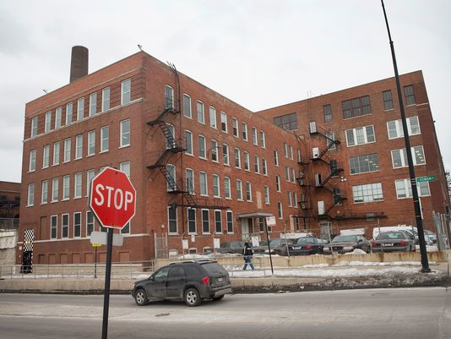
“This is one of the `black sites’ where torture of illegal detention of Chicago residents has taken place. These Chicago style black sites are appearing all around the country and they were linked to being a part of the Jade Helm 15 operation. Now they are being linked to rendition sites in Chicago, the announced future home of UN occupation troops… It’s happening a lot faster than I thought it would.
What is happening you may ask? The UN takeover over of Chicago is underway and I am shocked at the rapidity of the movement…The Black sites were a local form of the NDAA that surfaced in Chicago. It is where people would go to disappear for awhile. People who were arrested and taken to the site were subjected to extreme treatment, denied basic liberties including the right to an attorney…I was told that my source had reliable information that UN personnel, along with DHS, were making their presence known at the primary black site. The implication is that the UN/DHS is going to be involved in FEMA camp type activities in regard to the planned `policing’ of Chicago by UN `Peacekeepers’...It strongly appears that the UN is going be doing a lot more than patrolling the streets trying to stop gun violence as claimed by Commissioner Boykin of the Cook County Commissioners.
For several years, I have interviewed numerous eyewitnesses on my talk show about the presence of foreign troops (mostly Russian) training on American soil…Sherrie Wilcox has presented videotape and photo evidence. Others have provided their firsthand accounts of these events. I have detailed the existence of a FEMA bilateral agreement with the Russians to bring in 15,000 soldiers for `disaster training.’ What lies below is more proof that it will be foreign troops killing American citizens, not American soldiers who cannot be counted on to violate their oath to the Constitution.
Appendix N-Foreign Confinement Officer Training Program
Training U.S. Trainers: `N-43’: Soldiers and Marines who are assigned training missions receive a course of preparation to deal with the specific requirements of developing the target HN confinement officers (i.e. foreign detention officers).
…We often hear the question: “Will American soldiers fire upon American citizens in a martial law roundup of millions of Americans”? The answer to that question is a moot point. It is clear from analyzing data from Army concentration camp materials, that American soldiers will be used to round up detainees. However, the camps in which people will be deported to will ultimately be staffed and run by foreign troops.”

“FEMA Camps Are Slave Labor Camps: As was the case with the NAZIS, slave labor will be a part of the landscape as evidenced by the following Army document. Appendix J - J-20 FM 3-39.40 12 February 2010 - J-67

MY NOTE OF EXPLANATION: You really must read the official document that follows in this article. It tells what the FEMA camps will be like—i.e. like Auschwitz. Remember, the C.I.A. was created by Nazis. Since we brought all those thousands of Nazis into the U.S. from 1945, under “Operation Paperclip,” we inherited their nature, their gods, their plans, and their Nephilim-given technology. I’ve known about the CIA torture camps for over 20 years, and I’ve reported on them. It’s going to be Nazi Germany all over again, only this time on a worldwide basis. The CIA will continue “experiments” and torture, just as the Nazis did in WW II.
I know how true these reports are! The sending of our troops out, and bringing foreign troops in has been dubbed “the Stalin Plan.” He sent his troops into many other nations then brought in mercenaries and criminals to kill millions of Russian people. He knew his own army wouldn’t kill civilians. This happened in 2005 in Gaza, as I reported above. Many troops from many nations, including U.S. soldiers dressed like IDF soldiers, because many IDF soldiers said they couldn’t do it. Our U.S. soldiers are in over 100 nations, and policing America are mostly foreign troops, black-op mercenaries, and now U.N. troops. Also true is that FEMA is rounding up the homeless in the inner cities, and taking them to these “centers.” Many are being used like in prisoners in the death camps of the German Holocaust--for “experimental purposes.” This is not “hidden” information. I have much information from my years of living and teaching in other nations.

UN peacekeeping troops in Chicago might solve deadly violence in black community, official says – The Blaze - Dec 19, 2017 – Dave Urbanksi
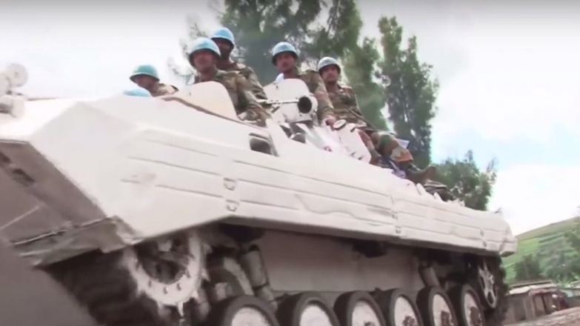
United Nations peacekeeping troops could stem the tide of deadly violence in Chicago, a Cook County commissioner said.
“ What are the violence numbers in Chicago?...`In my community of Austin, we’ve had 450 people shot, and 80 people killed this year alone, and so we have to do more to protect these communities, and that’s what we’re going to do,’ he told WBBM. `I mean this is really a genocide and we have to do something to stop it.’ `I’m hoping to appeal to the U.N. to actually come to Chicago and meet with victims of violence, and maybe even possibly help out in terms of peacekeeping efforts, because I think it’s so critical for us to make sure that these neighborhoods are safe,’ Boykin told the station at O’Hare International Airport. What else did Boykin say?
`Eighty percent of those who are being killed by gun violence are African American, and often killed at the hands of another African American,’ he said to WBBM. `So we must protect these population groups, and that’s what the United Nations does. They’re a peacekeeping force. They know all about keeping the peace, and so we’re hopeful that they’ll hear our appeal.’ … Boykin also told the station `we can’t wait until the mayor comes up with another 1,000 police to try to make the streets safer. Quite frankly, the people want to be safe right now in their homes and their neighborhoods, and we want to make sure that they’re safe.’ `If we can’t get it done here with the leaders of the city, the state, and the county working together to utilize their budgets to help protect these communities, then I have to appeal to a higher authority, and a higher force.’ ”

US Inner Cities Collapsing Taken Over by Violent Youth like Chicago and Baltimore: “Baltimore breaks city record for killings per capita in 2017” By David McFadden - associated press – ABC News – Baltimore January 2, 2018
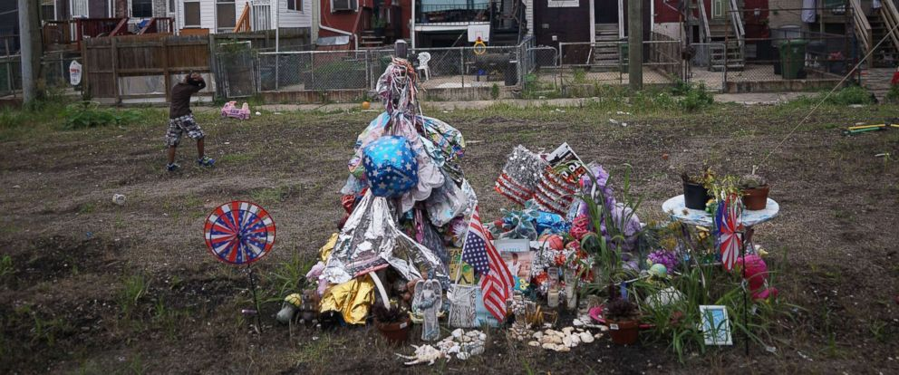
Mandel Ngan/AFP/Getty Images, FILE
A memorial for a shooting victim in east Baltimore, Md., Aug. 8, 2017
“A surge of homicides in the starkly divided city resulted in 343 killings in 2017, bringing the annual homicide rate to its highest ever - roughly 56 killings per 100,000 people. Baltimore, which has shrunk over decades, currently has about 615,000 inhabitants…Others blame police, accusing them of taking a hands-off approach to fighting crime since six officers were charged in connection with the 2015 death of Freddie Gray, a black man whose fatal spinal cord injury in police custody triggered massive protests that year and the city's worst riots in decades… Violent crime rates in Baltimore have been notoriously high for decades and some locals sardonically refer to their city as `Bodymore’ due to the annual body count…"The kids out there with guns don't care about anything," said Norman Armstrong, the pain of grief etched on his face.
Ericka Alston-Buck, who founded the Kids Safe Zone community center in the rough Sandtown-Winchester neighborhood, said concentrated poverty must be addressed and a measure of healing has to take place in order to truly tackle high rates of violence in Baltimore. `Hurt people hurt people. No one's doing anything to close those holes in their souls,’ she said. `As long as no one does that, nothing is going to change.’ "

Enter the U.N. Peacekeepers! Rahm Emmanuel, remember him under President Obama? He’s the Mayor of Chicago. It has been noted by researchers like Hodges, that Democratic Mayors in the biggest and most violent cities are welcoming the U.N. Peacekeepers. As the above article stated, and we noticed that in 2015, the police are strangely “standing down,” in violent areas and in shootings, like the one in Florida in 2016. They are acting impotent, but more than that – they are acting as if under orders to let the violence continue. The reason: Bring in the foreigners to do their job – the Black Ops, the Blackwater troops, the U.N. troops. We’re being set up for martial law.

U.N. in Maryland: “I went to investigate the United Nations vehicles in Hagerstown, Maryland…Here is what I found” – Dec. 31, ‘17 by Thomas Dishaw/GOV'T SLAVES: “Massive sighting of UN vehicles in Maryland and October 4, 2016…”
This is a really good-read. This man reminds me of myself a few years back, taking pictures of a FEMA camp in Fort Worth, Texas. I also commend Jerry Golden and Barry Chamish for their undercover taking pictures of a FEMA-like concentration camp inside Israel that America built a few years back with only Arab laborers. Thank Abba for those who love truth enough to scout it out, and record the evidence! I looked at the pictures of these two men and noticed the similarities to the pictures I took in Fort Worth.
Here’s a little of what Thomas Dishaw said in his article: “The United Nations is a cancer and it’s spreading to U.S. soil. Is it a coincidence that United Nations vehicles are being staged 1.5 hours away from Baltimore, one of the most violent cities in America? - Probably not. I think the Federal Government got a rude awakening after watching the Baltimore riots unfold and realized how ill equipped major cities were to handle civil uprisings. Less than one year after the Baltimore riots the U.S. agreed to allow U.N. peacekeeping troops and police to use force to protect civilians in armed conflicts according to this Military Times report: The United States has announced its support for a set of principles that give a green light for U.N. peacekeeping troops and police to use force to protect civilians in armed conflicts…Even more alarming is the fact that Cook County Commissioner Richard Boykin is practically begging the United Nations to come in and help with peace keeping efforts in another violent city, Chicago. Boykin hailed the United Nations as a ‘peacekeeping force’ and warned of the quiet genocide of gun violence taking place in Chicago.
Conclusion: There is no doubt that we are witnessing some sort of future U.N. takeover based on the many sightings of these vehicles, and even troops in US cities. It is of course an act of treason for U.N. troops to be here policing Americans, but the bigger question is what false flag event will set the stage and allow this to happen without as much as a second thought? The violence in inner cities is most likely just the mustard seed of fear that has been planted, but an even bigger catastrophe is certainly in the works to swing the pendulum of public opinion to not only turn a blind eye, but to actually welcome the presence of the U.N.”

“Executive Order: United Nations allowed to Use Force on US Citizens
Posted by Aaron Kesel | Jul 13, 2016 | wearechange.org
“United Nation military troops may soon arrive and see action on American soil following the United States’ announcement of support for `a set of principles that give a green light for U.N. peacekeeping troops and police to use force to protect civilians in armed conflicts,’ Military Times reports…” “…And this would not be the first time American politicians have attempted to sell their citizens out to the powers of the United Nations. The UN’s first attempt to capture America was in 1951. In strange fashion, forces flying the flag of the United Nations began to occupy small towns and cities across the United States. This was intended to test the will of the people and see if they would accept a UN `takeover.’ The test failed…YourNewsWire reports: `President Obama has signed an executive order that allows for the US military to use force against American citizens for the first time in history.’ The Executive order was signed on July 1st, 2016 by President Obama and is titled “Executive Order — United States Policy on Pre- and Post-Strike Measures to Address Civilian Casualties in U.S. Operations Involving the Use of Force…the order appears to have changed the rules of engagement between the military and ordinary U.S. citizens in an end-around the Constitution.” (Check this out)
Today, if there were a major false flag event in which it appears our nation is being attacked, the American people of would welcome U.N. troops!

Fox News: “Obama Signs Executive Order for Martial Law August 2016”
“Jay Sekulow (ACLJ.org) says the 2016 Law is a different: Definition on national defense is bigger, broader, than has been said by any other President. He actually changed the definition of national defense.” Thus, Obama expanded it! This is a YouTube video, explaining what Obama signed August 16, 2016. But, google “Obama Executive Order for Martial Law August 16, 2016” and bring up the official report from the government site. You can do this to get the official transcript of other Executive Orders. Check out the “Continuance of Government” Executive Order!

So what will happen under martial law?
Hodges gives a few things that will accompany it. We’ve been under “martial law” actually since 9/11/2001. But, it has not been implemented. Years ago I wrote about “Operation Cable Splicer,” and Operation “Garden Plot.” These are code names for actions that the police will take when Americans start rioting.
“17 Things That Will Happen When America Is Occupied by a Foreign Enemy” - Dave Hodges – The Common Sense Show – August 10, 2017
“With everything I have uncovered over the past two years, I have concluded that America will be thrust into martial law prior to fighting in WW III. Martial law is usually preceded by a false flag. There is no shortage of false flag possibilities…However, there are a definitive 17 elements of martial law that we can analyze in order to gauge the progress America is making with regard to being under total martial law.
The 17 elements of martial law are:
1-Mass roundup of political dissidents
2-Dusk to dawn curfews
3-Rationing of essential resources
4-The seizing of personal assets such as food and water
5-Control over all food and water
6-The prohibition of weapons of any kind including guns, knives or chemicals which can be turned into explosives
7-The confiscation of property, homes and businesses
8-Arrests without due process
9-Massive “papers please” checkpoints with intrusive searches
10-Forced relocations
11-Forced conscription into various labor camps and even into the military
12-Outlawing of free speech
13-The installation of massive surveillance programs and the establishment of snitch programs
14-The total control or elimination of religion
15-Control of the media
16-Executions without due process of law
17-Total suspension of the Constitution

UPDATE TO PRESENT - 2018
“The war in Chicago is bigger than the war in Israel, and nothing is being done about it. A whopping 887 people have been shot and wounded on the streets of Chicago in 2018 alone, 146 of those have been killed in what appears to be a all out war” By Lexi Morgan - May 16, 2018 – Intelihub

US: Chicago Violence Erupts August 5, 2018: “In less than 7 hours, 41 shot, 5 fatally as violence rips Chicago” Chicago Tribune August 6, 2018
Violence is erupting against, in Chicago, Charlottesville, Virginia, and Washington D.C.
“There, a 13-year-old boy was shot twice in the right arm. A car drove up to the gathering and two people got out and opened fire into the crowd, hitting two more teenagers and a 25-year-old man. `If they shoot you, they don’t even run,’ said one man watching police work the scene. `They just walk away, they ain’t trying to run.’ ”
What I’ve learned: The horror story is that the police are being told in these city riots to “stand down.” They are told to let it go … then later they mop up. This is because the goal of the Deep State/Globalists is to make the American Police look impotent, so that law enforcement agencies need is to call up the U.N. Peacekeepers. The American police are being replaced in many places in big cities with “Black Op” police, police who may or may not even be Americans.

US Violence DC and Charlottesville Virginia August 12, 2018
Livestream: As DC Prepares For Violence, Antifa Attacks Police and Reporters In Charlottesville, VA With 'Protests Bubbling Again' On Sunday
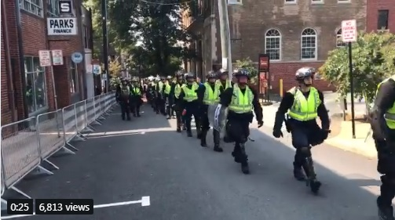
(Charlottesville, VA, Police Prepare For More Antifa Violence)
By Susan Duclos - All News PipeLine
This happened this weekend of August 12th. Rioting by George Soros sponsored Antifa, short for anti-fascism. Let me tell you about Antifa. Like George Soros’ Black Lives Matter, they are paid to fight against anything that is righteous and just.

***“CNN applauds violence of Antifa domestic terrorists, August 15, 2018 by Dr. Eowyn - Fundamental Opinion:
“In April 2016, the Obama administration’s DHS and FBI classified Antifa as a `domestic terrorist organization’ — but we didn’t find out about it until more than a year later. On August 12, 2018, only a few dozen so-called `white nationalists’ were at the Unite the Right rally in Lafayette Square, Washington, DC. They were grossly outnumbered by thousands of counter-protesters. (ABC News) Among the counter-protesters were the Antifas, who openly call for murdering President Trump…[he gives some of the vile filth phrases said in regards to murdering Trump].
At the counter-protest to a Unite the Right rally in Charlottesville, Virginia, Antifas went violent as a group of them went after NBC News reporter Cal Perry and an NBC cameraman. (Daily Wire) Perry said the rally was `almost entirely exclusively Antifa.’ Reacting to Antifa’s physical and verbal violence against a duly-elected sitting POTUS, Trump, CNN’s Chris Cuomo declared, on August 14, 2018, that `CNN will not condemn, but instead justify political violence against anyone CNN deems to be “bigots.’ Cuomo said: `…The bigots are wrong to hit. Antifa or whomever--anarchists or malcontents or the misguided--they are also wrong to hit. But fighting hate is right. And in a clash between hate and those who oppose it, those who oppose it are on the side of right…. It’s not about being right in the eyes of the law, but you also have to know what’s right and wrong in a moral, in a good and evil sense. That’s why people who show up to fight against bigots are not to be judged the same as the bigots, even if they do resort to the same kinds of petty violence.’
Breitbart‘s John Nolte points out: “[A]ccording to the network’s editorial tone over the past two years, signals open season on all Trump supporters for violent activists like Antifa and the Black Bloc… This is a dramatic turning point for the far left. Not only is CNN offering moral cover for those who engage in political violence, but — thanks to the ever-widening definition of “hate” — CNN is also calling for the left’s political opponents to be “stamped out.” [Yedidah’s comment: “Bigot” is an overall term for Christians and Messianics, or any type of conservative, especially those who think Trump is doing a good job. The Bible is considered a hate-crime book, and the Name “Yahweh” is illegal to use from the Vatican to the Hague]
“In condoning Antifa violence, whom the federal government identifies as domestic terrorists, Chris Cuomo and CNN are providing support to the Antifa terrorists, in violation of federal law U.S. Code § 2339A (1), which states: `[T]he term “material support or resources” means any property, tangible or intangible, or service, including currency or monetary instruments or financial securities, financial services, lodging, training, expert advice or assistance, safe houses, false documentation or identification, communications equipment, facilities, weapons, lethal substances, explosives, personnel (1 or more individuals who may be or include oneself), and transportation, except medicine or religious materials.
When a national and international TV network openly approves of violence by domestic terrorists, America has truly entered a dark phase.” ~Eowyn
***I downloaded this article this morning, August 15, and this afternoon it had been removed from the internet. The sign on the internet said it did not fit the policies of Wordpress. So they took it off. Dr. Eowyn told too much truth evidently!
***By the way, did you know that Alex Jones’ official Infowars.com website was taken down August 14th? The effort to get rid of truth-tellers is seriously underway.
So dear ones: How do we keep positive? A few days ago, Abba built on what Sha’ul said in Ephesians 5:18-19, by saying to me: “Joy is the Champaign of the spirit.” It is the bubbly within us that keeps us at peace and with a positive outlook on everything, giving us the strength to go on, even in dire situations. In Ephesians 6:10-11, Sha’ul writes: “…be strong in the Master and in the power of His might/the mightiness of His strength. Put on the whole armor of Elohim that you may have the power to stand against the schemes of the devil.” His joy is His might within us!
His joy transforms us and keeps us stable, even in the face of really bad things. I know, and it amazes me! It is not human nature to remain joyful, praising Abba, feeling strength, in the face of bad things happening in our lives. But, Sha’ul tells us, rather than be drunk with wine, be filled with the Spirit. The fruit of the re-born spirit flows out of us because we are filled with His Spirit. So, hide in the secret place! Know the reality, watch, pray, but be not afraid. Strengthen you faith by the Word, prayer, praise, and proclamation. He is in control! Are you resting in His control?
Shalom, love, blessings, Yedidah,
Originally written January 12, 2018, updated for posting August 18, 2018

