U.S. EMBASSY ATTACKED IN BAGHDAD
WAR WITH IRAN IS CLOSER THAN EVER

Updates below: January 2nd and 3rd, 2020, early AM in Baghdad
14 Pictures

IRAQ, IRAN, BAGHDAD, U.S. EMBASSY, NEW YEAR’S EVE 2019-2020
Paul Begley Reporting: “BREAKING: 2020 Predictions & Vision"
Begley commented that New Year’s Eve 2011 he reported on the black birds falling out of the sky in Bebe, Arkansas. He said that he knew then that it was the beginning of end-time trouble. When that report came through about the blackbirds, and hundreds of the same-species fish in the Arkansas River made the news, I began extensive research immediately. To this day, I’ve followed the DNA-targeting experiments worldwide, each with a specific species. I did such in-depth research from the beginning on this that I started getting DHS warnings that I was getting too “involved,” (i.e. “security breach”) with the Arkansas maps and the investigation. Experimentation on targeting certain DNA – for use on humans!
Last night, January 1, Begley reported on the attack of the U.S. Embassy in Baghdad with more details. Here are some of the details…
America struck a Hezbollah base inside Iraq on Dec. 30th. The response was a rocket attack on a U.S./Iraqi military base near Baghdad at Taji, killing a U.S. Contractor stationed there. The base was not hit by Iraqis, but by Iranian Hezbollah proxies. The retaliation continued, with thousands protesting and attacking the US Embassy. As you can see from the pictures below, the Embassy was damaged. The U.S. Ambassador was taken out successfully in a helicopter. The rest of the Embassy personnel is in a special sealed chamber inside the Embassy.
Trump wasted no time deploying troops to Baghdad. 64 Apache attack helicopters have arrived in Baghdad as last night. The first 100 Marines have arrived. 750 soldiers from the 82-Airborne left North Carolina yesterday, and were their way to Baghdad, arriving today. Trump is saying another 4,000 troops are coming.
Protestors took down the U.S. flag, put up the Hezbollah flag, and stole the Embassy seal off the outside wall. (see pictures below) Begley said that standing outside the Embassy, encouraging the protesters, was one of Iraq’s top Generals who was responsible for killing hundreds of American soldiers in both Iraq Wars.
A Steve Quayle alert yesterday (January 1st 2020): "Multiple sources reporting that the base at Taji, Iraq, where US troops are located, came under rocket fire. This follows US strikes against Kataeb Hezbollah (KH), an Iranian-proxy, earlier this evening (12/30). The US Embassy civilian staff is reportedly being evacuated from Baghdad and US Force." The attackers are supposedly Iranian/Hezbollah proxies. Trump lays the full blame on Iran.
I’ve learned to be skeptical of public news reports, and learned over the years that to be skeptical until all information is on the table is wise. Since childhood, I’ve asked a lot of questions because I want the whole Truth and nothing but the Truth!
A few questions: Are the attackers really proxies for Iran? Trump is laying the blame squarely on Iran and their Hezbollah proxies inside Iraq.
Why did the Iraqi police and military stand down – not protecting the American Embassy? It may be because they are under orders to stand down. It could be that the protestors are on assignment for the CIA, so they are being told not to get involved.
I lived moment by moment through the 2011 Cairo situation. I was living in the Middle East at the time. Reported by Egyptian believers, the rioters in Cairo, where I had just been the year before, were NOT Egyptians – but outsiders. I watched closely as Obama singlehandedly destroyed the peace in the Middle East. Later I learned first-hand that the protestors were really CIA-paid mercenaries.
Today the truth comes out that the Iraqi General seen with the protestors outside the U.S. Embassy yesterday was the general who killed so many Americans in Gulf War I and II. Pictures of him below….
I’ve reported on how the Israeli Mossad trained ISIS and Al Qaeda mercenaries in Dubai to pull off the attacks on oil ships in the Persian Gulf that were blamed on Iran. ISIS and Al Qaeda are working for the U.S. and Israel – created by the U.S. under George W. Bush and Barak Obama. That is documented fact.
Iran is in Iraq, yes, and so is ISIS. I reported on how ISIS was released and escorted into Iraq by Turkish and U.S. troops to take down the Iraqi government. The President of Iraq resigned quickly.
This is about creating the chaos to bring about “the order” – the new world order. The lust for war, using Iran as the bad guy by the US and Israel in particular, makes me wonder if this is just another CIA/Mossad set up – but it is a dangerous situation for sure!
Years ago, U.S. General Wesley Clark, under George W. Bush’s Administration, made it clear that George W. Bush told him that 7 nations would be taken down before the new world order would rise – the last one being Iran. Iran made it clear that they wanted no war with Israel or America. So, this is definitely provoked.
The scary part of it is that there are Iranian “sleeper cells” all over the U.S.! That means if we push hard enough, or even attack Iran, which Netanyahu says he wants to do, the “sleeper cells” will wake up. They have bombs. Iran has nuclear bombs that were given to them by North Korea years ago. Iran also has the backing of Russia and China, making Jeremiah 50-51 all the more real – nations to our “north.”
Yesterday President Trump said that Iran will pay a big price in all of this.

BELOW ARE MORE PICTURES
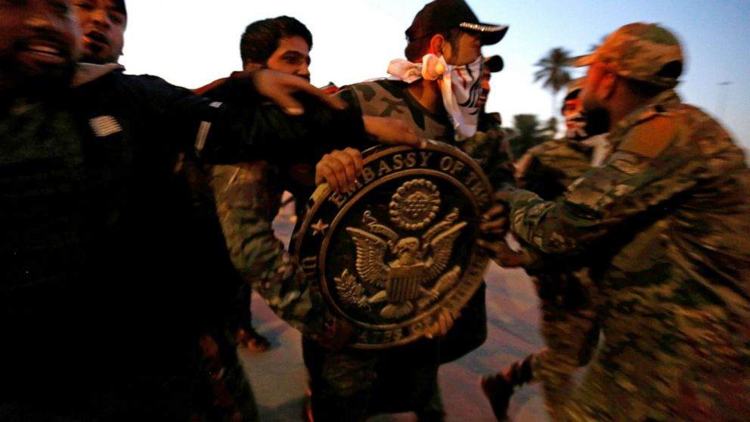
Protestors took down the Embassy Seal from the Embassy Outside Wall
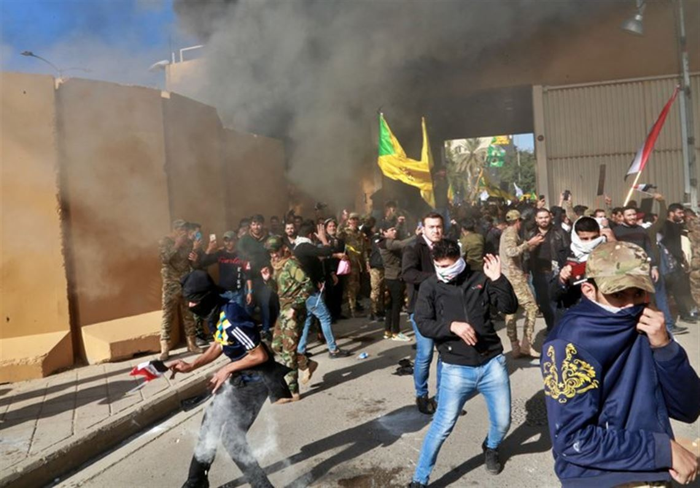
US Flag torn down; Hezbollah flag hoisted up (Dec. 31, 2019)
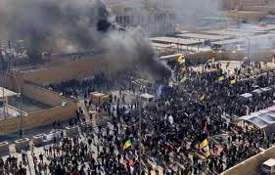
Thousands attack US Embassy

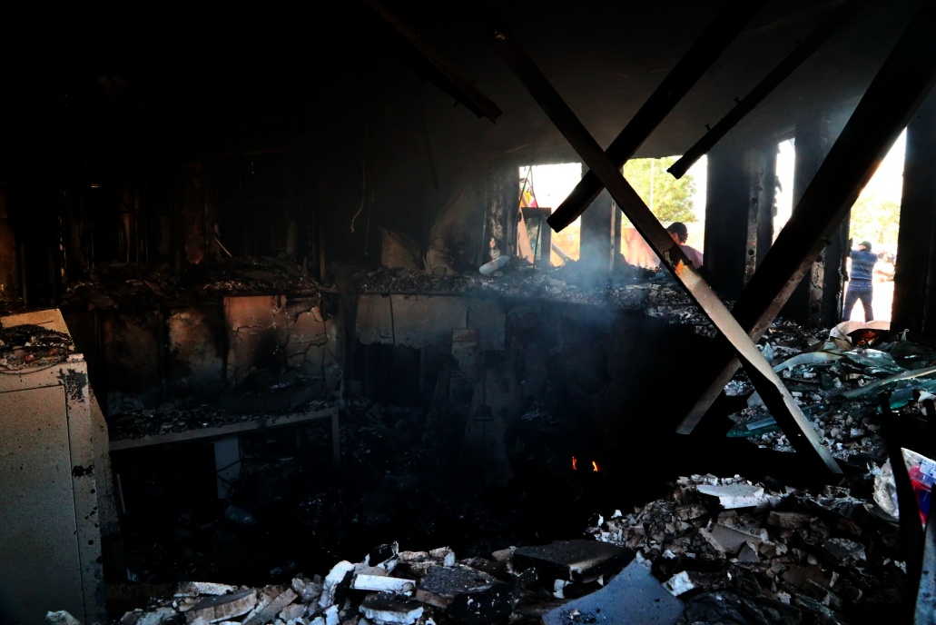
Times of Israel – Iran made a big mistake in attacking the US Embassy
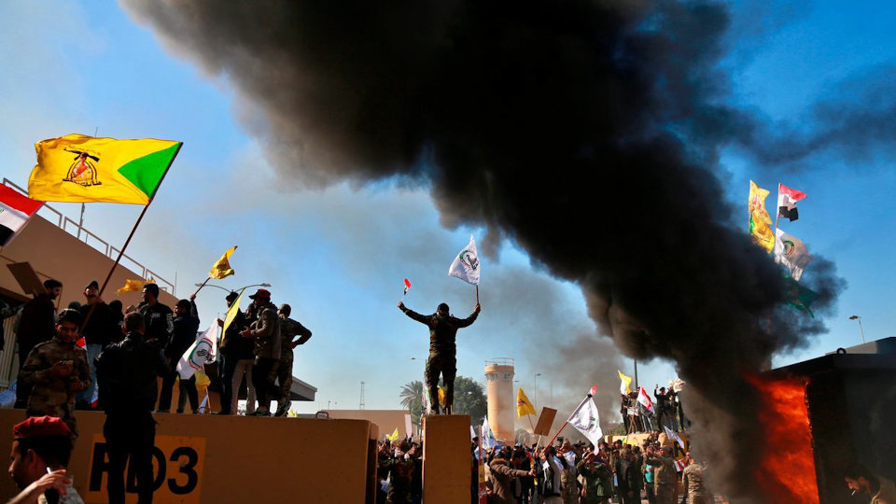

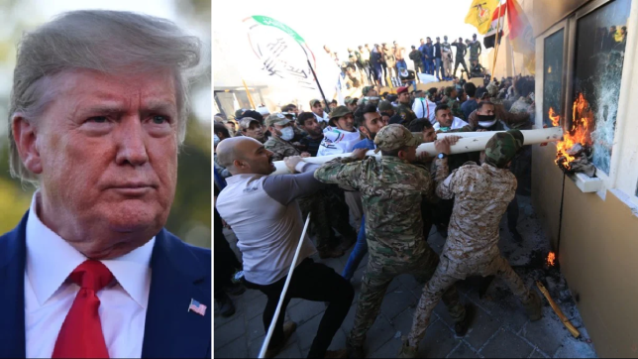
Trump says “Iran will pay…”
Since Iran is the last country to be taken down before the new world order comes, as Bush told Clark, then it’s all working according to plans.
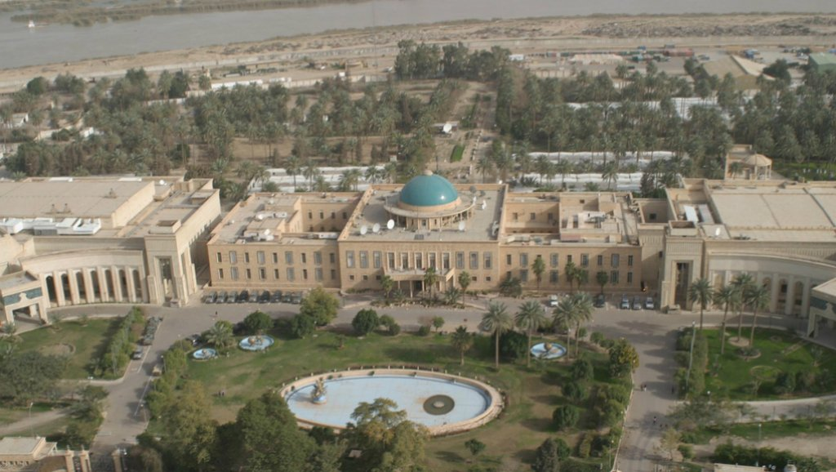
US Embassy 2017 – The largest US Embassy in the world

“President Trump May Be Walking Into A Globalist Trap: With Iranian Sleeper Cells Across America, War Against Iran May Be A Globalist Ploy To Unleash Death And Destruction Here - Iran Running War Games With Russia And China Hints Of Trouble Ahead” ANP Stephan Sanford – January

President Trump May Be Walking Into A Globalist Trap: With Iranian Sleeper Cells Across America, War Against Iran May Be A Globalist Ploy To Unleash Death And Destruction Here - Iran Running War Games With Russia And China Hints Of Trouble Ahead January 2, 2020 ANP
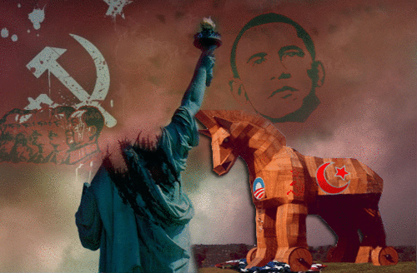
A Trojan Horse indeed!
The Iraqi General that killed hundreds of Americans in Gulf Wars I and II is leading the protests. He is pro-Iran. His name is Hadi al-Amiri.

MORE PICTURES from the Daily Mail – January 2, 2019
Iran: “Obama Welcomed Leader of US Embassy Attack in Baghdad to White House Dec. 2011” – January 2, 2020 Daily Mail
“Barack Obama welcomed leader of US embassy attack to the White House: Iran's 'point man' in Baghdad, Hadi al-Amiri, was hosted in the Oval Office in 2011 – eight years before he orchestrated siege in Iraq”
On Tuesday, he was outside the US embassy in Baghdad when it was breached and set alight by Iran-backed members of Kataeb Hezbollah, and other militia of the government-sanctioned Popular Mobilization Forces.
By Ross Ibbetson For Mailonline - Published: 2 January 2020 Daily Mail

Hadi al-Amiri was Iraq's minister of transport under then-Prime Minister Nouri al-Maliki and stood in the Oval Office as part of Maliki's delegation on a visit to the White House in December 2011.
On Tuesday, al-Amiri was among those leading the charge against the US embassy in Baghdad when it was stormed and set alight by pro-Iran militants. US Secretary of State Mike Pompeo shared a photograph of Amiri amid the rioters, condemning him as an 'Iranian proxy,' and calling those shoulder-to-shoulder with him 'terrorists.'
The head of a leading pro-Iran Shia faction, Amiri exerts great power within Iraq's state-sanctioned Popular Mobilization Forces (PMF) and was highlighted by Pompeo among three other men as the ringleaders of the siege.
The ease with which Amiri and these other commanders breezed through the heavily fortified 'Green Zone' has alarmed US officials, who have noted their militia's increased presence around diplomatic buildings in recent weeks.
A former guerrilla fighter who fought for Tehran in the Iran-Iraq War, Amiri has been accused of terrorism against the US, of helping Iran to ship arms to Bashar al-Assad in Syria and has been pictured bowing before the Islamic Republic's Supreme Leader Ayatollah Ali Khamenei.
As Commander of the Badr Corps, an Iranian vassal within the PMF, Amiri's men helped the US in their fight against ISIS in 2014 and 2015. But a recent spate of missile attacks by the Kataeb Hezbollah branch of the PMF, climaxing last Friday with the death of an American contractor at US base north of Baghdad, has revealed that Washington's friends in the region can soon become enemies.
President Donald Trump ordered USAF jets to decimate Kataeb Hezbollah bases and 25 were killed on Sunday night. Amiri joined thousands who flocked to funerals for the fighters in the Iraqi capital on Tuesday and then spearheaded the crowds who rushed through the Green Zone and breached the US embassy.
The 65-year-old, who was of 'grave concern' to lawmakers as Obama's guest in 2011, stood at the forefront of riots which prompted Donald Trump to deploy 750 Army paratroopers on Wednesday, with another 4,000 on standby.
On Tuesday, al-Amiri was among those leading the charge against the US embassy in Baghdad when it was stormed and set alight by pro-Iran militants. US Secretary of State Mike Pompeo shared a photograph of Amiri amid the rioters, condemning him as an 'Iranian proxy,' and calling those shoulder-to-shoulder with him 'terrorists.'
President Donald Trump ordered USAF jets to decimate Kataeb Hezbollah bases and 25 were killed on Sunday night. Amiri joined thousands who flocked to funerals for the fighters in the Iraqi capital on Tuesday and then spearheaded the crowds who rushed through the Green Zone and breached the US embassy.
The 65-year-old, who was of 'grave concern' to lawmakers as Obama's guest in 2011, stood at the forefront of riots which prompted Donald Trump to deploy 750 Army paratroopers on Wednesday, with another 4,000 on standby.
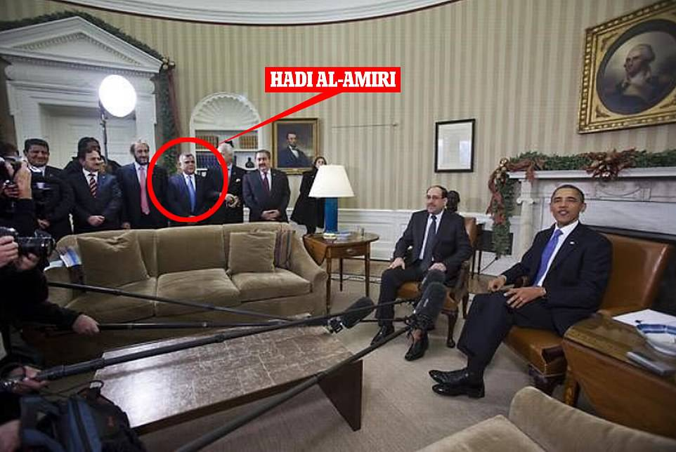
President Obama sitting alongside Iraq's then-Prime Minister Nouri al-Maliki in the Oval Office of the White House in December 2011 … Hadi al Amiri, who led a pro-Iran siege on the US embassy in Baghdad on Tuesday stands behind the sofa wearing a blue tie as part of Maliki's delegation
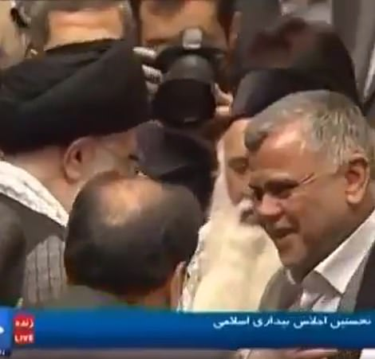
Kissing the ring: Hadi al Amiri bows before Iran's Supreme Leader Ayatollah Ali Khamenei and kisses his hand … Amiri, a veteran of the Iran-Iraq War, has never made a secret of his allegiance to Tehran

Demonstrators react as tear gas is fired down by US soldiers on the rooftop of the compound after they stormed through the main gate
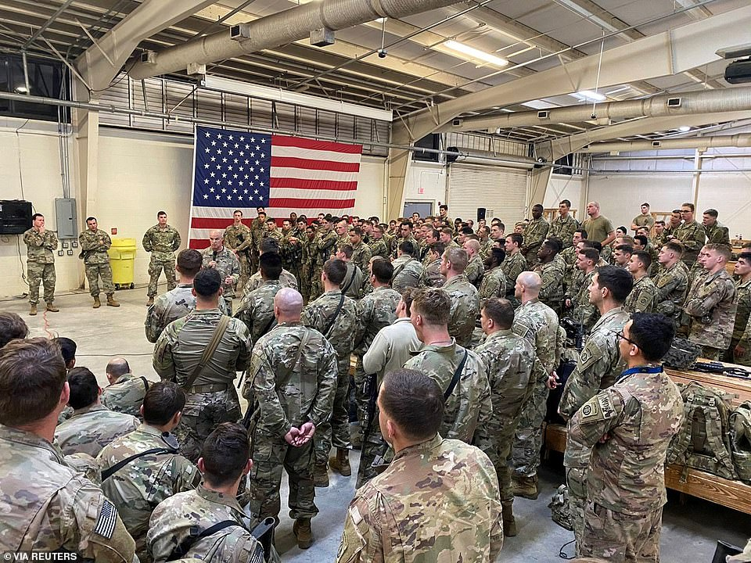
The first contingent of a paratroop infantry battalion from the U.S. Army's 82nd Airborne Division bound for Kuwait receive a briefing as they prepare to leave Fort Bragg, North Carolina on Wednesday amid soaring tensions with Iran

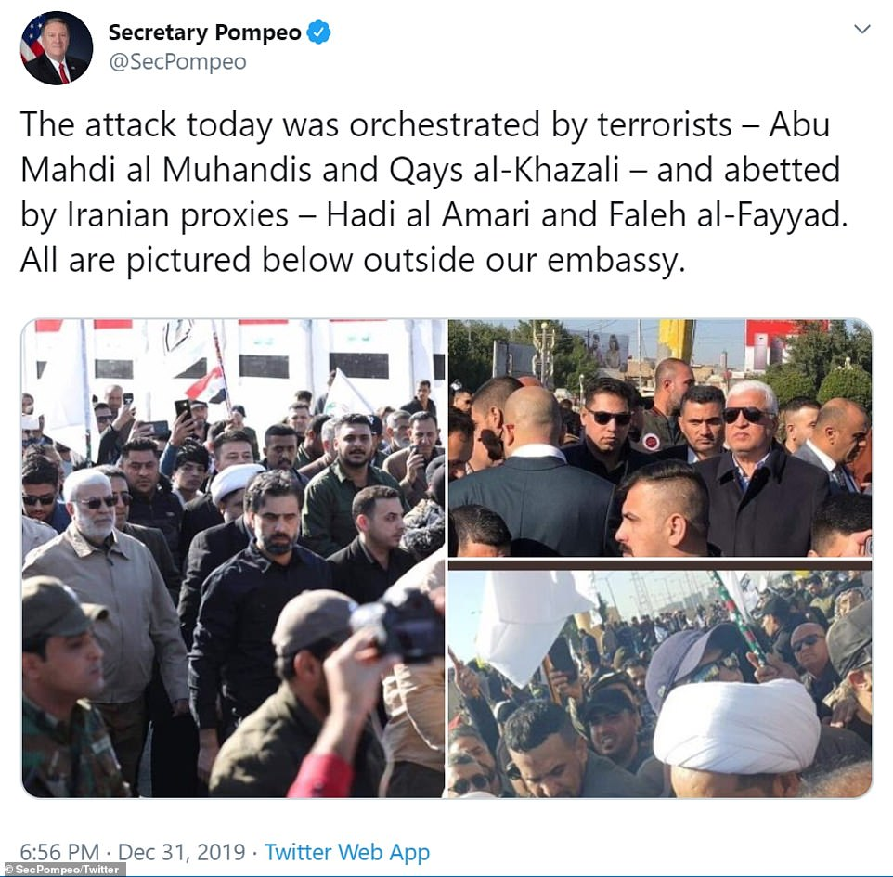

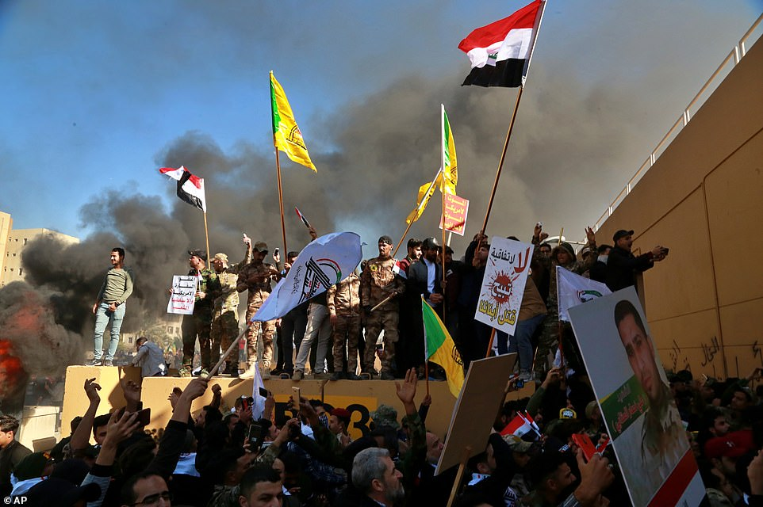

Updates January 3rd Early Morning Baghdad time: U.S. Drone attack on Baghdad Airport – High Ranking Iranian Military Men Killed
Iraq: Baghdad Top Iranian Proxies Killed Paul Begley:
1) Breaking “Top Iranian Militants Killed At Baghdad Airport USA Drone Strike”
Iranian Top Militant Mohammed Radha Killed by USA Drone Strike at Baghdad Airport. Radha was getting ready to leave for Iran, and a US Drone killed him. Twelve civilians were also killed, and an Iraqi soldier.
The airport went into an immediate shut down. US helicopters flying all around the airport. Radha was one of the orchestrators of the Embassy attack on the 30th.

2) Breaking “Iran Top Major-General Qassem Soleimani Killed By USA in Baghdad, Iraq, as USA Hits Iranian General Soleimani with a Drone At Baghdad Airport”
Soleimani was #2 Commander in charge of the Iranian Republican Guard – of the Al-Quds Regiment. He was also killed in the drone attack at the Baghdad Airport. So the U.S. took out two really big Iranian military leaders back to back.
Soleimani thought he could just get in a limo and go to the airport and fly home with the US doing nothing.
5 Hezbollah top leading militants were also killed. The reports are coming out of Russia and Lebanon also. The attacks happened Friday morning early …
Begley commented truthfully: “War could break out at any time!”
We watch, we pray, we prepare! Jeremiah 50-51 is near – the destruction of end-time Babylon, America. Refer to “Thirty Clues and More…”/Mikvah of Preparation.
In His shalom, Yedidah
January 2, 2020 11:00 PM CDT

