VOLCANOES
What is happening with the magma is happening in human nature!

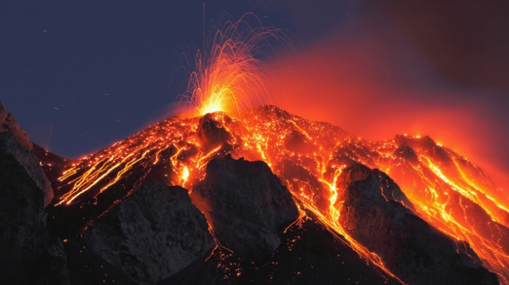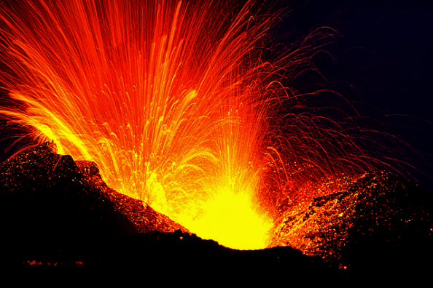
Italy Iceland
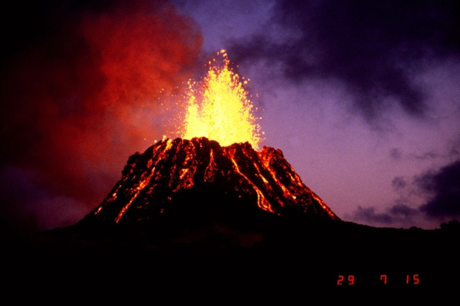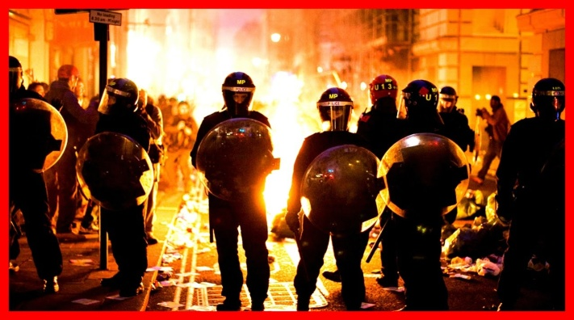
Hawaii's Kilauea volcano Riot Police amidst protesters in
Albuquerque, New Mexico

Rioting in Charlotte, North Carolina
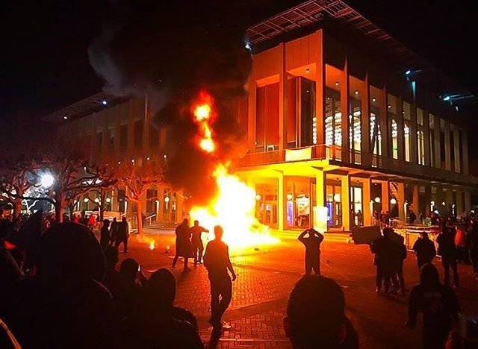
Violence erupts on University of Violent protests in Chicago
Washington Campus, Seattle

The Spiritual War IS Seeping Over To the Physical – The Days of Noah Are Upon Us by Ray Gano - - February 22, 2017 Prophezine

“For the past three years I have been sitting and watching what is going on in the US as well as in the world. I have been watching things transpire in the US that honestly blows my mind and I have to ask “do people see what is going on around them? I mean really see?” It isn’t until recently that the enemy has been showing his hand and the things that Luciferians have been doing and conducting have been coming to light, but I have not been able to put a name to it per say. All I could see out and out ruining of all that is good. I have been involved in the Bible Prophecy arena now for over 25 years. I have seen a lot, read a lot, studied a lot and researched a lot. I have known for years that the “Days of Noah” were coming and to be honest I have been living in my own “normalcy bias” not really wanting to see it or deal with it. That is till we moved out of the US and I was able to watch the US from a far. Tracye and I have been asking ourselves these past weeks “why did God move us out of the US?”
Truth-loving people are seeing the truth unfold before their eyes. The onslaught of the enemy is increasing drastically by the day. Every day multiple volcanoes are erupting worldwide, “diverse” earthquakes happen almost every hour, the earth’s crust is shifting. Every day in almost every household, people erupt with hot and damning emotions, some taking it to the streets, most using it to abuse their families.
For foundational material please refer these three articles: “The Rising of Hades From the Inner Earth”/January 28, 2016, “Earth is Cracking Like an Egg”…/May 20, 2016, and “Violence is Covering the Earth”/February 9, 2016.
The goal of Lucifer/Satan, his fallen angels, and demons (disembodied Nephilim) is in sight and they are preparing the earth’s people to be sacrificed to obtain their goal. The new world ruled by Satan’s forces must create the needed chaos, out of which they will move in to create the order. Their brand of “order,” has the goal of eliminating all, or nearly all, of earth’s human residents, as well as creation’s natural animal, bird, fish, insect, reptile, and tree and plant life.
All over America, in the UK, in many countries of Europe – along with the increase of volcanoes erupting, the world’s people are taking to the streets in violence--murdering, raping, destroying property, and spewing forth incredible hate and anger that burns away humanity’s life.
In France, Germany, and Sweden, police are overpowered by the violence--murder, rape, rioting, theft, protesting, shouting threats with angry displays by criminals of all type, including the rise of cannibalism. Recent Muslim muftis have said it is all right for Muslims to eat their victims. In some places where Muslims have taken over, skinned bodies of their victims are appearing in markets – sold as edible “meat.” The abuse of children has skyrocketed with the incredible worldwide pedophile rings being exposed, which also involve cannibalism – thus the gruesome nickname “pizzagate.”
What makes us human is that we have a separate “spirit” within us that can be born again and filled with the Spirit of Yahuwah. Once the spirit is locked down and down, and the will has closed that portal, the person slowly becomes an “entity,” taken over by demonic forces. This is what we’re seeing in groups like ISIS, which, by the way, has camps in all 50 American states. The words of Isaiah 13 must burn deep within us, so that we know what’s coming. In the Septuagint, Isaiah 13:1-13 says that Yahuwah will send giants to work His judgment. These are those also of Ezekiel 38-39; Joel 2-3; Zechariah 14:1-5; Revelation 9:14-21, 16:12-21. Now we know about giants appearing in various places--a 12-15 foot giant even killing U.S. soldiers in Afghanistan. But, also read Isaiah 13:14-22 and note verse 18. What will be unleashed on America, and the world, are demonized killers who have zero mercy.
I wrote some about the army of mind-controlled people that now numbers in the hundreds of millions in “The Shocking Hidden Goal of Globalism Exposed”/March 10, 2017 and “Fragmenting…”/March 17, 2017. (Revelation 19:19)
We are seeing that what is deeply embedded in animalistic mankind--sin (transgression of Yahuwah’s “Torah,” – His instructions for right standing in His Kingdom), rebellion, revolt, witchcraft, satanic ritual sex-magic, voodoo, violent anger, acts of violence, and all forms of merciless cruelty. This nature is now surfacing and spewing out of humans like magma/lava, burning with demonic fury as they are exposed to the light. It is becoming clearer that the most targeted ones for evil assault are those who worship and obey the Elohim of the Scriptures.
Along with the destruction of earth is the push for a “post human” world, as “scientists” of all types are working to mix human DNA with that of animals, birds, insects, fish, reptiles, and robots. Sex with robots is “”hot” topic now. The total destruction of humans is well underway. Our DNA has been slowly manipulated and changed in some ways by the use of chemicals, medicines, vaccines, water, food, air, and what comes off of “favorite electronics” that fragment people’s minds.
Genesis 6: 11-14a: “And the earth was corrupt before Elohim and the earth was filled with violence…for all flesh had corrupted their way upon earth. And Elohim said to Noah, `the end of all flesh has come before me for the earth is filled with violence through them. And, see, I am going to destroy them from the earth. Build yourself an ark…’ ” His word to you today is: “Prepare! Build yourself an ark.”
Do what you can to protect yourself and your family.
If you Google “violent people protesting” and click images, you will see photos of riots in Brazil, Guatemala, Venezuela, France, England, India, and many other places on earth. We ARE now as it was then--in the days of Noah.
Read Isaiah 24, Haggai 2:6, 21; Hebrews 12:25-29; Revelation 6:12-17, 16:18-21! Isaiah 10:23: “For the Master Yahuwah of hosts is making a complete end, as decided, in the midst of all the earth.” He will shake everything that can be shaken, and only a small remnant will remain.
The reason Yahuwah sent the Flood was not just to rid earth of the Nephilim and their hybrids that were destroying the entire human gene pool, but because of their violence. The giants were all cannibals. After the flood they spread across the earth. Evidence of them has been found world over, with a concentration on the North American and South American continents. Some have been kept in suspended animation as we are learning, in places like Antarctica and Sardinia. I recommend highly Steve Quayle’s True Legend’s DVD II, The Unholy See, and the new one coming out in April or May, Part III, “Holocaust of Giants.” The Unholy See is perhaps the finest documentary on giants ever made to date. I also applaud L.A. Marzulli’s entire Watchman Series exposing Nephilim. You can find these at stevequayle.com, and lamarzulli.com.
What has been brought before us in movies since the late 1940s is what has already been done – just hidden from us. The enemy copies Yahuwah! As Yahuwah says in Amos 3:7, the Illuminati does by letting everyone know what they are doing, only in fantasy-form so that no one really believes it is real! When it surfaces, the world will be horrified into great shock. (Luke 21:25-27)
Pre-flood technology came back into the earth around 1896 with the return of the Nephilim--the children of the original 200 fallen angels who mated with human women! (Genesis 6:2-4) The original 200 fallen angels are bound in Tartaros unto judgment.
The Nazis were given instructions on building flying saucers via séances from demonic spirit-sources as far back as 1922. I recommend that you keep up with Antarctica. A good start would be to read the awesome book Empire Beneath the Ice by Steve Quayle. Why are the world’s top political leaders and religious leaders being “summoned” to Antarctica in the last few years, especially in 2015-2016? These entitles that have been waiting for millennium are surfacing. The world’s Illuminati satanic elite have been working for centuries to return these pre-flood rulers to power over the earth as it was before the Flood.
We must be on the OFFENSE in spiritual warfare! Never allow yourself to be put in a defensive situation. You can’t sustain yourself in that position. The forces coming against us are more powerful than the eruption of a super volcano. Can you stand at the base of Italy’s already erupting volcano, Mount Etna, and command it to stop blowing rocks and lava from the earth’s inner core? - Of course not. It is the same with the explosive invasion of fallen ones into earth that we are facing now. But, if you stood before Mount Etna and began commanding it not to blow BEFORE it started blowing, you’d have a better chance of calming the forces of nature.
I don’t say that as theory. I’ve calmed and shut down storms, hurricanes, tornadoes, severe lightening, vicious animals and people, because it is our right to do so. See Messiah reaction in Mark 4:35-5:1 and read Luke 10:19.
Today on L.A. Marzulli’s “Politics, Prophecy, and the Supernatural” YouTube video, he interviewed a couple who saw UFOs. He spoke to them regarding the way they reacted to their encounter and brought out a very important point. I quote him: “As soon as you see these things, immediately go on the offensive and rebuke them, and ask questions later.” “Take immediate offensive action.”
I’ve taught this to pastors in Africa in seminars, and this is the way I live – on the offense. I lived on the defense for over 30 years, and never won the battle. Learn to be strong in the face of the enemy without flinching, so that your immediate reaction is to proclaim with the boldness of the Spirit to back you! Rather than waiting for the demons, the hybrids, the “entitles” of the evil one to bring dread, fear, physical illness, mind and emotional trauma, immediately rebuke in the Name of Yahuwah! (Zechariah 3:2!) If Yahuwah used His own Name to rebuke Satan, isn’t that a clue that we should do that also?
Natural human nature is becoming like the spewing of volcanoes--both rising from an inner core. Normally nice believers are feeling tension, anxiety, nervousness, anger, and the desire to lash out at others. This is not normal. But, this is what is happening as the enemy seeks a stronghold in our lives.
Deep within the earth’s core resides the fire of Hades--Hell, Sheol, Gehennah, the “lake of fire.” Deep within the core of unregenerate men’s “inner earth,” flesh and mind, resides the burning fire of Hades, stoked by rebellion and hate against Yahuwah and His Son-Messiah, Yahushua.
Please refer to: “Tornadoes of Judgment Descending – What Authority Do you Have to Stand Against Destructive Storms?/November 17, 2016.
Recently, in a town meeting in the U.S., a Christian man opened the meeting in the name of Jesus. The protests against him were instant—people spewing cursing against the use of “Jesus,” and the man’s quoting of the Bible. Headlines like these have filled the news reports since outbreaks in place like Ferguson, Missouri, Baltimore, Maryland, Chicago, Illinois, Charlotte, North Carolina, Seattle, Washington, etc. America has a brewing civil war on its hands.
Fires, bricks mark daylong assault on inaugural festivities – by Jessica Gresko / Associated Press - Friday, January 20th, 2017 …
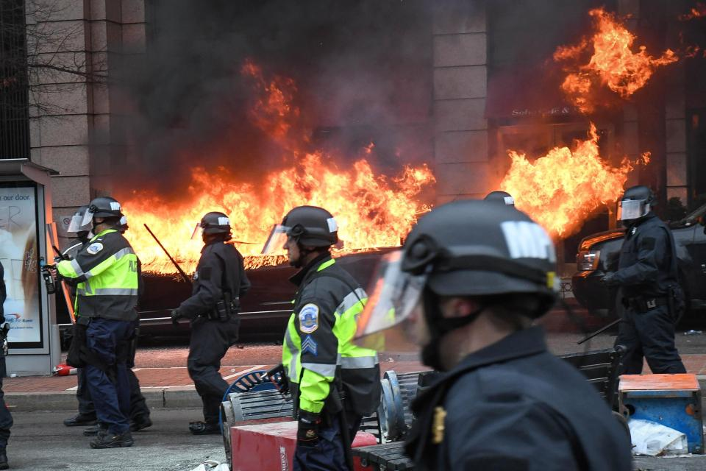
Washington DC Jan. 20th Inauguration Day protests
Also refer to: Volcanoes Erupting All Over the World: Is Something Happening To The Earth’s Core? Kalee Brown - March 3, 2017 – from CE collective evolution
Deepest Quake in Recorded History had Struck/Magma Layer: http:/www.BPEarthWatch.com – January 10, 2017. Again, refer to: “The Rising of Hades from the Inner Earth.” Read Isaiah 5:14, 24-25 and notice that verses 20-21 refer to this time! Read Isaiah 14:9-10. Notice it is in our time period.
What is setting off these deep earthquakes and volcano eruptions that are moving the tectonic plates under the oceans, and cracking the earth’ surface, so that magma from the inner the core of the earth is spewing up? There are many theories, like there is some huge object in space magnetically pulling on earth, or even the sun’s flares causing it. Maybe they’re right. But, man under the authority of the present Nephilim who rule at the top are making it happen using pre-flood technology. “They” want to present to Messiah a destroyed earth, as they did in Genesis 1:2. NOTE: There will be only one more re-creation: II Peter 3, Isaiah 65-66, and Revelation 21-22.
I refer to “them,” or “they,”--the entitles of Satan’s kingdom--but so does the Word. In Daniel 2:43, a prophecy that we’re unfold now, Daniel refers to “they” – the iron-“men” who rule the earth using “clay”—mankind-- as their slaves.
Please refer to: “The War Between the Children of Light and the `They’ of the Dark Kingdom”/February 26, 2016.
As we read from Revelation 11:15-19, Messiah comes to raise the righteous dead, but also “to destroy those that destroy the earth.” In general, Christian eschatology has left out what happens to earth after Messiah returns. Yahushua was the voice of creation. Without Him nothing was created (Colossians 1) The events that will happen before Messiah returns, when He returns, and after He returns ,is the largest topic in the entire Word.
Yahushua Messiah is the beginning, the end, and the center of the whole of the Word! Anything that distracts your focus off of Him and your obedience to Him will take you away from Yahuwah! Prophecies are abundant in the united Word--Tenach and Brit Chadasha. It is clear that we do not have to wait around on a destroyed earth for 1000 years waiting for Yahuwah to come and do the II Peter 3 re-creation of heaven and earth. Please refer to “The Day of Yahuwah,” at least for the Scriptures. II Peter 3:10 begins, “But, the Day of Yahuwah shall come …” This expression is a direct link to the coming of Messiah, not 1000 years later when Yahuwah comes with His city. (Revelation 20-22)
It appears that what Isaiah saw and what Kepha (Peter) reported on is the recreation of earth after Messiah comes. He’s not going to set up His Kingdom on a destroyed earth. This is why Isaiah 66:23-24 talks about our guarding the new moon calendar, the festivals, and Shabbats. So many prophecies describe the imploding of our sun and the darkening of the moon. So, for the earth, our solar system’s sun and our moon to function for our good, as they have, they will have to be restored. Let Abba show you, so that you understand what He knows.
Refer to: “Radiation Clouds, Another Earthquake at Fukushima, Oceans Dying, the Earth is Cracking –“to destroy those that destroy the earth”/March 5, 2017.
In “The Shocking Hidden Goal of Globalism Exposed,” learn how far mankind has gone to destroy our earth in his hate of the Creators, and how far Satan and his demonic entities have gone to destroy the minds and bodies of mankind to prepare and army for their ultimate sacrifice of 7.5 billion people, and to destroy Messiah and the resurrected ones with Him at His coming (Revelation 19:19).
Hardly anyone will be left on earth alive in the coming onslaught of the Beast, enthroned with the power, authority, and throne of Satan. (Revelation 13:1-3) He won’t be fully human. What has been hidden under the earth is now surfacing. Men’s hearts will fail from fear at seeing those things which are coming “up on the earth,” as the Apostle Luke told us. (Revelation12:12-17)
Once again, I end an article with the admonition of Shimon Kepha in II Peter 3:10-14: “But the day of יהוה shall come as a thief in the night, in which the heavens shall pass away with a great noise, and the elements shall melt with intense heat, and the earth and the works that are in it shall be burned up. Seeing all these are to be destroyed in this way, what kind of people ought you to be in set-apart behavior and reverence, looking for and hastening the coming of the day of Elohim, through which the heavens shall be destroyed, being set on fire, and the elements melt with intense heat! But according to His promise we wait for a renewed heavens and a renewed earth in which righteousness dwells. So then, beloved ones, looking forward to this, do your utmost to be found by Him in peace, spotless and blameless,…”
In His peace, joy, and love
Yedidah, March 21, 2017

