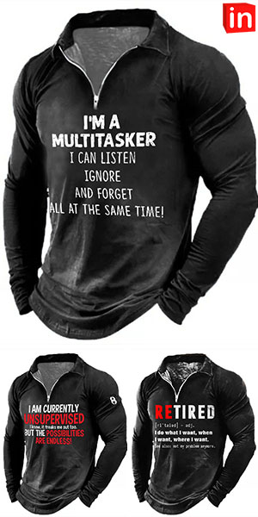
WELCOME TO 2023! JACKET MESSAGES REFLECT THE MENTALITY OF EZEKIEL 2!

Notice the jacket messages. Funny huh! Yes, they’re meant to be “cute.” Notice the top jacket’s message. I read it and laughed. Then I looked at it again and realized it described almost all western world citizens, especially US, British, European, Canadian, Australian, New Zealand, and any others in Greco-Roman culture/ civilization of modern-day Christians. Blasé, nonchalant, attitudes reign regarding Yahuwah’s absolutes! Most American Christians have rejected Yahuwah’s Word.
In the meantime, the rebellion of mankind against the “restraints” of the Word of Yahuwah and of Messiah Yahushua is growing to a belligerent, angry, hate-filled crescendo. Responsibility and diligence to obey Them is turning to throwing off any restraints of what one wants to do.
The second jacket says: “I am currently unsupervised.” Few want to be supervised or made accountable for anything if it doesn’t result in making money.
The third jack says: “ReTired: I do what I want, when I want, where I want.” Ezekiel 2’s description of His children is amazingly “today.”
Rebellion against being “told” what to do is at an all-time high. Once the restrictions of Biblical Christianity over society are removed, the Beast will impose Lucifer’s laws. The people will joyfully bow in worship of him (Revelation 13), and obey him, because he promises such good things for them if they obey him, and such absolute penalties if they do not. He has saved them from the “terrible restrictive laws” of the Bible. The one command of Lucifer to his unsuspecting victims is: “Do as thou wilt …” Before long, doing what one wills will backed by A.I. - implanted mind-control so that no one wants to will anything against him.
There is rising arrogance, haughtiness, aggression, pride, accompanied by sadism and all sorts of negative emotions in today’s throwing off of any restraints of Yahuwah’s order that might get in the way of self-will - getting what one wants in life. Mind control from childhood prepares a child to focus on “self” and the benefits of getting what one wants. Thus, we have major divorce rates, much rejection of marriage, the falling apart of the family unity, the rejection of responsibility to raise children – as each person, whatever age, takes on an “I am god” mentality with no conviction of wrong-doing against others.
They want what they want and will get what they want, no matter what they do to get it. The nature of Lucifer, the fallen angels, the Nephilim, the soon-coming aliens, is permeating all of society so that everything Yahuwah established for order and peace will be destroyed – and the “man of lawlessness,” the “man of sin” will reign over insane
Now we have renegade weather geo-engineered to destroy life on earth of all types. It started in the 1940s, but, especially since 2018, has been used as an extermination means – destroying crops, food animals, property, bringing diseases, releasing deadly creatures, and killing millions in a variety of ways with temperature extremes, and damage. The sophistication is now reaching new levels with directing “atmospheric rivers,” storms, moving the polar vortex, seeding clouds/the atmosphere, and so many other ways.
I suggest the awesome website of Dane Wigington, which covers geoengineering of weather – the making of weather a weapon against humanity and all life on earth: GeoengineeringWatch.org. I also suggest Steve Quayle’s fantastic book Weather Warfare and Other Natural Disasters: stevequayle.com.
Please read Ezekiel 2. It was a major calling for me from Abba Yahuwah!
All of earth’s order is now reflecting the rebellion of mankind under fallen angels! This is why Mark 13:9-13. Children will turn against parents, and parents against children, and lead them to their death. The darkness is falling.
Maintain the integrity of the Word of Yahuwah!
Yedidah - January 2, 2023

