WHERE’S YOUR BOMB SHELTER? WHO WARNED YOU TO FLEE?

[Refer to the two short articles below – amazing!]
Dear brothers and sisters! Do you feel abandoned by your government and the news media - orphaned, kept in the dark about reality? Well, it is not because you are paranoid, or imagining a vain thing – it’s because they have abandoned you. As far as government protection and more – We are on our own!
People like myself can keep you up with what is really happening that public news won’t tell you. However, having knowledge is one thing, acting on it is another. I can only give what Abba allows me to give, but then it is your responsibility to put into action what He tells you to do to protect yourself. He is our high tower, our fortress, our refuge – but we have to get to it and enter it to be protected. He expects us to rise up, prepare, and obey Him.
Governments of the world, for the most part, and their lying deceitful public news, are keeping the people so ignorant they don’t know to “flee from the wrath to come” – neither Satan’s wrath or Yahuwah’s wrath. I’ve written a lot on correct Scriptural spiritual warfare, but it must be a natural reaction because of Yahuwah’s methods that He’s trained you in - near-daily practice.
This is why more than ever, we must daily be sensitive to Yahuwah’s Spirit’s leading within us, so that we are prepared and go when He says “GO!” “He can’t direct a parked car.” That’s an old saying, but absolutely true. This is why Acts 1:8. You must get in position, then activate the will of Yahuwah within by taking your foot off of all mental and emotional brakes, and letting Him direct your path.
Psalm 27:11: “Teach me thy way, O Yahuwah, and lead me in a plain path, because of mine enemies.” Now that’s a good prayer to pray every day. He can teach you, but you have to follow the path He lays out for you. Knowledge is one thing, action to put it into “gear” is another.
The Spirit of Yahuwah is given to us to lead and guide us into all truth. We must act on it, so in cases of intensity when our mind shuts down, we don’t freeze in fear. The voice that speaks to our re-born spirit from within it is usually Messiah’s voice. But, in times of urgency, I suspect the booming voice of Yahuwah is what’s needed to jolt the slumbering into action.
Our Abba, who loves us, is sounding His alarm for His people through the righteous watchmen that He has raised up. I am in daily contact with information given from the finest watchman and his associates, as well as another who confirms – both inside the top-secret data-info. giving out to warn us and protect us, at the expense of their own safety. During 2003-2006, I warned Americans to flee. I even reached Jews in the New York area. I’ve done intercession over all major ports from the Houston Shipping Channel up the east coast and the west coast clear to Alaska, and along all the river-mouths that empty into the Gulf.
Yes, it is a known fact by people in the highest of Intel positions, that Putin loves his country and his people. Therefore, he has prepared safety shelters all over the nation for his people, particularly in the large capital city of Moscow (map to bomb shelters in Moscow below) – stocked with food, water, and medical facilities. Love takes action to protect!
Right now, in America, planes are taking key members of the government to shelters in the “provincial” capital, Denver, Colorado, where there are underground
facilities. They started this about two weeks ago.
Many planes are flying the elite of the U.S. government into other underground bunkers like Mount Weather in Virginia, Raven Rock, duel function bases like Cheyenne Mountain, under Denver Airport, at Wright, and even under the White House itself. However, in this case, DC is being evacuated mainly to the facilities under the Denver Airport.
Hey, what about us in America! Our government not only doesn’t love us, they are setting us up for death. The Deagle Report, a Rockefeller arm, reports that by 2025, 250 million Americans would be dead. Right now, there are close to 350 million U.S. citizens. According to the Yahuwah report, no one will survive the annihilation of America. This will happen way before 2025. Have you noticed on the map of China’s Belt and Road initiative that America is totally by-passed? After nuclear holocaust, Russian, Chinese, etc., ground troops will kill all, and confiscate all property. This has been promised to Russia and China by the U.S. government.
The Word also says that America will be totally annihilated. That includes those in bomb shelters! Abba talked me through this in 1992, when He said to me of Jeremiah 50-51: “This is American.” Now that is “common knowledge” among Word-loving watchmen.
The technology of Russia is 20 years ahead of that of the U.S. They have cloaked submarines off our east and west coast. The submarines have 300 megaton bombs, and lots of other types too. New York City, according to Revelation 18, and present reality, will be totally wiped off the map in one hour, and the nation in one day. The reality of Isaiah 13, Jeremiah 50-51, and other passages are very real. America is the final Babylon: Isaiah 21:9; Revelation 14:8; 18:2; Jeremiah 50:23, 51:8. What Nimrod started, America was created to finish.
Here is Hal Turner’s article today, and the article about the Hasidic Jews in NYC being warned to flee to the Catskills. Who warned them? My following of it and writing on it, #53.0, #55.0, and #71.0, of the Mikvah of Israel, Our Eternal Inheritance, makes it obvious who warned them. I’m glad they took him seriously.
So, folks most of us, no matter where you live in the world, are on our own. We must hear Yahuwah’s Spirit within. We must obey quickly – at least start packing, get the suitcase by the door, and receive your destination from Abba so that you move out in knowing, in peace, in focus, and go directly there.
Danger to the U.S. is because the U.S. is provoking an attack with all heart, mind, and soul, aligned with NATO and Ukraine. Given Joe Biden and Hunter Biden’s association with the crime in Ukraine, their desire to defend it is “understandable.” America will be wiped out, not just from Russia, China, North Korea, Iran, Venezuela, Cuba, and sleeper cells of terrorists inside the country, but also from Germany, France, and Canada. We’re not just surrounded on all sides, we’re infiltrated to the max. We’re already a taken-over target, because our usefulness to Nimrod is over. We brought him back, and this is our reward. We were chosen to bring him back, and we’ve done it. So, we’re disposable.
However, HalleluYah! Yahuwah does not see you as “disposable.” He has things for us to do for ourselves, for Him, and for others.
OK - look at these two articles:
***** BULLETIN ***** MOSCOW PUBLISHES MAP OF BOMB SHELTERS TO THEIR CITIZENS - WORLD NEWS - HAL TURNER 20 FEBRUARY 2022
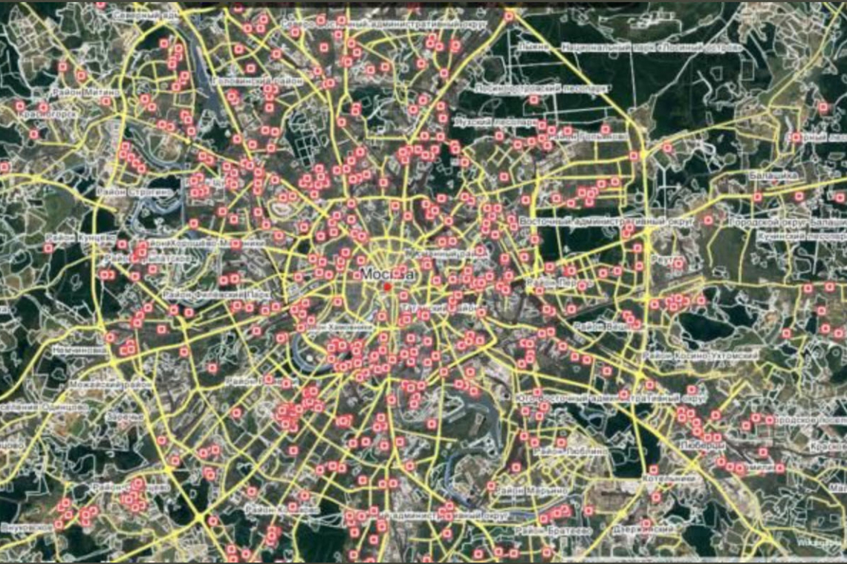
“The Russian government and the City of Moscow have, this morning, published a map for citizens showing the location of . . . BOMB SHELTERS, shown above. Who, in their right mind, would even try to bomb Moscow? Who even COULD bomb Moscow? Unless they KNOW they will be bombed because of what THEY are planning to do??? This is a staggeringly serious and very bad development. It hints at what may be coming for us all.
The situation in eastern Europe involving Ukraine is merely one aspect of the problem. For Russia, the actual root of the problem is the expansion of NATO itself, almost right up to Russia borders. Russian President Vladimir Putin is, if nothing else, an excellent strategist. When he sees a problem, and realizes it needs to be solved, he goes to the root of the problem, and not it's periphery. If the root of the NATO problem is the United States and, to a lesser extent, the United Kingdom, then his going to the root of the problem could mean hitting us - first.
If he hits the US and UK first, NATO instantly falls apart. His European security problem is instantly resolved. But he knows that if he does that, the US and UK can, and absolutely will, hit back. Which would mean the citizens of Moscow might need their bomb shelters. (HT REMARK: I just had this conversation with my wife. I actually saw the chill run up her spine. Unlike last week, I think she is now more amenable to us evac'g to Pennsylvania, maybe today.)
Folks, in or near major targets in the US/UK like major cities or, large military bases, should now think about and decide if it is safe to remain there. Things are suddenly looking very, very, dangerous right now.”
[I think they should relocate to the Appalachians or the Ozarks.]
The Hassadim (Hasidic Jews) have been warning to evacuate from NYC to the Catskill Mountains where many have retreats.
“WORD ON THE STREET: New York City Hasidim EVACUATING to Catskill Mountains” NOW WORLD HAL TURNER 18 FEBRUARY 2022
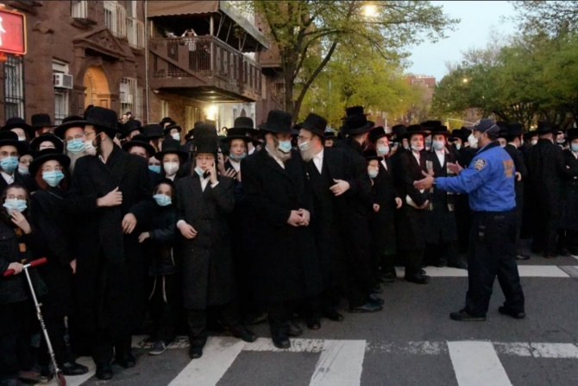
“Word on the streets here in New York City is that Bus-loads of Hasidim are going to their "summer" bungalows " cottages " in the Catskill region of NY state that's about 90 minutes north of NYC.
What makes this a red flag is that these bungalow colonies are SHUTTERED FOR THE WINTER. These folks don't go up that way until spring breaks for sure (no concerns of snow). Word on the street is the two main families have decided to move the young (still in studies or not married) out of NYC due to the possibility of extreme escalation with the things going down in Europe/Russia/Ukraine. New York City is a prime target for a nuclear strike. The fact that Hasidim are now allegedly evacuating should be a huge warning to sign to everyone else. (NOTE: The photo above is a file photo and does not show any present Hasidim activity in NYC.)”
From Quayle’s broadcast Feb. 19, 2022: Steve spoke of the Hasidim in NYC being warned to get out of the city. This is because they know the two main targets of nuclear war will be D.C. and NYC. Steve is vague here. He won’t give the name of who warned them, but said we’d be surprised. Then he asked `why would he warn them? Why were only the Hassidic Jews warned – not the Orthodox or any other Jews?’ ”
The warning person could very well be Donald Trump, or Jared Kushner If so, we know why. The Lubavitchers are Hassidic. The US is under Lubavitch Talmudic law via Rabbi Schneerson. Trump sided with them. The Hasidim, this specific group of Jews, is connected to Chabad. Trump and Kushner were very dedicated to Chabad. See Mikvah of Israel our Eternal Inheritance #53.0, #55.0, and #71.0 about Chabad, Trump, and Kushner.
So folks, we’re on our own, but not alone! Seek Abba’s will and obey!
In His love, Yedidah
February 20, 2022

