WHY WAS THE TRAIN DERAILMENT AND BURNING IN PALESTINE, OHIO
A PLANNED EVIL FOR DEATH BEYOND IMAGINATION?

Here I share with you more current information that aligns with loads and loads of hidden information - revealed/exposed by truth-tellers, but kept secret by the rulers of the dark kingdom, falsified or hidden - that is leaking out more and more, aligning together to form a very ugly pattern. There are those called of Yahuwah to share the truth – all now risking their lives to do it. The fallen ones have their list of those they deem “dangerous” to the cause of earth’s destruction.
Lucifer’s team of fallen angels, Nephilim, and hybrid humans, and sold-out humans, are united in one purpose: To destroy all life on planet earth and return it to the rule of the fallen ones that left the earth in the state it was in Genesis 1:2.
What I share with you here, is being downplayed by public news - because what is under the veneer of just another happening is a kill-attempt of all in America, without any nuclear bombs being dropped on us by the big 4: Russia, China, North Korea, Iran. It is aligned to all the deaths of millions of chickens, turkeys, ducks, now cattle, and all the destruction of farm land, waterways, crops near harvest – in other words, everything that has the life of Yahuwah in it from Genesis 1:3 creation is being destroyed under the command of Lucifer and his fallen ones.
Nimrod is even restored and on earth making his plans, guiding those under his Lucifer-given authority, to “pay God back” for the Flood, and pledge allegiance to Lucifer/Satan. The goal is reached as we read in Revelation 13. The world becomes a worshipper of the Beast and Lucifer who inhabit him. Anyone, not worshipping the Beast, thus not obeying and worshipping Lucifer, will be killed.
The heartland of America has been under destruction by those in government working for Lucifer/Satan for several years, as I have been reporting, with pictures and warnings. Via floods, drought, fire, blizzard, disease, tornadoes, poisons, released toxins in to the waterways, air, food, clothing, products most people buy that have chemicals, and now this – to release toxins over the food-growing, cattle, chicken areas, the water aquifers – the nation’s water systems, using all sorts of methods, they are working on one goal – ending humanity and all life forms on earth that reflect the Creators.
The maps show that area affected, many states, and around the world as the wind blows, and the rains fall, will move over the entire U.S. and into other nations nearby and over the seas.
This was a true Luciferic murder plan that was pulled off all too nicely for them.
Thus, public news media, working with them, won’t report the truth. But, those in high places of government and military still have those who risk their lives to get the truth to those they trust to report it truthfully – the granddaddy of them all being Steve Quayle, and those with him in unity. Therefore, again, to keep up with the fast pace of events, as I wrote in my last article, it would be well worth your money and time to subscribe to Quayle’s “Private Briefings” at gensix.com.
What was done purposely in releasing these toxins over the whole mid-USA was a planned out and purposed event, just like the CIA and Mossad planned out 9/11/01 and blamed it on non-existent Arabs, led by a man who died a few days later.
Do you remember a few years ago when the space shuttle in re-entering earth’s air space blew up and killed all on board – including the first and only Israeli astronaut? Where did it blow up? - Palestine, Texas … ! Now, this event that has destroyed all food and animal life forms in the area across many states to start with, was pulled off over Palestine, Ohio. What is the message to us?
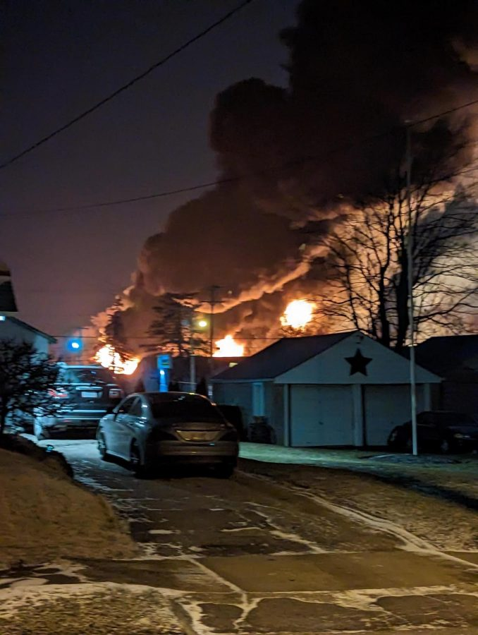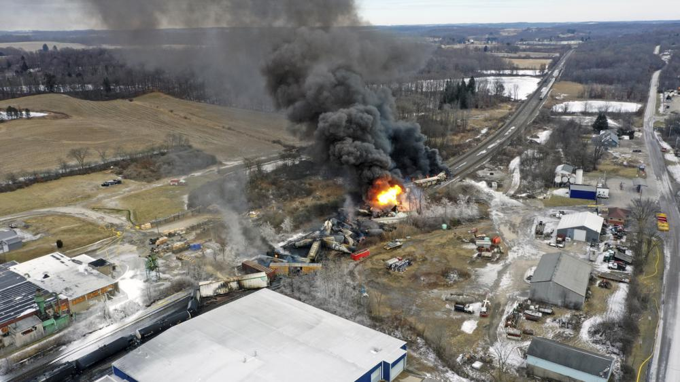

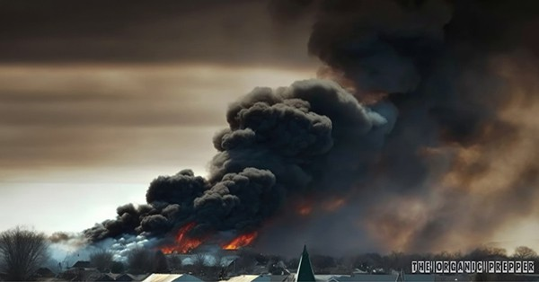 DEADLY TOXIC FUNES

I can’t download the map I have from the PDF gensix.com has, showing affected areas where the toxic fumes are already spreading over the majority of the U.S. from the epicenter of Palestine, Ohio. The internet “images” is not showing truthful maps, making it look like the affected area is tiny! NO, most of the whole interior of the U.S. is already being affected. Let me describe the area so far: It is clear up to the Canadian border in the heartland, reaching over the west of southern Montana down to the Gulf in Alabama, all along the Ohio River, into the mid-west.
So far both coasts are unaffected, probably because of sea breezes. But, remember, the military “owns the weather,” and weather warfare is in play. Keep up with this via geoengineeringwatch.org, Dane Wigington’s awesome site. He’s dedicated his life to warning us as to what is being done to our weather, our atmosphere, our earth in general, since at least the 1940s. Yes, Dane’s a friend of Steve Quayle’s.
The whole interior will be affected. And, said above – the chemicals will last in the ground for decades. No crops, water supply destroyed, no animal life – birds, insects – and fish life, etc. - and what about people-life?
Will all in that area have to leave, or end up with diseases, internal organ problems, breathing problems, skin problems? Yes …
What’s to fear other than Russia, China, Iran, and North Korea, drug cartels, all the assassins let into the U.S. via the Canadian and Mexican border killing what the nukes don’t? Do not forget the raging cannibalism of humans in the U.S. right now.
Folks, are you serious enough to solidify your relationship with Yahuwah and get on with serving the Master Yahushua? Are you serious enough to be filled with the Spirit and allow Him to control your life so that you don’t go off the deep end when the aliens come, when the food runs out, when the money is shut off? Messiah wasn’t kidding when He said this would be the worst time in human history!
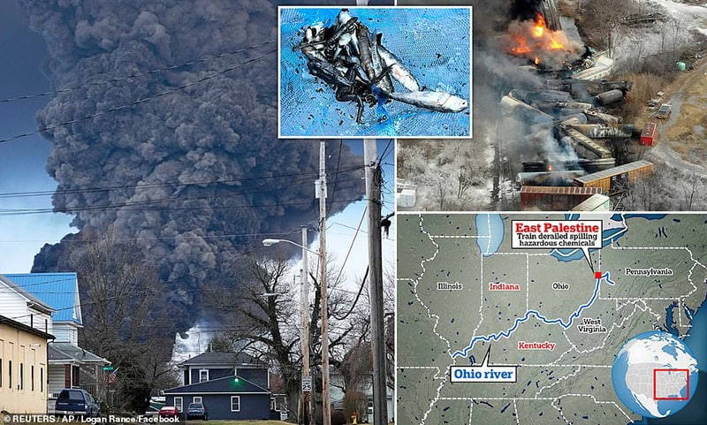
WORD TO THE WISE: PLEASE DO NOT SEND ANY ARTICLES OF MINE TO ANYONE WITHOUT PRAYING AND ASKING YAHUWAH IF HE WANTS IT SENT. THERE ARE THOSE WHO NEED TO HAVE THIS INFORMATION AND THOSE WHO MUST NOT HAVE IT.

“EMERGENCY REPORT PDF: WHAT REALLY HAPPENED IN OHIO! Feb. 22, ’23 by Steve Quayle’s science reporter
“THE DEADLY RAILROAD DERAILMENT AND HOW IT AFFECTS YOU FOR DECADES! BECAUSE OF WHAT IT WAS CARRYING AND BECAUSE OF HOW THE ENTIRE SITUATION WAS HANDLED (EVEN UNTIL NOW). IT WAS 100% PREVENTABLE BUT IN FACT BECAUSE OF TRACK SIDE SENSORS BEING SET INCORRECTLY THE WHEEL BEARING OF ONE OF THE CARS WAS ON FIRE 40 MINUTES BEFORE THE TRAIN CREW WAS EVEN INFORMED OF THE PROBLEM. IT IS THE GREATEST TRAIN AND CHEMICAL DISASTER THIS CENTURY. IF YOU DO NOT BELIEVE IT WAIT UNTIL YOU SEE THE IMAGES AND HEAR THE STORY THEN YOU WILL UNDERSTAND. FIRST, WE BEGIN WITH SOME PHOTOS OF THE SITUATION: THE TRAIN WRECK BURNING THE NIGHT OF THE DERAILMENT THE NEXT DAYS AS THE “CONTROLLED BURN SPEWED POISONOUS GASES AND ASH INTO THE AIR DOING MORE DAMAGE THAN THE NUCLEAR EXPLOSION IT LOOKS LIKE. THE WRECKAGE OF THE DERAILMENT RIGHT IN THE MIDDLE OF THE TOWN LOOK AT THE TANK CARS AND MOST IMPORTANTLY LOOK IN THE LOWER CENTER OF THE PHOTO. THAT FOOLISH RESPONDER IS NOT WEARING A HAZMAT SUIT EVEN WHEN HE KNOWS THE TANK CARS CONTAIN TOXIC CHEMICALS! AGAIN FOOLISH CONTRACTORS DOING “CLEANUP” OF TOXIC WASTE WITHOUT PROTECTION.

THE NEXT 2 PAGES CONTAIN THE TRAIN CARS THAT WERE PILED UP IN THE DERAILMENT FROM THE OFFICIAL REPORT:”
MY NOTE: READ ABOUT THE DEADLY TOXINS RELEASED INTO THE AIR, or SCAN FOR QUICK INFO. - OR JUMP TO THE END OF PAGE 5 AND CONTINUE!
“LINE # CAR ID LOAD/MTY CAR TYPE COMMODITY TANK CAR SPEC UN ID HAZ CLASS Status of Car 23 ARSX 4145 LOADED HOPPER POLYPROPYLENE Not in derailment pile 24 BRKX 66738 LOADED HOPPER POLYPROPYLENE Not in derailment pile 25 GPLX 75465 LOADED HOPPER POLYETHYLENE lading destroyed by fire 26 ECUX 860375 LOADED HOPPER POLYETHYLENE lading destroyed by fire 27 UTLX 684543 EMPTY TANK CAR residue lube oil DOT 117J100W scrap pending C&P 28 TILX 402025 LOADED TANK CAR VINYL CHLORIDE, STABILIZED DOT 105J300W UN1086 2.1 (FLAMMABLE GAS) car did not leak/cars vent product through the PRD and ignited/vent and burn performed 29 OCPX 80235 LOADED TANK CAR VINYL CHLORIDE, STABILIZED DOT 105J300W UN1086 2.1 (FLAMMABLE GAS) car did not leak/cars vent product through the PRD and ignited/vent and burn performed 30 OCPX 80179 LOADED TANK CAR VINYL CHLORIDE, STABILIZED DOT 105J300W UN1086 2.1 (FLAMMABLE GAS) car did not leak/cars vent product through the PRD and ignited/vent and burn performed 31 GATX 95098 LOADED TANK CAR VINYL CHLORIDE, STABILIZED DOT 105J300W UN1086 2.1 (FLAMMABLE GAS) vent product through the PRD and ignited/vent and burn 32 RACX 51629 LOADED TANK CAR DIPROPYLENE GLLYCOL DOT 111A100W1 fire impingement/no signs of tank breach 33 LYBX 5191 LOADED TANK CAR PROPYLENE GLYCOL DOT 117J100W flame impingement, no tank breach found 34 RACX 51435 LOADED TANK CAR PROPYLENE GLYCOL DOT 111A100W1 tank breached/lost most of load 35 UTLX 671772 LOADED TANK CAR DIETHYLENE GLYCOL DOT 111A100W1 had small leak from BOV, unknown amount of product in car 36 SHPX 211226 LOADED TANK CAR COMBUSTIBLE LIQ., NOS (ETHYLENE GLYCOL MONOBUTYL ETHER) DOT 111S100W1 NA1993 COMBUSTIBE LIQUID unknown status 37 TILX 331319 LOADED HOPPER SEMOLINA in pile, destroyed by fire 38 DOWX 73168 LOADED TANK CAR COMBUSTIBLE LIQ., NOS (ETHYLHEXYL ACRYLATE) DOT 111S100W1 NA1993 COMBUSTIBE LIQUID Car breached on head end/amount of product still in car pending 39 ROIX 57036 LOADED HOPPER POLYVINYL burned 40 NCUX 40057 LOADED HOPPER POLYVINYL actively burning 41 UTLX 100055 LOADED TANK CAR PETROLEUM LUBE OIL DOT 111A100W1 double comp car/both breached/entire load lost 42 XOMX 110664 LOADED TANK CAR PETROLEUM LUBE OIL 211A100W1 tank breached/lost most of load 43 UTLX 684798 LOADED TANK CAR PETROLEUM LUBE OIL DOT 117J100W flame impinged, may have had a small leak/will be determined when car is off loaded 44 UTLX 671310 LOADED TANK CAR PETROLEUM LUBE OIL DOT 111A100W1 flame impinged, small leak from top fittings, unknown amount left in tank 45 CERX 30072 LOADED TANK CAR POLYPROPYL GLYCOL DOT 111A100W1 flame impinged, tank breached/ most of load lost 46 SHPX 211106 LOADED TANK CAR PROPYLENE GLYCOL DOT 111S100W1 flame impinged, no signs of breach 47 NATX 231335 LOADED TANK CAR DIETHYLENE GLYCOL DOT 111A100W1 flame impinged, tank breached/ load lost 48 UTLX 671913 LOADED TANK CAR DIETHYLENE GLYCOL DOT 111A100W1 flame impinged, lost unknown amount at this time from damaged BOV 49 NATX 35844 LOADED TANK CAR ISOBUTYLENE DOT 105J300W UN1055 2.1 (FLAMMABLE GAS) some flame impingement/no signs of breach 50 UTLX 205907 LOADED TANK CAR BUTYL ACRYLATES, STABILIZED DOT 111A100W1 UN 2348 3 (FLAMMABLE LIQUID) Head breach/lost entire load (spill& fire) 51 UTLX 661296 LOADED TANK CAR PETRO OIL, NEC DOT 111A100W1 flame impinged, small leak from VRV stopped, car still loaded NOW WE GET DOWN TO WHERE THE RUBBER HITS THE ROAD AND THE TYPE AND VOLUME OF THE CHEMICALS MATTER: 1 CHEMICALS ON THE TRAIN 1.1 List of derailed cars carrying high-hazard chemicals[23] 1.2 Line # Car ID Contents Capacity Hazard class 1.3 28 TILX 402025 Vinyl chloride (stabilized) 25,800 US gallons (98,000 L) 2.1 (flammable gas) 1.4 29 OCPX 80235 Vinyl chloride (stabilized) 25,800 US gallons (98,000 L) 2.1 (flammable gas) 1.5 30 OCPX 80179 Vinyl chloride (stabilized) 25,800 US gallons (98,000 L) 2.1 (flammable gas) 1.6 31 GATX 95098 Vinyl chloride (stabilized) 25,800 US gallons (98,000 L) 2.1 (flammable gas) 1.7 36 SHPX 211226 2-Butoxyethanol30,110 US gallons (114,000 L) Combustible liquid 52 COCX 287059 LOADED TANK CAR ADDITIVES, FUEL DOT 111A100W1 flame impinged, no sign of breach 53 ROIX 59396 LOADED HOPPER POLYVINYL involved in fire 54 ROIX 57782 LOADED HOPPER POLYVINYL involved in fire 55 OCPX 80370 LOADED TANK CAR VINYL CHLORIDE, STABILIZED DOT 105J300W UN 1086 2.1 (FLAMMABLE GAS) car did not leak/cars vent product through the PRD and ignited/vent and burn performed 56 TBOX 640019 LOADED BOX CAR BALLS,CTN,MEDCL burning or has burned 57 BKTY 152621 LOADED BOX CAR SHEET STEEL burning or has burned 58 LINX 7278 LOADED BOX CAR VEGTABLE, FROZEN burning or has burned 59 DPRX 259013 EMPTY TANK CAR BENZENE DOT 111A100W1 UN 1114 3 (FLAMMABLE LIQUID) damaged, fire impinged/ no breach 60 DPRX 258671 EMPTY TANK CAR BENZENE DOT 111A100W1 UN 1114 3 (FLAMMABLE LIQUID) damaged, fire impinged/ no breach 61 XOMX 110236 LOADED TANK CAR PARAFFIN WAX DOT 211A100W1 flame impingement/no signs of breach 62 ELTX 7458 LOADED HOPPER FLAKES, POWDER burned, extinguished 63 ELTX 3421 LOADED HOPPER FLAKES, POWDER b in line, upright, impinged 64 NDYX 892049 LOADED HOPPER HYDRAULIC CEMENT 65 TTGX 953815 LOADED AUTORACK AUTOS PASSENGER 66 TBOX 889334 LOADED BOX CAR MALT LIQUORS 67 NOKL 603412 LOADED BOX CAR MALT LIQUORS 68 NS 472751 LOADED BOX CAR MALT LIQUORS 69 TBOX 676291 LOADED BOX CAR MALT LIQUORS 70 TBOX 670331 LOADED BOX CAR MALT LIQUORS 71 TBOX 662599 LOADED BOX CAR MALT LIQUORS 72 KCS 112405 LOADED BOX CAR MALT LIQUORS 73 TBOX 666771 LOADED BOX CAR MALT LIQUORS 74 TBOX 664264 LOADED BOX CAR MALT LIQUORS 1.8 38 DOWX 73168 2-Ethylhexyl acrylate 25,800 US gallons (98,000 L) Combustible liquid 1.9 49 NATX 35844 Isobutylene 30,110 US gallons (114,000 L) 2.1 (flammable gas) 1.10 50 UTLX 205907 Butyl acrylate (stabilized) 30,110 US gallons (114,000 L) 3 (flammable liquid) 1.11 55 OCPX 80370 Vinyl chloride (stabilized) 25,800 US gallons (98,000 L) 2.1 (flammable gas) 1.12 59 DPRX 259013 Benzene 30,110 US gallons (114,000 L) 3 (flammable liquid) 1.13 60 DPRX 258671 Benzene 30,110 US gallons (114,000 L) 3 (flammable liquid)
2 WHAT EXACTLY HAPPENED TO CAUSE THE DERAILMENT 2.1 About 48 hours after the derailment, the NTSB released preliminary findings indicating that the derailment was caused by a mechanical issue on one of the railcars' trucks, which may be connected to reports that an axle was observed throwing sparks about an hour before. The crew received an alarm from a wayside defect detector shortly before the derailment indicating a mechanical issue, and then an emergency brake application initiated. Which caused the derailment because of the weakened brakes an wheel bearings of the car with the bearing and brake fire.
3 WHAT HAPPENED AT THE WRECK: 3.1 THE SUPPOSED “SAFE AND COMPLETE CONTROLLED BURN, WAS NEITHER SAFE OR COMPLETE. 3.2 THE VERY BLACK SOOTY OILY SMOKE IS PROOF OF THAT BECAUSE A FULL CONTROLLED HIGH TEMPERATURE DIOXIN AND PHOSGENE BURN WOULD HAVE A CLEAR AND VERY HOT PLUME FED BY BOTH PURE OXYGEN AS WELL AS FIRE TEMPERATURE ACCELERANTS. THE DENSE BLACK CLOUD PROVES THAT SUCH DID NOT HAPPEN. 3.3 ADDITIONALLY INITIAL PRIVATE TESTING SHOWED THAT BOTH PHOSGENE AS WELL DIOXINS AND OTHER TOXIC WASTE ENTERED THE AIR, THE GROUND, AND THE WATER TABLE THUS CONTAMINATING FOR DECADES TO COME. (UNLESS THERE IS PRAYER AND THE HANDS AND AUTHORITY OF JESUS THE ONLY BEGOTTEN SON OF GOD THE FATHER TOUCH THE HIGHLY CONTAMINATED AREAS AND RETURN THEM TO NORMAL.)
3.4 IN ADDITION THE HUGE PLUME OF BLACK OILY STICKY TOXIC WASTE WAS CARRIED BY THE WIND TO MOST OF THE NORTH EAST. DUMPING DIOXINS, PHOSGENE GAS AND OTHER EQUALLY TOXIC CHEMICALS AS IT MOVED WITH THE WIND AND RAIN, WHICH CONTAMINATED THE AIR AND GROUND AND WATER IN RIVERS KILLING ANIMALS AND FISH AND POISONING THE RIVERS AND TILLABLE LAND AS WELL AS THE WATER TABLE AS THE TOXIC CHEMICALS SEEP INTO THE GROUND.
3.5 THIS FLYING DEATH HAS RESULTS MORE DEADLY THAN A NUCLEAR BLAST BECAUSE WITHOUT VERY EXPENSIVE INSTRUMENTS AND SKILLED TECHNICAL PEOPLE RUNNING THE INSTRUMENTS YOU MAY NOT EVEN KNOW THAT YOU HAVE ABSORBED A DEADLY AMOUNT OF THE TOXINS.
3.6 ANOTHER SIGNIFICANT EVENT WAS THAT A PLANE FILLED WITH THE SPECIAL INSTRUMENTS AND A TECHNICAL TEAM CRASHED ON THE WAY TO THE SITE KILLING THE PILOT AND ALL THE PASSENGERS.
4 THE AFTER EFFECTS AND LACK OF CONCERN BY JOE BIDEN SHOULD ANGER EVERYONE BECAUSE OF THE LONG-LASTING EFFECTS THE EVENT HAS CAUSED. 5 HOW THIS AFFECTS YOU EVEN IF YOU WERE NOT NEAR THE WRECK:
5.1 FARMS DOWNWIND OF THE DERAILMENT SITE WILL BE AFFECTED FOR DECADES AND THE FARM GOODS WILL HAVE TO BE TESTED FOR CONTAMINATION BEFORE THEY ARE SOLD OR EATEN. 5.2 ALL WATER SOURCES (PRIVATE AND PUBLIC) WILL NEED TO BE TESTED REGULARLY TO KNOW THAT THE WATER IS SAFE TO USE OR DRINK.
6 OTHER THINGS: 6.1 CAR PAINT IS PEELING AND BUCKLING ON CARS IN THE AREA OF THE WRECK AND DOWN WIND. 6.2 PEOPLE ARE COUGHING UP BLOOD AND SKIN IS COMING OFF.
6.3 LAWSUITS HAVE ALREADY BEEN FILED BUT THE EPA WHO CLAIMS ALL IS WELL NEED TO BE TAKEN TO COURT ALSO FOR LYING. 7 ADDITIONAL INFORMATION:
7.1 MAPS OF WHERE THE TOXIC POLLUTION HAS SPREAD SO FAR AND A MAP OF POTENTIALLY AFFECTED AREAS: AS YOU CAN SEE BASED ON THE RIVER AND WIND CONTAMINATION THE EFFECTS CAN BE NOTICED POTENTIALLY AS FAR AS THE BROWN AREA ON THE MAP
7.2 ABOUT 2 WEEKS BEFORE THE WRECK THE EPA CHANGED THE DANGER LEVELS OF THE VARIOUS TOXIC CHEMICALS WITHOUT DUE PROCESS AND FORMAL PUBLIC REVIEW.
IN ADDITION THE RAILROAD ALTERED THE SETTINGS ON THE TRACK ALERT SENSORS ON THAT ROUTE. THIS MEANS IN FACT THAT THE EPA AND THE RAILROAD BOTH EXPECTED AN EVENT LIKE THIS TO OCCUR SINCE THAT ROUTE COMMONLY CARRIED MULTIPLE CARS OF TOXIC CHEMICALS EACH RUN ON THE ROUTE. 7.3 ADDITIONALLY THE LAW REQUIRING THE RAILROADS TO HAVE ADVANCED “ECB” BRAKES ON ALL TRAIN CARS CARRYING TOXIC CHEMICALS WAS REPEALED BY DONALD J. TRUMP WHEN HE WAS PRESIDENT UNDER PRESSURE FROM THE RAILROAD LOBBY, AND THE FINAL DEATH OF THE LAW WAS DONE BY JOE BIDEN WHEN HE TOOK OFFICE SO IN FACT THERE IS NO CONSUMER SAFETY FOR RAIL CARS WHICH CARRY TOXIC CHEMICALS AND TOXIC WASTE.
7.4 NOW I GET TO THE BLUNT QUESTION YOU NEED TO ASK YOURSELF: WHAT IF THIS TRAIN WRECK AND ALL THE DESTRUCTION OF THE FOOD PROCESSING PLANTS AND COMPANIES IS PLANNED AND INTENTIONAL TO THIS IS THE ROUTE THE WATER TAKES TO GET TO THE OHIO RIVER AND ONWARD FROM THE DIRECT SPILL. THE WIND WILL TAKE THE PLUME EVEN FARTHER. FORCE FAMINE IN THE COUNTRY TO GAIN CONTROL OF PEOPLE IF THEY WANT TO EAT?”
Pray like you’ve never prayed before! Isaiah 13, 47, Jeremiah 50-51, Revelation 18 (NYC) etc., is in the works right now. America is targeted to be wiped out – totally destroyed! End-time “mystery Babylon” will be no more.
In reading Jeremiah 50-51 in 1992, Abba Yahuwah spoke to me: “This is America.” He also spoke that to others, and today the chief, the few, the seasoned, watchmen know this truth.
Refer to: “Thirty Clues and More…”/Mikvah of Preparation #46.0 for details, as well as “End-Time Babylon”/Mikvah of the Great Adventure #05.0 for Scripture study. For information on the return of Nimrod, refer to: “The Return of Nimrod”/Mikvah of Preparation #78.0.
For articles on the destruction of food crops, chicken and cattle deaths by various man-made means, begin in 2019 with articles on Famine under the Mikvah of Present Reality. In one article, I include a long list of the chicken processing plants destroyed in a very short time, purposely of course. Now the edict is out to destroy all cattle. Learn all you can and pray much!
In the love of Yahuwah, Yedidah February 25, 2023

