What America Legalized January 22, 1973 is Now
the Leading Cause of Death in America

January 22, 2019 marks the 46th-YEAR ANNIVERSARY of the LEGALIZING of the MURDER of HUNDREDS of MILLIONS of INNOCENT HUMAN BEING

Over 41 million abortions estimated in 2018, making ‘choice’ world’s leading cause of death – by Calvin Freiburger
“January 2, 2019 (LifeSiteNews) – Abortions dwarfed every other cause of death worldwide at more than 41 million in 2018, according to the statistics tracking service Worldometers.
Worldometers tracks and estimates statistics in real time on a wide variety of subjects, based on data from sources such as the United Nations, World Health Organization (WHO), International Monetary Fund (IMF), and more. It boasts recognition and citations from a wide variety of media outlets and academic works, as well as the endorsement of the American Library Association.
On December 31, a number of media outlets including Breitbart reported that as of the end of the year, Worldometers’ statistics page for abortion showed that more than 41 million induced abortions (as distinguished from “spontaneous abortions,” better known as miscarriages) had taken place globally in 2018.
Breitbart notes that Worldometers’ estimate makes legal abortion deadlier than `cancer, malaria, HIV/AIDS, smoking, alcohol, and traffic accidents combined.’ ” 2018 saw 8.2 million deaths from cancer, 5 million from smoking, and 1.7 million from HIV/AIDS.
Roe v. Wade forced legal abortion on all 50 states. On the other hand, the UK Department of Health reported last month that abortions in the United Kingdom reached a ten-year high in 2017. There was also a rise in “eugenic abortion” while repeat abortions rose to 74,204 last year.
Taxpayer-funded abortions in the UK “reached a record high of 134,768.” As of January 2, Worldometers’ abortion page estimates there have already been more than 170,000 abortions globally in 2019.”
By a 7-2 majority of the Supreme Court of America, the Roe vs Wade case was decided in favor of Roe on January 22, 1973. This choice of America’s Supreme Court to legalize the murder of the unborn continued on as America became the main promoter and funder of abortions worldwide, especially in third world countries, using American tax-payer money. In the early 1900s, America led the Eugenics movement. [Refer to: “Eugenics: The Planned End of Mankind.”]
Out of the early Eugenics Movement to eliminate the “unfit” – as in Downs Syndrome babies, babies with “defects,” or babies of minorities races, came Margaret Sanger and her “Planned Parenthood.” Planned Parenthood is funded by American tax-payer dollars, not just in America, but around the world in their clinics. President Donald Trump renewed America’s pledge to fund Planned Parenthood. Planned Parenthood was found to be trafficking in aborted body parts to various medical facilities and industries worldwide, yet it continues on.
America is the main promoter of the goal of Charles Darwin to eliminate the weak so that only the strong will survive, and the promoting of a similar goal of Hitler, who was inspired by Darwin - the elimination of what he thought was inferior, Jews, so that the pure Arian Germanic and Nordic races could rise to rule the earth. America promotes the world slaughterer of innocent human beings!
As I wrote in the recent article “The Super Blood Wolf Moon” regarding this phenomenon over Washington D.C., as it begins crossing America January 20, 2019 and ends on January 21, 2019, it crossed midnight. It will cross over the White House, the Capital Building, the Pentagon, and the Supreme Court Building. The significance of the timing of this super blood wolf moon prophetically, and related to President Trump, is amazing. It is #117.0/Mikvah of Present Reality.
A super blood moon that will not be seen again until April of 2022, as we approach the end of this 7-year cycle we are in on Yom Teruah 2022/2023. The super blood moon of January 20-21, 2019 is super blood moon is a “wolf moon,” which American Indians called a full moon in January. The wolf is a predator!
America is a predator of innocent souls of human beings. Israel, per capita, has more abortions than any other nation. Political Israel is controlled by America, the U.N., the Vatican, and the Rothschild dynasty. Israel has legalized a sex-slavery industry in Tel Aviv--legalized prostitution. Women soldiers in the IDF are given two free abortions. Do not live in illusions. We are in an evil world at an evil time, and Yahuwah is giving us signs in the heavens (Genesis 1:14) to let us know that judgment is near, and Joel 2:28-32 is in its beginning stages of completion.

Proverbs 6:16-23
Thus says Yahuwah Elyon: “These six things Yahuwah hates, and seven are an abomination to Him: A proud look, a lying tongue, hands shedding innocent blood, a heart devising wicked schemes, feet quick to run to do evil, a false witness breathing out lies, and one who causes strife among brothers. My son, watch over our father’s command and do not forsake the Torah of your mother. Bind them on your heart always; tie them around your neck. When you are walking about it leads you, when you lie down it guards you, and when you wake up talks to you For the command is a lamp, and the Torah is a light, and reproofs of discipline a way of life.”
WHAT ELOHIM HATES, HE WILL DESTROY!
Proverbs 9:10: “The fear of Yahuwah is the beginning of wisdom.”
Proverbs 8:13: “The fear of Yahuwah is to hate evil.”

Roe v. Wade Fast Facts
CNN Library from April 15, 2018
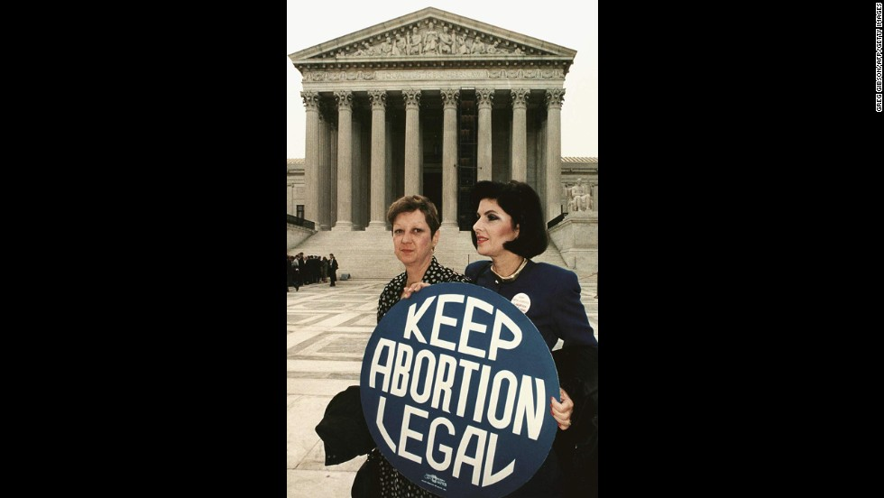
WASHINGTON, DC - APRIL 26, 1989: This file photo shows Norma McCorvey(L) formally known as Jane Roe, as she holds a pro-choice sign with former attorney Gloria Allred(R) in front of the U.S. Supreme Court building in Washington, DC, just before attorneys began arguing the 1973 landmark abortion decision which legalized abortion in the US. (Photo credit GREG GIBSON/AFP/Getty Images)"
(CNN)Here's a look at the US Supreme Court case Roe v. Wade.
Facts:
“January 22, 1973 - The US Supreme Court, in a 7-2 decision, affirms the legality of a woman's right to have an abortion under the Fourteenth amendment to the Constitution.
1971 - The case is filed by Norma McCorvey, known in court documents as Jane ROE against Henry WADE, the district attorney of Dallas County from 1951 to 1987, who enforced a Texas law that prohibited abortion, except to save a woman's life.
The Case:
The Constitutional Question: Does the Constitution embrace the right of a woman to obtain an abortion, nullifying the Texas prohibition? The ruling allows for legal abortions during the entire pregnancy, but set up conditions to allow states to regulate abortion during the second and third trimesters.
The Decision:
The Court held that a woman's right to an abortion fell within the right to privacy (recognized in Griswold v. Connecticut) protected by the Fourteenth Amendment. The decision gave a woman a right to abortion during the entirety of the pregnancy and defined different levels of state interest for regulating abortion in the second and third trimesters.
The ruling affected laws in 46 states.
Legal Timeline:
1971 - The Supreme Court agrees to hear the case filed by Norma McCorvey, known in court documents as Jane ROE, against Henry WADE, the district attorney of Dallas County from 1951 to 1987, who enforced a Texas law that prohibited abortion, except to save a woman's life. The Texas law had been declared unconstitutional in an earlier federal district court case (United States v. Vuitch, 1971). Wade ignored the decision and both sides appealed.
December 13, 1971 - The case is argued before the US Supreme Court.
October 11, 1972 - The case is argued before the US Supreme Court.
January 22, 1973 - The US Supreme Court, in a 7-2 decision, affirms the legality of a woman's right to have an abortion under the Fourteenth amendment to the Constitution.
June 17, 2003 - Norma McCorvey (Jane Roe) files a motion with the US District Court in Dallas to have the case overturned and asks the court to consider new evidence that abortion hurts women. Included are 1,000 affidavits from women who say they regret their abortions.
September 14, 2004 - A three-judge panel of the 5th US Circuit Court of Appeals in New Orleans dismisses a motion from the original plaintiff in Roe v. Wade to have the case overturned, a court clerk tells CNN. McCorvey's motion claimed she had new information that would affect the 1973 case.
The Players:
Norma McCorvey, who was known as Jane Roe, was a Texas resident who sought to obtain an abortion. Texas law prohibited abortions except to save the pregnant mother's life. McCorvey was pregnant when she became the lead plaintiff in the case. She gave up the baby for adoption.
Norma McCorvey has since come forward and changed sides on the abortion debate. In 1997, McCorvey started Roe No More, a pro-life outreach organization that was dissolved in 2008. McCorvey died on February 18, 2017.
Henry Wade - District Attorney of Dallas County from 1951 to 1987. Norma McCorvey sued him because he enforced a law that prohibited abortion, except to save a woman's life. He died on March 1, 2001.
Sarah Weddington - Lawyer for Norma McCorvey.
Linda Coffee - Lawyer for Norma McCorvey.
Jay Floyd - Argued the cause for Texas in the first argument.
Robert C. Flowers - Argued the cause for Texas in the second argument.
Supreme Court Justice Opinions:
Majority: Harry A. Blackmun (for The Court), William J. Brennan, Lewis F. Powell Jr., Thurgood Marshall
Concurring: Warren Burger, William Orville Douglas, Potter Stewart
Dissenting: William H. Rehnquist, Byron White”
Every January for several years, I wrote an article for the Cherokee Scout county newspaper in Murphy, North Carolina, which they published, to awaken people to the horrors of what was legalized in 1973.
America was the creator of the “science” of Eugenics – the “survival of the fittest” doctrine of Charles Darwin. The American government is the prime supporter of Planned Parenthood, and the eugenics philosophy of Margaret Sanger.
America is the prime trafficker in illegal drugs, protector of smuggler drug cartels, protected and sponsored by the CIA. America is the prime exporter of violent movies, violent music, and pornography worldwide. America is the prime trafficker worldwide of sex slaves, and especially small children to pedophiles worldwide.
America is now setting up the world for the arrival of anti-messiah and world government.
The majority of American Christians and Messianic have stopped crying “Come Messiah Come,” instead it’s “come money come,” “come prosperity come,” “come comfort and ease,” – “stay away Messiah.” The cries of the innocent don’t reach the ears of their heart.
Today abortion is not only done in the first trimester of pregnancy, which is bad enough, it is done in the 2nd trimester, the 3rd trimester, and as the baby is being born, and even after it is born--in other words murder.
Scientists have come out and admitted that a baby is a human being from conception. By the time a woman knows she is pregnant, the baby’s heart is beating, and its feet are perfectly formed. The baby has a spirit, which no other form of life has. The spirit is eternal, linking humans to the Creators.
Today, Satanism, human sacrifice of babies to Satan/Lucifer, or other gods of the ancient world – fallen angels – is a common practice. The cannibalizing of aborted babies is a common practice in China, but also in America and other nations, including other first world nations.
It is a proven and documented fact that aborted baby parts are used in vaccines, medicines, in products we use on our bodies, and in food additives, like “natural flavor” additives for example. Yes, “natural flavors” used by some main brand name products. I have the documentation. The use of aborted babies for experimental purposes of the Transhumanist Movement, for example, is also known fact. The eating of aborted babies for power in the demonic realm is a practice of Chinese nurses, for example. The sudden influx of fallen angels, demons (Nephilim), and the influence of Satan himself into our world, lets us know that Messiah’s return is close.
Many women who have been pressured to have abortions, out of fear, or guilt, or panic that they are pregnant, have later regretted it bitterly with tears. Our heavenly Father is merciful. The spirit of a baby, even from conception is eternal Those babies are with Yahuwah! And, He forgives the repentant.
But, as I reported on January 20, 2016, the day Trump was inaugurated as the 45th President of America, hundreds of women marched in the streets protesting against him, some screaming loudly, “I love to kill my babies,” and I love Satan.”
Our world is ripe for judgment. Major Hollywood personalities are not just promoting abortion, but mocking it, laughing about it, even saying, teasing or not, that they like to eat babies. I have lots of documentation on that, too. But, then, so many of Hollywood’s elite are Satanists.
Human sacrifice is very real and on the rise. Moloch, Ba’al, and all the ancient names of the gods and demigods, pre-Flood and post-Flood, are back on earth, and demanding human sacrifice and worship. Satan is demanding the sacrifice of billions of human beings to him. Cannibalism is on the rise, and laughed about by leading elite personalities. Our world has entered the time of judgment.
If you have had an abortion and now are repentant and bitterly sorry, turn to the Savior, the Redeemer, the One who shed His blood for you, the One who died in our place, Yahushua/Yeshua/Jesus, so that His Father (Yahuwah/Yehovah/God) could erase our sin, erase what we’ve done against Him, and give us new life, eternal life, in Him.
Know that your baby is with Elohim, and you will see your child in heaven if you will receive the redemption bought for you by the blood, shed on the stake/cross, and receive His resurrection for your eternal life. The God of the Bible is merciful and receives us when we humble ourselves, repent, put our faith in His Son, and ask Him to remove our sins. For you who have miscarried babies, your child is waiting for you to come to heaven to be with you. Praise the Creator for His loving kindness and mercy.
After we repent and receive forgiveness by the Savior, He says to us: “Go and sin no more.” Promote life! Tell others about the life that is in our Savior, our soon-coming Messiah! Cry out to Abba to sent Messiah to stop the evil that is rampant on earth today, and to rule as King of Kings. (Revelation 11:15-18)
Please share this article with those who have had abortions, or are considering having an abortion. Minister healing to those who are repentant and who seek redemption. Redemption means “to buy back that which was lost.” Mother and aborted child can be reunited in the love of our Abba Yahuwah through faith in Yahushua/Jesus Messiah.
In His love,
Yedidah
January 19, 2019

