WHY YEMEN?

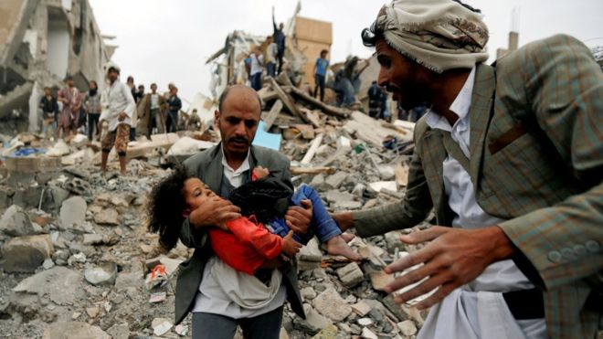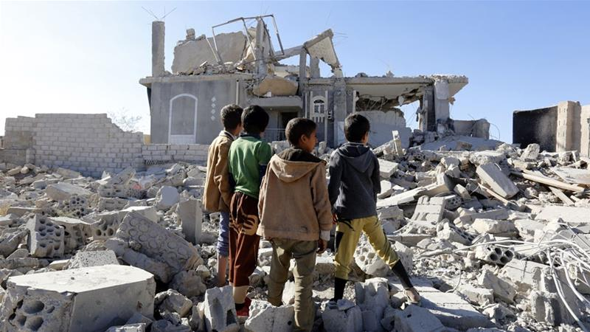
BBC - Yemen Al Jazeera - Yemen

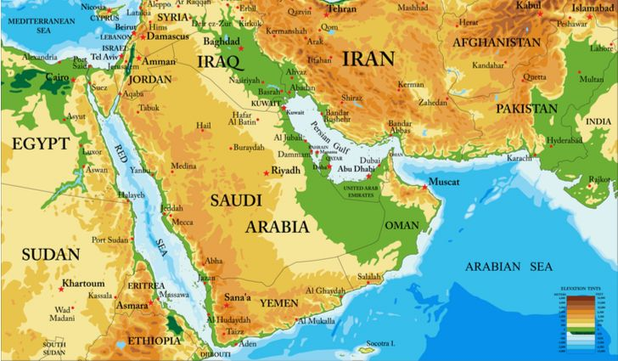
Yemen south of Saudi Arabia, at the tip of the Red Sea

I’ve held back writing an article on Yemen for months, but now it’s time to get things out in the open. Yemen is in the news as a terrorist nation that’s controlled and manipulated by Iran. But, is that true? What is the truth about Yemen? How did Yemen go from a nation few cared about to being front page news?
I’ve always asked lots of questions since childhood in my life-time of searching for, and demanding to know Truth. I don’t want surface answers that can be twisted into lies and deceptions. I want the whole Truth and nothing but the Truth. I want answers by those who know the reasons behind what we’re seeing and are willing to share it with others, especially inside contacts.
We’re in the day of Isaiah 59:14-15 and Amos 5:10: “Truth has fallen in the street…” “They hate the one who reproves in the gate, and they despise the one who speaks the Truth.” This is in the time-period before Messiah’s return.
When it comes to going to the root of the Truth, this is my logic: The Author of the Word of Yahuwah lives inside of me. He is the only one who has 100% Truth. So why waste my time on web-surfacing to get human opinions or theories? I don’t have time to waste listening to “news analysts?” I have no time to listening to Christian or Messianic opinions either. I don’t want to hear “well I think,” “well this is the way I see it.” What is the pure Truth about real-time events that are leading to the coming of Yahushua Messiah? I want “thus says Yahuwah.” And I want facts in real time! Yahuwah guides us into Truth and always confirms it by two or three witnesses. “…When He comes, the Spirit of Truth, He shall lead you into all truth….” (John 16:13)
I sure hope you’ve carefully read “Planned for Years! Shocking News! Iran: Key to World War III – Launching One World Government”/Mikvah of Present Reality. It is the foundation for this article and on-going news. It is horrendous how pubic news is reporting lies, deceptions, and twisted information about what is really going on with the alliance of America, Israel, and Saudi Arabia. Why are Israel and Saudi Arabia buddies in attacking Iranian targets in Syria and Iraq?
The above-mentioned article on Iran is loaded with information that you must know in order to interpret correctly what is unfolding. Iran told Israel last year they did not want war with Israel. Both Israel and America are following the Babylonian Talmudic principle of the “rodif”/”pursuer.” I’ve written about this in the now 22-article series on the plans of elite leaders in Israel for world rule. The law of “rodif” is that if you suspect something might harm you later on, without any proof, no evidence of any such harm, you have the right for a first strike – even if it’s an unborn baby. That’s why Israel and America are the two chief nations responsible for murdering unborn children, for euthanasia, genocide of gentiles, and war.
This is why after the false flag of 9/11, America went into Afghanistan to bring down a dead man and a terrorist group that America created. I’m talking about the businessman partner of George W. Bush and the Queen of England--Osama bin Laden--whose family built most of the U.S. Military Bases in the Middle East, and Al Qaeda – a CIA data base for the hiring of mercenaries to carry out false flags and terrorist attacks worldwide. It’s true, Israel’s Mossad trained ISIS and Al Qaeda mercenaries (both created and sponsored by America) to carry out false flag attacks on ships in the Persian Gulf that were blamed on Iran. No, Iran is no saint! They are potentially dangerous. But, back in 2018 they made it clear to Israel that they did not want war! So what’s going on?
This is why we went into Iraq. There was no reason for Gulf War I or Gulf War II. This is why in January 2011, President Obama began destabilizing the entire Middle East singlehandedly, starting wars, all over the Middle East. What did Syria ever do to the U.S.? What did Yemen do to the U.S.? And who has been the major targets to eliminate in Syria, Yemen, Iraq, etc.? -- Civilians and Christians!
Iran has not attacked anyone for 200 years. Their religious leaders have big mouths and are liberal with threats, but search out why! Why in the past did Iran call Israel “little Satan,” and America “big Satan.” What did they know we didn’t know at the time? Who started the Sunni – Shiite conflict? Both groups lived side by side peacefully for centuries. Why not, is this all being called a conflict between the Sunni and Shiite Muslims? Who started the conflict? Yea, you guessed it: America, Saudi Arabia, Israel - led by America and the CIA. But Why?
The public mind-controlling news, propaganda news, is lying through their teeth about Iran. The Globalist Elite and their Reptilian controllers are “chaffing at the bit” to get on with this one world order. By the way, “chaffing at the bit” is an American expression for a horse pawing the ground waiting for the starting gate to open in a horse race, or to go anywhere. They know the race is in front of them, and they are really nervous to get on with it, pulling on the reins that hold the mouth “bit” in their mouth. I feel like that when I get ready for a ministry trip.
Since Jerusalem is to be the capital of the one world government, there is already a shift to Jerusalem of many important things. War with Iran is supposed to launch World War III according to the 1871 Pike/Mazzini Plan.
Refer to: “The Pike-Mazzini Plan of 1871: The Plan For Global Government – The Perfect Execution of Parts I, II, and Now Part III”/Mikvah of Israel, Our Eternal Inheritance. It was the Illuminati – Freemason – Zionist – Jesuit plan for world rule that was the basis of the Plan. All of these groups have their roots in political and religious Judaism.
There are many born-again believers in Iran. In fact, the Good News of salvation is going forth mightily in Iran. Yahuwah’s Spirit is being poured out in Iran. So here comes Satan. Pray for many in Iran to be born again and stand strong in faith.

CURRENT NEWS AND THE BACKGROUND ABOUT “YEMEN”

Notes from Steven Ben Nun, Israeli News Live: “Houthi Rebels Take over 2,000 Saudi Prisoners in a brutal and bloody attack”
Supposedly, Yemen’s Houthi Rebels murdered thousands of Saudis and took over 2,000 prisoners in a brutal bloody battle. Their actions were blamed on Iran. (September 29, 2019) Supposedly, Yemen’s Houthi rebels are proxies of Iran, under their orders to do awful things to Saudi Arabia. The Truth Card has not been played yet.
Steven remarked: “If Iran is blamed for this, America may just drop tactical nuclear weapons on Iran, and Russia may just activate their plans for the US as David Hodges reported today.”
Another false flag event, most likely yes! Is this a planned event to bring about war in Iran and take down the U.S. as a result – i.e., the “killing two birds with one stone” game? We have Jeremiah 50-51 coming into focus. The reason for war with Iran will be a false flag! The taking out of America will be Biblical fulfillment! Steven: “Russia and China are ready to activate troops inside America”
Steven remarked: “This attack will not blow over. It will result in something. The U.S. destabilized the government of Yemen under Obama and this is the result – `the Houthi Rebels.’ Recently Israel and Saudi teamed up to bomb Iranian targets inside Syria. Steven was sent videos showing the death and carnage of the Houthi attack on the Saudi military. He showed them. He has insider military contacts within Israel and Iran who supply him with information. These contacts told him about the setting up of Iran for destruction when Iran did nothing to provoke it--all attacks blamed on Iran except the shooting down of an American drone over Iran were false flags by ISIS-trained terrorists in Dubai by the Israeli Mossad.
Russia is an ally of Iran. Steven confirmed what Yahuwah showed me: IF the U.S. goes to war with Iran, there are two hundred thousand Russian military soldiers and thousands of Chinese soldiers inside the U.S. who will be activated after Russia and China hit from the air. Yahuwah told me in 1991 as I read Jeremiah 50-51: “This is America.”
It is possible that mercenaries posing as Houthi rebels are trained, funded, and supplied with weapons by the U.S., as are almost all terrorist organizations. Jimmy Carter created the Taliban. President George W. Bush created Al Qaeda as a CIA data base for mercenaries, and President Obama created ISIS and other terrorist groups in Syria. The granddaddy of the terrorist groups is the Muslim Brotherhood, which was created by the CIA after WWII. The Muslim Brotherhood was allowed it to infiltrate the highest ranks of the U.S. government. When Obama TOLD Hossni Mubarak, President of Egypt to get out – he did. The CIA-staged protests in Cairo were blamed for Mubarak stepping down. I lived in Jordan at that time. I knew better! Obama then put in his friends of the Muslim Brotherhood into leadership in Egypt. Why do I say “friends?” It was the Muslim Brotherhood who funded his supposed college education. Yes, I have documentation on this. Dirt particles seep through the tiniest of cracks and later the dust is visible to all.
Refer to: “Thirty Clues and More…”/Mikvah of Preparation. Read carefully Jeremiah 50-51! This prophecy gives a post-1948 scenario, and it is America, end-time Babylon - NO doubt about it!
More than 70,000 people have died in Yemen since 2016. A great amount of this misery for the people is because of American sanctions. Why has America put sanctions on Yemen?
Supposedly, as the current story goes, Sunni rebels want to hijack the Black Stone in Mecca and take it to Jerusalem to set up their own Sunni power area. *****Avi Lipkin told Pastor Begley recently that it was America who created a Shiite-Sunni confrontation! It was the CIA and America that set up the war between these two main Islamic factions.
The U.S. is running the show. It has been the destiny of the U.S. to bring forth the antichrist and his Beast Kingdom in Jerusalem. It’s being set up between America and Israel right now. Be sure you’ve read “America’s Secret Destiny”/Mikvah of Preparation. Come Yahushua Come!
Notice how Mike Pompeo, Secretary of State, blames Iran for everything without any proof? Iran may be the key to the manifestation of the new world order. The Sanhedrin is now asking the U.N. to relocate in Jerusalem. They are asking the world court, the Hague, to move their headquarters to Jerusalem. Donald Trump may just soon order the building of the third temple. Steven ben Nun thinks he will order its building. We’ll see! The Trump-Kushner Peace Plan is in the works. The plans for world government are now being put in motion.
Before going any further, I want to review what General Wesley Clark was told years ago by President George W. Bush. Some of this information is in the recent article: “Planned for Years! Shocking News…” about Iran, but below I add more.

General Wesley Clark: Wars were planned on seven ... - YouTube
https://www.youtube.com/watch?v=B3B5xzApMZg
General Wesley Clark: Wars were planned on seven ... - YouTube
https://www.youtube.com/watch?v=B3B5xzApMZg
Feb 19, 2017 - A 15 minute excerpt. The full interview is here: https://www.youtube.com/watch?v=fH8NGfsLV7s.

WHAT’S HAPPENING NOW WITH IRAN HAS BEEN PLANNED FOR A LONG TIME! General Clark said that America is after “regime change” in all Middle East/North Africa nations – also Venezuela, and other nations like them. The nation of Yemen also has been under U.S. “regime change” war and sanctions since Obama.
Look at what Obama did to Syria. John Kerry described how he sat is a secure area and watched the massacre of Christians, children, and Syria civilians of all ages right before his eyes. He was not remorseful!
*****“Regime change” is about getting out those who opposed global rule/world government, dissolving borders, and putting in puppet-rulers of puppet-governments that will bow to the rulers/ruler of the new world order.
General Wesley Clark said in several interviews that you can watch on YouTube that wars were planned years ago: “Years ago it was planned to take out seven countries in five years.” He said the decision to go to war with Iraq was pre-planned. He said this is about taking down governments for a new world order. Clark said “…there was no reason to take down Iraq; they just decided to take down the government.” President George W. Bush told Clark how they intended to take out seven countries in five years, and Iran would be the last one to be taken down. Here are the countries: Iraq, Afghanistan, Lebanon, Syria, Egypt, Libya, and Iran. Notice the order and the execution of each one? This has been planned for years!
***October 3, 2007 interview for FORA.TV “General Wesley Clark: The U.S. Will Attack Seven Countries in Five Years” (7.36 minutes)
***General Wesley Clark: The US will attack 7 countries in 5 ... - YouTube
https://www.youtube.com/watch?v=nUCwCgthp_E Sep 3, 2013 –
General Wesley Clark said that in 1991, “we” (America) provoked the Shiite uprising in the Middle East! He said he was told that “…we can use our military in the Middle East and the Soviets won’t stop us.” [The main Shiite nations are Iraq and Iran. Main groups aligned with them are Hamas and Hezbollah]
Clark said he was told: “…we’ve got about five to ten years to clean up those old Soviet regimes – Syria, Iran, Iraq, before the next great super power comes on the scene to challenge it.” [Saddam Hussein of Iraq was a Communist. He only converted to Islam before Gulf War I to get the aid of his Arab allies. He was a personal friend of George Bush, Sr.]
Clark referred to the U.S. “Starting wars and change governments, invading countries…” Clark said of America: “This country is taken over too…” (He names men like Wolfowitz, Rumsfeld.) “THEY WANTED US TO DESTABLIZE THE MIDDLE EAST, to turn it upside down, and bring it under our control.”

CONTINUING ON WITH MORE RIGHT-ON INFORMATION
“The War No One Is Talking About Proves The Deep State Is Alive And Well In America And Still Murdering With Impunity - These demons will fight their wars until there is no more life left on planet Earth” - Submitted to All News Pipeline by David William Pear – November 6, 2018
On October 31st (2018) the US Secretary of Defense James N. Mattis and the US Secretary of State Michael R. Pompeo called for a cease fire and a negotiated settlement to the war against Yemen…
…It is the US that is leading from behind the Saudi and other Gulf Cooperative Council countries’ war against Yemen. The GCC front countries for the US are the Kingdom of Saudi Arabia (KSA), United Arab Emirates (UAE), Bahrain, Kuwait, and Qatar. The KSA and Qatar are embroiled in a feud. Oman has opted out of the war for now. Non-GCC countries Egypt, Morocco, Jordan, Sudan, Djibouti, Eritrea and Somalia are also contributing to the massacre of the people of Yemen.
The US has recruited the usual suspects of non-state actors, Blackwater mercenaries (rebranded Academi), Daesh, and al Qaeda to terrorize Yeminis on the ground, while Saudi pilots pound them with 2000-pound bombs. The Saudi coalition pilots purposely target school buses, villages, markets and hospitals with precision guided bombs…genocide in Yemen.
The UN has authorized a one-sided arms embargo against Yemen, which the US and Saudis have turned into a total blockade of food, water, and humanitarian supplies. The blockade is keeping vital supplies from the Yemeni civilians, which are desperately needed by them to sustain life.
The UN continues the façade that the “internationally recognized legitimate government” of Yemen is Abdrabbuh Mansur Hadi. His term as an interim president in Yemen expired in 2014. He illegally extended his term for one year, and then he was driven out of office by the Yemeni people. The people had had enough of Hadi’s corruption, catering to the International Monetary Fund, austerity and the privatization of state enterprises at fire sale prices.
In a Houthi-led uprising the people of Yemen forced Hadi out of office. Hadi resigned as president and then fled from the capital city of Sana’a and went to the southern port city of Aden. In Aden Hadi rescinded his resignation and tried to reconstitute his moribund government. When that failed, he fled to Riyad, Saudi Arabia.
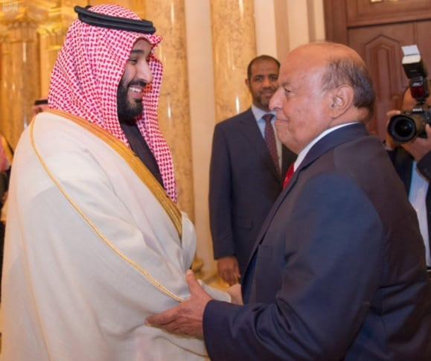
Abdrabbuh Mansur Hadi greeted by Saudi Crown Prince Mohammed bin Salman

With US and Saudi backing, Hadi makes the claim from the Riyadh Ritz-Carlton Hotel that he is the legitimate government of Yemen. He has no portfolio with which to govern, and it is rumored that MBS is holding him prisoner in the Ritz-Carlton. Regardless of the rumor, he is still just a Saudi tool. The de facto government of Yemen is the Houthi-led movement’s leaders, which are supported by the people and the security forces of Yemen. The US blames the war on Iran which has not invaded another country in over 200 years.
The US does not have a shred of evidence that Iran is backing the Houthi movement. Yet the mainstream media constantly regurgitates whatever the US government’s warmongers feed them to say.
The Houthis in Yemen are the Zaydi Shia sect, which is similar to Sunni Islam. For centuries the Zaydi Shia and Sunnis have lived in peace and even pray together in Yemen’s mosques. Simplistic Western propaganda has tried to fabricate that the war in Yemen is a Sunni vs. Shia war, with the Houthis being backed by Shia Iran. The Zaydi Shia in Yemen are a very different sect of Shia than the Iran Twelvers. (Western journalists are too lazy to look it up in Wikipedia). So, the US government dominated mainstream media never fails to repeat the propaganda that the Houthis are “Iran-backed.” ***Iran is the imaginary boogeyman that the US has invented. [Like Russia is an imaginary boogeyman the US globalists have invented]
The real Halloween boogeyman who is killing hundreds of thousands of Yemenis is the US-backed Saudi boogeyman Mohammed bin Salman. He is known affectionately as MBS, by his drooling admirer Thomas Friedman of the New York Times. MBS is a blood drenched madman. He chops off the heads of his critics, dismembers their bodies with bone saws, stones women for adultery, and crucifies victims just for the fun of it.
The US turns a blind eye from this bloody madman, because he buys billions of dollars’ worth of US weapons. Then MBS uses the US weapons to kill innocent civilians in Yemen. Friedman says MBS is a liberal reformer in Saudi Arabia because MBS lets women drive cars (as long as they get their husband’s permission first).
[Yedidah’s input: The U.N., in 2018, issued a proclamation commending Saudi Arabia for its human rights, saying it was one of the most humane nations in the Middle East. Yet, according to statistics, Saudi is one of the most brutal regimes, and worse offender of human rights in the world! Lies, lies, lies to justify alliances!]
***There would be no war against Yemen had the US-led Saudi coalition not first attacked that country from the air, land and sea. Tens of thousands of people, most of them children, would not have died. There would not be the worst cholera epidemic in history and 20 million people would not be suffering from a man-made famine, had the US-backed Saudis not invaded Yemen. It was the Obama administration that gave the Saudis the nod, wink and the military support for its war of aggression against Yemen. Yemen had not attacked or threatened anybody.
***[Yedidah again: Let me give you a clue as to why Yemen. Prime Minister Golda Meir expressed her disgust and hated of Yemenite Jews in Israel. She openly based her disdain saying “they always carrying their Bibles.” They are a deeply religious group of Jews, who go by the Tenach. Barry Chamish exposed the “ring worm” experiment by Israel and America on thousands of Yemenite children. Many were experimented on in Israel. But, thousands were “shipped” to the U.S. to be experimented on – yes, kidnapped. The children had their heads zapped with high doses of radiation to see how it would affect them. Many died. Why Yemenite Jewish children? - The Yemenite Jews go by the Bible – they’re connected to the God of Israel! This “experiment” is well documented by Barry Chamish!]
***** “It was the US-led Saudi coalition that started the war in 2015. It was code named Operation Decisive Storm. Like most US-backed wars it was not decisive. Operation Decisive Storm was supposed to be a short war, a cakewalk as the military likes to say. As we have seen in Afghanistan, Iraq and Syria, these cakewalks turn into never-ending wars that turn into quagmires, they kill hundreds of thousands of people and they leave millions of people in dire distress.
Three years later in 2018, the US-led coalition in Yemen is still bombing, blockading, starving civilians and purposely causing the spread of the worst cholera epidemic in history. It is another US dirty war similar to the wars in Afghanistan, Iraq, Libya and Syria. As with the US-imposed blockade of Iraq in the 1990’s, a million children will die of cholera because of the destruction of the water purification works and the blockade of replacement parts and potable water. Anybody that has been following US foreign wars knows that the US and the Saudis are together in them. They both have blood up to their eyeballs.
…The US preconditions for Yemen is that it has to surrender. It has to stop resisting the US-led invasion. In return the US made the `generous’ offer of not bombing civilian targets. Only then will the US be willing to dictate the terms.
Mattis demanded that Yemen surrender or else the US-led Saudis are going to bomb more school buses, fish markets, hospitals, funerals, weddings, and civilian infrastructure. Those are war crimes…They are threatening to kill more children that they are holding hostage, unless Yemen bows to US terms.
The US-led Saudi coalition has dropped over 15,000 2000-pound bombs on Yemen. Yet for three years the UN has insisted that (only) 10,000 civilians have been killed. The actual number is in the tens of thousands, perhaps hundreds of thousands. The siege warfare and biological warfare of starvation and cholera have taking tens of thousands of lives as well. Most of those killed have been children.
*****Yemen is another US dirty war. The US is using the same subterfuge and dirty tricks that it uses in Afghanistan, Iraq, Libya and Syria. The US and its co-conspirators Saudi Arabia and the other Gulf countries have been bombing Yemen and invading it with terrorist groups such as al Qaeda, Daesh and Blackwater mercenaries from South America.
It is the US-led Saudi coalition that started the war. If Mattis and Pompeo want to end it all they must do is to stop bombing and attacking Yemen. Open the ports and let the humanitarian aid flow in. Stop funding Daesh and mercenaries in Yemen. It really would be that easy.
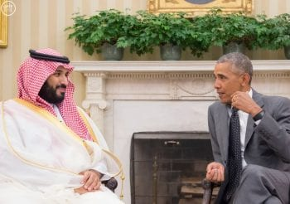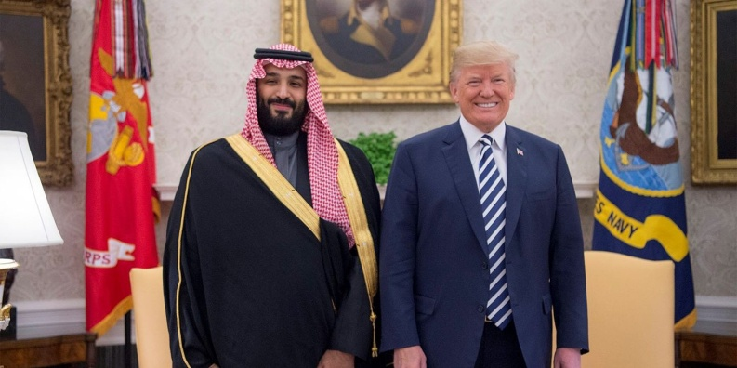
Left: Obama with MBS in 2016 Right: Donald Trump with MBS in 2018

All US presidents must work to maintain the `special relationship’ with the Saudi regime. [Yedidah: This goes back to the 1940s when America pledged allegiance to Saudi Arabia because of the oil trade—an allegiance above any other nation on earth. I have a Newsweek Article from the late 1940s with this pledge.]
The US’s real concern is that a new government in Yemen will not be compliant to Western neo-liberalism and IMF imposed austerity and privatization. The Saudi’s are worried that a Houthi-led government in Yemen would not be under its oppressive thumb. Together the UN, the US, the KSA and other Gulf Cooperation Council countries declared Hadi as the “internationally recognized legitimate government” of Yemen.
Functioning out of a Riyadh five-star hotel, Hadi supposedly asked for the US-led Saudi coalition to aid him in restoring himself to power, in what he calls a civil war. Saudi Arabia and the UAE claim that they are coming to the aid of the “internationally recognized legitimate government” of Yemen. (Notice that the Western mainstream media always uses that exact phrasing to describe Hadi). The United Nations imposed a one-sided arms embargo on Yemen, which is actually a blockade. All of this happened with a wink, a node and a push from President Obama in 2015.
With US logistical support, Saudi Arabia launched an air assault on Yemen in 2015 code named Operation Decisive Storm. When that failed the US-led Saudis appropriately renamed it Operation Restoring Hope. The US-led Saudis intensified their attacks on the civilian population, destroyed their water works and sanitation facilities, which has predictably caused an outbreak of cholera. The blockade of humanitarian supplies, food, potable water and needed repair parts has, again predictably, resulted in the worst cholera epidemic in history. It is germ warfare, which is the same as the US used in the 1990’s to kill hundreds of thousands of children in Iraq.
The US-led Saudi coalition is a genocidal aggression. It has put 20 million people at grave risk of starvation and disease. Tens of thousands of Yemenis have died at the hands of the US, Saudi Arabia and the UAE. The people of Yemen do not have the 30 days that Mattis is taunting them with to begin a peace conference. In 30 days another 10,000 children or more will die of cholera, starvation and disease.
Yemen is not threatening to attack anyone. All Yemen wants is to be left alone. The blockade should be lifted immediately for humanitarian reasons. Lifting the blockade would allow desperately needed food, water, medical supplies and other essentials to enter the country. Lifting the blockade would save tens of thousands, maybe millions of lives. With the bombing stopped, terrorists subdued, and the blockade lifted, then humanitarian organizations such as Doctors Without Borders and the International Committee of the Red Cross could safely rush in to provide life-saving treatment for the thousands of dying children. Stopping the war in Yemen would not be complicated.”

“Why We Know So Little About the U.S.-Backed War in Yemen
What the U.N. calls the `world’s worst humanitarian crisis’ is an unhappy confluence of American media taboos’ - By Matt Taibbi Rolling Stone July 27, 2018 from Al Jazeera: `Yemen on Brink of New Cholera Epidemic,’ Charity Warns.”
US Saudi Holocaust in Yemen began March 22, 2015 and continues.
Syrian Conflict began March 15, 2011 – soon after destabilization of Lebanon in January 2011. January 25-February 11, 2011 saw the overthrow of Hosni Mubarak by the CIA and Obama’s intervention, as Obama singlehandedly destabilized the whole Middle East…Dates of Gulf War II, beginning March 20, 2003, Purim, ending December 18, 2011.
There were over a million reported cases of cholera between the fall of 2016 and spring of 2018, the largest documented outbreak in modern times. …Since the conflict began, medical services have been devastated across the war-torn country, and children in particular have been affected, with as many as 400,000 at imminent risk of starvation. In April, U.N. General Secretary Antonio Guterres said that 8 million people in Yemen didn’t know where they were getting their next meal...which weeping mothers can be seen holding their malnourished babies and saying things like, `I’m losing my son and there’s nothing I can do about it!’
The reason for inattention is obvious: The United States bears real responsibility for the crisis. A quote from a Yemeni doctor found in PBS reporter Jane Ferguson’s piece sums it up: `The missiles that kill us, American-made. The planes that kill us are American-made. The tanks … American-made. You are saying to me, where is America? America is the whole thing.’ ”
Please refer to the article, though it’s an old one: “False Flags”/Mikvah of Present Reality, to get an idea of what’s really being done against Iran. Did the Houthi rebels really blow up the Saudi airport, the Saudi oil fields, and cause the massacre of Saudi troops a few days ago? It’s possible. It’s also possible that the ISIS and Al Qaeda mercenaries trained by the Mossad did these things, acting like the Houthi rebels. Yahuwah will judge righteously. He knows the Truth!
Creating False flags is an old trick. The wicked ones do damage, and blames it on an innocent nation or individual. This provides the guilty perpetrator with the illusion they need as a reason to make war against the innocent.
When you know the truth, you are not deceived into thinking something is evil, when the one yelling “evil” is the real devil.
Pray for the people in Yemen, Iraq, Iran, Saudi Arabia, Lebanon, Egypt, and Syria--there are many strong believers in these nations.
In the love of Yahuwah, Yedidah
October 3, 2019

