WORKING HARD TO CREATE AN EXCUSE TO LAUNCH THE FINAL LONG-PLANNED WWIII
TRIGGER-WAR

June 13, 2019: Two Japanese Oil Tankers were “torpedoed” in the Gulf of Oman. One ship carrying oil from Iran to Japan sunk totally. The second ship was on fire. Mike Pompeo immediately blamed Iran without any evidence.
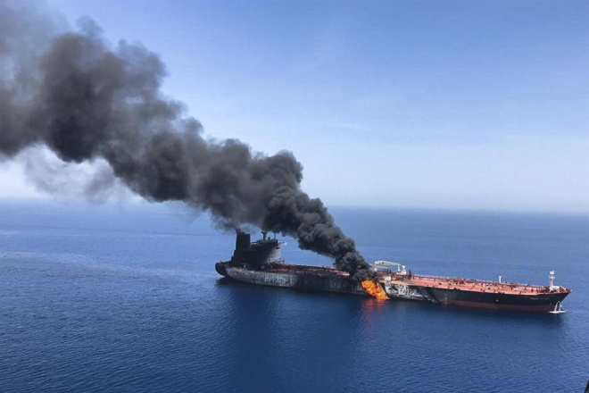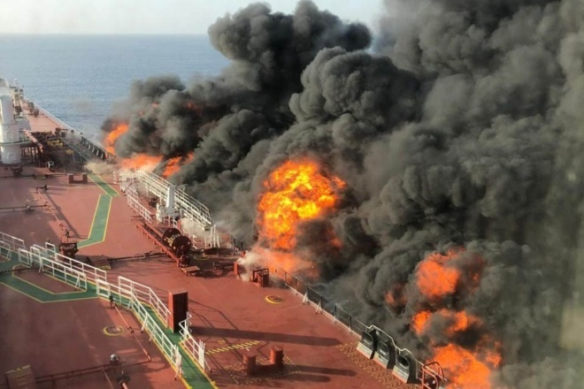

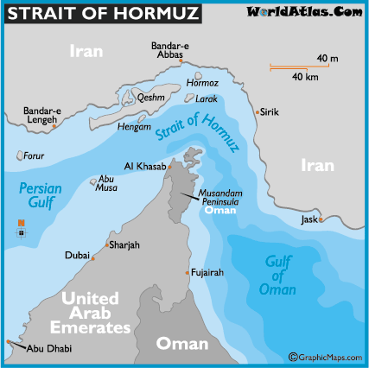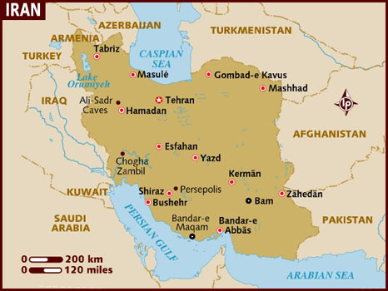

Two days ago, as I got up for the day, I began weeping. The source of the weeping was my spirit. Abba was full of grief. The weeping went on for about two hours. This has happened to me quite a few times before. This time, I wondered what was happening in the world that would cause Him to weep with such grief. I sensed it had something to do with what’s being provoked with Iran. It also had to do with the fact that His children whom He loves are not prepared for what is about to happen to them, especially His children in America. I grieve with Him.
The morning of June 19th, Abba spoke to me: “This morning in reviewing the current situation that Putin is warning America about regarding a catastrophic war, my Abba Yahuwah spoke to me: “It was the Medes and the Persians that took down ancient Babylon.” Details below…
On June 12th, in a speech to world leaders, Vladimir Putin made these comments: “If we don’t keep this fiery serpent under control…”…“If you let it out of the bottle, God forbid, it could lead to a global catastrophe.”
He was talking about nuclear war and Iran. He also talked about nuclear weapons being taken into outer space. He was warning America to weigh what they have planned in the light of what it will trigger.
Last night, listening to a report by Steven ben Nun, ex-CIA Intelligence insider, quoting from his insider contacts in Iran, Israel, the U.S. military, and others, he gave sensitive information that he had to word well so that his contacts were not exposed nor the entire information revealed. But, he gave enough, and I’ll share some of that with you in this article.
When he finished reporting, he grew very somber. He looked into the camera and hesitated, guarding his words. He said that he knew of some who were preparing to flee out of America. He said that was a good idea, and that we should do so if we can. Then, he basically said to his audience, “PREPARE,” store food and water. Prepare spiritually. He knows what has been planned is coming down hard and fast.
I, and usually 1-2 other believers with me, spent a great deal of 2005 and 2006, and on into 2007, doing prayer and intercession over all the major rivers of America, seas, the Gulf, and waterways, from Galveston, Texas, to Anchorage, Alaska, regarding the fleeing remnant. I taught about fleeing from America, especially in East Texas, during 2006. From the northern states down through East Texas to the Gulf there is a definite thoroughfare of rivers and waterways. I even had a contact with Jews in Michigan whom I put in contact with Jewish shipping owners in the Gulf of Mexico to help them get down and out of America.
In 2008, there were various warnings that went through the synagogues of Orthodox Jews that they would have to flee, even the main newspaper in Riyadh, Saudi Arabia, warned them to get out because their government friends would turn against them.
I share with you here how what is happening with Iran is the beginning of the end of the Pike-Mazzini Plan, paving the way for anti-messiah/antichrist, along with the deaths of billions of people. Scriptures like Isaiah 10:16-27; Isaiah 13; Isaiah 24, and Jeremiah 50-51 tell us that there will be very few people left alive on earth when Messiah descends.
Brother Steven ben Nun was speaking to us in America particularly, for what is happening with Iran and America right now was planned out 148 years ago. I will share some things he said that you sure won’t hear from public news!
In order to understand what I write here, and have been researching, writing and teaching since the 1990s regarding plans to usher in the new world order, be sure to read “The Pike-Mazzini Plan of 1871: The Plan For Global Government – The Perfect Execution of Parts I, II, and Now Part III” under the Mikvah of Israel, Our Eternal Inheritance, article 59.0.
The third part of the Mazzini/Pike Plan speaks of World War III between the Zionist state of Israel and the Muslims to destroy both Israel and the Muslim world, and destroy Christianity and atheism at the same time. Albert Pike states in his book Morals and Dogmas, known as “the Masonic Bible,” that the god of Freemasonry is Lucifer. Strangely, practicing Kabbalist Orthodox and Hasidic Jews also pray to Lucifer, and also to Satan, and to many other gods. World War III will prepare the way for the one world government to come to pass. Therefore, America as a global super power must also fall.
I have been teaching and writing for years on America being end-time political and economic Babylon. America was chosen by secret societies in the 1500s to be the nation to bring forth the world ruler, the embodiment of Nimrod, aka Gilgamesh, Osiris, and Apollo, as in Revelation 9:11 – Apollyon.
The reason for teaching about America as end-time Babylon is because one day in 1992 upon studying Jeremiah 50-51 Abba spoke to me: “This is America.” He showed me details in Jeremiah 50-51. Later He showed me more details in Isaiah 10, 13, 18, 47, Jeremiah 25, Zechariah 2, and Revelation 17-18. I’ve been studying and teaching on these things ever since.
Please refer to: “Thirty Clues and More Identifying America in Prophetic Scripture”/Mikvah of Preparation.
About 20 years ago, I learned that America was founded with a secret destiny. It would be created as a nation to be a world superpower in order to prepare the world for the kingdom of Nimrod, founder of Babel/Babylon, to restore him to world power, thus restoring what he set out to do at his Tower of Babel – Genesis 11:1-10. Please refer to: “America’s Secret Destiny”/Mikvah of Preparation.
Europe is dedicated to this Plan. E.U. symbols include the “woman riding the beast,” and their Parliament Building being a replica of Nimrod’s tower. In taking in the Muslim refugees, the E.U. is fulfilling Hitler’s Plan, and opening the door for the chaos to bring in “the order.” Refer to: “Hitler’s Secret Plan for World Conquest Exposed – It is Unfolding Before Our Eyes in Western Europe, the U.K., and America”/Mikvah of Present Reality
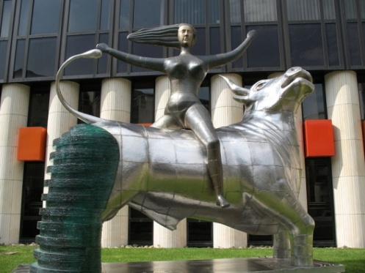

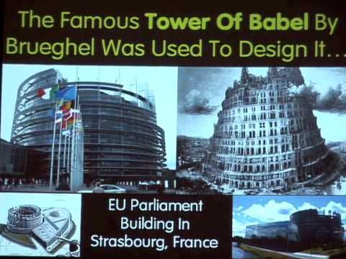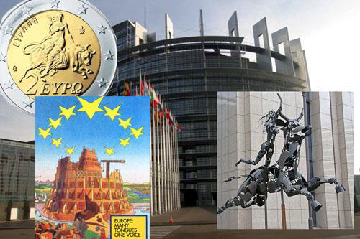

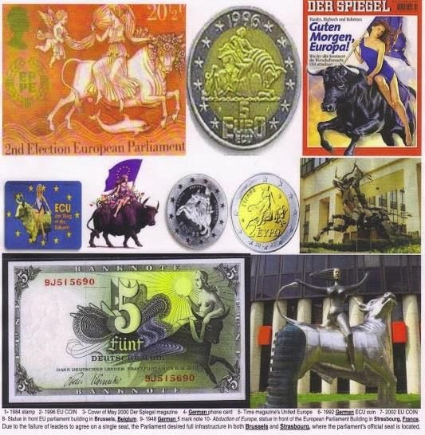
Abba has revealed to His servants the plans of the fallen angels, which are being accomplished through their hybrid offspring, Nephilim, and by their human servants. All of it is prophesied throughout the Bible, especially in the book of Revelation. We understand also that the spirits of the dead Nephilim were destined by Yahuwah to roam the world until their judgment. We know them by their manifesting, tormenting, and possessing as “demons.” This is why they constantly crave to have a body to work through, whether human or animal, reptile or bird.
In order for America to fulfill her destiny and give life to the returning Nimrod, America had to be created as a nation, then come to global power, which happened in 1945 after World War II. According to Jeremiah’s prophecy (Jeremiah 25:11-16, 27-33), an end-time prophecy, America would be given 70 years to accomplish their task, decline, and then be destroyed totally.
Ancient Babel/Babylon was never annihilated totally. The spirit of Nimrod lives on through the Nephilim who possessed him, and giants like him. Isaiah 13:1-3, Septuagint Version, tells us that Yahuwah will use giants in judging the earth. The portals of the underworld are now being opened (Revelation 9:1-11.)
There are other prophecies regarding this. America’s 70 years was launched in April 1945 at the fall of Germany. America emerged from World War II as the world’s super power. America’s 70 years were up in April 2015. In April of 2016, the 120 years allotted the returned Nephilim ended. The Spirit of Yahuwah is no longer striving with them. He has withdrawn His striving, holding back, in order to allow the plans of Satan’s forces to go forth, setting up the world for Yahuwah “Day” and the return of Messiah with His wrath.
Thus, today we see clearly that America has forsaken our wonderful Bible-based Constitution and has implemented laws based on Babylonian Talmudic Law under Rabbinic Zionist-Judaism, a code of Law that is the basis of Communism, Nazism, Fascism – and all basic Socialism. Law based on the exaltation of the Elite, and the suppression and use of all others as their slaves.
We see clearly now what has been going on for many years, at least 50 years, as America has been controlled by the Babylonian Brotherhood, the Nephilim hierarchy since then. Now America has nearly fulfilled its purpose. It is the one to instigate Pike-Mazzini Plan Part III for World War III.
ALL OF THIS HAS ALL BEEN CAREFULLY PLANNED SINCE AFTER THE FLOOD!
The restraining forces holding back the Plan have all been removed, and America is being set up for its prophesied destruction. “Babel has fallen, has fallen, and become a dwelling place of demons, a haunt for every unclean spirit…” (Revelation 18:2). Steven ben Nun’s admonition last night was Revelation 18:4!
It’s no longer needed; the laboratory is being closed down and the American people who have been used for experiments, like lab-rats, will die in the process. We’ve been warned over and over for decades!
Now that the man of sin, “son of perdition”/destruction, the “lawless one,” is waiting to take his throne in Jerusalem, his faithful false prophets are united as one to make it happen. They control Israel. The way it will come down has finally been exposed. The puzzle pieces are now coming to light and the total picture is being unfolded.
To learn some of the tremendous amount of reality that has surfaced since January 2019, please refer to “Beware of the Noahide Laws”/Mikvah of Present Reality, and the eleven article group about the Noahide Laws, Kabbalah, the Babylonian Talmud, and plans for the coming of antichrist, under the Mikvah of Israel, Our Eternal Inheritance #s 50, 52, 53, 54, 55, 56, 57, 58, 59, 60, and 61.
In late 2016, Abba began showing some things about Donald Trump. He showed me His view of the hundreds of thousands of Christians who were praying Trump into office to stop war and make America “great again.” Abba related it to me as another Numbers 16 quail scenario.
I know that what I heard from Abba in 2016 flew in the face of all the celebrating. “God gave us a savior” was the victory shout of Christians and some seculars too. President Trump in late 2017, with his announcement of moving the U.S. Embassy from Tel Aviv to Jerusalem and proclaiming Jerusalem as the rightful capital of Israel, became known as “Cyrus,” to Christians, the Sanhedrin, and Prime Minister Netanyahu, too. He riled up world hate within the Muslim religion.
Trump started off his Presidency sending missiles flying into Syria for a spurious reason based on hearsay. He also continuing to fund ISIS and other Jihad terrorist groups inside Syria, all created by America, who killed Kurds, Syrian Christians, and innocent Muslims, to help unseat a man who gave them freedom. The ruse for America to be in Syria was to get rid of ISIS. Recently we learned that instead of getting rid o President Obama’s creation, we used ISIS as helpers in our taking over Syrian oil fields. Friends to the end! It was a Saddam Hussein repeat, a Hossni Mubarak repeat. It looked like Trump was setting up war with Putin for a while. But, the plan being carried out now, which Trump is going along with, is a deadly one that will bring retaliation back on America.
I’m going to share some things with you that are shocking, but now coming out from those who are tired of tolerating America’s deceit and wickedness.
I wrote an article before Trump started getting us into more wars, like now with Libya and Venezuela, and working with Israel and Saudi Arabia to provoke Iran. While raising our employment rate, and doing some good things for the America people, President Trump has been constantly involved in war-promoting and war-starting. He and his son-in-law Jared Kushner have created a “Peace Plan” for Israel and the entire oil-rich surrounding nations, Iran excluded, that is brilliant, yet a deception that is monstrous.
From a video shown on Israeli News Live about a month ago, we saw how far back the planning of nation take-downs goes. The video contained a speech by General Wesley Clark, who was a major General during the time of George W. Bush. It’s all about a new world order. Clark said that the decision to go to war with Iraq was pre-planned. Clark said it is about taking down governments for a new world order. Clark said “There was no reason to take down Iraq; they just decided to take down the government.” George W. Bush told him that they were going to bomb Afghanistan, and planned to go to war with Iraq. He told Clark how they intended to take out seven countries in five years: Iraq, Afghanistan, Lebanon, Syria, Egypt, Libya, and finally Iran. Sudan and Yemen were also taken down during that time, and Hezbollah given control of Lebanon.
It’s been nearly proven to death that the 9/11/2001 twin tower terror was a False Flag operation orchestrated by the U.S. government to create a “ground zero” for the launching of World War III. It was blamed on a dead boogie-man--Osama bin Laden. Saddam Hussein of Iraq was also made out to be a boogie-man. He supposedly had “weapons of mass destruction,” but he had none.
Osama bin Laden died of kidney failure in Dubai less than a week after the “Twin Tower” disaster. A candidate for election as President of Pakistan was interviewed in England. She said that Osama bin Laden was murdered. She returned to Pakistan, and she was murdered.
Osama, George W. Bush, and the Queen of England were business partners in the Carlyle Group. George W. Bush and Osama and his family used to vacation together. The bin Laden family built most of the U.S. military bases in the Middle East. Former President George Bush, Sr. was personal friends of Saddam Hussein.
The CIA created the Muslim Brotherhood, a Nazi-related terrorist organization. The CIA created Al Qaeda, which is no more than a data base or their hiring of mercenaries to do their dirty work. It had nothing to do with Osama bin Laden.
ISIS was created also as a “data-base” for mercenaries for hire under President Barak Obama to do more dirty work. Since then, other Jihad groups have been created for U.S. purposes. This is not secret knowledge, but common knowledge. These terrorist groups are all over the U.S. in hidden “sleeper cells.”
The granddaddy of all the terrorist organizations is the Muslim Brotherhood. They even infiltrated the U.S. government after World War II. Oh well, I could go a few hundred pages exposing, but I won’t. It’s just facts I’ve gained from years of research guided by Yahuwah and confirmed by human insiders exposing lies.
So back to what is happening with Iran. The whole set up is another “Saddam has weapons of mass destruction” ruse. It’s another “Russia blew up my Reichstag” ruse of Hitler’s to justify war with Russia. It is so fake that it’s sickening!
But, as Steven ben Nun pointed out truthfully: Donald Trump is not in control of his own government! He cannot do as he wants to do. He has been controlled for most of his presidency.
I have statistics, facts, information and confirmation that Mr. Trump is part of the overall Globalist plan. I’ve known for years, because it’s fact, that the Rothschild Dynasty owns and rules Israel along with papal power via the Jesuits (Zionist political and economic conspirators with the Rothschilds). Multi-billionaire Donald Trump has been in the pocket of the Rothschilds, in debt to them, for a long time to do with his up and down financial life. He’s also indebted to George Soros and other billionaires dedicated to the destruction of America. The Rothschilds say they are Jews but they are not, they are part of the hybrid Nephilim-rooted Babylonian Brotherhood dynasty. They are trillionaires. They control world finances through their “City of London.”
Please refer to “The Mysterious City of London – Gog and Magog” and “The Shocking Hidden Goal of Globalism Exposed – Psalm 2 and Revelation 19:19/both under the Mikvah of Present Reality.
As ex-CIA Steven ben Nun said speaking of President Trump, “He’s one of `them.’ ” Steve Quayle commented that in watching Trump’s inauguration, he saw several top Evangelical leaders of America standing with the President, whom he knew to be all Globalists. The Church was taken over by deceivers a long time ago. Oh the pitiful religious folks who follow man and go by their own head reasoning, yet have shut off access to hearing from Abba/Father. (Jude 1)
Jeremiah 4:22, 6:10-11, 19: “For my people are foolish; they have not known Me. They are stupid children and they have no understanding…To whom shall I speak and give warning so that they hear? See, their ear is uncircumcised, and they are unable to listen. See, the Word of Yahuwah is a reproach to them, they do not delight in it. Therefore I am filled with the wrath of Yahuwah. I have become weary of containing it…Hear O Earth! See, I am bringing evil upon this people, even the fruit of their thoughts because they have not listened to My words, nor My Torah, and they rejected it.”
Who is speaking? It’s not Isaiah. The One speaking says “I am filled with the wrath of Yahuwah.” Who is the Torah-giver, the living Word made flesh? Who is the one that the world hates is being gathered against? Who is the One who has been cast aside by many of His own people? Who is the One coming with the wrath of Yahuwah? He is filled with the wrath of Yahuwah (Isaiah 63:1-6; Revelation 19).
Abba Yahuwah has been sending watchmen to warn His people for decades, especially during the 20th and 21st century. But, hardly anyone has applied the knowledge to prepare. Yet, in these last days, the planet is being controlled by the “them” of Daniel 2:44. These “them” have mixed their seed with the children of men just as they did in Genesis 6:1-4. Also many clones now house Nephilim.
In 1963, leading Jesuits dedicated the Vatican to Satan through satanic ritual in a mock human sacrifice, beneath the Vatican. At the same time, a dedication was also made in a Masonic Lodge in Savanna, Georgia, using real human sacrifice. The Freemasons were formed out of Babylonian Talmudic Judaism. Thus you have Rabbinic Jewish Talmudic Kabbalists praying to Lucifer and Satan as part of Kabbalah. The Masonic god is Lucifer, stated clearly in Albert Pike’s Morals and Dogmas. You have a large group in the U.S. military who are Satanists. You have a rising army in the hundreds of thousands who have been ritualistically fragmented by methods like Nazi Yosef Mengele’s Monarch Mind control. From Mengele the U.S.’s CIA created their MK Ultra mind control plus several other hideous means of breaking apart a child’s mind by terror so that it can be programmed to kill or steal, or whatever plans the military has for them, or the Intelligence and political groups have for them to do. In the 1960-70s, the CIA experimented with the drug LSD by introducing it to college students. They wanted to know how they could use drugs to mind-control people. Their “experiment” got way out of hand didn’t it!!! The CIA is in charge of America’s drug trafficking worldwide. This trafficking pays for the wars we start. I wrote about that too in a recent article.
Some U.S. military bases are now set up with special areas for Satanist “worship.” Witchcraft is huge in America and worldwide! The increase in fallen angels and Nephilim offspring in cloned bodies is overwhelming. All of this taking over, and Christians are turning to New Age mysticism for spiritual reality, tapping into the dark kingdom.
Indeed, as I’ve written, Donald Trump is the “Looser” (Revelation 6:1-2) He’s done a lot of loosing since January 2017! Now, he is allowing the final stage III of the Pike/Mazzini Plan by political Zionists to commence World War III. For more on Donald Trump as the “Looser”, refer to “The Rider on the White Horse – The Crowned Conqueror Rides Forth to Loose.” He is clearly now loosing the Globalist agenda for the new world order by backing the false flag of “Iran did it.” But, like I said above, he is not in total control of this.
Steven bin Nun sees that this is a coordinated effort to put the blame on Iran to justify a war against America. At this point, so do I.
Notes from Israeli News Live June 19th program “Is the Stage Set for War?” --
A spokesman on a video with The Guardian in England said that Iran has not admitted to doing any of the attacks. Steven bin Nun said that one of his intelligence sources reported that China had given Iran highly sophisticated weaponry that could take out all the U.S. ships and boats in the Persian Gulf and Gulf of Oman all at once. Steven said he held back that information even though he was asked to share it by a U.S. insider whistleblower. He is concerned for U.S. troops in that area of the Persian Gulf, like those on our battleship the USS Abraham Lincoln in the Gulf of Oman.
U.S. sources say that Iran and China are working on technology that is beyond U.S. capability to deal with or stop. This is no ruse – the technology is partly understood by Intelligence sources and they know it is beyond U.S. capability.
John Bolton, Secretary of Defense, has been trying to force a regime change in Iran, like the U.S. took out the Shah of Iran. This has happened and is happening in many nations, especially since President George W. Bush launched the final stages of the Pike-Mazzini Plan Part III in 2001. Does it irritate you – as in “what right does the U.S. have to tell other nations what to do?” There’s always some noble sounding reason, but the goal is destabilizing of nations to bring in a one world government with no national boundaries.
“Unfortunately, President Trump doesn’t have full control as President of the United States.” (Steven bin Nun, June 19, 2019)
It’s been pointed out since early 2018, that something had happened to the President to make him dump his promises and begin to flow with the globalist agenda. The human and hybrid Globalist Elite, the Babylonian Nephilim controllers, the “them” of Daniel 2:44 are ruling the events of earth now. It is also possible that the antichrist is ruling from the shadows, preparing his own entrance. America is under their control from now on. America, in the 1970s at least, began promoting the political Zionist plan for world takeover. Now Israel is controlled by the Kabbalist Sanhedrin who are also political Zionists.
Here I give you some shocking insider information, but I know it’s true. The Israeli Mossad, the Israeli equivalent of the U.S. CIA, is working with UAE (United Arab Emirates) to train members of ISIS to do the dirty work that will set up the plan for World War III using Iran.
Inside information speaks of them training “frogmen,” called “sea warriors,” as a multi-national force, working in the Persian Gulf. These “frogmen” are under the control of the Israeli Mossad to do what is necessary in the Persian Gulf – like blow up oil tankers. The Mossad is heavenly involved with the training of Al Qaeda operatives also n Yemen. Again, Al Qaeda and ISIS are U.S. mercenary data bases for the CIA, mostly non-Muslims, hired to kill and aid in world government plans. These ones being trained are going to be involved in more false flags until war breaks out.
Steven reported that John Bolton is involved with using his “thugs,” like the Houthi rebels, to do his dirty work to blame attacks on the Saudi airports on Iran.
The torpedo attacks, and all the diversions, are to cover up what the Chinese have given to the Iranians, Steven said.
Steven believes that the ISIS and Al Qaeda operatives being trained by the Mossad are the ones carrying out the attacks, as on the tankers.
Summarizing: Part I of the 1871 Plan by Kabbalists/Zionists Albert Pike head of the Scottish Rite of Freemasonry in America and Giuseppe Mazzini, head of the Illuminati in Bavaria, was fulfilled perfectly, from killing the Czar of Russia and his family, to the Bolshevik Revolution, to the killing of 60 million Russian Christians and Jews (overseen by rabbis), to World War I which led to Part II. Part II was fulfilled perfectly by World War II, and the Holocaust, which was created to force the Jewish people to want a homeland of their own. (Nazi concentration camps were ruled over by rabbis) I know that the “rabbis” comment may sound overwhelming, but it’s historically true. This all led to Part III beginning in 1945.
In 1947, America stepped into position to launch Part III with the creation of the Jewish State by political Zionists who wanted nothing to do with God. Now Part III is right in our face. The Elitist rabbis despise the “am ha’aretz,” the common people, this is why they had no problem with overseeing the Holocaust, or the death of their people in Russia. They’ll have no problem getting rid of the “am ha’aretz” in Israel either. Messiah Yahushua warned the common people to flee immediately when the antichrist messiah of Talmudic Rabbis came to power. (Matthew 24:15-22)
What we are watching is the beginning of the culmination of the Plan from 1871 coming together very quickly using usurpers, deceivers, liars, and murderers, who are fulfilling major Biblical prophecies perfectly. Make sure you’ve read the 12-part series mentioned above on the Babylonian Talmud and it Noahide Laws so that you understand that we’re NOT dealing with the tribe of Judah. We’re not dealing with those descended from Abraham, Yitzak, and Ya’cob. We’re dealing with a race of imposters who used ancient pagan writings from the captivity in Babylon to create a monster religion that has risen over the whole earth – a religion that now rules all nations under the Babylonian Talmudic Noahide Laws.
It is a well-established proven fact that there is no such thing as a “Jewish race.” The word “Jew” is not in the Bible anywhere in the original languages. The tribe of Judah was one tribe of the twelve tribes of the sons of Ya’cob/Jacob. Today, there are those who have been DNA tested back to Judah, back to Ya’cob/Jacob, back through Yitzak/Isaac to Abraham, like some of the Palestinians and Arabs, Kurds, African tribes, people of Mexico, Central and South America, and Sephardic Jews of Spain. But, Rabbinic Judaism is only a system of law taken from the Babylonian Talmud which has been adopted and empowered by those from the Caucasus Mountains of Russia from the 8th century who adopted the religion and are using it to subject he entire world to themselves – they come from the ancient empire of Khazaria.
I explain thoroughly in the 12 articles. We’re dealing with the Revelation 2:9 and 3:9 “Jews who say they are Jews but are not, but are of the synagogue of Satan.” They will use the Babylonian Talmudic Oral Law as an excuse to behead anyone not obeying them. They’re out to be the rulers of the world. It’s all there in the Talmud spelled out in detail. Judaism today is no more than a severe law-system that puts mankind under rabbis.
Please know that Yahuwah’s born-again children are the chosen race, the royal priesthood, the holy nation, through their true new birth, chosen before the foundation of the world. (I Peter 1; Ephesians 1) If your faith is in the blood of the Lamb of Elohim, Messiah Yahushua/Jesus/Yeshua for your salvation, your name was written in the Lamb’s Book of Life before the foundation of the world. You are the “chosen,” the “elect.” Yahuwah did not choose one tribe out of Ya’cob’s 12 sons to rule the world! These are imposters! Their pride and arrogance is incredible!
And Messiah warns you as a chosen one, an elect one of Yahuwah, not to be deceived (Matthew 24:21-25). Yahuwah never lost one person of any of the tribes! He knows just where everyone was – the “stars of the heavens and sand of the sea” people (Genesis 22:17).
In Genesis 17:5, Abraham is also promised to be the “father of many nations.” Today, America is the largest container of all the tribes on earth. Also, England, Western Europe, Canada, Australia, and New Zealand are large containers of all the tribes of Abraham, Isaac, and Jacob.
In the Bible, Judah was never known as a “Jew.” That came from their captivity in Babylon. That is a Talmudic term today, adopted by the Khazarian Empire in the 8th century CE who adopted the Babylonian Talmud. Today by DNA testing 95% of all Ashkenazi Jews (European-origin Jews) are from Khazaria, from the Caucuses Mountains of Russia.
Judah is the tribe of Messiah, “the Lion of the Tribe of Judah.” The very nature of the Talmudic rabbis is the opposite of the nature of Ya’cob’s Judah. The rabbis, DNA-tested to the Khazar Empire want all who believe in Yahushua/Jesus/Yeshua dead by beheading, as the Talmud demands. (Revelation 20:4)
OK folks! What about Iran? Why is Israel helping to set up Pike-Mazzini Plan Part III? First up, it was Khazar Zionism that created the plan using Masonic and Illuminati Kabbalists. All along it has been Zionists who have orchestrated the wars necessary to bring about their world rule. What’s going on? As per what was told to General Wesley Clark, Iran is the last nation to be taken down before world government can be set up.
The problem for the U.S. is not totally Iran. The kicker is that in taking down Iran, its allies Russia and China and North Korea and other nations will join to fulfill Isaiah 10, 13, Jeremiah 50-51, the annihilation of America.
Be sure you understand how America as end-time political Babylon, the Vatican as the ancient “second Babylon,” and Jerusalem is “Babylon the Great” united under Mystery! – the woman of Revelation 17:1-5.
Reigning in and from Jerusalem to worldwide, she will be totally drunk with the blood of the set-apart ones. The great deception that will deceive and damn billions is now global, and racing quickly to its showdown.
If you’ve been following the news, Israel has been aggressively bombing Iranian sites inside Syria for months with preemptive strikes, even after Iran said they did not want war with Israel. Russia has shown extreme control in not retaliating against the U.S. or Israel both united in bombing Syria. Now false flag after false flag is being blamed on Iran. And now Saudi and Israel have become allies.
A few weeks ago, seven oil tankers were bombed as they were leaving the Straits of Hormuz in the Gulf of Oman carrying Iranian oil. Trump made the decree that no one will ever buy Iranian oil again. He has put sanctions on Iran. Tensions keep rising. I wrote about Trump’s decree, his ultimatum to Iran.
Please for foundational understanding refer to: “U.S. Makes Major Move Toward War With Iran – `Nobody is Going to Be Buying Oil From Iran Anymore’ ”/Mikvah of Present Reality.
Iran is a nuclear nation! They’ve had nuclear weapons for years from North Korea. Now China is sending Iran super weapons, highly sophisticated weapons for their defense against an attack by the U.S.
The U.S. has united with Saudi Arabia and Israel who are united against Iran. President Obama created that horrible tragedy in Syria along with tragedy in other nations just to bring the destabilization necessary for Pike-Mazzini Part III – to bring in the new world order, the one world government.
It is a horrible thing that Obama started in January of 2011. I began reporting on it since then. He actually started with creating a coup in Lebanon, destabilizing the government, sending Hezbollah down into the area where the Lebanese Christians had been living securely in south Lebanon. Israel withdrew their military presence from south Lebanon and left it wide open for Hezbollah headquarters, giving Hezbollah a strategic position to fire missiles into Israel.
Recently, there have been two plane attacks on Saudi Arabian airports, blamed on Houthi rebels in Yemen, supposed proxies of Iran. Yet, as intelligence sources pointed out to Steven ben Nun, John Bolton has connection with the Houthi rebels in Yemen. He is gung-ho to attack Iran. He is pressing President Trump to attack Iran. Suspicious! John Bolton is the National Security Advisor of the United States.
I’ll stop right here and tell you that I’m feeling very sorry for President Trump. He needs prayer. He needs to escape from his controllers. Yet, yesterday, June 19th, he announced his candidacy for reelection in 2020. The rally in Florida was said to be gigantic. Perhaps he’s such a good puppet that his controllers don’t want to let him go. Right now, they are blaming all their dirty work on him.
Steven ben Nun played a video a few days ago of Yacov Kadini, a Russian Jew in Israel, an Israeli Intelligence leader, speaking in Russian. Kadini warned America recently from Israel. He said that Iran is too vast, and there are not enough U.S. troops to cover it. He said that if the U.S. concentrates on Iran it will leave the Far East unprotected and “set China loose.” The first thing that China will do if there is no U.S. resistance in the region will be to attack Taiwan.
Kadini said, “America is too spread out.” We’re in Syria, Libya, Venezuela, Afghanistan, Iraq, and loads of other countries. To attack Iran, we’d lose. We’d also draw Russia, China, North Korea, down on us from our north. (Jeremiah 50-51)
He said that the American army isn’t able to conduct two medium-sized wars, let alone such a huge one in Iran. He said: “Americans don’t even know what a stupid thing they did when they overthrew Saddam Hussein.” Iraq is 60% Shia. In the south of Iran there are Arabs who are Shia. Saddam Hussein was a Communist until he was threatened, then he became Shia Muslim to get the maximum backing of Iraqi citizens and the military, as well as the backing of Iran if need be. In Saudi Arabia where the oil is pumped, the Arabs are Shia. The majority of Kuwait’s population is Shia. 80% of Bahrain’s citizens are Shia. The Sunni won’t be able to help their people if war breaks out in the Middle East.
He’s right! His opinions are correct. Overall, however, the reason for our attacking Iran would be so that Russia, China, North Korea, and other nations will attack America in retaliation. “Babel is fallen; Babel is fallen, and ha become a dwelling place of demons…” (Isaiah 13:19-22; Isaiah 21:9; Revelation 18:2)
Steven said: “The Sanhedrin will be the leader of the one world government on a global scale.” They are ready to promote the AI Beast and use him to assume full power. The government of Israel, under the morally vile and filthy Babylonian Talmudic Law, has become evil to the core. I go into details in the 12 articles on the Noahide Laws, but also refer to: “Setting the Stage for the Death of the Two Witnesses in Jerusalem – Revelation 11:3-12”/Mikvah of Israel, Our Eternal Inheritance. When Messiah comes Israel will be a wonderful Eternal Inheritance!
Recently we have learned that bombs went off near Baghdad, Iraq, by supposed proxies of Iran, giving Trump the go-ahead to bring all U.S. non-military personnel out of Iraq.
Then a few days ago, two oil tankers carrying oil bought by Japan were attacked in the Sea of Oman, one was sunk, the other one did not sink but was on fire. American ships in the region rescued the crews. At the same time of the attack, the President of Japan was sitting talking to the Ayatollah Khomeini in Tehran. Japan had broken U.S. sanctions by buying the oil.
Immediately U.S. Secretary of State Mike Pompeo declared that Iran blew up the ships with mines, even though one crewman said he saw a torpedo flying through the water at the ship.
The US went into great indignation that it was Iran that did it. Iran, who was at the time talking to one of their best oil customers, the President of Japan, who just bought two tankers of Iranian oil. And Iran blew up their own oil? That’s crazy!
But, America, without investigating, cried: Iran did it!”
I’ve been reporting on false flag schemes since 2001. When I heard that Iran blew up seven oil tankers, my first thought was “why?” Iran vehemently said “we didn’t do it.” They have insisted they are not responsible for what has been blamed on them. Duh… does anyone smell a rat? Why blow up tankers with your own oil when the buyer is sitting with you?
Ever wonder about the Scripture in Revelation about anti-messiah rising out of the pit being Revelation 9:11? I ask a lot of questions, but ya know what – I get a lot of answers too!
Using the excuse that Osama was balled up in Afghanistan, Bush sent troops into Afghanistan. Our troops are still there protecting our billion-dollar poppy industry that makes us enough money to fund the wars we start.
These things are called “false flags”--blaming someone else for what you do as an excuse to do what you want to do, and it looks justifiable. To begin the war with Poland, Adolf Hitler ordered the blowing up of his own Reichstag Government building and blamed it on the Russians.
The Globalists are moving into the final plan of the Zionists – so they’ve got to trigger a war, out of which will come the new world order. The antichrist is waiting. Eliyahu and Moshe are waiting. The remnant of His people are busily being made ready by Yahuwah’s Spirit.
Dear ones, are you moving into position for your last-days assignments by flowing in His will daily now, sitting in His Presence, waiting on Him to teach you and give you your marching orders?
Watch this situation with Iran. Watch the provoking. Don’t buy the lies of pubic news out of Washington D.C.!
Steven ben Nun, in a recent Israeli News Live You Tube presentation, showed a video put out by the U.S. showing the removal of a mine from the still standing tanker. The video was blurry, taken from a distance, obviously spiced, of a small boat of several people at the side of the hull of the remaining tanker that did not sink about five days ago. One man appeared to be taking an unexploded mine off the side of the ship as proof that Iran did it, while about six others looked on.
Steven showed pictures of magnets and suction cups that are placed on the side of the ship to hold ladders in place in case of having to exit the ship by the ladders, so that they don’t blow in the wind. The supposed mines were the same size as the ladder magnets, or suction cups. The video showed one man was trying to take off the “mine,” with both hands. Are you following the dots? Are you going “tilt?”
If he’s taking off a mine that could blow a huge hole in a ship, why are there about six other people with him in the boat, and why is he taking the mine off with his own two hands? It’s actually funny. However, people in the western world of affluence are so dulled in mind that most don’t ask questions. They do not notice things that are suspicious. They don’t think! They just accept whatever they’re told is truth. Obviously the video was of a staged performance.
In the meantime, Donald Trump’s son-in-law, Jared Kushner, is bringing what is called “the Deal of the Century” peace plan to Jerusalem. June 25-26 in Bahrain the economic plan will be laid out to the oil-rich Arab nations. It is said that in July the political plan will come to Israel for discussion.
Already the oil-rich Arab nations are pledging billions of dollars for the fulfillment of the economic plan. Saudi Arabia is waiting to be the administration over East Jerusalem, and say they will allow the Sanhedrin to build a third temple or their messiah, our anti-messiah. In order for their messiah to come the third temple must be built they say.
Steven ben Nun said: “A new world order is on the horizon.”
Folks, you gotta ask questions! Was Bashar Assad murdering his citizens, wiping out Christians and Kurds? No, he had been protecting them. Along comes ISIS, who America created, arms, and funds, under the Obama Administration, to wipe out Christians in northern Iraq and Syria, blaming Assad for it. Why is ISIS set up in all 50 American states?
Was Mubarak harming his people in Egypt? NO, they were content. He protected the rights of Coptic Christians to worship freely. What has America done to bring peace to the Middle East? Nothing! America has poured billions of dollars into providing weapons for Israel, and for the P.A.’s Fatah, a terrorist organization.
In attacking Syria, and North Africa, America has created much of the refugee problem in Europe, the UK, and America.
So, when Mike Pompeo, Secretary of State, declares that Iran did it – and it would have been crazy for Iran to do it – we must put up a BIG QUESTION MARK!
As Steven ben Nun points out, John Bolton accused Iran of sinking the 7 oil tankers in May near the Straits, blaming it on Iranian proxies in Yemen. Then there are the two attacks on Saudi airports recently supposedly by Yemenite rebels.
Then there was the attack on Baghdad in Iraq, which was blamed on Iranian proxies by the U.S. Yet, the Mossad and the UAE are training ISIS and Al Qaeda?
Iran vehemently denies doing any of it. Don’t quote me, but I believe them.
I lived in the Middle East a lot of 16 years. During my first 8 years in Aqaba, Jordan, I met people from all the Muslim countries surrounding Jordan. I loved them all. I found the Palestinians, Egyptian, Iraqis, Syrians, Lebanese, and Bedouin, to be kind, thoughtful, and considerate.
June 18th, in reviewing the current situation that Putin is warning America about regarding a catastrophic war, Abba Yahuwah spoke to me: “It was the Medes and Persians that took down ancient Babylon.”
Darius the Mede was the uncle of Koresh/Cyrus the Persian. The Media-Persian Empire conquered Babylon in the days of King Belshazzar, son of Nebuchadnezzar.
All of Isaiah 13 speaks about the destruction of America! America is the end-time Babylon chosen to reincarnate and restore Babylon’s founder, Nimrod, to world power. It was the Medes and Persians, modern area of part of southern Russia and Iran, who quietly took out King Belshazzar and took control of that great super power of the ancient world. Look at the words of Daniel 5 interpreted by Daniel to Babylon’s King Belshazzar the night before Darius the Mede took the city by quietly diverting a water shaft and taking his troops through it. No one died that night but Belshazzar.
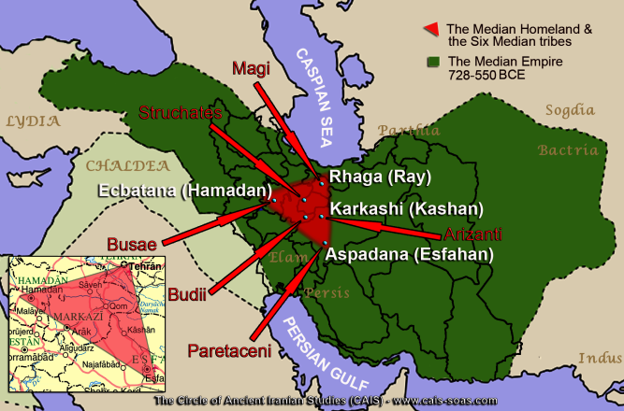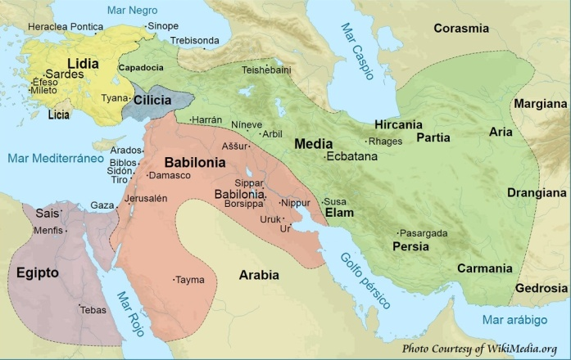
728-550 BCE
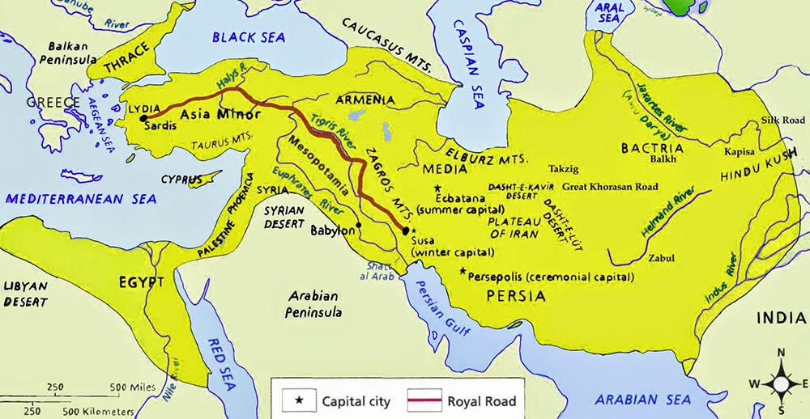
By 600 BCE, Persia had expanded to this great size … “Iran” means “land of the Aryans.” They speak the language of Farsi, not Arabic.
First the Medes under Darius, and then Koresh/Cyrus the Persian ruled Babylon.
The “spirit of the Medes” in Isaiah 13 is not the kinder spirit of Darius and Koresh. They are an unmerciful Iran with Russia, China, and North Korea as allies. When these Medes, which are intermixed with Persia/Iran get ready to take down end-time Babylon, America, the words of Isaiah will come to pass.
Are you seeing the seriousness of what is happening right now?

Isaiah 13:9-23, Septuagint: “For behold! The Day of the Lord is coming which cannot be escaped, a day of wrath and anger, to make the world desolate, and to destroy sinners out of it. For the stars of heaven, and Orion, and all the host of heaven, shall not give their light; and it shall be dark at sunrise, and the moon shall not give her light. And I will command evils for the whole world, and will visit
their sins on the ungodly: and I will destroy the pride of transgressors, and will bring low the pride of the haughty. And they that are left shall be more precious than gold tried in the fire; and a man shall be more precious than the stone that is in Ophir--for the heaven shall be enraged, and the earth shall be shaken from her foundation, because of the fierce anger of the Lord of hosts in the day in which his wrath shall come on. And they that are left shall be as a fleeing fawn, and as a stray sheep, and there shall be none to gather them: so that a man shall turn back to his people, and a man shall flee to his own land. For whosoever shall be taken shall be overcome; and they that are gathered together shall fall by the sword. And they shall dash their children before their eyes; and they shall spoil their houses, and shall take their wives. Behold, I will stir up against you the Medes, who do not regard silver, neither have they need of gold. They shall break the bows of the young men; and they shall have no mercy on your children; nor shall their eyes spare thy children. And Babylon, which is called glorious by the king of the Chaldeans, shall be as when God overthrew Sodom, and Gomorrah. It shall never be inhabited; neither shall any enter into it for many generations; neither shall the Arabians pass through it; nor shall shepherds at all rest in it. But wild beasts shall rest there; and the houses shall be filled with howling; and monsters shall rest there, and devils shall dance there, and satyrs shall dwell there; and hedgehogs shall make their nests in their houses. It will come soon, and will not tarry.”
Jeremiah 51:6-13: “Flee from the midst of Baḇel, and let each one save his life! Do not be cut off in her crookedness, for this is the time of the vengeance of יהוה, the recompense He is repaying her. Baḇel was a golden cup in the hand of יהוה, making drunk all the earth. The nations drank her wine, that is why the nations went mad! Baḇel shall suddenly fall and be broken. Howl for her! Take balm for her pain – if so be, she might be healed. We would have healed Baḇel, but she is not healed. Let us leave her and each go to his own land, for her judgment reaches to the heavens and is lifted up to the clouds. יהוה has brought forth our righteousness. Come and let us relate in Tsiyon the work of יהוה our Elohim. Polish the arrows! Put on the shields! יהוה has stirred up the spirit of the sovereigns of the Medes. For His plan is against Baḇel to destroy it, because it is the vengeance of יהוה, the vengeance for His Hĕḵal. Lift up a banner on the walls of Baḇel, strengthen the watch, station the watchmen, prepare the ambush. For יהוה has both planned and done what He spoke concerning the inhabitants of Baḇel. You who dwell upon many waters, great in treasures, your end has come, the measure of your greedy gain.”
What “His Hekal” today, His temple? His temple is within the spirit of those Christians and Messianic believers in Messiah – Messiah, whose blood was shed as He died taking the punishment we deserved, and arose to give us eternal life. We are His chosen, the elect! Our spirit is His temple! Because of the worldwide harming of His children in myriads of ways, even to assisting with their death, idolatry, immorality, sin that reaches to the heavens, America is allowed to be destroyed by Yahuwah!
From on-line information: “In 1935 the Iranian government requested to call Persia "Iran," which is the name of the country in Persian. The suggestion for the change is said to have come from the Iranian ambassador to Germany, who came under the influence of the Nazis.”
As Lisa Haven points out, “10,000 terrorists roam free in America, and at least 6,000 are from Iran. Sleeper cells are all over the U.S. from Iran, ISIS, other terrorist groups, China, Russia, Jihad groups, drug cartels – there are many Trojan Horses inside America waiting for their `go-ahead’ orders.”

TWO ARTICLES
ARTICLE 1: “Will A False Flag Iran War Cause A Financial Crisis?” by John Rubino ◆ June 17, 2019 Dollar Collapse.com: “…Someone attacked some ships and oil infrastructure in the Middle East, the US and Saudi Arabia accused Iran, and now the fear is that a major regional war will interrupt the flow of oil, sending its price way up and causing a financial crisis…It is a legitimate concern… Second and potentially more serious, the pretext for this war is so blatantly false that it risks destroying what little creditability the US government has left. Think about it: With the US doing everything it can to delegitimize and destabilize Iran while positioning assets for an invasion, Iran’s leaders start attacking oil tankers in its offshore waters. Does that make sense? Of course not! Much more likely is that this is yet another false flag--that is, an incident faked to give a pretext for war – and a clumsy one at that.
For readers who aren’t clear on the FALSE FLAG concept and its ubiquity in geopolitics, here are just a few of the dozens of documented examples:
1) Japanese troops blew up a train track in 1931, blamed it on China and used it to justify the invasion of Manchuria.
2) After taking power, the Nazis burned down their own parliament building and blamed the communists. Later on, they faked attacks on German citizens and blamed the Poles, to justify the subsequent invasion of that country.
3) In 1939 the Soviets shelled one of their own villages and blamed Finland, prior to invading.
4) In 1954 Israeli terrorist cells operating in Egypt bombed U.S. diplomatic facilities, leaving behind evidence implicating Arabs.
5) The CIA hired Iranians in the 1950s to pose as Communists and stage bombings in Iran in order to ignite a rebellion against the democratically-elected government. After the rebellion succeeded the US installed a hand-picked dictator.
6) The US staged a naval engagement — the Gulf of Tonkin incident – and blamed the North Vietnamese, providing a pretext for entering the Vietnam War.
7) The FBI used provocateurs in the 1950s through 1970s to carry out violent acts and falsely blame them on political activists.
8) In 1984, Israel faked radio messages that linked Lybia to terrorism. The US bombed Libya immediately thereafter.
9) Russian blew up apartment buildings in 1999 and falsely blamed it on Chechens, in order to justify an invasion of Chechnya
The list goes on seemly forever. But these examples are enough to make the twin points that 1) lots of countries employ false flags attacks, and 2) the US is especially fond of them.
There’s just one problem this time: Everyone is on to it. Even the New York Times, which has never met a Mid East war it didn’t love, sees through the deception: As Trump Accuses Iran, He Has One Problem: His Own Credibility. To President Trump, the question of culpability in the explosions that crippled two oil tankers in the Gulf of Oman is no question at all. `It’s probably got essentially Iran written all over it,’ he declared on Friday.”

Shortly after becoming President it was rumored that Syria’s Bashar Assad was going to release deadly Sarin gas against his own people. Trump jumped on it, sent a ship and bombed Syria with lots of missiles. Then the truth came out that it was America that set up the operation with their Jihadist groups to blame it on Assad. The canisters with the Sarin gas in them were from Germany. Assad never attacked his own people, America did - America’s ISIS did, their Jihadists did. Russia and Iran moved into Syria to protect the government of Assad.
No, Assad is not a saint. But, like Hosni Mubarak, Saddam Hussein, Muammar Kaddafi, Iranian leaders, and all other Middle East dictators, they usually stay to themselves and their people are fine with that. Life goes on. Before Obama’s “Arab Spring” the surrounding governments were at peace with Israel, at least coldly.
But, Obama, inspired by the Nephilim Babylonian Brotherhood, launched “Arab Spring,” which was proved to be a CIA set-up across board to bring down nations and set the region up for World War III. I followed this from January of 2011. Everything has shown me of the deceit has proved true.

ARTICLE 2: War with Iran planned by Trump to occur in the Fall of 2019,” by Government Slaves, 04/18/2019 – “UPDATE: White House insider who predicted Iran False Flag, David Goldberg, found dead in his New York apartment.”
“President Donald Trump and his inner circle are planning an extensive invasion of Iran, according to a source working in the White House. The plan involves a ground invasion and the use of tactical nuclear weapons, in a campaign planned for the Fall of 2019…The war will be promoted by the news media…after an `expected False Flag’ pinned on Iran, probably something involving the boats in the Strait of Hormuz. The False Flag is an integral part of the plan, as Iran has reportedly no desire or intent to start a war, according to the whistleblower. The war plans have the White House staff `in an excited tizzy’ as war-hawks like John Bolton put the `finishing touches’ on the planned strike. President Trump initially showed resistance to the plan, but has since jumped on board with enthusiasm, convinced Iran is an `existential threat to Israel’ and as such, a war is required to `eliminate them.’ … France, the U.K., Canada, Saudi Arabia and Israel are expected to join a “coalition” in support of the war. CIA assets and counter-intel efforts have been ramped-up over the past year in preparation. Propaganda is being prepped by White House and Israeli counterparts. Israel will support the effort and Benjamin Netanyahu was reportedly `smiling ear to ear’ during a recent meeting with John Bolton….Expected casualties range between 1.2 Million and 2 Million Iranians and 5,000 US troops. Due to President Trump’s close relationship with Jared Kushner, a sense of `sober import’ has been placed on the war effort, which is being as a fulfillment of `Jewish prophecy’ within White House circles. Many in the White House believe Jared Kushner is the `Messiah,’ or Jewish `Moshiach,’ who cannot attain his `throne’ until Iran is wiped out.”
My comment on what is said in this second article is that there is nothing said that is out of line with what is coming, no matter how it comes. My word to you is: TAKE IT TO ABBA AND ASK HIM! What do you sense He’s saying about it? What is the nature of Abba? Would He allow such a plan to go forward?
I say, Abba is in control! He uses the enemy to bring forth His plans for the good of His children. Our future is in His hands, and He is righteous!
Steven ben Nun June 18, 2019 shares this article title: “Remnants of ISIL/ISIS were brought to UAE (United Arab Emirates) to train with Mossad to carry out attacks in the Persian Gulf Region.” I spoke into this above, but you check it out.
Our Abba/Daddy is no sadist! The “Day of Yahuwah” is near, and it is a 24-hour Day in which Messiah pours out His wrath. Abba judges and punishes then it’s over.
What is Abba showing you? Keep watch! Our Redemption draws near!
In His love,
Yedidah
June 20, 2019

