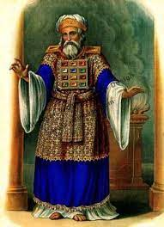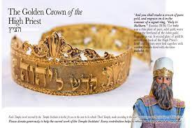
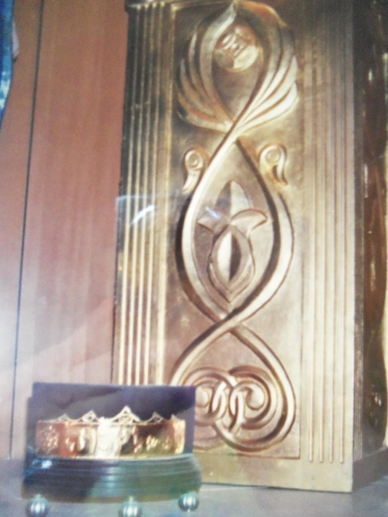
AS A PRIEST BEFORE YAHUWAH YOU MUST WEAR YOUR GOLDEN CROWN
Temple Institute Crown with Altar of Incense
2004 In Jerusalem at the Temple Institute
I Peter 2:9: “You are a chosen race, a royal priesthood…” Messiah is THE HIGH Priest, yet He says now must dress ourselves in the garments of the High Priest for battle, as we see in Ephesians 6:10-18.
“The Hebrew Names and Titles of the Creators of the Universe – The Father and Messiah of Israel” is #2.0 under the Mikvah of the Covenant. This was first written in 2004. It was December a few days before Christmas. I was living in Aqaba, Jordan. A good friend from Glen Rose, Texas, was coming to visit me for a few days, and we were going to Israel, primarily to Jerusalem. I had finished the above article and was about to send it out to subscribers. Back then, I sent via bulk mail – I had no website. As I started to prepare it for posting, Yahuwah spoke clearly to me NOT to post it until I got back from Israel.
That was upsetting to me. I’d worked so hard to have it finished before my friend came, but I obeyed Him. On one day, we had gone through the Arab quarter in walking around the Gates of the Old City. We went through the Israeli customs and entered into the Wall Area compound. I sat down on a bench that faced the big open area in front of the Wall. My friend realized she had left her purchases at the Israeli customs. She hurried back to get them. As soon as she left, a nice-looking gray-haired man came up and introduced himself as Roy and asked me if I knew Yahuwah. Being leery of strangers in that area I hesitated, then said “yes.” He said “I saw you coming down the steps into the Wall area, and Yahuwah said that I had something you needed.” He and a Messianic rabbi were often in that area speaking to the Rabbinic Jews, the Orthodox, the Hassidic, about Messiah, about Yeshua, and also that they needed to use the Name “Yahuwah.” He was carrying a brief case.
Roy sat down and told me about his staying with his 90-year-old mother who was a “prayer warrior.” He and his Messianic rabbi friend had written up some pages to hand out to the Orthodox/Hassidic rabbis. As my friend came back, he opened the briefcase and handed me a whole set of papers. I put them in my tote-bag. I told him I was going to take her to the Temple Mount. He said: “Oh no, take her to the Temple Institute,” where they are making the needed furniture and instruments for Ezekiel’s Temple. Of course, now, they want to build a “third temple,” not Ezekiel’s Temple, which will be desecrated by the “Beast.” The rabbis know it is not Ezekiel’s Temple, as stated in Ezekiel 40-46, Zechariah 6:12-15.
I took the papers home and was shocked. The Messianic Rabbi that Roy was partnering with, named Ruven ben Gershom, had given me the inside information that I needed to put into that article on the Names before I sent it out. Yahuwah wanted me to have that information! I incorporated much of what he wrote.
It is always best to obey the voice of the Spirit, who is Yahuwah Himself, within our re-born spirit, our Temple, our Speaking Place, as Solomon called the physical “Most Set-Apart Place,” where the Ark sat and Yahuwah rested over it.
I took my friend to the Temple Institute. I felt that since Roy and I had touched base in the Spirit, he was telling me something I needed to do. Before going to Israel at that time, I had begun to study and write about the golden crown that was on the head of the High Priest, and its incredible importance. I studied Leviticus 8 and 10 – Aaron was not to take off the crown. I wrote about its significance now.
My friend and I paid our small fee and went into the area where they had made things for the temple. In a large glass case was the altar of incense. But I froze in place as I saw what sat at its base on a small pedestal – the gold crown. It had just been made and put out for display I was told. It was the 1st day it was on display.
What about Yahuwah’s timing when He wants to tell us something? I took the picture above while there that day.
Our mind has to be covered in this time more than any other time, because the minds of people are being taken over subtly by the influences of the fallen angels and Lucifer himself. Very, very few now have the mind of Messiah that Sha’ul talked about. The gold covering of the forehead was so important that Moses warned Aaron not to take it off (Leviticus 10).
“The word says in Psalm 140:7: “O Yahuwah, the Lord, the strength of my salvation, You have covered my head in the day of battle.”
He covers the heads of those who are His followers, His faithful servants, so that nothing penetrates our mind or emotions or will from the outside – from the world system, from man, from demons/Nephilim, from fallen angels, or from Lucifer himself. It is the mind that must be protected above all things, and guarded carefully so that even if we hear lies and deceptions, or fearful things that are true, we immediately submit them to the Master who has told us, as Moses told Aaron in Leviticus 10, “Do not take off the crown.” The crown holds on the turban that wraps around the head.
Moses told Aaron, “Do not grieve” because of Yahuwah’s judgment on your two sons - except under the grief of Yahuwah Himself. He must control the mind, or the fallen ones will control the mind, man will control the mind – the “jezebel spirit” is strong in the earth in both women and men – the lust to control others.
Ephesians 6:11-18 “Put on the complete armor of Elohim, for you to have power to stand against the schemes of the devil.12Because we do not wrestle against flesh and blood, but against principalities, against authorities, against the world-rulers of the darkness of this age, against spiritual matters of wickedness in the heavenlies. 13Because of this, take up the complete armor of Elohim, so that you have power to withstand in the wicked day, and having done all, to stand. 14Stand, then, having girded your waist with truth, and having put on the breastplate of righteousness, 15and having fitted your feet with the preparation of the Good News of peace; 16above all, having taken up the shield of faith with which you shall have power to quench all the burning arrows of the wicked one. 17Take also the helmet of salvation, and the sword of the Spirit, which is the Word of Elohim, 18praying at all times, with all prayer and supplication in the Spirit…”
More than ever in human history, the keys to the underworld are opening the dimensions of the fallen ones, giants are being released from statis, a state of sleep, of silent consciousness, yet they are very much alive. Who is doing the unleashing? Yahuwah controls the time of their release. It began in 1896 with the release of the fallen ones of the book of Enoch, following the end of Enoch’s 4,900- year prophecy. Please refer to the two podcasts on Genesis 6 for more on that.
Yahuwah has given permission for their rising because as Isaiah 13 tells us, Septuagint Version, He will use giants as part of His judgment of earth. All over the earth those in statis are being brought back into consciousness, whether by Lucifer’s orders, or human intervention. Those kept in the underworld, hidden even in military bases underground, reptilians have been meeting with world government officials, or with the militaries of nations like the U.S. and Israel for example. As reported in those two nations, these are very tall, and have an IQ of at least 9,000. We just know that now, Yahuwah has given the order to begin to release them. They will come up from the underworld, up onto the earth, and from the outer atmosphere through other dimensions, APPEARING to be beings from outer space, i.e. “aliens,” but they are not. The grays are simply Nephilim (hybrids of fallen angels and human women) cloaked in “suits” that are frightening.
Luke 21:10-17, 23-27: “Then He said to them, “Nation shall rise against nation, and kingdom against reign. 11 And there shall be great earthquakes in various places, and scarcities of food and deadly diseases. And there shall be horrors, and great signs from heaven. 12 But before all this, they shall lay their hands on you and persecute you, delivering you up to the congregations and prisons, and be brought before sovereigns and rulers for My Name’s sake. 13 And it shall turn out to you for a witness. 14 Therefore, resolve in your hearts not to premeditate on what to answer. 15 For I shall give you a mouth and wisdom which all your adversaries shall not be able to refute or resist. 16 And you shall also be betrayed by parents and brothers and relatives and friends. And some of you shall be put to death. 17 And you shall be hated by all because of My Name”…23-27 ““And woe to those who are pregnant and to those who are nursing children in those days! For there shall be great distress in the earth and wrath upon this people. 24 And they shall fall by the edge of the sword, and be led away captive into all nations. And Yerushalayim shall be trampled underfoot by the gentiles until the times of the gentiles are filled. 25 And there shall be signs in the sun, and moon, and stars, and on the earth anxiety of nations, in bewilderment at the roaring of the sea, and agitation, 26men fainting from fear and the expectation of what is coming up onto the earth, for the powers of the heavens shall be shaken. 27 And then they shall see the Son of Aḏam coming in a cloud with power and much esteem.”
Matthew 24:8-14: “And they shall deliver you to the tribulation of those days and put you to death and you will be hated by all nations for My Name’s sake. And then many will fall away and betray one another and hate one another. And many false prophets will arise and lead many astray. And because lawlessness will increase, the love of many will grow cold. But, the one who endures to the end shall be saved. And this gospel of the Kingdom will be proclaimed throughout the whole world as a testimony to all nations, and then the end will come.”
Messiah is speaking to His people. No rapture, no world getting saved – this is the time before Messiah returns for His SECOND and final coming. Yes, Messiah said that the Good News of salvation would be preached in all nations and THEN the end would come. He is not talking about the whole world getting “saved” and then He can return in maybe 100 or more years from now, as the “Apostolic Movement,” so popular today, is preaching. Messiah was talking about the witness of the martyrs by the hundreds of millions who will go the guillotine with praise for Jesus/Yeshua/Yahushua on their lips. Look at the context of His statement.
The battle is not just not on in some places of earth, because the fallen ones are such masters of deception, and the world’s people do not have a clue as to what is happening, even to their own thinking. People are acting differently, attitudes are different, emotional levels are rising in hate, anger, seeking revenge against those totally innocent of anything but righteousness. Mankind is being invaded by forces that speak to the mind. We must keep our head covered – for we ARE in the day of battle. The fulcrum has tipped downward, and all on earth’s timeline are in danger of destruction.
“Gird up the loins of your mind” the Word says. Amplified Bible, I Peter 1: “So prepare your minds for action, be completely sober [in spirit—steadfast, self-disciplined, spiritually and morally alert], fix your hope completely on the grace [of God] that is coming to you when Jesus Christ is revealed.”
Isaiah 26:3-4: You (Yahuwah) will keep him in perfect peace, whose mind is
stayed on You, because he trusts in You.. 4 Trust in the LORD forever, For in Yahuwah, the LORD, we have an everlasting Rock.”
You open your mind to the fallen ones by listening to human beings talk out of their soulish carnal realm, often expressing the deceit of Lucifer, often expressing opinions that are against the Word of Yahuwah – like up front – public news, news and chit chat on public media of all types, written news in newspapers and magazines, news and speeches on TV, emergency alerts on TV, church preachers who are working with FEMA as their “clergy responses team.” Most all leaders of big megachurches preach a Luciferian-approved feel-good gospel, “tolerant” gospel, a perverted “gospel” that keeps everyone happy no matter what sin they’re into, chit chatting with those given over to the mind of the programmers. All public everything is controlled by the Luciferian elite right now.
Keep yourself as low-key as much as possible except to immediately obey the dictates of Yahuwah and Yahushua – which in order to reach others with the Good News of salvation, or instruction in preparation, or in righteous dealings of any type, you must speak under His orders. We are reaching the time when it is dangerous to “work” for the Master, for A.I. has covered the globe and is prying into everything you do, you say, you think. This is why you must not touch what is called “public media,” “public forum,” for all A.I. technology regarding you is directed at knowing everything about you – down to what you think.
Very important that you review these articles:
1) “The Zadok Priesthood Part II: Correct Intercession and Spiritual Warfare in the Garments of the High Priest”
2) “Why We Must Not Prepare Our Defense Beforehand – Mark 13:9013; Luke 21:14-15” #52.0 Mikvah of the Spirit
3) “Mind Take-Over Urgent Need for Transfer of Authority Present Reality 277.0
4) “The Most Serious Warning of All” #148.0 Mikvah of the Heart of Elohim.
Remember: We have NO ORIGINAL THOUGHTS. Our thoughts come from what we hear someone say, our reasoning on those thoughts, or our study of what is said that amplifies or disqualifies the thoughts. Thoughts come from reading books, watching TV, using the computer, the cell phone, and other information devices, or just talking with a friend. They also come from religious meetings where not all said is truth. This is why you must hear clearly from Yahuwah in your spirit!!!
We once thought that Lucifer and the fallen angels could not read our minds. But, in studying the human mind, thought waves are understood, and the working of different parts of the brain are now understood. Machines have been created to not only read your thoughts, but your body reactions to certain information, blood pressure, heart rate, your general health, etc.
This is why it is so vitally important that you be filled with the Spirit of Yahuwah as began in Acts 2. For the “Spirit” is Yahuwah Himself. Without Him dwelling in your eternal spirit as He once dwelt over the Ark in Solomon’s temple, making the Most Set-Apart Place a “Speaking Place,” as Solomon wrote in I Kings 8.
In His love and shalom, Yedidah July 26, 2023

