ANAK Krakatoa is Blowing Its Top, Unleashing a Tsunami
The Prophetic Significance
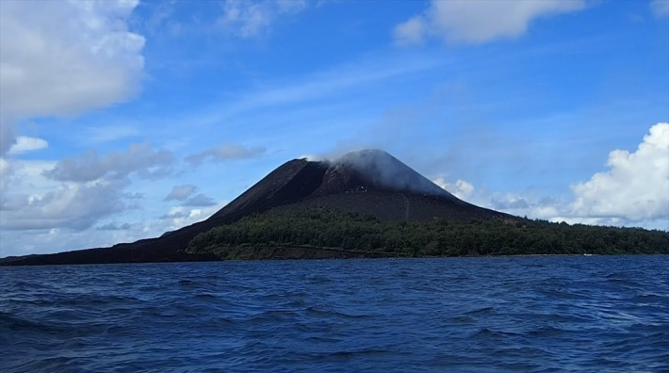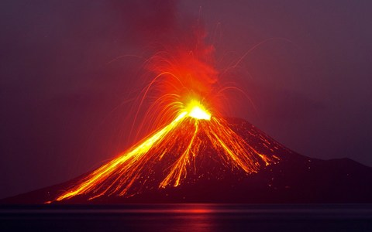
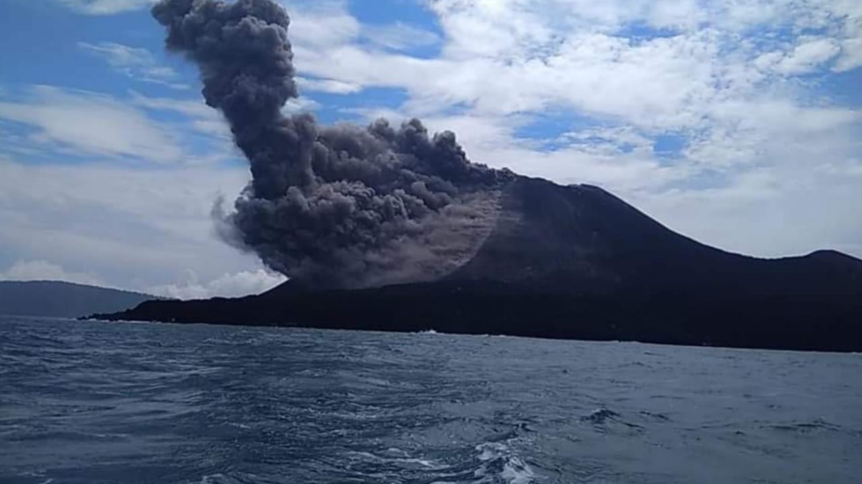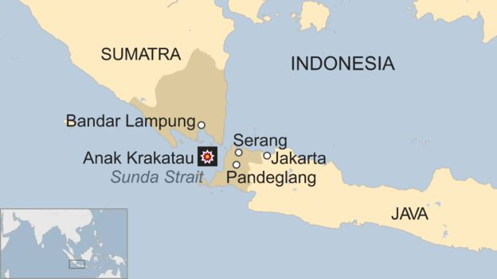
Anak Krakatoa December 20-23, 2018
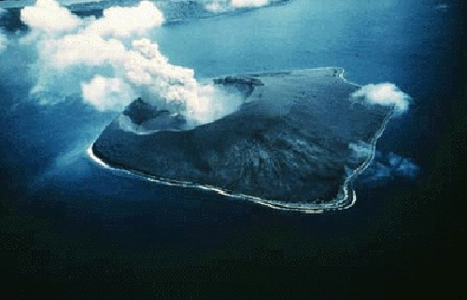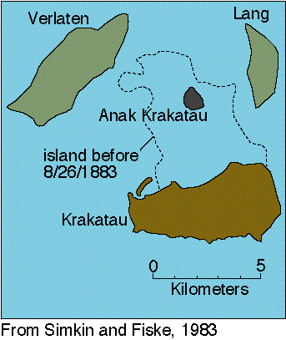
Ariel view of Anak Krakatoa/Krakatau
The word “Anak” in Indonesian means “son.” This volcano, birthed in 1928, is known as the son of Krakatau/Krakatoa--the larger volcano to the south, near Java. In 1928, Krakatau erupted so violently that it created a “son,” a second volcano that is now extremely violent like its mother back in 1883.
In Hebrew, Anak was the father-giant of the giant Anakim, his hybrid offspring. (Numbers 13-14) Volcano eruptions and earthquakes are increasing by the day.
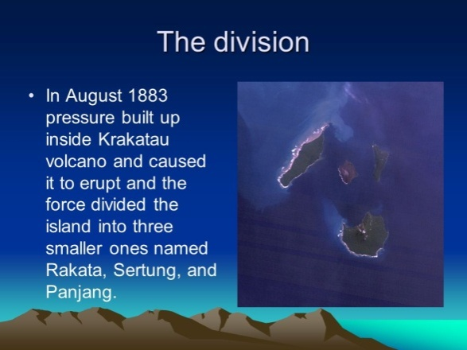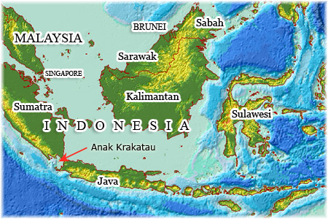
“Another Krakatoa Alert: Another Eruption Could Potentially Kill Millions and Significantly Lower Global Temperatures for Five Years”
The Washington Standard, December 24, 2018
“Because most Americans are focused on preparations for Christmas, not a lot of attention is being paid to the massive disaster that just took place in Indonesia and that was a huge mistake. Anak Krakatoa has sprung to life, and there is good reason to as to why it is the most dangerous volcano on the entire planet…”

*Refer to: “Facing the Anakim,” January 5, 2008/Mikvah of the Great Adventure
*In my podcasts LXXVIII and LXXIX, I talk about the Anakim, and why the Israelites had to wander 40 years in the wilderness when they could have crossed the Red Sea, received the Torah at Sinai, then 11 days after breaking camp at Sinai walked into the Promised Land and taken down the Anakim.
From 1999-2007 I lived in Aqaba, Jordan, on the Red Sea. From the Jordanian border with Saudi Arabia, it is 75 miles (by car or bus) south to Sinai. From ancient Ezion Geber (Aqaba) across to Eilat, Israel, is about 5 miles. (Deuteronomy 1-2) However, the Israelites in general made one main fatal mistake after being at Sinai, one fatal mistake most all humans make, that kept them wandering to the east of the Jordan River for 40 years, unable to enter until they all died out. Then their children entered under Joshua and Caleb. All except Moses, Joshua, and Calab did not know Yahuwah well enough to trust Him to do what He said He would do!
Read Deuteronomy 1-3. Moses recounts the attitudes that caused their 40 years of wandering. Excerpts from Deuteronomy 1:26-32: “…but you would not go up and rebelled against the mouth of Yahuwah your Elohim and grumbled in your tents…`where are we going to?’ … `the people are greater and taller than we. Their cites are great and walled up to the heavens. We saw the sons of the Anakim there too. Then I (Moses) said to you `Have no dread or fear of them. Yahuwah your Elohim who is going before you, He does fight for you according to all He did for you in Egypt before your eyes…yet in this matter you are putting no trust in Yahuwah your Elohim…”
Read Numbers 13 and 14 carefully. The Anakim, sons of Anak, were giants, perhaps 25 feet tall, or more. Yet, in Numbers 13:1, Yahuwah said He had given that land to the sons of Ya’cob/Jacob. He expected them to go in and take down the Canaanite Nephilim-giants, the non-human hybrids, and possess their land.
It was there’s for the taking! All they had to do was put their faith in Him, and He would fight for them. But, they had NO faith in Him! They were terrified, and their report terrified the 6 million or more Israelites who had not long before come out of the security of their slavery in Egypt. Abba had to punish them. The faithless complainers had to die out. The remnant who entered 40 years later were the two who began in faith and continued in faith, along with the children of the faithless who died in the wilderness.
The coming tribulation is to condense a similar scenario into a few short months, so that the Joshua and Caleb types with a “different spirit” can enter the Kingdom, and those that have no faith in the supreme power of Yahuwah will fall prey to the coming global government under “antichrist.”
***The coming worldwide tribulation is something Yahuwah has to allow in order to divide between His real children and the “tares”—the fake believers and other wicked ones. It is also a time of setting apart the fallen ones and their “offspring” for sentencing to the lake of fire (Revelation 20). The eruption of Krakatoa/Krakatau in 1928 divided the Island the volcano was in into three parts.
When momma Krakatoa exploded upward on August 26, 1883, it divided the Island it was on into three parts. Momma exploded again in 1928 and gave birth to her “son,” Anak Krakatoa. Anak is now exploding, even being heard as far away as Australia, and unleashed a deadly tsunami. There is much in Scripture about things, especially to do with the sea, dividing into three parts, i.e. Revelation 8, and Ezekiel 4. Abba showed me this yesterday (December 22, 2018).
Steve Quayle said years ago that when Anak Krakatoa went violent and continued to be so, it was a sign of what was to happen throughout the world – the chaos, the upheaval of demonic forces from under earth, preparing the way for the Beast, “antichrist.”
In the last two days, the violence of Anak Krakatoa has caused a tsunami that is killing lots of people in the Sundra Strait towards Java. It has even made world news in America. That says a lot. Its violence is unleashing spirits in the underworld, part of the waking up the giants that have been kept in stasis underground all over the earth.
Isaiah 13:2-3, Septuagint: “Lift up a standard on the mountain of the plain, exalt the voice to them, beckon with the hand--open the gates, ye rulers. I give command, and I bring them: giants are coming to fulfill my wrath, rejoicing at the same time and insulting.” (Also Joel 2)
This prophecy is in context with “the Day” of Yahuwah, the Day of Messiah’s return with the wrath of His Father. [Refer to: “The Day of Yahuwah” for many Scriptures regarding this approaching day]
“Without faith it is impossible to please Elohim.” (Hebrews 11:6) If fear, man’s soothing comfort and reasoning, or mental fantasy, dims your faith, the Anakim in spirit will flock to you like crazy black crows to destroy your life.
The tsunami that is killing people right now in Indonesia as a result of the eruption of Anak Krakatoa is symbolic of the tsunami of demonic spirits, (Nephilim, i.e. Numbers 13:30-33 and Genesis 6:2-4) that is deluging our earth from the dimension of the dark kingdom, and from under the earth as the bowels of Hell are opening for the arrival of the king of the pit--Revelation 9:11.
Indeed the bowels of Hades, Hell, Gehennah, Sheol, Tartarus, are opening. The disembodied spirits of the Nephilim are amassing in abundance to take bodies to work through, as well as the giants, former bound ones, too - all dark forces are amassing to do their worst before facing the Judgment of Yahuwah and Yahushua on the “Day of Yahuwah.”
Will you be a part of the judging of these fallen “angels?” Sha’ul wrote in I Corinthians 6:3: “Do you not know that you will judge angels, how much more the things that pertain to this life?” We sure won’t be judging the likes of Micha’el or Gabri’el, except to thank them for being faithful!

A few facts:
Wikipedia: “The Anakim/Anakites were a formidable race of giant, warlike people (Deuteronomy 2:10, 21; 9:2) who occupied the lands of southern Israel near Hebron before the arrival of the Israelites (Joshua 15:13). The Anakim ancestry has been traced back to Anak, the son of Arba (Joshua 15:13; 21:11), who at that time was regarded as the `greatest man among the Anakim’ (Joshua 14:15). The name `Anakim’ most likely means `long-necked,’ i.e., `tall.’ The Hebrews thought them to be descendants of the Nephilim, a powerful race who dominated the pre-Flood world.” (Genesis 6:4; Numbers 13:33).

“Krakatau volcano (Indonesia): continuous intense explosions heard 42 km away, off scale seismicity” by Volcano Discovery - July 12, 2018
“…the current seismicity of Anak Krakatau: "Krakatau is going crazy ...100 times explosion a day ... very loud could be heard until Carita 42 km away…
Vulcan eruption at Krakatau on 7 July 2018: The explosive activity of the volcano continues and seems to be increasing with strombolian to Vulcan-style explosions from the summit crater.”
Steve Quayle: “IT HAS BEEN TOLD TO ME THAT KING ANAK WAS PLACED IN STASIS TO RETURN, OR BE GENETICALLY RESURRECTED, IN THE LAST DAYS--TAKE IT TO THE LORD IN PRAYER”-SQ
Steve Quayle alert: August 1883 peaking on August 27of that year - 135 years ago” http://www.stevequayle.com/index.php?s=33&d=2194 Alerts
“Steve Quayle: “CONCERNING THE EXPLOSIVE ERUPTION OF ANAK KRAKATOA AS A TIMING SIGNAL FOR THE RETURN OF THE ANAKIM, REPAHAIM GIANTS, OFFSPRING OF THE FALLEN ANGELS AND THEIR COMING REIGN OF TERROR FIRST POINT.”
Steve Quayle information after the 100 explosions of Anak Krakatau, July 7, 2018: “ANAK, WHILE IT MEANS (SON) IN THE INDONESIAN LANGUAGE, WAS THE GIANT KING OF THE ANAKIM DETAILED IN THE OLD TESTAMENT. THIS VOLCANIC EXPLOSION HAS BEEN ONE OF THE LARGEST VOLCANIC EXPLOSIONS OF OUR GENERATION, INCLUDING THE LARGEST MAGNITUDE EARTHQUAKE (9.5) IN THE 1800s (19th century, 1883), WHICH WAS' HEARD 42 KMS AWAY'-42, AS MOST BIBLE PROPHECY STUDENTS ACKNOWLEDGE IS THE PERIOD OF TIME MENTIONED IN THE BOOK OF DANIEL IN WHICH THE PROPHET LINKED TO THE APPEARING OF THE ANTICHRIST, FALSE PROPHET AND END TIME EVENTS GET UNDERWAY. THE COMING GLOBAL FAMINE: I AM ALSO WATCHING FOR MORE SUPERNATURAL EVIL EVENTS AND THE LIVE SIGHTINGS OF GIANTS TO BEGIN INCREASING ALONG WITH OTHER PRETA-NATURAL EVENTS. REMEMBER THE MOCKERS AND SCORNERS IN NOAHS DAYS CONTINUED ON UNTIL THE FLOODS CAME AND DROWNED THEM ALL! IT WILL BE THE SAME AS THESE DAYS WERE SPOKEN ABOUT BY JESUS, THAT PRIOR TO HIS SECOND COMING, IT WOULD BE AS IN THE DAYS OF NOAH. THOSE DAYS ARE UPON US AND AS THE GENETIC CORRUPTION OF CRISPR TECHNOLOGY AND THE HYBRIDIZATION OF HALF ANIMAL, HALF ONCE HUMANS ACCELERATES. EXPECT GOD'S JUDGMENT TO INCREASE UPON THE EARTH IN A CORRESPONDING AND ACCELERATING FASHION!”

STEVE QUAYLE ALERT JUNE 22ND 2018: “BACK GROUND ON 'KING ANAK' OF THE GIANTS, AND WHY I AM CONCERNED ABOUT ANAK KARAKATAU ERUPTING - THIS IS A TOTAL 'EVIL SPIRITUAL EVENT' MANIFESTING IN THE PHYSICAL, SIGNALLING THE GIANTS RETURN”

Continuing from Volcano Discovery July 12, 2018:
“Anak (/ˈeɪˌnæk/; Hebrew: עֲנָק‎, translit. ɐ̆nɔːq, lit. 'Giant'[1]) is a figure in the Hebrew Bible. His descendants are mentioned in narratives concerning the conquest of Canaan by the Israelites. According to the Book of Numbers, Anak was a forefather of the Anakim. The Bible describes them as very tall descendants of the Nephilim. The text states that the Anakim were Rephaites, and that Anak was a son of Arba. Etymologically, עֲנָק means `neck,’, implying that the `sons of Anak’ were `long-necked men.’ The sons of Anak are first mentioned in Numbers 13. The Israelite leader Moses sends twelve spies representing the Twelve Tribes of Israel to scout out the land of Canaan. The spies enter from the Negev desert and journey northward through the Judaean hills until they arrive at the brook of Eshcol near Hebron, where reside Sheshai, Ahiman, and Talmai, the sons of Anak. After the scouts have explored the entire land, they bring back samples of the fruit of the land; most notably a gigantic cluster of grapes which requires two men to carry it on a pole between them. The scouts then report to Moses and the congregation, that "the land indeed is a land flowing with milk and honey," but ten of the twelve spies discourage the Israelites from even attempting to possess the land, for they reported that the men were taller and stronger than the Israelites, and moreover the sons of Anak dwell in the land, and that they felt like grasshoppers in their presence.
The Anakites are later mentioned briefly in the books of Deuteronomy, Joshua, and Judges. Joshua, the Israelite leader and one of the twelve spies sent by Moses into Canaan, later drove out the descendants of Anak — his three sons — from Hebron, also called Kiriath Arba (Joshua 11:21).”
For detailed information and spiritual application, I refer you to the research study: “ANAK KRAKATAU - The Father, the Son, and the Tongues of Fire
PART ONE - ANAK Krakatau, June 2009
Excerpt from this study: “On May 20, 1883, the captain and crew of the German warship Elizabeth reported seeing a 6.5 mile high cloud of ash and dust rising above the uninhabited island in the Sundra Strait of Indonesia. After two centuries of comparative silence, Krakatau had begun to stir.
Exactly 100 days later, at 1:06 PM on August 26, 1883, the mountain entered its cataclysmic stage beginning with an immense series of nearly continuous explosions propelling heavy ash 17 miles hurling searing pumice onto ship decks 11 miles away. The violent eruptions raged for more than fourteen hours until, on August 27th, four massive explosions completed the event with the final blast becoming the loudest recorded noise, shattering eardrums and being heard 2000 miles away. The cataclysmic paroxysm occurred when all three volcanic vents erupted simultaneously. The combined force of these blew Krakatau apart
reducing the size of the island by two-thirds before collapsing to a depth of 250 feet below sea level. These final explosions would produce an atmospheric disturbance worldwide.
Travelling from the center of the now conjoined peaks, an atmospheric wave proceeded outwards to become a great circle, the voluminous ash circling the globe seven times. The ash would redden the skies and deposit ash in South and North America, Europe, Asia, South Africa and the entire southeastern area of Asia and the South Pacific. The human death toll resulting from the explosions and associated tsunami activity would be calculated by Dutch authorities at over 36,000. The environmental impact would not be measured until decades later.
A horrifying spectacle presented itself to our eyes; the coasts of Java, and those of Sumatra, were entirely destroyed. Everywhere the same grey and gloomy color prevailed. The villages and trees had disappeared; we could not even see any ruins, for the waves had demolished and swallowed up the inhabitants, their homes and their plantations…This was truly a scene of the Last Judgment.” R.A. Sandick Eruption on Krakata

A very prophetic statement: “…a scene from the Last Judgment.” Revelation 8 speaks of volcanic eruptions that throw 100 pound volcanic rocks into the air, known as “hailstones,” which fall into the sea and destroy sea life. The sea “turns to blood.” The darkening of the sky by volcanic ash is also prophetic.
This volcano, and hundreds of others along the Ring of Fire, will explode around the same time, sending tsunami waves into Asia, America, and along the Mexico, Central and South American coasts, probably over Antarctica as well, connecting to the Atlantic. There are hundreds of volcanoes on ocean floors also, like the Atlantic, that will also explode upwards. Even now, fire is often seen on the top of waves in the sea as underwater volcanoes are erupting. The tectonic plates of earth are shifting. We are in a definite pole shift. The earth will reel and shake.
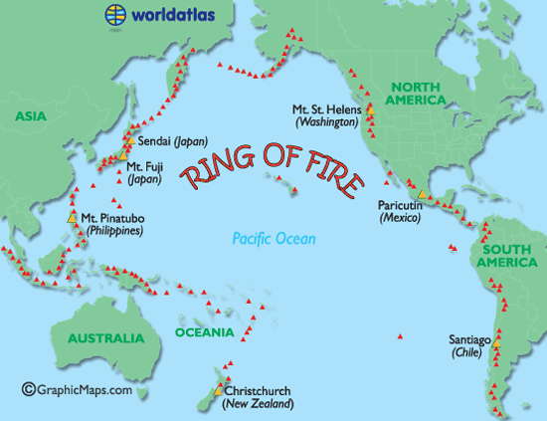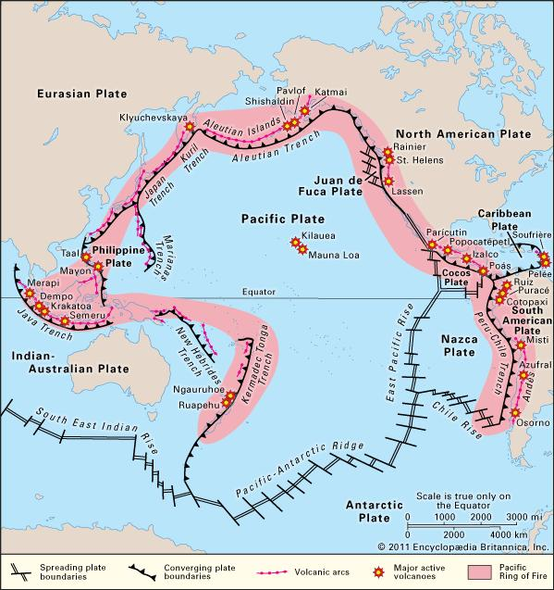
Left: Each one of the red triangles is a major volcano
Right: Note Krakatoa, Java Trench
Isaiah 24 is a good description of the underworld of Satan’s kingdom arising. Yahuwah says “I will shake the heavens and the earth, the sea and the dry land,…” (Haggai 2)
Can you imagine the smoke from all those volcanoes, including the 169 volcanoes inside America’s borders, and the 1,500 active volcanoes all over the world? The skies will go black with smoke, and deadly chemicals will fill the air. Read about the end-time shaking of earth: Isaiah 24; Isaiah 13:13; Hebrews 12:25-29; Haggai 2:6-7, 2:21; Revelation 16:18-21, and Joel 3:16
The shaking is part of Yahuwah’s wrath and judgment on those harming His children, during which He also rescues His children. Those that know Him remain unshaken in body, soul, and spirit: Hebrews 12:27b-298: “…so that the unshaken things might remain, therefore, receiving an unshakable Kingdom, let us hold the favor through which serve Elohim pleasingly with reverence and awe, for indeed our Elohim is a consuming fire.”
Steve Quayle repeated a comment this morning in reference to Anak Krakatoa and its prophetic significance. He wrote: “STATED ON HAGMANN AND HAGMANN 5 MONTHS BEFORE MID-SEPT, THAT AFTER OUR BRANSON CONFERENCE EVERYTHING CHANGES, AND THE WORD `NORMAL’ WILL NEVER BE AGAIN.” He probably did not know that his Branson Conference, September 13-15, 2018, was in the vicinity of Yom Teruah, at which point in time we entered 2019 on the Creator’s calendar. We’ve turned a prophetic corner, heading towards global government, “antichrist’s” reign, and the return of Messiah! Pray for those in Indonesians. The death toll continues to rise.
I remember praying during the tragic tsunami that hit on several nations December 26, 2004, spawned by an earthquake near Sumatra (Indonesia). I was living in Aqaba then, and Israeli news reported it as the death toll rose.
From online facts: “The December 26, 2004 Indian Ocean tsunami was caused by an earthquake that is thought to have had the energy of 23,000 Hiroshima-type atomic bombs. The epicenter of the 9.1 magnitude quake was located in the Indian Ocean near the west coast of Sumatra…the tsunami in 2004 is believed to be the deadliest tsunami in history, killing more than 230,000 people across 14 countries. It began at 7:59am local time on December 26, 2004, when a 9.1-magnitude quake struck off the northern tip of Sumatra in Indonesia”…Earlier report: “The tsunami killed at least 225,000 people across a dozen countries, with Indonesia, Sri Lanka, India, Maldives, and Thailand sustaining massive damage.”
“Jan 28, 2005 - The number of people presumed dead in last month's Asian tsunamis rose to more than 283,000 yesterday.”
The death toll continued to rise: “Thailand was next. With waves traveling 500 mph across the Indian Ocean…The death toll in Thailand was nearly 5,400 including 2,000 foreign tourists. I remember from Israel news, that the total reached near 400,000 by the time the tsunami body-count was finished.
Sumatra is just north of Anak Krakatoa, and Anak just released a deadly tsunami south towards Java.
The whole “Ring of Fire” is coming alive! I wrote an article on its “coming alive” in the spring 2018: “The Whole Ring of Fire is on Alert! – Deadly Serious Earthquake and Volcano Eruption Danger”/Mikvah of Present Reality, with maps and pictures.
From: I PETER 3:10-15a: “…the Day of Yahuwah shall come as a thief in the night in which the heavens shall pass away with a great noise and the elements shall melt with intense heat and the earth and the works that are in it shall be burned up. Seeing all these things are to be destroyed in this way, what kind of people ought you to be in set-apart behavior, with reverence, looking for and hastening the coming of the Day of Elohim through which the heavens shall be destroyed, being set on fire and the elements melt with fervent heat. But according to His promise we wait for a renewed heaven and a renewed earth on which righteousness dwells. So, then, beloved ones, looking forward to this, do your utmost to be found in peace, spotless, and blameless--reckoning the patience of our Master as deliverance…” [Refer to: “The Day of Yahuwah” – Look up the Scriptures and learn about this soon-coming DAY/Mikvah of Present Reality]
Shalom, shalom, shalom – peace in His love!
Yedidah
December 24, 2018

