**MAGNIFICENT SPIRITUAL LESSON FROM REAL WILDLIFE WISDOM**

**HOW DOES AN EAGLE GET A CROW OFF ITS BACK**

**Here is what my son sent me via text message. This is such a powerful revelation. If you can grab hold of this, no crows can ride on your back!**

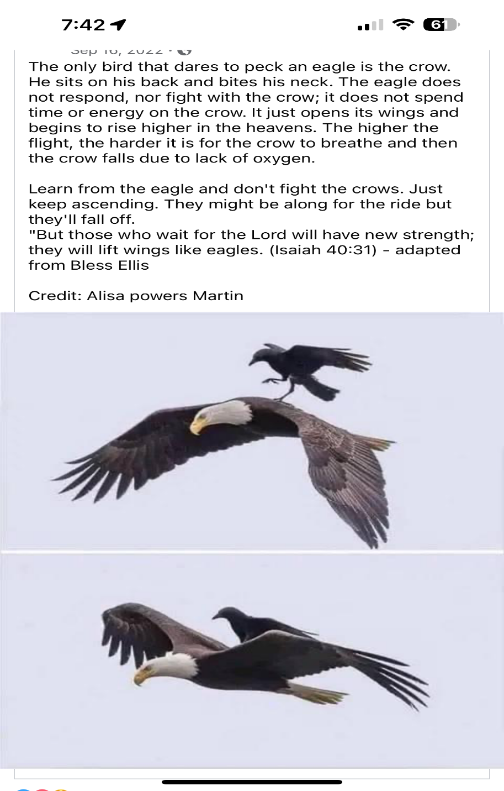

**Colossians 1:1-4**, ISR: “If, then, you were raised with Messiah, seek the *matters* which are above, where Messiah is, seated at the right hand of Elohim. [**2**](https://biblehub.com/colossians/3-2.htm)Mind the *matters* above, not those on the earth. [**3**](https://biblehub.com/colossians/3-3.htm)For you have died, and your life has been hidden with Messiah in Elohim. [**4**](https://biblehub.com/colossians/3-4.htm)When the Messiah, who is our life, is manifested, then you also shall be manifested with Him in esteem.

Did you read that information above carefully on how an eagle responds to a crow on its back? The eagle does NOT respond or fight the crow. He gives the crow no “glory.” He gives the “crow” no hopeful opportunity. The just rises higher and higher into the sky as if the crow was not there. As the crow gets higher up where the oxygen level is meager, it falls off. Do you see how this parallels to the “crows” the enemy sends to ride on our back, to ride on our mind, our emotions, forcing our will to accept it?

Dear ones, instead of doing air-loops, shaking, being upset or angry, depressed, or feeling sorry for yourself - get the crows off your back by SIMPLY RISING HIGHER INTO HEAVEN. TAKE YOUR SEAT IN THE THRONE ROOM. The enemy’s crows can’t go there! If they try, they’ll die.

First you have to realize YOU ARE AN EAGLE! He tells us we will mount up with wings like eagles… You are not a chicken or a blue bird, a robin, or a crow.

Isaiah 40:31: “Even youths shall faint and be weary and young men shall fall exhausted, but they who wait for Yahuwah shall renew their strength. They shall mount up with wings like eagles. They shall run and not be weary. They shall walk and not faint.”

As you mount up with eagle’s wings don’t stop mid-flight to cruise – that’s when crows come to ride on your back. Keep going higher and higher into the Presence of Yahuwah and Yahushua. No crow can live in that atomosphere!

We are called to soar in the heavenlies with Yahuwah and Yahushua, rising higher and higher as we grasp the fresh air of our freedom in Their salvation, basking in Their Word that instructs us how to be free.

I’m sure you’ve heard this old story but it sure carries the truth with it. A farmer found an unusual egg in his chicken yard. He put the egg under a chicken to hatch it if possible. Well it hatched. It was a weird looking bird that emerged. The bird grew. The chickens pecked at the corn on the ground. It didn’t like the food of chickens. One day, the farmer saw the bird fly up on the fence. But, before he could catch it, it flew. It flew higher and higher, spreading its wings out. All the while the chickens just kept pecking. The strange bird did not belong with chickens – it was an eagle.

Today, those with the spirit of an eagle, the empowerment of Yahuwah’s Spirit ruling, are being prepared to soar in the heavenlies. Those content to peck at the ground will never know the joy of spreading their wings and soaring on the wind.

As in the pictures above, you and I do not have time to waste on crows (black aggressive birds that take, not give). You have no time for humans who drain you dry in spirit either. Do fall into the trap of false responsibility. So many people can drain us because they only care about themselves. We’re called on by our Master to soar in the heavenlies with Him. The higher we get with Him, no crow-nature can attach itself to us, or even come near us.

Soaring in the heavenlies makes you of ultimate “earthly good.” You’re able to help others soar with you! You’ll have many chances to witness to the soon-coming of our Savor. I am filled with peace, joy, and expectancy for what He has ahead. It frees me to be open with my love for Yahushua and express it to others.

Instead of crying, being depressed, allowing the enemy to work on your mind and emotions, go into the Presence of Yahuwah and Yahushua. Allow Them to take you into Their realm - into the Heaven itself, sitting in heavenly places with them. Talk to Them, praise, worship, and delight in Them. They will raise your mind and emotions into the third heaven-realm. You’ll begin to think like they do. Your carnal mind will be relieved of all the demonic spirit want to burden you down with.

“Lift up your head, your redemption draws near.” Abba is compacting all prophetic events, and preparing us for our eternal rewards. Yield to Him. Allow Him to talk you through everything. He speaks as THE SPIRIT within His temple of flesh – our spirit.

Oh how we must have the infilling of His Spirit, as He once came down over the Ark in response to the prayer of Solomon in **I Kings 8**. Now, Yahuwah’s Spirit comes within us in response to a truly born-again person who is ready for His teaching, His empowerment, His gifts, His directives - His requirements for the Kingdom. By our submission to Him within us, we proceed to be set-apart unto Him and begin working on our eternal rewards.

Rise up! Set your spirit to rise higher than ever before – into the eternal realm. Soar in the heavenlies with Yahuwah, Yahushua, and Their righteous angels.

Do not let yourself be bogged down with a crow on your back, or a “monkey on your back” either. The higher you soar with Elohim (Father and Son) and the higher you learn and submit to the Word of Yahuwah, as He teaches you, the freer you will be – the more peace, the more joy, the more excitement and expectancy for great things.

I’ve never been called a “warrior” more than at this time - by my children and close friends, people on my website list, as well as some therapists where I am now.

I’m getting freer to speak for the Master too. The more you demonstrate the characteristics of your “God,” your Father and His Son, Yahushua/Jesus, the more people are drawn to you whom He wants you to minister to, even if only in a sentence or two. We have so little time left to do His will while it is “day,” because as Messiah warned us about the great tribulation time, “night comes when no one can work.”

We will be hidden, or translated, or martyred for our faith. Soon Bibles will be illegal.

It’s all coming down fast. Most all who have been warned have done little or nothing to prepare for the allowed reign of Lucifer and the Beast over the earth. I hope that’s not you! The wise prepare. Even the ant prepares, the squirrels prepare for cold weather. Bears hibernate. We must obey Abba and get where He wants us to be. Rise up, rise high.

Pray, praise, seek His wisdom in His Word, share with others. You must be valuable to the Kingdom. You can’t be valuable to the Kingdom if you are self-centered! Your nature must give joy to Yahuwah and Yahushua, being like Their nature. Get an eagle mentality. This world is not our home. We’re just flying through.

In the love of Elohim, Yedidah

October 17, 2023