THE DEATH OF FAITH AND COURAGE
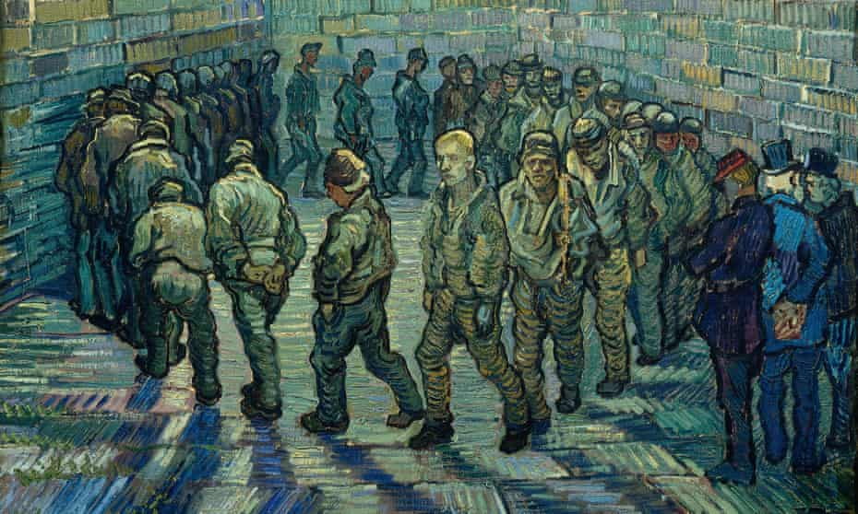
[Vincent van Gogh’s Prisoners Exercising, 1890 Photograph: © The Pushkin State Museum of Fine Arts, Moscow. This 1890 work needs little explanation. Painted while Van Gogh was heavily depressed and in an asylum in Saint-Rémy, it is expressionism at its most downcast.]
This article is taken partly from the Rumble video: “Why are Most People Cowards? Obedience and the Rise of Authoritarianism” January 26, 2022
Aleksandr Solzhenitsyn said: “A decline in courage may be the most striking feature an outside observer notices in the West in our day…should one point out that from ancient times, declining courage has been considered the beginning of the end.”
The spirit of human beings is being crushed – that innate motivating, up-beat spirit that leads human beings to rise to challenges with courage, and embrace difficulties with strength of faith in a Living God.
My son just texted me: “There is a must to now be the ones who walk on water and call others to get out of the boat. It’s all Messiah ever wanted. To have a people to walk in His footsteps – to deliver the captive because that’s what He did.”
Messiah had His faith firmly imbedded in His relationship with His Father, whom He know, walked with, and obeyed. He knew that His Father would not leave Him, but that what He was assigned to do, He would do – and His Father would expand it to reach all of mankind.
We unite in fellowship and friendship with Yahuwah and Yahushua, to do Their united will, and thus have a victorious conclusion, as did the Son. “Our Father, who is in heaven, set-apart of Your Name. Your Kingdom come; Your will be done – on earth as it is in heaven!” His will must be done in us completely as we submit to Him, so that what He wants to do through us becomes reality.
Many forces have shaped human complacency, primarily in affluent Western-culture nations, such as public news, public school systems from Kindergarten through University level, the lust for ease and convenience, dependence on government helps which bring a false security, dependence on government leaders for protection, dependence on insurance, and retirement plans, dependence of doctor, hospitals, medicines, etc. etc. Dependence on man is like depending on a life raft to keep you safe in an ocean full of encircling sharks.
The Christian religion has become weak and powerless, “denying even the Master who bought them” with His blood, and become a religion of “self-help,” “what’s in it for me.” Most pastors care little for their flock. Many of the pastors of big churches are millionaires, famous, popular, with the arrogance that goes with it.
Our society has become filled with conformists. Most people go along to get alone. We are programmed to not speak certain things that might offend a small minority, for the “powers that be” back the small minority that is in rebellion against the Word of God.
Few people claiming to be born again have courage to witness openly about the salvation of Messiah. Few stand up for the truth of Yahuwah’s Word, except to try to up-root other’s beliefs that is. The ancient 2nd or 1st century-version of Phariseeism is alive and well today in our world, subtly, for now, towering up over those who have salvation through the “Lamb of Yahuwah,” with pride and arrogance, criticizing, condemning, and thrusting their beliefs on those weak in their relationship with Yahuwah and Yahushua personally and experientially.
Yahuwah’s people are cowering, scared, and intimidated by others, so the lost are dying and going to hell without ever knowing the love of the Savior. The words of Ezekiel 33 are for us.
The opposite of courage in our age is conformity to the status quo - out of fear of being out of order with the flow of the ones who have courage to promote evil.
Righteousness is now cowering in the face of opposition by evil. Evil is putting fear into the children of Yahuwah because they do not know Him whom they say they believe in. Thus, in order to conform, great numbers of once “believers,” are “denying the Master who bought them.” They are ashamed of Him. They keep quiet about Him. They keep their words light and frivolous so that no one becomes “at odds” with them.
The anti-vaxxers are being ostracized from society – from friends, even from family. Their knowledge sets them apart from the vaccinated. They know what it does to the body, and thus they resist it. The spotlight of the dark kingdom is on the ones who resist his physically and spiritually deadly poscient.
A pathological need to follow the rules of man … a driving force to conform, even give up freedom, rights of human beings, to conform … it is a driving force that turns the rules of man into a religion of submission to doing what one is told – a slave mentality.
The very root of human stance for justice, for right, for standing against evil is being removed – it is becoming a sickness. The nature of vaccinated people is changing – becoming very defensive of their choice to be vaccinated, coupled with arrogance and pride, haughtiness, defensive against anyone who questions them - even becoming vicious against those not vaccinated.
This is proof that they have taken into their bodies something that is not of the Kingdom of Light, but indeed that of the Kingdom of darkness. The nature of darkness is taking many over, and the body is reacting, too, and dying. Humility, compassion, kindness, care for others (a natural human trait) gentleness, of course love, is not in their nature anymore. They become hooked up in mind and spirit to the forces of darkness, to which they become slaves. Revelation 9:20-21; Revelation 14:9-11; Revelation 16
Today in our society, a “good person” is a “compliant person,” a person doing what they are told by the overlords their prison-house. People are now prisoners of their own fears – yes fears – not free anymore to stand for what is right in the face of hostility.
Fear rules, hostility rules. People who comply with the dictates of evil government breathe a breath of hope that they will be left alone from all the bad things out there – yet the demands get worse and worse.
Thus, believers are joining together to stand against other believers who won’t comply with government demands, or even church leaders telling them to be vaccinated. Many in high places in the church world are Luciferians/Satanists, planted there by governments who want the people so blinded to truth that they flow with what feels good to their flesh and satisfies their prison wardens in government. Beware of the “Clergy First Response Team” of F.E.M.A.!!!
Differentiating between morality and legality has been lost. The United Nations, a satanic organization as I’ve point out from at least 3 articles in the last few months, has promoted such anti-Biblical teachings as the 100-genders for children ages 5 and up to choose from, and the promotion of the progressive rebellion of the LGBT 2% of society. The family unit is being destroyed totally. Children are becoming programmed anarchists against their own parents and grandparents. Youth are becoming rebels against anything that was sane in the past.
The good history of America is being totally wiped out, so that youth in school do not know the courage it took to bring freedom to our country, of about the years when the Bible was the basic text in schools, taught in colleges, and respected in society. Our freedoms were based on the Bible. Our wonderful Constitution was based on the Bible and its Amendments for our freedoms.
Today, our Constitution has been “laid to rest.” The rules today violate our “unalienable rights.” In fact, worldwide, clear to the International Court of the Hague, the Bible is considered a hate-crime book, for it speaks against the LGBT agenda. It speaks of God creating a man and a woman.
The Bible speaks clearly against the sins of fornication, adultery, bestiality, homosexuality, and the abuse of babies and children. It speaks against abortion, against pedophilia. It pronounces hell-fire punishment for harming them.
The Bible speaks of obedience and submission to Yahuwah and Yahushua – our Creators. In Matthew 10, Messiah warned his disciples (taught ones) saying: “all men will hate you for My Name’s sake.” It is the time we are in now.
The great majority of our national leaders are into deep sexual perversions and all sorts of corruption for personal gain. Thus, shedding the blood of the innocent means nothing to them – their consciences are “seared with a hot iron.” For example, many government leaders in the White House, the Senate, the House of Representatives, also Governors and Mayors, are leading the nation into Communism, and the total destruction of most of our citizens. Many of them are receiving millions of dollars from China.
For example, Obama and Hillary both were avid students of Saul Alinsky – who wrote Rules for Radicals as his textbook, and taught how to take over a nation for communism. But, then, you have the new world order lust of nations from Egypt, to Assyria, to Babylon, to Media-Persia, Greece and Rome, 6 empires of history, with their passion to restore the gods of pre-flood days over the earth again.
This was the lust of Nimrod, and the reason for his portal-opening “tower.” He wanted to bring back the gods of the pre-Flood world, aka fallen angels listed and reported on so well in Enoch I. After the Flood Yahuwah incarcerated them in Tartarus (II Peter 2) until the last days of their release for final punishment. They returned in 1986 for their 120 years of being let-loose under the “striving” or holding back by the Spirit of Yahuwah. That ended in 2016. From that point on, as we entered a new 7-year cycle on Yom Teruah 2015 going into 2016 on the Creator’s calendar, everything began to change, as Yahuwah’s Spirit began withdrawing. Now, Yahuwah is in judgment mode, and everything is coming to a climatic head.
In 2003, as I’ve written about so much recently, Nimrod’s body was exhumed along with his plans for the tower. His body came to the U.S. for cloning, and his plans went to CERN to open other dimensions, stargates, portals into the cosmos, other dimensions, and to the underworld – so that those giants in stasis and the fallen ones in the earth can rise to do their final evil before Messiah splits the sky for our final redemption.
The portals are wide open. The fallen angels are amassing into the earth now. Their new Nephilim offspring are in the tens of thousands. They appear to be normal humans but with powers, though limited, of their fallen angel fathers.
The disembodied spirits of former Nephilim offspring are here, taking over the bodies of many humans. A demon is simply a disembodied spirit of a Nephilim.
Lucifer is ruling the elite of this world from his control center, from his palace under the ice in Antarctica, summoning the chief leaders to give them his demands. Reports of this have leaked out, and we are watching the unfolding of his plans.
The resurrected, cloned, and reanimated Nimrod, the Beast of Revelation 9:11, is on earth giving his demands - already with trillions of dollars having being given to him for his military and government.
I have shared with you facts regarding this, as in the article “He’s Here, in Control…”/Mikvah of Present Reality.
In Rollo May’s book Man’s Search for Himself, he wrote: “…our particular problem in these days is an overwhelming tendency toward conformity. In such times, ethics tend more and more to be identified with obedience. One is `good’ to the extent that they obey the dictates of society…it is as though the more not questioning of obedience the better.”
Mankind is going round and round getting nowhere, as it seeks to conform in a world that has become a prison, as in the picture on page 1.
From Stanley Feldman: “…people who value social conformity support the government when it wants to increase its control over social behavior, and punish non-conformity … valuing social conformity increases the motivation for placing restrictions on behavior. The desire for social freedom is now subservient to the enforcement of social norms and rules. Thus, groups will be targeted for repression to the extent that they challenge social conformity.”
This has been called “a continuum of destruction.” Yes, we are on the “broad road” that leads to destruction (Matthew 7:13-14).
Thus, we see the division more clearly. The broad road vs. the narrow road that leads to eternal life. Those with just a religious head belief are being scared into conformity to the fears produced by government. This is why we’re seeing so many Christians taking the “mutagenic injections,” and even submitting their babies and children to this DNA-mutating serum of death.
In other words, it is a monster that keeps feeding itself to grow bigger. People fears to conform encourage world government to create more fear and give more demands. The people of earth are actually feeding this monster to the point where Lucifer, aka Satan, aka “the old Dragon,” aka the Devil, and his Beast son, can easily rule the world because of those who submit to all of their demands. Those who won’t submit, they simply behead, hang, shoot, poison, bomb, starve to death, or kill by spraying diseases from the air.
This is where we are as a nation, and as a world - and where we are headed from here really fast - at an accelerating pace. We must take our position on what side we want to stand on, and “having done all to stand, stand therefore…” as Ephesians 6:10-18 so clearly tells us. We either go forward or fade back into the crowd.
For a long time now, the fear of offending someone has led most pitiful “believers” to keep their mouth shut, and tell no one about the love of the Creators, the Father and Son, tell no one of the Plan of Salvation, tell no one about the Savior’s soon return and the proof of it. Cowards are increasing by the day. Revelation 21:8 tells us that the fearful and cowardly will go into the lake of fire, because if we can’t stand up for our Savior now, what will we do when facing a guillotine and the command to renounce our faith in Him?
Let us exalt the soon-coming Messiah and help prepare people with love, faith, peace, joy, sound knowledge, understanding, and wisdom, to endure and overcome to the end, in order to stand before the Judgment seat of Yahushua, and receive reward in His Kingdom of Light. Let us lead the lost to salvation, and teach them faith in His faithfulness, and His Word. Yahuwah sends out “good shepherds” to feed and edify, protect, and strengthen His people. Even if we “shepherd” two or three with His Word, not ours, He will increase us and protect us.
I get reports now and then of those whose lives have been changed, strengthened, encouraged by the work that I do under the Master’s authority through my website. It keeps me going. In Africa, I led so many to be born again and filled with the Spirit of Yahuwah. I saw people healed, delivered from demons, and set free with a desire to share the Good News of salvation with others.
Tragically, in leaving third world nations, I saw very few miracles among western-culture believers in affluent nations, because of their mind ruling instead of the Spirit of Yahuwah ruling their spirit. Their minds kept reasoning and analyzing instead of receiving like a small child receives a gift. They could receive knowledge into their mind, but to allow the Spirit to control from within - it was near impossible. Of course, with Mexican people and “Black” people, even in America, most received the things of the Spirit easily – His infilling, and His miracles. It is because western people are taught to take control over their lives, plan out their lives, do as they will, and get what they want. This is taught from childhood. So, in receiving what they can’t control – it is almost impossible to receive it. This is the one thing that is hindering most people for victorious faith – their having to control everything and everyone around them. They feel insecure if they can’t control. The Spirit of Yahuwah has to be in total control for Him to help us or do anything for us. So you see the problem we’ve been brainwashed into. Fear of letting go and letting Him take control – that’s got to stop! That is the great fear – and the great illusion. Technology is putting thoughts into people’s minds. Please refer to: “The Greatest Warning of All.” Your mind is being manipulated, programmed, and monitored.
A person who is used to using their mind for everything, is shut off from receiving from the mind of Yahuwah and Yahushua. The natural mind cannot understand the things of the Spirit. Only as the natural mind lets go of its control, can we receive from Yahuwah’s Spirit. (I Corinthians 2:9-16) Read that!
Today, the forces of the dark kingdom are wearing down the people of earth. We, as children of Yahuwah must quickly surrender to Him so that His Spirit can unite our mind, emotions, will (soul) with our re-born spirit so that we can become ONE SPIRIT MAN. Please refer to: “The Uniting of the Soul and Spirit…”/Mikvah of Set-Apartness #58.0 and 59.0
The video I’ve been quoting from goes on to talk about the demonizing of the non-compliant, the vilifying of them, the ostracizing of them, the turning them in to the authorities as being non-compliant. Very soon, it will be ILLEGAL TO OWN A BIBLE. They will be confiscated, as will guns, thus ending the second Amendment rights of people to protect ourselves in a natural way, or hunt for food in the wild. I find this rather humorous in a way. Vladimir Putin has told the U.S.: “Tell your citizens not to give up their guns.”
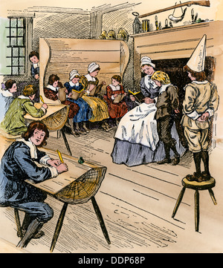
Above is an old painting of a 1700s school. The boy who did not do as he was told was stood on stool with a dunce cap on his head. This is a powerful picture of 2022. The boy in the picture was probably being naughty and the teacher frustrated with him – justifiably.
However, now, the dunce cap is being put on all those who defy the unrighteous laws of the nations under Beast-Lucifer orders. You see a student behind a barrier in the back of the picture. He’s observing, perhaps trying to figure out if he should come out or not. He is a good example of the cowering of those who are afraid – yet, do not conform to the demands of the unrighteous.

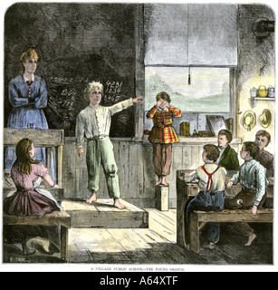
Here we see an 1800s painting of a school, where the Teacher folds her arms and lets a student do the accusing of a boy standing on a dunce block. The boy covers his face in shame – whether he was guilt or not. The other students see the stance of the Teacher and the pointed finger of the accusing student, and are warned that if they do the same, they’ll be on a dunce block too. The boy, pointed out for all to see, is not going to defend himself. He tries to hide his face.
This is a very clear picture of those today who provoke accusation, those who accuse, and those who cower in shame, whether guilty of any wrong doing or not.
Put this in 2022 prospective. Perhaps the boy had not been vaccinated. Perhaps he had tried to witness to someone about Jesus and the accuser was angry. Perhaps he had spoken out against the demands of an unrighteous decree.
The children watching understood, some feared – right or wrong. One child was pointed out for all to see. The Bible says this will happen to all righteous ones who will be pointed out and taken away to their death, like parents being turned in for wrong doing by their children - like Hitler’s Youth, and Mao Tse Tung’s “Red Guard” of youth. (Mark 13:9-13) Many once-Christians will turn in others who are not vaccinated, or who speak against the evil of the government.
Right now, in Canada, Trudeau’s government set rules that no citizen should quote the Bible openly in public. Thus. in some places, the police have been vicious against pastors, arresting them, putting them in prison. One pastor was put in prison for baptizing his daughter.
“The wicked run when no man pursues, but righteous are as bold as a lion.” (Proverbs) Why are the righteous bold when even the wicked are terrified and run to hide? Because, the righteous know Yahuwah and Yahuwah personally, and have learned to trust Them through many experiences of seeing goodness at work. They cannot deny Them whom they know. If you know Father and Son personally, you can’t deny Them, even in the face of death!
Shalom and blessings as you stand for Truth unwavering in faith.
Love, Yedidah
January 30, 2022

