THE WORLD IS already WORSHIPPING THE BEAST
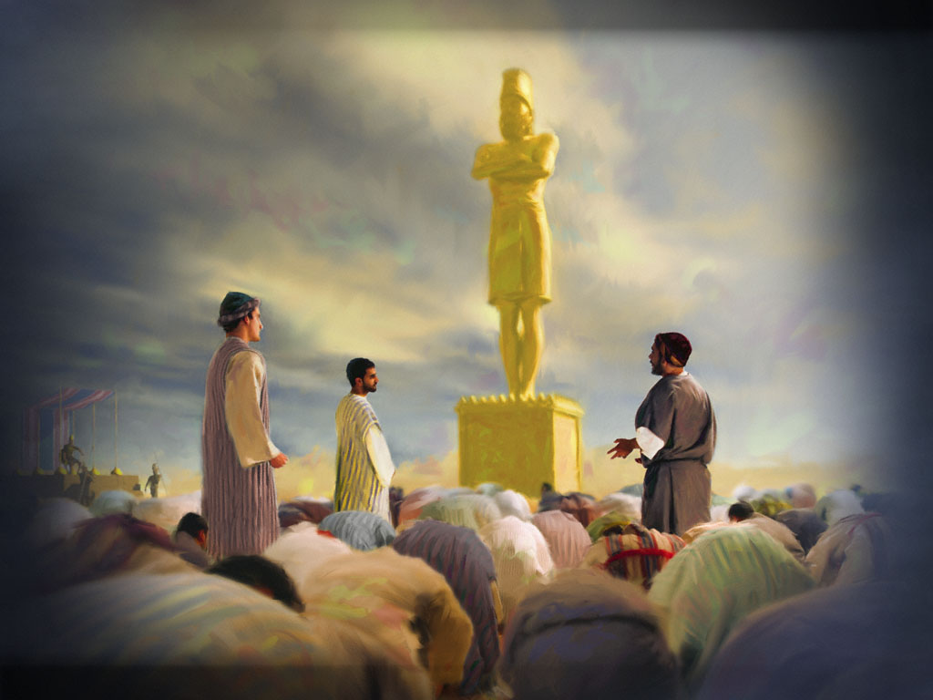
Revelation 13:1-10, NAS: “And the dragon stood on the sand of the seashore. Then I saw a beast coming up out of the sea, having ten horns and seven heads, and on his horns were ten diadems, and on his heads were blasphemous names. 2And the beast which I saw was like a leopard, and his feet were like those of a bear, and his mouth like the mouth of a lion. And the dragon gave him his power and his throne and great authority. 3I saw one of his heads as if it had been slain, and his fatal wound was healed. And the whole earth was amazed and followed after the beast; 4they worshiped the dragon because he gave his authority to the beast; and they worshiped the beast, saying, “Who is like the beast, and who is able to wage war with him?” 5There was given to him a mouth speaking arrogant words and blasphemies, and authority to act … was given to him. 6And he opened his mouth in blasphemies against God, to blaspheme His name and His tabernacle, that is, those who dwell in heaven. 7It was also given to him to make war with the saints and to overcome them, and authority over every tribe and people and tongue and nation was given to him. 8All who dwell on the earth will worship him, everyone whose name has not been written from the foundation of the world in the book of life of the Lamb who has been slain. 9If anyone has an ear, let him hear. 10If anyone is destined for captivity, to captivity he goes; if anyone kills with the sword, with the sword he must be killed. Here is the perseverance and the faith of the saints.”
Right now, the world is being united to openly worship the coming “Beast.” Faith in, and personal relationship with, Yahuwah the Father and His Son, our Savior - Yahushua/Yahshua/Yeshua/Jesus – belief that the whole Bible as the Word of God, belief in a real Satan, and in a real Holy Spirit, is almost gone from Christianity and Messianic Judaism. Pagan religions are national, regional, or tribal. “Rabbinic Judaism” as a religion, is based on the Babylonian Talmud, the Mishnah, the Zohar and Kabbalah. It is not based on the Tenach, or on the worship of Yahuwah as the supreme God. It is a polytheistic belief - paganism from Babylon passed off as the “Oral Law” to Moses. Kabbalah is pure satanism and polytheistic.
Just to read some quotes from the Talmud itself is shocking. Refer to: “Quotes That Forever Dispel Damning Lies”/Mikvah of Israel, Our Eternal Inheritance.
Many rising religions are steeped in Satanism. As the great falling away, the
“apostasy” mentioned in II Thessalonians 2, the rejection of the Savior as Deity, is happening among former believers in the God and Savior of the Bible, so the rise of the antichrist can take place. Ridding the world of faith in the Word of Yahuwah, spoken by Yahushua, and salvation by faith in the Savior’s shed blood and resurrection is paramount to the worship of the Beast rising as his kingdom on earth is now rising.
Therefore, Christian and Messianic defection from the whole Word and faith in both Persons as Deity, Father and Son, is actually making the way for the antichrist to come and receive worship. If mind-manipulation doesn’t work, beheading will get rid of the true believers (Revelation 6:9-12; 7:9-17; 14:13-14; 20:4)
Where are the three young Hebrew men who defied the edict to worship the statue of Nebuchadnezzar and were thrown into a blazing furnace of fire? With Yahuwah and Yahushua of course! (see picture page 1) These three would not bow to Nebuchadnezzar’s power-hungry rule that demanded them to worship his “image.” Daniel 3! Note the word “image.”
Revelation 13:11-18, NAS: “Then I saw another beast coming up out of the earth; and he had two horns like a lamb and he spoke as a dragon. 12He exercises all the authority of the first beast in his presence. And he makes the earth and those who dwell in it to worship the first beast, whose fatal wound was healed. 13He performs great signs, so that he even makes fire come down out of heaven to the earth in the presence of men. 14And he deceives those who dwell on the earth because of the signs which it was given him to perform in the presence of the beast, telling those who dwell on the earth to make an image to the beast who had the wound of the sword and has come to life. 15And it was given to him to give breath to the image of the beast, so that the image of the beast would even speak and cause as many as do not worship the image of the beast to be killed. 16And he causes all, the small and the great, and the rich and the poor, and the free men and the slaves, to be given a mark on their right hand or on their forehead, 17and he provides that no one will be able to buy or to sell, except the one who has the mark, either the name of the beast or the number of his name. 18Here is wisdom. Let him who has understanding calculate the number of the beast, for the number is that of a man; and his number is six hundred and sixty-six.”
They were bound and thrown into a fire that would have consumed them in a second. The fire was so great that it burned up the men who threw the three young Hebrew Yahuwah-worshipping men into the fire. Yet, when Nebuchadnezzar went to see their ashes, he saw four men in the fire walking around unharmed. He ordered the four brought up, but only three came out of the fire – unharmed. The fire did not even touch them. They did not even smell like smoke. Where did the fourth one go? Who was he? Any understanding of Scripture will let you know it was the pre-incarnate Yahushua, the same one who would be with Daniel when he was thrown into a den of hungry lions by King Darius the Mede. THESE FOUR YOUNG HEBREW MEN ARE AN EXAMPLE OF THE NATURE OF THE END-TIME BRIDAL REMNANT OF REVELATION 14:1-5.
WHO YOU WORSHIP WILL DETERMINE IF, OR NOT, YOU GET ANY HELP IN THE DAYS AHEAD FROM YAHUWAH!
From Revelation 17, the 7th kingdom is rising. The Beast is of the 7th but is also of the 8th” - the returning one, the “Apollyon,” of the lineage from Nimrod – Revelation 9:11. Nimrod aka Gilgamesh attempted world rule as a god (Genesis 11). Like Nimrod, Osiris ruled Egypt as a god and Apollo ruled Greece as a god. The Caesars of Rome demanded worship as gods. The rulers of all six, so far, world empires demanded worship as gods. The ones refusing to worship them were killed. This is what is ahead for the world today.
This Nephilim-entity is returning with his 7 heads – representing the empires through which he ruled in the past: Egypt, Assyria, Babylon, Media-Persia, Greece, Rome, and a recent empire, or “Reich” in German. The world will recognize the Beast, and worship him, giving him their allegiance, honor, and absolute obedience.
All these millennium man has had the instructions of Yahuwah for our right standing in Covenant relationship with Him, all picturing His Son. Then for two millennia we’ve had His Son incarnate for our salvation, and still, only a few really know Them. People do what they’re told to keep themselves in power – in control, by their mind’s demands. Only a few really know how to worship Yahuwah and Yahushua. They are strangers to earth’s people, and for the most part strangers to Christians and Messianic “believers.” Read Revelation 4 and 5!
Philippians 2:6-11: “…Let this mind be in you which was also in Messiah Yahushua, 6who, being in the form of Elohim, did not regard equality with Yahuwah a matter to be grasped, 7but emptied Himself, taking the form of a servant, and came to be in the likeness of men. 8And having been found in fashion as a man, He humbled Himself and became obedient unto death, death even of a stake. 9 Yahuwah, therefore, has highly exalted Him and given Him the Name which is above every name, 10that at the Name of Yahushua every knee should bow, of those in heaven, and of those on earth, and of those under the earth, 11and every tongue should confess that Yahushua Messiah is Master, to the esteem of Yahuwah, the Father.”
The worship of Yahuwah and Yahushua with understanding by the Word and by the Spirit is normal for the truly born-again who are Spirit-filled - submitted to the Spirit. Being in Their Presence is peace and joy, rest and relaxation. It is a lifestyle. High worship from our re-born spirit also strengthens the immune system of the body, and also strengthens the mind against deception.
Because of submission to man’s teaching and the rejection of the Spirit’s teaching, few “believers” even have a clue as to how to act in Their Presence. Few know Them personally and are taught by Yahuwah’s Spirit - directed, empowered, and totally under His control. People choose to go by their carnal mind and follow the teachings of whoever sounds the best to their mind.
II Timothy 4:1-4: “In the sight of Elohim and the Master יהושע Messiah, who shall judge the living and the dead at His appearing and His reign, I earnestly charge you: 2Proclaim the Word! Be urgent in season, out of season. Reprove, warn, appeal, with all patience and teaching. 3For there shall be a time when they shall not bear sound teaching, but according to their own desires, they shall heap up for themselves teachers tickling the ear, 4and they shall indeed turn their ears away from the truth, and be turned aside to myths.”
Oh how well that describes modern Christianity and Messianic religions!
This is why the “few” are being empowered now. This few will stand in the face of the Beast like the three Hebrew young men and refuse to obey his orders to worship him.
Yet, because these are the “first fruits of the first resurrection” even the Beast knows he cannot touch them. So, he turns his fury at the last on their leaders – two “witnesses.”
In his August 20, 2020 interview with Paul Begley, “Mike from around the world,” a government intelligence insider, said some powerful things I want to share with you,
“The world’s people have to be wicked to the core in order to obey the evil ones.” I add, or scared into horrific terror of losing their lives or the lives of their family. “Mike” said: “We’re giving the Beast his authority! We’re empowering the Beast and his system by obedience to do what they tell us.”
The word “worship” in Revelation 13 means: “voluntary adoration, observance, subservience, and obedience.”
“So, actually, the world’s people are being brought into worship,” “Mike” said. It is Satan who has great spiritual impact on the minds of the earth’s people to terrify them, or woo them, to making the decision to worship him, to deny Yahushua/Jesus Messiah, to stop worshipping any other God but him.
“Mike” said that the world’s Elite must have the people’s support, i.e. worship, compliance, submission, so they are using fear to obtain obedience. And right now, earth’s people, for the most part, are being caught up in the fear and scared to death to not do as they’re told to do.

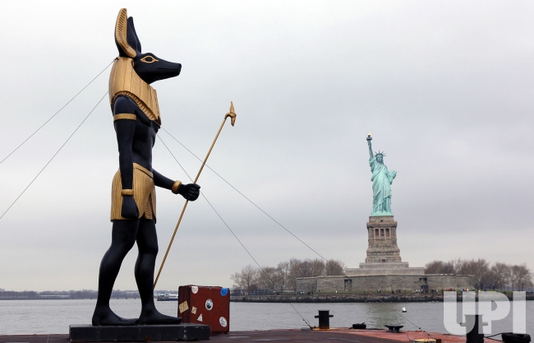
A 25-foot tall, 7-ton replica statue of the Egyptian God Anubis passes by the Statue of Liberty in New York Harbor signaling King Tut's return to New York in New York City on March 23, 2010. UPI/John Angelillo
“Mike” said: “Most of the world’s leaders have walked with, and interacted with, Anubis,” and I add, also with the incarnated spirits of other ancient gods. TRULY “THEY” WALK AMONG US, as Daniel 2:41-43 tells us. They are as iron mixing with “clay” – humanity. Right now, as Steve Quayle has said, and “Mike” confirms: “Prominent world militaries are controlled by fallen angels and Nephilim. Yes, they want blood sacrifice to empower Satan and the coming antichrist. Key world militaries have been taken over by these entities and rule through militaries. I know that America and Israel are two of those nations.
“Mike” said: “They make what they taught us `home’ in our minds. It takes God to break the patterns that the enemy has taught us.”
“Mike” also said it like this: “If a child is born in a jail cell and grows up in the jail cell, he’s not going to call it a jail cell – he’ll call it `home.’ This is what has happened to mankind. We think we’re free, but in actuality, we’re in a prison cell and feel comfortable with it.” Powerful statements!
So true! Most people are so used to being told what to do, what to say, how to think and what to put faith in, that they are in a jail cell in their mind and emotions and the prison warden is Satan and his kingdom allies. This is why religion so easily gets people to depend on what man says to believe. Most have never been set free by a true new birth. With a head full of doctrine and theology, they are totally subservient to the one who taught them. We are slaves to whomever we submit ourselves to.
Romans 6:16: “Do you not know that to whom you present yourselves servants for obedience, you are servants of the one whom you obey…” I Corinthians 7:23: “You were bought with a price, be not the servants of men.”
Most people submit their mind in obedience to what their chosen teacher tells them – pastor, rabbis, YouTube guy, etc. and then wonder why they never hear from Yahuwah! To be free by having the Spirit teach them, well, it goes back to my vision, and article, “The Cage”/Mikvah of the Great Adventure. Also refer to: “It’s Our Time of Cage Break”/Mikvah of the Heart of Elohim.
Most people are terrified “of being set free from their cage. It’s like what “Mike” said about those born in a jail cell – it’s home. In “The Cage,” Messiah wanted to break the bars of the cage for the bird to go free, but it cried out “NO, NO, NO,” in terror. Many men and women who have spent years in prison, if they are released, do not want to leave the prison. In the prison they were told what to do, they had food, they had no responsibilities to do anything except what their wardens told them. It became comfortable to them.
This is the hell of religion – man’s control over the mind. How many ministers actually teach the people John 16 and 17, or the lifestyle of the book of Acts? I hope you’ve listened to my podcasts of the book of Acts. Very few ministers teach what the requirements for a new birth is, let alone discipleship. This may be because, if people really get hold of what it means to submit to the Spirit of Yahuwah and learn from Him, they’ll not bow in worship to their pastors, their messianic rabbis, or in Judaism to their rabbis. They’ll be free to allow the Spirit to transform them.
In Rabbinic Judaism, it is a fact that religious Jews are raised to actually worship their rabbis to the point of insanity, trying to copy them in everything. They are total prisoners, told what to do, what to say, how to think, how to feel, how to react to others in the world, taught to obey the Talmud, not the Torah/Tenach. They are so often enslaved by Kabbalah which is pure satanism in disguise.
Religion is satanic at the core, and is a mind-control device. The Spirit of Yahuwah does not speak to the mind or human emotions, carnal emotions, He only speaks to a re-born spirit that He has re-birthed by His methods. Refer to: “The True New Birth”/Mikvah of Eternal Salvation. Refer to the articles under the “Mikvah of the Spirit.”
Without Him being within you, which was the normal process in the early assemblies of the followers of the Nazarene, the followers of “the Way,” one’s re-born spirit is not the temple of the Spirit of Yahuwah but sits empty and vulnerable. The new birth prepares the temple, but He must be asked to enter. This two-part process is very clear in I Kings 8 to do with the dedication of Solomon’s Temple. Receiving the Spirit after a true new birth has been something natural to the House of Judah and the House of Ephraim from ancient times, so was natural in the early assemblies.
“Mike” said about the earth’s takeover by the fallen ones: “The Elite walk among these entities every day and they are afraid. They know what they are. They understand their supernatural powers. They fear them; they submit to them.” Thus, already world rulers, military rulers, economic rulers, and religious rulers of this world know these entities, interact with them, and fear them. They “worship” them out of fear, and do as they are told.
I’ve reported on inside information from ex-CIA Steven ben Nun to do with the Israeli military and the Pentagon, reporting that they are working with the reptilian giants, the leaders – with IQs upwards of 9,000. Yes, they are in control of the world and Abba is letting it happen for a short time, in order to divide between His true children and the carnal religious fakes.
“Mike” began preaching that “they” cannot take over and do as they will with those under the tallit of Yahuwah. They fear those who are sealed (Revelation 3:7-13). They are under orders not to harm those who will be translated and yet stay on earth to torment the Beast.
Paul Begley asked “Mike” about the old-time politicians in Washington. Mike said “they are in torment.” … “They are having dreams every night. If they lay their heads down to `cat nap,’ they have a dream. They live in fear. The only solace they have is participation in horrendous sin, always some new horrendous sin that includes the abuse of others, driven to the darkest of mental conditions – demon possession.
As Dr. Michael Lake has also taught, “Mike” talked about the “iniquity force,” that is happening over the earth. People are turning to deep sin. Abortion is part of it, sacrifices to Satan as full-term abortion. Pedophilia is increasing to a high degree – the sexual exploitation, torture, and sacrifice of children is major among the Elite in world governments. In other words, folks, mankind is becoming demon possessed, so that they think, say, and do (act out) what they are told to do to kill almost all of the 7.5 billion people on this planet.
“Mike” said that the Elite are very aware of the timing of Yahuwah. They are very aware of the timing of the fallen ones, and they all fear the most set-apart ones who will challenge them in the days ahead.
I’ll stop here. You can read my report on September 13, 2007 in “The Shmittah Year Prophecy” and “The Shmittah Year Prophecy Revisited,” written in 2016.
I am not date-setting, and neither is “Mike,” for after my research in these areas since the early 1960s, I have my finger on the pulse of time, and the heart of Yahuwah.
Right now, all 223 prophecies of the entire Word to do with Messiah’s second coming are all happening. Abba is layering events to shorten the time for us. End-time prophecy is not chronological as fundamental Christian eschatology teaches. Yahuwah has no charts. Christian leaders really have to take verses out of context to support their version of end-times. There is not even a 7-year tribulation in the Bible at all. So much of what they teach will not happen as they say. Christianity appeals to the logical mind of the Western-world people, yet it is ancient Hebrew document. It does not contain Western-cultural thinking. It is one complete Book that reaches deep into the re-born spirit. Those living by the flesh in their minds cannot understand it, even if they say they believe it. It is “spiritually discerned.”
I close with wise words from the Apostle Sha’ul, who understood living by the Spirit. I Corinthians 2: “…4 And my word and my preaching were not with persuasive words of man’s wisdom, but in demonstration of the Spirit and of power, 5in order that your faith should not be in the wisdom of men but in the power of Yahuwah. 6Yet we speak wisdom among those who are perfect, and not the wisdom of this age, nor of the rulers of this age that are being brought to naught. 7But we speak the wisdom of Yahuwah, which was hidden in a secret, and which Elohim ordained before the ages for our esteem, 8which no one of the rulers of this age knew, for if they had known, they would not have nailed the Master of esteem to the tree. 9But as it has been written, `Eye has not seen, and ear has not heard, nor have entered into the heart of man what Elohim has prepared for those who love Him.’ 10But Yahuwah has revealed them to us through His Spirit. For the Spirit searches all matters, even the depths of Yahuwah. 11For who among men knows the thoughts of a man except the spirit of the man that is in him? So also, he thoughts of Yahuwah no one has known, except the Spirit of Yahuwah. 12And we have received, not the spirit of the world, but the Spirit that is from Yahuwah, in order to know what Yahuwah has favorably given us, 13which we also speak, not in words which man’s wisdom teaches but which the Set-apart Spirit teaches, comparing spiritual matters with spiritual matters. 14But the natural man does not receive the things of the Spirit of Yahuwah, for they are foolishness to him, and he is unable to know them, because they are spiritually discerned. 15But he who is spiritual discerns indeed all matters, but he himself is discerned by no one. 16For “Who has known the mind of יהוה? Who shall instruct Him?” But we have the mind of Messiah.”
In His love, Yedidah - August 23, 2020

