THE BLESSINGS OF THE AWL
A Special Message for Elul

We welcome the special month of Elul--the month of T’shuva, repentance, which prepares us to be all that we were created to be. By the sighting of the new moon from Jerusalem on the eve of August 23rd, today, August 24th, is Elul 1.
Elul is our month of preparation for the season of the coming of Yahushua Messiah. It is the season of the harvesting of the grapes, and the making of the new wine. It begins the harvesting of the five species of fruit, first the wine, then figs, pomegranates, dates, and later, olives. It is a priceless time for us to take inventory of our lives and make sure we are solid in faith, strong in the Word, quick in obedience, and walking with Yahuwah and Yahushua in the Light of Their Kingdom. [Refer to the articles: “We Welcome Elul and T’suvah” and “Elul and the Message of Repentance,” written by Derek, under the Mikvah of the Covenant.] Elul is our month of mercy, extended to us by Abba. Let us make this one especially precious! [Refer to: “The Season of the Coming of Messiah” with loads of Scriptures, under the Mikvah of Preparation] It’s our time to cleanse our life so that we might stand pure before Elohim.

Deuteronomy 15:15-17, KJV: “And you shalt remember that thou wast a bondman in the land of Egypt, and the Lord thy God redeemed thee. Therefore, I command thee this thing to day. And it shall be, if he say to thee, I will not go away from thee because he loveth thee and thine house, because he is well with thee. Then thou shalt take an awl and thrust it through his ear unto the door, and he shall be thy servant forever, and also with thy maidservant, thus shalt thou do likewise.” (Also Exodus 21:1-6)
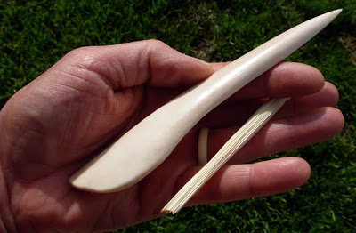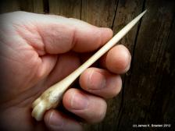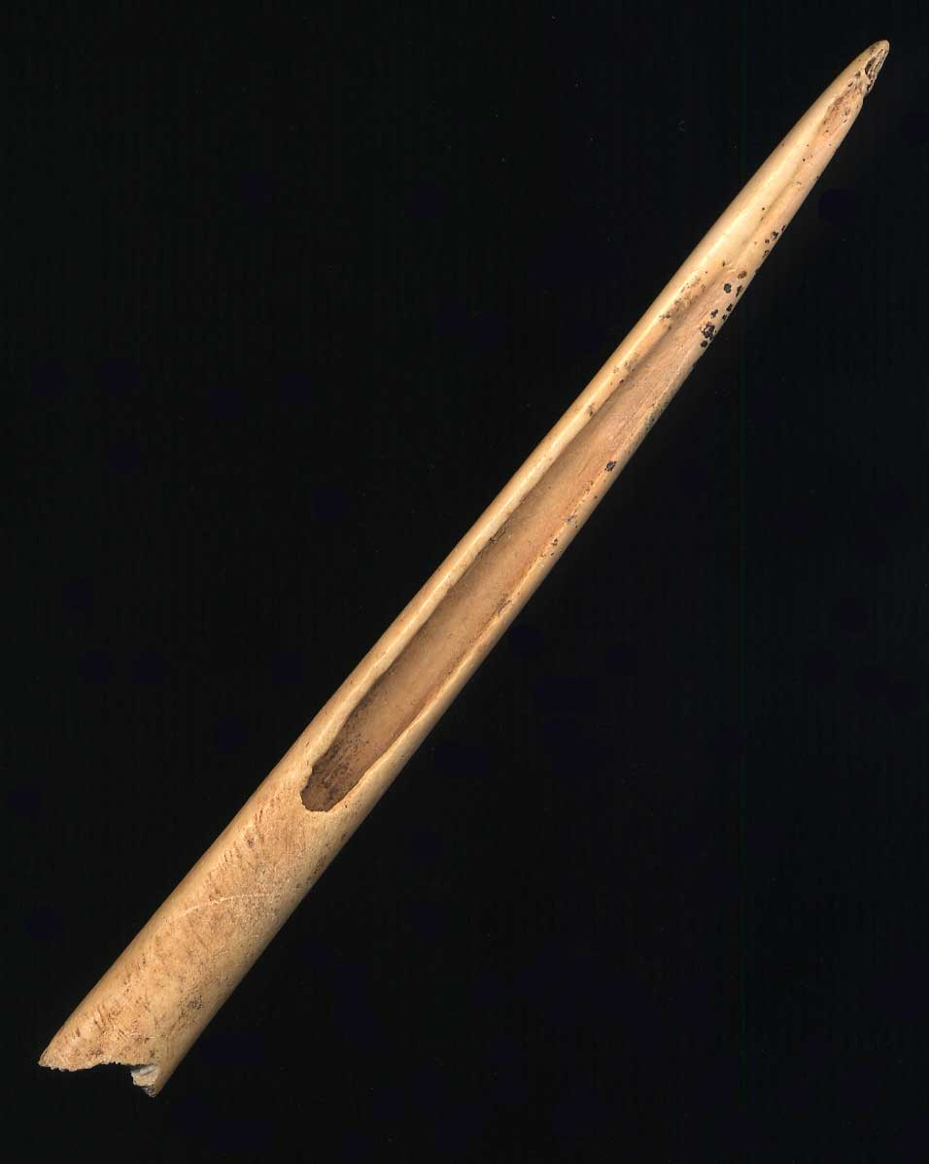
Awls made of bone Deer bone awl

The context of Deuteronomy, and Exodus, is the every-seven-year time of release, the sabbatical year, when debts are written off, and slaves/bondsmen and maid servants, were set free to go. The timing of Yahuwah is in 7-day allotments, 7-week allotments, 7-year allotments, and 7 X 7 year allotments. Every 7 years was a sabbatical year. If a person had servants, bond slaves, they were released, with provisions. But, IF they did not want to go, they could choose to be life-time servants because they loved their master and his family, and didn’t want to leave. If this were the case, they had to be marked as belonging to one master! The marking instrument was called an “awl,” kind of like an ice pick. A hole was made in one ear of the servant to mark him, or her.
In like manner Yahushua willingly made Himself a servant of His Father in agreeing
to incarnate and give Himself as a substitute for His sin-prone children.
Therefore, Messiah says in Psalm 40:6 through the words of His human forefather King David: “You have opened my ears. Burned offering and sin offering you did not ask for…I have delighted to do your pleasure, oh my Elohim,, and Your Torah is within My heart.”
In Isaiah 50:5-7, Messiah says: “The Master Yahuwah has opened My ear, and I was not rebellious, nor did I turn back. I gave My back to those who struck Me, and My cheeks to those who plucked out the beard, I did not hide My face from humiliation and spitting. The Master Yahuwah helps Me, therefore I am not humiliated. So, I have set My face like a flint, and I know that I am not put to shame.”
In both Psalm 40:6 and Isaiah 50:5, the Hebrew word is the same for “opened,” meaning “pierced.”
Messiah Yahushua spiritually had His ear pierced to only hear and obey His Abba as a servant, to redeem His Father’s family. His ears were trained to obey one voice above all, His Father’s/Abba’s. Our ears must be “opened” to hear and obey only His voice.
Philippians 2:5-6: “Let this mind be in you that was also in Messiah Yahushua, who, being in the form of Elohim, did not regard equality with Elohim a thing to be grasped, but emptied Himself, taking the form of a servant, and came to be in the likeness of men…”
He freely chose to be the servant of His Father, to take our punishment so that we could take His righteousness. His ear was pieced before the foundation of the world, as we read in Revelation. II Corinthians 5:21: “For He (Abba Yahuwah) made Him (Yahushua) who knew no sin, to be sin for us, so that in Him we might become the righteousness of Elohim.”
If we have been truly born of from above, Yahushua is our Master. To follow Him, we must also submit our ear to His awl. Yes, the piercing hurts, and the soreness lingers for a short while, but once marked, we can’t be unmarked. We are either marked by His awl, or we’ll be marked by the awl, the piercer, of the Beast by some means.
Forsaking all, we follow Him to the death, beginning with death to self will, self-exaltation, self-set goals and desires, death to all that is not of Him, in order to humble ourselves as a little child, so that He might raise us up. Elul is the prime month to submit to the marking as we go into another year on Tishre 1 on the Creator’s calendar, the timing for the world, as well as for us. He gave us another calendar for the festival timing (Exodus 12:2), but He didn’t trash His from-creation timing! Both work together like clogs in a wheel, moving perfectly forward until time ends and eternity begins.
The true new birth is all about repentance and forsaking the dark kingdom to come into the kingdom of Light and submit to a new Master, a master who loves us. It is a transfer, as I Peter 2:9 and Colossians 1:13 tell us. But, we must learn as servants, if we want to rule with Him in His coming Kingdom. Without being a good and faithful servant, we won’t hear Him say to us, “enter into the joy of your Master.” [Refer to: “The True New Birth” under the Mivkah of Salvation]
Actually, the greatest blessing of all in being one of His marked servants is the security that comes from knowing we don’t have to fight our own battles. We don’t have to strive. We don’t have to wear ourselves out trying to make things happen that we want to happen. We can live a life of peace, rest, contentment, joy, faith, love, and blessing because we’re not in charge of life--our Master is in charge. Our life is simple. All we have to do is hear and obey, hear and obey.
John 10:7, 9, 11, 27: “I am the door of the sheepfold…I am the door. Whoever enters through Me he shall be saved and shall go in and out and find pasture. I am the good Shepherd. The good shepherd lays down his life for the sheep...My sheep hear My voice and they follow Me.”
How much responsibility over their life does a sheep have? All they have to do is to make sure they keep the shepherd in sight, and don’t leave him. And, when he says “go” they go in the direction he goes, and when he beds them down at night, they sleep in peace knowing that he is the door of the sheepfold. Nothing harmful can get past him.
Now isn’t that better than living in tension and turmoil, striving, and planning, trying to control things, trying to get things to go our way. People who are trying to control their lives sometimes end up with a nervous breakdown, or they get hooked on alcohol or drugs, to make the stress go away. Messiah has a better way.
Matthew 18:2-3: “…And He called a little child to Him and set him in the midst, and said, `Truly I say to you that unless you turn and become as little children, you shall by no means enter into the reign of the heavens…”
How much striving does a little child do to control his world? Hopefully, being if from a good family, he is content to obey daddy and mommy and to believe that they love him and will always do good for him. It is a peaceful life of faith and obedience, trusting, and loving. Sadly, there are few families in today’s world where a child feels peaceful, but as the children of Elohim, we’re sure in a good family!
In our true new birth, our transfer begins with repentance. It begins as we reject the dark kingdom and its cruel masters. Us trying to control our lives by our volatile mind and emotions of the soul, give us a yoyo existence--up and down all the time depending on if our will is satisfied or not. Trying to control our own lives is a futile striving – because we’re really not in control anyway--our flesh is, our sin nature, and those that feed off of it from the dark kingdom. We become a continual snack for the demonic realm that draws power from our negative emotions and mental confusions.
I Peter 2:18-19, our subtle enemy at work: “For speaking arrogant nonsense, they entice, through the lusts of the flesh…promising them freedom, they are slaves of corruption, for one is a slave to whatever overcomes him.”
Satan and his fallen ones promise us freedom, but then chain us in slavery. Yahuwah offers us slavery--the privilege of being His servants in training for reigning-- but then He unchains us to enjoy real freedom in His Kingdom now, and forever.
There’s only one path to travel if we want free of that being jerked around all the time by circumstances and our own mental striving to make things go our way. The only safe and wonderful escape from all the mental and emotional torment of trying to control our own lives is to submit to the awl of Yahuwah. Once marked by the awl, it sends a message to the dark kingdom: IF YOU WANT TO MESS WITH ME YOU HAVE TO GO THROUGH MY NEW MASTER.
Our Abba Yahuwah is more of an Abba, a Father than a “God.” He created the heavens and earth to house His family. He wants His children to depend on Him, like a little child does, so that we always feel safe, secure, and content.
Messiah says to us: “Come unto Me, you who labor and are heavy laden, and I will give you rest. Take My yoke upon you and learn of Me, and you will find rest for your souls.” Our striving, laboring, trying to bearing weights we can’t carry, is nothing but futile. The pressures will destroy us. The only sane thing to do is stop it! Submit to the awl, and rest. He is Elohim; we are not. Oh the freedom Iyob/Job had when he finally got that message and embraced it.
In 2011, Abba put me through the same test. I passed – HalleluYah. I wrote about it in “The Test of Iyob” under the Mikvah of Set-Apartness.
To the ones who strive to create their own world, with their own security walls in place, their own control in full operation, just when they think all is secure, then I Thessalonians 5:3 will happen, whether nationally, internationally, or personally. .
We can rest in Romans 8:28-39: Knowing that we have a Master who controls our steps, rules our minds and emotions, and loves us more than any human could ever love us. But, once the awl is applied, our one main responsibility is obedience to the voice of our Master, both in His written instructions and personal verbal instructions, not when we want to obey, but when He wants us to. Absolute obedience brings great reward! I speak from personal experience.
In the hymn “A Mighty Fortress is Our God” is the sentence: “If we in our own strength confide, our striving would be losing…” Yes, and Ah-main.
Oh the peace of knowing we belong to someone who loves us, wants us, and needs us. We work with our Master to reverse what the watchers started on Mount Hermon, and what sinful man continued in rebellion against our Creator. By our walking in the nature, ways, and thinking of Elohim, we send a constant message to the enemy – you lose.
I Corinthians 6:19-20: “Do you not know that your body is the Dwelling Place of the Set-Apart Spirit who is in you, which you have from Elohim, and you are not your own? For you were bought with a price…”
I Corinthians 7:23: “You were bought with a price do not become slaves of men.”
I Peter 1:18-19: “…you were not redeemed with corruptible things as silver and gold …but with the precious blood, as of a lamb without blemish and without spotless, foreknown, indeed before the foundation of the world, but manifested in these last times for your sakes…”
Revelation 1:20-21: “From Yahushua ha Mashiach who is the faithful witness and the first born of the dead, and the prince of the kings of the earth unto Him who loved us and washed us from our sins in His own blood, and has made us kings and priests unto Elohim, His Father, to Him be esteem and dominion forever and ever. Ah-main. Behold He comes with the clouds and every eye shall see Him…even so, come Yahushua…”
We were BOUGHT. Yahushua paid the highest price--the price His blood. Only slaves are bought, Greek, “doulos”--bond servants. We were slaves to Satan, to our flesh, to our own will, lost and undone, and on our way to eternal death. He paid the price for our sin, a price we deserved to pay. He made it possible for His Father, the ultimate Judge of the universe, to be able to wipe out our sins. He bought us back – redeemed us, drew us out of a terrible deep pit and set our feet on a Rock. He cleaned us up and established our going on a whole new path. He set us free. He took us from darkness to light, from death to life, from slavery to freedom.
He said that unless we forsake all that we are, and all that we have, we cannot be His disciples. Once we allow Him to save us, He is Master, we are not. He is Creator. We create nothing eternal outside of Him. Without Him we have no hope against the onslaught of the Dragon. But, as in Revelation 12:11, we overcome the Dragon by the blood of the Lamb of Elohim, the word of our own testimony of our own salvation, and that we love not our lives unto death because we are not our own – we are bought with a price.
Stop fighting Him! Submit to the awl! This piercing marks you. If you’re marked by Him, you won’t fall for any marking by the Beast. If you’re marked, the enemy knows who you’ve sided with. Yes, there will be many martyrs in the days ahead. But, better to be one of the Revelation 7:9-17 group than the Revelation 20:11-15 group – right?
If you drag your feet and don’t make a decision ahead of the “suddenly,” when the time comes to stand for the Master, you won’t hear “well done, good and faithful servant.” There are only two alternatives in being a servant: Obey or rebel. The two results are in Matthew 25:21 and 23 or 30, or in Luke 12:37 through 40, or 47-48.
The marking of Elohim opens your ear to hear Him, and your spirit to interact with Him. There is no higher privilege on earth than that!
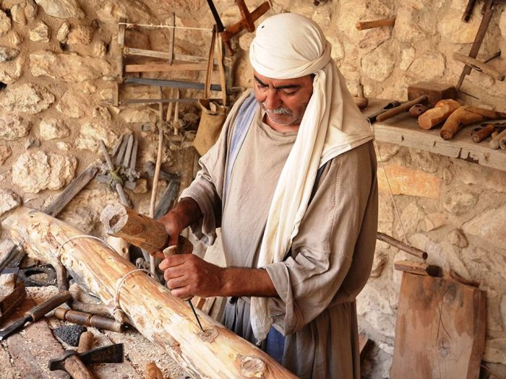
A man working with an awl--it looks like he’s at Nazareth Village, Israel…

A wonderful prayer to pray from a Christian brother, by Precious Sheep of Renown
“How many times have you saved me - All honor, glory, and praise is due unto You! You saved me from my sins, yes--sins which were many, sins which were both seen and well-hidden, sins which would have kept me out of Heaven, sins which were warping and twisting my soul, making me unfit for human companionship and unfit for fellowship with You. My life is now not my own, for YOU have bought it when you delivered me, and over and over again in so many ways. Thank YOU for opening my eyes now to see Your protection of me. I cannot even begin to repay YOU. So… here is my life. I give it to YOU. I lay my ear on the doorpost. Pierce it with Your set-apart awl. I am Yours forever.”
Shalom, love, and blessings,
Yedidah
August 24, 2017

