What Message Does the Burning of Green Grass Give to Yahuwah’s People?

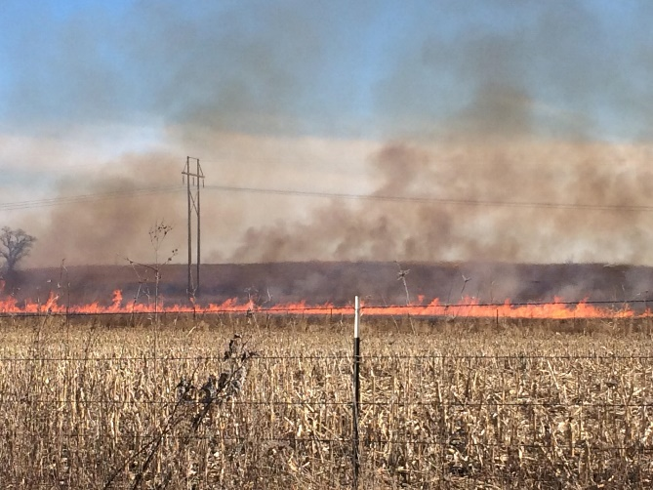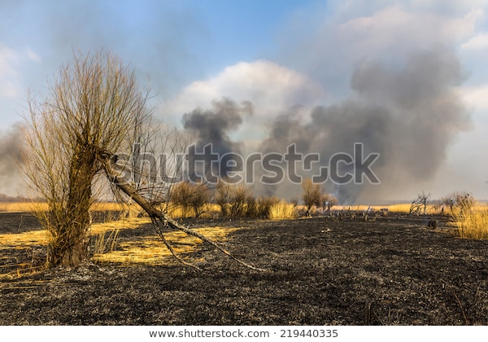

Deuteronomy 29:22-26: “And the generation to come of your children who rise up after you, and the foreigner who comes from a far land, shall say when they see the plagues of that land and the sicknesses which יהוה has sent into it: 23 ‘All its land is sulfur, salt, and burning; it is not sown, nor does it bear, nor does any grass grow there, like the overthrow of Seḏom and Amorah, Aḏmah and Tseḇoyim, which יהוה overthrew in His displeasure and His wrath.’ 24 And all nations shall say, ‘Why has יהוה done so to this land? What does the heat of this great displeasure mean?’ 25 And it shall be said, ‘Because they have forsaken the covenant of יהוה Elohim of their fathers, which He made with them when He brought them out of the land of Mitsrayim. 26 And they went and served other mighty ones and bowed themselves to them, mighty ones that they did not know and that He had not given to them, 27therefore the displeasure of יהוה burned against this land, to bring on it every curse that is written in this book.’”
Is that clear enough? I believe so. There is a direct connection between a parched, dry, burned wilderness instead of green grass, crops, trees, and turning from Yahuwah to serve other gods, including exalting and worshipping human beings as gods. As Jeremiah 50-51 and Revelation 18 tell us, the final Babylon is a land of idols and the adoration of foreign gods by its people. It is a land of witchcraft, pride, arrogance, and rebellion against Yahuwah and His Son, Yahushua. It is speaking of America 2020.
Jeremiah 17:1-8: ““The sin of Yehuḏah is written with a pen of iron, engraved with the point of a diamond on the tablet of their heart, and on the horns of your altars, 2while their children remember their altars and their Ashĕrim by the spreading trees on the high hills. 3“My mountain in the field, I give as plunder your wealth, all your treasures, your high places of sin, throughout all your borders. 4“And you, even of yourself, shall let go of your inheritance which I gave you. And I shall make you serve your enemies in a land which you have not known, for you have kindled a fire in My displeasure which burns forever.” 5Thus said יהוה, “Cursed is the man who trusts in man and makes flesh his arm, and whose heart turns away from יהוה. 6“For he shall be like a shrub in the desert, and not see when good comes, and shall inhabit the parched places in the wilderness, a salt land that is not inhabited. 7“Blessed is the man who trusts in יהוה, and whose trust is יהוה. 8“For he shall be like a tree planted by the waters, which spreads out its roots by the river, and does not see when heat comes. And his leaf shall be green, and in the year of drought he is not anxious, nor does he cease from yielding fruit.”
Here we see another example. Going after other gods and turning from Yahuwah brings drought, famine, dried green things – crops for food and trees for oxygen.
I recently wrote about the great Aquifer of the heartland of America, the largest of its type in the world, being polluted and drying up. It is the water source for at least 8 states for farms and drinking water, via city reservoirs or private wells. All over the world, water is drying up. We can’t live past 3 days without water. NO water no crops, oxygen levels drop. Fires start in dried grass.
Please refer to the article that tells of “Terraforming of Earth”/Mikvah of The Heart of Elohim. The purposed destruction of food crops and water sources using weather warfare, the purposed destruction of the Pacific Ocean by radiation, by dumping toxic chemicals and plastics into the ocean, chem.-trails polluting the air, GMO foods destroying the nutrition of food,
Chemicals in clothes, lotions, about everything we put on our body, and by many other means, the depopulation of earth agenda is well on its way now with the creation of viruses and the spraying of them, and by the weakening of the human immune system, mankind is a dying life form. In the meantime, as Jeremiah and Hosea tell us, the animals and birds, and sea life, are dying by the multi-millions.
Jeremiah 12:4, Jeremiah’s lament because of the wicked: “How long shall the land mourn, and the plants of every field wither? The beasts and birds are consumed, for the evil of those who dwell there, because they said, “He does not see our latter end.”
Hosea 4:1-3: “Hear the word of יהוה, you children of Yisra’ĕl, for יהוה has a case against the inhabitants of the land: `For there is no truth or kindness or knowledge of Elohim in the land. 2Swearing, and lying, and murdering, and stealing, and committing adultery have increased. And bloodshed follows bloodshed. 3 Therefore the land mourns, and everyone living there languishes, with the beasts of the field and the birds of the heavens. And the fish of the sea are taken away.’”
As Isaiah 13, 47, Jeremiah 50-51, and Revelation 18 tell us, the reason for the Judgment on the final Babylon, the nation chosen to bring forth Nimrod again to build his “tower” to rule the world, is under the severe judgment of Yahuwah for its idolatry, for the slaughter of 130 million babies to date, and the funding of up to a billion abortions worldwide, the trafficking of children for pedophilia, for being the world’s leader in drug smuggling, etc. America has even turned against its once-basic religion of Christianity. The religion itself has become defiant of His Word and His Son.
The roots of Babylon go back to Nimrod – who funded Babel, who became a Nephilim giant/Rephaim – who hated Yahuwah with all his being and set out to gather all the world’s people into one under him as their king, to go into the heavenly city and kill Yahuwah and His Son Yahushua. (Genesis 11) Abba ended that before it ever took off. However, through the ages, there have always been secret groups with the burning desire to complete what Nimrod began. America became the chosen nation to fulfill the desires of Luciferians and Satanists. The fulfillment is nearing by the day.
The goal of the fallen ones is to destroy all mankind and all life on earth and leave it desolate wilderness as we read in Isaiah 13 regarding America. Read Isaiah 13 slowly. Look at the Septuagint Version and read Isaiah 13:3, where Yahuwah says He will use giants to execute His wrath on earth. Even now, giants, like Nimrod, Nephilim, are being brought out of stasis to live again, and seen by many in remote places, like by the U.S. military in Afghanistan and Iraq.
Isaiah 13:17-22: “See, I am stirring up the Medes against them, who do not regard silver, and as for gold, they do not delight in it. 18And bows dash the young to pieces, and they have no compassion on the fruit of the womb, their eye spare no children. 19 And Baḇel, the splendor of reigns, the comeliness of the Chaldeans’ pride, shall be as when Elohim overthrew Seḏom and Amorah. 20 She shall never be inhabited, nor be settled from generation to generation; nor shall the Araḇian pitch tents there, nor shepherds rest their flocks there. 21But wild beasts of the desert shall lie there, and their houses shall be filled with owls. And ostriches shall dwell there, and wild goats frolic there. 22And hyenas shall cry in their citadels, and jackals in their pleasant palaces. And her time is near to come, and her days are not drawn out.”
Ancient Babylon was never destroyed, just quietly one night taken over by the Mede Darius and the Persian Koresh/Cyrus. No one died except King Belteshatsar (Daniel 5).
It is end-time, the final Babylon, that will be so destroyed by nuclear destruction that nothing can live on its soil anymore except hybrids (satires) and owls, and other creatures of the night.
Sodom and Gomorrah were reduced to a fine ash, filled with sulfur (brimstone). I have some of that ash in a jar in my bedroom. When I stuck my hand inside a pillar of ancient Gomorrah, I pulled out my hand with ash and brim stones (sulfur, which still can be lit and burns) and smelled it – it smelled like sulfur. So, are the plans of China, Russia, North Korea, Iran, and other nations regarding America.
You might say that China wants our farmland and water and possessions, and yes they do. But, once nuclear attacks begin, the nation go up in explosive flames, possibly igniting the great natural gas reserve under all of America, coast to coast.
Today, the great super power of the earth is now being taken over by Communism, particularly Chinese Communism. The mind-programming has begun, and the worship of the fallen ones and their offspring is rampant in many forms. Over 70% of those who once claimed to believe in the God of the Bible and Jesus as their Savior, are not denying that the Bible is God’s Word, denying the Deity of Jesus/Yahushua, denying that there is even a “satan” or a “Holy Spirit, rejecting the book of Acts for today, some hating “Paul” because he does not conform to their religious beliefs, and on and on.
II Timothy 3:1: “But know this, that in the last days raging insanity shall come. 2For men shall be lovers of self, lovers of money, boasters, proud, blasphemers, disobedient to parents, thankless, wrong-doers, 3unloving, unforgiving, slanderers, without self-control, fierce, haters of good, 4betrayers, reckless, puffed up, lovers of pleasure rather than lovers of Elohim, 5having a form of reverence but denying its power. And turn away from these! 6For among them are those who creep into households and captivate silly women loaded down with sins, led away by various lusts, 7always learning and never able to come to the knowledge of the truth.”
II Timothy 4:2-8, Sha’ul final words to his spiritual son, Timothius: “Proclaim the Word! Be urgent in season, out of season. Reprove, warn, appeal, with all patience and teaching. 3For there shall be a time when they shall not bear sound teaching, but according to their own desires, they shall heap up for themselves teachers tickling the ear, 4and they shall indeed turn their ears away from the truth, and be turned aside to myths. 5But you be sober in all matters, suffer hardships, do the work of an evangelist, accomplish your service completely. 6For I am already being poured out, and the time of my departure has arrived. 7I have fought the good fight, I have finished the race, I have guarded the belief. 8For the rest, there is laid up for me the crown of righteousness, which the Master, the righteous Judge, shall give to me on that Day, and not to me only but also to all those loving His appearing.”
Revelation 7:1-3: “And after this I saw four messengers standing at the four corners of the earth, holding the four winds of the earth, that the wind should not blow on the earth, nor on the sea, nor on any tree. 2And I saw another messenger coming up from the rising of the sun, holding the seal of the living Elohim. And he cried with a loud voice to the four messengers to whom it was given to harm the earth and the sea, 3saying, `Do not harm the earth, nor the sea, nor the trees until we have sealed the servants of our Elohim upon their foreheads.’ 4And I heard the number of those who were sealed, one hundred and forty-four thousand, sealed out of all the tribes of the children of Yisra’ĕl:…”
Revelation 8:6-7: “And the seven messengers who held the seven trumpets prepared themselves to sound. 7And the first messenger sounded, and there came to be hail and fire mixed with blood, and they were thrown to the earth. And a third of the trees were burned up, and all green grass was burned up.”
Revelation 9:3-4: “And out of the smoke locusts came upon the earth, and authority was given to them as the scorpions of the earth possess authority.
4And it was said to them that they shall not harm the grass of the earth, or any green thing, or any tree, but only those men who do not have the seal of Elohim upon their foreheads.”
To all true humans, green things are symbolic of life, health, peace, joy, prosperity, contentment, and a good future, as well as closeness to God – no matter what their religion, or lack of religion. All mankind knows that green things are a sign of good.
The determined destruction of the green things is happening world-over as we’ve kicked into a Eugenics agenda. Kill off all but 500 million is the goal to use them as laborers of the ultra-rich, the trans-human mutates, fallen angels, and their offspring. All Yahuwah-given life is being destroyed in some way.
In Syria, ISIS beheaded lots of Christians. Their bodies were hung in the meat markets for sale. In “civilized” countries, scientists began talking about the nutritional qualities of human meat. Hollywood is infamous for cannibalism and the drinking of blood – babies and children, of course. More and more we hear of cannibalism in America. Refer to my article “Cannibalism…”/Mikvah of Present Reality. Abba told Steve Quayle years ago that when Cannibalism was in the headlines and many volcanoes began going off at the same time, the tribulation period had begun. Those two things are happening simultaneously now in large numbers.
Human beings are being taken over by demonic spirits (spirits of dead Nephilim), and losing their minds. They are so tormented as “Mike from around the world” reported on a Paul Begley broadcast in 2019, regarding the ultra-powerful in government, the ultra-rich, the Satanists, the pedophiles, etc., that they have to do insane things with babies and children to satisfy their lusts or they go crazy.
This is a world being taken over by all the fallen ones, and we who are still pure humans are the targets for extinction. The only power we have is not from us. We are frail beings, and the minds of all are being taken over and dulled, made compliant to the will of the fallen ones. For us who are born again truly by the power of Yahuwah’s Spirit, new creations in Messiah, we have ONLY ONE POWER SOURCE, and that is the indwelling Spirit within the re-born spirit. However, as reported above, 70% or more are rejecting the Spirit of Yahuwah as needed in today’s world. Therefore, they are rejecting their only power source, their only connection to heaven that is afforded to mankind by the Kingdom of Heaven. Think hard about that. The rejection of the Spirit is the rejection of Yahuwah Himself, who is THE SPIRIT. Without His indwelling a re-born spirit, there is no power source, no way to be taught and led by the Spirit, no way to know the power of the Spirit and operate in His gifts. Left to ourselves, the powers of the fallen ones in the up-coming “alien disclosure” (“Mysterious Monoliths…”/Mikvah of Present Reality) will take over, and eternal life be ended.
Much to think about, and to watch. Be sure to watch the great historic conjunction tomorrow night of Jupiter and Saturn – the brightest light in the night sky.
In the Love of our Master, Yedidah - December 21, 2020
HAPPY 50TH BIRTHDAY DEREK!!! MANY BLESSINGS!!! MUCH LOVE!!! mom

