YAHUSHUA WANTS A WARRIOR BRIDE
TOTALLY ALIGNED TO HIM IN EVERY WAY

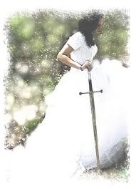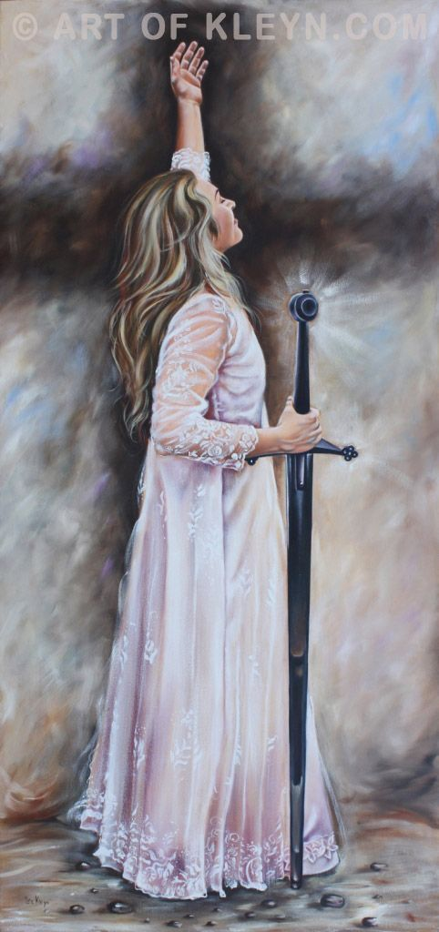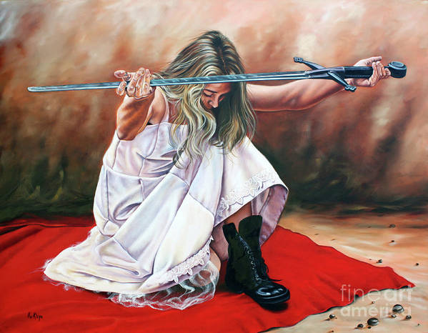
Shabbat eve, Derek wrote me a text about his studying the bride of Messiah, and her carrying a sword, i.e. a warrior bride. He referred to Psalm 45. He had taught on it that evening at the Prayer Center meeting.
I began doing some research in the Word and was quite amazed at the distinctive personality He wants in His Bride. Yahushua (“Yah is salvation”): He is a Mighty Warrior. His Father is a “Man of War” – Exodus 15. He is mighty in battle. He won’t have a wimp Bride - a Bride focused on herself, a fearful, withdrawing Bride. He wants fiery passion in His Bride - in her loyalty, submission, and total uniting with Him as her Beloved. This is something I knew, but after last night’s study, I am amazed at the solid reality of this.
Yahuwah chose 300 warriors out of a willing 32,000 to fight the enemy in the Valley Jezre’el. What caused Him to choose those particular 300? They lapped like a dog: They never took their eyes off the enemy, but brought water to their mouth in their hands. A dog keeps their eyes straight out while lapping.
It was their nature that got them chosen - the same nature as the Master – vigilant, diligent, faithful, responsible, focused, obedient to the finest detail of their Captain’s orders – total dedication, total loyalty, total commitment, total focused.
This is what the Master must have in a Bride. The 10 Commandments are His requirements – but #1 is of the utmost importance: NO OTHER GODS IN HIS FACE. HE WANTS TOTAL EXCLUSIVITY. He wants His Bride totally focused on Him! That includes the will, the mind’s reasoning, the emotions, the absolute loyalty to only ONE – THE BRIDEGROOM.
This is the 144,000 remnant that He trusts, as He trusted Jeremiah, to take His message to the nations, fearlessly. This remnant in our day: Revelation 3:7-12, 7:1-8, 9:4, 14:1-5, 22:3-5.
He will protect His Beloved Bride! Not one of the 300 under Gideon was killed or even wounded in battle. The 300 obeyed Gideon’s instructions implicitly. Therefore, we see the Psalm 91 protect on a particular people with a particular nature – the nature of a warrior who DWELLS in the same space as his Captain. The promises of Psalm 91 are only for those that live Psalm 91:1!
His Bride cannot be “self-centered,” fearful, doubting, rationalizing, mind-reasoning, emotional, independent and self-willed. He won’t have that type of Bride. His Bride must be totally in love with Him - thus strong and fearless, retaining a gentle nature, yet not gentle in facing the enemy. She implicitly trusts her Beloved One. She knows Him! She knows He will never leave her or forsake her.
Psalm 45:1-15: “My heart is overflowing with a goodly word; I address my works to the King; My tongue is the pen of a speedy writer. 2You are more handsome than the sons of men; Favor has been poured upon Your lips; Therefore, Elohim has blessed You forever. 3Gird Your sword upon Your thigh, O Mighty One, Your excellency and Your splendour. 4And ride prosperously in Your splendor, on the matter of truth and humility, righteousness; And let Your right hand lead You to awesome matters. 5Your arrows are sharp in the heart of the Sovereign’s enemies – Peoples fall under You. Your throne, O Elohim, is forever and ever; The sceptre of Your reign is a sceptre of straightness. 7You have loved righteousness and hated wrong; Therefore Elohim, Your Elohim, has anointed You with the oil of gladness more than Your companions. 8All Your garments are myrrh and aloes, cassia; Out of the palaces of ivory, stringed instruments have made You glad. 9Daughters of sovereigns are among Your precious ones; At Your right hand stands the Queen in gold from Ophir. 10Listen, O daughter, and see, and incline your ear, and forget your own people and your father’s house; 11And let the Sovereign delight in your loveliness; Because He is your Master – bow yourself to Him. 12And the daughter of Tsor with a gift. The rich among the people seek your favour. 13The daughter of the King is all esteemed within the palace; Her dress is embroidered with gold. 14She is brought to the Sovereign in embroidered work; Maidens, her companions following her are brought to You. 15They are brought with gladness and rejoicing; They enter the Sovereign’s palace.”
Yahushua comes to the wedding on Yom Kippur: Revelation 19:7-16: ““Let us be glad and rejoice and give Him praise, for the marriage of the Lamb has come, and His wife prepared herself. 8And to her it was given to be dressed in fine linen, clean and bright, for the fine linen is the righteousness of the set-apart ones. 9And he said to me, `Write, Blessed are those who have been called to the marriage supper of the Lamb!’ …11And I saw the heaven opened, and there was a white horse. And He who sat on him was called Trustworthy and True, and in righteousness He judges and fights. 12And His eyes were as a flame of fire, and on His head were many crowns, having a Name that had been written, which no one had perceived except Himself – 13and having been dressed in a robe dipped in blood – and His Name is called: The Word of יהוה. 14 And the armies in the heaven, dressed in fine linen, white and clean, followed Him on white horses. 15And out of His mouth goes a sharp sword, that with it He should smite the nations. And He shall shepherd them with a rod of iron. And He treads the winepress of the fierceness and wrath of Ěl Shaddai. 16And on His robe and on His thigh He has a name written: KING OF KINGS AND MASTER OF MASTERS.
Isaiah 63:1-9: “Who is this coming from Eḏom, with garments of glowing colors from Botsrah, who is robed in splendor, striding forward in the greatness of His strength? `It is I who speak in righteousness, mighty to save.’ 2Why is there red on Your raiment, and Your garments like one who treads in the winepress? `3`I have trodden the winepress alone, and from the peoples no one was with Me. And I trod them down in My displeasure, and I trampled them in My wrath. Their blood is sprinkled upon My garments, and I have defiled all My raiment. 4 For a day of vengeance is in My heart, and the year of My redeemed has come. 5 And I looked, but there was none helping, and I was astonished that there was none upholding. So, My own arm saved for Me, and My wrath upheld Me. 6 And I trod down peoples in My displeasure, and made them drunk in My wrath, and brought down their strength to earth.”
Three different accountings of Yahushua coming in the power of His might with the judgment of a warrior-El.
His “wife” comes with Him. In Hebrew culture, the engaged woman is the “wife.” The married woman is the “Bride.” After the nuptials on Yom Kippur, those who have agreed to His requirements become His Bride. Then He and His Bride go to the wedding Feast, as per Matthew 25:1-12 – Hebrew Matthew.
The Bridegroom does not come all “dolled up.” He comes with the blood spread on His garments from speaking the Word to those amassed in the valley of Megiddo – and the blood runs to the horse’s bridals, as per Zechariah 14:1-9.
Revelation 14:8-20: “Here is the endurance of the set-apart ones, here are those guarding the commands of Elohim and the faith of יהושע. 13 And I heard a voice out of the heaven saying to me, `Write, ‘Blessed are the dead who die in the Master from now on.’ `Yes,’ says the Spirit, `in order that they rest from their labors, and their works follow with them.’ 14And I looked and saw a white cloud, and sitting on the cloud was One like the Son of Aḏam, having on His head a golden crown, and in His hand a sharp sickle. 15And another messenger came out of the Dwelling Place, crying with a loud voice to the One sitting on the cloud, `Send Your sickle and reap, because the hour has come for You to reap, because the harvest of the earth is ripe.’ 16And the One sitting on the cloud thrust in His sickle on the earth, and the earth was reaped. 17And another messenger came out of the Dwelling Place which is in the heaven, and he too held a sharp sickle. 18And another messenger came out from the altar, having authority over the fire, and he cried with a loud cry to him having the sharp sickle, saying, `Send your sharp sickle and gather the clusters of the vine of the earth, because her grapes are ripe.’ 19And the messenger thrust his sickle into the earth and gathered the vine of the earth, and threw it into the great winepress of the wrath of Elohim. 20And the winepress was trodden outside the city (Jerusalem), and blood came out of the winepress, up to the bridles of the horses, for about three hundred kilometres.”
Four instances recorded at least of Messiah’s return, showing the fierceness of His return with the wrath of His Father. He takes vengeance on all of His people, saved by faith in His blood.
The wedding, from most ancient times, contains “guests,” “attendants,” or “friends of the Bridegroom, and “the Bride.” Three groups, three eternal destinations: 1) the throne room forever, 2) “kings of the earth,” the “friends” of the Bridegroom, who govern earth and also represent those of earth in the throne room, and 3) guests who live on the new earth is the light of the City – Revelation 21-22.
The ”foolish” 5 virgins had grown accustomed to the darkness and failed to maintain oil to light their lamps. They were not allowed into the wedding feast, though they thought they would go in to the Feast. Yahushua shut the door on them. Matthew 25:1-12: He told them “I do not know you.”
The Bridegroom and Bride KNOW each other well. They are “echad,” two in unity as if they were one. Their fierce loyalty gets stronger as the days approach for the wedding, as in NOW. She has proved herself, her loyalty, her love, her devotion, her exclusiveness. She does not break the 1st Commandment! He is her focus! This has to be the mind-set of the martyrs too – no turning back, i.e. Revelation 7:9-17.
She is a warrior-bride. She carries a sword, which is, according to Ephesians 6, “the WORD OF YAHUWAH.” Yahushua is the Living Word of Yahuwah – He spoke it from Genesis 1:1, 3 onward. She lives by every Word that proceeds from the mouth of her Beloved.
Ephesians 6:10-18: “..,be strong in the Master and in the mightiness of His strength. 11Put on the complete armor of Elohim, for you to have power to stand against the schemes of the devil. 12Because we do not wrestle against flesh and blood, but against principalities, against authorities, against the world-rulers of the darkness of this age, against spiritual matters of wickedness in the heavenlies.
13Because of this, take up the complete armor of Elohim, so that you have power to withstand in the wicked day, and having done all, to stand. 14Stand, then, having girded your waist with truth, and having put on the breastplate of righteousness, 15and having fitted your feet with the preparation of the Good News of peace; 16above all, having taken up the shield of faith with which you shall have power to quench all the burning arrows of the wicked one. 17Take also the helmet of deliverance, and the sword of the Spirit, which is the Word of Elohim, 18praying at all times, with all prayer and supplication in the Spirit, watching in all perseverance and supplication for all the set-apart ones;…”
His Bride wields “the sword of the Spirit,” against His enemies, who are her enemies. She aligns to His Word, she proclaims His Word in spiritual warfare. The Word from His mouth, like a sword, destroys the enemy. Nothing stands above His Word – the Word of her Bridegroom!
The wimpy religious, the whiners, the cowards, the self-absorbed, the fearful, the world-lovers, the mental-emotional do-nothings, the lazy who do not know His Word, the Word of THE WORD, the man-followers – are surely NOT the Bride of Yahushua!
“He is MASTER OF ALL, OR HE IS NOT MASTER AT ALL,” said Hudson Taylor.
She’s a submissive, yet power-filled, eastern Bride, who will NOT put any other “god” in His face!
Daniel 11:32, in context of the time of Beast-reign: “…those that KNOW their Elohim will be strong and do exploits.”
NKJV: “Those who do wickedly against the covenant he (anti-messiah) shall corrupt with flattery; but the people who know their God shall be strong, and carry out great exploits.”
The word “know” is the clue. It is an intimacy term. Two, deeply in love, who know each other like no other knows … intimacy that produces “fruit,” offspring.
She speaks of Him so that others are attracted to Him and also trust Him for their salvation. It is used in Hebrew in Genesis 2:24: “Therefore a man shall leave his father and mother and be joined to his wife, and they shall become one flesh.” The word in Hebrew for “one” is “echad,” meaning two in unity as if they were one – the John 17 unity among those who are united with the Master. It is a unity that is eternal, with great power.
The Bride of Messiah is One with Him, not off on her own, living her own self-ruled life, religious but so self-centered. These can’t know the Bridegroom.
I know there is so much more to this. However, as Jeremiah 6:16 tells us: Yahuwah wants us to return “to the ancient paths, where the good way is.”
It’s all about the nature that He wants to be “married to” for eternity. He is passionate in His love and closeness. He speaks to us. We feel His Presence. He is very personal and intimate. However, most who say they trust Him for salvation do not know Him at all as He is. Tragic!
He is preparing His “Gideon 300” “144,000” symbolic remnant now, to prepare the way for His return – just as He sent out Jeremiah to the nations (Jeremiah 25), He will send forth those He knows who cannot die. They “abide” in Him (John 15:7), and He in them.
In His love, Yedidah – October 14, 2023

