ERASING THE RAINBOW
Rare double rainbow seen high in the sky. Note how the secondary arc is fainter, and the order of its colors is reversed. SBORISOV/ISTOCK/GETTY IMAGES PLUS

Why do millions of raindrops only make one rainbow?

The colors are: red, orange, yellow, green, blue, indigo, and violet. There’s the 7-signature so common in Scripture.
From Science Focus: The true figure for the number of raindrops involved is in the trillions, but more importantly, in reality, there’s never just one rainbow. The almost poetic truth is that everyone gets their own unique rainbow. The reason each of us only sees one is because of the way rainbows are formed. When a ray of sunlight enters raindrops, the different wavelengths of light it contains are bent off-course by different amounts: those corresponding to the color red being deviated the least, and violet the most. What emerges from the raindrop is thus a spread of colors, each bent through an angle of between around 40° and 42°.While this happens with every raindrop lit by the Sun, each of us only sees the rainbow formed by those raindrops that happen to be at the correct angular direction to send the different colors into our eyes. So, each of us receives our own special rainbow created by a dedicated set of raindrops in the sky. Aaah.”
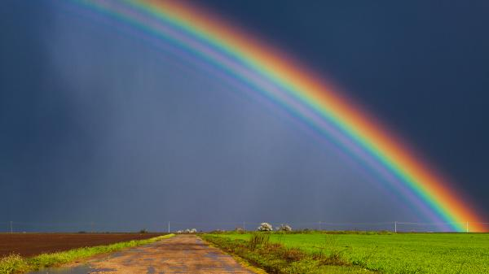
Sun + Rain = Rainbow
Basically, the reason why Bill Gates and other want to erase the rainbow is because it was Yahuwah’s sign to Noah that He would not judge the earth again by Flood. The rainbow is a scientific marvel of light. So, what’s the real reason for erasing the rainbow? More in-depth attempt to erase the promise, along with the Person of Yahuwah who gave the promise, off the earth.
The hate for Yahuwah and Yahushua is found at the root of Eugenics, Evolution, Population Reduction, and Transhumanism. The goal is to erase Yahuwah and Yahushua off the earth, out of the cosmos, and kill all who have any faith or memory of Him. The blue sky, the perfect atmosphere around the earth, the seasons, the beauty of nature, the flowers, the trees, the birds, the sea life – everything that Yahushua spoke into existence in Genesis 1:3 is now targeted for extinction – especially humanity that was created in His image and likeness.
Satan tried to get Nimrod to open a portal to go through and kill Yahuwah and Yahushua. Genesis 11: Yahuwah stopped that. Now the purpose for his tower is a driving passion of the evil ones. Nimrod, aka Osiris, Apollo/Apollyon/Abaddon, Revelation 9:11, is being resurrected, brought back to rule the world. He wants everything to do with the Creators destroyed.
Dimming the sun is a big project underway, blocking photosynthesis, destroying food crops. Manipulating weather as a weapon to destroy instead of bless earth has been around since 1947.
The rainbow is a sign of Yahuwah’s victory over the children of fallen angels and human women. It is a sign that Yahuwah will always have a remnant to represent Him on earth because of His Son’s death and resurrection for us sinners. The hate for Messiah, Savior, Redeemer, Yahushua, Yeshua, Yahshua, Jesus, Isa, etc., is growing and growing. He said: “All men will hate you for My Name’s sake.”
His Name means “Yahuwah is salvation.”
If there is anything the evil ones hate it is beauty, order, light, what points one to worship Yahuwah and Yahushua. So, the destruction of all that makes earth so special is underway, from the dirt to the Ionosphere.
Creation is groaning – crying out for the restoration of life, love, and all that connects it to its creator. Refer to: “Terraforming the Earth” and “70 Years of Geoengineering…”
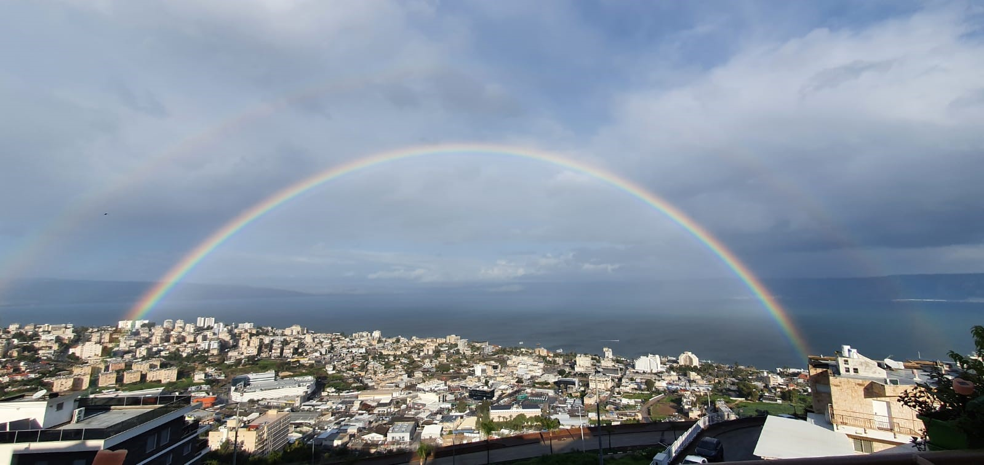
A special rainbow: Taken from a friend’s apartment overlooking Lake Kinneret, the Sea of Galilee, from Tiberias, Israel

Now for some shocking, mind-blowing information as to what is happening to do with dimming the sunlight, and erasing the rainbow. From Steve Quayle’s book Xenogenesis, 2014:
“It would seem that the attempts to transform our atmosphere, and thereby change the exposure we have to the sunlight filtering down to us, will be very detrimental to human health as well as that of other living things on our planet. As such, transformation to our atmosphere through chemtrails and other systems could do profound harm.”
I have been reporting on how the dimming of the sunlight is having very harmful effects on the growing of food crops, as well as the proper working of the bodies of all creatures on earth.
When we are inside for long periods of time without sunlight it has an adverse effect on our over-all health. It is now spring time in the northern hemisphere -- time to get plants outside into the sunlight, and outdoor air. It is time to get our bodies out into the sunlight and outdoor air. Sunshine is psychologically uplifting to the mind and emotions also.
Yes, as we read from Revelation 16, there will come a time in the not far future when the sun will burn people’s skin and the air be polluted that we can’t go outside. So, let us appreciate the natural creation of our Creators as long as we can, and give Yahuwah and Yahushua praise! Oh, how beautiful our earth is. Oh, how hard the fallen ones and their human lackeys are working to destroy everything beautiful, pure, and set-apart unto the esteem of the Creators!
Xenogenesis page 258, chapter 14: “Recently, scientists have found that we need light to be in good health…of course, we know that green plants quickly die if they don’t get enough light. Life on our planet depends on adequate sunlight reaching the surface so that green plants can employ photosynthesis to grow and create fruits and seeds. After years of thinking that sunlight caused cancer and was best avoided, researchers have discovered that the Vitamin D in our bodies when exposed to sunlight actually fights cancer. Sure, you don’t want to overdo things (sunburns do promote skin cancer), but far from being detrimental to our health, moderate exposure to sunlight is actually healthy”
Page 259: “…it’s through sunlight exposure that your body is able to produce vitamin D – and optimized vitamin D levels are key to preventing numerous types of cancer, including melanoma…Might it be that Satan would try to destroy the good things that our Lord created for us by blocking the sunlight from us?
THE COVENANT:
Genesis 9:12-18, NAS: “Then God spoke to Noah and to his sons with him, saying, 9`Now behold, I Myself am establishing My covenant with you, and with your descendants after you; 10and with every living creature that is with you: the birds, the livestock, and every animal of the earth with you; of all that comes out of the ark, every animal of the earth. 11I establish My covenant with you; and all flesh shall never again be eliminated by the waters of a flood, nor shall there again be a flood to destroy the earth.” 12God said, “This is the sign of the covenant which I am making between Me and you and every living creature that is with you, for all future generations; 13I have set My rainbow in the cloud, and it shall serve as a sign of a covenant between Me and the earth. 14It shall come
about, when I make a cloud appear over the earth, that the rainbow will be seen in the cloud, 15and I will remember My covenant, which is between Me and you and every living creature of all flesh; and never again shall the water become a flood to destroy all flesh. 16When the rainbow is in the cloud, then I will look at it, to remember the everlasting covenant between God and every living creature of all flesh that is on the earth.” 17And God said to Noah, “This is the sign of the covenant which I have established between Me and all flesh that is on the earth.”
Now about the rainbow 2021, from Xenogenesis Chapter 13, pages 140-141.
“Most of us consider the rainbow to be only a sign. But like Project Blue Beam and HAARP it may be that there is much more than meets the eye with the Lord’s sign.
It may very well be one of the missing keys to understanding the dangers that human beings now face from the powers intent on destroying us.”
Steve Quayle had a friend who was a high-ranking CIA official. He called Steve to ask him if he was aware of chemtrails: `They are trying to remove the Alpha and the Omega,’ he told me.” He told him about the “Blazer” Project, advanced technology of the dark kingdom that was attempting to “tap into and manipulate the `other dimensions,’ of the spiritual realm.”
This is what CERN is attempting to do, and has done to a certain degree already. His friend went on to say “Think of a rainbow…all the colors flowing together like a river…Now imagine…that the colors of the rainbow are different frequencies of energy, all held in check by the `Alpha and Omega.’ Life is orderly, as long as these two frequencies are there and doing what they do. We don’t often see rainbows, but God created the rainbow as a visible sign to us that He is in control of all of the forces of nature and spirit on this planet. We appreciate it when we see a rainbow…it is, somehow, a spiritual comfort to us. All is well, so to speak.
His tone became more serious and ominous. `What they are working on…and it’s very `black ops’…is a way to remove the Alpha and Omega, the `banks’ that hold all of this in check. This would allow the intermingling of forces that are all now kept separate from one another, forces that were not intended to be together and operating on the same dimensional plane of existence. It will be the unleashing of chaos into the earth.’
Consider the Alpha and Omega to be the `God force’ in the universe. When you think about it, God had been a real presence upon the earth. I mean He literally walked with men upon the earth at the time of creation, and for some time a after…”
Quayle’s friend spoke of Adam and of Enoch. Then Yahuwah’s removal of direct contact with men in a general sense. He spoke of Moses and the Spirit who came down on Jesus. He spoke of the sin of Adam and Eve and how they disrupted the “boundaries that God had set for them. The result was chaos.” He spoke of the dark forces of fallen angels to get humans to cooperate with them, and to join them in overthrowing God from His throne. He spoke of Nimrod and his tower – a attempt using the dark forces of the fallen angels to destroy everything Yahuwah and Yahushua created. Then he mentioned the phrase in Genesis 11 “nothing will be kept from them that they conceive.”
Quayle’s friend, nicknamed “Langley,” made this powerful statement: “Think about how unusual that statement is. God can do whatever He wants, but the building of this tower was of concern to him. This is a striking statement! The tower represented something unique, a willing participation between fallen angels and a human…Towers, pyramids, mountains, all places of dark worship…”
“Langley”: “Patiently, these dark forces waited, suggesting to men new ideas and inventions, new technologies and innovations, the discover of new materials and concepts that would eventually lead to today’s `information and technological revolution’ – which is nothing more than a return to the Tower of Babel.”
Steve Quayle: “As to the removal of the Alpha and Omega, “Langley” was convinced (as I am) that the final chapter is about to be revealed…that we are on the verge of witnessing the restraining walls between dimensions, the restraining power of the Holy Spirit being removed.”
This blew me away – it still is overwhelming to learn what is happening to our planet, and thus to all life on it. I began writing on these things a few years back. In January of 2016 I wrote 3 articles on the removing of the restraining power of the Spirit. In Genesis 6:1-4, it refers to the Yahuwah, the Spirit, giving those “who are also flesh” 120 years, but with His striving with them, as they seek to accomplish their final desires on humanity. Then He would withdraw His restraint, and for a time of “tribulation” mankind would be exposed to the full brunt of fallen angel power. Yet, Yahuwah would not leave earth without a representation of His set-apart ones whom the evil ones have no power over. It would be at time of great massive slaughtering of almost all true believers, as we see in Revelation 6:9-11, Revelation 7:9-17, Revelation 14:12-13, and Revelation 20:4, 6.
According to Enoch 70 generation prophecy, the return of the fallen ones happened in 1896. It’s not just me saying that - it’s lots of others too. That was the year marked by “knowledge shall increase and men shall run to and fro,” Daniel 12. The technology given to man by the fallen ones before the Flood began to be given to mankind again, for the destruction of earth and all life on it.
That 120 years of the Spirit’s striving ended in January of 2016. Thus, I wrote what Yahuwah gave me to write in those three articles about “Withdrawal…” Since, then, final things have compacted together, and more so as every day goes forth – the prophetic word leading to the return of Yahushua Messiah.

THE RAINBOW, THE COVENANT SIGN OF YAHUWAH WITH HIS PEOPLE
Excerpts from Xenogenesis pages 244-252
Quayle: “Mankind has come to the point in history where he is, technologically, able to do most anything that he conceives of. “Thinking themselves wise, they became fools.”
“Jesus said, `I AM the Alpha and Omega, the Beginning and the End, the First and the Last.” In Hebrew: “I AM the Aleph and the Tav …”
“Langley,” Quayle CIA friend passed away in 2009. He understood the powerful control of Yahuwah and Yahushua upon Their Creation. The enemy is NOT FREE to do as he wills, though he wants you to think so. Yahuwah has given His born again and Spirit-filled children, authority over “all the works of the enemy,” with gifts and powers – if they would only use them. Inspired by Yahuwah, the Apostle Sha’ul gave us II Corinthians 10:3-6 and Ephesians 6:10-18. But King David also understood warfare, in the natural and in the spirit-realm. The Psalms give us wonderful proclamations in warfare. We do not have to be under the jurisdiction of the fallen ones – we are free because of the blood of Messiah shed for us, and His resurrection, which we just celebrated on April 4th.
Now, those who are tapping into stolen technology, stolen from Yahuwah by the fallen angels, they want to do away totally with human DNA and create a hybrid race of part once-humans and robots within the blood stream, or within a metal robot. The RNA-messaging vaccine now being demanded to “buy or sell” is no more than a human DNA-destroying technology to build inside a human body, in 4 phases, a system of control, to finally join the human body to an A.I. system using 5-G for starters. No longer human, these entities will not be able to die … thus Revelation 9. But, then, most probably won’t want to die – they will be worshipping the Beast.
To conclude this erasing of the rainbow, quoting from pages 245-248:
They want to erase everything that Yahuwah has placed on earth for our good!
“Remember that the rainbow is more than just a pretty promise that God put in the sky. It is a visual representation of the atmosphere. The different colors represent different frequencies of light. Those frequency-layers were put there by God as a barrier to block certain dark frequencies from being able to be as active on the earth.”
“`Project Blue Beam’ is more than just a code name. The blue, violet and purple colors/frequencies, are the God-frequencies – the Alpha and Omega frequencies, representing Jesus.” Please refer to: “Mysterious Monoliths … which has information on what Project Blue Beam really is/Mikvah of Present Reality/December 10, 2020.
“The current scientific work being done by the powers that be are to lessen or eliminate those three colors, or barriers, so there will be an increase in the dark frequencies. The more visible to us in this state of existence, the further these frequencies are from God – more worldly.
Removing the blue-violet-purple, through HAARP and other means, results in a concentration of negative power. By eliminating or lessening the blue range of light, they are removing the barriers that keep the dark frequencies in check … allowing them to concentrate…allowing dark forces to come together and increase in strength.
God’s rainbow is a visible reminder that He has all of the forces of nature and spirit in check. Some men understanding this and are working to eliminate those checks and balances, for their own and the dark force’s agendas.
The rainbow represents the atmospheric covering that God placed over/around the earth after the flood, so that demonic forces would not have the ability to directly interact with men like they did in the days of Noah.
Of course! The Bible says that the end-times will be AS the days of Noah, so you can see how it is important to the powers that be to put things back like they were before the flood?
This is the purpose of HAARP and aircraft chem.-trails [`chemical trails’] and all of the other projects. The true purpose is known by the powers that be, but even those high up in the programs don’t always realize this true purpose.”
Refer to the 5-G articles/Mikvah of Present Reality beginning December 12, 2019 “5-G: Deadly Radiation is Covering the Earth, and January 31, 2020 “5-G: HAARP, the Military…’
“One more thing about HAARP and the Alpha and Omega frequencies, There are over 2,700 satellites right ow that ae in space and that have turners that can increase of block the Alpha and Omega frequencies that reach the earth. When they want to, they can bombard the earth with the negative waves/ frequencies…You will suddenly see increased negative tension and anxiety, such as family arguments. As the frequency strength is increased, outright unexplainable violence and crime will be seen.
God has had His hand on us. Man, aided by demonic forces, is about to try to remove the natural order that God set up after the flood. God will allow this to some degree – then He will stop is and put all things as they should be.”
As Quayle asks, have you noticed that we are seeing fewer and fewer rainbows? I lived near Boquete, Panama, for about 3 years. I loved it. Boquete is known as the “Rainbow capital of the world.” We saw so many of them. It is so sad that we hardly see any nowadays. When living in Costa Rica I saw rainbows. But, in the U.S., they are lessening.
So, the rainbow is not just a sign that no more flooding of the earth would happen, but a real scientific happening – that blocks the entrance of the fallen ones to a degree … but now, as they lessen, become less frequent, and fade as the sunlight fades, we see the attempt to open portals to other dimensions for the entrance of more fallen angels and their mutates – which we call “aliens.”
War in the heavenlies is a real thing! The attempted removal of everything that Yahushua spoke into existence in Genesis 1:3 is being attacked, to eliminate His likeness and image from the earth – to erase His nature, ways, and thinking, the most powerful being love, joy, peace, faith, gentleness, kindness, compassion, patience, self-control of emotions, and mercy. Notice the changes in human nature, especially since January 2020?
Our whole atmosphere is also being changed. Refer to: “Terraforming the Earth…”/Mikvah of Present Reality. It is a fallen angel-Nephilim project.
Our water supplies, food crops, the air we breathe, our clothing and products we use daily are all contaminated with health destroying chemicals. Please refer to my three articles on “chemtrails” under the Mikvah of Present Reality, to get further information on what HAARP is doing, and what is being sprayed on you. It’s really necessary that you get this information and share with others.
Yes, our sun is being dimmed. Photosynthesis is what makes plants grow: sunlight, water, CO2 – what we exhale. All of life on earth is being harmed, damaged, destroyed – bees are dying of dementia from what is being sprayed from airplanes. I give you lots of pictures of chemtrails in those three articles. Please learn all you can for your own survival.
Make sure you’ve read the two articles with the titles “Is the Covid 19 Vaccine the Mark of the Beast?” They contain much information that is backed by much confirmation.
In His love, Yedidah
April 7, 2021

