THE HIDDEN RIGHT HAND OF YAHUWAH
Exposing the Satanic Counterfeit

Psalm 74:11: “Why do you hold back Your hand, even your right hand from the midst of Your bosom…?”
John 1:18: “No one has ever seen Yahuwah. The only begotten Son, who is in the bosom of the Father, He has declared Him.”

I’m sure you’ve heard the story of the man who went to work for the counterfeit-tracking division of the U.S. Treasury. After a few weeks of training, a friend remarked to him: “I bet you’ve seen loads of counterfeit bills.” The man replied, “No, I have not seen one. The idea is for me to see only the genuine and observe every detail, so that if I ever see a counterfeit, I’ll recognize it right away.”
In the foundational article for this one “Yahuwah’s Right Hand and the Right Arm,” posted January 17th/Mikvah of the Covenant, I take you through an eye-opening study of the right hand and right arm of Yahuwah, which is connected amazingly with reference to Messiah, hidden in the Hebrew words, like “yeshua.”
Here, hoping you’ve already grasped the genuine “right Hand” of Yahuwah, as in Isaiah 41:10, 13, I begin showing you the counterfeiting by Elite globalist Satanists of the “hidden hand” within the bosom of Yahuwah.
I conclude this article by giving you a powerful revelation -- another connection to the right hand of Yahuwah, which He conceals in His bosom until the right time to take out the “Hand” and send Him forth to end the reign of Satan and the fallen ones, and to take His rightful place as King and Judge over the earth. (Revelation 11:15-18; Revelation 19) I also give you Hebrew and Greek word meanings.
Satan and his “illumined” forces can only counterfeit what originated with Yahuwah. If they create something “new” it is founded on technology and other knowledge they learned from their once-close association with Yahuwah.
Below are pictured history-changing people with their right hand in their bosom, the area between the arms.
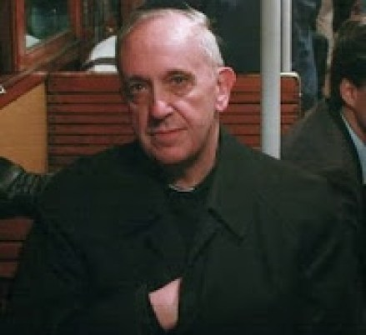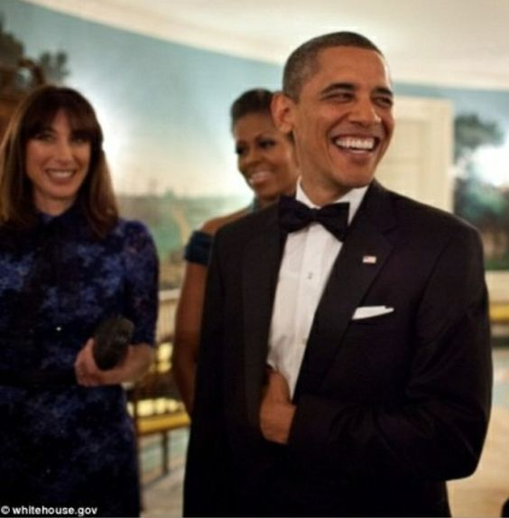
Pope Francis President Barak Hussein Obama
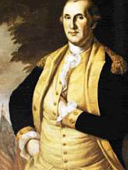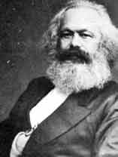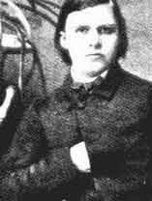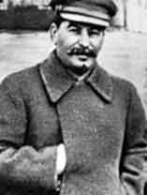
George Washington Karl Marx Friedrich Nietzsche Joseph Stalin
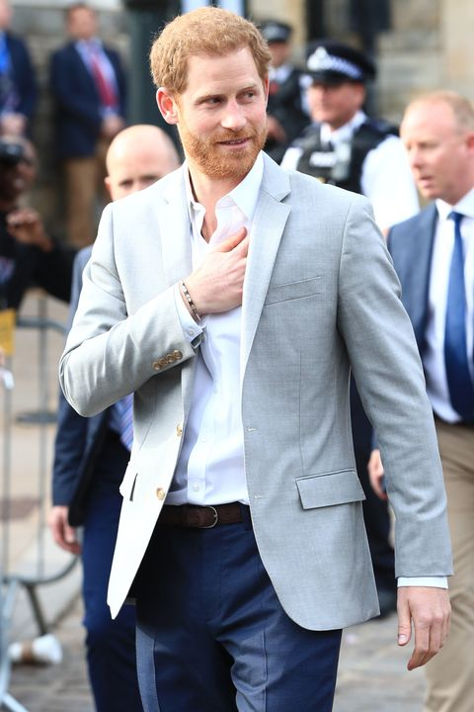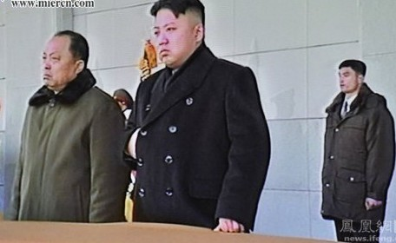
Prince Harry Kim Jong-Un – North Korea

There are many Illuminati and Freemason gestures of elite world rulers who have united to bring forth a new world order, from 1776. These gestures and handshakes are ways of communicating to their fellow treacherous “gang members” that they are united as one in their hidden goals--goals for a one world government, a return to the pre-Flood “Golden Age” when the gods ruled the earth. Each one has belief he will be changed into such a god to rule earth. It is a mentality steeped in Satanism – the fastest growing religion on earth right now.
Nothing that Satan and his followers do is original – all is counterfeited and copied from what they saw Yahuwah do, using His ingenious methodology.
Why would they use the hidden hand symbol through history from 1776 and even before? It was in 1776, that the son of a rabbi who became a Jesuit, who taught in a Jesuit College in Bavaria, name his secret organization the “Illuminati,” the society of the Illumined ones. Of course, the Hebrew “Heylel,” the Latin “Lucifer,” also means the illumined one, the light-bearer.
In Albert Pike’s Masonic “Bible,” Morals and Dogmas, he referred to Lucifer as the god of Freemasonry. It was Albert Pike, founder of the KKK (Klu Klux Klan), Grand Master of the Scottish Rite Freemasons in America, who, in 1871, worked with Illuminati chief Giuseppe Mazzini, founder of the Mafia, to create a three-part plan for three government uprisings and three world wars that would lead to the new world order.
Please refer to this plan in “The Pike-Mazzini Plan of 1871: The Plan For Global Government – The Perfect Execution of Parts I, II, and Now Part III”/ Mikvah of Israel, Our Eternal Inheritance.
It has been carried out to the letter with the hidden purpose behind WWI and WWII, leading to WWIII which will usher in a world government.
Who is at the top of the world rule under Satan, the fallen angels, and their hybrid offspring Nephilim? Satan’s goals are carried out through Weishaupt’s Illuminati and their foot soldiers--Elite Scottish Rite Freemasons. Also alongside the Illuminati is the Jesuit Order of the Vatican, founded by the Jewish Ignatius Loyola who had converted to Catholicism. Loyola later founded the Jesuit Order. Standing also as messengers and foot soldiers are the Elite of the political “Labor Zionists.” Behind it all is the Satanic power of the Shabbati Tsvi-Jacob Frank world leaders going back to 1666. Servant groups abound, and, at the core worship Satan.
For details of that mind-boggling history please refer to “1666: Shabtai Tzvi and Redemption Through Sinning”/Mikvah of Israel, Our Eternal inheritance. I guarantee that if you read this article, you’ll understand a lot of what’s going on.
Through infiltration into Judaism, Islam, and Christianity, this evil death-cult, organized under the Tzvi and Frank has placed the world deeper under the control of the fallen ones who actually control everything in the world system today.
If you’re up to it, I recommend David Icke’s 900-page book Trigger. He not only exposes all of this, but shows how it connects with all major events that are leading up to earth’s full control under global government--the “new world order,” the “one world government.” This is all spelled out in the Bible. The “trigger” to the completion of the “Plan” began with the false flag of 9/11. Icke is a bottom-line writer, and how he starts with 9/11/2001 USA and ties it to the world rule of the Shabbati-Frankists is a masterpiece. I’ve studied these things from back in 2001, and Icke “summarizes” in his 900-pages. I met Barry Chamish in Jerusalem. He dedicated his life, literally, to exposing evil that is harming the world’s people.
Icke condenses the information in classic exposés, like Barry Chamish’s Shabtai Tzvi, Labor Zionism, and the Holocaust, and Rabbi Antelman’s two volumes, To Eliminate the Opiate. What these men have exposed is absolutely true, and brings to light very many lies we’ve been told.

Youtube Interview with David Icke: “DAVID ICKE - SABBATIANISM AND THE HIDDEN HAND OF 9/11” | London Real/September 11, 2019
Icke says that the “hidden hand” is a “web” of those seeking global rule. He tells of the emergence of a rabbi named Shabbtai Tzvi in 1666 who was proclaimed the messiah, June 18, 1666. Note June is the 6th month, 18 is 3 sixes, and year’s date.
To understand the obsession of rabbinic Judaism with 6s, refer to: “Explaining the 666: Kabbala’s Gamatria and Its Obsession with the Sixth Hebrew Letter under the Mikvah of Israel, Our Eternal Inheritance.
Tzvi taught that God had reversed everything in the Torah so that what was unlawful became not just lawful but mandatory. He taught that we are now redeemed by sinning--deep, deep sinning. Years later his disciple, Jacob Frank, took it further, and the doctrine of salvation by sinning became accepted by over 70% of European Jews.
The Babylonian Talmud became the book outlining this doctrine and the Kabbala continued on with a total immersion into Satanism. To spread the doctrine initially, Tzvi was called before Islamic leaders who threatened to kill him if he didn’t convert to Islam. He converted to Islam and continued to teach this doctrine from the inside of Islam. Later Jacob Frank pretended to convert to Islam, and then converted also to Roman Catholicism. He worked from the inside to control doctrine, to take over governments, financial institutions, commerce, trade, universities, colleges, education from its lowest levels, to promote sin as not just OK but required by God.
The Jesuit Order bought into this doctrine through Loyola, and also began to take over worldwide by infiltration into high positions in governments, in banking, commerce and trade, religions, and the militaries of the world.
What Icke brings out in this interview is that the world is now under the total rule of the followers of Shabbatianism and the Frankists. You can get the bottom line details in my shocking article “1666: Shabbtai Tzvi and Redemption Through Sinning”/Mikvah of Israel, Our Eternal Inheritance
David Icke explains the cult is known as Shabbtaism. He emphasizes that it is NOT a Jewish plan to take over the world! But, it is a plan that has worked through a few Jews (those “who say they are Jews but are not”/Revelation 2:9 and 3:9) who want to rule the world.
This hierarch Elite hate anyone they consider beneath them – especially the Jewish people as a whole, even to participating in the slaughter of 60,000 Jews and Christians under Stalin, and with the Holocaust death camps under Hitler. They promote the execution of, and conclusion of, the 1871 “Plan” of Pike and Mazzini.
This is a satanic cabal that has used the Jews, Christians, and Muslims to reach their goals, as you’ll read in that article “The Pike-Mazzini Plan of 1871: The Plan For Global Government – The Perfect Execution of Parts I, II, and Now Part III” and “One World Religion! The Mystery Babylon We Never Imagined! The Vatican Bows!”/both under the Mikvah of Israel, Our Eternal Inheritance.
We love the Jewish people and we despise what the enemy has planned for them, for Israel, and for Jerusalem! We pray for their salvation through Yahushua!
What is behind the decayed morals in our Western culture --incredible upsurge of adultery, abortion, pedophile abuse of children, the emotionless murder of those who get in their way, lying, deceiving, wars, etc? It’s all about the complete reversal of the Torah, especially the Ten Commandments, that is believed by the globalist Frankists/Illuminati/Jesuits who now rule the world under a hidden world government.
I, and about 5 other ladies, saw and heard the official announcement from the U.S. Pentagon of the establishment of the one world government in May of 1999 while in Aqaba, Jordan, via CNN and BBC Europe. It was heard over the U.K. and Europe, but not ever heard in America.
Please read the and see for yourself the lies told by Orthodox and Hasidic Rabbis to people worldwide in order to hide their dedication to only the Babylonian Talmud and the Kabbalah in ““Quotes That Forever Destroy Damming Illusions”/Mikvah of Israel, Our Eternal Inheritance.
Today the reverse-of-Torah Shabbtai-Frankist doctrine of reversal, redemption by sinning, which is encouraged in the Babylonian Talmud, is the basis for many laws in America, like abortion laws, and in other countries.
As Icke explains, this is not about precious Jewish people. It is about what been done to harm them and everyone else.
In the interview, David Icke tells how the Islamic religion was infiltrated from Shabbati Tzvi’s fake conversion to Islam, until it became the religion of the Saudi Royal family. It also reached far into the British Empire. Hitler said that he wished Islam would be the world religion, but he meant the cult within it that controlled much of it – Shabbtaiism. There were Muslims who helped the efforts of Hitler.
Icke clearly calls this a “Satanic cult.” Those in this cult hate Jewish people with a vengeance, he said. Jacob Frank claimed to be the reincarnation of Tzvi.
The followers of Frank infiltrated the Roman Catholic Church. Enter Ignatius Loyola and his Jesuits. The Jesuits at the top are known to be practicing Satanists. They adhere to the Shabbtaian-Frankist cult. They are #2 under the Illuminati. Their founder, like Weishupt, was a Jewish Shabbtai-Frankist whose family had converted to Catholicism. So, when the cult slithered into the Jesuit Order, it infiltrated inquisitions and the hierarchy of the Church to the point where the Jesuit leader, “the Black Pope,” became more powerful in the Vatican than the “White Pope.” (The black and white refers to their religious apparel.)
Icke tells how the “Christian Zionist” movement came out of the infiltration of the Shabbtai-Frankist cult into the Evangelical and Charismatic churches. Doctrines were introduced into these church groups from the 1800s that radically changed the teachings of the Evangelical and Charismatic Protestant churches. I go into that in “Warning! Exposing Nine Lies…”/Mikvah of Present Reality.
Jacob Frank got in tight with the Rothschilds, and the billionaire Rothschilds began to spread the cult-doctrine of reversal of Torah. The plans of Pike and Mazzini were funded to a great degree by the Rothschilds. Rothschild money was used to a great extent to found Israel.
Jacob Frank and Amschel Rothschild hooked up with Adam Weishaupt and we got the Illuminati. The “Bible” of this cult is the Kabbalah!
The leading book of the Kabbalah is the Zohar. The word “Zohar” means illumination. This is where Frank, Amschel Rothschild, and Adam Weishaupt, got the name “Illuminati.”
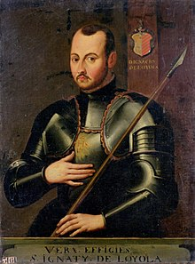
Ignatius Loyola, founder of the Jesuit, a Spanish soldier, a Sephardic Jew whose family converted to Catholicism to escape the Inquisition.
“The “Illuminati” is an ultra secret organization, purportedly founded by a trained Jesuit named Adam Weishaupt in 1776. The Illuminati is in fact a reincarnation of the ancient Alumbrados, whose one time leader was Ignatius of Loyola, the founder of the Jesuits, Ignatius Loyola himself.” “Alumbrados” means “illumination, Illuminati, illumined ones.”
Is this whole picture clicking together in your understanding?
From 1776, offspring groups of the Shabbati-Frankists began doing more infiltrating. Most Jesuits are not priests, but are leaders in governments, banks, commerce and trade, education, and religion. Joe Biden is a Jesuit.
Icke tells the plan for WWII to get the Jews back to “Palestine.” It’s the set up for WWIII. Of course Yahuwah allowed it to fulfill His prophetic Word. He enjoys spoiling the plans of His enemies.
Now you know why Israel and Saudi Arabia’s royal family are so closely tied together.
In his book, Trigger, Icke tells how the Shabbtai-Frankists moved into America to take it over. They worked closely with the Vatican and with the Jesuits. Charles Chinique’s classic autobiography, Fifty Years in the Church of Rome, tells much of this. In fact, the Pope hired Jefferson Davis as his infiltrator, and financed the Civil War. It was the Jesuits who plotted the murder of Abraham Lincoln and succeeded. Chinique’s book tells the details, since early on Lincoln was Chinique’s Lawyer. In his book, it shows that the Word of Elohim and the true new birth triumphed over all opposition to it by the Church. It’s an awesome book.
The Shabbtai-Frankists infiltrated the C.I.A., the Israeli Mossad, too, the U.S. Pentagon, many other groups within the government, the present Democratic Party, and Congress, etc. Their doctrines of Torah-reversal, and God’s new commands to sin, have given them license to do all the horrible things they do.
Ever wonder why they have no problem doing evil? With all law of God removed, they can do as they will to please their new master, Lucifer/Satan.
Shimon Perez, President of Israel during the days Ariel Sharon was Prime Minister, made a statement in one of his speeches about the need to remove the Jewish people from Gaza. He said “Gaza first for Shabbati Tzvi.” He was a Shabbtai-Frankist, as have been many ruling Americans for nearly 400 years, and the Israeli Prime Ministers from the beginning.
Iche concludes his interview by saying that this cult was behind 9/11. It was the trigger for the launching of world government. Yes, it was!
Therefore, the hidden hand gesture of the Illuminati – the Shabbati-Frankist cult – Jesuits, all of their servant groups like Freemasons, Skull and Bones, Bilderberger Group, Clue of Rome, Council on Foreign Relations, the Trilateral Commission, etc., and all Elite world rulers of today, is a secret sign that their god, who has been hidden, will soon come out to take world power.
Now where did they get that! – By counterfeiting Psalm 74:10-12 and John 1:18! Are you grasping the enormity of that! (Revelation 9:11!)
***The Shabbtai-Frankists, and all under them, the Satan-worshipping counterfeiters, are preparing to bring their hidden messiah, their returned “Holy Serpent,” the Beast of Revelation 13:1-10, out of their collective bosom to rule the world!
***At the same time, Yahuwah is pulling His Hand, His Son, out of hiding, to release Him to come and end the reign of Satan and beast-son forever! The final confrontation is found in Revelation 19:11-21, as Messiah descends and the first resurrection occults. Note Revelation 19:19 – short fight.
Now that the counterfeit is exposed, we see where they got the idea of the hidden hand gesture they use to communicate with those of like mind.
Psalm 74:11: “Why do you hold back Your hand, even your right hand from the midst of Your bosom…?” (“right hand” Strong’s #3225 is “yamin”)
John 1:18: “No one has ever seen Yahuwah. The only begotten Son, who is in the bosom of the Father, He did declare.”
Psalm 89:10, 13 “You have scattered Your enemies with the arm of Your strength…You have a mighty arm; Your right hand is strong; Your right hand is exalted.”
Isaiah 40:10-11: “See, the Master Yahuwah comes with a strong hand and His arm rules for Him. See, His reward is with Him and His recompense before Him. He feeds His flock like a shepherd. He gathers the lambs with His arm, and carries them in His bosom, gently leading those who are with young.” *This is a profound prophecy of Yahushua Messiah, known here as “His right hand and His arm.”
The word “bosom,” in Hebrew, is Strong’s Dictionary #2436 “cheq.” It means to lie in one’s arms at the chest/breast, the interior, midst, hidden within.”
Messiah Yahushua, the Son, is the right hand of Yahuwah hidden between the “arms” of His Father, Yahuwah, close to the chest of “Shaddai.” He awaits the time when His Abba will release Him to return for us.
Does this reveal Psalm 91 also? While we in the West say that “Shaddai” means “Almighty,” it’s more expressive meaning, closer to the Hebrew understanding, is “the many-breasted One,” literally “the One with many teats.”“Shaddai” is the name that Abraham knew Him as – the one who provides all that we need as we cuddle up at His breast, between His arms, under His talit.
The Son, the right arm, the right hand of Yahuwah, symbolically and spiritually, lies in the bosom of His Father, waiting for the time when He will be taken out to avenge the sin of the evil ones against His Father. All judgment will be put into His Hands as He descends at His return.
The Greek word in John 1:18 for “bosom” is “kolpos.” It means “the upper part of the chest where a garment naturally is folded to form a pocket, called the `bosom.’ ” “The position is synonymous with intimacy, union. The word means `in front of the body, between the arms.’
Understanding John 13:23, “kolpos” further means: “The one who so reclines at the table that his head covers the boson or the chest of the one next to him. The `bosom’ of a garment is the hollow formed by the upper forepart of a rather loose garment bound by a girdle used for keeping and carrying things, a fold or pocket.”
John 13:23: When Yochanan/John leaned on the bosom of Messiah, he asked Him who would betray Him. Yahushua showed great grief. Because of the intimate trusting friendship between them, Messiah told John what He told no one else. Messiah knew that He would come to show this disciple the future we read in Revelation.
We have the privilege of snuggling up into the bosom of Messiah also, to hear what He is saying now. Messiah is waiting for His Father to take Him, His right hand, out of His protective “pocket,” and loose Him to mount His horse to descend with His wrath (Isaiah 34, 63:1-6, Revelation 19, I Corinthians 15:51-58)
Messiah ascended back into heaven (Acts 1:8) after crushing the head of Satan, thus passing final judgment on him and all of his fallen ones. Revelation 19-20 tells our future and their future. He’ll conclude the crushing at His return (Revelation 20).
Knowing their future, the fallen ones are using human beings to infiltrate into humanity for them. And human kind has done a good job of it – sinning to the max – worshipping and obeying Satan/Lucifer. Abortion and wars are just two of the blood sacrifices offered to Satan, along with murders of all types. Wherever the blood of innocents is shed by evil, it is a sacrifice to Satan.
Refer to: “Is There a Blood Curse Over Planet Earth?”/Mikvah of the Heart of Elohim. The Babylonian Talmud, and the Zohar of Kabbalah, spells out just how to do the evil necessary to appease Satan and their messiah--the “Holy Serpent,” “Leviathan,” (Isaiah 28: )--the fourth Beast of Daniel 7, Revelation 13:1-10, and Revelation 17.
In Psalm 74, King David called out in his despair for Yahuwah to take His right arm out of His bosom. In John 1:18, Messiah said He was in the bosom of Yahuwah. Yahuwah is about to pull His right arm, His right hand, out of hiding - to go forth and conquer– Revelation 19.
Please add this insight into your of His right hand and right arm that brings Him His victory in “The Right Hand and Right Arm is Yahushu,” Mikvah of the Covenant.
Messiah fights for you too! In many of the verses about Him which I’ve listed in “Yahuwah’s Right Hand and Right Arm is Yahushua,” the Hebrew words for “salvation” and “deliverance” are in the same verse, like “Yeshua,” and “yesha.”
Be blessed! In His love, Yedidah
January 22, 2020

