The four proclamation pillars spoken by Messiah
A message for First Fruits

I Corinthians 15:20, 23: “…Now Messiah has been raised from the dead, and has become the first-fruit of those who have fallen asleep. For since death is through a man, resurrection of the dead is also through a Man. For as all die in Adam, so shall all be made alive in Messiah. For each in his own order: Messiah the first-fruits, then those who are of Messiah at His coming.”

Iyob/Job 19:23-27, KJV: “Oh that my words were now written! oh that they were printed in a book! 24That they were graven with an iron pen and lead in the rock forever! 25For I know that my redeemer liveth, and that he shall stand at the latter day upon the earth: 26And though after my skin worms destroy this body, yet in my flesh shall I see God: 27Whom I shall see for myself, and mine eyes shall behold, and not another; though my reins be consumed within me”

Iyob 14:13-15, KJV: “O that thou wouldest hide me in the grave, that thou wouldest keep me secret, until thy wrath be past, that thou wouldest appoint me a set time, and remember me! 14If a man die, shall he live again? all the days of my appointed time will I wait, till my change come. 15Thou shalt call, and I will answer thee: thou wilt have a desire to the work of thine hands.”

Iyob/Job, is the oldest book in the Bible. Yet, Iyob well knew about the resurrection unto life of those who know the Living God. He knew that one day he would see “God” – he would see Yahuwah; he would be translated at the coming of Yahushua.

I Corinthians 15:50-58, KJV: “Now this I say, brethren, that flesh and blood cannot inherit the kingdom of God; neither doth corruption inherit incorruption. 51Behold, I shew you a mystery; We shall not all sleep, but we shall all be changed, 52In a moment, in the twinkling of an eye, at the last trump: for the trumpet shall sound, and the dead shall be raised incorruptible, and we shall be changed. 53For this corruptible must put on incorruption, and this mortal must put on immortality. 54So when this corruptible shall have put on incorruption, and this mortal shall have put on immortality, then shall be brought to pass the saying that is written, Death is swallowed up in victory. 55O death, where is thy sting? O grave, where is thy victory? 56The sting of death is sin; and the strength of sin is the law. 57But thanks be to God, which giveth us the victory through our Lord Jesus Christ. 58Therefore, my beloved brethren, be ye stedfast, unmoveable, always abounding in the work of the Lord, forasmuch as ye know that your labor is not in vain in the Lord.”
The Torah taught us right and wrong, sin and righteousness. It gives us Festivals that picture the plan of salvation from Yahushua’s death to His second coming and “tabernacling” with us. Colossians 2: It was the penalty for sin against the righteousness of the Torah that was nailed to the stake. Messiah took on the sin of disobedience to His Father as spelled out in the Torah onto Himself and died to pay the penalty of death for breaking the Torah. Therefore, as born-again believers, we owe everything to Yahushua Messiah, for without His being the “Lamb of Yahuwah who takes away the sin of the world,” we are without hope, being “under” the penalty of disobedience. John 3:8: “Sin is the transgression of the Torah.” He died to REMOVE our sin, something animal sacrifice could never do. Please listen to the podcasts on Hebrews 9 and 10 to understand what that means. The transcripts for both podcasts are under the Mikvah of Israel, Our Eternal inheritance.
The shedding of the blood of bulls, goats, sheep for the COVERING of sin was totally done away with in the death, burial, and resurrection of Yahushua, so that the good rules of the Torah for right standing in His Kingdom might be observed by those born-again by faith in the blood of the Lamb, Yahushua.
The “last trumpet” is found in Revelation 11:15: “And the seventh trumpet sounded and there came to be loud voices in heaven saying, `The kingdoms of this world have become the kingdoms of our Master, and of His Messiah, and He shall reign forever and ever.”
At the last trumpet, He descends with the wrath of His Father, and in the “twinkling of an eye,” He resurrects those who died with faith in Him, and those from the days before His coming to earth who had faith in Him, like King David who prophesied details of His crucifixion/nailing to the stake, and His glorious entrance into heaven with His blood to redeem us. I will soon be podcasting Hebrews 11, showing that all who died in faith did so looking for their Redeemer, Savior, their “yeshua” salvation, the right-hand and right arm of Yahuwah, to deliver them.
Please refer to “The Right Hand and the Right Arm of Yahuwah is Yahushua,” Mikvah of the Covenant.

THE FOUR PROCLAMATIONS BY MESSIAH YAHUSHUA, ON WHICH THE WHOLE OF SCRIPTURE IS ATTACHED

1) Genesis 3:15, spoken by Yahushua to the Nachash in the Garden in the presence of Adam and Eve, before they were expelled from the Garden of Eden: “And I will put enmity between you and the woman, between your seed and her Seed. He shall crush your head, and you shall crush His heel.”
This is called the “Protoevangel,” the first evangelistic message by Messiah to the human race. He told the serpent, Lucifer/Satan, that there would be warfare between human beings and his fallen angel kingdom but in the end, though he may crush the heel of Messiah in an attempt to take Him down, ultimately Messiah, born of the virgin Miriam, would crush his head forever, and send him to the lake of fire.

2) John 19:30: “It is Finished” “And when Yahushua took the sour wine, He said: “It is finished.” Bowing His head, He gave us up His spirit.” He had accomplished the payment for our sin, and taken our sin upon Himself. It was over. Those words in Greek mean “DEBT PAID IN FULL!” - IT IS ACCOMPLISHED ONCE FOREVER. He paid the debt we owe for rebelling against Yahuwah’s nature, ways, thinking, and His commands - His Word.
II Corinthians 5:21: “For He (Yahushua) who knew no sin, become sin for us, so that in Him we might become the righteousness of Yahuwah.”

3) John 11:25-26, words spoken to Martha before He raised her brother Lazarus from the dead: “I AM the resurrection and the life. He who believes in Me, though He dies, he shall live. And everyone who is living and believing in Me shall never die at all. Do you believe this?”
Please refer to: “The Really Good News About Martyrdom and Death” for in-depth teaching on the passing from death to life.

4) John 14:3: “And if I go and prepare a place for you, I will come again and receive you to Myself; that where I am, there you may be also.”
Because He lives, we live also, and there is no death – only eternal life. Therefore, Messiah, in triumphing over sin and death itself, is able to take us to Himself in passing from the carnal body of flesh into His Kingdom.
These four proclamations by Yahushua encompass the message of salvation through Him,
On the stake, He crushed the head of the serpent, the Nachash, Satan, and his sentence was passed – into the lake of fire forever. That Day of His return with the wrath of His Father is the day of finality for all the fallen ones who followed Lucifer in rebellion against Yahuwah. Revelation 19-20
The whole of the Word, starting with Genesis 1:1 through Revelation 22:21 is all about Yahushua and the salvation of a lost family of human beings, created in the likeness and image of Yahuwah. All of creation was perfect until the fallen ones corrupted it and corrupted even those living in the portal of the throne room at the base of Mount Moriah, between Moriah and Zion and the Mount of Olives.
In that small area, the epicenter of the Garden, Messiah prayed in the Garden of Gethsemane. He looked right at where the tree of the knowledge of good and evil once stood, right at where the tree of life still stands. “For the joy before Him, He endured the cross/stake/pole/tree.” On the stake, He looked down and saw Yochanan, His disciple, standing by His mother, Miriam. He knew that soon He would be giving the Revelation of these days we’re in to His second coming, to Yochanan. Also, as my son brought out, He saw Miriam, of the House of Judah, and Yochanan of the House of Ephraim, standing together in Jerusalem. This is particularly why He came: To unite the whole House of Ya’cob into one (Ezekiel 37:15-28). This is the promise of the Kingdom - so that all in Messiah, all of His family, will be together in the Kingdom on this earth in their own inheritance. (Ezekiel 47-48) All in Messiah are children of Abraham by faith in Yahushua.
Today is the day before First Fruits 2021. In 2003, I walked to the Garden that enclosed the ancient ruins of the pools of Bethesda, at the north end of Mount Moriah/the Temple Mount. As I entered the garden, Yahushua spoke to my spirit: “After 38 years.” At those ruins (John 5), a man who had been waiting for his healing for 38 years was healed by Messiah. I did some quick math. 38 years before, I had made a decision that cruelly damaged 38 years of my life, 30 years physically, mentally, emotionally, and 12 of those years spiritually. Then 8 years of more mental anguish because of memories.
I began crying very hard. I walked to the entrance of those ruins. And as stood at the entrance, I saw Messiah Yahushua standing in front of me. I stopped and stared. He graciously bent over slightly, and with a sweeping gesture of His right arm, He welcomed me to the ruins. I cried so hard. I walked around those small ruins slowly. As I came out, He said the words to me that He said to the man who was healed there, “go and sin no more.” From that moment, every mental and emotional hurt was removed, memories dulled, and I walked out of there free - healed of the past. To this day, 18 years later, I have had no bad memories of those days, nothing but peace. So, I celebrate First Fruits with the memory of His face. He rose from the dead to give us eternal life. He also arose to change things in this life for us as we submit to Him as Master – to lighten our load, to set us free.
Matthew 11:29-30: “29Take My yoke upon you and learn from Me; for I am gentle and humble in heart, and you will find rest for your souls. 30For My yoke is easy and My burden is light.” Berean Study Bible
Rejoice in the Master Yahushua today and forever! For what was planned by He and His Father before the foundation of the world, choosing us to be born-again and filled with Yahuwah’s Spirit, to become as One of His children, is the greatest gift anyone could ever give us.
Please read the article “Revelation 5: Being Found Worthy/Mikvah of the Heart of Elohim,” and worship Him today.
This screen shot was shared today on our Prayer Center Group Messaging – Awesome!!! Yes, Yahushua Messiah/Yahshua/Jesus paid it all for us – “all to Him we owe!!
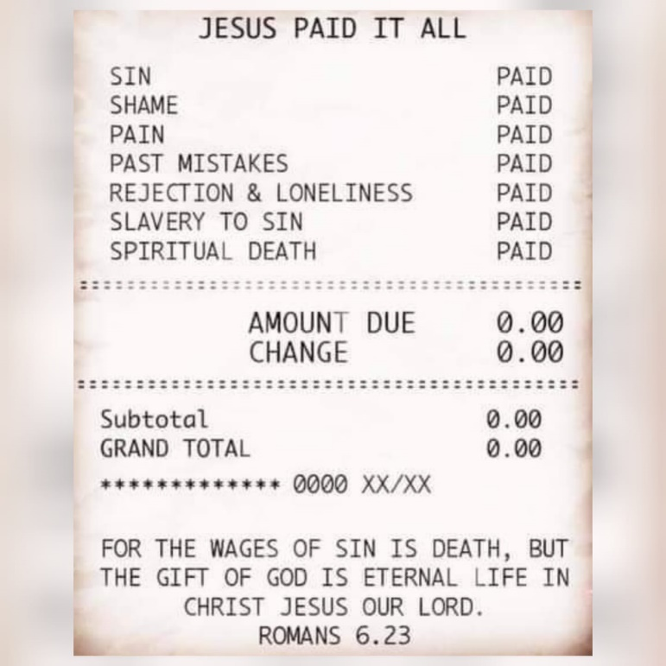
Shabbat Shalom, love, Chag Sameach! Yedidah
April 3, 2021

