YAHUWAH IS SHADDAI, ELYON!
HE IS THE ULTIMATE AUTHORITY! HIS WILL RULES - NO ONE CAN USURP IT!
ISAIAH 40-46 and JEREMIAH 32

Psalm 91:1: “He who abides in the secret place of the Most High abides under the shadow of the Almighty.”

About a year after our family was led by Abba to move to Fort Worth, Texas, from California, in 1986, I began teaching a class at Grace Temple Church on end-time prophecy. I was inspired to study and teach on how current events were fulfilling the prophetic Word. A well-known ex-satanist and his wife who attended the church became close friends of ours. It was this man that stoked the fire that launched my research and teaching on the end times. I had asked him a question about the Masons and it led to his loaning me a book by Scottish Rite guru Manly P. Hall on the Masons, Rosicrucians, and Illuminati. I studied the book with diligence to learn what I had to learn to understand what was fueling America’s destiny and leading the world towards the rise of anti-messiah. Friends at the church were worried about my studying such deeply occult things. Pastor Nichols and an evangelist-friend told them that I knew what I was doing, saying that they trusted me. One day while reading that book, Abba said gently to me: “Put it down.” I set it on the floor. He asked: “Tell Me, what did you learn from the book?” I did not hesitate to answer Him. I said: “I learned Isaiah 40-46, that You are Almighty, Most High, Creator of heaven and earth, and there is none higher or more powerful than You.”
With that learned, I gave the book back to my friend, and Abba began showing me more. From that time, He has trusted me to study the plans and plots of the enemy so that I might relate them to His children in order to strengthen them for the battle that is now greatly intensifying. To this day, the more I learn about the dark Kingdom, the more powerful and precious my Abba and my Savior become!
I urge you to read Isaiah 40-46. Since Yahuwah is the One with all power in heaven and earth, with all authority over His creation, the Most powerful King of the Universe, why does pitiful man so easily choose to substitute the reasoning of the mind, the opinions of mortal men, the lusts of the flesh, and the pleasures of this world, for sitting in the Presence of the Most High and learning from Him? To me it is pure craziness, but I know how the enemy’s and lies and carnal lusts can dull the spirit! For the most part, His people have lost their passion and loyalty to their Elohim, substituting what intrigues the mind and satisfies the flesh. Tragic!
Through Yahushua Messiah we can sit in heavenly places with Him, and enjoy His Presence. There is peace, joy, contentment, and provision for all we need! There we can receive His power to fight against the forces of darkness. We can receive His power to fight for us Through Him we can be victorious. Outside of Him, we are weak and pitiful losers, always going by what we feel--overcome in mind and emotions--so that we are weakened and defeated.
Psalm 91 is so often quoted by believers as a verbal amulet against what they fear, yet it was exclusively written by Moses to a Bridal-minded remnant of those who would live Psalm 91:1. What a mighty privilege to be called to dwell, abide, and continually reside in the shadow of Elyon, the Most High, in the Presence of Shaddai, the Almighty!
Isaiah 40:5, 10: “And the esteem of Yahuwah shall be revealed and all flesh shall see it together, for the mouth of Yahuwah has spoken it…See the Master Yahuwah comes with a strong hand, and His arm rules for Him. See, His reward is with Him and His recompense before him.”
His “strong hand,” and His “arm,” His extension into the earth, is Yahushua, His Son, our Redeemer!
Isaiah 40:28-31: “Did you not know? Have you not heard? The everlasting Elohim, Yahuwah, the Creator of the ends of the earth, neither faints nor is weary. His understanding is unsearchable. He gives power to the faint, and to those who have no might, He increases strength. Even youths shall faint and be weary and young men stumble and fall, but those who wait on Yahuwah renew their strength, they raise up their wings like eagles--they run and are not weary, they walk and do not faint.”
“Waiting” is an action word, not apathetic passivity. We wait on Him as we serve Him and serve His people. We must be patient to receive from Him in His timing!
Isaiah 41:10, 13: “Do not fear, for I am with you. Do not be dismayed, for I am your Elohim. Yes, I will strengthen you! Yes, I will help you! Yes, I will uphold you with the right hand of My righteousness…For I, Yahuwah, your Elohim, am holding your right hand saying to you `Do not fear; I will help you.”
Question: If He is holding our right hand with His right hand, where is He standing? - He is standing in front of us, facing us. When He takes our right hand in His right hand, what does that signify? It is a “handshake,” indicating the uniting of trust and mutual support. It is an ancient Covenant gesture! He is saying: I am for you 100%. If we take His hand, we complete the gesture by saying: “I am with You 100%.” It is a uniting of our whole being with Him in a Covenant. His “right hand” is Yahushua. When Yahushua becomes our personal Savior, at a true new birth, we commit our total being to honor and obey Him as a servant, in training for reigning.
Isaiah 42:8, 13: “I, I am Yahuwah, that is My Name, and my esteem I will not give to another, nor My praise to idols…Yahuwah goes forth like a mighty man. He stirs up ardor like a fighter. He cries out like a fighter. He cries out, yea, shouts aloud. Over His enemies He shows Himself Mighty”
Isaiah 43:13, 15: “Even from the day, I am He, and no one delivers out of my hand. I work and who turns it back? I am Yahuwah, your Set-Apart One, Creator of Israel, Your King.”
Isaiah 44:6, 8, 22: “Thus says Yahuwah, King of Israel and His Redeemer Yahuwah of hosts, `I am the First and the Last, beside Me there is no Elohim…Do not fear, nor be afraid…Is there any Eloah beside Me? There is no other Rock, I know not one…I shall wipe out your transgressions like a cloud, and your sins like a mist. Return to Me, for I shall redeem you…”
Isaiah 45:3-6, 18-22: “And I give you the treasures of darkness and hoarded wealth of secret places, so that you know that I, Yahuwah, who are calling you by your name, am the Elohim of Israel…I shall call you by your name, I give you a title, though you have not known me. I am Yahuwah, and there is none else, there is no Elohim beside Me. I gird you though you have not known Me, so that from the rising of the sun to its going down, there is none but Me. I am Yahuwah and there is none else…For thus says Yahuwah, Creator of the heavens. He is Elohim, Former of earth and its Maker. He established it. He did not create it to be empty. He formed it to be inhabited. I am Yahuwah and there is none else. I have not spoken in secret, in a dark place of the earth. I have not said to the seed of Ya’cob `Seek me in vain.’ I am Yahuwah, speaking righteousness, declaring things that are straight. Gather yourselves together you who have escaped from the gentiles. No knowledge have they who are lifting up the wood of their carved image to pray to a mighty one that does not save. Declare and bring near. Let them take counsel together. Who has announced this from of old? Who has declared it from that time? Is it not I, Yahuwah? And there is no might one besides Me, a righteous El and a Savior. There is none besides Me. Turn to Me and be saved all you ends of the earth For I am El and there is none else.”
Isaiah 46:3-5, 9-10: “Listen to Me, O house of Ya’cob, and all the remnant of the House of Israel who are born from the belly, who are carried from the womb, even to our old age – I am He, and even to gray hairs; I carry. I have made and I bear; I carry and I rescue. To whom do you liken Me and compare Me and make me similar that we should be alike?...Remember the former events of old, for I am El and the is none one else – Elohim, and there is none like Me, declaring the end from the beginning and from of old that which has not yet been done, saying `My counsel shall stand and all My delight I do.”
He sure made His point didn’t He! Since He is the Most High/Elyon, the Almighty/Shaddai, His children should never fear anything man or devils can do! He has all in His power and under His command! And overshadowing all that He does for us is His great love for us, His children! The pathetic whining of those that do not know Him, yet claim Him, is a ridiculous affront to His love!
The more we lift up His greatness and acknowledge His supreme authority over heaven and earth, the more boldness we will have, the more peace, the more assurance that since He controls our lives, we are free of the control of Satan and his forces, and man’s forces. We have nothing to fear from them. It is because His people do not know Him as He is that they lean on puny man, and are cursed (Jeremiah 17:5-10).
Throughout my life, I have seen Him do very many miracles of all types in my life and in the lives of others. Recently, I have seen Him work miraculously in a mighty way in my move to the ‘gathering place” in Fort Worth. IMPOSSIBLE situations were turned around. He is using His authority to loosen His children who serve Him, to position them for His gathering. (Genesis 49:10) I’ve lived a lifetime watching Him do what man says is impossible!
In March, 2018, I began crying out to Him with all my heart. Abba was readying me for my future work for Him. In the ensuing months, He pulled off a seemingly impossible Psalm 18:1-19-type deliverance. In August, my new fellowship pastor in Fort Worth prophesied and prayed for me to have a Psalm 18 rescue. I latched onto that chapter with all my heart. In March 2018, Abba went into urgent-mode. He pressed me to begin by getting a car. I am still in a daze as to how He pulled it off, sending me precious helpers!
In my life, I have seen Him work the most incredible, detailed, planned-out miracles in so many varying situations, including miracle healings, even a creative miracle so that I can still walk. Yet, I am always amazed at His original methods that leave me shaking my head at His sovereignty.
I WILL NOT TELL HIM how to do things! I control nothing! He controls all - thus I am free! We must NEVER LIMIT HIM! (Psalm 78:41) In April, He asked me to gather a prayer team to stand with me during my move. He daily told me what to do as I began packing, showing my faith. He gave me strength way beyond my abilities. It is amazing that when Abba gets ready to pull off a miracle, He gathers those who are aligned with Him, uniting them with Him so that intercession-proclamation is done by His Spirit moving through them, with no one inserting their own reasoning!
In proclaiming victory for my son’s deliverance from a dangerous situation that appeared more impossible by the day, Abba began waking me up every night around 1:00 AM for a couple of weeks, anointing me to make bold declarations--not with carnal emotions or human requests. He, speaking through me, led me to call on His Might and His power as Shaddai (the Almighty, the “many breasted One”), and Elyon (the Most High). “Shaddai” was the Name He gave Abraham (Exodus 6:3).
I began praising Him for His power and authority over the fallen angels, over the “principalities and powers” over nations, and over men who use their power for deceitful manipulation and control over His children. I declared, “You are Shaddai; You are Elyon! There is none higher than You! You have supreme authority over heaven and earth. Let no one usurp your perfect will! You rule in the kingdom of men! Take your great power and rule!”
The only safe way to approach the Most High is in total submission to His will, not asking what we want, but abandoning our will for His will.
Abba gave me Revelation 3:7-8. Truly, when He opens a door, it stays open. When He shuts a door, it stays shut. He is in the saving and rescuing business!
Only Abba can work things out so that no closed door is opened, and no open door is closed. To Elohim be all the honor and esteem! In July, as I rose from my chair in my room, He gave me a quick vision of a closed door and a long narrow and semi-dark corridor before me. He let me know that He had shut the door where I was, and I was to walk forward towards the closed door at the end of the corridor. As the days progressed and I walked toward the closed door ahead, doing what He said to do each day, the door began opening until it fully opened and I was loosed.
We can offer supplications, requests. We can pray, during which we listen for His instructions. But, when we declare His will back to Him, when we proclaim His personal promises to us back to Him, then He is freed to do what He wants done – we untie His hands by relinquishing our will to His will.
When you declare, “Our Father who is in heaven, set-apart is Your Name. Your Kingdom come; Your will be done in earth as it is in heaven,” you walk on the path to wholeness and strength, boldness, and victory. How faithful is He to rescue us when things look impossible and to redeem what appeared to be lost?
Hebrews 11:11: “By faith also Sarah herself was enabled to conceive seed, and she bore a child when she was past the normal age, because she judged him faithful who had promised.” [Refer to: “I Judge Him Faithful”/Mikvah of the Spirit]
Jeremiah 32! Nebuchadnezzar was positioned on a hill with his army outside of Jerusalem ready to attack, destroy the city, and take the people as slaves to Babylon. Jeremiah had spent 23 years warning the people, but the people would not heed his warnings. The kings would not heed his warning. Instead, they listened to the soothing words of the false prophets, even though they knew the false prophets were lying. They wanted to hear only what made them feel good. So much of the time, when people are afraid, they hide in denial and fantasy!
Knowing in his spirit that the time of the attack by Nebuchadnezzar was imminent, Jeremiah’s uncle came to visit him. Jeremiah, a Levite from the Levite city of Anatot, was the “kinsman redeemer” for the family, the elder son who had the right to buy the land and redeem it for future generations. But, hey – Neb was coming to destroy the land. What would cause him to buy land that would be destroyed and lost in antiquity to future generations? It was insanity in the reasoning minds of man, but sanity for those who walk by faith in every word that proceeds from the mouth of Yahuwah! That’s sanity!
Jeremiah paid his uncle in full, a deed of purchase was drawn up, and the deed was notarized. It was official! He put the deed in a clay jar covered by a lid to preserve it. He buried it in the field outside of Anatot. It is still out there somewhere in that field to this day!
Jeremiah’s father, under King Josiah, had been the High Priest. Jeremiah was in line to be the High Priest, but he rejected that position to take Yahuwah’s message to the nations (Jeremiah), returning after the death of Josiah to become the prophet of Yahuwah. By doing so, Jeremiah was blackballed by his family until just before Neb attacked. Neb would end life in Anatot, and evidently his family knew it.
So why did Jeremiah buy the field? - Because he saw the future through the eyes of Yahuwah! Are you making decisions today based on what Yahuwah sees, using faith that reaches far beyond what is coming upon us in the near future?
It was March 2014. I went with three other intercessors into the “West Bank” to a do intercession over a small new Levite town named Anatot. In the very place where ancient Anatot once stood, today Levite families are living once again.
A stirring in my spirit brings tears to my eyes as I think of this miracle of His faithfulness. Yahuwah led Jeremiah to buy the land, and Jeremiah obeyed. With my friends, I stood by the sign of in Hebrew for ANATOT, which was next to a large field at the entrance to the once ancient city of Anatot. We rode into the town to do intercession, to proclaim the will of Abba there. We rode through the few streets and noticed the signs on the mailboxes or on the houses that had Levite names on them in different languages, mostly Hebrew and Russian names. It is once again a Levite town after about 2,500 years. While we were doing intercession over the valley below between high hills, school children came into the area during their lunch break. Yahuwah’s Word is eternally faithful!
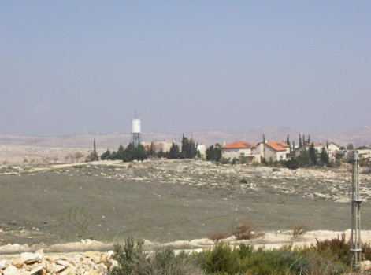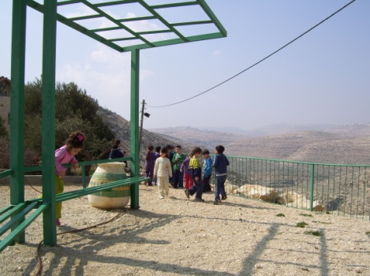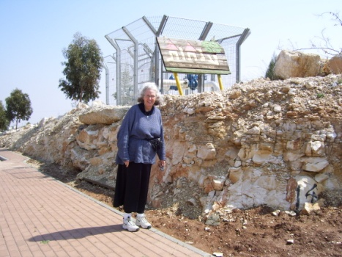
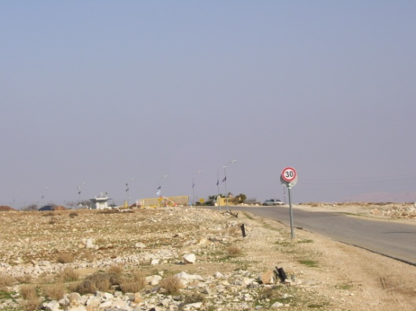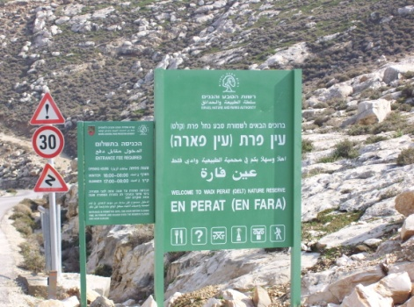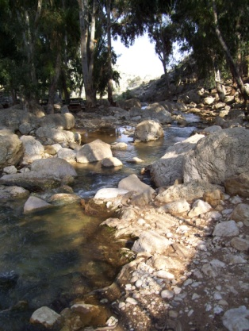
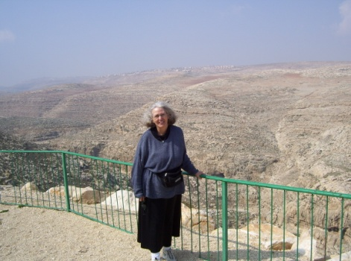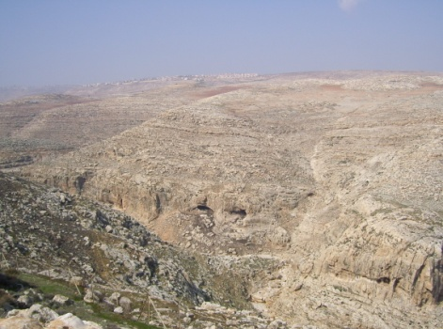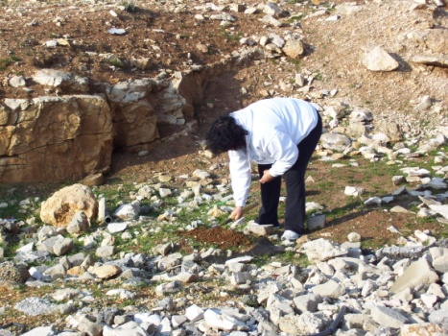
[Sharing a few pictures of Anatot, and En Perat (Ein Perat)…The lady standing beneath the sign saying “Anatot” in Hebrew, and standing just above the En Perat tributary below where the Jeremiah 13 caves are located, is wearing five layers of clothes. It was cold that March 4th of 2014, and she had no coat! I know she looks very fat, but, just for the record - that’s an illusion (smile)]
Just below the hill of Anatot, in the valley, were many caves. In the Bible all of the references to the Euphrates have to do with the headwaters in today’s Syria and Turkey, but one reference has to do with an area below where Jeremiah lived. It was below his town that he buried the girdle and then dug it up again later. But, wait--he buried the girdle near an ancient tributary of the Euphrates River that flowed into the Jordan just below Anatot! How awesome is that! Just near where the caves are, we see a lovely little brook--note picture. That tributary of the Euphrates is still there. It is an Israeli National Park--En Perat.
We four wrote our prayer requests and declarations. We folded them into a small square or rolled them into a small scroll and placed them in little clay jars that we bought at an Arab market nearby. We took the jars and buried them in that field in front of Anatot. Out there somewhere is the deed that Jeremiah had drawn up and buried so long ago!
Conclusion: Numbers 23:19, declaration of Baalim: “El is not a man that He should lie, neither the son of man that He should repent. Has He not said and will He not do it? Has He not spoken and will He not bring it to pass?”
Isaiah 55:8-11: “`My thoughts are not your thoughts, neither are your ways My ways,’ declares Yahuwah. `For as the heavens are higher than the earth, so are My ways higher than your ways and My thoughts than your thoughts. For as the rain comes down, and snow from the heavens, and does not return there but waters the earth and makes it bring forth and bud and gives seed to the sower and bread to the eater, so is My Word that goes forth from My mouth--it does not return to me void but shall do what I please, and shall certainly accomplish what I sent it for. You shall go out with joy and be led forth with peace, the mountains and the hills break forth into singing before you, and all the trees of the field clap their hands. Instead of the thorn the cypress comes up, and instead of the nettle the myrtle comes up. And it shall be to Yahuwah for a name, for an everlasting sign that shall not be cut off.’ ”
Deuteronomy 8:3: “…man does not live by bread alone but by every word that proceeds from the mouth of Yahuwah.”
He disciplines us as a good Father and puts us through many tests, so that we learn the lesson that we live by His Word, His promises, respecting His boundaries, conforming to His requirements, and believing His prophecies. Those that live by the Word, both the Logos/written Word and the Rhema/spoken word to our spirit, will shout and sing at the coming of Messiah!
Do you personally know this great El Shaddai? Do you walk with Him as Abraham once walked with Him? (Genesis 17:1) Exodus 6:3: “Shaddai” is the title He gave to Abraham to use – Shaddai, the “many breasted One” who gives us all we need, who hold us, and cares for us like a mother.” Isaiah 66:13: “As one whom his mother comforts, so I comfort you.”
Psalm 46:1-2, 10: “Elohim is our refuge and strength, a help in distress soon found. Therefore, we do not fear though the earth reels and the mountains topple into the heart of the seas…Be still and know that I am Elohim. I am exalted among the nations; I am exalted in the earth.”
Isaiah 64:4: “Since the beginning of the ages, they have not hard or perceived by the ear, nor has eye seen, any Elohim besides You who acts on behalf of those who wait for Him.”
Knowing Him is the greatest adventure life affords us … and it prepares us to be with Him forever.
ARE YOU IN COVENANT RELATIONSHIP WITH HIM? He holds out His right hand to you. It is by relinquishing control of your own life and reaching out to put your right hand into His right hand that you come into unity with Him for His eternal purposes and for your blessing!
In His love, Shabbat Shalom!
Yedidah
December 1, 2018

