YOM KIPPUR, DAY of ATONEMENT - LEVITICUS 16
YOM HA DIN, DAY of JUDGMENT and WRATH
DAY of YAHUWAH

The Scriptures, Leviticus 16: 1 “And יהוה spoke to Mosheh after the death of the two sons of Aharon, as they drew near before יהוה, and died. 2And יהוה said to Mosheh, “Speak to Aharon your brother not to come in at all times to the Set-apart Place inside the veil, before the lid of atonement which is on the ark, lest he die, because I appear in the cloud above the lid of atonement. 3 With this Aharon should come into the Set-apart Place: with the blood of a young bull as a sin offering, and of a ram as a burnt offering. 4 He should put on the set-apart linen long shirt, with linen trousers on his flesh, and gird himself with a linen girdle, and be dressed with the linen turban – they are set-apart garments. And he shall bathe his body in water, and shall put them on. 5 And from the congregation of the children of Yisra’ĕl he takes two male goats as a sin offering, and one ram as a burnt offering. 6 And Aharon shall bring the bull as a sin offering, which is for himself, and make atonement for himself and for his house. 7 And he shall take the two goats and let them stand before יהוה at the door of the Tent of Meeting. 8 And Aharon shall cast lots for the two goats, one lot for יהוה and the other lot for Azazel. 9 And Aharon shall bring the goat on which the lot for יהוה fell, and shall prepare it as a sin offering. 10 But the goat on which the lot for Azazel fell is caused to stand alive before יהוה, to make atonement upon it, to send it into the wilderness to Azazel. 11 And Aharon shall bring the bull of the sin offering, which is for himself, and make atonement for himself and for his house, and shall slaughter the bull as the sin offering which is for himself, 12 and shall take a fire holder filled with burning coals of fire from the altar before יהוה, with his hands filled with sweet incense beaten fine, and shall bring it inside the veil. 13 And he shall put the incense on the fire before יהוה, and the cloud of incense shall cover the lid of atonement which is on the Witness, lest he die. 14 And he shall take some of the blood of the bull and sprinkle it with his finger on the lid of atonement on the east side, also in front of the lid of atonement he sprinkles some of the blood with his finger seven times. 15 And he shall slaughter the goat of the sin offering, which is for the people, and shall bring its blood inside the veil, and shall do with that blood as he did with the blood of the bull, and sprinkle it on the lid of atonement and in front of the lid of atonement. 16 And he shall make atonement for the Set-apart Place, because of the uncleanness of the children of Yisra’ĕl, and because of their transgressions in all their sins. And so he does for the Tent of Meeting which is dwelling with them in the midst of their uncleanness. 17 And no man should be in the Tent of Meeting when he goes in to make atonement in the Set-apart Place, until he comes out. And he shall make atonement for himself, and for his household, and for all the assembly of Yisra’ĕl. 18 And he shall go out to the altar that is before יהוה, and make atonement for it. And he shall take some of the blood of the bull and some of the blood of the goat, and put it on the horns of the altar all around. 19 And he shall sprinkle some of the blood on it with his finger seven times, and cleanse it, and set it apart from the uncleanness of the children of Yisra’ĕl. 20 And when he has finished atoning for the Set-apart Place, and the Tent of Meeting, and the altar, he shall bring the live goat. 21 Then Aharon shall lay both his hands on the head of the live goat, and shall confess over it all the sin of the children of Yisra’ĕl, and all their transgressions in all their sins, and shall put them on the head of the goat, and shall send it away into the wilderness by the hand of a fit man. 22 And the goat shall bear on itself all their sin, to a land cut off. Thus he shall send the goat away into the wilderness. 23 Aharon shall then come into the Tent of Meeting, and shall take off the linen garments which he put on when he went into the Set-apart Place, and shall leave them there. 24 And he shall bathe his body in water in the set-apart place, and shall put on his garments, and shall come out and prepare his burnt offering and the burnt offering of the people, and make atonement for himself and for the people, 25 and burn the fat of the sin offering on the altar. 26 And he who sent away the goat to Azazel washes his garments, and shall bathe his body in water, and afterward he comes into the camp. 27 And the bull for the sin offering and the goat for the sin offering, whose blood was brought in to make atonement in the Set-apart Place, is brought outside the camp. And they shall burn their skins, and their flesh, and their dung with fire. 28 And he who burns them washes his garments, and shall bathe his body in water, and afterward he comes into the camp. 29 And this shall be for you a law forever: In the seventh month, on the tenth day of the month, you afflict your beings, and do no work, the native or the stranger who sojourns among you. 30 For on that day he makes atonement for you, to cleanse you, to be clean from all your sins before יהוה. 31 It is a Sabbath of rest for you, and you shall afflict your beings – a law forever. 32 And the priest, who is anointed and ordained to serve as priest in his father’s place, shall make atonement, and shall put on the linen garments, the set-apart garments, 33 and he shall make atonement for the Most Set-apart Place, and make atonement for the Tent of Meeting and for the altar, and make atonement for the priests and for all the people of the assembly. 34 And this shall be for you a law forever, to make atonement for the children of Yisra’ĕl, for all their sins, once a year. And he did as יהוה commanded Mosheh.”
Leviticus 23:27-32: 27 “And יהוה spoke to Mosheh, saying, `On the tenth day of this seventh month is the Day of Atonement. It shall be a set-apart gathering for you. And you shall afflict your beings, and shall bring an offering made by fire to יהוה. 28 And you do no work on that same day, for it is the Day of Atonement, to make atonement for you before יהוה your Elohim. 29 For any being who is not afflicted on that same day, he shall be cut off from his people. 30 And any being who does any work on that same day, that being I shall destroy from the midst of his people. 31 You do no work – a law forever throughout your generations in all your dwellings. 32 It is a Sabbath of rest to you, and you shall afflict your beings. On the ninth day of the month at evening, from evening to evening, you observe your Sabbath.’ ”
Abel understood that the sacrifice of a perfect sheep or goat was a substitute for his sins. He understood blood atonement. After Adam and Eve sinned, the first thing Yahushua did was kill an animal and make clothing from the skins for them.
While studying archeology at Cerritos College in California, I read in my text book that archeologists are stumped as to why all of sudden without any foundation for it, about 6,000 years ago, people in the Middle East, began raising sheep and goats, and at the same time the practice of magic and sorcery began. Wow! What do you think of that! I immediately thought of Cain and Abel!
Enoch 8:4-8: “And again the Lord said to Raphael: 'Bind Azâzêl hand and foot, and cast him into the darkness: and make an opening in the desert, which is in Dûdâêl, and cast him therein. 5. And place upon him rough and jagged rocks, and cover him with darkness, and let him abide there forever, and cover his face that he may not see light. 6. And on the day of the great judgment he shall be cast into the fire. And heal the earth which the angels have corrupted, and proclaim the healing of the earth, that they may heal the plague, and that all the children of men may not perish through all the secret things that the Watchers have disclosed and have taught their sons. 8. And the whole earth has been corrupted through the works that were taught by Azâzêl: to him ascribe all sin.”
Enoch 9:6-9: “Thou seest what Azâzêl hath done, who hath taught all unrighteousness on earth and revealed the eternal secrets which were (preserved) in heaven, which men were striving to learn: 7. And Semjâzâ, to whom Thou hast given authority to bear rule over his associates. 8. And they have gone to the daughters of men upon the earth, and have slept with the women, and have defiled themselves, and revealed to them all kinds of sins. 9. And the women have borne giants, and the whole earth has thereby been filled with blood and unrighteousness.” (Genesis 6)
Enoch 10:1-8: “Then said the Most High, the Holy and Great One spake, and sent Uriel to the son of Lamech, and said to him: 2. '〈Go to Noah〉 and tell him in my name "Hide thyself!" and reveal to him the end that is approaching: that the whole earth will be destroyed, and a deluge is about to come upon the whole earth, and will destroy all that is on it. 3. And now instruct him that he may escape and his seed may be preserved for all the generations of the world.' 4. And again the Lord said to Raphael: 'Bind Azâzêl hand and foot, and cast him into the darkness: and make an opening in the desert, which is in Dûdâêl, and cast him therein. 5. And place upon him rough and jagged rocks, and cover him with darkness, and let him abide there forever, and cover his face that he may not see light. 6. And on the day of the great judgment he shall be cast into the fire. And heal the earth which the angels have corrupted, and proclaim the healing of the earth, that they may heal the plague, and that all the children of men may not perish through all the secret things that the Watchers have disclosed and have taught their sons. 8. And the whole earth has been corrupted through the works that were taught by Azâzêl: to him ascribe all sin.”

THE 70 GENERATION PROPHECY
Enoch 10:11-15: 11 And the Lord said unto Michael: 'Go, bind Semjâzâ and his associates who have united themselves with women so as to have defiled themselves with them in all their uncleanness. 12. And when their sons have slain one another, and they have seen the destruction of their beloved ones, bind them fast for seventy generations in the valleys of the earth, till the day of their judgment and of their consummation, till the judgment that is forever and ever is consummated. 13. In those days they shall be led off to the abyss of fire: and to the torment and the prison in which they shall be confined forever. And whosoever shall be condemned and destroyed will from thenceforth be bound together with them to the end of all generations. 15. And destroy all the spirits of the reprobate and the children of the Watchers, because they have wronged mankind. Destroy all wrong from the face of the earth and let every evil work come to an end: and let the plant of righteousness and truth appear: ⌈and it shall prove a blessing; the works of righteousness and truth⌉ shall be planted in truth and joy for evermore.”
Enoch 12:1-10: “And Enoch went and said: 'Azâzêl, thou shalt have no peace: a severe sentence has gone forth against thee to put thee in bonds: 2. And thou shalt not have toleration nor request granted to thee, because of the unrighteousness which thou hast taught, and because of all the works of godlessness and unrighteousness and sin which thou hast shown to men.' 3. Then I went and spoke to them all together, and they were all afraid, and fear and trembling seized them. 4. And they besought me to draw up a petition for them that they might find forgiveness, and to read their petition in the presence of the Lord of heaven. 5. For from thenceforward they could not speak (with Him) nor lift up their eyes to heaven for shame of their sins for which they had been condemned. 6. Then I wrote out their petition, and the prayer in regard to their spirits and their deeds individually and in regard to their requests that they should have forgiveness and length of days. 7 And I went off and sat down at the waters of Dan, in the land of Dan, to the south of the west of Hermon: I read their petition till I fell asleep. 8. And behold a dream came to me, and visions fell down upon me, and I saw visions of chastisement, ⌈and a voice came bidding (me)⌉ I to tell it to the sons of heaven, and reprimand them. 9. And when I awaked, I came unto them, and they were all sitting gathered together, weeping in ’Abelsjâîl, which is between Lebanon and Sênêsêr, with their faces covered. 10. And I recounted before them all the visions which I had seen in sleep, and I began to speak the words of righteousness, and to reprimand the heavenly Watchers.”
When Messiah died on the stake/cross, just before evening beginning Passover, He became Yahuwah’s Passover Lamb for each individual who would receive Him -- His chosen ones--those who would be born again by faith in His Lamb’s shed blood for the forgiveness and removal of their sin. He also became the Yom Kippur Lamb who died for the sins of the entire family of the redeemed--all of those born again ones who would form His “holy nation.”
I Peter 2:9: “For you are a chosen race, a royal priesthood, a holy nation, and people for a possession, that you should proclaim the praises of Him who called you out of darkness into His marvelous light.”
I Peter 1:2: “…chosen according to the foreknowledge of Elohim the Father, set apart by the Spirit unto obedience, and sprinkling of the blood of Yahushua Messiah…”
Ephesians 1:4: “…He chose us in Him before the foundation of the world that we should be set-apart and blameless before Him in love…’
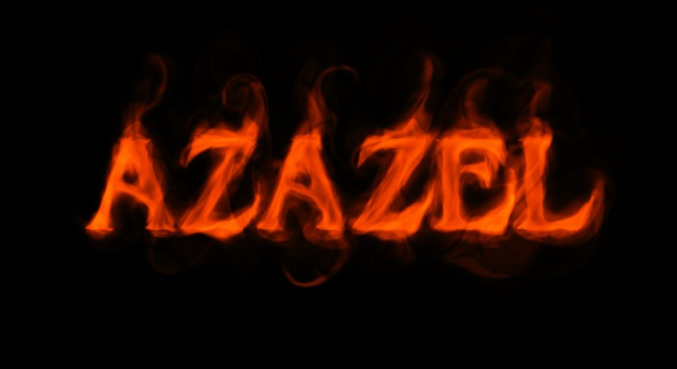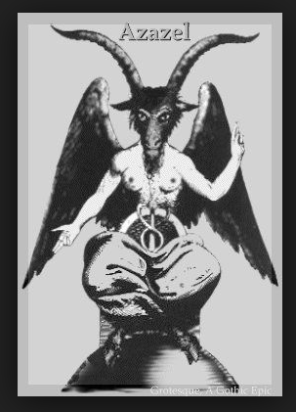
“Send the goat TO AZAZEL” with the sin of the nation on its head …
Azazel, chief prince in the hierarchy of fallen angels that rebelled, along with Lucifer/Satan, against Yahuwah before Genesis 1:1--was chief in turning mankind against Yahuwah. He brought mankind the knowledge of making war to murder and destroy, and to sin with all types of sexual sin. The spirits of the princes of the fallen angles, like Azazel, returned with a host of Nephilim in 1896, at the close of Enoch’s 70 generation prophecy. They brought mankind what was taught to mankind before the Flood. They are now taking over the world in all high places.
We watch as war and death increase. The martyrdom of Christians is great. We learn about new technology of weapons that are destroying the earth, and all living things in it. We note technology for space travel, and technology to end human life and replace it with robotics, increasing along with hideous sin against the innocent.
New technology for war is being introduced, not just for war on earth, but for war in outer space, along with sexual perversions of all types, the sacrificing of children to Satan, and the use of children for sexual atrocities. The worship of Aazael is in the earth today young people call on him for power to do evil. You see the picture on the right of Baphomat. Satanists are putting up this statue in public places, even one with two children looking up adoring him.
What is meant in Leviticus 26 by sending sin to Aazael? When we come before Yahuwah with the blood of Yahushua for our salvation, with His love for us, repenting, receiving His substitution-death for us, His resurrection for our eternal life, Yahuwah transfers our sin onto the head of Azazel, because it was through him, and others like him, that man was introduced to sin and rebellion against the Creators. They brought their rebellion against Yahuwah to earth and deceived mankind into rebelling against Yahuwah with them. Messiah died to redeem us from our sin, which is rebellion, back to His Father. He also died to pass final judgment on Lucifer/Satan and the fallen angels. When the Flood occurred, Yahuwah locked up the 200 fallen angels that descended on Mount Hermon in the days of Jared in Tartaros, the lowest pit of hell, until their final judgment. Our sin is locked away with them. We must never try to take our sin back, for if we do, we’ll end up with them forever.
Messiah died on the stake to break the power of Satan, and of all the fallen angels, including Azazel, over us, so that we could be free to live in the Light of our beloved Yahuwah and Yahushua. Our sin is on the head of the fallen ones forever.
For eternity they are in the lowest Hell. Those who come to the Lamb of Yahuwah must come with repentance and submission to Him so that we are declared “not guilty.” Then it must become our lifestyle not to rebel.
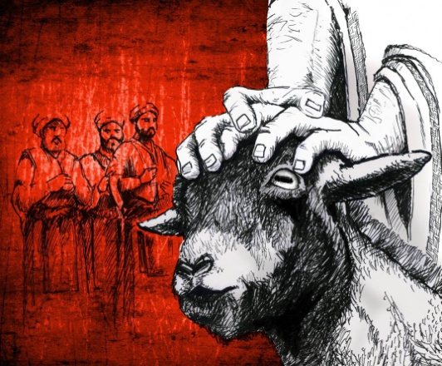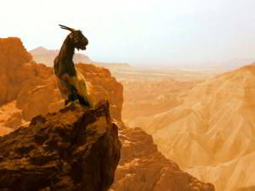

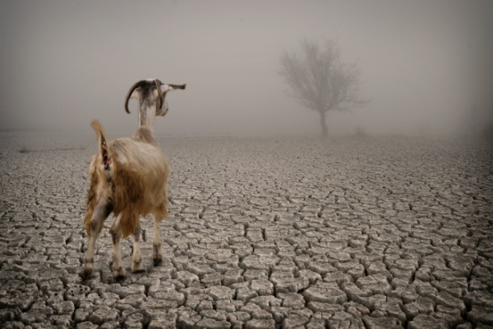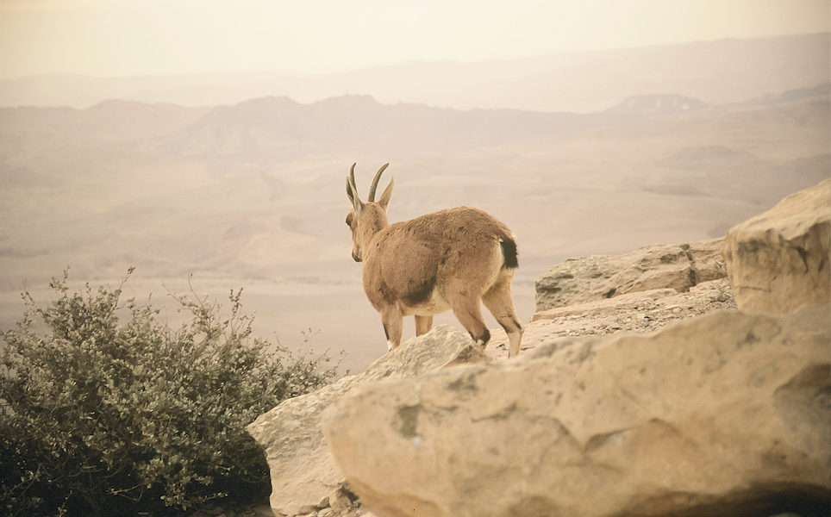

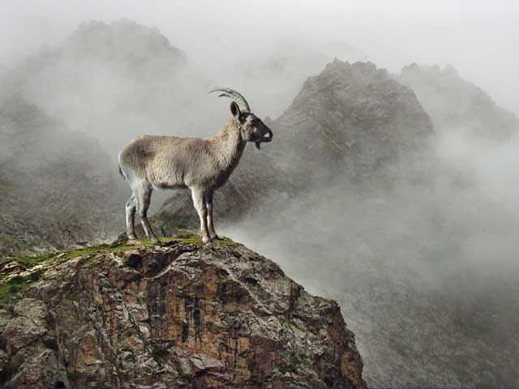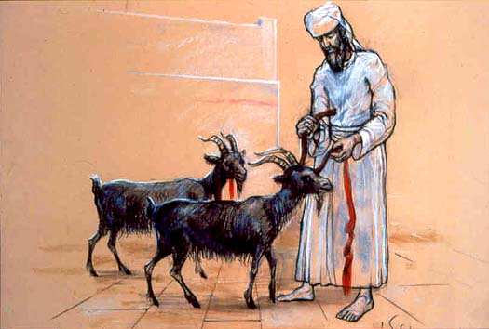
Azazel, is very popular today in movies, video games, and rituals of Satanism, especially among youth. These fallen angels bound in Tartaros have quite a following among modern man. Enoch 10:22-23 …
The memory of the bound fallen angels is being brought into the earth again - as it was before the Flood. Aazael is worshipped in Satanism. Baphomat, as seen above, is symbolic of Azazel, the goat head god. The streets between the White House and the Masonic House of the Temple are laid out in the shape of Baphomat’s head and horns. I walked the “head” in intercession with a friend of mine in 2010. Once at the House of the Temple, we took a tour through it. Our tickets were $3.33 each--equaling $6.66.
Other fallen angels are taking up where they left off, along with their old and new offspring in preparation for the son of Satan to take his throne in Jerusalem.
It appears that Satan is thrown into the earth at the beginning of the ten “Days of Awe” between Yom Teruah and Yom Kippur to work with his Beast-son, antichrist, in an attempt to destroy all of Yahuwah and Yahushua’s creation. He’s in a rage. (Revelation 12:11-17)
The last three days of the ten before Yom Kippur, the two witnesses are killed by the Beast and thrown into the street below the Temple Mount. After three days, their bodies rise before Messiah as He prepares to descend with the wrath of His Father. (Revelation 11)
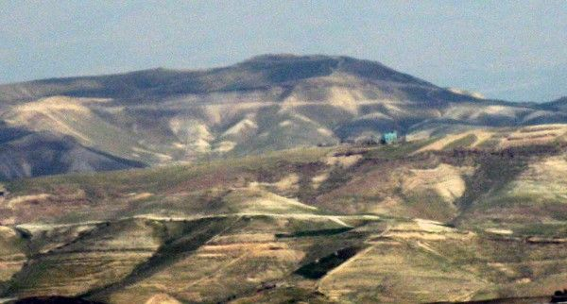
Mount Azazel in the Judean Desert/Jabal Muntar in Arabic
Beginning the eve of September 9th, 2019, we begin the 24 hour “Yom Kippur,” the “Day of Atonement.”
Without our sin being transferred onto the spotless Lamb who died in our place, and our sin removed, there is no atonement! Without the blood of the Lamb of Yahuwah who took away the sin of the world, there is no redemption, no salvation, no hope for eternal life. We must be truly born again by faith in Him to receive eternal life! Refer to: “The True New Birth”/Mikvah of Eternal Salvation.
Leviticus 17:11: “For the life of the flesh is in the blood, and I have given it to you upon the altar to make atonement for your lives, and it is the blood that makes atonement for the life.”
Hebrews 9:22: “And according to the Torah, almost all is cleansed with blood, and without the shedding of blood there is no forgiveness.”
I John 2:1-2: “My little children, I write this to you, so that you do not sin. And if anyone sins, we have an Intercessor with the Father, Yahushua Messiah--the Righteous One. And He Himself is the atoning offering for our sins; but not for ours only but for the sins of the whole world.”
Above, in Leviticus 23, you’ve read Yahuwah’s requirements for this “Day,” “Yom ha Din,” the Day of Yahuwah, the Day of the Wrath and Judgment of Yahuwah as Messiah comes to bring an end to the wicked. No, we do not bring blood sacrifice of an animal. We bring our faith in the shed blood of the Lamb of Yahuwah, our Savior Yahushua Messiah/Yeshua/Jesus.
John 1:29: “On the next day, Yochanan/John saw Yahushua coming toward him and said: `Behold the Lamb of Elohim who takes away the sin of the world.”
Revelation 5:12: “Worthy is the Lamb that was slain to receive power and riches, wisdom and strength, and honor and glory, and blessing!”
In the revised, updated, September 8, 2019 article, #36.0 under the Mikvah of Present Reality, originally posted in 2014, you will find Scriptures and get more understanding of Yom Kippur. The article is entitled: “Day of Yahuwah.” It is a 24-hour day.
It is on the Day of Yahuwah that Messiah descends with the wrath of His Father in judgment against all the unrepentant, sealing them until the “second resurrection” unto damnation (Revelation 20). All rebellion against Yahuwah and Yahushua will end on that Yom Kippur. It is the final day of separation. No one can repent after that.
If you look carefully at Revelation 14, you see that it is in chronological order. The Bridal remnant, “the first fruits of the resurrection,” is transformed on Yom Teruah so that “she” cannot die. This remnant has been tested and tried and found to be “blameless” before Elohim. The Eve before Yom Kippur day, before sunset, all repentance must be accomplished, for after that the Book of Life is closed--no more names can be entered. An angel flies through the heavens that afternoon proclaiming the “everlasting Gospel.” If there no repentance by sunset, it’s over for them. Then Messiah descends with the wrath of Yahuwah to “reap the earth.”
Read very carefully Joel 2:30-32. Look at the timing. Once sunset begins and Yom Kippur begins, the way of escape from damnation is closed. As we see from Revelation 9:20-21 and Revelation 16, by this time, no one repents. At sunset beginning the 10 day, the Day of Atonement, the Day of Yahuwah, Messiah descends with the wrath of His Father. The resurrection of justified takes place. As He descends, there is a historic earthquake. That’s Isaiah 24! That’s Revelation 16! Read about it in II Peter 3. Then the Creator calls for a new heaven and a new earth. Be sure to read “The Day of Yahuwah…” for Scriptures and explanations.
There is a cut off time. Leviticus 23:27-29 speaks of Yom Kippur before the final one: “On the tenth day of this seventh month is the Day of Atonement. It shall be a set-apart gathering for you. And you shall afflict your soul… it is the Day of Atonement, to make atonement for you before Yahuwah your Elohim. For any soul who is not afflicted on that same day, he shall be cut off from his people.”
Yahuwah reserves His wrath for the end of the “Ten Days of Awe” to give mankind a chance to repent. If they do not repent, and most don’t by the beginning of Yom Kippur, there is nothing left to do but destroy them all and seal them for eternal damnation. The whole of the Word backs this up.
Please refer to the recent: “Days of Awe – Yamim Noraim…” under the Mikvah of the Covenant. It will explain A LOT!
Beginning with the sound of the shofar blast for Yom Teruah, the sound that goes forth to gather/unite His people for the battle ahead, for standing together against the forces of darkness, for moving forward in unity under His Spirit, for shouting and rejoicing because our “Nissi,” our banner, is Yahushua Messiah, we enter “the Ten Days of Awe.” This is the only ten-day set-apart period time in the Word. These 10 days are mentioned in Revelation 2:10. They are days of massive martyrdom of those who are born again by faith in Yahushua or Yeshua or Jesus. During these ten days we submit to Yahuwah and separate ourselves by repentance of all sin. We submit ourselves to Yahushua for salvation. As said above, Yom Teruah begins with the final sealing of the Bridal remnant for preservation during the 10 days of Satan’s greatest wrath. This is when he is thrown into the earth in Revelation 12:11-17, and begins killing all by his rage. He “knows his time is short.” He kills the two witnesses three days before Messiah returns. As they rise, He descends (Revelation 11) at the last trumpet.
In Matthew 24:29-31, we read about the return of Messiah: “And immediately AFTER the tribulation of those days, the sun shall be darkened and the moon shall not give its light, and the stars shall fall from heaven, and the powers of the heavens shall be shaken. And then the sign of the Son of Adam shall appear in the heaven and then all the tribes of the earth shall mourn and they shall see the Son of Adam coming on the clouds of heaven with power and great esteem. And He shall send His messengers with a great sound of a trumpet and they shall gather together His chosen ones from the four winds and from one end of the heavens to the other.” That “great sound” is the long blast of the shofar blown for Yom Kippur.
Do you notice that the wording of Matthew 24:29-31 aligns to Joel 2:28-32? Did you notice in Joel 2:15-17 that it says: “Let a bridegroom come out of his room and a bride from her dressing room?” The wording is a precursor to the return of Messiah. Do you notice in Isaiah 2:19-22, that the wording is the same as in Revelation 6:12-17 about the coming of Messiah with the wrath of His Father? Do you notice the time of tribulation and then resurrection to eternal life in Daniel 12:1-3? What I’m trying to point out is that the Word cross references itself. The Spirit will do that for you, if you take the time to let Him teach you!
Why can’t Messiah come on Yom Teruah? It is “the day and hour no man knows!” At sunset at the end of the month of Elul, as the new moon is sighted from Jerusalem for Tishre 1, the shofars are blown announcing Yom Teruah, the Feast of shofar blowing and shouting. It is also called “yom ha din.” On this night that begins the final “Ten Days of Awe,” the translation of the Bridal remnant takes place. (Revelation 14:1-5) Also, because Satan is thrown into the earth, into Jerusalem, to join his son-Beast, the antichrist, the final extent of the Matthew 24 fleeing into the wilderness for protection also occurs by those in Jerusalem. Many go underground, too, into the tunnels, as we see from Zechariah 14:1-5.
Fleeing takes place over the head and wings of the great eagle in the topography of the Dead Sea, into Jordan, where a highway picks up that goes into Petra. Today that main crossing point is across from Masada. The wings are the mountains of Jordan. Messiah said to “flee to the mountains.” There is only one mountain in Israel and it’s on the Syrian border. I’ve heard from Orthodox and Karaite Jews in Israel who know that the crossing point in fleeing is at Masada. They understand that “mountains” means Jordan.
Messiah does not come with the wrath of Yahuwah on Yom Teruah. He comes at Yom Kippur. My son and I dedicated this “ten days” to getting Abba’s truth about Yom Teruah and Yom Kippur. We each studied under the tutelage of the Spirit without comparing notes except a couple of times, but with no discussions. When we finally compared notes, we found that we had learned the same things.
When Messiah comes there is no more chance for repentance. The whole ten day period is preparation for His coming by repentance. Messiah cannot come on Yom Teruah because the ten days of testing by Yahuwah has just begun.
Until “that Day,” “Day of Yahuwah,” we’re being tested and we’re rehearsing.
On Yom Kippur, as it begins at sunset, the 7 bowls of wrath begin to be poured out, Revelation 15 and 16. Look carefully at the wording. It keeps repeating itself all the way through. We’ve just not seen it in its entirety until now. He is revealing His Word and its timing, because we are so close to the “great tribulation.”
When Messiah comes, He will have to create a new heaven and new earth because the old one will be so destroyed. Right now man’s destruction is in process.
II Peter 3:10-14: “But the Day of Yahuwah shall come as a thief in the night, in which the heavens shall pass away with a great noise and the elements shall melt with intense heat, and the earth and the works that are in it shall be burned up. Seeing all these are to be destroyed in this way, what kind of people ought you to be in set-apart behavior an reverence, looking for and hastening the coming of the Day of Elohim through which the heavens shall be destroyed, being set on fire and the elements melt with intense heat, but according to His promise we wait for a renewed heaven and a renewed earth in which righteous dwells. So then beloved ones looking forward to this do your utmost to be found by Him in peace, spotless and blameless…” (Compare with Isaiah 65:17-25; 66:22-24)
Use this Yom Kippur to fast, repent, pray, and seek His face as never before, ask Him to prepare you for “the Day” in which He will end all repentance, and separate mankind into two groups forever. We must cling to our eternal life!
Sample Scriptures of Messiah’s return: In wrath: Isaiah 34, 63:1-6; Zechariah 14:1-5; Resurrection of the righteous dead: I Corinthians 15:51-58; I Thessalonians 4:13-18; Revelation 11:15-19; His return and our eternity: Revelation chapters 19-22.
In His love, peace, and joy,
Yedidah
September 8, 2019

