A Horse Named Justify Won the Triple Crown
…But What About Gronkowski?

Did you know that each of us runs to win the Triple Crown?
All those who have been Justified by the One Who Wore the Crown of Thorns Must Run the Race to Receive Their Own Triple Crown!

I want you watch this 2.37 minute video before reading this article:

2018 Belmont Stakes Aerial View: Justify wins Triple Crown | NBC ...▶ 2:37
***https://www.nbcsports.com/.../2018-belmont-stakes-aerial-view-justif...
Watch Justify's Triple Crown triumph in the 150th Belmont Stakes from a unique perspective above Belmont Park – from an aerial view (June 9, 2019)

*As a foundation for this article, please review “Run That You May Win”/Mikvah of the Great Adventure with pictures, or in podcast form under Audio Messages.
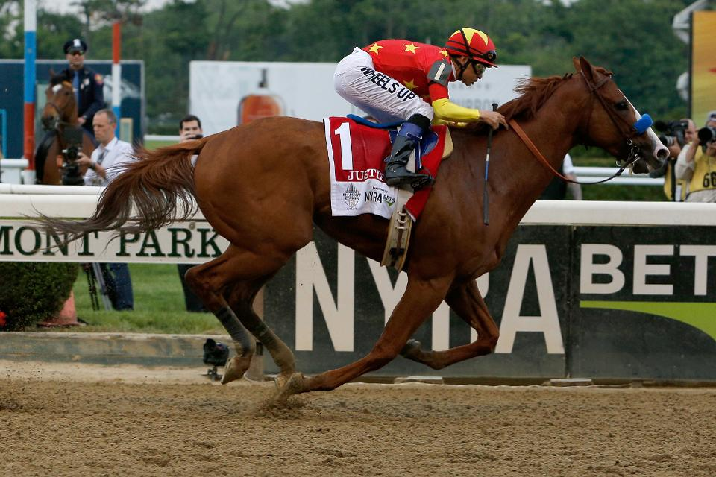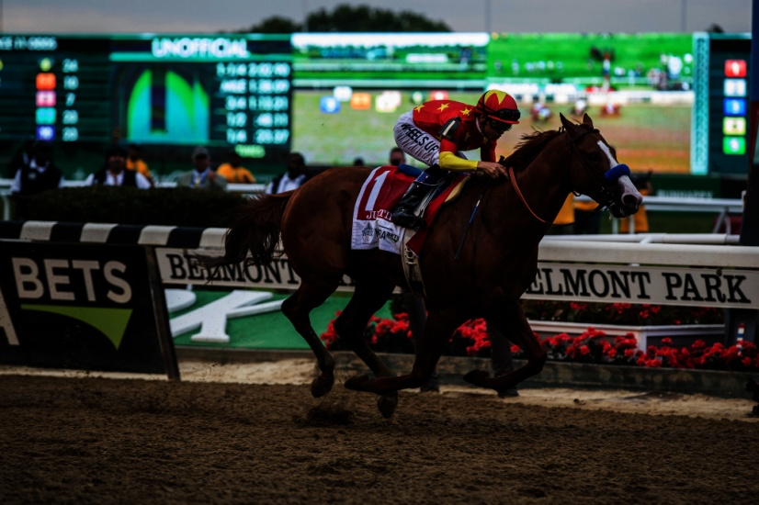
Justify
I want you to notice two things from the video: 1) Justify shot out of the starting gate and never stopped, and 2) The horse that was way behind during almost the whole race, in the last few seconds ran into second place behind Justify.
Before the race the jockey’s draw numbers to see what gate position they will be in. In the Kentucky Derby, Justify’s jockey, Mike Smith, drew #7. In the second race, the Preakness, Mike Smith drew #7. But, in this 150th Belmont Stakes, Mike drew #1. The number 1 slot put him next to the fence. If he did not bring the horse out fast enough, other horses could have pushed Justify into the fence. But, watch this video! You see that Mike Smith brought him out fast, and he never stopped. He kept riding to the finish line out in front of all the other horses.
From CBS Sports: “Justify just downright dominated the race from start to finish, at one point gaining a two-length lead, and overcoming a push from Bravazo, he stormed toward the finish line with a triumphant stride and an 11-length lead that will go down in history.” “Justify is the 13th horse to win the Triple Crown. Justify also joins 1977 Triple Crown winner Seattle Slew as the only horses to win the Triple Crown as an undefeated horse.”
Gronkowski drew the #6 slot. He missed out on the Kentucky Derby because of an infection. In the Belmont, Gronkowski was a horse that at first appearance to miserably trailed the others. But, as the finish line was seen, the jockey pushed him forward to win in the second place position, right behind Justify.
Justify is an example of about 2% of today’s Western world believers. The other horses just behind Justify represent varying type of believers. They want to win, but each has its own obstacles to overcome. However! Gronkowski is an example of about 2% of today’s Western world believers who see the finish line approaching and react to cross it in victory.
I taught in public and private schools for a while. This type of percentage is seen in what is called a “grading curve.” About 2% of the students are A to B+ students. About 2% of the students are D to F students. Most are in between i.e. B or C students. Each child got rewarded for his own work, his own ability, and his own diligence.
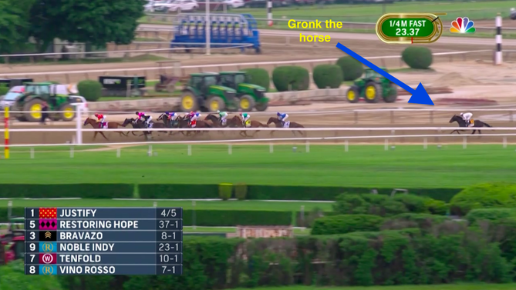
***See Justify on the left--his jockey wore a red shirt. See Gronkowski on the right--“Gronk the horse.” He went from way back there to right behind Justify in the last seconds of the 1.5 mile race. He represents a lot of believers worldwide in the last ahead--racing to catch up, but crossing the finish line in victory.
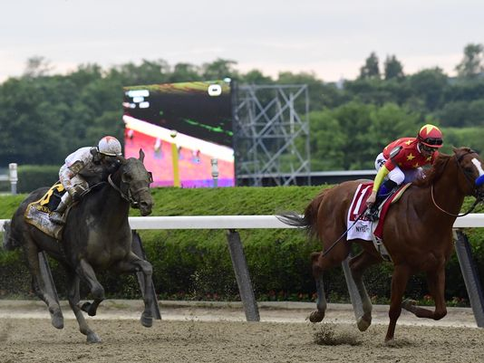
Gronkowski moving into second place behind Justify

***Be sure to watch this replay and see this amazing parallel to your own life.
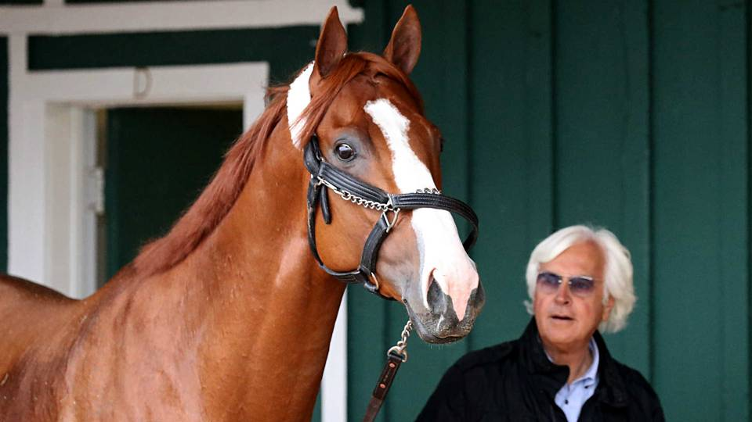 Bob Baffet is the owner of Justify. He was also the trainer. Can you imagine how proud Mr. Baffet was that his horse won the Kentucky Derby, the Preakness, and the Belmont stakes? In fact, in the five races his horse has been in, he won them all.
The conditions of the weather at the Preakness was awful – mud, rain, and a heavy fog. Yet, through it all, he kept on going to win. It was also a rainy day at the Kentucky Derby. But, the Belmont was held in New York on a beautiful day. No matter what Justify had to tromp through, he did it and won!
Do you see the spiritual significance of all of that!!!
Messiah intended for His disciples to pull out strong from the starting gate (the true new birth) and to remain strong throughout the whole race of life. He gave us His Spirit to empower us so that we could do that. But, most of us fell behind at some point. We got a mental or spiritual “infection.” Yet, Yahuwah’s Spirit kept riding like a jockey. Oftentimes, we wanted to throw Him off, stop, rebel, and lie down. Each individual is like one of those race horses because of his to win or not to win. The Gronkowskis of the Kingdom might come out of the gate slow, when they see the finish line ahead they’ll speed up to maximum speed and cross in victory.
Matthew 25:14-30: We’ve each been given special abilities to use to win. It’s what we do with them and how we increase them that will bring the results, rewards or no rewards, at the coming of Messiah.
We need to encourage each other to run that we may win, for the finish line is not far ahead of us! Let us cheer on the human Gronkowskis in this race of life.
Did you know that we run to win a Triple Crown?
Our Master wore the crown of thorns, but when He came up victorious from the grave, after 40 days, He ascended before His Father and received crowns of glory, honor, and esteem! (Matthew 27:28-31)
From Revelation 19:11-13: “And I saw the heavens opened and there was a white horse. And He that sat on him was called Trustworthy and True, and in righteousness He judges and fights. And His eyes were as a flame of fire and on His head were many crowns … and His Name is called The Word of Yahuwah…” All who have died will ride a white horse behind His as they ascend to earth in victory!
I Peter 1:8-9, KJV: “Whom having not seen you love, in whom, though you see Him not, yet believing, you rejoice with joy unspeakable and full of glory, receiving the end of your faith – even the salvation of your souls.”
***Rewards come on the other side of the finish line! These are our triple crowns.
II Timothy 4:7-8, Sha’ul confession before his beheading: “I have fought the good fight; I have finished the race; I have guarded the faith. For the rest, there is laid up for me the crown of righteousness, which the Master, the righteous Judge, shall give to me on that Day, and not to me only, but to all those who love His appearing.”
Revelation 2:10, Messiah speaking “…Be trustworthy unto death and I will give you the crown of life.”
Ya’cob/James 1:12 “Blessed are those that endure trial, for when he has been proved, he hall receive the crown of life which the Master has promised to those who love Him.”
I Thessalonians 2:19: “For what is our expectation, or joy, or crown of rejoicing? Is it not even you, before our Master Yahushua Messiah at His coming? For you are our esteem and joy.” This is often called “the soul-winner’s crown.” It is a crown given to those who complete the ministry given to them to share the Good News, disciple the believers, pray, prophesy, proclaim – who obey the Spirit one day at a time!
Revelation 3:11, Messiah speaking: “See, I am coming speedily! Hold onto what you have that no one takes your crown!”
This goes back to Luke 8:17-18: “For whatever is hidden shall be revealed, and whatever is secret shall be known and come to light. Therefore take heed how you hear. For whoever possesses to him more shall be given more, and whoever does not possess, even what he thinks he possesses shall be taken away from him.”
At our true new birth we are given gifts and abilities to increase for the Master. The words of Luke 12:31-48 should be enough to make us run our race with diligence.
Crowns are earned as part of our reward for faithfulness, obedience, and love of the Master who bore the crown of thrones that He might bear many crowns of honor
He is our example.
Justify, Gronkowski, and all the other horses in those three races, were highly trained, and highly disciplined, and highly united with the jockey who guided their steps. They had to learn not to go against the directives of the rider. They had to learn to be under submission, to obey.
I Corinthians 9:24-25: “Do you not know that those who run in a race indeed all run, but one receives the prize? Run in such a way as to obtain it. And everyone who competes controls himself in every way. Now they do it to receive a corruptible crown, but we for an incorruptible crown…”
Where are you in this race to the finish line? Please re-read the 2004 vision I had of my own horse race into the “cloud of witnesses,” (Hebrews 11-12:2) in the article “The Cloud of Witnesses is Waiting for Us”/Mikvah of Eternal Salvation.
Be encouraged! In this race of eternal life, we will stand before the Master Yahushua, the Judge of all, to receive the rewards we’ve won, and the crowns we’ve won.
Shalom, in His love,
Yedidah
June 12, 2018

