CAMPING or DEPARTING
MOVING WITH the CLOUD

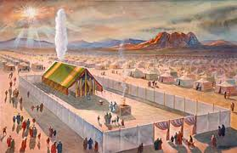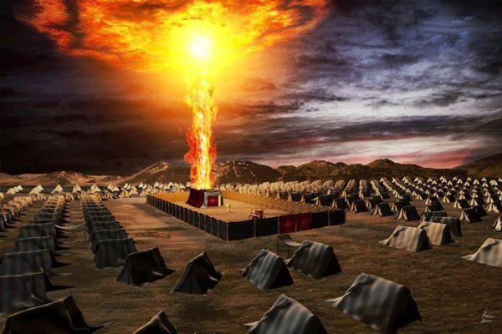
Numbers 9:15-23; 10:12-14, 28, 33-36

“And, on the day that the Dwelling Place was raised up the cloud covered the Dwelling Place--the Tent of the Witness. From evening until morning it was above the Dwelling Place like the appearance of fire. Thus it was continually: the cloud covered it by day, and the appearance of fire by night. And whenever the cloud was taken up from above the Tent, after that the children of Yisra’ĕl would depart. And in the place where the cloud dwelt, there the children of Yisra’ĕl would camp. At the command of יהוה the children of Yisra’ĕl departed, and at the command of יהוה they camped. They remained camped as long as the cloud dwelt above the Dwelling Place. Even when the cloud lingered many days above the Dwelling Place, the children of Yisra’ĕl guarded the Charge of יהוה, and did not depart. And so it was, when the cloud was above the Dwelling Place a few days: according to the command of יהוה they camped, and according to the command of יהוה they would depart. And so it was, when the cloud dwelt only from evening until morning: when the cloud was taken up in the morning, then they departed. Whether by day or by night, whenever the cloud was taken up, they departed. Whether two days, or a month, or a year that the cloud lingered above the Dwelling Place to dwell upon it, the children of Yisra’ĕl camped, and did not depart. But when it was taken up, they departed. At the command of יהוה they camped, and at the command of יהוה they departed. They guarded the Charge of יהוה, at the command of יהוה by the hand of Mosheh…And the children of Yisra’ĕl departed, setting out from the Wilderness of Sinai. And the cloud dwelt on it in the Wilderness of Paran. Thus they departed the first time, according to the command of יהוה by the hand of Mosheh. And the banner of the camp of the children of Yehuḏah departed first according to their divisions. And over their army was Naḥshon, son of Amminadab…So they set out from the mountain of יהוה on a journey of three days. And the ark of the covenant of יהוה went before them for the three days’ journey, to seek out a resting place for them. And the cloud of יהוה was above them by day when they went out from the camp. And it came to be, whenever the ark set out, that Mosheh said, `Rise up, O יהוה! Let Your enemies be scattered, and let those who hate You flee before You.’ And when it rested, he said, `Return, O יהוה, to the countless thousands of Yisra’ĕl.’ ”

I Corinthians 6:19-20: “Do you not know that your body is the Dwelling Place of the Set-Apart Spirit who is in you, which you have from Elohim and you are not your own? For you have been bought with a price, therefore, esteem Elohim in your body and in your spirit which are of Elohim.”
Messiah died and rose again so that the Spirit of Yahuwah, who is Yahuwah Himself, might dwell inside of you as He once dwelt over the Ark in the Tabernacle of Moses, and in the Temple of Solomon.
II Corinthians 3:17-18: “Now Yahuwah is the Spirit and where the Spirit of Yahuwah is, there is freedom. And we all, as with unveiled face, see as in a mirror the esteem of Yahuwah and are being transformed into the same likeness from esteem to esteem as from Yahuwah, the Spirit.”
Upon repentance and reception of Yahushua as our Master and Savior, putting faith in His death, taking our place, for the forgiveness of sin, and His resurrection for our eternal life, we have the privilege of asking for Yahushua Messiah to baptize us into the Spirit of Yahuwah, so that His omnipresent Spirit enters us within our spirit. The temple within is in the area between the breast-bone and top of our legs, the “loins area,” behind our naval. He comes to dwell with us within our temple to teach us, guide and direct us, speak to us, convict us of sin, and transform us into His nature, with His ways, and His thinking. Thus, an eternal portal is opened within us through our re-born spirit, so that we can dwell with Him as in Psalm 91:1, on earth, yet also in His throne room. It is a type of return to the Garden of Eden, where Adam and Eve dwelt on earth, yet within a portal that connected earth with the throne room of Yahuwah.
In other words, the “cloud” and the “fire” of His Spirit are over our “ark,” where His commandments are sealed within us, and when He says to move, we move. When He says to stay and wait, we stay and wait. We are under the same orders, for now we are His Tent of Meeting! Within us is His showbread, His menorah, and His altar of incense. From our spirit we send up a sweet smelling fragrance into His Presence in heaven, and to those who are saved (II Corinthians 2:14-16). We feast on His Word, the “bread of life.” We are part of the family of Ya’cob. We are His lights in the world – His menorah, filled with the oil of the Spirit that keeps us burning bright in a dark world of sin. We are the Tabernacle in which He dwells.
Luke 3:16-17, Yochanan/John the baptizer said: “I indeed baptize in water, but One mightier than I is coming, whose sandal straps I am not worthy to loosen. He shall immerse you in the Set-Apart Spirit and fire. His winnowing fork is in His hand and He shall thoroughly cleanse his threshing floor and gather the wheat into his storehouse, but the chaff He shall burn with unquenchable fire.”
The cloud leads us by day and the fire by night. The “cloud,” His Spirit-Presence is within us to let us know when to camp, when to prepare, when to move into a new place. He is our Commanding Officer and we are subject to do as He commands if we want to walk through the war zone of life and come out victorious. If we do things on our own at any point, we forfeit time and energy on dangerous potential.
We must live under the cloud and the fire of His Presence every second of our lives for our own protection and for our knowledge of His will. On the wilderness journey, Yahuwah looked out from the cloud and the fire – His Spirit was in both.
Exodus 13:21-22: “And Yahuwah went before them by day in a pillar of a cloud, to lead them the way and by night in a pillar of fire, to give them light, to go by day and night. He took not away the pillar of the cloud by day nor the pillar of fire by night from before the people.”
Exodus 14:19: “And the angel/messenger of Yahuwah who went before the camp of Israel, removed and went behind them; and the pillar of the cloud went from before their face, and stood behind them, and it came between the camp of the Egyptians and the camp of Israel. It was a cloud and darkness to them, but it gave light by night to these, so that the one came not near the other all the night.”
The “malak,” or messenger, of Yahuwah, called “angel” in the King James version, was Messiah Yahushua. He appeared many times on earth to His people before His incarnation in 3 BCE. He is the Son – Yahushua Yahuwah.
Exodus 14:24: “And it came to pass that in the morning watch Yahuwah looked unto the host of the Egyptians through the pillar of fire and of the cloud, and troubled the host of the Egyptians, and took off their chariot wheels so they drove them heavily, so that the Egyptians said `Let us flee from the face of Israel for Yahuwah fights for them against the Egyptians.’ ”
Exodus 16:10b: “…and the esteem of Yahuwah appeared in the cloud.”
We see in Exodus 19 and 24 that at Sinai, a thick cloud covered the Mount. The Presence of Yahuwah is seen today in what appears to be a cloud at times. I was in a meeting in Fort Worth Texas at Calvary Cathedral. I was late for the meeting. I entered quietly. I looked up and saw that a misty white cloud had descended on the people. I made my way down the long aisle, and when I entered the cloud, I had to grab onto an aisle seat to keep from falling because of the heaviness of the cloud – Yahuwah’s Presence. I had to hold onto aisle seats until I found one to sit in. Remember the story of Messiah on Mount Hermon? Matthew 17:1-8? Remember that the cloud, Yahuwah’s Presence, came down upon them all, and Yahuwah spoke to the three disciples? (Matthew 17:5)
Exodus 33:9: “And it came to pass that as Moshe entered into the tabernacle, the cloud pillar descended and stood at the door of the tabernacle, and Yahuwah talked to Moshe. And all the people saw the cloud pillar stand at the tabernacle door, and the people rose up to worship, every man in his tent door. And Yahuwah spoke with Moshe face to face as a man speaks to his friend.”
What is wrong with “believers” today? They run to men to hear their theology about “God”--a Being they don’t know, or not well enough. They do not know Him “face to face,” or as a Friend. Many reject the power and anointing of the Spirit that is in the book of Acts. Moshe lived in His Presence. The people stood afar off and worshipped. Do you see your choices?
Joshua/Yehoshua chose to stay near Moshe. Do you see the divisions of the wedding? What group represents the Bride? Who represent the attendants? Who represent the guests?
Exodus 40:33b-38: “And Moses completed the work…And the cloud covered the tent of the congregation and the esteem of Yahuwah filled the tabernacle. And Moshe was not able to enter into the tent of the congregation because the cloud abode thereon. And the esteem of Yahuwah filled the tabernacle. And when the cloud was taken up from over the tabernacle, the children of Israel went onward in all their journeying. But, if the cloud was not taken up, then they journeyed not till the day that it was taken up. For the cloud of Yahuwah was upon the tabernacle by day and fire was on it by night in the sight of all the House of Israel throughout all their journeys.”
As soon as the tabernacle was completed, Yahuwah came into it upon the ark in the Most Set-Apart Place. He resided with His people. The same tabernacle was in Shilo in the Land, but the Ark and the Presence of Yahuwah was under a tent in King David’s backyard for 40 years where praises and worship went up continually.
Please read: “Worship - The Journey of the Ark of the Covenant”/Mikvah of the Spirit. This article will give you more understanding about the residing of His Presence. Also the article: “His Presence”/Mikvah of the Spirit.
Today in 2018, nothing has changed as far as He is concerned. He is preparing to send Messiah to take back the earth for His people, and a third temple will be built that has the Presence of Yahuwah over the Ark.
Zechariah 6:12-15 – the Branch, the “nazar,” the One from Nazareth, Yahushua Messiah, will have Ezekiel’s Temple built. He will sit as the High Priest and as King over all of His people. (Psalm 132:13-14, Ezekiel 43:1-7a)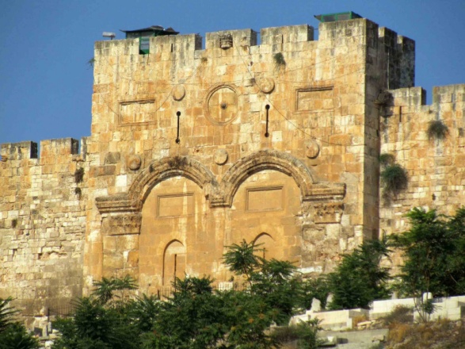 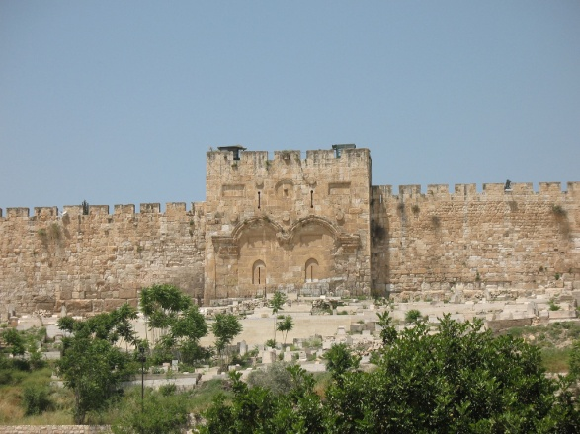
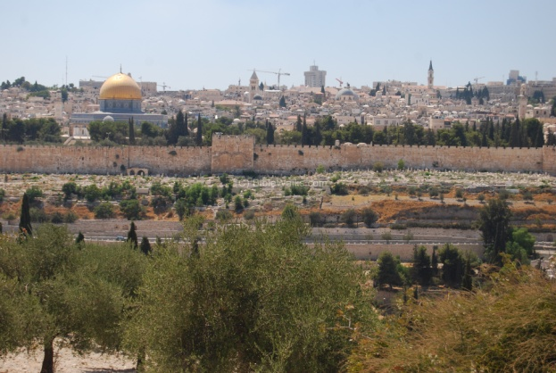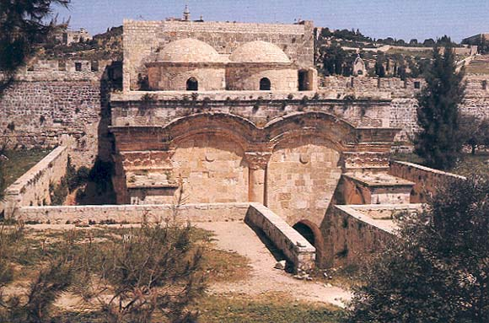
Left: Photo taken of the Eastern Gate from the Mount of Olives, the northern Kidron Valley, the “Valley of Jehoshaphat,” runs between the Eastern Gate and the Garden of Gethsemane in the foreground
Right: The back of the Eastern Gate seen from the Temple Mount facing East
The Eastern Gate in Acts 3:10 is also known as the “Golden Gate.”
Internet secular info: “Ottoman Sultan Suleiman the Magnificent rebuilt it together with the city walls, but walled it up in 1541, and it stayed that way. Suleiman may have taken this decision purely for defensive reasons, but in Jewish tradition this is the gate through which the Anointed One (Messiah) will enter Jerusalem.”
Even the Muslims believe “Jesus” will enter through this gate, so they put a graveyard in front of it to prevent his crossing it, for they reason that he would never cross a graveyard. However, Yahushua Messiah will cross it and the gate will open for Him, and for all of us who are with Him.
Let us prepare for His entrance by following the cloud and the fire. As He moves, we move! As you read above, in Numbers 10:33, the Levites went ahead following the cloud, carrying the Ark with them. “So they set out from the mountain of Yahuwah on a journey of three days. And the Ark of the Covenant went before them for the three days’ journey to seek out a resting place for them.”
Hosea 6:1-3: “Come and let us turn back to Yahuwah, for He has torn but He shall heal us. He has stricken but He binds us up. For two days He will revive us, on the third day He shall raise us up, so that we live in His sight. So let us know, let us pursue to know Yahuwah…”
Exodus 19:10-11: “And Yahuwah said to Moshe: `Go to the people and set them apart today and tomorrow. And they shall wash their garments, and shall prepare for the third day. For on the third day, Yahuwah shall come down upon Mount Sinai before the eyes of all the people.”
Messiah has been gone from us nearly three “days”--three thousand years. He is coming to bring us to our resting place. Are you ready to see Him face to face?
Revelation 3:4-5: “Nevertheless, you have a few names in Sardis who have not defiled their garments. And they shall walk with Me in white, because they are worthy. He who overcomes shall be dressed in white robes, and I shall by no means blot out his name from the Book of Life, but shall confess his name before my father and before His messengers.”
If you intend to meet the Master at His coming, or be in His entourage, you must have washed your garments, your life, and walk in purity before Him.
The cloud is lifting! Have you prepared to move with it!

Isaiah 21:11-12a: “Watchman, watchman, how much of the night has passed? The watchman said, `Morning is coming, but also the night…”
The night approaches quickly! We need the cloud by day and the fire by night, the Presence of Yahuwah’s Spirit, to lead us! We need the Messenger of Yahuwah with us, for He is the One we cry to: “Come Yahushua Come!”
In His love,
Yedidah
August 5, 2018

