EMP ATTACK, NORTH KOREA,
AMERICA’S FUKUSHIMA
JEREMIAH 50-51 AND REVELATION 18

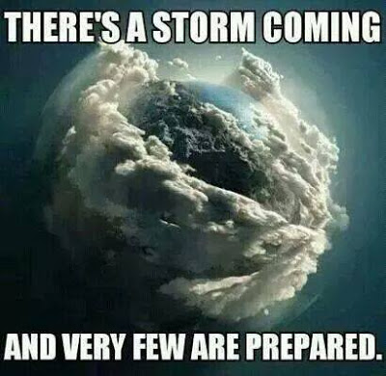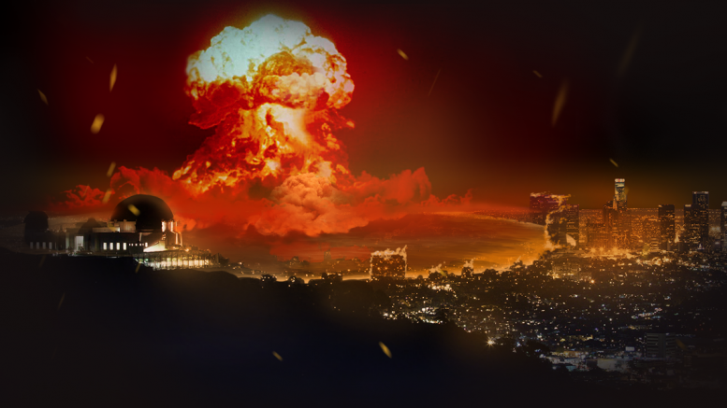

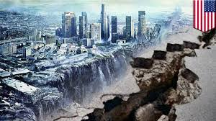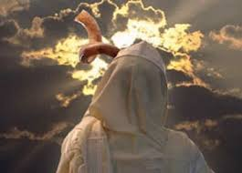

March 8, 2016, an e-mail from my son, Derek, who drove his car to be with his dad: “On the way over here, I entered tornado warnings. I loudly rebuked them and very loudly spoke in tongues. I had to. I drove through serious 60-70 mile per hour winds. Abba kept me safe. Praise His set apart name!” He sent me a video he took while driving, which he entitled “entering the storm.”
A second e-mail today from Derek regarding his trip through the storm: “It's time to enter the hiding place/ark. The set apart ones are being called in to gather around the Hen. Dial up our sensitivity to His Spirit. We must for our survival!”
[For you chicks who don’t remember who the “Hen” is: Luke 13:34-35]
Matthew 24:21-22: “For there shall be great distress such as has not been since the beginning of the world until this time, no, nor ever shall be. And if those days were not shortened no flesh would be saved, but for the sake of the chosen ones, those days will be shortened.”
When you have a U.S. Brigadier General warning us that a short, but final, World War III could take place before the end of spring 2016, you have more to think about than your next meal.
Events today are compiling, accelerating, burgeoning, and not going away. If you’ve read “The Abomination That Lays Waste”/November 21, 2014 and “Warning! Exposing Nine Lies”/August 6, 2015, and also kept up with my current-events updates, you are aware that most all fundamentalist Christian Eschatology is virtually worthless. You are watching the proof of that. Your eyes are open to see that the nice little man-reasoned package that has been presented to us of things that have to happen before Messiah comes is indeed very misleading. Most Christians are waiting around for something to happen that won’t happen, because Yahuwah is focused in another direction. We’ve got to get His mind about everything, by being taught by His Spirit! Otherwise, we could be lying in a theological ditch somewhere while the Master has moved on. For sure, we’re definitely at the threshold of everything breaking loose in the world, and even may have crossed it. Neither the Tenach (the Hebrew Scriptures), or the Messianic Writings (the “New Testament”), support the end-time theology of mainstream Christian religious leaders! The theology might sound good to the flesh, but it sure has kept a lot of people away from preparing for what the Word teaches. II Timothy 4:3-4 sure describes the mainstream church-goers who seek out teachers who will tell them what they want to hear. And, as with religion, the theology of religion has kept a lot of people away from knowing the real Elohim of the Scriptures! We must love Truth enough to get it from the only source of absolute Truth – the Spirit of Yahuwah!
I’m going to briefly tell you some of the up-to-date news, so that you might act wisely.
Proverbs 16:25; 27:12: “There is a way that seems right to a man, but the end therefore are the ways of death…a clever man foresees calamity and hides himself, but the simple go on and are punished.” The “simple” are dull-minded, not disciplined, not aligned to Yahuwah, so understand little and take action even less. I hope that’s not you!
To understand America in Scripture, please go over the Scriptures in “End Time Babylon.” There are over 30 clues in these Scriptures that identify “end-time” Babylon as America. For these clues translated into life today, I also recommend John Price’s documented book: “The End of America…”, and his three novels of the “Second Term” series that describe exactly what we’re seeing happen.
Jeremiah 50:8-9; 51:6-8, 45: “Flee from the midst of Babel…For look, I am bringing up and stirring up against Babel an assembly of great nations from the land of the north…Flee from the midst of Babel and let each one save his life. Do not be cut off in her wickedness, for this is the time of the vengeance of Yahuwah, the recompense He is repaying her…Babel shall suddenly fall and be broken…Come out of her midst, My people! And let everyone deliver his being from the burning displeasure of Yahuwah.”
These two chapters are set in post-1948 setting. Jeremiah 50 uses Messianic-Era terminology. ***Please carefully read all of Jeremiah 50-51, Isaiah 47 and Revelation 18 carefully to understand what I write in this update-article, and to understand how America is judged for what we’ve done to Israel.
Historically, the spirit, politics, and goals of ancient Babel, the goals of its founder, Nimrod, moved to Pergamum, then to Rome. By the first century Rome was known as “the second Babel.” I Peter 5:13: Kepha/Peter was writing from Rome, giving the code name for it. From Rome, it moved across Western Europe and on to America. America was chosen before the Pilgrims ever got to its shores to resurrect and reincarnate Nimrod to rule the world. This is the dream that goes back centuries and now is foremost in the works of the Illuminati and highest ranking Freemasons--the Elite of the Luciferic world all inclusive. [Refer to: “America’s Secret Destiny”/January 25, 2009]
Revelation 18:4: “Come out of her My people, lest you share in her sins, lest you receive of her plagues.” Revelation 18 prophesies about a disaster that hits New York City and destroys it in one hour. All of America is destroyed in one day. How can I be so dogmatic about Revelation 18 being New York City? The list of 25 commodities, listed in the chapter, are only all sold every day in one place on earth--Wall Street, NYC.
[Refer to the article “Jeremiah 25”/July 18, 2014] Jeremiah 25 speaks of the end-time judgment on all world nations. From Jeremiah 25:12 about end-time Babylon: “`…these nations shall serve the king of Babylon 70 years. And it shall be when 70 years are completed, that I will punish the king of Babylon and that nation…for their wickedness,’ says Yahuwah, `and shall make it everlasting ruins. And I shall bring on that land all my words which I have pronounced against it, all that is written in this book, which Jeremiah the prophet has prophesied concerning all the nations.’ ”
A Scriptural generation is 70 years. After World War II, America became the reigning super power of the earth. It is described well in Jeremiah 50-51. August 2015, the 70 years were up! The sword of Yahuwah hangs in the air over America. It’s soon destruction is now predicted by political leaders, economists, military leaders, and Elohim’s prophetic watchmen to America!
With the earthquakes and promises of tsunamis, fires, volcano eruptions, pestilence, and death from many arenas, America is sitting on Yahuwah’s preverbal powder keg.
Nations of the earth are not just saber-rattling anymore, but bent on destroying America. Its destruction has already been set up within its borders by the “current administration.” There are enemies crawling all over inside America just waiting for the gauntlet to be thrown so that they can proceed to kill the American people. I give you hear only a small sampling of my recent research on these things:
Dave Hodges, the Common Sense Show, March 8, 2016: North Korea to Use Specialized EMP Weapons Against the United States: In this article, Hodges tells how the U.S. Navy has been preparing for a wrong-type of EMP attack for seven years. In an EMP attack, the electric grid goes down. Without power, people will dehydrate within 3 days, or starve to death. It is predicted that over 90% of the American people will die in the first year after such an attack. But, but the EMP attack has become more sophisticated than what the Navy has prepared for. Now, even hackers can take down our grids.
Now, how would China, Russia, and North Korea, the big 3 nations to the north of America that Jeremiah 50-51 talks about, know how to take down our grid?
Hodges writes: “We taught the Chinese and the Russians how to turn the lights out! Obama has already shown the Russians and the Chinese how to take down our grid. As as part of the November 2013 Grid EX II drill, which simulated an EMP attack upon the United States, Russia and China, are most formidable enemies, were invited to attend.”
EMP stands for “electromagnetic pulse” waves.
I’ve been writing about the approximately 200,000 Russian troops doing maneuvers with America troops on America soil. They’ve been here for several years, and they’re not leaving. Years ago, America gave our San Diego Navy base to the Chinese, and now they own a lot of US National parks and territory. The U.S. military has also done maneuvers with Chinese troops not too long ago. North Korea, Russia, and China, are all good friends--especially in unity over destroying America. But, so is the goal of the “powers that be” that rule America!
Hodges continues: “In other words, Obama gave the Russians and the Chinese the knowledge on how to affect a grid take down. Of course, who could forget when outgoing DHS director, Janet Napolitano, stated in her August 2013 farewell address that …“it is not a matter of if but when such an attack will occur. There is virtually no defense.”
From “North Korea Has Nothing to Lose” Al Jazeera, Yahoo News March 8, 2016 by Andrei Lankov: Last Monday the North Korean government told the world that we should ready ourselves for a nuclear war on the Korean Peninsula. According to the official statement, North Korean armed forces "have a military operation plan of our style to liberate South Korea and strike the US mainland…In 2013, North Korean TV showed Kim Jong-Un in front a large map indicating targets for North Korean nuclear strikes; these included not only Washington and New York, but also, curiously, Austin, Texas…The game changer is the UN Security Council Resolution 2270, which was passed on March 2 in response to a nuclear test North Korea conducted in January, followed by a missile launch in February. Resolution 2270 is much tougher than earlier resolutions and is, essentially, unprecedented...”
The problem with trying to do something like “sanctions” is that Kim Jong-Un is demonically insane. He doesn’t care what he does, or who he hurts. China’s President has already made the statement that he’d wipe out the entire American population, except that his military won’t go for it. (hum…) Russia’s been threatening the U.S. for a long time, and the game goes on with Obama prodding these three to do it—i.e. bosom buddies to the end. For several years, Russia and China have been sitting off the American coasts and in the Gulf in nuclear-powered submarines, Russia has been flying warplanes into American airspace, and North Korean missiles have been found in Alaska – just for starters. Wow, Jeremiah 50-51 is front page news! It even calls America what the world calls America – “the world’s policeman,” the “hammer.”
From All News Pipeline, March 7, 2016: “North Korea Threatens to Attack; South Korea South Korea Preparing: Everything Could Change In One Moment - North Korean Nuclear Threat Over US-South Korean Foal Eagle Military Drills Simulating Collapse of Kim Jong-Un's Regime May Be Much More Than It Appears To Be” by Stefan Stanford.
It is important for you to know what will happen in an EMP attack. For starters, anything that runs on electricity will be gone, not temporarily but for at least long enough for everyone to die in America. The held-back terrorists in America, ISIS included, the criminals, the gangs, the on-the-ground Russians and Chinese, the martial law troops, the MK Ultras, and every other kind of vicious unmerciful fiend, besides other starving people, will destroy everyone they can. In fact, an EMP Attack is worse than being hit by a nuclear bomb!
From the All News Pipeline article: “While most traditional nukes could cause massive devastation upon one city as well as our nation’s economy and psyche, only an EMP attack would allow the North Koreans to accomplish their stated goal of 'destroying America all at once.' As we also told you in the 'Problem From Hell' story, North Korea does have the capability to launch an EMP attack upon America via one of two satellites that flies over America several times every day...and as previously warned, experts say there is very little to nothing that we can do to stop them. According to Dr. Peter Vincent Pry, the H-bomb recently detonated in a test by North Korea fits well within the requirements of a 'Super EMP', a device that could nearly instantly send America back hundreds of years and wipe out our electrical grid over a huge portion of the country according to the Washington Examiner. In fact, according to Pry, `the US is not only totally defenseless against such an attack but North Korea has practiced such EMP attacks against America already. North Korean leader Kim Jong Un has threatened a 'merciless sacred war' against its enemies and as we learn here, a Super EMP weapon would be much more dangerous to the United States than the most powerful H-bomb ever built due to its potential to kill off 90% of the US population - the masses dead through starvation and the collapse of society. Forget a massive bomb that could completely destroy cities; this one could be far more devastating to America.’ So now we know...a Super EMP, which North Korea has the capability to deliver, would be far more dangerous to the US than the most powerful hydrogen bomb ever built. While of course, any nuclear weapons attack upon a US city would be enough to allow a total lockdown of our nation, it wouldn't be able to destroy the whole country in 'one fell swoop' as an EMP attack upon us would.”
Before going on to “America’s Fukushima,” here is an unusual sign: 13 Bald Eagles Found Dead at Maryland Farm by Connor Mannion NBC News March 6, 2016: “Thirteen bald eagles were found dead at a Maryland-area farm over the weekend and federal authorities are currently investigating, and offering a reward for any information… The NRP were in the process of searching their records and had not seen anything matching this die-off event.”

[You might want to refer to this article also: The Eagle is Shot Dead - Sr. Pastor Terry D. Hale 5/13/2014 - Dream given 12-28-11 to Sr. Pastor Terry D. Hale of Calvary Christian Center, Gallipolis, OH, 740 682-9023, jackcoe@hotmail.com]
Yes, America is under the sword of Yahuwah. The roots of evil go back into the 16th century, and today evil has blossomed and is bearing fruit. It is also ready to receive the judgment on its fruits.
AMERICA’S FUKUSHIMA:
Not long ago, in reading about the NYC nuclear reactor leaking, it clicked that perhaps an EMP attack and/or an explosion of the leaking reactor would cause the scenario in Revelation 18, rather than a nuclear bomb. Most of us have thought that NYC would be destroyed in one hour by a nuclear bomb, just as Hiroshima and Nagasaki were destroyed in 1945. America dropped two Atomic bombs and ended World War II, even though they didn’t have to--the Japanese had already surrendered!!! Rising out of that horrendous power-show, America became the great super power of the world--invincible, unstoppable, impossible to impregnate, and virtually impossible to be destroyed. So much for the Titanic! The pictures below gives me chills …
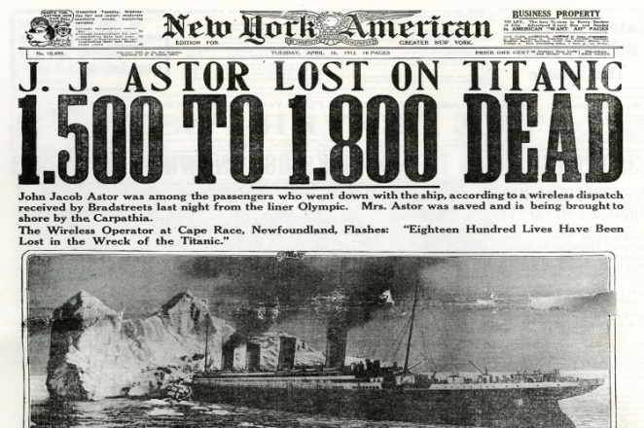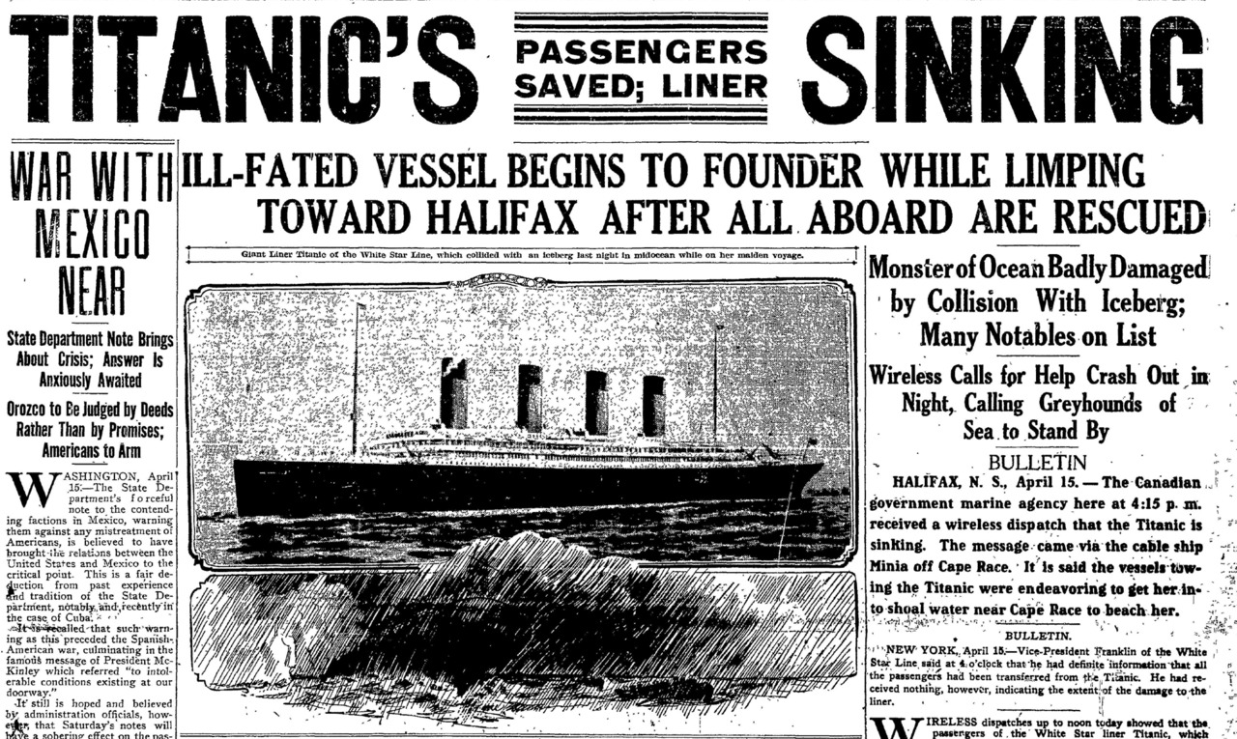
New York newspaper, April 16, 1912 Note article on war with Mexico near…As we
know many died after the rescue attempt

The Titanic hit an iceberg, which only showed its tip above water, but underneath it was a massive column of ice that tore the ship apart. America appears on the surface to still be in power and control. But, it has been so weakened by what has lain under the water, hidden from the eyes of its fantasyland mind-programming citizens, that it is now wide open to destruction. The enemy that was once held outside has now been invited inside by our own government--sheltered, fed, and given lots of money to stay here.

MARCH 12, 2016 is the 5th ANNIVERSARY OF THE FUKUSHIMA NUCLEAR FACILITY DISASTER IN JAPAN!

First picture: Minato, Japan, a week after the magnitude-9.0 earthquake and subsequent tsunami devastated the area. On March 11, 2011, at 2:46 p.m. local time, a magnitude-9.0 earthquake ruptured a 500-kilometer-long fault zone off the northeast coast of Japan. On March 12, 2011, the Fukushima Nuclear Reactor was found to be
leaking radiation. Second picture: The Fukushima Daiichi reactor found damaged from the earthquake and also the tsunami.
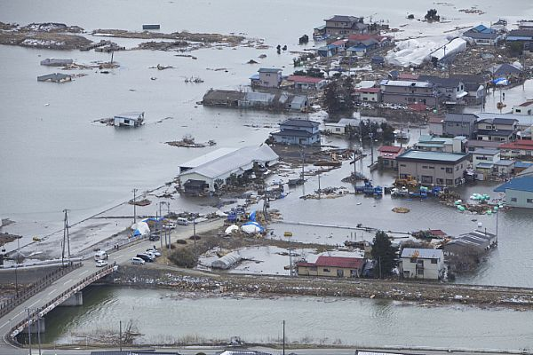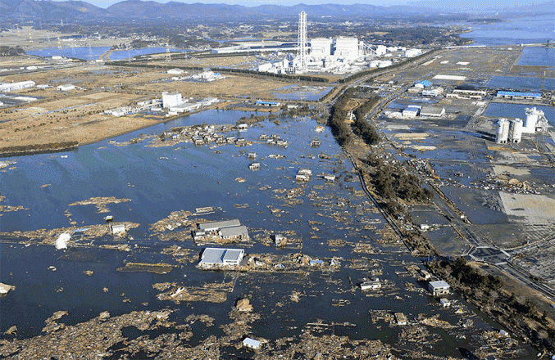
On March 11, 2011, a tsunami hit Japan with such force that it shut down a powerful nuclear reactor that began to leak radiation into the Pacific Ocean. Today, March 11, 2016, that radiation has traveled to the West Coast of America. Radiation has caused the death of many fish, infiltrated the milk of cattle, destroyed crops, and put people at great risk.
UPDATE: March 9, 2016, Reuters article: “Fukushima's ground zero: No place for man or robot” by Aaron Sheldrick and Minami Funakoshi: (Reuters) – “The robots sent in to find highly radioactive fuel at Fukushima's nuclear reactors have `died’… Five years ago, one of the worst earthquakes in history triggered a 10-metre high tsunami that crashed into the Fukushima Daiichi nuclear power station causing multiple meltdowns. Nearly 19,000 people were killed or left missing and 160,000 lost their homes and livelihoods. Today, the radiation at the Fukushima plant is still so powerful it has proven impossible to get into its bowels to find and remove the extremely dangerous blobs of melted fuel rods… What to do with the nearly million tonnes of radioactive water is one of the biggest challenges, said Akiro Ono, the site manager. Ono said he is `deeply worried’ the storage tanks will leak radioactive water in the sea, as they have done several times before…The utility has so far failed to get the backing of local fishermen to release water it has treated into the ocean…Artie Gunderson, a former nuclear engineer said, `The reactors continue to bleed radiation into the ground water and thence into the Pacific Ocean.’ ”
Fukushima’s melt down is a disaster that is continuing to damage human beings and sea life and animals, clear over into the east coast of the United States!
So, what about America’s leaking nuclear reactor in New York? “America's Little Fukushima: Nuclear Plant Leaking 'Uncontrollable' Amounts of Radioactive Waste into Drinking Water of 23 Million New Yorkers” - March 2, 2016 – Blacklisted News – Photo of New York’s leaking nuclear plant…

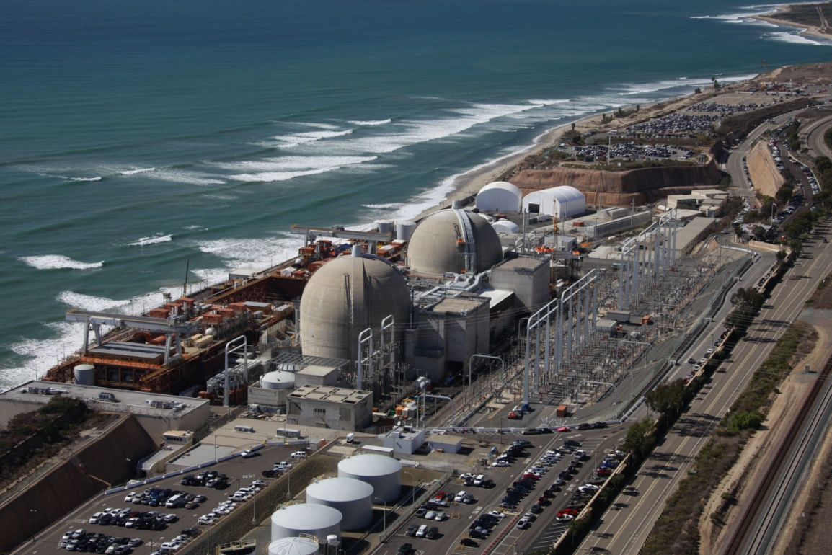
﻿ “An investigation recently called upon by New York governor Andrew Cuomo after the Indian Point Nuclear Power Plant reported nuclear material leaking into the areas groundwater reveals a staggering 80% increase in contamination over previous samples. Reported as a "disaster waiting to happen" experts suggest the immediate deactivation of the facility located just 25 miles north of New York City to halt the further contamination of 23 million people's water.”
The plant which is owned and operated by Entergy has experienced and reported leaks in the past but one iron worker who worked at the facility is unsurprised citing: "I was kind of shocked at how decrepit the facility seemed" upon receiving work there. More troubling though is that the official numbers reported of the most recent samples may not be nearly as accurate as samples from other locations which reported results as much as 65,000 percent times the readings taken before the Cuomo's investigation.”

From research notes during one of my Word studies:
Revelation 18:8-10a: “Because of this, her plagues shall come in one day--death, mourning, and famine. And she shall be burned up with fire because the Elohim who judges her is mighty. And the kings of the earth who committed whoring and lived riotously with her shall weep and mourn over her when they see the smoke of her burning--standing at a distance for fear of her torture…--for your judgment has come in one hour.”
Revelation 18:15, 17-18: “And the merchants of these--those who became rich by her--shall stand at a distance for fear of her torture, weeping and mourning…for in one hour such great riches were laid waste. And every shipmaster, and every passenger, and sailors, and as many as work the sea for their living stood at a distance and cried out when they saw the smoke of her burning…”
Radiation burns bring great torture on the outside and the inside of the body.
It brings a slow death. It is possible that this, and other nuclear reactors in the New York area, explode--setting off the fire. If it were just a fire, it could be put out. If it is fire from a nuclear bomb, hardly anyone would be left alive within its radius to suffer torment. If it were a nuclear attack, surely the ship owners wouldn’t stand at a distance to watch and mourn, no one would be able to get anywhere near it. The ships are unable to dock. That indicates that there is a radius of suffering and death, a boundary to it. The merchandise is ruined, not just burned up. Of course, missiles fired from enemy submarines out in the sea could hit the nuclear facilities and set off, not only fire, but radiation. A scenario like the one in Japan would not allow the seamen to watch and mourn. I see a combination of two or more of these things as most likely. Whatever the scenario, it is massive!
In the scenario of Revelation 18, it appears that the ships were approaching the port to unload or load their cargo. This would indicate that it happened suddenly, i.e. “in one hour,” with no pre-warning, or they would have turned back at sea! The disaster makes them draw back from the port, yet stop and watch from their position off-coast, giving time to lament and mourn. If it was, say, Russia that dropped a bomb, or sent nuclear missiles into the city, the reaction would be different. The ships would not stop and watch, but be dissolved in the nuclear blast. For ships to be offshore, unable to enter, yet watch what is going on, would mean that something happens within the radius of NYC that wouldn’t appear to immediately affect those coming into the harbor until the ships got close. It is also possible that huge enemy missiles carrying chemical and biological warfare are fired into the city. That could blow up nuclear facilities, and set fire to the city also. That would certainly bring on plagues, and cause the ships to remain off-shore. If it were a tsunami, or a tidal wave, the ships would be destroyed. Thus, an identical scenario for an American Fukushima is not likely, but may be part of the whole. Also, fire would destroy any food, so those trapped in the city would be starving, as well as dying of radiation poisoning, or chemical or biological burns and disease. In Syria, nerve gas was released on citizens and many died horrible deaths. Radiation poisoning takes a while for a person to die.
And, after all those possible scenarios, Dave Hodges says in his March 9th article, “America Is Under Attack by Weather and Earthquake Weapons,” regarding man-made, man-orchestrated weather manipulation: “Who needs nuclear bombs when weather and earthquake wars can produce such an event?” Besides, Yochanan doesn’t tell us in Revelation 18 how far off-shore those ships really are!
In John Price’s third novel of his “Second Term series,” he tells about people dying of radiation poisoning. He is writing about events during the “second term” of Obama. It is very realistic!
Revelation 18 is directly related to Isaiah 47. Revelation 18:4: “Come out of her My people lest you share in her sins, and lest you receive of her plagues.” Radiation and fire are certainly plagues. A plague goes on and on ... it is not something that just happens and it’s over. A plague eats away at the flesh.
Revelation 18:8: “…Because of this her plagues shall come in one day, death, and mourning and famine. And she shall be burned up with fire, because Yahuwah Elohim who judges her is Mighty.”
From the Interlinear Greek of Revelation 18:8, the word “plague.” Strong’s Concordance #4147 “plege,” pronounced “play-gay.” [Now, isn’t that a shocker, that the sound of the word “plague” in Greek fits in perfectly with American society, which has legalized and honored homosexuals, lesbians, bi-sexuals, and trans-genders--those that “play gay.”
The Greek word means: “a blow, as in a beating or flogging, stripe or wound, as in a death-blow, heavy, tormenting affliction brought on many people.”
A physical disease that affects many people is also called a “plague.” Radiation is a plague, for it eats at the flesh like a disease. People suffer from wounds, burns from the fire, or sores from radiation.
Also, we see in Revelation 16:9-11 that during the outpouring of Yahuwah’s bowls of wrath, people who took the mark of the beast break out with sores on their bodies, while the sun scorches them with fire.
We also know from the books of Joel and Revelation that by this time a lot of diverse beings on earth are not fully human. This is why Yahuwah tells His people to flee before America is turned into a land of hybrids, Nephilim, zombies--like the ones shown in the movie “I Am Legend,” 2009). Isaiah 13, Septuagint version speaks of the giants, satires, monsters, and the spirit of the unmerciful in America.
When the preverbal “smoke clears,” all of America will be burned up, so that nothing can live on its soil--it is so radiated--except monsters, satires, owls, and various types of mutates. (Isaiah 13 Septuagint Version, Jeremiah 50-51)
America also faces the very real possibility of being divided in half, by monstrous earthquakes, volcano eruptions, tsunamis, and water power.
Revelation 14:9-11 gives us a glimpse of what happens when a person takes the “mark of the Beast.” Their DNA is somehow changed. We see from Revelation 9 and 16 that those who take this “mark,” or etching under the skin, do not repent, for they cannot repent. They are no longer human. They are no longer in the image and likeness of Yahuwah.
Revelation 18 is also at the time of the final fall of Babylon. So a lot of those in the Revelation 18 scenario, including the merchants of the earth, the men at sea, the passengers of the ships, and the people in NYC, would be non-humans! That’s another reason why Yahuwah tells His people to flee!
Revelation 14:8: “Babylon is fallen, is fallen, that great city, because she made all the nations drink of the wine of the wrath (of Yahuwah) on her fornication.” (Psalm 75:8, Isaiah 51:22-23; Jeremiah 25:15, 27-28; Jeremiah 51:7; Habakkuk 2:16; Revelation 17:4)
Revelation 18:2: “Babylon the great is fallen, is fallen, and has become a dwelling place of demons, a haunt for every unclean spirit, and a haunt for every unclean and hated bird.” When NYC is destroyed, the rest of America will also be destroyed, in one day!
Isaiah 21:9: “Babylon is fallen, is fallen, and all the carved images of her gods He has broken to the ground.”
Jeremiah 51:8: “Babylon is suddenly fallen and destroyed.”
Scientifically, a nuclear bomb on NYC, which would be far more powerful than the Atom Bombs dropped in 1945. Yet, look what an elementary “A-Bomb” did to Nagasaki and Hiroshima, Japan, in 1945? A nuclear blast over NYC would kill 23 million instantly. Those in surrounding states would die slowly from the effects. Other coastal states, like New Jersey, would also come under the plague of NYC.
Now look at this: March 7th: “South Carolina Nuclear Reactor explodes and causes fire …” They don’t know what made it explode, but it caused a fire. They reported no radiation leakage, but for them to even mention radiation is significant. Note these three words in one short article: explosion, fire, and radiation
March 8th, from Dave Hodges: The Navy Has Prepped for An EMP Attack for 7 Years: “Since Obama has been President, the Navy has been involved in an unprecedented 7 year war game. In actuality, this move, by the Navy Department is designed to keep as many ships out to sea because they fear being victimized by an EMP attack.”
An EMP attack would cause suffering and death for over 300,000,000 Americans. Would the merchant ships of Revelation 18 be hovering off America’s shore after an EMP attack? Very likely! Consider: If at first they did not know initially what had happened, or the extent of the damage, once they did find out, they would mourn, because they would realize that America is GONE. They would realize that the U.S. economy is GONE, thus the commerce and trade is GONE--life is over for most people! While I believe that many factors will cause the Scriptural scenarios that destroy America, I believe that an EMP attack would be the start of the end. The merchants of earth would greatly lament – yes.
Here’s my point in sharing this: We’re in a time-tunnel that breaks out into the light at the coming of Messiah. Before He returns, earth will be wiped out and only a few people left alive. My job as a watchman is to warn the wise to act before it’s too late.
I highly suggest you read Isaiah 13, 47, Jeremiah 50-51, Revelation 18, etc. about America, and passages like Isaiah 24 about the whole world. The book of Joel is about what’s coming, Zephaniah, Zechariah. Malachi – actually all the Prophets – just read them all!!! There’s nothing like reading the Word, IF you ask the Spirit of Yahuwah to guide you into all truth that is. (I John 2:28; John 16)
I teach and preach against fear. Fear cancels faith, and without faith He cannot help anyone! I simply warn! Things will happen fast and furious. The 3½ year thing is not in the Tenach. It was added in a re-write of Revelation by the Jesuits, along with their Dispensational and pre-7-year tribulation rapture doctrines sent into America to “undermine the faith of the American Christians.” Our Father has promised to help us THROUGH this time of testing and purification. [Refer to: “Through”/May 4, 2012] We must pass “The Test of Iyob.” (Article: January 30, 2013)
I exhort you not to focus on what the devil’s are doing, though we must keep up with their activity, but to focus on the return of our Beloved One who is coming with the wrath of His Father to save us from our enemies as well as from our sinful ourselves. He’s coming to judge the earth (Psalm 96, 97, 98, 99). Proclaim these Psalms! Proclaim victory. Build your faith! Praise Him! If we need faith at any time in our lives, it’s now! Praise, proclaim the Word, and rejoice in your freedom and eternal life.
From a final e-mail Derek sent me on March 8th in reference to his trip through the storm that day in Texas: “The eye of the storm is the center of His will...for therein is calm and peace, while the swirling winds surround us. He is our eye in the storm!” HALLELUYAH!!!
Shalom, in His love,
Yedidah
March 11, 2016

