HOLD ON TIGHT TO THE MASTER’S HAND!
IT ALL LEADS TO OUR ETERNAL GOOD

“In just a little while, He who is coming will come and will not delay.” Hebrews 10:37

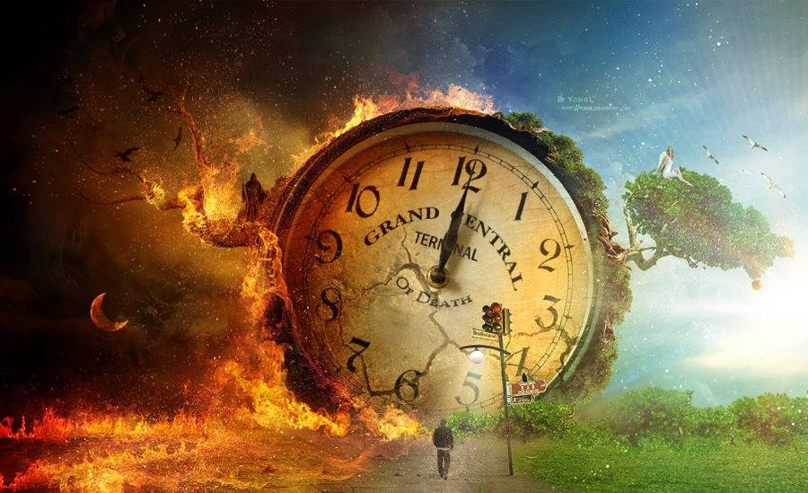

“Then the LORD said to Moses, “Stretch out your hand toward the sky, that there may be darkness over the land of Egypt, even a darkness which may be felt. So, Moses stretched out his hand toward the sky, and there was thick darkness in all the land of Egypt for three days. They did not see one another, nor did anyone rise from his place for three days, but all the sons of Israel had light in their dwellings.” Exodus 10:21-23

Our earth, our sun, our moon, and the stars, are letting us know that it is ready for the Creators to recreate. The sun, moon, stars – the entire universe – are letting us know it is ready for an end to defilement by the fallen angels, their offspring, and their mutant creations. The animals, birds, insects, all sea life, plants, and trees – all are waiting for the manifestation of the born-again ones upon a renewed earth in a renewed heaven.

This article contains things to take before Abba, as some hidden things are now being revealed about our future before Messiah returns.
Isaiah 65:17-19: “For behold, I create new heavens and a new earth, and the former things will not be remembered or come to mind. But be glad and rejoice forever in what I create; For behold, I create Jerusalem for rejoicing, and her people for gladness. I will also rejoice in Jerusalem and be glad in My people. And, there will no longer be heard in her the voice of weeping and the sound of crying.”
Isaiah 66:22-23: For just as the new heavens and the new earth, which I make will endure before Me,” declares the Yahuwah. So, your offspring and your name will endure. And it shall be from new moon to new moon and from sabbath to sabbath, all mankind will come to bow down before Me,” says Yahuwah.”
II Peter 3:12-14: “…looking for and hastening the coming of the day of Elohim, through which the heavens shall be destroyed, being set on fire, and the elements melt with intense heat! But according to His promise we wait for a renewed heaven and a renewed earth in which righteousness dwells. So then, beloved ones, looking forward to this, do your utmost to be found by Him in peace, spotless and blameless…”
Revelation 21:1-7: “And I saw a new heaven and a new earth: for the first heaven and the first earth were passed away; and there was no more sea. 2And I Yochanan/John saw the holy city, new Jerusalem, coming down from Yahuwah out of heaven, prepared as a bride adorned for her husband. 3And I heard a great voice out of heaven saying, `Behold, the tabernacle of Yahuwah is with men, and He will dwell with them, and they shall be His people, and He Himself shall be with them, and be their God. 4And He shall wipe away all tears from their eyes; and there shall be no more death, neither sorrow, nor crying, neither shall there be any more pain: for the former things are passed away.’ 5And He that sat upon the throne said, `Behold, I make all things new.’ And He said unto me, `Write: for these words are true and faithful.’ 6And He said unto me, `It is done. I am Alpha and Omega, the beginning and the end. I will give unto him that is athirst of the fountain of the water of life freely. 7He that overcomes shall inherit all things; and I will be his God, and he shall be My son.”

There is a remnant rising up – with the fire of the Word in them.
Jeremiah 20:7-9: “I am in derision daily--everyone mocks me. 8For when I spoke, I cried out. I shouted, `Violence and plunder!’ Because the word of the Lord was made to me a reproach and a derision daily. 9Then I said, `I will not make mention of Him, nor speak anymore in His name.’ But His word was in my heart like a burning fire shut up in my bones and I was weary of holding it back, and I could not hold it back.’”
With eyes on eternity and a spirit that is on fire within us by the Spirit of Yahuwah, we press on to the day when there will be no more evil, lies, deception, insanity, cruelty, killing – no more Satan and his forces – only the Kingdom of Heaven over a new earth under the authority of Yahuwah and Yahushua.
What we see and experience now is temporary; what is near future is eternal.
I Corinthians 4:16-18: “Therefore we do not lose heart, but though our outer man is perishing, yet our inner man is being renewed day by day. 17For momentary, light affliction is producing for us an eternal weight of glory far beyond all comparison, 18while we look not at the things which are seen, but at the things which are not seen; for the things which are seen are temporal, but the things which are not seen are eternal.”
I John 2:17: “And the world is passing away, and the lust of it; but he who does the will of God abides forever.”
It is horrendous what is not being told on public media. Two million Christians were literally slaughtered in Indonesia and Sudan nearly 20 years ago, yet for nearly a year pubic news headlined the O.J. Simpson trial and the Jon bene Ramsey murder case. Not one mention – 2 MILLION! Today Nigeria is a slaughter-house for Christians by Muslim extremists, but all we hear about is this plannedemic with lies and more lies.
Did you know that tens of thousands of soldiers are on their way to the Middle East from many nations, and nothing is being reported on the news? Many of those soldiers are from America. War is pending!
In my articles “End-Time Babylon,” going back to 1992 and forward and “30 Clues…” Mikvah of, it is clear that all that is prophesied there about the last-days political Babylon is speaking of the destruction of America in detail.
Revelation 18 is definitely New York City by many clues.

STEVE QUAYLE 2007 Q-ALERT – PROPHECY REGARDING NYC
Be wise, discern - for Intercessors!
“THE NIGHT HAS COME AND THAT WHICH HAS BEEN PROPHESIED HAS COME”
“HUGE ALERT FOR NEW YORK CITY-TRANSMISSONS INTERCEPTED INDICATE -THE TIME OF DAVID WILKERSON’S VISION MAY BE AT HAND FOR NEW YORK CITY, WHICH WILL SOON BE KNOWN AS'THE CITY OF 1,000 FIRES'
BOTTOM LINE: IF PEOPLE ARE NOT READY NOW IT IS RATHER TOO LATE BECAUSE THE HUGE RIOTS ARE HEADED TO NEW YORK CITY.WHEN THE PROTESTERS AND LOOTERS HIT D.C. I EXPECT THAT THERE WILL BE 'MULTIPLE HIGH-LEVEL MURDERS.'”
From Rhonda Morgera: “ODDLY ENOUGH THE RUSSIANS ARE PLAYING THEIR HAND NOW IN D.C. TO SOME DEGREE YET THE CHINESE ARE BAILING OUT OF THE CITY WHICH INDICATES THEY FEAR REPRISALS WHEN THEY LAUNCH AN ATTACK.
'THE RUSSIANS HAVE A MUCH MORE ORGANIZED PLAN FOR THE FINAL EVACUATION OF THE D.C. EMBASSY AND OTHER CRITICAL RUSSIAN ASSETS, WHICH NEED TO EXIT AT THE SAME TIME'”, SCIENCE GUY.
Steve Quayle: “WHEN YOU HEAR OF EMBASSY EVACUATIONS IN BOTH CITIES, IT WILL BE THE LAST WARNING BEFORE TOTAL HELL IS RELEASED, BUT ALL SURVIVAL PLANS OF THOSE IN N.Y CITY SHOULD GO NOW- 'IT'S MUCH MORE PRUDENT TO LEAVE WHILE YOU CAN AS YOU CAN ALWAYS COME BACK', AS OPPOSED TO NEVER BEING ABLE TO LEAVE' - SAME WARNING IS IN EFFECT FOR THOSE IN THE D.C. AREA.
BRETHREN, WE MUST PRAY FOR GODS SAFETY AND PROTECTION OF OUR BRETHREN IN THESE CITIES IMMEDIATELY July 3, 2020)
https://www.stevequayle.com/index.php?s=33&d=2472
For years I have warned about what will happen to New York City. Just that list of 26 “commodities,” in Revelation 18, including #26 - the trafficking of children for pedophilia, for sex slaves, and as field-workers with little pay - are only bought and sold daily in one place on earth as a whole--Wall Street, New York City (NYC).
Revelation 18: NYC will be destroyed in one hour. America will be destroyed in one day, Isaiah 10, 13, 47, Jeremiah 25, 50-51.
In 1992, as I was reading Jeremiah 50-51, Abba clearly said to me, “This is America.”
LIGHTNING FORKED LIGHTNING FORKED TONGUE: WORLD TRADE CENTER NYC-IS THERE A MESSAGE? July 6-9, 2020 Daily Mail
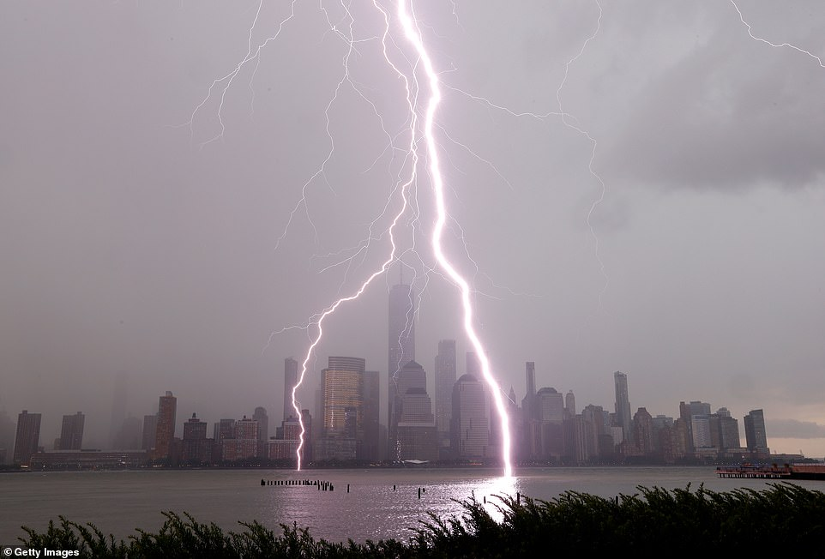
The forks of electricity blasted the water in front of the lower Manhattan skyline during a storm above New York City on Monday, July 6 [perfect encasement!]
WHAT’S GOING ON WITH ALL THE HORRENOUS LIGHTNING STRIKES?
Within 24 hours a few days ago:
Australia 330,000 lightning strikes
Israel: thousands of lightning strikes in a short time
Maryland Chesapeake Bay lightning strikes
Pennsylvania 2 dead from lightning strikes
Georgia 11 dead from lightning strikes
315 dead from lightning strikes in India
In the last few days, NYC has reported that because of the Covid-19 restrictions on restaurants, people have to sit outside to eat. But, sewers are opening and huge rats are coming out and biting people’s legs as they sit outside at the restaurants.
Red snow fell in Switzerland from cosmic ironized dust from space debris. Dallas, Texas had a reddish sky from the ironized dust that blew across southern America with mighty winds off of the Sahara Desert of Africa about 10-14 days ago.
6” to 8” locusts by the multi-billions are out of control on 4 continents: Asia, Africa, the Middle East, and South America. Now they’re moving north. Read the article that connects Joel 2 with Revelation 9: “Joel 1 2020, May 12th and Following”/Mikvah of Present Reality.
Note: No, May 12th did not bring the cataclysmic events that were seen on the scientific instruments earlier in the year. It may have had to do with Comet Atlas which was headed right at us. But the comet broke up into four pieces as it began going around the sun, and thus stopped what could have been a disaster. However, the reality of monstrous debris fields and radiation energy waves hitting earth is increasing by the day, as we get reports from around the world.
Two days ago, it was 119 degrees F in Phoenix, Arizona. Our temperatures are staying at 100 here in Northeast Texas, up to 109 so far. The hottest weather I’ve ever been in, out in the Jordanian desert by the Jordan River was 130F (53 C).
In China right now, 66 nuclear power plants are in danger because of great flooding. Millions of people would die. Japan today is hit with many meteors that started fire.
At least six regional wars are now turning into national wars that are growing bigger. Today Egypt got the go-ahead to “invade” Libya – actually to move their huge weapons arsenal into Libya, to protect Libya from a Turkish invasion.
We are looking at Pike/Mazzini Plan III for World War III to bring in the new world order. Refer to: “The Pike-Mazzini Plan of 1871: The Plan For Global Government – The Perfect Execution of Parts I, II, and Now Part III”/Mikvah of Israel, Our Eternal Inheritance.
Luke 21:11, 25-26: “And great earthquakes shall be in divers places, and famines, and pestilences; and fearful sights and great signs shall there be from heaven…And there shall be signs in the sun, and in the moon, and in the stars; and upon the earth distress of nations, with perplexity; the sea and the waves roaring; Men's hearts failing them for fear, and for looking after those things which are coming on the earth: for the powers of heaven shall be shaken.”
Meteors are hitting earth in larger and larger numbers. The debris field accompanying the binary system (called “binary” because it has 2 suns), is beginning to drop more and more debris our way. Note: “Mike” said that most solar systems or dwarf-star systems in our cosmos have 2 or more suns. So, our little earth with our one sun is unique.
On September 1st an asteroid 150 feet wide will come within 46,000 miles of earth’s atmosphere. NASA is very concerned. Of course, it is coming between earth and the moon. But, so are other huge objects. Revelation 8 is coming into focus now.
“Mike” told us last week that by September we should be able to see the binary system that is now visible by infrared telescopes. Yes, as said already, it is a monster, with two suns that will actually will affect our sun greatly, but supposedly the brown dwarf star and suns will not hit earth--just shake earth so bad that it will look like the stars are falling from heaven (Isaiah 24; Revelation 6:12-17) It’s right there in the Bible. The stars won’t fall, but they will look like they are to those on earth. It will terrify those great and might men in Petra.
Mike said “the stars will actually look like they are going up and down. Earth will shake, but it will appear that the stars are shaking. Mike said that “our orbital speed will become so great that people will not be able to handle it. This is Luke 21:11. “And there will be horrors, and great signs from heaven.”
Mike talked about how as the binary system approaches we’re rotating faster, and soon our timing will be off-center. He said that as the binary system approaches, our weather worldwide will change drastically. We’re seeing that now.
Regarding the birds, Mike said “Birds are literally disappearing from certain areas. Four to five states in the U.S. are without birds. Birds are leaving center-areas. Animals are becoming nervous. The core of the earth is stretching.”
Steven ben Nun of Israeli News Live, said in his July 10, 2020 broadcast, “Objects in the Heavens Effect Events on the Ground” that his sources, generals and officials at the Pentagon say that by September we should be able to see the monstrous binary system in part – with its two suns that will begin affecting our sun. That’s confirmation. I’ll report more as we get closer to these events.
Due to the incredible gravitational pull of this dwarf star and its entourage of two suns, the earth has begun to literally pull apart, stretching. The core of the earth is heating up so bad that it is melting the magma, which has begun to flow. Thus, earth is heating up drastically. Radiation is pouring into the earth, and at the same time, our magnetosphere is weakening, and other radiation protections that the Creators put into our earth’s atmosphere.
In Revelation 16, we read how the sun will scorch people. Yes, as the binary system’s main sun of the two suns comes near our sun, it will pull protons out of our sun, making it look dark. I’m sure you’ve read that in Joel 2 and Revelation 6 and etc. It will not destroy our sun, which will continue to give heat, but not light. The darkness will cover the earth!
“Mike” said on July 5th: “We’re not at the beginning of something – we’re in the middle of something.” He knows what we’re looking at from a Biblical perspective.
For our sakes, the destruction will be short, and then …
Matthew 24:21-22, 29-31: “For then there will be great tribulation, such as has not been since the beginning of the world until this time, no, nor ever shall be. 22And unless those days were shortened, no flesh would be saved; but for the elect’s sake those days will be shortened…Immediately after the tribulation of those days the sun will be darkened, and the moon will not give its light; the stars will fall from heaven, and the powers of the heavens will be shaken. 30Then the sign of the Son of Man will appear in heaven, and then all the tribes of the earth will mourn, and they will see the Son of Man coming on the clouds of heaven with power and great glory. 31And He will send His angels with a great sound of a trumpet, and they will gather together His elect from the four winds, from one end of heaven to the other.”
Our Abba is not a sadist!!! For the sake of His chosen ones from the foundation of the world, He will cut the days of tribulation shorter.
Ephesians 1:3-6: “Blessed be the God and Father of our Lord Jesus Christ, who has blessed us with every spiritual blessing in the heavenly places in Christ, 4just as He chose us in Him before the foundation of the world, that we should be holy and without blame before Him in love, 5having predestined us to adoption as sons by Jesus Christ to Himself, according to the good pleasure of His will, 6to the praise of the glory of His grace, by which He [a]made us accepted in the Beloved.
I Peter 1:1-9: “Peter, an apostle of Jesus Christ, To the pilgrims of the Dispersion in Pontus, Galatia, Cappadocia, Asia, and Bithynia, 2elect according to the foreknowledge of God the Father, in sanctification of the Spirit, for obedience and sprinkling of the blood of Jesus Christ: Grace to you and peace be multiplied. 3Blessed be the God and Father of our Lord Jesus Christ, who according to His abundant mercy has begotten us again to a living hope through the resurrection of Jesus Christ from the dead, 4 to an inheritance incorruptible and undefiled and that does not fade away, reserved in heaven for you, 5who are kept by the power of God through faith for salvation ready to be revealed in the last time. 6In this you greatly rejoice, though now for a little while, if need be, you have been grieved by various trials, 7that the genuineness of your faith, being much more precious than gold that perishes, though it is tested by fire, may be found to praise, honor, and glory at the revelation of Jesus Christ, 8whom having not [d]seen you love. Though now you do not see Him, yet believing, you rejoice with joy inexpressible and full of glory, 9receiving the end of your faith—the salvation of your souls.”
[Kepha/Peter was writing to those dispersed in 722 BCE of the House of Israel who went West, all the way to America, then north and south]
Luke 21:34-36: ““But take heed to yourselves, lest your hearts be weighed down with carousing, drunkenness, and cares of this life, and that Day come on you unexpectedly. 35For it will come as a snare on all those who dwell on the face of the whole earth. 36Watch therefore, and pray always that you may be counted worthy to escape all these things that will come to pass, and to stand before the Son of Man.”

“Look up, for your redemption draws near.”
In His peace and joy! Yedidah
July 15, 2020

