STRANGE RECONCILIATIONS - MYSTERIOUS MEETINGS
ANTARCTICA
Pope Francis, Patriarchs Bartholomew and Kirill, Queen Elizabeth, Barack Obama, John Kerry, the Ross Sea Marine Protected Area, the Nazis, the New Zealand Earthquake, FEMA, Israel, the Super Moon,
and the Secret Connections Behind Them All

I realize this long title has the words “strange,” “mysterious,” and “secret,” in it. I am not trying to copy Jonathan Cahn with his emphasis on mysteries, but let’s face it--as we watch the movements of the Elite, the ultra rich, the Globalist-Illuminists, as they prepare their arks for coming catastrophes, we see that they are working hard to set things up, calling attention to themselves--seen by those with eagle-eyes. Those that have learned to connect dots are reaching the finish line on the puzzle. The whole picture is becoming crystal clear.
In this exciting mystery article, I give you starting points so that you might watch with more understanding the movements of world governments, world economy, world religion, and world military buildup as it goes. In the last two years, we read of billionaires dumping stocks, of underground tunneling systems being prepared, like near the Denver Airport and under Mount Weather. We read of people fleeing the US more than ever and of preparation by those wise as an ant or a squirrel storing for winter. Look at who is in Petra when Messiah rises over Mount Seir: Revelation 6:12-17.
Mark 4:22-23: “For whatever is hidden shall be revealed, and whatever has been kept secret shall come to light. If anyone has ears to hear, let him hear.”
Enjoy reading about the mysteries, some that have been hidden for 5,000 years. They are rising to the light. Enjoy the pictures, maps, and astonishing information that I present to you here.

What is the bond between Pope Francis, the Patriarch of the Russian Orthodox Church, and the Patriarch of the Eastern Orthodox Catholic Church? The rifts go back 1000-1600 years. Why all of a sudden is Pope Francis “reconciling.” What is the common denominator that has brought these three, plus Obama, and now James Kerry, to Antarctica?
Refer back to of my report on the visit of Pope Francis to Israel, entitled: “The Hidden Agenda Behind the Pope’s Visit”/June 20, 2014. There’s another mystery word: “hidden.” The historic meeting of the reconciliation took place on the Mount of Olives in East Jerusalem, May 24, 2014. I was there in East Jerusalem, took pictures, and was a distant eye-witness of the reconciliation of Pope Francis with Patriarch Bartholomew of Istanbul, formerly Constantinople--former headquarters of the Byzantine Empire. Bartholomew is the 270th Arch Bishop of Constantinople, of the Eastern Orthodox Church.
Wikipedia: “He (Bartholomew) has exchanged numerous invitations of Church and State dignitaries. His efforts to promote religious freedom and human rights, his initiatives to advance religious tolerance among the world’s religions, as well as his efforts to promote ecology and the protection of the environment, have been widely noted, and these endeavors have earned him the title "The Green Patriarch.” Bartholomew is considered an “ecumenical religious leader.”
While Bartholomew is not known as a Communist, he is ecumenical, and believes in a unity that globalists strive for in order to reach their goals. His beliefs have Marxist leanings! To unite these three under the Roman “mother church,” is most important to the compiling of a one world religion.
The Clash of Patriarchs: Kirill I, Bartholomew I, and the Future of the Orthodox Church - November 12, 2016
“…Bartholomew I of Constantinople, the Ecumenical Patriarch, historically the “first among equals” in the Orthodox Church hierarchy.
A mere six years older than Kirill, Bartholomew has held this prestigious position since 1991, the beginning of his tenure strangely coinciding with the break-up of the Soviet Union.
Over the years, Bartholomew’s political statements and actions have mirrored so closely the U.S. and NATO global geopolitical agenda that, as a result, he was fêted everywhere he went in the West. He received numerous honorary doctorates (in the U.S., at both Georgetown and Yale) and distinguished awards, including the Congressional Gold Medal, which, in addition to the Presidential Medal of Freedom, is the highest U.S. civilian award…There has been a long-term effort in the U.S. to make Bartholomew a statesman-type celebrity figure, the equivalent of an Orthodox `pope.’ ”
Tom Horn, in his book The Final Roman Emperor, page 160, comments on the reconciliation between the Western Catholic Church and the Eastern Orthodox Church of Istanbul: “Pope Francis has been credited with ending the Great Schism of 1054 BCE that created the Eastern Orthodox Church.
CNN reported, `Francis and Patriarch Bartholomew I – the spiritual leader of some 300,000,000 Orthodox Christians worldwide signed a declaration on Sunday committing to unity between the two churches.’ ”
On pages 259-260 of his book, Tom Horn tells about the seven periods of church history spelled out by a 15th century German priest, ‘the Venerable’ Bartholomew Holtzhauser in his Commentary on Revelation. “According to him, the 5th period began in 1520 and would extend until the time of the `Holy Pope’…marked by major wars, the loss of Roman Catholic Church influence, moral laxity, and that Muslims would rise up to cause the Catholic Church problems…Pope Francis seems to match the description of the `Holy Pope’…even more, the `Holy Pope’ is prophesied to bring the Eastern Orthodox back into communion with Rome. Right on cue, in an address to the Orthodox Church of St. George in Istanbul (formerly Constantinople) Pope Francis said, `the one thing that the Catholic Church desires and that I speak as Bishop of Rome…is communion with the Orthodox Churches.’ Francis then followed this in February 2016 by meeting with Patriarch Kirill in `first-ever papal meeting with the head of the Russian Orthodox Church, an historic development in the 1000-year schism that divided Christianity.’ ”
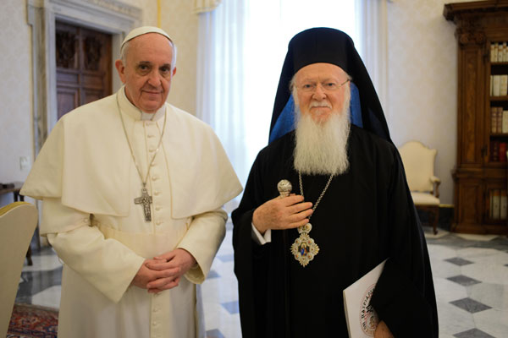
Pope Francis and Patriarch Bartholomew
May 25, 2014, Jerusalem

JERUSALEM, May 25, 2016 – “His All-Holiness Ecumenical Patriarch Bartholomew, spiritual leader of over 300 million Orthodox faithful worldwide, met today with Pope Francis on the Mount of Olives. At the site known as Viri Galilaei (Acts 1.11), the Patriarch and the Pontiff met for the third and final time during their joint pilgrimage to Jerusalem and the Holy Land. It marked the conclusion of an historical pilgrimage and fraternal encounter… They sealed their pilgrimage and fraternal exchange by reaffirming their commitment to advance peace, dialogue and mutual understanding among all people of the world. This Apostolic Pilgrimage commemorated the fiftieth anniversary of the meeting of their predecessors, Pope Paul VI and Patriarch Athenagoras in 1964, the first time an Ecumenical Patriarch and a Pope had met in over five hundred years…His All-Holiness Bartholomew is the Archbishop of Constantinople-New Rome and the Ecumenical Patriarch. He is the 269th successor to the First-Called Apostle Andrew, the founder of the 2,000-year old local Christian Church of Constantinople.”

NOW ABOUT PATRIARCH KIRILL
This reconciliation is more mysterious than ever, until you find out what unifies him with Pope Francis.
Tom Horn in his book The Final Roman Emperor… pages 155-156: “Dave Hunt wrote, `Liberation Theology was spawned in Latin America by radical Catholic priests and nuns whose aroused consciences would no longer justify the oppression of the masses by the Church and State.’ Communism and Liberation Theology have the same basic goals, but Liberation Theology turns to the Christian faith rather than atheism to rationalize its confiscation of private property allegedly to benefit the less fortunate…As a group they are philosophically indebted to the perspectives of Kant, Hegel, and Marx. Martin wrote that Gutierrez, a Peruvian Jesuit priest, `analyzed theology in the light of the Marx theory of class struggle.’ …Liberation Theology was really a Communist conspiracy. According to a Roman defector, `Gutierrez was under the spell of the Soviet KGB.’ ”
Here we go with connections...
Vladimir Putin was head of the KGB before he ever became leader of Russia. The KGB stands for Komitet gosudarstvennoy bezopasnosti – in English, the Committee for State Security of the USSR, like America’s CIA, DHS, or Israel’s Mossad, all of them evil to the core, doing covert operations for their internationally Elite rulers. Now we come to the Russian Orthodox Patriarch Kirill.
Tom Horn continues, pages 156-157: “The head of the Russian Orthodox Church, Patriarch Kirill, was working for the…KGB under the code name `Mikhailof.’ Pacepa bluntly asserts, `Liberation Theology was not invented by Latin American Catholics, but rather it was developed by the KGB.’ Liberation Theology was concocted by the KGB, and Patriarch Kirill promoted it. Thus Kirill was instrumental in spreading Marxism into the Western Hemisphere, an existential threat to US soil. Kirill appears to be a rather sinister character. According to the investigative journalist Stephenson Billings `The man in question is Patriarch Kirill, a genuinely ruthless figure in the harsh world of Soviet politics. A former KGB agent and now a close associate of Vladimir Putin, he has called his leader `a god.’
He is widely condemned for spreading Stalinism and atheism to the Ukraine in a cruel bid to expand his empire. Evidence unearthed in Soviet archives has revealed that the Russian Orthodox Church has long been infiltrated and managed by the KGB as a tool of population control. This is one of the main reasons why the CIA has kept a close watch on the secretive kingpin Kirill for decades.’ Apparently, the KGB pays well because Archbishop Kirill’s personal wealth is estimated at $4 billion by the Moscow News…The Evangelical Dictionary of Theology emphasizes that Liberation Theology `is, for the most part, a Roman Catholic theological movement.’ It follows naturally that as a former Argentine Cardinal, the Pope was profoundly influenced by this communist-inspired Latin American movement. In fact, his socialism is impossible for American Catholics to explain away.”
Page 327: “President Obama’s ambition to become UN general secretary has become public knowledge…More so Vladimir Putin and Prelate Archbishop Kirill have openly declared a twenty-first century crusade while remaining belligerently pro-Assad/anti-USA, and we cannot help but sense that it is leading to a time when reptilian spirits will be gathering the world’s leaders (Revelation 16:14) and that the world is already perched upon the ultimate battle of Biblical prophecy…”
I have research, and pictures, showing that this Pope is not only a militant communist, but also a member of the Illuminati. But, of course, the Illuminati was created by a Jesuit priest, and he is a Jesuit priest. I also have research telling about his involvement with pedophile rings and his murders of his own priests who would not go along with Liberation Theology. The pope wears the mask of a saint, but he has the heart of Satan. (II Corinthians 11:13-15)

WHERE DID THE RECONCILIATION BETWEEN THE ROMAN CATHOLIC CHRUCH AND THE RUSSIAN ORTHODOX CHURCH TAKE PLACE?
The Guardian, February 13, 2016: “Pope and Russian Patriarch Krill meet for first time in 1000 years (since 1054 CE) February 13, 2016 in CUBA….Pope Francis and Patriarch Kirill, head of the Russian Orthodox church, have met in Cuba in a historic act which some believe may have political motivations -
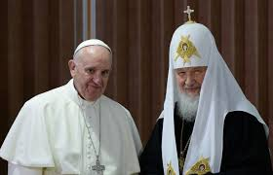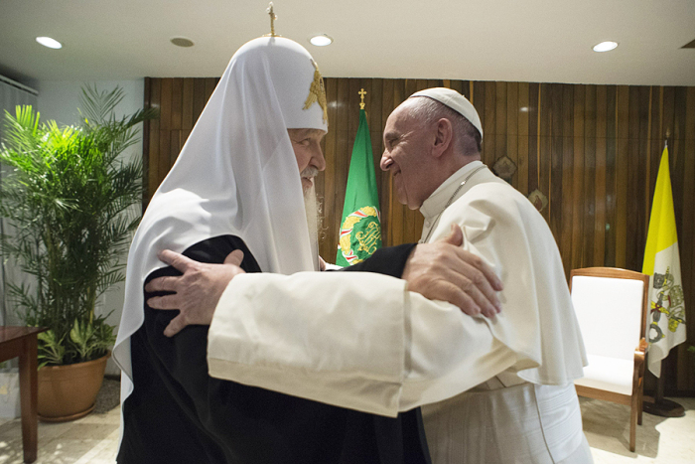
This “reconciliation” between two hard-core Marxists took place in a compatible country for them both--Communist CUBA!
Putin greets Patriarch Kirill on his 70th birthday
November 20, 2016 TASS – “Putin highlighted "the huge input" Patriarch Kirill is making "in development of inter-religious and inter-ethnic dialogues, in strengthening of peace and social harmony in this country."
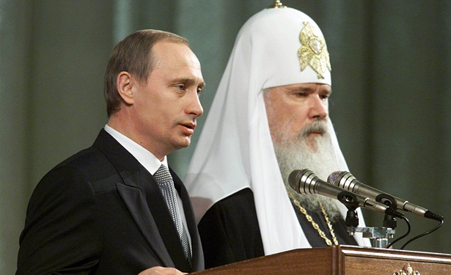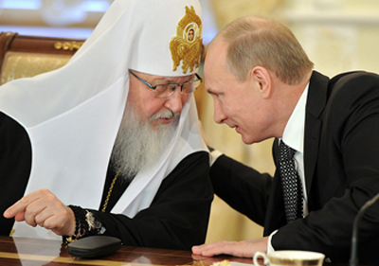
Left: Vladimir Putin and Russian Orthodox Patriarch Alexy II stand at the podium during a reception in the Kremlin in Moscow on January 11, 2000, less than two weeks after Putin became acting president of Russia, following Boris Yeltsin's resignation. (AP Images)
Right: Putin with Patriarch Kirill
Communism, like Roman Emperor worship, never died--it just hid in religion and nationalism. Today atheists in Russia are condemned by the government – even though communism is an atheistic religion itself. The masked front-man of communism in Russia is the Patriarch. Beware of religion in all forms! Beware if trust any man. Know your Elohim personally! (II Corinthians 11:13-15)
BBC on the meeting of Kirill with Pope Francis: “The meeting marks the first encounter in history between a Roman Catholic pope and a Russian Orthodox patriarch in the nearly 1,000 years since Eastern Orthodoxy split with Rome. “Finally!” the pope exclaimed as he embraced Patriarch Kirill in the small, wood-paneled VIP room of Havana’s airport, where the three-hour encounter was taking place. `We are brothers.’ … Asked if Putin had approved the Cuba rendezvous, Patriarch Kirill’s spokesman, Alexander Volkov, would only say there was a “100% guarantee that the meeting is between two church leaders and has no relation to politics.”
And who also has recently politically reconciled with Cuba, March 20-22, 2016, exchanging a brotherly Masonic handshake with President Raul Castro? -- Communist operative, trained by Saul Alinsky in radical Communist takeover, Barack Obama. In the picture below on the right, you see two Masonic/Communist brothers shaking hands – Pope Francis and Fidel Castro. Notice the handshake is the same in both pictures.
“President Obama made a historic trip to Cuba this week as the first sitting US president to visit the Communist ruled island since Calvin Coolidge did in 1928. `My lifetime has spanned a time of isolation between us,’ Obama said. `I have come here to bury the last remnant of the Cold War in the Americas.’ ”-Lloyd Young, the Big Picture
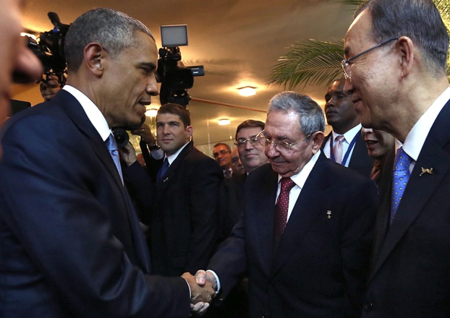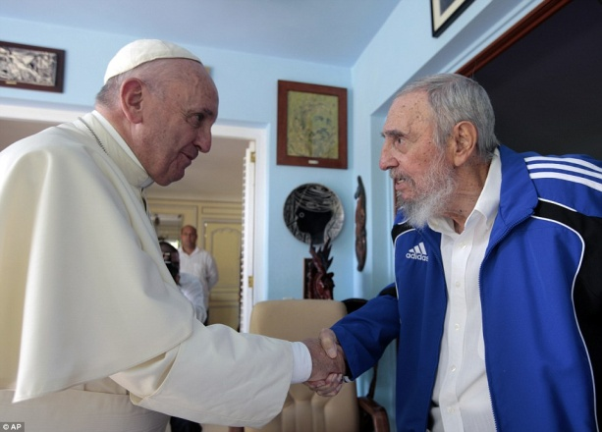
The first of the Mazzini/Pike Plan of 1871 was the rise of Communism in 1917 and the overthrow of the Russian Czar, bringing about World War I. The connection between the Pope, Bartholomew, Kirill, Obama, the Clintons, and the Globalists in general is the goal of world rule, subjecting the poor to the rich - Marxist doctrine!

Where did Patriarch Kirill go within a few days after the “reconciliation?” – ANTARCTICA! More on Kirill’s visit to Antarctica below...

HOW DOES THE QUEEN OF ENLAND FIT IN?
Queen Elizabeth Warns Of Holy War to End All Wars
Posted on October 21, 2016 by Baxter Dmitry for yournewswire.com
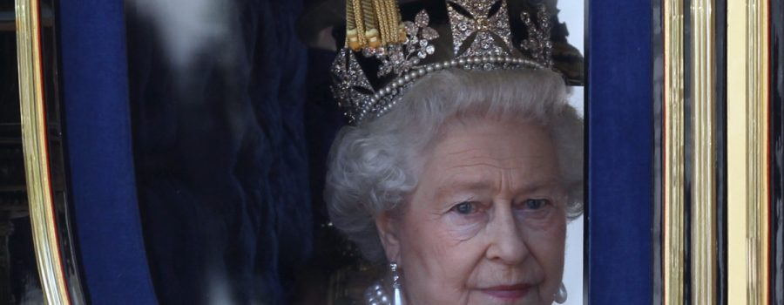
Queen Elizabeth has been meeting with religious leaders to discuss an imminent global war that she claims will bring about the “end times” for humanity.
“At a meeting with Russia’s Patriarch Kirill and the Archbishop of Canterbury, the Queen said, `One must now make the necessary preparations to say goodbye to loved ones as one cannot assume who will live and who will die. Many will die in these final days,’ according to BBC production staff.
`My beloved country is about to enter its darkest period in the coming months as a brutal and apocalyptic war will be waged in the east. I am not concerned with the trivialities of Christmas. I am concerned with the terrible consequences we must face as the war drums beat ever stronger,’ the Queen said.
After meeting with Queen Elizabeth, the Patriarch of Moscow and All Russia called on all countries to unite behind the fight to defeat `evil,’ the BBC reported.
`Today’s war on terror should be a joint effort…This isn’t just Russia’s fight. It’s for all countries, we should unite to defeat this evil,’ Kirill said, adding, `And this war I call a holy one.’
The highest ranking official in the Russian Orthodox Church, Kirill is on close personal terms with President Vladimir Putin. In 2012 he campaigned to pass a bill that would criminalize vandalism of religious sites, and now he is joining the Queen in urging Christians of the world to unite.
The discussion between the Patriarch and the Queen was `devoted to the position of Christians in Europe,’ Kirill’s secretary Alexander Volkov said. `The Church should also play a role in international relations. Through faith, through the Church, the soul of a nation is manifested.’
The Pope is also talking about it: `This is war. There was a war of 1914. Then that of 1939-45. Another Great War, then there is this one. It is maybe not organic. It is organized, yes, but not organic. But it is a war,’ the Pope said.”
The Queen is not virtuous, nor sympathetic with humanity, anymore than the Archbishop of Canterbury, Patriarch Kiril, or the Pope – which is nil. The message is: To avoid World War III, we must unite under the banner of unity as humans for good will. America has created a world villain, ISIS to terrify and do brutal acts against Christians and Biblical-related antiquities. The word for the world is tolerance, acceptance love, and uniting as humans to save the planet, uniting against global warming and climate changes, uniting against terrorism on the ground, uniting against world famine, uniting against a world pandemic, uniting against worldwide economic collapse, uniting against what might fall from outer space on our planet, uniting to receive our alien “parents” from outer space who will bring peace to the earth, and any other uniting possible. How appropriate! A very popular movie now playing in the theaters is entitled “Arrival.”
The pope has united all major branches of Christian churches, and united leaders from most every other world religion under his authority--for above all, we must have religious unity also.
Once the world desires peace above everything else, unity under a single leader, single government, single economy, single religion, single mind-set over all, will seem the only right thing to do. Why would the Queen turn to the Patriarch of Moscow for answers?

LET’S TALK ANTARCTICA AND NEW ZEALAND

I highly recommend Steve Quayle’s book Empire Beneath the Ice – How the Nazis Won World War II. You’ve probably heard about Admiral Bird’s expedition to Antarctica to check out the Nazi bases there, but I bet few of you know what really happened to cause Byrd and his team members to return to the U.S. in failure.
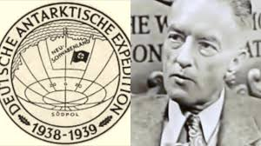
Admiral Byrd – Operation High Jump--Antarctic focus

In 1922, the Vril Society, forerunners of the Nazis, like the Thule Society, occult to the core, conducted séances from which they got instructions from the “gods” as to how to build a “flying saucer.” They acted on the instructions, from 1922. This book has lots of pictures of their “saucers” and tells the story of the Nazis and Antarctica.
Nazis have underground facilities in Antarctica, from the 1940s, in which they carried on the experiments from Germany—experiments on human beings, on DNA-mixing, cloning, biological warfare, flying saucers, and other high technology they received from the “gods”--“the men of renown” (Genesis 6:2-4).
America, Russia, and maybe Germany too, have been melting ice caps on the North and South Pole (Antarctica) for a long time, to get at three basic thing: 1) the natural reserves of oil and gas, 2) Nephilim remains for DNA/cloning experiments, and 3) for Nephilim technology. Before the Flood there were no ice caps – the whole earth was at a pristine 72 degrees all over, and the earth was watered from subterranean rivers. That’s why the “deep broke up” to begin the Flood. The technology used before the Flood was stolen by the fallen ones--stolen from Yahuwah. That knowledge, the “mysteries,” came through the Flood and was given to mankind after the Flood. When the Nephilim returned in 1896, 120 years ago, they brought back the technology to give to mankind. That’s why around 1900, all of sudden knowledge started doubling faster and faster, vehicles and air planes and weapons of war began surfacing. Up to 1900, world knowledge increased about once every 100 years. Today it is doubling every few weeks. The world’s Elite are working with the returned Nephilim!
So, why all of a sudden do we have Patriarch Kirill going to Antarctica a few days after the “reconciliation” with the Pope (two communists) on Cuba, then Obama goes, then John Kerry goes again--and how are Kerry’s visits connected to New Zealand earthquakes? They are all interconnected!

KIRILL IN ANTARCTICA
Havana, Cuba, Feb 12, 2016 / 02:51 pm (CNA/EWTN News)
“In a historic first, Pope Francis on Friday met with Russian Orthodox Patriarch Kirill. The Feb. 12 meeting took place in Havana, Cuba, a stop added at the start of the Holy Father's Feb. 12-17 trip to Mexico. In addition to meeting privately, Pope Francis and Patriarch Kirill signed a joint declaration.”

“Patriarch Kirill meets penguins at Russian base as he becomes first Orthodox leader to visit Antarctica” - The Telegraph - By Roland Oliphant, Moscow - 18 Feb 2016: “Patriarch Kirill, head of the largest of the world’s various eastern Orthodox churches, arrives at the Bellingshausen research station on King George Island.”
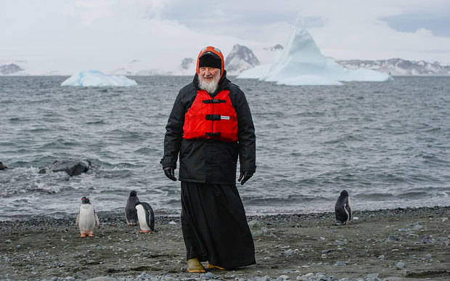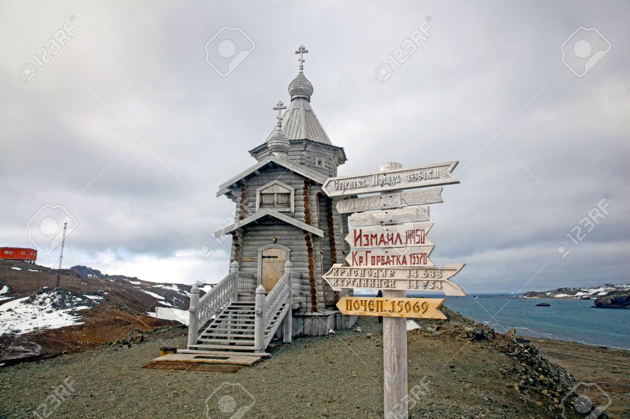
Left: “Russian Orthodox Patriarch Kirill visiting Russia's Bellingshausen scientific station on the Island of Waterloo in the Antarctic. Photo: AFP / MOSCOW PATRIARCHATE / IGOR PALKIN
Right: The Russian Orthodox Church; Kirill was the first Patriarch to speak in this church at Bellingshausen Station – the only permanent place of worship in Antarctica
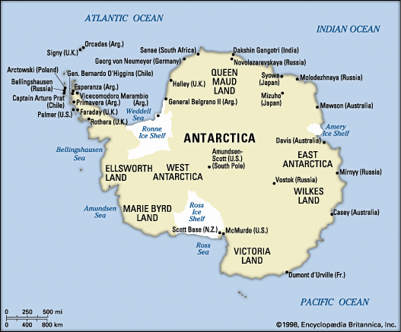
Notice Bellingshausen Station Northwest, US base just south of Russian base, and the Ross Sea and Scott Base NZ south; Note Russian bases also on the east
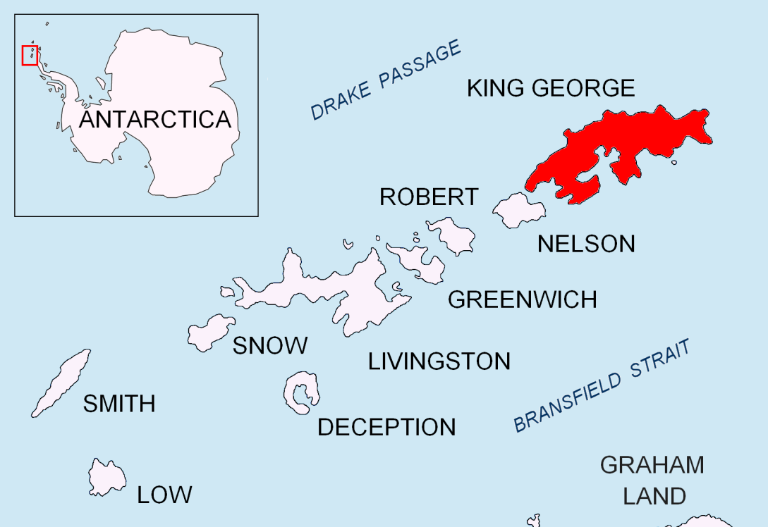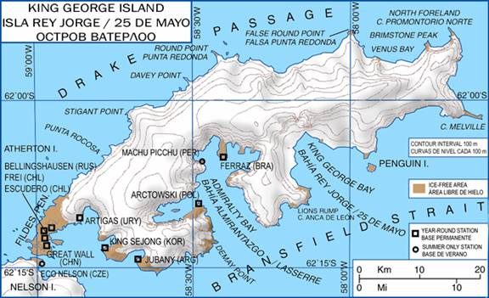
Russian Orthodox Church Patriarch Krill poses at the Bellingshausen station at King George Island of Waterloo, Antarctica

OBAMA IN ANTARCTICA March 22-24 and Argentina
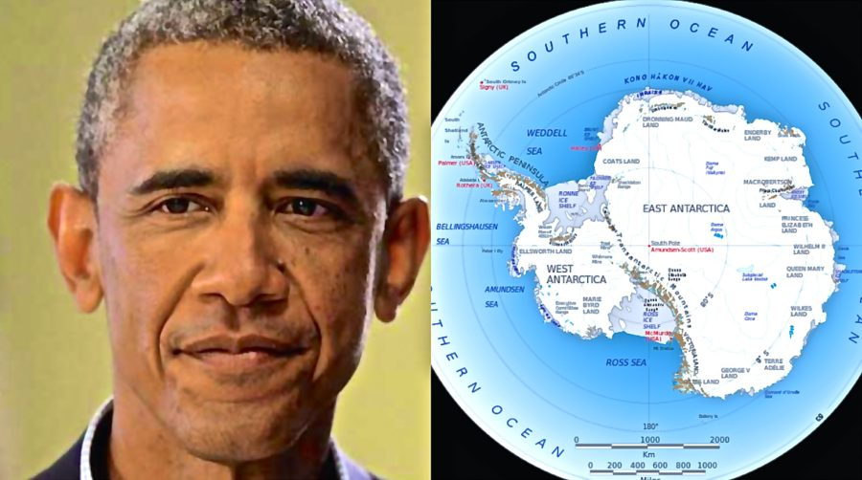
Posted by Gerard Zwaan on April 1, 2016
poleshift.ning.com/profiles/blogs/antarctic-focus
“The question is about all these secret visits to Antarctica recently by a number of high profile people such as Patriarch Kirill and Obama. Just before the Obama visit, it was revealed that China has built a giant space exploration base in Southern Argentina”…Posted by Gerard Zwaan on April 1, 2016
“The visit comes as part of Kirill's Latin America trip, which saw an unprecedented historic meeting with Pope Francis in Havana on February 12th.
Is there a nexus between the US National Intelligence Program director Clapper’s secretive visit to Australia and New Zealand in early March, the press revelation in March of a secretive China space observatory having been established in Patagonia, Obama’s pressing need to visit Argentina in March, and the Russian Orthodox Patriarch Kirill visiting Antarctica in late February? There is indeed, and the fact that all of these countries surround the continent of Antarctica is no accident. Antarctica will be newly habitable land in the Aftertime, as will the new land due to rise between the tip of South America and South Africa, and the rush to make claims there no secret.”
“Something strange happening around Antarctica…” Benjamin Fulford 3-22-16… “Something is happening around Antarctica these days that is shrouded in secrecy but is also attracting a lot of heavy hitters. The visit to Antarctica by Patriarch Kirill, the head of the Russian Orthodox Church, in February was the first sign of something unusual happening..…Now this week US Presidential spokesperson Barack Obama will be visiting the Nazi South American headquarters in Bariloche, in Southern Argentina.
Just before the Obama visit, it was revealed that China has built a giant space exploration base in Southern Argentina. Following this revelation, the Argentine government reported they sank a “Chinese fishing boat,” near a restricted area off the coast of Southern Argentina. Pentagon sources say the boat was probably a Chinese spy vessel since a normal fishing vessel would have responded to Argentine warnings.
Now CIA sources in Asia are saying their connections `who are above the government,’ are all `flying South’ this week, and hinted strongly that `South’ referred to Antarctica. This is all very interesting because years ago Paul Laine, a source in Pentagon military intelligence, told this writer the then state of the art UK guided missile destroyer HMS Sheffield had been captured by Nazis operating out of an undersea base in the region. The Sheffield was supposedly sunk in 1982 during the Falklands war between Argentina and the UK by an Exocet missile.
This increase in highly secret activity in the Southern Hemisphere near Antarctica is somehow connected to ongoing negotiations over a gold mine in Papua, New Guinea, that Laine also indicated was the location of a Nazi secret base.
America’s top spy, James Clapper, flew to Australia last week in what Australian media reports described as a `secret visit.’
http://mobile.abc.net.au/news/2016-03-16/us-spy-boss-makes-secretive-visit-to-australia/7251590
http://www.abc.net.au/news/2016-03-10/australia-nothing-to-fear-from-darwin-port-lease-says-china/7237218: However, there is also a very different agenda being discussed connected to gold and secret bases…”

JOHN KERRY IN ANTARCTICA

The Antarctic Ban for another 35 Years to cover-up The Secrets from The Past - 11/13/2016 – Tales From Out There
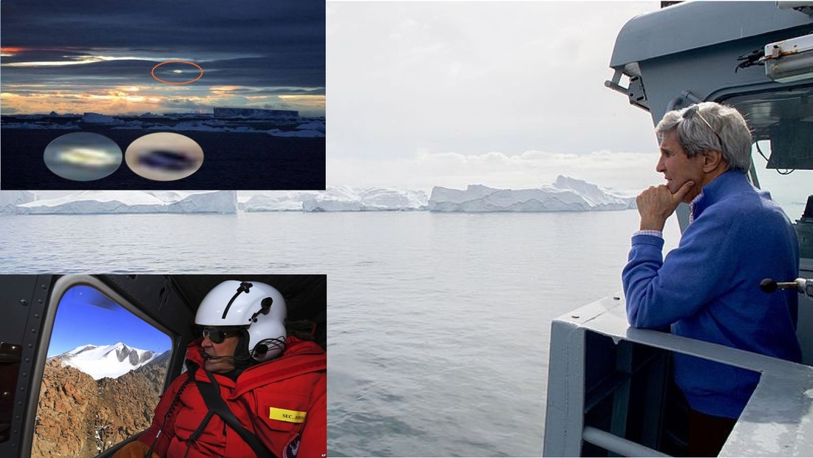
“The recent John Kerry 11-7-2016 departure trip to Antarctica by discussing the new agreed upon Nation State Treaty, banning private ships from traveling to Antarctica without advanced authorized permission to do so, for a period of 35 years”
“The top diplomat of the U.S. is en route to Antarctica this Election Day
By Max Bearak – World Views - The Washington Post - November 7, 2016
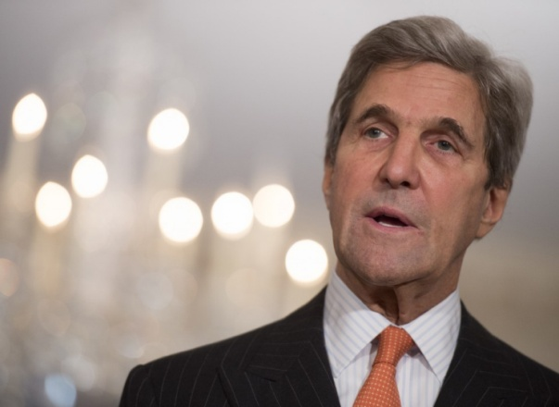
Secretary of State John F. Kerry speaks at the State Department in Washington on Nov. 4. (Molly Riley/AP)
“As the first election results roll in and the rest of the world sits glued to screens, U.S. Secretary of State John F. Kerry will be in the air, en route to Antarctica…He will be the highest-ranking U.S. official to visit the land of ice, penguins and research outposts…He will also see firsthand part of the recently established Ross Sea Region Marine Protected Area, which came into existence last week, is the world's largest, and was pushed heavily by Kerry and the Obama administration. John Kerry just visited the most stunning example of our changing climate.”
[No natural climate change – the ice is being melted for Globalist purposes]

Why World Powers Are Fighting Over this Sliver of Antarctic Ocean
Written by Sarah Emerson - May 10, 2016 Motherboard
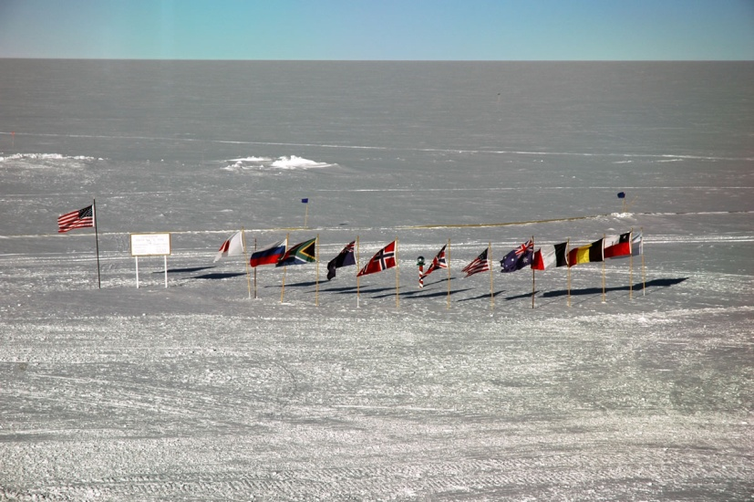
Flags of the 12 nations that signed the Antarctic Treaty fly around the ceremonial pole at the Amundsen-Scott South Pole station. Image: University of Maryland Particle Astrophysics Group
“Eager to create new legacies, polar scientists from Argentina, Australia, Belgium, Chile, France, Japan, New Zealand, Norway, South Africa, the Soviet Union, United Kingdom, and the United States proved that unprecedented international cooperation could successfully demystify elements of the most understudied frontier on earth.
Now, decades later, those original signatories are at odds over a vital sliver of ecologically and industrially important ocean habitat—the Antarctic’s Ross Sea.
The Ross Sea, nicknamed `The Last Ocean,’ has remained relatively untouched by human activity, pollution, and invasive species, largely due to its remote location and formidable conditions. Scientists regard it as the only unspoiled ocean system on Earth.”
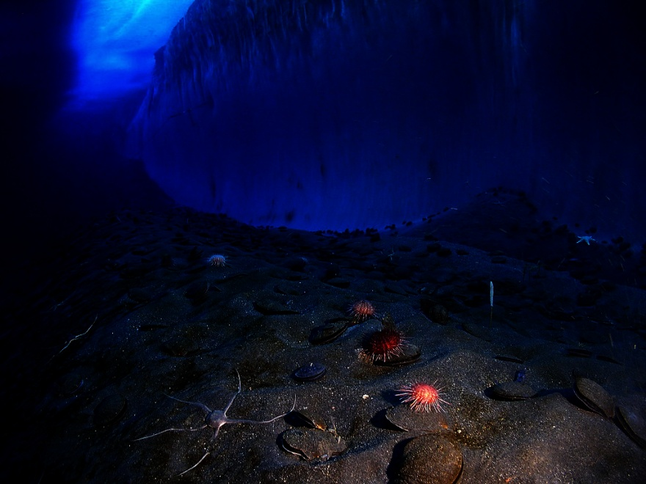
Ice wall underneath the water at the Ross Sea's McMurdo Sound
Image: NSF/USAP/Steve Clabuesch
“Discovered by British explorer James Clark Ross in 1841, the Ross Sea is one of two areas of the Southern Ocean, and stretches 1.9 million square miles over an incredibly deep continental shelf.
Currently, seven countries assert disputed territorial ownership of Antarctica. New Zealand, whose jurisdiction includes the Ross Ice Shelf, maintains a controversial and largely unrecognized claim of the Ross Sea’s land masses. Technically, the Southern Ocean surrounding the polar continent belongs to no one.
Since 2013, environmentalists from the Commission for the Conservation of Antarctic Marine Living Resources (CCAMLR) have been vying to see it designated as the world’s largest marine reserve. More than 700,000 square miles of water would be set aside for conservation and research.
The commission’s 25 member states, which include those nations belonging to the Antarctic Treaty, voted in favor of the sanctuary with further backing from the European Union.
Some environmental groups have criticized the CCAMLR for its inability to create the Ross Sea sanctuary. Representatives of Greenpeace have stated that fishing interests are exerting too much control over ocean governance bodies such as the CCAMLR, and engendering distrust in conservation agencies’ ability to protect marine ecosystems.
November 7th John Kerry said, `Antarctica is a collection of superlatives: the highest, coldest, windiest, driest, remotest, most pristine place on Earth. Explorers tried to cross it without any guarantees of safe return,’ US Secretary of State John Kerry said of the marine reserve proposal. `When it comes to the Ross Sea and Antarctica, we’re not going to wait for a crisis to take action.’ Permanent marine protections couldn’t come soon enough, as commercial and illegal fishing threatens to inflict irreversible damage on this pristine ecosystem. Overfishing of Antarctic’s toothfish--a type of cod that’s sometimes referred to as `white gold’ due to its lucrative value--could topple the ocean’s food chain. Together, the United Nations, various NGOs, the Antarctic Treaty, and the CCAMLR effectively regulate the majority of Antarctica’s natural resources.”
In historic agreement, nations create the world’s largest marine reserve in Antarctica -- The Washington Post -- November 14, 2016 on Yahoo Main Page
“
A historic deal has been hammered out to create the world's largest marine reserve in the Antarctic Ocean, stretching for 600,000 square miles in the Ross Sea. After years of stalemate, world leaders have finally agreed to protect a vast expanse of Antarctica’s Southern Ocean. Covering an area of 600,000 square miles in the Ross Sea, it will be the largest marine protected area (MPA) in the world. And while the preserve is not permanent, it will remain in effect for the next 35 years before world leaders will discuss its renewal.
The Commission for the Conservation of Antarctic Marine Living Resources (CCAMLR), the international body responsible for the management of the Southern Ocean, announced the agreement Friday morning in Hobart, Australia, after two weeks of meetings and negotiations.
The new protected area will bar fishing, with a few exceptions in designated areas for research purposes. It will help preserve one of the most pristine marine ecosystems left on Earth, environmentalists say.
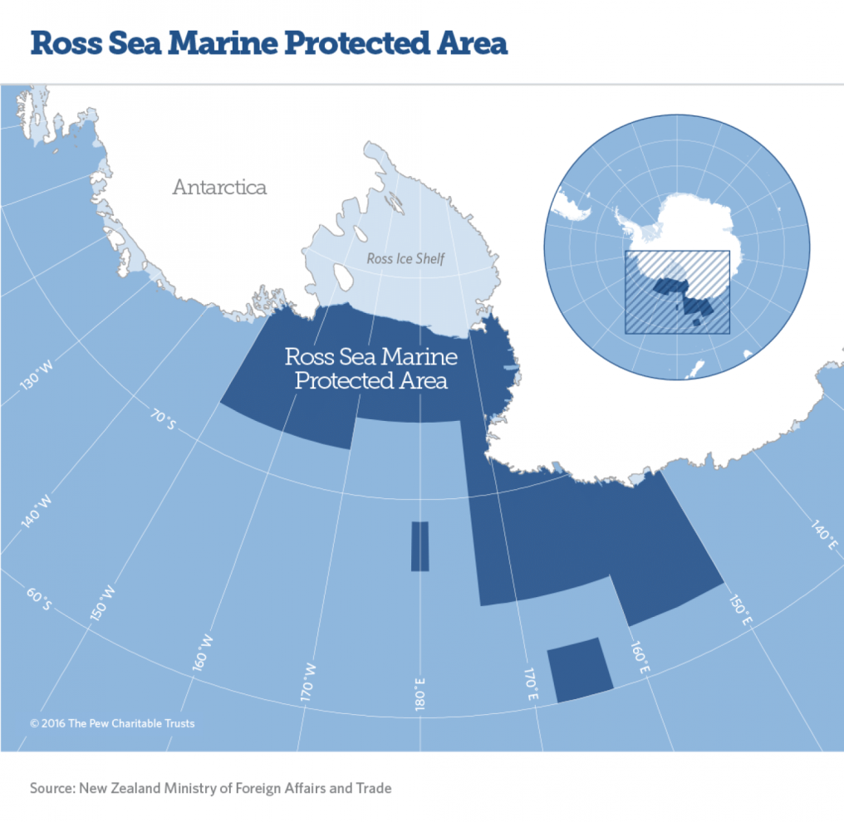
According to CCAMLR rules, all 25 members — which include 24 nations and the European Union — must reach a consensus before an MPA can be established. As of the start of this year’s proceedings, Russia was the only member that had yet to agree with the proposal
The 35-year time limit is `disappointing,’ she said, but added that `we’re confident that in 35 years’ time, the conservation benefits will be well established.’
According to Bloom, many CCAMLR members, including the United States, would have preferred a permanent designation, but a compromise was necessary in reaching this year’s agreement.”

KERRY SIGNED THE TREATY FOR THE UNITED STATES--THEN OFF TO NEW ZEALAND. THE TRUTH THEY ARE TRYING TO HIDE
The Elite world rulers do not care anything about the sea life in the Ross Sea – they’re covering up the reason why they melted the ice caps. They don’t want any fishing boats, no commercial cruisers. Beneath the ice is incredible treasure of all sorts from natural resources to Nephilim technology and DNA, perhaps even Nephilim cities. They could be preparing landing bases for UFOs, not just Nazi flying saucers anymore. But, they sure are not down there because they love Yahuwah’s creation!

THE NEW ZEALAND EARTH QUAKE, JOHN KERRY, F.E.M.A., THE BLAST SHIP OVER THE FAULT LINE, AND THE OIL BEDS UNDERNEATH

Why has John Kerry been in the Christ Church region TWO TIMES when a major destructive earthquake has hit? Why this time was F.E.M.A. there, plus a blasting ship sitting over the fault line where the powerful 7.8 quake struck?

From Stan, the Jerusalem Watchman: New Zealand warning – November 16, 2016
“The earthquake Monday struck just hours after visiting US Secretary of State John Kerry ended a number of closed-door meetings in Wellington with Prime Minister John Key and members of his government.
While Kerry was reportedly in that part of the world on business related to the Obama administration’s ‘climate change’ policy – he flew from Christchurch to Antarctica and back that weekend – this might have been a smokescreen designed to hide his real purpose: an effort to finalize a US-NZ understanding concerning the creation of ‘Palestine’ in the historical land of Israel. Israel’s leadership and friends of the Jewish state have expressed real concern that a lame duck President Barack Obama might use his remaining time in office to serve the ‘two state solution’ on Israel via the UN Security Council, perhaps by refusing to use the United States’ veto in the event that France or another nation bring a resolution to this effect.
Before flying to Antarctica, Kerry expressed gratitude for New Zealand having become “such a key contributor to global peace and security, including through their recent and very productive term on the UN Security Council.”
It is notable because when New Zealand was rotated onto the Security Council on January 1, 2015 and Foreign Minister Murray McCully stated that his country’s two year term `will place us at the heart of international decision-making for the next two years,’ a major goal of the Key government was to `punch way above our weight, and use the opportunity to push Israel and the Arabs effectively towards the two state solution.’
The Times of Israel at the time referred to New Zealand as a `diplomatic bantamweight’ which, although the Key government had been considered a close friend of Jerusalem, is currently convinced that the peace process needs to be advanced, if necessary by forcing a solution on the parties.
Key and McCully have just over a month left to Do Something…
And indeed, this past Sunday (November 13) the New Zealand Herald reported that one of the closed-door discussions between Kerry and Key was a potential UNSC resolution on the ‘two state solution’.
McCully had even raised the possibility of the US or New Zealand still sponsoring such a resolution.” [I recommend you read the whole article for details]

FEMA AND THE BLAST SHIP
Geoengineered NZ Earthquake Revealed, Hillary Knew
From Plane Not a Planet – Nov. 15, 2016
“The World’s biggest seismic blasting ship the Amazon Warrior was photographed off Rarangi Beach in Cloudy Bay last night. Right on top of a major fault line. The ship was met with protests when it arrived on the 13th!
And I guess we now know why John Kerry was making a short notice / unexplained trip to NZ right in the middle of a fierce US ‘elitecon’…He went to Antarctica, which has a HAARP at the US base.
The World’s Biggest Seismic Testing Ship – The US Amazon Warrior – Parked On Top Of New Zealand Fault Line during the November 13, 2016 Earthquake!
The World’s biggest seismic blasting ship the Amazon Warrior was photographed off Rarangi Beach in Cloudy Bay last night--right on top of a major fault line. The ship was met with protests when it arrived on the 13th! It was seen off the Coast of Kaikoura on Nov. 13th, but its ETA from Panama was 10 am on Nov 14th in Wellington.
The Amazon Warrior came from Panama, was seen off of Kaikoura on the 13th and then went to anchor off of Cloudy Bay at the top of the South Island, across the channel from Wellington. If you are steaming to NZ from Panama, and your destination is Wellington, then there is no need to go an extra 95 miles south before arriving at your charted destination; after a long sea journey of 7,353 miles. This fact alone shows that there was something very fishy going on in the state of Aotearoa.”
New map reveals that six faults ruptured during the Kaikoura earthquake in New Zealand - By Strange Sounds - Nov 18, 2016
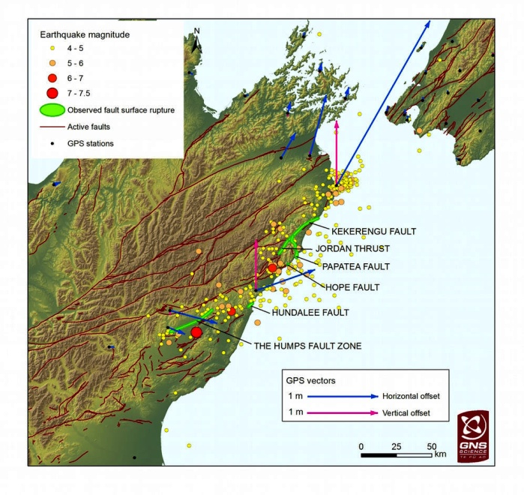
“The magnitude -7.5 quake that rattled New Zealand, killing at least two people and stranding thousands of people, completely transformed the underlying faults in the region. In overall, six major faults ruptured as a result of the New Zealand quake. The Kaikoura earthquake struck the South Island of New Zealand early in the morning on Nov. 14 local time, triggering landslides, tsunamis and hundreds of aftershocks. During the quake, bystanders captured images of mysterious earthquake lights painting the sky in eerie blue and green.” [Condensed from article’s video: Blast ship right on fault line before it happened; F.E.M.A. there at the time of the quake; Big oil find hidden under sea …”

FEMA IN NEW ZEALAND AT THE TIME OF THE EARTHQUAKE
FEMA in Christchurch At Time Of Earthquake – Using Natural Disasters To Bring In A Police State? Posted on February 24, 2011 by Clare Swinney
What a coincidence!
WashingtonPost – by Ed O’Keefe, Wednesday, Feb 23, 2011: The White House is deploying disaster-response and urban-search-and-rescue teams to New Zealand
“They will be greeted there by Timothy W. Manning, a deputy administrator at the Federal Emergency Management Agency who is in the country assisting with response efforts and is particularly qualified to do so.
Talk about being in the right place at the right time: Manning is a trained geologist, paramedic and firefighter – the perfect combination for earthquake response. He is in New Zealand as part of a U.S. delegation visiting for trade and global security talks.”

Tag investment opportunities in New Zealand: www.tagoil.com/investors/opportunity/new-zealand
New Zealand’s discovery potential has been compared to major producing regions such as California and Norway and is recognized as one of the few remaining untapped oil and gas frontiers in the world. This major potential has attracted the world’s most prominent international explorers such as Statoil of Norway, US-based Chevron, the Indian government-controlled ONGC Videsh and others. With fewer than 300 wildcat wells drilled, this prolific, region is still in its infancy — major discovery potential remains. With reported proved oil reserves of 534 million barrels and proved gas reserves of 7.3 trillion cubic feet discovered, TAG is firmly positioned with its fertile hunting grounds.
https://www.newzealandnow.govt.nz/work-in-nz/nz-jobs-industries/oil-gas-jobs
New Zealand is a fast-emerging oil and gas producer with many underexplored basins and significant petroleum potential. Where New Zealand differs from most global oil destinations is that it is based in an environment that is very conducive to lifestyle and offers some of the finest outdoor and recreational opportunities in the world without the challenges of a desert or huge city location
Developing industry: Oil and gas exploration and production has become increasingly important to New Zealand in recent years… There are underexplored basins, the possibility of significant unrealized reserves and readily available, free seismic information… To date, all current and historical petroleum production in New Zealand has come from just one of the country’s 18 recognized basins - the Taranaki Basin on the North Island’s west coast.
On and offshore fields there continue to drive the industry overall. However, exploration work is being carried out on and off the South Island’s west and southern coasts.”
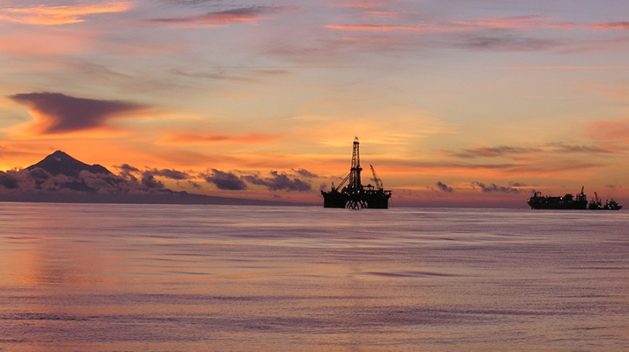
Taranaki, New Zealand
My Bottom line: Blow the sea floor! Tap into the gas and oil reserves under the sea on the East south island. Why else would FEMA and the “blast” ship be there along with John Kerry at the time of the November 14th massive earthquake off the east coast of the southern NZ Island not far from Christ Church?
Why on the morning of November 14th – the very time when the super super moon was in perigee – closest to the earth?
THE SUPER-SUPER MOON OF NOVEMBER 14TH – THE MOON CLOSEST TO THE EARTH SINCE 1948!
Some say the pull of the earth by this huge moon contributed to the quake. Why all this converging at the same time – the biggest moon of our century corresponding to the huge New Zealand earthquake, Kerry in Christ Church, F.E.M.A. there, too, and the seismic blast ship right over the fault line?
Too many coincidences to be a coincidence!”
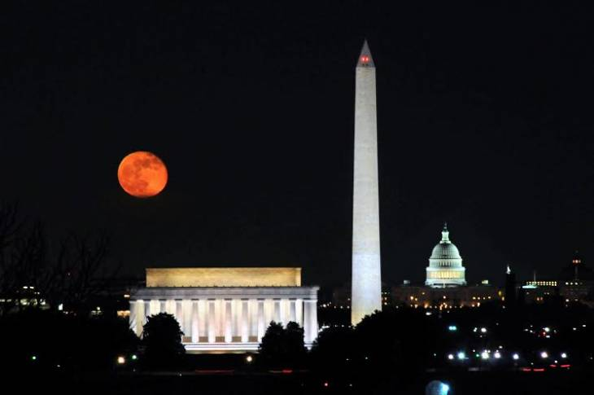
What a picture! The picture shows the super moon, early morning November 14, 2016, largest since 1948 in perigee (closest to the earth), along with Osiris’ phallus in the foreground (Washington Monument—666’ tall from its lowest foundation) and the womb of Isis in the background (the U.S. Capital Building), with the Lincoln Memorial below the moon. There has to be a message in there somewhere!

New Zealand’s earthquake was so powerful the sea floor lifted TWO METRES and exploded through the sand- Kate Darvall-Daily Mail Australia-17 November 2016
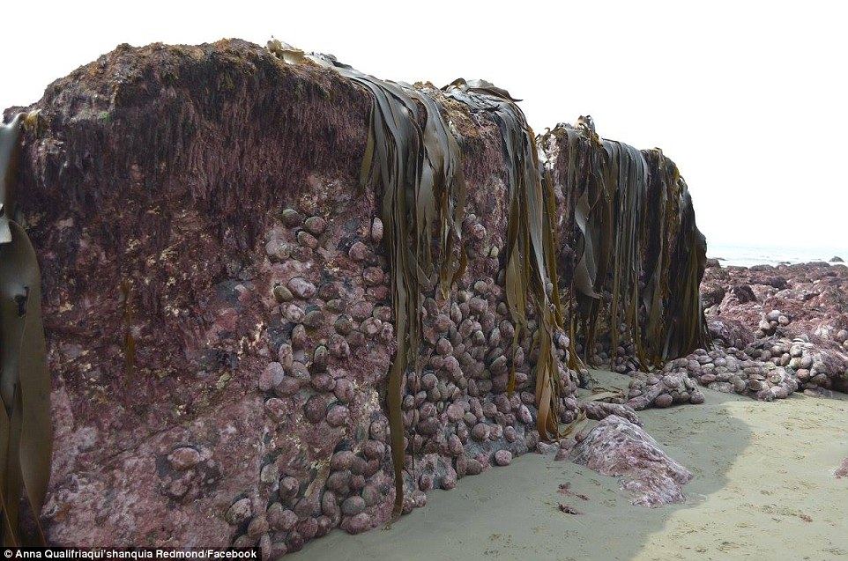
“Devastation: Incredible photographs show how New Zealand 's 7.8 magnitude earthquake lifted the seabed two metres - and exploded through the sand…
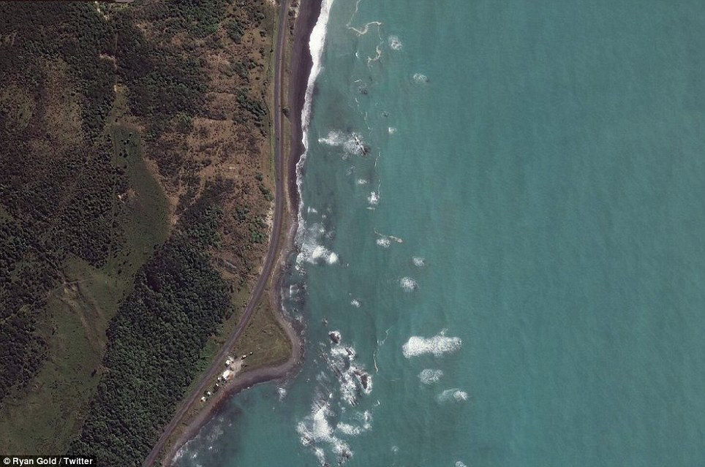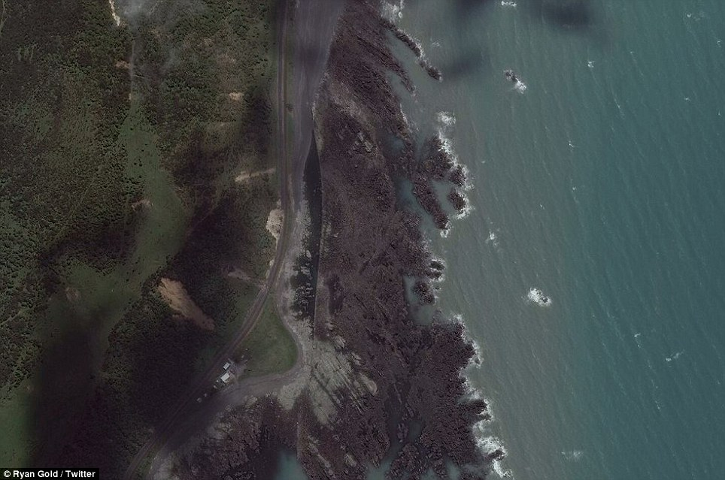
A 'before photo' taken in March 2016 shows how the coastline looked before the earthquake struck on Monday (left). An 'after' photo taken in recent days shows the extent of the damage caused by the earthquake (right)
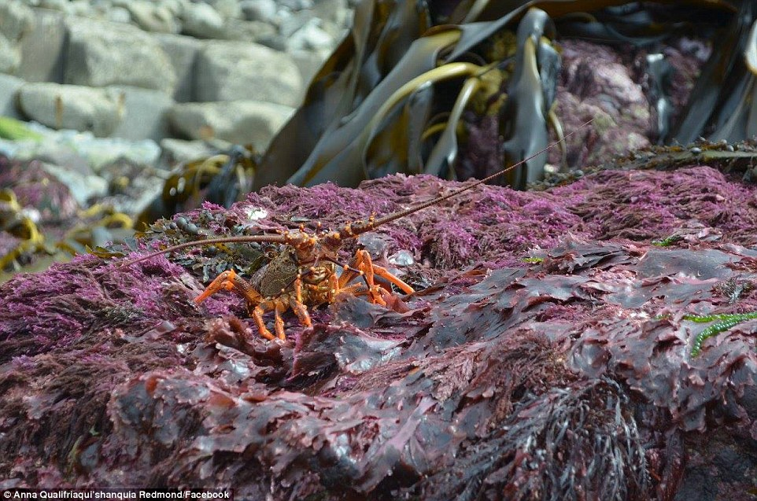
While incredible, the photos capture the devastating death of sea-life, some of which cannot survive above water.”
Steve Quayle, as one link in his November 20th article list, referred to Tom Horn and Josh Peck’s new book coming out December 6th, Abaddon Rising. Before the book comes out, Tom is posting previews on Skywatch TV. Stever refers to Part III of the previews: What Are They Trying to Awaken at CERN and in Switzerland? MUST READ THIS AS IT TIES IN WITH THE ANTARCTIC IN A MAJOR WAY--THE GATES OF HELL ARE OPENING WORLD WIDE FROM UNDER THE ICE AND DEEP UNDER THE EARTH! Steve is not trying to be a sensationalist, it’s just fact. Hell is literally rising, and what is in it is rising to the surface (Revelation 9-- Isaiah 5:14 and 14:9). [Refer to my article “The Rising of Hades from the Inner Earth/January 28, 2016]

HOW IT ALL TIES TOGETHER
Do you like working 100-piece jigsaw puzzles? It takes a long time to put all the pieces together, and a quite a while before anything even looks like a connected picture. But now, the picture is not only connecting, but the details are become clearer.
This list of recent meetings and curious coincidences, all tied into a super-super moon that has not come this close to the earth since 1948, the year Israel officially became a nation and our prophetic time clock began to count forward. Then the serious earthquake, dignitaries running here and there, the US shadow government included with its visible puppet-government – F.E.M.A. and Kerry – suspicious seismic blasting ship, communists galore in religious garb and political garb, the earth trembling, weather warfare, a suspicious marine reserve to help fish, and talk of World War III … all make one huge stew of putrid ingredients. No good in any of it.
Watch the movement of these Elite and how they relate to Israel. Use this article as a spring board for your own research. Some of the key Elite have planned to hide out in Antarctica during the devastation. They know what is coming, and they are acting on what they know. Underneath much of Antarctica are Nazi bases, huge underground cities and tunnels. Admiral Bird and his men were attacked by Nazi space craft. I learned years ago that Antarctica was a microcosm of the New World Order. It appears that the Globalists are moving in all directions now. [Refer to my article: “What are the World’s Elite Doing to Prepare Their Ark for Coming Disasters?”/February 27, 2008] I follow this with two articles about preparing for famine, one updated to May 20, 2011. The ultra rich who know their own plans for this planet are preparing to go underground. What preparations have you made for you and your family?
Our priority is to know His Word, be filled with His Spirit, led by His Sprit, taught by His Spirit, to be set-apart, to be reaching out with the Good News of salvation to a lost and dying world. We have much to do as Ambassadors of the King of Kings and His/our Kingdom. Let us be about our Father’s business, and take Noah’s example to prepare our own ark.
Shalom, blessings, in His love,
Yedidah
November 22, 2016

