“TELL THE CHILDREN OF ISRAEL TO GO FORWARD!”
IT’S NOW TIME TO CROSS THE JORDAN!
The Jordan River today at spring flood stage
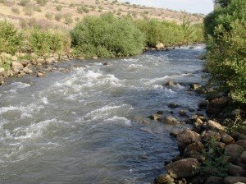
The muddy Jordan today in late summer

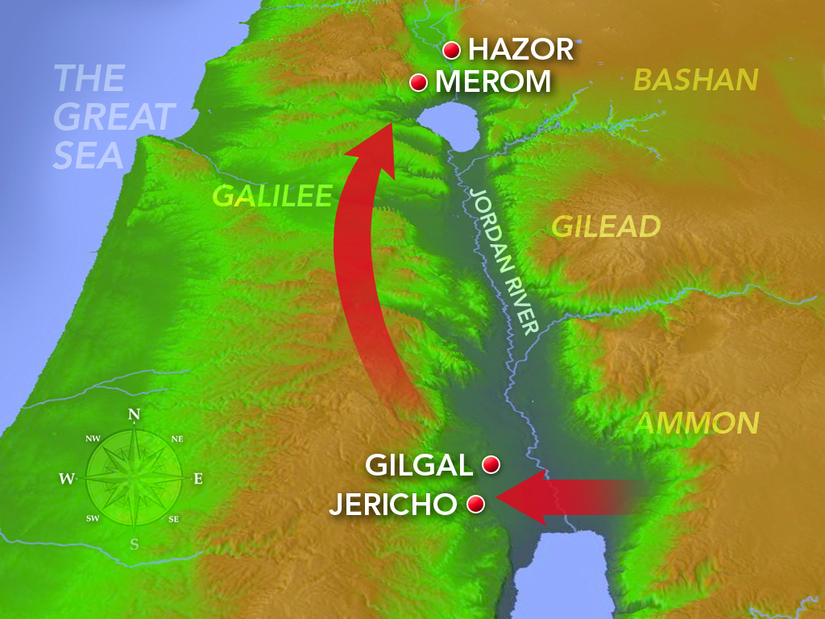
Back then, the place of crossing was about 2 miles, 3.2 km, from bank to bank, and 100’ water depth. Compared to back then, the river is very much more shallow and narrow now. This map shows where Joshua led the Hebrews across the surging Jordan River into the Promised Land at Passover time - in a Shmittah Year, followed by a Jubilee Year.
The Jordan originates at the base of Mount Hermon in the area that was allotted to the tribe of Dan (Hebrew letters: dalet and nun). The river descends from the area of the tribe of Dan. Its name comes from the Hebrew word “yarad.” Strong's #3383: “meaning to “flow down,” or “descend.” The name in Hebrew is “Yarden” or known “descending, flowing down, from Dan.”
As the winter snows melt, the melted snow-water rushes down with great force. I’ve seen the river in the spring at Tel Dan. Indeed, the water is very powerful! No one could put their foot in it without being washed away. Thus, Yahuwah parted the waters for Joshua and the Hebrews so that they could walk over the Yarden as the Hebrews once walked across the Red Sea – on dry ground.
I have been at the place of crossing. Of course, the river there is more tame now! It was more calm/tame when Yochanan/John the baptizer was baptizing there. And, as the Word tells us, the Yarden is muddy – it was muddy and it still is muddy.
This is where Eliyahu went up to heaven (II Kings 2)
This is where Yochanan/John was baptizing – at Bethabara, east of the Jordan
This is where Messiah was baptized (John 1:28)
This is where Messiah went into the desert following His baptism and was tempted by Satan – at least Satan tried and failed! (Matthew 4)
Just to the East of the river is the “Plains of Moab,” and rising beyond is Mount Nebo, where Moses looked into the Promised Land. Yahuwah buried Moses in the Plains of Moab.
Living in Jordan, I got to see a lot of these places. Amazing that Eliyahu went up to heaven right where Yochanan was baptizing. The spirit of Eliyahu rested on Yochanan, so clearly seen in Matthew 3.
From that place on the Jordan, at Bethabara, continuing on in a straight line west we see Jericho, then onward is East Jerusalem - the Temple Mount, the Mount of Olives, Mount Zion – the area of the Garden of Eden with these three portals into heaven.
There was a huge Byzantine church, built in the 4th century CE, constructed at the place of the baptism site, facing Jericho and the backside of East Jerusalem. It had a marvelous mosaic tile floor as is typical of Byzantine churches. This church was discovered by Hashemite Jordanian Archeologists from a map found in mosaic tiles on the floor of a Byzantine church in Madaba, Jordan. The map is still there – I got to stand right next to it. The map shows that the baptism site was not up near Tiberias in north Israel, but down where the Jordan empties into the Dead Sea.
The archeologists found caves there, near where Yochanan was baptizing, carved out for Byzantine priests who oversaw the huge church. The archeologists discovered the “Brook Cherith,” where Eliyahu was fed by ravens, and just above it where he went up to heaven (I Kings 17 and II Kings 2). It’s all right there. In reading the Bible account of Eliyahu being fed by ravens in I Kings 17, and about his ascension into heaven in II Kings 2, the details are seen so clearly – all in that little compact area. Just about 50 miles due north are the ruins of Tishbe, where Eliyahu grew up and learned to hear Yahuwah. Eliyahu was of a Levite lineage.
I stood over those ruins of Tishbe on a mountain top rising above the Jordan Valley in 2005, where another Byzantine church, with a story-telling mosaic tile floor had been built to honor Elijah/Hebrew: Eliyahu, meaning “My El is Yahuwah.”
It was there that Yahuwah answered a question for me in a dramatic way. The question was why I was there – to get an answer. The response by Yahuwah to my shouting out His Name three separate times over the wide Jordan Valley, over Listib/Tishbe below, on a sunny day, was witnessed by two friends standing a ways behind me. No expected what He did! Each time I shouted out His Name, a crash of thunder exploded near us, and it rolled down the valley – yet a sunny day. It was witnessed by one friend from Wales and one from England who, with jaws dropped, and mouths open, were stunned by His response each time I called His Name.
It was one of those life-changing things. I got my answer. I knew that His Name had not been spoken there since the days of Eliyahu, so I called it out loudly over the wide Jordan Valley to bring His Name into that place once again.
Eliyahu once told the rebel House of Israel, worshippers of Ba’al, on Mount Carmel: “…the God who answers by fire, let Him be God (I Kings 18). He still answers by “fire.” Lightning is also fire!
For nearly 2,000 years, as Yochanan said in Luke 3:16, Yahuwah’s Spirit comes like fire, descending from heaven, within those born-again ones who ask Him to enter and reign over them from within their spirit. You can read about it in my autobiography: Touching the Eternal, on Amazon.
The Yarden descends from the region once occupied by the tribe of Dan. The fire of Yahuwah still descends on those who submit to Yahuwah by faith in His Son. But, once the fire descends, we no longer have the right to choose our own way, but are under the tutelage of a new Master. Everything changes when the fire descends!!!
I am just one of those people who has to see things! It’s the Middle East ancient mentality! They want to see what He can do. They want to experience Him. For the ancient mentality of the Word, faith is based on seeing or hearing from those who saw – like the Red Sea crossing. It is based on the miracles we see. Thus Yahuwah is a Father who shows His children who He is, and what He can do. But, in pagan western culture with no “ancient” understanding to go by, few understand how very personal He is, and wants to be. He wants to show Himself faithful, show Himself loving, show Himself as a Father to you and me. I want to see with my human eyes, and hear with my human ears, and know in my human mind what His personal touch is about. I ask Him questions and He answers. It’s not because I am special, but because I want relationship with Him, not religious fluff. So much of western Christianity is religious nonsense – because He can’t reveal Himself to those who are self-centered and reject Him at the root level.
I don’t just want to just read about things or watch travel logs, or documentaries on TV or the web. I want to go and see, so that I can hear Yahuwah tell me what He wants me to know, and see what He wants me to see. I have always had little as far as possessions, money, and things of this world. I’ve learned the peaceful simplicity of “adequate.” We need so little. I traded the typical lifestyle of world-loving carnal western culture for the simplicity of third world nations, with a mind-set more like those in the Middle East than anything else. My Cherokee heritage from my dad, most likely. The Cherokee came from the Middle East.
Thus, the world has never held any influence over me. Now, it holds even less interest. I use it, like we all have to do to pay bills, buy groceries, etc. But it has within it a slave mentality. So, we see the results of that bondage to the system of man in the fear that is being generated over falsehood.
This lovely place on the Yarden was the place where Yochanan baptized – east of the Jordan. Yochanan came in the spirit of Eliyahu. This is where Joshua brought the tribes of Yahuwah. They walked across the river at flood stage, like across a mini-Red Sea, to enter the Promised Land. Not only have I been there twice, but got the privilege of meeting 2 of the archeologists who discovered all that wonderful treasure at the real ancient baptism site east of the Jordan River. Because I was inside the newly built tourist center building, hosted by the Director of it all, former mayor of Aqaba, where I lived, I got to talk to these archeologists who just happened to enter and sat down next to me. I asked them where the Brook Cherith was, and they said just below where Elijah went up to heaven – all the detailed descriptions in Kings match that place. How did I fellowship with Muslim archeologists? They go by the Scriptures exclusively for their finds – so we discussed the Scriptures. There are about 120 Biblical sites in Jordan. These archeologists have meetings with Israeli archeologists twice a year in Aqaba.
This place where Yochanan baptized sadly is now a commercialized religious place called “Bethany Beyond Jordan,” which the pope dedicated in 2002. It is not in its pristine state that I saw it in. When I saw it, it was virtually unchanged from the original finding - on my first visit in 2002. The Jordanian archeologists did not disturb its simplicity. However, the hype and the desire for money-making, and the pope’s approval, all brought in religiosity and commercializing.
When I went back about 2004, Jordan had built that large Visitor’s Center. At that time, the project was in process to clear the area around the Jordan/Yarden of land mines, so that people could go down to the water and be baptized. Though allowed to go in a van to the river, I was not allowed to get close or get out of the van because they had not blown up all the land mines yet.
Religious commercialism by the Roman Catholic Church all over Israel and Jordan have made genuine sites into no more than commercial sites for religious tourism, like Lourdes in France or Our Lady of Fatima in Portugal, or the Vatican in Rome. Whatever man touches he corrupts, and promotes what draws crowds and makes money.
So, what’s the message from Yahuwah in this, besides a review of Joshua 5-7? In Podcast CCLXXXV: Powerful Prophetic Principles Mandatory for Progress and Victory – Joshua 5-7” In this podcast, I show carefully how it is an exact representation of the true new birth through Yahushua ha Machiach, our dying to self, our submission to Him, our obedience to Him as we follow His explicit instructions, given through Him by Abba Yahuwah. The whole “Good News” is prophesied in the actions of Joshua/Yahushua, whose name means “Yahuwah is salvation.”
Also, the Name of our Savior-Messiah is Yahushua! He came in His Father’s Name. When He used “I AM” in Hebrew to the Pharisees in John 8:55-59, they tried to kill Him. It was the use of His Name that caused the High Priest to send Yahushua to Pilate for execution. “Yahuwah is salvation!” Moses renamed Hoshea “Yahushua.” Look at Numbers 13:8 and 16!
The Jewish rabbis spell “Joshua” like this: “Yehoshua,” because they won’t say “Yah.” “Yah” was the name given to Moses when Moses asked what Name he should tell the children of Israel to call Him (Exodus 3:13-15). Yah means “I AM.” “Yahuwah” means basically, “I AM the ever-living One who breathes.” It is a statement of His eternal Being.
But, clear back to Babylon, and onward to 2021 CE, religious insanity has blocked His people from using that precious Name, even though it’s still in our English Bibles in Psalm 68:4. Talmud-oriented rabbinic Judaism boldly tells parents not to teach their children the Bible, only the Babylonian Talmud. Please, do yourself a favor, read “Quotes That Forever Dispel Damning Lies,” under the Mikvah of Israel, Our Eternal Inheritance to really see what the rabbis teach. Since 133 CE when Rabbi Akiva created Rabbinic Judaism, the rabbis were exalted above Him, and He was made to be a joke, a buffoon, a lesser god. Later Kabbalah, a pantheistic religion of Judaism, created Ein Sof – who supposedly created Yahweh.” Do yourself a favor and Read Matthew 3 and Matthew 23 to see what Yochanan the baptizer and Messiah called the rabbis of their day.
So, do you see why my love for His Name on the mountain above Tishbe in the Jordan Valley, brought His powerful response? Not because I’m some special “saint.” OH NO, I am not. But, the passion of my spirit is for Yahuwah and His Son!
He says in Isaiah 42:8: “I am Yahuwah! That is My Name, and My esteem I do not give to another, nor My praise to idols.” He said in Exodus 20:7: “You shall not bring the Name Yahuwah to nothing, for Yahuwah does not leave the one unpunished who brings His Name to nothing.” Uh … it isn’t merely talking about using “Jesus” as a curse word, or even rejecting Him as God.
It has to do with bringing Him down under the feet of man!
Psalm 138:2, Berean Study Bible: “I bow down toward Your holy temple and give thanks to Your name for Your loving devotion and Your faithfulness; You have exalted Your name and Your word above all else.” NAS: “I will bow down toward Your holy temple And give thanks to Your name for Your mercy and Your truth; For You have made Your word great according to all Your name.” NKJ: “I will worship toward Your holy temple, And praise Your name For Your lovingkindness and Your truth; For You have magnified Your word above all Your name.”
If His Word is untrustworthy in one tiny “jot”/yud or “tittle”/tail on tav, then His Name means nothing. So, to honor His own Name, He makes sure that everything He says is manifested for us to SEE AND EXPERIENCE.
The honor of YAH, YAHUWAH, is only as good as His Word. “A man is as good as his word,” is an old statement back when a handshake meant “covenant,” as we see in Isaiah 41:10 and 13.
His Name is honored because of your life, if you live in honor of His Name. If your life reflects His nature, His ways, His thinking – and the fruit of His nature is manifesting through you (Galatians 6:22-24), then you honor Him. Otherwise, you are a shame to Him. Religion is of this world, of man. The religious do not honor Him. They make mental converts, but leave them still “hell bound,” as Messiah spoke to the hybrid Pharisees in Matthew 23.
The freed Egyptian slaves, the Hebrews, children of Abraham, Yitzak, and Ya’cob, were whining, complaining, panicking. They had gotten to the Red Sea. Pharaoh’s army was pursuing them, and they were scared. What did Yahuwah say to them? They had just seen 10 plagues on Egypt and themselves protected by Yahuwah, but fear took over. Sounds like so-called “believers” today!
What did Yahuwah say to them and to Moses? Exodus 14:12-15: “…It would have been better for us to serve the Egyptians than to die in this wilderness.” However, Moses said to the people, `Do not be afraid. Stand still, and see the deliverance of Yahuwah which He does for you today. For the Egyptians whom you see today, you are never, never to see again. Yahuwah does fight for you, and you keep still. And Yahuwah said to Moses, `Why do you cry to Me? Speak to the children of Israel and tell them to go forward.”
Do you know Him by experience? Have you seen what He can do by His tangible intervention into your life? Do you see His daily input? Are you taught by His Spirit within you? If not, you will not make it through the horrible days that are upon us.
You will not mentally be able to maintain faith if your faith is in your religious mind. Only those that know Him from their re-born spirit and interact with Him will hear Him give instructions that will save your life!
For 8 years I lived with the view out my kitchen window, or from the roof of my small apartment building, of the Red Sea. I saw the border of Israel with Egypt at Eilat. I saw Egypt, and Saudi Arabia, and Jordan. Just south of Eilat, Israel, not too far, is Nuweba. This is where they crossed over. It’s about 5 miles across at that point.
Genesis 19:15-17: The escape of Lot from Sodom: One of the angels with Lot in Sodom said to Lot: “Get up, take your wife and your two daughters who are here, lest you be consumed in the punishment of the city. And it came to be, when they had brought them outside that he said, `Escape for your life! Do not look behind you, nor stay anywhere in the plain. Escape to the mountains lest you be consumed.’”
***Luke 17:28-33, Messiah speaking: “And likewise it came to be in the days of Lot…it shall be the same in the day the Son of Adam is revealed…Remember Lot’s wife! Whoever seeks to save his life shall lose it, and whoever loses his life for My sake shall preserve it.”
***Luke 9:61-62: “And another said to Him `Master, I shall follow You, but let me first say good-bye to those in my house.’ But Yahushua said to him, `no one having put his hand to the plough and looking back is fit for the Kingdom of Yahuwah.”
Here we are! In the days of Noah and the days of Lot!!!
What is typically not taught in churches or messianic groups is what the true new birth is all about. However, I stress it so that you act on it. Most people do not know what they’ve been saved from. It’s all plastic – nothing solid for most people.
Yahuwah and Yahushua have done all They can do for your eternal salvation. Now it is time for you to do something for yourself that involves your preparation to enter Their Kingdom! It’s called “set-apartness,” or Christianized “sanctification.”
When you receive a true new birth, your life is no longer your own. “Please refer to “The True New Birth…”/Mikvah of Eternal Salvation. You were bought with a price, and Yahushua is your new Master. He redeemed you by His own blood from slavery to the world, the flesh, and the Devil. You owe Him your full allegiance, all of your loyalty! Your life is no longer yours! You are required to submit to Him as Master in training for reigning in His Kingdom and forever in eternity with He and His Father.
There must be no “yea but” I am going to do this first. No, after repentance, you are a “doulos,” which is Greek for a “bond servant.” You are a Deuteronomy 15:16-17 servant whose “ear has been pierced” by the awl. Refer to: “The Blessings of the Awl” 35.0 Mikvah of Set-Apartness.
You, then, must ask Him, your Master, to immerse you, baptize you, into the Spirit of His Father, for your teaching (John 16), your guidance, your gifts (i.e. I Corinthians 12:1-11), your correction, and your transforming into the image and likeness of Yahuwah, so that you walk and live and breathe in His nature, ways, and thinking. The fruit of the Spirit within your spirit, as per John 7:37-39, and Acts 2, which comes from a true new birth, is found in Galatians 5:22-24. These are NOT emotions of the carnal mind. They can’t be pumped up. They can’t be manipulated. They are separate totally from any carnality of the human mind and emotions.
Please understand, the “fruit of the Spirit” flowing through us from Him in our re-born spirit, in our belly area (John 7:37-39) are NOT EMOTIONS, though His emotions can ride on them! The “fruit is YAHUWAH’S STATE OF BEING!!! IT IS WHO HE IS. HE IS LOVE. HIS STATE OF BEING IS IN US THROUGH HIS SPIRIT IN OUR RE-BORN SPIRIT!!!
This is why Yochanan/John said that unless we love our brothers and sisters in Messiah, we walk in the darkness of the evil ones.
The true new birth prepares us to receive Him, not into a temple made by hands, but into a temple behind our naval – a cleansed and prepared temple. Just know that when He moves in, He is Master; He is Supreme, and we are not! (I Corinthians 6:19-20)
Yochanan/John wrote in I John 4:8-11 “GOD IS LOVE.” If He is in us, we, too, are in a state of love as our natural nature. If He is in control of our lives, He is freed to be Himself within us! No judging others, no carnal emotions, no self-righteousness, no religious superiority, NO pride are allowed. Only His control is allowed, thus His nature is in control.
Those carnal emotions of self-righteous pride are satanic in nature and cannot enter the Kingdom of heaven! This is why gossip and slander, unrepented of, can end a person in damnation.
Please refer to: “The Reason Why Gossip and Slander Can Be Eternally Punishable Sins”/Mikvah of the Heart of Elohim.
We must be humble vessels only, through which Yahuwah can pour out His love on others. He is Judge, not us! Thus, a true new birth, followed by being filled with His Spirit, and total submission to His transformation of our mind, emotions, and will, is mandatory to enter the Kingdom of heaven.
***Genesis 1:2, the Spirit of Yahuwah brooded over the waters and prepared what was defiled and destroyed to be recreated and made new. The true new birth is encapsulated in Genesis 1:1-3 – reflecting 1) Adam in an eternal state in the Garden, 2) then sin, then 3) redemption and renewal. This is powerful – all praise to Yahuwah and Yahushua!
II Corinthians 5:17: “If anyone is in Messiah Yahushua he is a NEW creation, old things have passed away, behold, all things have become NEW.” Do you understand that this parallels Genesis 1:1-3!!!
WE ARE GOING FORWARD IN TIME! ARE YOU ALLOWING YAHUWAH’S SPIRIT TO PREPARE YOU TO TAKE ON A NEW BODY AND LIVE IN ETERNITY? WE WILL BE RECREATED, NOT DESTROYED AND REMADE – RECREATED AT OUR RESURRECTION. OUR CROSSING INTO THE PROMISED LAND IS VERY CLOSE.
If you take on His state of being, which is His nature, ways, and thinking, you will become Love, Joy, Peace, etc. etc. You will reflect your Father’s nature naturally, not in carnal emotion, but in emotion of the Spirit. It is you, your nature, your ways, your thinking. It is not religion!!! It is what makes you a “child of Yahuwah,” because you act like Daddy!
On July 25th I turned 77. I had a delightful birthday weekend, filled with so much genuine love from my spiritual family and natural family. However, as I spoke with Derek and Pastor, what I was feeling was confirmed! Something happened in the spirit realm of Yahuwah over July 24-25th. A transition! Pastor really felt it. Steve Quayle even reported on it. People, we’ve turned a corner – and now going in a new direction towards the “full day.”
As Derek said, I entered the journey to 78. Seven in the Bible is symbolic for “completion” and eight is symbolic of new beginnings. Messiah rose the 8th day of that Passover week -- early on the 8th day, after sunset Saturday night (Shabbat), beginning Sunday (Yom Rishon).
I know within myself that we’re entered a “now or never” time. You’re either prepared, walking in His way on the narrow path that leads to the narrow gate, that leads to life (Matthew 7:13-14), or you are on the “broad way” that leads to destruction. Let go of all that would hinder you from moving at His speed!
It is the principle of His intervention as we determine to “leave Egypt,” or “leave the land of the giants,” for the Promised Land. Entering the “Promised Land” they could have gone 11 days and taken their inheritance. Instead, they wandered in the wilderness for 40 years until all who came out of Egypt died. Only the trained, the ready, the prepared, under a seasoned warrior-leader, like Joshua, will take the land, battle the hybrids and win. Because of the dulling influence of imaginary prosperity and freedom, people have been programmed into apathy regarding anything they don’t want to do, or believe. The word “apathy” carries with it the idea of “rebellion.” “My life is my life and I’m going to control it, and control as many others as I can for my benefit” is the demonic spiritual attitude controlling most in the western world of fantasyland, illusions, and mind-control.
There is going to be lots of warfare between now and Messiah’s coming.
Lots of hard things are ahead, but the way can be simplified IF we just obey the Master and don’t balk at the Anakim!!!
Number 13-14 was the turning point. They let go of any faith they had in the One who parted the Red Sea, and feared the Canaanite giants of the fallen angel Anak. Yes, they had long necks, and were perhaps 35’ tall at least. However, Yahuwah said “take the land,” and they were scared and disobeyed. With a lot of people, it’s not apathy that is their problem - it’s fear. They Hebrews tried to do it on own terms after hearing their punishment from Yahuwah in Egypt, but most of them died in their pitiful attempts outside of His protection. OBEDIENCE PUTS A PROTECTIVE SHIELD AROUND US!!!
Today, Yahuwah is training the Joshua and Caleb leadership, as well as their companion in faith. All who are trained and seasoned warriors will cross with this leadership, be valiant in battle, and victorious.
They people under Moses did NOT have to fight to cross the Red Sea!!!
We do NOT have to war against the enemy with sticks and stones! He has given us “weapons of warfare that are not carnal.” Please read Judges 7 and II Chronicles 20.
Learn from those who obeyed Yahuwah’s commands under Gideon and Jehoshaphat!!! II Chronicles 20:17: “It is not for you to fight in this. Position yourselves, stand still, and see the salvation of Yahuwah with you, O Judah and Jerusalem! Do not be afraid of fear, go out against them tomorrow, for Yahuwah is with you.”
And how did they go out to face an army greater than they? HA!!! SINGING! It scared the enemy so bad they killed each other.
DO YOU KNOW YAHUWAH AND YAHUSHUA LIKE THIS?
We must war against our own lack of faith and our own self-love and protection on of our sin. Repentance cuts the ties with Egypt. The blood of the Lamb covers us and removes sin, so that we can be bold and strong in spirit. The receiving of the Spirit gives us the gifts, the power, the Teacher, the leader and director from within who will take us into the Promised Land. ARE YOU READY?
In His love, Yedidah - July 27, 2021

