THE CLOSER YOU GET TO CROSSING THE RED SEA
THE CLOSER PHARAOHS ARMY MOVES IN
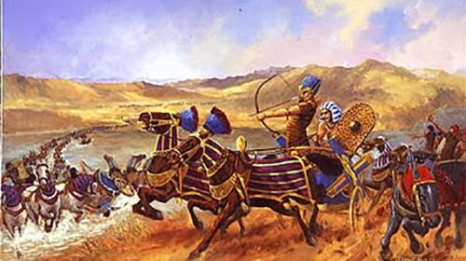
Pharaoh’s heart was hardened, and he decided to pursue his fleeing slave army with the best of his forces. He was personally in command of a strike force of 600 Egyptian chariots, 50,000 riders and 200,000 infantry (according to Josephus).
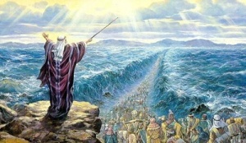

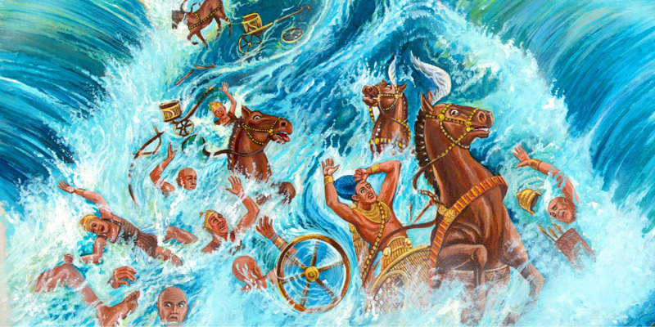
Exodus 14
***The closer we get to the return of Messiah and our deliverance into His Kingdom, His Promised Land, the more the army of Pharaoh moves in to try to produce fear and doubt in Yahuwah’s children so that they do not go forward in faith, in boldness, in obedience to the commands of the Master for our victory.
The closer Pharaoh’s army gets to those waiting to cross the sea, the more fear his army tries to produces - the more despair, the more hopelessness, the more loss of faith, and even panic ensues. The crossing is our freedom from slavery, our new beginnings, our going forward to do all and be all that Yahuwah has planned for us.
However, the sign of the closing in of Pharaoh’s army means that the people of Yahuwah are ready to cross into position to take the Promised Land. Pharaoh fears losing his slave-force. We are freed from slavery to the kingdom of darkness at our true new birth, freed from control of the fallen ones, and their plans for our eternal damnation, as we cross over into the Kingdom of Light.
We then come under the reign of Yahuwah and Yahushua in training for reigning in the Kingdom. Everything changes – all becomes new. Messiah said His burden was easy and light. The burdens of the fallen ones are heavy and oppressive. And so, as we give ourselves to our new Master, our peace and joy overflow – we’ve entered “promised land.”
The people in Exodus 14-15 were ecstatic with joy until they faced their first obstacle, and then they wanted to go back to Egypt. Forty years later, their children went into the Promised Land to take possession of it under Joshua and Caleb. The land for taken by warfare against the fallen ones, but they overcame and took it.
This foreshadows most believers today – delivered from eternal death, but not growing in faith, not being strengthened by life with Abba. Thus they remain as those in the wilderness who never grew up into faith and so lost their inheritance.
Life before entering the Promised Land is one of trials and tests, but those whose faith is solid in the One who parted the Red Sea, will go on to victory.
The Hebrews, waiting to cross the Red Sea (Exodus 14) were terrified by Pharaoh’s army that was closing in to kill the people. Yet the army was held off by a cloud by day and a fire by night – the Presence of Shaddai, El Yon – the one who defeated the evil attempts of Pharaoh 10 times with the plagues, the final time taking the lives of all of Egypt’s first born, Pharaoh’s son included.
Pharaoh was seeking revenge on Yahuwah for the plagues, yet he was restricted from coming too close. All night, the pillar of fire held off the army. As dawn began, the sea became fully opened, and the exodus began.
Is Pharaoh going to back off? No, of course not. He is going to overtake them in the midst of the sea, though he sees that Yahuwah is working another miracle with the sea water. As the last Israelite gets across the 5 miles of sea floor to the land of Arabia, Yahuwah lets the water fall.
All that time, the people were terrified as they fled, because Pharaoh would not let up. Today we see one of the chariot wheels beneath the sea that was on Pharaoh’s chariot, and parts of chariot wheels of his army strewn everywhere, covered in sea weed. Yahuwah kept His promise. He didn’t tell the people it would be easy, nor that the threat of Pharaoh would not be there. He never promised the people a cake-walk, a stroll in the park, a pleasant outing. He did promise them that they would be delivered from Egypt.
The sign of Pharaoh’s attempts to stop them is a sign that Pharaoh feared. He knew that Yahuwah was more powerful than all the gods of Egypt. Yet, to show his hate for Yahuwah he had to try to stop them, just as the fallen ones today and us.
This is the pattern of Lucifer and his army of fallen angels, Nephilim, and aliens. They pursue, but cannot touch those who rest in the perfect will of Yahuwah. Strays yes, but not those walking the narrow path through the narrow gate to the other side of the sea.
The demonic spirits of Lucifer’s forces try to terrify, to cause Yahuwah’s people to say “let’s go back to Egypt.” Pharaoh tried to instill a feeling of defeat, a denial of the power of Yahuwah in the people, so they would disobey Moses and, in mass, turn back. But Joshua was also there, and Caleb, who stood with Moses. Moses knew the ability of Yahushua. Joshua knew; Caleb knew, Phinehas knew … but otherwise, only a tiny few others knew. Even Aaron was fearful.
They had no time to get look back. They had to go forward. It was the only way – they were pressed into the narrow tube on the sea floor – one direction only. To turn back, they knew, would result in immediate death by Pharaoh.
Abba has boxed us in. Either we go forward with Him or retreat into the waiting arms of Lucifer and his army of fallen angels, Nephilim, and the giants/Rephaim.
Here we are now in the Spring of 2022 in the Northern Hemisphere. The Beast of Revelation 13 is now making his demands for trillions of dollars for his army and his rule. Lucifer dwells in a giant palace under the ice of Antarctica, with 35’ giants ever-ready to seize and eat anyone who gets in his way or doesn’t bow to him. That’s recorded fact. Refer to: “The Midnight Meeting”/Mikvah-Present Reality.
The plans of the fallen ones to return to the Golden Age of pre-flood days are well in effect, and to kill all on planet earth who will not worship him. “Pharaoh” has indeed got his army ready to eliminate all who will not bow to the will of the Beast.
After 40 years of not obeying Yahuwah, wandering round and round in the wilderness of Sinai, and even as far north as Bashan, all those who came out of Egypt under Moses died out except for 2 – Joshua and Caleb.
Yahuwah appointed Joshua, whose Hebrew Name is Yahushua, “Yah is salvation.” He took the children of those who came out of Egypt into the land, battled the Nephilim and the giants, and won the victory. Joshua and Caleb had passed the test of the Anakim (Number 13 and 14), and chose to obey Yahuwah rather than return to the worship of the golden calf of Egypt worship. Only 2!
We approach 8 billion people on planet earth. The Elite want to reduce the population down to 500 million hybrids of man and machine hooked up to Alien Intelligence, actually “Alien Implants,” also known as Artificial Intelligence. Not human - just controlled slaves.
Yahushua Messiah is not going to let that scenario totally play out.
The Sea is parting once again for those like Joshua and Caleb who will look at the Anakim and say “We are the giants; they are the grass hoppers.”
I’ve had many encounters directly with fallen angel spirits, principalities, powers of darkness – none has come near me, the closest just to the end of my bed.
I’ve had to deal with several varieties of various levels of authority.
They know that I know the power of Shaddai, El Yon, Yahuwah and His Son Yahushua. They know who backs me because of relationship. Yet, like Pharaoh, they pursue and try to bring fear, anxiety, nervousness, concern – always playing the role of “we’re here to get you and take you out.” But I’ve learned instant battle in the spirit realm and the rise of the power of the Spirit when fighting for me. I’ve learned battle plans that work and what does not work. I am teaching you mainly in podcasts now, under “Audio Teachings” on comeenterthemikvah.com.
Joshua 1:5-9: “Be strong and of a good courage.”
Psalm 48: “…be still and see the salvation of Yahuwah with you.”
I know that if they can’t bluff and make fear come, they’re going to be run off. They know their eternal destination. Learning the hard way, I have gained wisdom of Yahuwah’s battle plans in this warfare. The battle is getting stronger and stronger – the enemy has pulling out all stops – coming after those whose job it is to deliver the people of Yahuwah – like “Moses.”
My prophecy given to me in 1971: “You are Moses, deliver My people.” I have seen Moses twice in vision, and once face to face in real time. Three times, yet each time was a surprise. We all have callings that we’re being prepared for – your task is to get before Abba and learn what it is, yield to the preparation, and give yourself to carrying it out, taking it one step at a time as He leads you.
In 1996, I was given Joshua 1:5-9 as a word from Yahuwah. Now I understand it more than ever before. We are in the most intense training now. As we obey Him, He becomes more and more tangible as He leads us and teaches us the details.
We are all in the delivery business – delivering from demons, delivering from sin, delivering from oppression and depression, delivering from hopelessness, delivering from a state of hell bound. You are a carrier of the power of Yahuwah.
Witchcraft has a pattern, uses patterns. Voodoo uses patterns. The human agents of the fallen ones have their timing patterns to the second - especially between 12 midnight and 3:00 AM. The patterns become obvious because they are repeated. It is at this time that witches and warlocks cast spells, send curses, do rituals, prayers, and proclamations for the torment and harm of those that the fallen ones fear. You sure don’t have to take their attempts to beat you up. The more you stand firm in praise and worship, in proclamation of Their will, the blood of Messiah, and His soon return, the more they will back off. Remember the words and put them into practice of Revelation 12:11!
Now, the closer we get to our final positioning before the return of Messiah, they fear those who are Spirit-filled and walk in the authority and power of Yahuwah more than any others and so concentrate on using all they have at their disposal to frighten, wear down, discourage, anger, and implant thoughts of sin into those they fear. So much of this is done between midnight and 3:00 AM. Speaking in the languages of heaven also carries great power, for they cannot penetrate the words.
For me, they work through the computer, through thoughts of people that are not fully on Yahuwah side, yet pretend to be “spiritual,” itching in the night so bad that it is nerve-wracking and sleep is impossible – at exact times, right on the dot.
In doing fierce and fiery proclamations of praise and honor to Yahuwah and Yahushua, they back off, but then try again. Falling has been a serious problem for me. Keeping me in pain, keeping me discouraged – yet, I know that no Anakim can keep me from obeying the Master. We are the giants in faith because of our relationship with our Master. The fallen ones are the grasshoppers. Don’t let the grasshoppers scare you into thinking otherwise! (Numbers 13-14) Please refer to: “Facing the Anakim”/Mikvah of the Great Adventure #11.
They could have crossed in 11 days from Horeb/Sinai into the Land, if they had taken out the Anakim. Abba would have found for them to victory. But their fear stopped them and they never made it in. They all died out after 40 years of wandering. Their children went in with Joshua and Caleb. Fear will bind you, stop you, and destroy you – for fear is a spirit that comes from doubting the power of Yahuwah. Doubt and fear go hand in hand.
This is March 29, 2022. We, the children of Yahuwah, are being spiritually boxed in with the sea before us and the army of Pharaoh behind us. The forces of darkness intimidate, scare, cause the people to deny reality, bury their heads in the sand, - weak, shallow, whiny – because they never took the time to get to know the Almighty, the Most-High. They relied on men to protect them, to tell them what to do and what to believe and 99% of what they think they know, is a lie. No personal responsibility taken - no effort made to pursue the only path to the Kingdom. Sad, tragic, yet the tribulation time is part of Yahuwah’s purpose to single out the few whom He knows and trusts, to pull off the greatest victory of all – before Messiah comes. To walk among the destroyers and they can’t do anything to harm them.
So, I teach on faith. Please tap into the podcast series “Faith Walk,” #5 under the Mikvah of the Spirit, now being amplified under “Audio Teachings.”
I teach on set-apartness. I teach on the baptism into Yahuwah’s Spirit. I teach on the gifts of the Spirit and His empowerment. I teach on the victory and the rewards. Yet, tragically, as all the watchmen moan, hardly anyone wants to put it into practice because they so mind programmed into ease, comfort, security, having all lusts of the flesh satiated, with vacations, more money, good retirement funds, new houses, and peace with the family – not realizing that just behind them stand Pharaoh with a smile on his face.
The fallen ones never leave those who are absorbed with self. However, they have to leave those who have the authority backing of the Most High. While most are scared of the snakes, scorpions, and what might harm or disrupt their good-planned out life, Messiah said to His disciples: “I give you power-authority over all the works of the enemy and nothing shall by any means harm you.”
Oh the giant trap that Americans have fallen for. In my going to the nations for so many years, especially the poorer ones, I noted the hope of going to America, land of fulfilled dreams - of wealth, the good life, the easy life, that was an obsession for the poor. All the while, in America, land of dreams, it has been the greatest trap of the whole fallen realm, to seduce, and beguile, the flesh-loving carnal ones into a trap they can’t escape from. It’s like putting out bait on a mouse trap. The mouse takes the bait and the hammer comes down and kills it. That is America – land of mice who take bait from the fallen one’s hands. A few are not so gullible, but the few have learned truth and so avoid the traps. The systems for security are actual systems to destroy faith in trusting Yahuwah. How can we really walk by faith and be so entangled in what man says we “need” in order to be secure? Abba removed all of it from me, and oh how thankful I am.
Then you have Noah. “What’s this idiot doing building this big whatever?” Noah saved his family. Noah foreshadowed the end-time remnant who would hear from Yahuwah and astutely obey, thus escaping the judgment of righteous Yahuwah.
As those who are righteous by the blood of the Lamb, we must really give ourself to the will of Yahuwah to escape His judgment. We are not “appointed to wrath,” as I Thessalonians 5 tells us, but we can deserve it by lukewarm apathy.
For those wanting to enter the Kingdom of heaven, yet not being a diligent follower of Yahushua in their life, the opportunity to be beheaded in one of FEMA’s death camps, or in Israel’s huge American-built death camp, or death camps all over the world, may be the only option for entering. (Revelation 20:4)
Bottom line is: We are approaching the crossing point, and Pharaoh in the form of witches, warlocks, voodoo priests and priestesses, and Christian and Messianic pastors and teachers will cooperate with the beheading. For a long time now, underground and top ground facilities are everywhere stocked heavily with guillotines. (Mark 13:9-13) Friends and family will betray the true believers.
The gospel of ease, convenience, and we live as gods, getting what we want, is not in the Bible. He calls us to forsake all to follow Him.
Prepare psychologically and spiritually so that you remain in peace, determine to go through whatever you have to go through in order to enter the Kingdom. Beheading is a lot better than spending eternity in the lake of fire. (Revelation 7:9-17; 14:11-12) Firmly put faith in Yahuwah and His love for you!
As the modern-day forces of evil move in to try to stop us from moving on to victory, to freedom, to our eternal inheritance, it is a sure sign the symbolic Red Sea is about to part for us.
This is a pre-Passover special for you. Passover will be in April. We will be on guard to see if the new moon if sighted from Jerusalem on April 2nd for the month of Aviv. As they crossed the Red Sea, they had not long-before celebrated the first Passover (Exodus 12-14).
We’re at a place of waiting, as the forces of today’s Pharaoh amass against us. But, we’re down on the water’s edge, and Messiah is holding out the rod of authority for us – so we soon cross.
Indeed, a great adventure if we’ve prepared for it. For the prepared, we know there is nothing to fear but fear itself. We are assured of victory if we go forward at the command of the One of whom Moses spoke of in Deuteronomy 18:15-22 with John 5:43-47. Our Redeemer is soon to return for us. Let us press hard into the Word and into the Presence of Yahuwah and Yahushua, so that we know Them, we trust Them, and they know us and trust us.
Prepare your spirit to be totally encased with the Spirit of Yahuwah, and become passionate about your preparation to enter the Kingdom.
In His love, shalom, Yedidah
March 29, 2022

