THE MIDNIGHT MEETING
THE PRESENT TAKE OVER BY THE SERVANTS OF LUCIFER

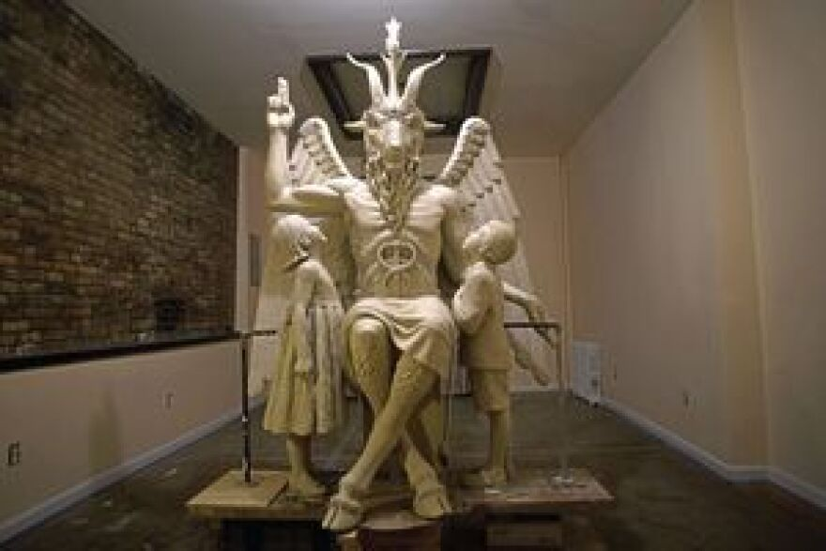
Statue of Baphomet, Arkansas State Capitol

Most people run from anything that does not soothe their mind and emotions – from that which is calling them to sacrifice anything that they don’t want to give up. They don’t want to get involved in anything that takes them away from their planned life. Thus, they adjust things like their religious belief-systems to deny the demands of Yahuwah and Yahushua throughout the Word for right standing in Their Kingdom, to continue undisturbed by the demands they make on themselves to prosper in the kingdom of their own making. This is why the rejection of the infilling power of Yahuwah’s Spirit, because it costs us everything to be able to function freely in His Kingdom authority, with His Kingdom backing. Yahuwah will not back anyone who is not submitted totally to His requirements and obedient without questioning.
Satan can only counterfeit! He can’t create anything. He promises his loyal servants a high position in his kingdom for 1,000 years, as he has promised all of his servants throughout the ages. All he can do is counterfeit – i.e. Revelation 20:1-5. That’s what the Nachash/Serpent promised Adam and Eve in the Garden if they’d forget Yahuwah’s demands and accept his promises of godhood—they’d get all they wanted to satiate their own desires.
It’s all now coming to a head. Take you side – but realize that in taking sides, you are committing to 100% loyalty to whoever rules the side you’re on. Most want to fence-straddle – one foot on either side. But, as we read in Revelation 3, the message to Laodicea, when Messiah Yahushua “rends the heavens and comes down,” all who straddle the fence will be vomited out of His mouth into hell.
Right now, the battle between the Kingdom of Light and the kingdom of darkness is reaching the highest level of preparation for the appearing of the son of Satan, the Beast, the “antichrist,” on center stage, and the return of Yahushua Messiah.
I want to report to you some of what our enemies are doing to position themselves for the battle ahead against you and me. In this way, you’ll know just what you’re up against, and hopefully make the right decisions.
Most of us do not celebrate the birthday of Jesus on December 25th. In my “classic” article “Joyful Abomination/Mikvah of Set-Apartness, I tell why we should stay away from celebrating this day, as we would avoid touching of October 31/Halloween. I also wrote a very accurate and scientific article about the real birthday of Yahushua, which corresponds to Scripture, as to His conception and birth on a Yom Teruah, entitled “Yehushua’s Birthday,”/Mikvah of Eternal Salvation.
I do not judge anyone who really does love Jesus, a brother or sister who will go to heaven upon death. So many of the world’s people, taught by American or British missionaries, have learned some wrong doctrine – yet they apply also the correct doctrine of salvation that few in the western world ever apply and act on. Thus, it makes you wonder who is a part of this Daniel 11:32 remnant that is rising now: “They that know their Elohim (Father and Son), shall be strong, and do exploits.” It’s those who are already doing the acts of service to the Elohim, promoting the Master Yahushua. It’s those who are totally submitted to their Savior, out of love, and obedient to the Word of Yahuwah, taught and directed by the Father, Abba Yahushua.
While the “believers” in first world nations of ease and comfort, convenience, and self-promotion, play games with their religious beliefs to suit themselves, those in third world nations under great persecution for their faith, are already going forth in the power of the Spirit to do the exploits western-world believers never would do.
However, now, the western culture world, the Greco-Roman first world of affluence, is turning to Satan who promises them wealth, and anything their carnal mind and their fleshly desires can up with that they want – especially the incredible evils done to children. The giants of old, before and after the Flood, were homosexuals, pedophiles, perverted in every way imaginable. It is the same today. Centers of such things are Washington D.C. and NYC, as well as worldwide - full of atrocities that are coming to light for all to see.
In the picture above, note the two children in adoration of the goat god. Baphomet promotes the sacrifice of children to Satan. Current real-time statistics are below – horrendous statistics but true. The nation most promoting abortion worldwide, pedophilia, sex-trafficking of children, the selling of baby parts for such trivial things as food and drink flavoring, handles for purses, also for blood-drinking and cannibalizing, is America.
Hollywood is a major center of the cannibalizing of babies and children. We are under the great judgment of Yahuwah! I don’t think that surprises any of you! As the chosen nation from over 400 years ago to bring forth the Beast to power, we’re the chief nation of servants to Satan. Refer to: “America’s Secret Destiny”/Mikvah of Preparation.
Certain key streets in Washington D.C. are laid out in the outline of Baphomet …his beard rests on the White House. The flame of the candle on his head ends at the House of the Temple, the 33rd Degree Scottish Rite Temple that contains the remains of Albert Pike in a pillar. In 2010, I walked from the White House to the House of the Temple, along the streets outlining the body of Baphomet. I was with a friend, a fellow-intercessor. When we got to the House of the Temple, we took their personal tour. Our tickets were $3.33 – each – uh, that’s 6.66 total. I had read Tom Horn’s book of his tour of this “temple,” and I saw what he saw. I also had studied and written about Albert Pike. As we took the tour, I kept asking the guide questions that shocked him. I wasn’t supposed to know what I was saying. He asked me if I was there because of Tom Horn’s book. I said “no.” I told him it was because of my family’s lineage of 33rd degree Masons. As I took the tour, I was shocked to see a picture of my grandmother’s 1st cousin, Ty Cobb among those who were 33rd Degree Masons. I heard that Ty was born again not long before his death. I hope so. Taking the tour gave me deeper insight into my family’s lineage who was, in part, entangled into this web back in the late 1800s, early 1900s. My dad wouldn’t marry my mother until she got out of the Eastern Star extension of Freemasonry for ladies. She loved him!
In walking the streets of the outline of Baphomet, my friend and I did serious spiritual warfare, from the White House to the House of the Temple.
The House of the Temple controls much of what is put into law in the White House. This is why the beard of Baphomet rests on the White House.
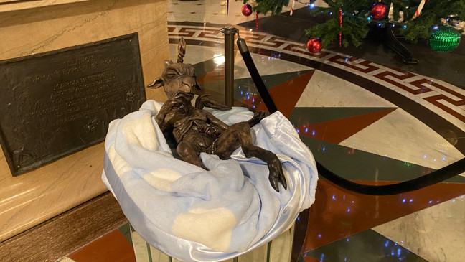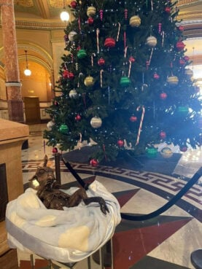
A baby Baphomet, brought by the Satanic Temple Illinois, is included in a holiday display in the Illinois Statehouse rotunda in Springfield, Illinois, Dec. 20, 2021 WICS Jakob Emerson
Now, baby Baphomet, ugly as he is, is in a “manger” for Christmas in the Rotunda of the Capital Building of Illinois. As you’ll see below, the news reporting showed Roman Catholics protesting and reported what they said. Good for them – they said it right! Were Evangelicals and Charismatics there too protesting, praying, witnessing to the real soon-coming Messiah? Hopefully some.
From Steve Quayle’s Briefing December 21, 2021- real statistics from those keeping statistics. From top-ranking “science guy” reporting:
Date: December 20, 2021 “I bring this report with a heavy heart because I know it will destroy the image many of you have regarding the USA and how strong it is. There are a great number of `hidden’ sins of the USA and now that these sins grow larger God will harshly judge the USA. If you doubt me consider the following facts: 1 The USA has a population of 332 million people at this time. 2 Additionally, another 245 million innocents have been murdered by the USA. 2.1 125 Million abortions 2.2 25 million late term or full birth abortions 2.3 50 million sacrificed in ritual sacrifices. 2.4 45 million children from around the world sacrificed or used in experiments by Americans As God extracts his judgment expect that 245 million people will rapidly and painfully die like the innocents they killed or let die. Now that I have your attention, I will explain more of the foolish things that the current USA government is doing to HASTEN the demise of the USA. 1 The USA and NATO are doing specific things to provoke Russia to be the one to start the war”…
The reason for war? The reason for all the wars, especially WWI and WWII and now the pending WWIII: Blood sacrifice demanded by “Lord Lucifer” – his desired title.
From a Briefing December 18th: “AT MIDNIGHT TONIGHT IN ANTARCTICA WORLD LEADERS HAVE BEEN SUMMONED TO MEET WITH “LORD LUCIFER” TO GET THEIR INSTRUCTIONS FOR BRINGING IN THE WORLD RULER
The Current Plan - whether it happens soon or not, it will happen: Steve Quayle said: “This war will be the fastest war in history!” He said “maybe 1-2 hours.”
Russia’s hypersonic missiles can hit their targets within minutes - especially Europe, the UK, and the USA. Russia sits in the Arctic. Intel talk is that Russia will begin to hit targets before December 25th. Their Christmas is January 7th. Over 50% of the Russian people in Moscow are already in bomb shelters. Notice America doesn’t have any bomb shelters stocked with food, beds, toilets, in America. Because we were chosen to bring back Nimrod to power, and we’ve done it – the “Lab” is no longer needed, so the “lab rat” can be destroyed. That’s their understanding.
China is ready to strike Taiwan. Iran is ready to strike Israel, or vice versa. China is also ready to strike North Korea – a new development – Xi and Jung are not friends!!! War has always been about blood sacrifice to Satan.
In a nuclear strike on NATO nations and America, these are the CITIES TO BE TAKEN OUT 1ST OF ALL: BRUSSELS, WASHINGTON DC, NYC (note the details of Revelation 18)
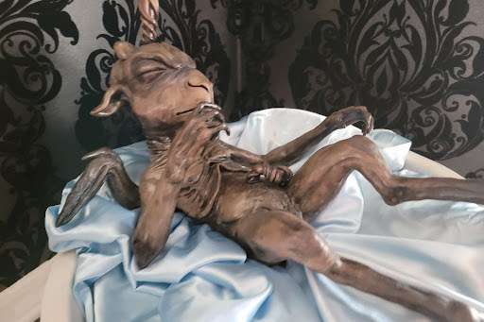
“The Illinois state Capitol Rotunda will feature a controversial holiday art display from the Satanic Temple that will stand alongside other religious exhibits. This year’s installment, the third for the organization, will feature the satanic figure Baphomet depicted as a baby to celebrate the holiday Sol Invictus, the State Journal-Register reported. The display was designed by Albuquerque horror artist Chris P. Andres. According to the organization’s website, Sol Invictus is a `celebration of being unconquered by superstition and consistent in the pursuit of sharing knowledge,’ and has its origins in the cult of Sol in pre-Christian Rome. `This year’s tradition marks a greater urgency in the Baphomet’s message of harmony and reconciliation,’ Satanic Temple’s director of campaign operations said…The display has been a source of controversy…A Nativity scene was installed at the rotunda recently at an event sponsored by the Diocese of Springfield, where Bishop Thomas Paprocki said `the Satanic Temple’s displays should have no place in this Capitol or any other place,’ according to the State Journal-Register. `Mocking the millions of Christians in the state of Illinois and billions around the world by depicting the baby Jesus this Christmas with the satanic deity. Baphomet is the very definition of evil and causing division, …’ said Andrew Hansen, a spokesperson for the diocese. The Satanic Temple extended its invitation to the bishop `to hold hands with members of The Satanic Temple while we come together and stand before all of the religious displays at the rotunda,’ Helian wrote.”
“Baby Baphomet takes its place alongside a Christmas tree, Nativity, and menorah in Capitol Rotunda, Posted on December 20, 2021
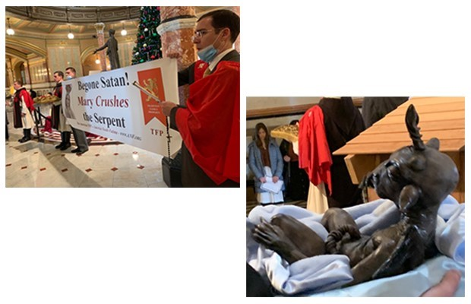In addition to the various displays, there stands a large sign from the Secretary of State’s office explaining how all of it is legal. (Photo courtesy: Dave Dahl/WJBC)
By Dave Dahl: SPRINGFIELD – “The baby Baphomet – a goatlike creature worshipped by Satanists – has taken its place alongside a Christmas tree, Nativity, and menorah in the Capitol Rotunda. Men from a Catholic group sang and prayed before, during, and after the Satanic Temple of Illinois’ ceremony installing the statue in the Rotunda – which, a large sign points out, is obligated to welcome displays of all faiths — and of the faithless. What would Jesus do? `He would whip the Satanists out of the Capitol building,’ said John Ritchie of Pennsylvania, part of Tradition, Family, and Property. In addition to the various displays, there stands a large sign from the Secretary of State’s office explaining how all of it is legal. Dave Dahl can be reached at News@WJBC.com.
Note again the statistics above on the sacrificing of babies, children, adults, our soldiers, the citizens of America and the nations to this hideous extension of Satan. In America much of that is legal too. But the evil America is legalizing will be punishable in the judgment of a Kodesh/Set Apart Elohim!
The adoration of the children before the big statue of Baphomet is a sick, sadistic, evil message, saying that the god of this world plans to do as he pleases, as he reigns in his palace under the ice in antarctica, and his loyal servants are ready to do his will.
During the meeting on December 18th, those who were summoned were also taken into other dimensions to meet with the fallen angels there. Each of the loyal servants of Satan will have their own grouping accompanied by hundreds of angelic and Nephilim helpers.
Please refer to the article “Strange Reconciliations …” /Mikvah of the Great Adventure. There you will learn about an earlier summoning of world leaders at the time Trump was elected President – amazing information.
In the meantime, “Lord Lucifer” the lord of losing the eternal battle, has been summoning various groups under his control. They report how beautiful is his palace and how beautiful he is. “Lord Lucifer,” as he is called, requires that they pledge their total loyalty to him. And as a gift to him, they are required to participate in human sacrifice in his presence.
This is real. The fastest growing religion in America is Satanism, but also true in other 1st world nations i.e. the British Isles and Europe (east and west), Australia, New Zealand, Canada. Satanism is practiced in the United Nations building, the U.S. White House, and Capital Building, in state capitals, in the U.S. military, and across the nation. It is estimated by one of the U.S. top generals that 60-65% of our military troops are practicing satanists.
Russ Dizdar, now in heaven, was sacrificed/murdered a couple of months ago, as was his wife Shelly, for their stand against satanism and the exposing the depths of it. Russ went into the depth of the pit to rescue those who were fragmented and mind-programmed into satanism, victims of sexual abuse, pedophilia, and torture. Russ wrote a must-read book entitled The Black Awakening. What Russ said was coming is now happening. He has much to say about the U.S. military and the fragmented ones of the MK Ultra CIA mind-programming efforts.
Already, over 100,000 once-fragmented children are totally sold out to Satan. Because of this toddler-time fragmenting of their minds, most having been kidnapped, held in cages and traumatized so that their minds split into several compartments, they have grown up to be slaves of Satan’s agents.
If you ever saw the movie “The Manchurian Candidate,” you realize how true this is. Hollywood is a major extension of the dark kingdom’s mind-control programming. People think something is only a movie, but it is absolute truth being told about what is really happening. The enemy can only counterfeit; he can’t create anything. He is proud of what he does, and so movies are made about what he does. Gene Roddenberry was the writer of the Star Wars TV series. Everything we saw on Star Trek was taking place in space – for several nations even were at war in space. Russia blew up our space station on the moon around the 1960s, or so. Yes, humans have been in underground bases on Mars for a long time. The creation of mutated, hybrid, “aliens” has taken place in such places on several planets.
Now, as we see these things out in the open, most people just disregard them as only an expression of another opinion - little-knowing that the message is: “THE BEAST IS WITH US AND WILL SOON BE TAKING CONTROL.”
I’ve reported the fact that Gulf War II was created by George W. Bush for one reason – to have an excuse to send U.S. troops along with German archeologists to unearth the body of Nimrod from his tomb in Iraq. America was chosen over 400 years ago to be the nation to restore Nimrod to power over the earth, so that what he planned at the tower of Babel (Genesis 11) would come to pass in a united world - the destruction of Yahuwah and Yahushua, and all on earth that represent Them - from plants and trees, flowers, and pure water, to insects, to birds, to animal mammals, and of course all human beings. Now, that plan is far into its completion.
Are you ready to face anything for the Master that He requires of you? Yahuwah will not let the plans of Satan overcome His plans! Remember the final end of Satan and all of his fallen ones: Revelation 19 and 20.
Pray like you’ve never prayed before, proclaim the imprecatory prayers of the Psalms against the pure evil that is sold out to Satan. Study the Word with the Spirit of Yahuwah within to teach you, and lead you and guide you, speak to you, and anoint you with His power.
In the love of Yahuwah and Yahushua, Yedidah
December 22, 2021

