TO WHAT BIRD TYPE DOES
YOUR SPIRIT RELATE?
ARE YOU A HIDDEN WHITE WINGED DOVE?
ARE YOU A SOARING HAWK OR AN EAGLE?
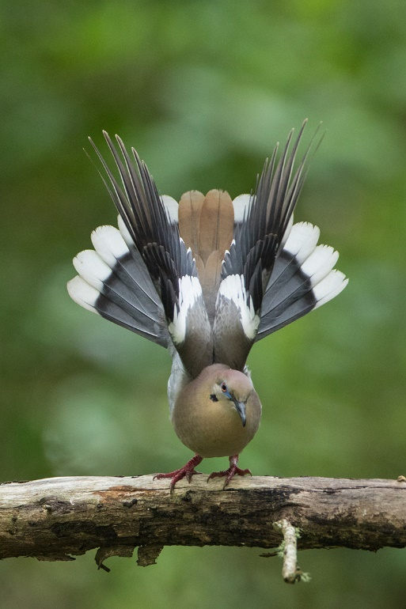
White Winged Dove
Sweet little bird. You can see its dove face and body – and sitting by the roadside they look like any other dove. But when the male especially spreads his wings – he’s magnificent! This is a picture of the children of Yahuwah. We are ordinary-looking humans, yet by our eternal re-born spirit we are destined to spread our wings and soar. You may be like the white-winged dove in that you hide who you really are before Yahuwah, yet when it comes time to spread your wings, the beauty comes out. Or you may soar like an eagle and not be seen by many, for few look up into the sky. Thus, you would be hidden there. The day is coming my brothers and sisters, when what we are in Yahuwah’s sight will be manifested to all!
I see these doves and so many other birds every day in the field across from my house. One day I was looking out my back window into a sheltered area with a barn on the other side of the fence. All of a sudden a male White Winged Dove landed on the fence post a few feet away from me. Then he began showing off like the one in this picture. Magnificent!
It is the same with many other birds, like the hawk family. They may seem drab when they’re just sitting on a tree limb, but when they take off and soar, spreading those big, wide wings, some around 3-4 feet wide or more wide - they are magnificent.
Below, the 1st picture is like the one I took of the “Red Tailed Hawk” sitting across the road on a tree limb. I first saw him sitting in a high tree across the field. I’ve bought binoculars since. The “Red-Tailed Hawk has a noble and magnificent hawk face. His wing spread is near that of an eagle’s – 3’-4’. But when he soars, the 2nd picture is how he looks. This hawk is my favorite. But the Swainson Hawk is my #2nd favorite.

FOUR RED-TRAILED HAWK PICTURES
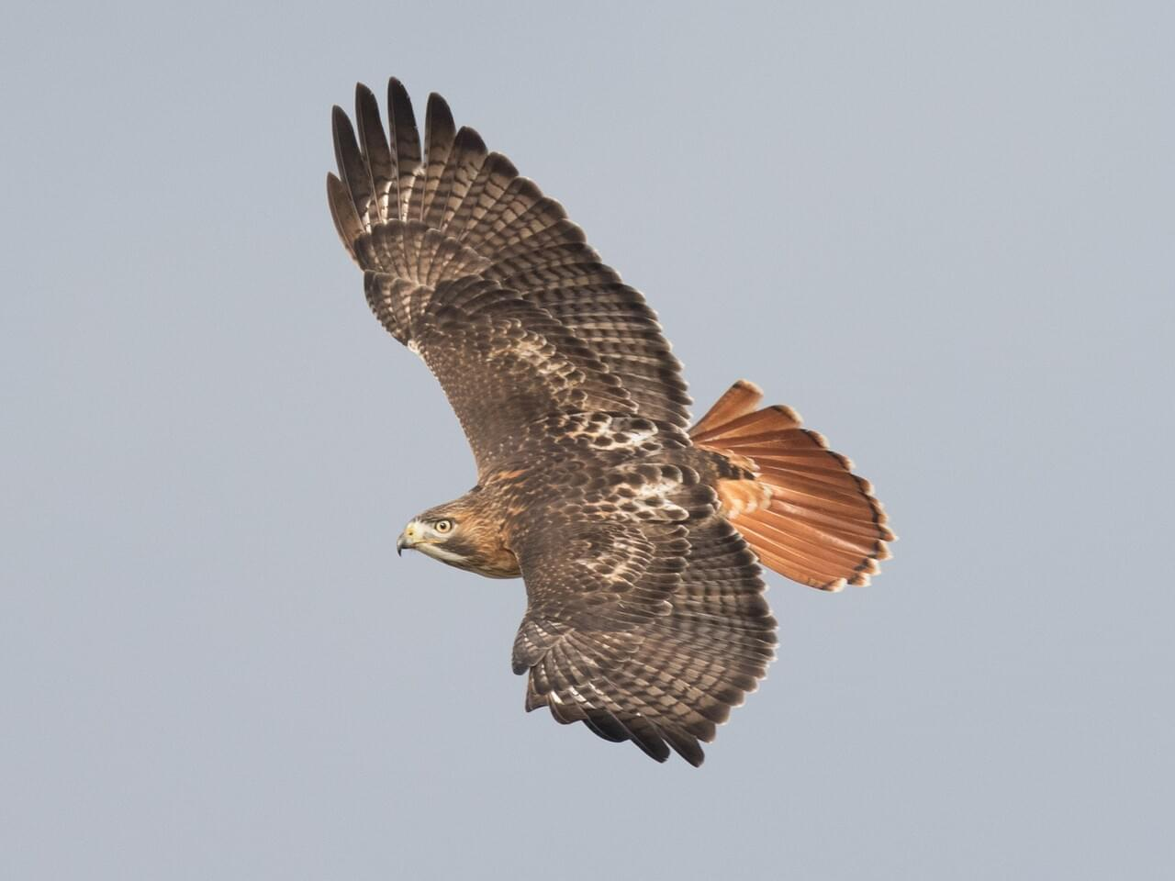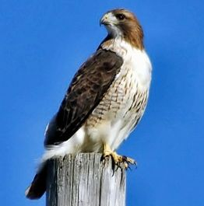
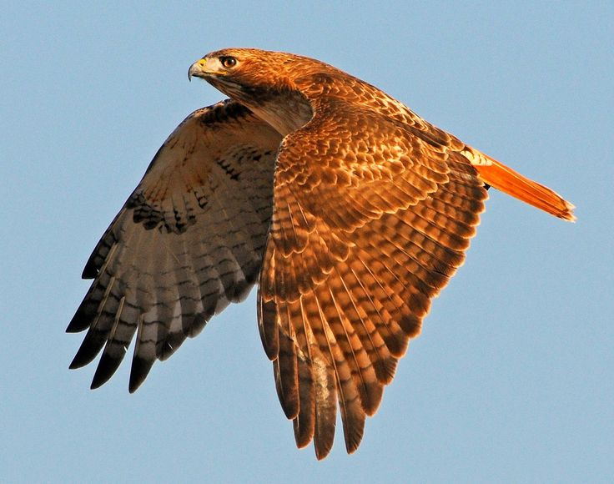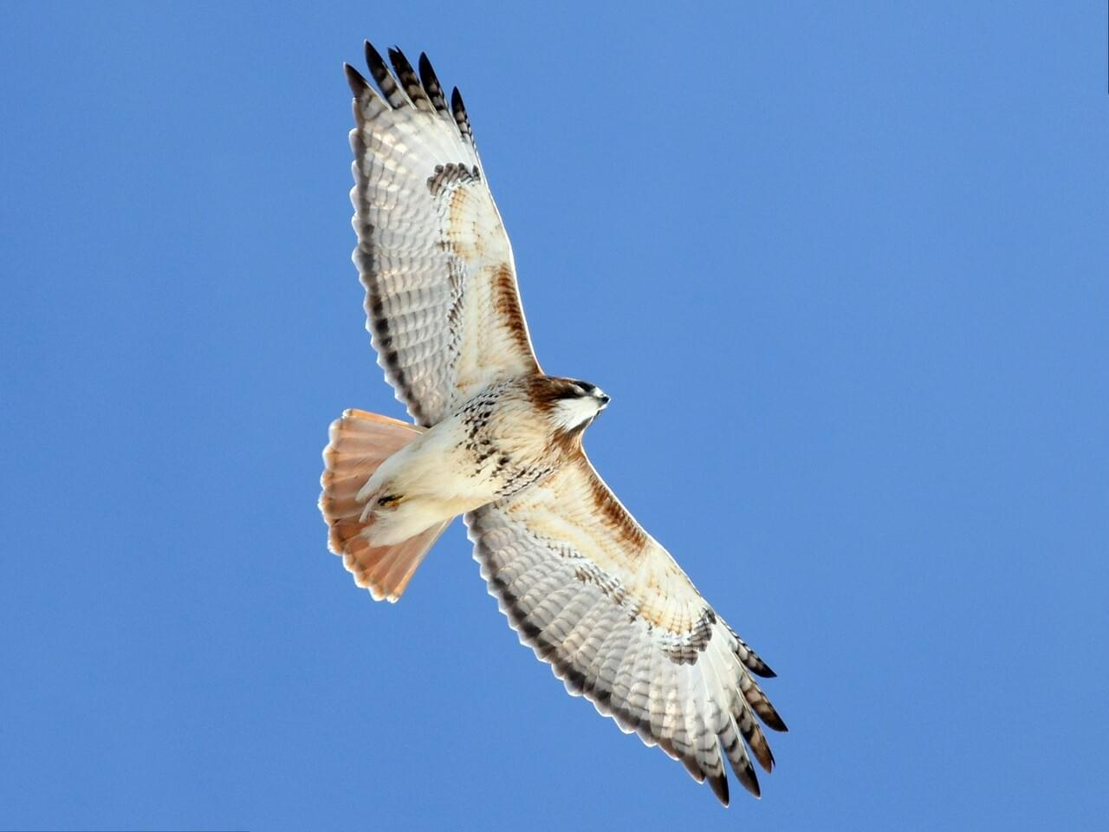
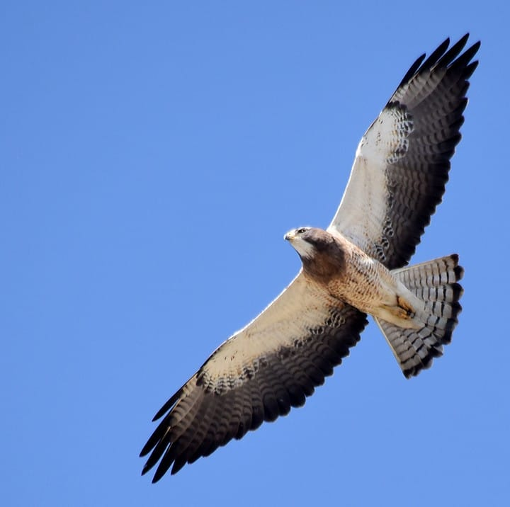 The Swainson Hawk
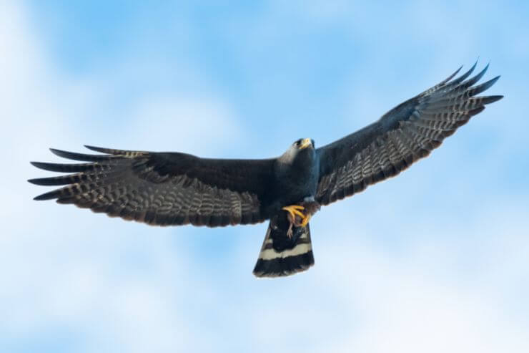
This “Common Black Hawk, with the white on the tail is like the 5 or 6 hawks I saw soaring together high above the trees on Shabbat morning April 6, 2024
. 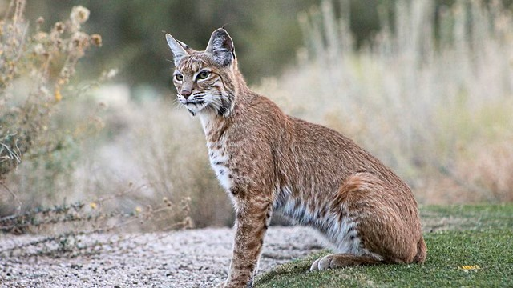
A little humor: This is a “kitty cat” that I saw come slowly strolling up my driveway just to the left of my living room windows last week. He went around the side of the house into the back yard, and turned to stare at me as I was watching him and taking his picture out my kitchen window. I sent the picture to my son and to my daughter-in-law’s mother. Both had seen this guy walking around outside their houses. So, to my pictures, both responded that this is “kitty” that has been hanging around here on and off for a while. As you can see “kitty” is rather large. And if you look at the tail, you see it is NO KITTY. It’s a TEXAS BOBCAT. I watched as this non-kitty crouched down to attack a bird not far away by an old barn.
This is a reminder to us that the “enemy” of our soul, our body, our eternal life, is always roaming around “like a lion,” as the Bible says, seeking who, he might take down, and devour.
Birds who don’t soar are often in danger from predators who don’t soar! This is a warning to us. We must soar high in the Presence of our Father and His Beloved Son, for only there is our safety! I noticed early on when I first saw the big hawk sitting in a high tree near the pasture, that he sat still a very long time – like 3-4 hours. When I took his picture, sitting on some wood across from my windows just across a little road, he just sat there – at least until I pulled the car out of the garage and scared him.
Never a dull moment!!! Two days ago, my son was doing some work on my daughter-in-law’s mother’s house and heard a noise that was rather loud over a machine he was using. He turned around to see a 4’ rattlesnake in strike position. I remember that sound as I was walking in the desert of the Navajo Reservation on a hill near the missionary’s house I was staying in. I had bent over to pick up a piece of wood that was decorative, that I wanted to give to one of my daughters. I slowly lifted my eyes to see a rattlesnake 4’ preparing to strike. That was a while back. I simple said very slowly in the direction of the snake: “Jesus.” Perhaps it was the “sss” sound in the name, but he stopped the rattle. I was still bent over. I slowly stood up as I said “Jesus” two more times. Once standing, I said to the snake: “Put your head down.” The snake puts its head down and I preached it a very short sermon. I was not afraid one speck – until I got back to the missionary’s house and told her what happened (smile). I am so thankful that my son is all right. So, another big project of clearing all wood piles away from any structure.
Here, in as few words as possible, I want to share with you a revelation that Yahushua gave me on April 6th, Shabbat, that will make the 3 groups of the born-again and the eternal 3 positions more understandable. Those 3 are all through the Scriptures, all through nature, all through our body to do with His Temple that Yahuwah wants to dwell in.
The revelation came as a surprise to me. I was just watching the many birds out my front living room window that Shabbat morning. It was a gorgeous sunny day. There were many small birds, from little swallows to the beautiful red Cardinals, to the brown doves and white-winged doves, the King Bird, the Eastern Mockingbird, etc. So precious! All fluttering around doing their bird-business.
The King Bird, though small, can fly up to the tall tree, but the others I have not seen do that. The littler birds flap their wings and fly all over the area. Sometimes they soar a little, but because of their being small it requires more energy to stay up in the air, so they flap their wings a lot. They peck for worms and bugs and seeds like a chicken pecks in a chicken yard. These birds are family oriented. Doves mate for life – so you see husband and wife doves together.
The various groups stay together, but because of their small to medium size, they happily flap and fly together in small areas. “Birds of a feather flock together.” Yes, that applies to birds and to people in general, and to Yahuwah children too.
As I watched them on Shabbat morning, I looked up to see the smaller-winged hawks, “common black hawks,” soaring in mid-air, high up near a tall tree in the field. Looking for things to eat most likely - bunny rabbits, field mice, and other little creatures. I was enjoying all the bird-activity: Small ones at eye level, the black hawks flying high at tall tree level.
I had been missing the “Red-tailed Hawk.” I thought maybe he had gone to another pasture. Then I got closer to the window and looked higher. Way up above the medium to large sized black hawks, I saw my beautiful “friend” soaring above them all. Rarely did he flap his eagle-sized wings. He just soared, also looking at the ground for breakfast. I sat there and cried. A deep love for that soaring hawk came all over me. I asked Abba: “What is happening to me with this love for that hawk?” He was alone. I’ve never seen him with another bird of his kind. I saw the King Bird dive bombing him one day as he sat in the tall tree. The King Bird, about a 4th the size of the hawk, would attack his back feathers and then fly away. The Hawk just sat there as if nothing was happening. Then the King Bird attacked the Hawk’s tail, at the base of its thick feathers. That must have hurt. But all the Hawk did was just fly away. Cool dude! No problem with the little nuances … because he knew who he was, and King Bird was simply a pest that did not impress him. I think the King Bird had a nest up in the tree was his problem, because I’d always see the King Bird in 2s, as “husband and wife.”
I was in tears as I saw the “Red-Tailed Hawk” soaring up there solo. I’ve never seen any other hawk with him. He must have a wife and kids somewhere. But this is what Abba showed me, as I cried. He said to me: “That Red-Tailed Hawk is you.” That’s what started the tears.
I was an only child. I grew up alone but had friends in the neighborhood. Then in my travels, always alone on the long flights except for a few trips, like to Bolivia with a dear friend. In our walk with Yahuwah and Yahushua, because we are “extra-dimensional” in our spirit and seek to be with Them in the throne room. If we are obedient to Yahuwah’s will at all times, we can soar in His protected zone. But it is a lonely “walk.” Flying so high, a lot of the dangers of lower flight are out of reach to the high-flyers. However, sadly, few understand what it means to know Yahuwah and Yahushua and to be obedient to Their every request, the Logos and the Rhema.
Those Spirit-taught by Yahuwah, the Spirit, can be together for many days or weeks or years, and never disagree on anything, because they have the same Teacher. This is what Messiah was getting at in John 14-17. It’s not a matter of prestige, or favoritism, or status, or anything to do with “self.” It has to do with spirit to Spirit relationship with Them. But, like the hawk way up high just soaring, that’s what He wants from all of us who believe in His Son for salvation! It’s not an exclusive club.
Look at John 13. Yahushua and His inner circle of disciples were sitting on the floor, reclining, and having a meal together the day before Passover Eve day. Kepha/Peter tapped Yochanan/John on the shoulder and whispered. “Ask Him who He is talking about who will betray Him.” Why didn’t Peter asked Him? Yochanan leaned over and asked Him. He said, the next one who dips in the `sop,’ the gravy-like mixture, he is the one who will betray Me. Well, as Yochanan watched, it was Judas. This is why the discussion of Peter/Kepha with Messiah in John 21. Yochanan and Miriam, Yahushua’s earthly mom, stood together at the foot of the stake until He died. Imagine the encouragement when He saw Miriam and Yochanan there. All the other disciples had fled in terror. Not a mother, and not Yochanan. It says in Hebrews “For the joy set before Him, He endured the stake/cross.” Yes, in His eye sight, He saw the young teenage boy that He would be giving the revelation of His return to in the book of Revelation. It was Yochanan more than any other who understood Yahushua’s prayer in John 17: “…that they might be One even as We, Father, are One.” Yochanan became known as the Apostle of love because he understood the heart of Elohim.
When you understand the heart of Elohim you and He can become close friends. Elohim simple is a plural of “Eloah,” the Father, meaning Father and Son. Genesis 1:1: “In the beginning Elohim created the heavens and the earth.” Father and Son working together - the Son being the “Word.” John 1:1 – the apostle John understood.
You, too, can be like that soaring hawk, as was John/Yochanan! It’s up to you.
Just know that this “hawk” soars alone, yet he’s not totally alone ever. The 5-6 hawks quite a way below him were soaring around together looking for “food-movement” on the ground. The little birds were content to fly here and there flapping their wings and looking beautiful. They each were content in the group they were born into. In our new birth, depending on His foreknowledge of us before the foundation of the world, we are put into groups that He works with to develop our full potential for this life on earth and for eternity.
There are three positions in this life with Father and Son for training in the three positions in eternity with Father and Son. Each position has its blessings, its peace, joy, love, and eternal rewards. If you look closely at Revelation 21-22, you see the three groups that are all through the Word. It’s not a matter of religiosity. It’s not a matter of “favoritism.” This so often produces jealousy in people or in groups who think they deserve what they don’t.
In order to even qualify for the Kingdom we can’t be “religious.” Religion is defined by man and man’s thinking and reasoning. There are 143,000 at least denominations and organizations of Christianity. Each one is a little different depending on what human leader is dictating its belief-system. People who do not go on after a new birth to study the Word with the Spirit of Yahuwah to Teach, who deny His entrance into the temple of our “Most innermost being,” our spirit, who go off big headed because they think they’ve got an “in” with God, yet they do not know Him at all. Thus, passages like Matthew 7:23-25, 25:11-12, Luke 12:22-30 and others show that some who think they have an “in” with “God” are often pompous, proud, arrogant, self-inflated, looking down at others whom they deem to be not as “spiritual” as they are, or worse, they are jealous of those who are favored by Yahuwah above them and do evil to them. They will find out, as did the “foolish virgins” that they are way off of the “narrow path” that leads to life: Matthew 7:13-14.
Matthew 7:15, warns about those religious leaders who are not right with Yahuwah. They look good, but they are not good. “Discernment of spirits” is one of the 9 gifts of the Spirit when He enters our re-born spirit to take control of our life. He either rules or He doesn’t! Those in religious arrogance and pride are far from the Kingdom of Elohim. Those who are to enter the Kingdom long for the return of Yahushua! They have His nature, which is the nature of His Father too. Yahuwah’s Spirit teaches them and leads them into all Truth. They are preparing for the Kingdom of Yahushua! They obey Father and Son with no balking.
The three positions of the birds are like the three positions I’ve been writing about and teaching about since the 1960s. The Bible is all about a Wedding! It is about the three groups that enter the Kingdom, as in Matthew 13: the 30-fold, the 60-fold, the 100-fold, or 1) the guests (Matthew 22:1-14), the attendants or faithful servants as in Luke 12-13, those known as the “friends of the Bridegroom, as in Mark 2, servants as in John 2, later known as the “kings of the earth,” Revelation 21, and the Bride and Groom. Each position is dependent on what level one is in relation to their heavenly Father. Rewards are according to our relationship with Yahushua, the Bridegroom.
What kind of a child gets the greatest privileges? All are loved equally by a good Father. But a good Father can only bless according to the nature of the children. If the children have His nature, ways, and thinking, there is no end to His personal involvement. They soar with Him in His domain – in His dimension, even now.
These three are in the Temple of Solomon – 1) the outer court, the area of animal sacrifice and talking, and worshipping, and interacting with others, 2) the area of priestly ministry in the Set-Apart building inside the court area. It is here that the priests interact with the requirements of Yahuwah, keeping the lights burning, the shewbread fresh, the altar of incense always giving off His brand of perfume 3) those who only want to dwell in one place – in the Presence of their Beloved One, those who are totally given over to the One they love and serve – Yahushua ha Machiach, their Master and Friend. Messiah said to the disciples in John 15, “You are My Friends IF you do what I ask you to do.” He gives different assignments to different groups depending on how He knew each one of us before the foundation of the world, when He wrote our names in the Book of Life.
The Bible was written in context of an ancient culture - not modern self-centered first world arrogance and pride, haughtiness and jezebel spirited. No, we’re talking about a real woman of Yahuwah who is a real Bride of Yahushua, His Son. No divorce in this marriage. She knows that her Husband rules and she submits to His rulership! If that is not now, she’s not Bride-quality.
Then there are the three parts of our body, and how these match the Temple of Solomon. The body we have that loves to be fed, and washed, and smell good, and pampered - we gotta have it for now (smile). The mind, emotions, reasoning, and will – the “soul.” The soul has the privilege of giving all of its will-power to Yahuwah. Matthew 6: “YOUR KINGDOM COME, YOUR WILL BE DONE ON EARTH AS IT IS IN HEAVEN.” Is His will being done in you as His will is being done in heaven.” If not, you can’t sour with the great-winged hawks or eagles. Eagles soar up there very high, soaring the highest of all the birds. Can the promise of Isaiah 40 be yours, “they will rise up with wings as eagles…?” Your spirit is an extra dimensional part of you that can be connected to heaven IF you truly are born again and filled with Yahuwah, the Spirit, and in obedience to Him. Don’t tell me there is a book of the Bible that is not for us today!!! That is blasphemy of the Spirit, who is Yahuwah Himself. To deny the right of the Father to enter our body and speak through us is the “sin unto death” as Messiah said in Matthew 12:22-32, I John 5:16-17. Yet whole denominations of Christianity say it “not for today.” What right do they have to say that? NONE!
There are many, many threes in the Bible – all reflected in our very body, soul, and spirit. We as humans are a distinctive creation above all others. It is the goal of Lucifer and the fallen ones to deceive every human to worship him/them. But the ultimate goal is the death of the now 8 billion human beings on our planet. Many have died from famine, war, disease and more from the spurious “vaccines,” from man killing man by food, water, air, weapons of war – no matter what way to kill, even “direct targeting” from airplanes to start fires, as in Maui, and destroy crops, destroy cattle and etc. etc. etc. … Messiah said: “I have come that you might have life, and have life more abundantly.” Now, the name “Jesus,” or “Yeshua,” whatever refers to the Savior of the Bible is hated. Please read Matthew 10 SLOWLY to absorb Messiah’s warnings. All prophecy, over 200 of them, are now coming to pass all at once for Lucifer’s world ruling “beast” is soon to take power. Do not worship false people-groups. We worship Yahuwah and Yahushua! Let us keep Them close to our heart, always praising Them, for They hold the keys to our entire forever.
We all have one main calling: Lead others to salvation, pray for them to be filled with the Spirit, heal the sick, pray for the dying, cast out demons, give honor and praise to the Savior, Hebrew Name: Yahushua, meaning “Yah is salvation.” He came in His Father’s Name – which is Yahuwah (I AM the ever-living One).
I’ll stop here. You go to Yahuwah in prayer. You ask Him where you stand with Him if you have that question. But be sure to give yourself to Father and Son totally to obey what They tell you in your spirit. No matter whether you’re a guest at the wedding, or an attendant of the guests and of the Bride and Groom, or a part of the Bridal remnant, you are loved and wanted, and your eternity will be pain-free! No more hurt in body, soul, or spirit. As in Revelation 2: “Be faithful unto death and I will give you a crown of life,” Messiah said. Some of you may be destined to martyrdom. Just remember, the martyrs are great blessed forever.
There are hundreds of categories of birds, i.e. land birds and water bird, big birds and tiny birds – such a variety. That’s the way the body of Messiah is – in various nations and cultures, and skin colors – yet He died for each and all of us to remove our sin so that we could live with He and His Father forever in Their domain.
Three groups were shown to me April 6th, Shabbat morning. The Bible mentions different types of birds, too. Birds go from tiny Hummingbirds to farm chickens, turkeys and ducks. Our Creator has such a variety of these birds, especially those who feel at home in the sky!!! Each has its beauty. But today we focus on what they teach us about the Creator’s mind-set.
Various species live on different levels, but all good ones. They are trusted with being themselves. They have varying personalities, too. Each is beloved of Yahuwah and Yahushua.
However, consider: What can They (Father and Son) do with those who don’t want to fly with Them in their domain? When it comes to air-birds, we either fly with Father and Son, or we’re grounded! Let us “rise up with wings, like eagles…”
The wedding is a theme throughout the entire Bible. The main reason for marriage outside of love and companionship is “procreation.” We are called to join with our Master, Yahushua/Jesus to bring eternal souls to faith in Him. This is how His family increases. Please be sure you’ve gone over the article under “Eternal Salvation,”: “The True New Birth.” So many are not what a true new birth even means, let alone understand it from the whole of the Bible. Let the Spirit of Yahuwah be your Teacher. He will send you confirmation of what He tells you!
Shalom, love, peace, and joy! Yedidah – April 18, 2024

