TRANSCRIPT OF PODCAST CCCXII: THE BOOK OF GENESIS CHAPTER 19
Genesis 19, The Scriptures Version: “And the two messengers came to Seḏom in the evening, and Lot was sitting in the gate of Seḏom. And when Lot saw them, he rose up to meet them, and he bowed himself with his face toward the ground, 2and he said, `Look, please my masters, please turn in to your servant’s house and spend the night, and wash your feet, and rise early and go your way.’ And they said, `No, but let us spend the night in the open square.’ 3But he urged them strongly, and they turned in to him and came into his house. And he made them a feast, and baked unleavened bread, and they ate.4Before they lay down, the men of the city, the men of Seḏom, both old and young, all the people from every part, surrounded the house. 5And they called to Lot and said to him, `Where are the men who came to you tonight? Bring them out to us, and let us ‘know’ them.’ 6So Lot went out to them through the doorway, and shut the door behind him, 7and said, `Please, my brothers, do not do evil! 8 Look, please, I have two daughters who have not known a man. Please, let me bring them out to you, and do to them as you wish, only do no deed to these men, because they have come under the shadow of my roof.’ 9But they said, `Stand back!’ And they said, `This one came in to sojourn, and should he always judge? Now we are going to treat you worse than them.’ So they pressed hard against the man Lot, and came near to break down the door. 10But the men reached out their hands and pulled Lot into the house with them, and shut the door. 11Then they struck the men who were at the doorway of the house with blindness, both small and great, and they wearied themselves to find the door. 12And the men said to Lot, `Have you anyone else here? A son-in-law, and your sons, and your daughters, and whomever you have in the city – bring them out of this place! 13 For we are going to destroy this place, because the cry against them has grown great before the face of יהוה, and יהוה has sent us to destroy it.’ 14And Lot went out and spoke to his sons-in-law, who had married his daughters, and said, `Get up, get out of this place, for יהוה is going to destroy this city!’ But to his sons-in-law he seemed to be as one joking. 15And when morning dawned, the messengers urged Lot to hurry, saying, `Get up, take your wife and your two daughters who are here, lest you be consumed in the punishment of the city.’ 16And while he loitered, the men took hold of his hand, and his wife’s hand, and the hands of his two daughters, יהוה having compassion on him, and they brought him out and set him outside the city. 17And it came to be, when they had brought them outside, that he said, `Escape for your life! Do not look behind you nor stay anywhere in the plain. Escape to the mountains, lest you be consumed.’ 18And Lot said to them, `Oh no, יהוה! 19 Look, please, your servant has found favor in your eyes, and you have increased your kindness which you have shown me by saving my life, but I am unable to escape to the mountains, lest calamity overtake me and I die. 20 Look, please, this city is near enough to flee to, and it is small. Please let me escape there – is it not a small matter – and let my life be saved?’ 21And he said to him, `Look, I have favored you concerning this matter also, without overthrowing this city for which you have spoken. 22 Hurry, escape there. For I am not able to do any deed until you arrive there.’ So the name of the city was called Tso‛ar. 23The sun had risen upon the earth when Lot entered Tso‛ar. 24And יהוה rained sulphur and fire on Seḏom and Amorah, from יהוה out of the heavens. 25So He overthrew those cities, and all the plain, and all the inhabitants of the cities, and what grew on the ground. 26But his wife looked back from behind him, and she became a pillar of salt. 27And Aḇraham arose early in the morning and went to the place where he had stood before יהוה, 28and he looked toward Seḏom and Amorah, and toward all the land of the plain. And he looked and saw the smoke of the land which went up like the smoke of a furnace. 29Thus it came to be, when Elohim destroyed the cities of the plain, that Elohim remembered Aḇraham, and sent Lot out of the midst of the overthrow, when He overthrew the cities in which Lot had dwelt. 30And Lot went up out of Tso‛ar and dwelt in the mountains, and his two daughters were with him, for he was afraid to dwell in Tso‛ar. And he and his two daughters dwelt in a cave. 31And the first-born said to the younger, `Our father is old, and there is no man on the earth to come in to us, as is the way of all the earth. 32 Come, let us make our father drink wine and lie with him, so that we preserve the seed of our father.’ 33So they made their father drink wine that night. And the first-born went in and lay with her father, and he was not aware of it when she lay down or when she arose. 34And it came to be on the next day that the first-born said to the younger, `See, I lay with my father last night. Let us make him drink wine tonight as well, and you go in and lie with him, so that we keep the seed of our father.’ 35So they made their father drink wine that night as well. And the younger arose and lay with him, and he was not aware of it when she lay down or when she arose. 36Thus both the daughters of Lot became pregnant by their father. 37And the first-born bore a son and called his name Mo’aḇ, he is the father of the Mo’aḇites to this day. 38And the younger, she also bore a son and called his name Ben-Ammi, he is the father of the children of Ammon to this day.”

South end of the Dead Sea – both on now Israeli and Jordan sides:
The five “cities of the plain” destroyed: Included Sodom, Gomorrah, Admah, Zeboiim and Zoar. Three of these are on what is now the Jordanian side of the Dead Sea. The Jordanian archeologists say that the ruins of these cities show that their destruction came straight down upon them from heaven, they were burned to the ground, and are ash, as the remaining area of Gomorrah on the Israeli side just south of Masada.
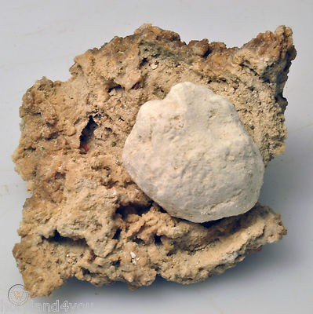
Sulfur balls still found there, and if lit, they burn bright… I have a jar with ash from Gomorrah and sulfur balls. When I pulled the ash out of a pillar, it smelled like sulfur. Friends were lighting the sulfur they found. The area is covered with it, like it was “rained down” - which it was.
More pictures of Gomorrah just south of Masada. It was on the Dead Sea, but due to mineral mining by Israel and Jordan, the area is now filled in – making a land bridge between the two countries.
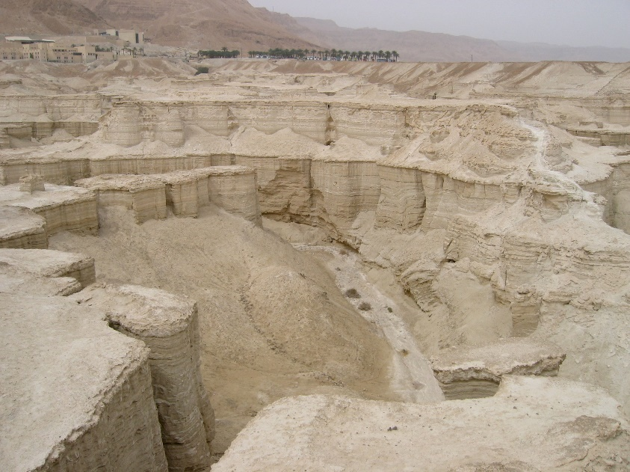
Masada in the distance
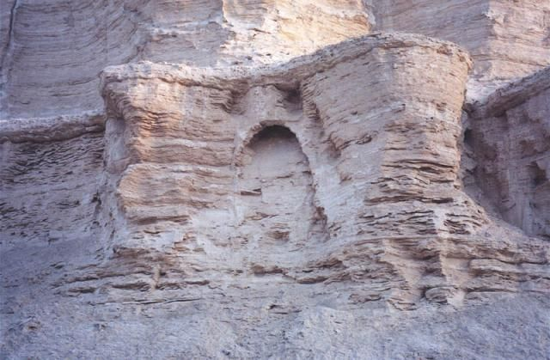

Note the archway is perfect – entrance to something that is now ash
Please refer to: “The Decision of the Supreme Court of Babylon in Reality Pictures of Gomorrah/Mikvah of Israel, Our Eternal Inheritance. I wrote this in 2015. It includes pictures I took of Gomorrah when there. It was my second visit, and the deeper I got back into the canyon, the more like a massive city it became.
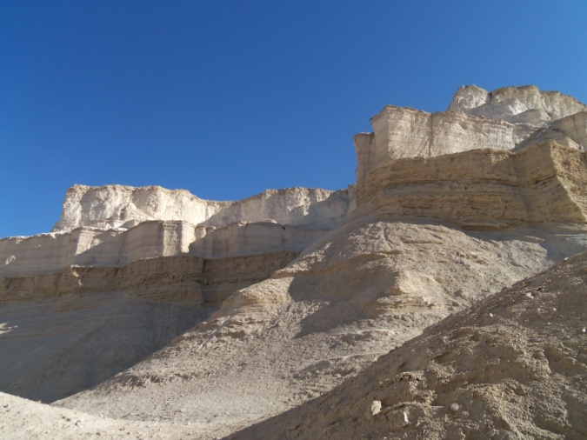
Photo taken by Yedidah

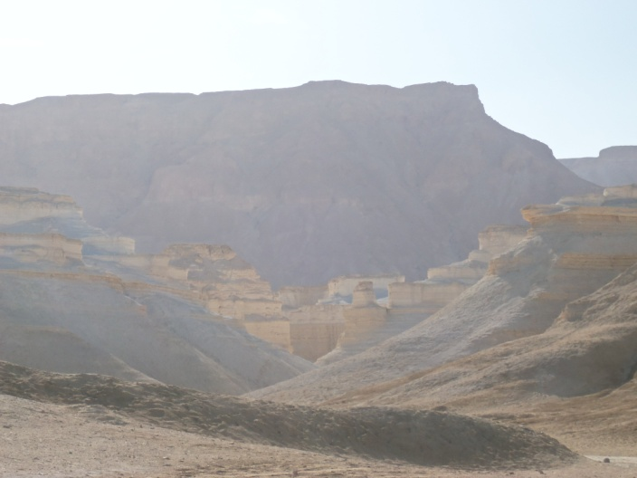
This layout looks just like a city “frozen” in ash – 2015 Yedidah

Moab: The mighty men of David fought with lion-like men of Moab
I Chronicles 11:22: “Benayah was the son of Yehoyaḏa, the son of a brave man from Qaḇtse’ĕl, who had done many deeds. He smote two lion-like Mo’aḇites. He also went down and smote a lion in the midst of a pit on a snowy day.”

Jeremiah 48:25, Berean Study Bible: 24 “…upon Kerioth, Bozrah, and all the towns of Moab, those far and near. 25The horn of Moab has been cut off, and his arm is broken,” declares the LORD. 26`Make him drunk, because he has magnified himself against the LORD; so Moab will wallow in his own vomit, and he will also become a laughingstock.…’

Ezra 9:1: “When these things had been done, the Jewish leaders came to me and said, “Many of the people of Israel, and even some of the priests and Levites, have not kept themselves separate from the other peoples living in the land. They have taken up the detestable practices of the Canaanites, Hittites, Perizzites, Jebusites, Ammonites, Moabites, Egyptians, and Amorites. 2For the men of Israel have married women from these people and have taken them as wives for their sons. So the holy race has become polluted by these mixed marriages. Worse yet, the leaders and officials have led the way in this outrage.” Berean Study Bible

Levites in Babylon married hybrid women and corrupt a great part of the tribe of Levi – the priestly tribe. In going back to Jerusalem at the end of the 70 years captivity, Ezra, who had gone back earlier, found out about this intermarriage with hybrid tribes. When Joshua entered the land, he was told to kill men, women, and children and cattle, and other mammals defiled by fallen angels and their Nephilim offspring with human women. Some of the Levites had brought these pagan women back to Jerusalem with them. They were told to send them away with the children.
Ezra 9 and 10. Please read the result of this abomination among the Levites in Babylon and how today that same “viper seed” continues on in modern Pharisees. Messiah, in Matthew 23 and John 8, calls them “seed of vipers,” and “of your father the devil.” Yochanan called them “seed of vipers.” They were hybrid. They were the ones who, under Rabbi Akiva, in 133 BCE, embraced Rabbinic Judaism, which is based, not on the Bible, but on the Babylonian Talmud, compiled by these renegade Levites who had married into Nephilim races.
Please refer to: “Ezra 9 and 10…” under the Mikvah of Israel, Our Eternal Inheritance to see how they became Pharisees and Sadducees via the Hasmonians.

Ruth – a Moabite woman – married Boaz – in the lineage of Messiah
Today modern Jordan – Edom, Moab, Ammon – the five cities of the plain
Steven ben Nun brought out an amazing idea, which might be correct. It appears that this story of Sodom and the angels is about the men of Sodom being a sex-crazed bunch of homosexuals rejecting Lot’s daughters and wanting the “men.” But obviously they knew they were not ordinary men, but angels of Yahuwah. Was their agenda lower than we think? They may have wanted them to mate with their daughters and produce hybrids/Nephilim. It’s possible that the daughters were hybrids, and that Lot’s wife was a hybrid. The whole city was given over to perversion. I ask these questions because from the lineage of Lot and one daughter came the Moabites – known to be hybrids, and the same for Lot and the other daughter – the Ammonites known to be hybrids.
The expression “sodomy” has to do with sex with different species … not homosexuality. It especially refers to sex between fallen angels and human women.
Just something to consider. The two angels were there to give Yahuwah the go-ahead, i.e. “yea, these men of Sodom deserve being wiped out.” The perversion of not just homosexuality and bestiality was going on there, but something bigger, for all the tribes of “ites” from Ham’s son Canaan and his descendants, were part human and part fallen angel.

Luke 17: “And as it came to be in the days of Noaḥ, so also shall it be in the days of the Son of Aḏam: 27`They were eating, they were drinking, they were marrying, they were given in marriage, until the day that Noaḥ went into the ark, and the flood came and destroyed them all. 28“And likewise, as it came to be in the days of Lot: They were eating, they were drinking, they were buying, they were selling, they were planting, they were building, 29but on the day Lot went out of Seḏom it rained fire and sulphur from heaven and destroyed all. 30It shall be the same in the day the Son of Aḏam is revealed. In that day he who shall be on the housetop, and his goods in the house, let him not come down to take them away. And likewise the one who is in the field, let him not turn back. Remember Lot’s wife.”
Please refer to: “And His Wife Looked Back”/Mikvah of Preparation 6.0

Yes, they were drinking blood and eating human flesh, just as what is going on in D.C. and Hollywood and in governments of other nations. The top elite are drinking the blood of babies and children and eating them. Hollywood is infamous for it. Some of the top leaders in D.C., well known Senators and House Representatives, heads of Offices, and entities in other places, are pedophiles and Satanists – and drinkers of the blood of babies and children, and eaters of human flesh. The reported finds of torture, dismemberment, sacrifice, and cannibalism under the White House … do your own research. However, the story has been hushed up.

Revelation 11:3-8: “And I shall give unto my two witnesses, and they shall prophesy…clad in sackcloth.” 4These are the two olive trees and the two lampstands that are standing before the Elohim of the earth. 5And if anyone wishes to harm them, fire comes out from their mouth and consumes their enemies. And if anyone wishes to harm them, he has to be killed in that way. 6These possess authority to shut the heaven, so that no rain falls in the days of their prophecy. And they possess authority over waters to turn them to blood, and to smite the earth with all plagues, as often as they wish. 7And when they have ended their witness, the beast coming up out of the pit of the deep shall fight against them, and overcome them, and kill them, 8and their dead bodies lie in the street of the great city which spiritually is called Seḏom and Mitsrayim, where also our Master was nailed to the stake…”
Jerusalem today is indeed Sodom and Egypt. Its Gay Pride parades are famous worldwide. It’s operating in satanic leadership is known by those seeking world control. It is not a “holy land.” Yahuwah will purge it in His judgment before He sends His Son to reign there as King of kings and Master of masters. Jerusalem then will be “a praise in the earth.”

Genesis 13:12-13: Berean Study Bible: “2Abram lived in the land of Canaan, but Lot settled in the cities of the plain and pitched his tent toward Sodom. 13But the men of Sodom were wicked, sinning greatly against the LORD.”
From the June 27, 2015 article: “The Decision of the Supreme Court in Reality Pictures of Gomorrah” See pictures that I took at Gomorrah in 2003 and 2015.
“This is what Yahuweh means when He says to America in Jeremiah 50:39-41 and Isaiah 13:19-22: “…the wild desert beasts shall dwell with the jackals, and the owls shall dwell there, and it shall be no more inhabited forever, neither shall it be dwelt in from generation to generation. `As Elohim overthrew Sodom and Gomorrah and neighboring cities,’ says Yahuweh, `so man shall abide there, neither shall any son of man dwell therein…’ ” “And Babylon, the glory of kingdoms, the beauty of Cauldean excellency, shall be as when Elohim overthrew Sodom and Gomorrah…it shall never be inhabited…but wild beasts of the desert shall lie there…” Look carefully at these pictures exemplifying America’s near future…

Jeremiah 50:38-42: “A sword is upon her waters, and they shall be dried up. For it is a land of carved images, and they boast about their idols.
39“Therefore the wild desert beasts shall dwell with the jackals, and the ostriches dwell in it. And it shall never again be inhabited, nor dwelt in, unto all generations. 40“As Elohim overthrew Seḏom and Amorah and their neighboring cities,” declares יהוה, “so no one would dwell there, nor would son of man sojourn in it. 41“See, a people shall come from the north, and a great nation and many sovereigns stirred up from the ends of the earth. 42 They lay hold of bow and spear; they are cruel and they show no compassion. They sound like the roaring sea, and ride on horses, set in array, like a man for the battle, against you, O daughter of Baḇel.”

Righteous Lot – II Peter 2:6-8: “But God also rescued Lot out of Sodom because he was a righteous man who was sick of the shameful immorality of the wicked people around him. If He condemned the cities of Sodom and Gomorrah to destruction, reducing them to ashes as an example of what is coming on the ungodly; 7and if He rescued Lot, a righteous an distressed by the depraved
conduct of the lawless 8 (for that righteous man, living among them day after day, was tormented in his righteous soul by the lawless deeds he saw and heard)—…”
The cities destroyed were at the base of what is now the Dead Sea. It was once called “the garden of God” for its beauty. But, under it was lots of salt, and bitumen – like asphalt for road laying. When Yahuwah bombed the 5 cities, it loosed the bitumen to fly high in the air and the salt too – so Lot’s wife was kind of like tarred and feathered … the salt stuck to her because of the sticky bitumen.
The message is clear: “Remember Lot’s Wife” don’t look back. When the destruction comes, flee. Wisdom says to flee before it comes. My message has not changed since I did all my warnings and intercession across America – but hardly anyone responded to put it into action. Many seculars, billionaries, millionaires, have fled America and built bunkers in places like Patagonia and New Zealand. Many are even now underground in places in Colorado. The wise act on warnings; fools go on and are destroyed. Didn’t Solomon say something like that? Hum ..
Yes he did: Proverbs 22:3 and 27:12: “A clever one foresees evil and hides himself. But the simple go on and are punished.” Proverbs 28:1 says: “The wicked shall flee though no one pursues, but the righteous are as bold as a lion.”
SHALOM, BLESSINGS, IN HIS LOVE, YEDIDAH SEPTEMBER 2, 2021

