TRANSCRIPT OF PODCAST CCCXXVI: THE BOOK OF GENESIS CHAPTERS 32 AND 33

GENESIS 32: 1And Ya‛aqoḇ went on his way, and the messengers of Elohim met him. 2And when Ya‛aqoḇ saw them, he said, `This is the camp of Elohim.’ And he called the name of that place Maḥanayim. 3And Ya‛aqoḇ sent messengers before him to Ěsaw his brother in the land of Sĕ‛ir, the field of Eḏom 4and he commanded them, saying, `Say this to my master Ěsaw, Your servant Ya‛aqoḇ said this, “I have sojourned with Laḇan and stayed there until now. 5 And I have bulls, and donkeys, flocks, and male and female servants. And I have sent to inform my master, to find favour in your eyes.’” 6So the messengers returned to Ya‛aqoḇ, saying, `We came to your brother Ěsaw, and he also is coming to meet you, and four hundred men with him.’ 7And Ya‛aqoḇ was greatly afraid and distressed. So he divided the people that were with him, and the flocks and herds and camels, into two groups, 8and he said, `If Ěsaw comes to the one group and attacks it, then the other group which is left shall escape.’ 9And Ya‛aqoḇ said, `O Elohim of my father Aḇraham and Elohim of my father Yitsḥaq, יהוה who said to me, “Return to your land and to your relatives, and I do good to you, 10“I do not deserve the least of all the kind acts and all the truth which You have shown Your servant, for I passed over this Yardĕn with my staff, and now I have become two groups. 11Deliver me, I pray, from the hand of my brother, from the hand of Ěsaw, for I fear him, lest he come and shall smite me and the mother with the children. 12 For You said, ‘I shall certainly do good to you, and shall make your seed as the sand of the sea, which are too numerous to count.”’
13And he spent the night there, and took what came to his hand as a present for Ěsaw his brother – 14two hundred female goats and twenty male goats, two hundred ewes and twenty rams, 15thirty milk camels with their colts, forty cows and ten bulls, twenty female donkeys and ten foals. 16And he gave into the hand of his servants, every drove by itself, and said to his servants, `Pass over before me, and put some distance between drove and drove.’17And he commanded the first one, saying, `When Ěsaw my brother meets you and asks you, saying, “To whom do you belong, and where are you going? And whose are these in front of you?”18then you shall say, ‘They are your servant Ya‛aqoḇ’s. It is a present sent to my master Ěsaw. And see, he also is behind us.’ ” 19So he commanded the second, and the third, and all who followed the droves, saying, `Speak to Ěsaw this same word when you find him, 20and you shall say, “Also look, your servant Ya‛aqoḇ is behind us.” For he said, `Let me appease him with the present that goes before me, and after that see his face. He might accept me.’ 21And the present passed over before him, but he himself spent the night in the camp. 22And he rose up that night and took his two wives, and his two female servants, and his eleven sons, and passed over the ford of Yabboq. 23And he took them and sent them over the stream, and sent over what he had.24And Ya‛aqoḇ was left alone. And a Man wrestled with him until the breaking of day. 25And when He saw that He did not overcome him, He touched the socket of his hip. And the socket of Ya‛aqoḇ’s hip was dislocated as He wrestled with him. 26And He said, `Let Me go, for the day breaks.’ But he said, `I am not letting You go until You have blessed me!’ 27So He asked him, `What is your name?’ And he said, `Ya‛aqoḇ.’ 28And He said, `Your name is no longer called Ya‛aqoḇ, but Yisra’ĕl, because you have striven with Elohim and with men, and have overcome.’ 29And Ya‛aqoḇ asked Him, saying, `Please let me know Your Name.’ And He said, `Why do you ask about My Name?’ And He blessed him there. 30And Ya‛aqoḇ called the name of the place Peni’ĕl, `For I have seen Elohim face to face, and my life is preserved.’ 31And the sun rose on him as he passed over Penu’ĕl, and he limped on his hip. 32That is why the children of Yisra’ĕl to this day do not eat the sinew of the hip, which is on the socket of the thigh, because He touched the socket of the thigh of Ya‛aqoḇ, in the sinew of the hip.”

GENESIS 33: And Ya‛aqoḇ lifted his eyes and looked and saw Ěsaw coming, and with him four hundred men. And he divided the children among Lĕ’ah, and Raḥĕl, and the two female servants. 2And he put the female servants and their children in front, and Lĕ’ah and her children behind, and Raḥĕl and Yosĕph last. 3And he himself passed over before them and bowed himself to the ground seven times, until he came near to his brother.
4And Ěsaw ran to meet him, and embraced him, and fell on his neck and kissed him, and they wept. 5And he lifted his eyes and saw the women and children, and said, `Who are these with you?’ And he said, `The children with whom Elohim has favoured your servant.’ 6Then the female servants came near, they and their children, and bowed themselves. 7And Lĕ’ah also came near with her children, and they bowed themselves. And Yosĕph and Raḥĕl came near, and they bowed themselves. 8Then Ěsaw said, `What do you mean by all this company which I met?’ And he said, `To find favour in the eyes of my master.’ 9But Ěsaw said, `I have enough, my brother, let what you have remain yours.’ 10And Ya‛aqoḇ said, `No, please, if I have now found favour in your eyes, then receive my present from my hand, because I have seen your face like seeing the face of Elohim, and you were pleased with me. 11Please, take my blessing that is brought to you, because Elohim has favoured me, and because I have all I need.’ And he urged him, and he took it. 12And he said, `Let us depart and go, and let me go before you.’ 13But he said to him, `My master knows that the children are weak, and the flocks and herds which are nursing are with me. And if the men should drive them hard one day, all the flocks shall die. 14 Please let my master go before his servant, and let me lead on slowly according to the pace of the livestock that go before me, and according to the pace of the children, until I come to my master in Sĕ‛ir.’ 15And Ěsaw said, `Please let me leave with you some of the people who are with me.’ But he said, `Why this? Let me find favour in the eyes of my master.’ 16And Ěsaw returned that day on his way to Sĕ‛ir. 17And Ya‛aqoḇ set out to Sukkoth, and built himself a house, and made booths for his livestock. That is why the name of the place is called Sukkoth. 18And Ya‛aqoḇ came safely to the city of Sheḵem, which is in the land of Kena‛an, [today it is Nablus, an Arab town, situated between Mount Gerizim and Mount when he came from Paddan Aram. And he pitched his tent before the city. 19And he bought the portion of the field where he had pitched his tent, from the children of Ḥamor, Sheḵem’s father, for one hundred qesitah. 20And he set up an altar there and called it Ěl Elohĕ Yisra’ĕl.”
Deuteronomy 2:11-13, Berean Study Bible: “11Like the Anakites, they were also regarded as Rephaim, though the Moabites called them Emites. 12The Horites used to live in Seir, but the descendants of Esau drove them out. They destroyed the Horites from before them and settled in their place, just as Israel did in the land that the LORD gave them as their possession.) 13 Now arise and cross over the Brook of Zered. So, we crossed over the Brook of Zered.…”
Deuteronomy 2-3 speaks of Etzion Geber – the backbone of the Mighty one – today’s Aqaba, Jordan on the Red Sea. These chapters speak of the tribes of Nephilim. As Moses and the children of Ya’cob/Israel moved north into Bashan, what is now the Golan, they encountered huge giants like Og and Sihon, whom Moses and Joshua killed. Today, “Gilgal Rephaim” is a major archeological site in Israel – the Circle of the Giants – Og is thought to be buried in the middle of that circle. To this day as Barry Chamish reported in his book on Giants in Israel, and the return of these spirits/entities in our day, seen by people along the north Mediterranean Sea, and on the Golan. L.A. Marzulli has lots of information on Gilgal Rephaim. That site is connected to sites in America long lei lines, as is Ba’albek in Lebanon. Today, Israeli archeologists believe Gilgal Rephaim was where Og lived and is buried. They speak of the Nephilim, which is Hebrew for “fallen ones.”
The giants, most of the Canaanite tribes of northern Israel, were terrified of Moses, Joshua, and about 6 million “campers” invading their space. So, many of the Canaanite tribes migrated to the West and built their huge megalithic structures, especially in areas like Sardinia, an Island off of Italy. Steve Quayle has a magnificent DVD documentary of this area.
Esau violently ran out the Horites, or cliff dwellers. It’s like the Pueblo Indian rock-cared houses of America. In fact, this area, in Greek, “Petra,” in Hebrew “Sela,” is today a Bedouin area. Part of it is a tourist area of rock caves, which will be the hiding place for some of Yah’s people in the times of great tribulation. There are caves carved throughout that region – some could hold hundreds of people. The United Nations is keeping close watch on it. I have been in that area so many times, and taken so many people there with me, that the Bedouin called me “Miss Aqaba.”
Every June for many years, the elite of earth - the multi-billionaries, trillionaries, Pulitzer Prize winners, etc. – have met in Petra with the King of Jordan. When the Condor airplanes were popular, I saw a travel booklet at my Travel Agency offering special trips in the Condor to Amman, for tours of Petra. Each flight was small. The cost for each person was way up in the tens of thousands of dollars – at that time, about $45,000 each, I think. The ultra elite know where to flee to. They know where to go. Did you ever wonder how they end up in Petra (Revelation 6:12-17)?
Revelation 6:12-17: “And I looked when He opened the sixth seal and saw a great earthquake came to be. And the sun became black as sackcloth of hair, and the moon became as blood. 13And the stars of the heaven fell to the earth, as a fig tree drops its unripe figs, being shaken by a strong wind. 14And heaven departed like a scroll being rolled up, and every mountain and island was moved out of its place. 15And the kings of the earth, and the great ones, and the rich ones, and the commanders, and the mighty, and every slave and every free one, hid themselves in the caves and in the rocks of the mountains, 16and said to the mountains and rocks, `Fall on us and hide us from the face of Him sitting on the throne and from the wrath of the Lamb, 17because the great day of His wrath has come, and who is able to stand?’”
Revelation 12:12-17: “Because of this rejoice, O heavens, and you who dwell in them! Woe to the earth and the sea, because the devil has come down to you, having great wrath, knowing that he has little time. 13And when the dragon saw that he had been thrown to the earth, he persecuted the woman who gave birth to the male child. 14And the woman was given two wings of a great eagle, to fly into the wilderness to her place, where she is nourished for a time and times and half a time, from the presence of the serpent. 15And out of his mouth the serpent spewed water like a river after the woman, to cause her to be swept away by the river. 16And the earth helped the woman, and the earth opened its mouth and swallowed up the river which the dragon had spewed out of his mouth. 17And the dragon was enraged with the woman, and he went to fight with the remnant of her seed, those guarding the commands of Elohim and possessing the witness of יהושע Messiah.’”
Petra is a place of plenty – wild game, and edible plants, plenty of water, and rock-shelters shut off from the world. Covering some high caves near the back of the tourist area, are windows – those are “offices” for the U.N. who controls the area incognito.
My first teaching experience in Israel was in a home meeting of believers in Tiberias. The pastor’s wife of the mostly Russian Jewish assembly was there, one of my very dearest friends, too, and her daughter. After the meeting her daughter shared a dream she had of being in rock enclosure during the tribulation. She said a Fedex truck pulled up with food (symbolic of course of provision) with food. Underground water is in abundance in that area. A “palace” was discovered in that area that Mark Anthony built for Cleopatra, so archeologists say. Underneath it were found large statues of gold idols to various gods.
About 7 of the group, including the pastor’s wife also had dreams of being in Petra. They had never been there, nor had they discussed their dreams of it, yet their descriptions of it were identical. My friend’s daughter asked me: “How can that one area escape the rampage of the Beast? I turned to her to say “I don’t know.” Then I remembered Iyob/Job. And I said to her, “Job.” The enemy could not do anything to him without Yahuwah’s permission. And, by the way, where was Iyob? He was at Al Baida – Little Petra. He lived right there in the very area of Esau’s Sela, his capital – once capital of the Horites (rock dwellers).
They took up an offering for me that night. My friend handed it to me saying, “we’ve never had such a big offering to give to anyone.”
Oh my, silly Christians, silly people with their ideas about the “wings of the great eagle” in Revelation 12 being America, flying people to Petra for their safety. By that time, America, end-time Babel, nation chosen to restore Nimrod himself to power over the world, will be utterly destroyed. [Isaiah 13, Jeremiah 25:11-12, 50-51, Revelation 18 (NYC).]

Revelation 12:12-17: “`Because of this rejoice, O heavens, and you who dwell in them! Woe to the earth and the sea, because the devil has come down to you, having great wrath, knowing that he has little time.’ 13And when the dragon saw that he had been thrown to the earth, he persecuted the woman who gave birth to the male child. 14And the woman was given two wings of a great eagle, to fly into the wilderness to her place, where she is nourished for a time and times and half a time, from the presence of the serpent. 15And out of his mouth the serpent spewed water like a river after the woman, to cause her to be swept away by the river. 16And the earth helped the woman, and the earth opened its mouth and swallowed up the river which the dragon had spewed out of his mouth. 17And the dragon was enraged with the woman, and he went to fight with the remnant of her seed, those guarding the commands of Elohim and possessing the witness of יהושע Messiah.”

Dead Sea Topography NASA
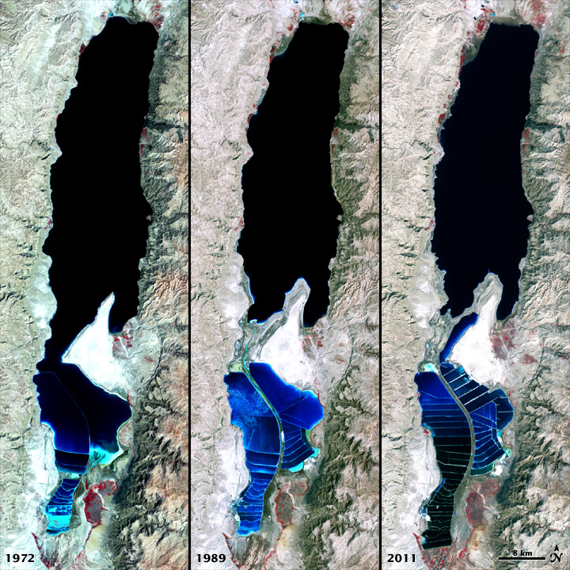
“The Dead Sea is so named because its high salinity content discourages the growth of fish and plants. It is not drinkable water. This salt sea resides in a depression in the Earth's crust, where the continents of Africa and Asia are pulling away from each other. It has pulled in visitors and industries for thousands of years. The Dead Sea is the lowest surface feature on Earth, sitting roughly 1,300 feet (400 meters) below sea level. On a hot, dry summer day, the water level can drop as much as one inch (two to three centimeters) because of evaporation.
The false-color images above were captured by the Landsat 1, 4, and 7 satellites. The Multispectral Scanner System on Landsat 1 acquired the top image on September 15, 1972. The middle image was acquired on August 27, 1989, by the Thematic Mapper on Landsat 4. The third image is from the Enhanced Thematic Mapper Plus on Landsat 7 on October 11, 2011.
All three images include a combination of near-infrared, red, and green wavelengths. Deep waters are blue or dark blue, while brighter blues indicate shallow waters or salt ponds (in the south). The pale pink and sand-colored regions are barren desert landscapes, while green indicates sparsely vegetated lands. Denser vegetation appears bright red. Near the center is the Lisan Peninsula, which forms a land bridge through the Dead Sea.
The ancient Egyptians used salts from the Dead Sea for mummification, fertilizers, and potash (a potassium-based salt). In the modern age, sodium chloride and potassium salts culled from the sea are used for water conditioning, road de-icing, and the manufacturing of polyvinyl chloride (PVC) plastics. The expansion of massive salt evaporation projects are clearly visible over the span of 39 years.
The region is also famous for its historical and religious significance. Between 1947 and 1956, a series of 972 ancient papyrus-and-ink texts were discovered in caverns near the sea’s north-eastern shore. These “Dead Sea Scrolls” are some of the oldest preserved fragments of the Hebrew Bible and other Judeo-Christian texts.
NASA and the U.S. Geological Survey (USGS) jointly manage Landsat, and the USGS preserves a 40-year archive of Landsat images that is freely available data over the Internet. The next Landsat satellite—now known as the Landsat Data Continuity Mission (LDCM)—is scheduled for launch in January 2013.
NASA image by Robert Simmon, using Landsat data from the United States Geological Survey. Caption by Aries Keck and Mike Carlowicz.”

The beak is called the “Lisan Peninsula.” The wings, appearing in a dark green, spread out over the mountains of Jordan, as the hills and valleys form the wings. Revelation 12 is talking of the “eagle” in the topography of the Dead Sea, whose “wings” in the topography of the mountains of Jordan, runs a road into the King’s Highway that leads directly into the Petra area.
I talked with an Orthodox Jew, and a little later a friend talked with a Karaite Jew on her tour of Israel and told me what he said. They both said that they know where the crossing place is from Israel into Jordan that comes out between the “wings of the great eagle,” onto a major highway that leads to Petra. They know that is the place to flee.
Israel and Jordan have worked for years extracting the mineral resources from the Dead Sea, so that the water above the head of the “eagle” form, is now dried up, so that the head touches the Israeli side. The talons of the eagle are clearly seen. The beak being the Lisan Peninsula in the Dead Sea. That is the area that was blown up during the Genesis 19 raining of fire and sulfur down on the 5 cities of the plain when Yahuwah destroyed Sodom and Gomorrah.
The bitumen, aka asphalt, underneath the sea was blown up into the air with salt that covered the top of it. It was than which rained down on Lot’s wife and covered her, making her a “pillar of salt.” The hot bitumen made the salt stick to her, cremating her quickly.
I travelled past that area on both the Israeli side and the Jordan side many times. I finally took pictures of the Lisan Peninsula from the bus. So, yes, those from Israel will flee across the “wings of the great eagle” in the topography of what became the “Dead Sea” into the Rose-Red Rock City of the Horites and then Esau.
Wikipedia: “Lisan Peninsula after mineral mining dried up the area between the head and the Israeli side of the Dead Sea.”
Here is a picture of the wing spread inside Jordan, which is more clear.
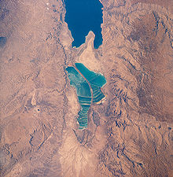
Lisan Peninsula: Wikipedia: “The Lisan Peninsula is a large spit of land that now separates the North and the South basins of the Dead Sea. Its name is Arabic for "tongue". The peninsula, located entirely within Jordanian territory, separates the northern section of the Dead Sea from its shallow southern part.”
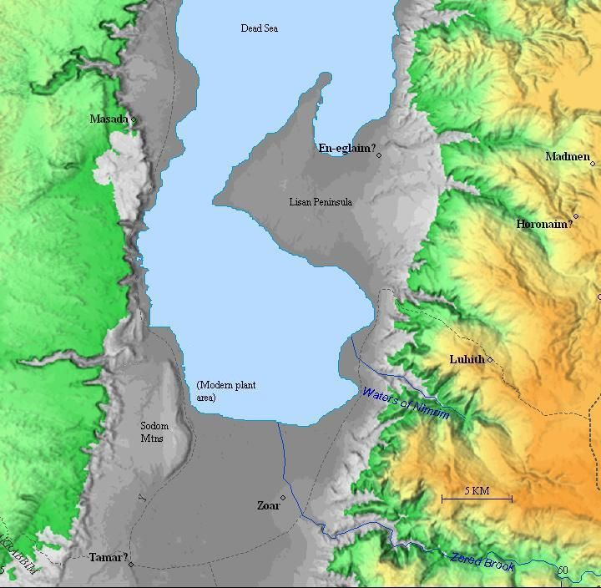
Sodom, Zoar, Zared Brook, Masada from a satellite picture
Later we know that the descendants of Esau went into what is now Rome, and some say founded it. We know they did control it. It has been the headquarters of the Edomites to this day.
Why was Esau nice to Ya’cob when he met him with 400 men? Perhaps Esau thought Ya’cob had come to fight with him.
Earlier on, Esau was impressed that when Isaac told Ya’cob not to take a wife from the Horites, or any Canaanite tribe, and that Ya’cob obeyed him and went clear up into Mesopotamia, Armenia, to take a wife from the brother of Abraham. He saw how Isaac was pleased with Ya’cob. Esau had taken two wives of the Hittites, and then moved nearly next door to Isaac/Yitzak and Rivkah/Rebecca, and tormented them with the presence of the Nephilim wives – hybrid wives. The grandkids from those unions were part Nephilim. So, Isaac made sure that Ya’cob only fathered from full-blooded human wives and concubines as Abraham had done.
Later Esau took wives of the children of Ishmael because of what Yitsak told Ya’cob. Sons of Ishmael to this day are a race of human beings.
I’ve been in the capital of Esau’s original “empire,” Sela, which is called Al Baida, or “Little Petra.” It is home for Bedouins. It is also the area once called Utz – land of Iyob/Job – northwest Arabia. (Job 1)
Ishmael had 12 sons who moved out and inhabited areas all over what today is Saudi Arabia. However, one area became part of Jordan – the area the bucked up to Utz. Thus, 2 of Job’s “friends” were from that area – Ishmaelites. Today the Bedouin are descendants from Kadar and Naba’ot, the two oldest sons of Ishmael. The other friend who appeared to be more intelligent was Eliphaz. If you do your research, you’ll see that Eliphaz was the son of Esau. He lived in what is now known as Teman, a town near today’s main entrance to Petra today.
The actual area of Esau’s capital has stone condominiums caved into it, with carved stone beds and nitches for idols. (Pictures below) Each set of condominiums has a water storage tank. The water underground is very deep there. It also rains and fills up the water storage “tanks.” I have a picture of myself standing by an Oleander bush that is about 20’ feet high.
Esau, or Edom meaning “red,” produced many hybrid children by hybrid wives as well as fully human children by Ishmael’s daughters. Here is what it says about Esau in retrospect:
Malachi 1:2-5, Berean Study Bible, written to the sons of Ya’cob: 2“`I have loved you,’ says the LORD. But you ask, `How have You loved us?’ `Was not Esau Jacob’s brother?’ declares the LORD. `Yet Jacob I have loved, 3but Esau I have hated, and I have made his mountains a wasteland and left his inheritance to the desert jackals.’ 4Though Edom may say, `We have been devastated, but we will rebuild the ruins,’ this is what the LORD of Hosts says: `They may build, but I will demolish. They will be called the Land of Wickedness, and a people with whom the LORD is indignant forever.…’”
Hebrews 12:16-17, Berean Bible: “See to it that no one is sexually immoral, or is godless like Esau, who for a single meal sold his birth right. 17For you know that afterward, when he wanted to inherit the
blessing, he was rejected. He could find no ground for repentance,
though he sought the blessing with tears.”
Later when Moses took the children of Israel/Ya’cob up The King’s Highway past Mount Paran, to near today’s entrance to Petra, Moses asked to enter their area for a time of rest. (King’s Highway: Numbers 20:17; 21:22)
Here is how the descendants of Esau treated the Hebrews hundreds of years later: Numbers 20:17-19, Berean Study Bible: 17 “`Please let us pass through your land. We will not cut through any field or vineyard, or drink water from any well. We will stay on the King’s Highway; we will not turn to the right or to the left until we have passed through your territory.’ 18But Edom answered, `You may not travel through our land, or we will come out and confront you with the sword.’ 19 `We will stay on the main road,’ the Israelites replied, `and if we or our herds drink your water, we will pay for it. There will be no problem; only let us pass through on foot.’…

Sela – Siq Al Barid or Little Petra
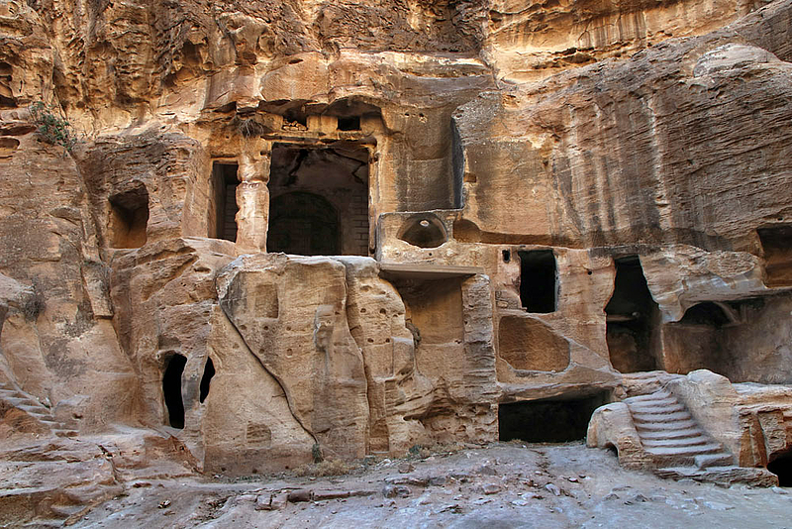
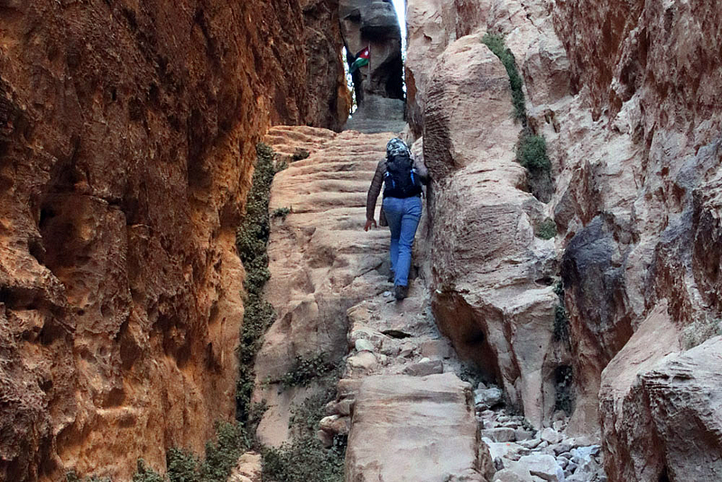
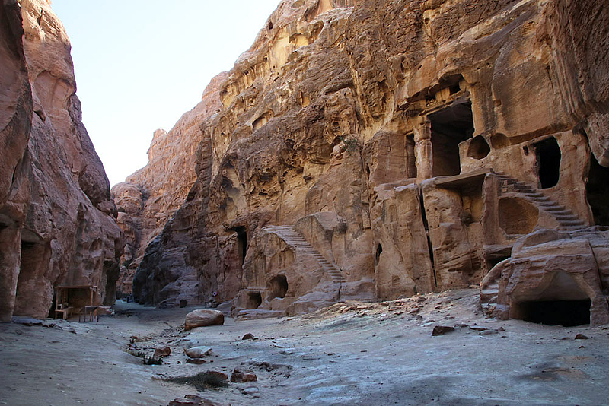
Isaiah 26:20-27:1: “Go, My people, into your chambers/rooms and shut your doors behind you – hide yourself, as it were, for a little time, until the displeasure is past. For look, Yahuwah is coming out of His place to punish the inhabitants of the earth for their sin. And the earth shall disclose her blood and no longer cover her slain. In that day, Yahuwah with His severe sword, great and strong, punishes Leviathan the fleeing serpent. Leviathan that twisted serpent. And He shall slay the monster that is in the sea.”
Revelation 13:1: “And I stood on the sand of the sea and I saw a beast coming up out of the sea having seven heads and ten horns and on his horns ten crowns and on his heads names of blasphemy.”
Revelation 20:19-20: “And I saw the beast and the kings of the earth and their armies, gathered to fight against Him who sat on the horse and His army. And the beast was seized and with him the false prophet … The two were thrown alive into the lake of fire burning with sulfur.”
Jeremiah 49:8: “Turn and run! Lie low, O dwellers of Dedan (Sheba and Dedan tribes of Ishmael in Arabia) for I will bring disaster on Esau at the time I punish him.”
Jeremiah 49:10: “But I will strip Esau bare; I will uncover his hiding places, and he will be unable to conceal himself. His descendants will be destroyed along with his relatives and neighbors, and he will be no more.”
Jeremiah 49:16: “`The terror you cause and the pride of your heart have deceived you, O dwellers in the clefts of the rocks, O occupiers of the mountain summit. Though you elevate your nest like the eagle, even from there I will bring you down,’ declares the LORD.
Jeremiah 49:20: “Therefore hear the plans that the LORD has drawn up against Edom and the strategies He has devised against the people of Teman: Surely the little ones of the flock will be dragged away; certainly their pasture will be made desolate because of them”
Ezekiel 25:13,14: “Therefore thus saith the Lord GOD; `I will also stretch out mine hand upon Edom, and will cut off man and beast from it; and I will make it desolate from Teman; and they of Dedan shall fall by the sword…’”
II Kings 14:7: Amplified Bible “Amaziah killed 10,000 [men] of Edom in the Valley of Salt, and took Sela (rock) by war, and renamed it Joktheel, to this day.”
Amaziah's Victories, Berean Bible, II Chronicles 25:10-12” …10So Amaziah dismissed the troops who had come to him from Ephraim and sent them home. And they were furious with Judah and returned home in great anger. 11Amaziah, however, summoned his strength and led his troops to the Valley of Salt, where he struck down 10,000 men of Seir, 12and the army of Judah also captured 10,000 men alive. They took them to the top of a cliff and threw them down so that all were dashed to pieces.…
It was most likely in this region that King David came upon King Saul, his enemy, who was seeking his life. David found him sleeping in a cave of this area, near the “Valley of Salt,” the Dead Sea, and clipped a piece of cloth off of his robe, to let him know that he could have killed him, but did not. This is most likely the area David hid out.

Notes from the Passion Version on word meanings:
From Genesis 32:24: “The Hebrew word for `wrestle’ is related to a word for `dust’ or `to get dusty.’ There is an amazing play on words in the Hebrew between the words `he wrestled’ `Jabbok’ or `yabboq’ and `Jacob’ or `Yaaqob.’”
Genesis 32:25: “Jacob grabbed a heel; God grabbed his hip.” “Through these private encounters with the Lord, we become those whose names have changed … we have changed into humbled, transformed ones who are subdued by the power of God.
From Genesis 32:27: “This was a strange question because knew his name. God touched not only not only his hip but also his slumbering conscious. When asked this question, Jacob’s imagination took him back over twenty years to the dark tent where his blind, aged father had faced him with the same question and he had answered `It is I – Esau… Now the Lord has come to Jacob insisting he acknowledge that he was the one who had taken advantage of his father, and his brother. `Jacob’ means `heel grabber,’ or `supplanter.’ The Lord was insisting that his blessing would only begin when Jacob realized the true need of his heart. By speaking out his name, Jacob confessed his true name. `I am a deceiver, a cheat, my name is hell grabber.; The confession liberated Jacob and opened the way for inner transformation.”
“Israel means `one who struggled with God and prevailed,’ `may God (El) preserve’ or `prince with God.’
From Genesis 32: 30: “Penial means `the face of God.’” “Once you have seen the face of God, the faces of those who oppose you can no longer intimidate you. Jacob was able to look into Esau’s eyes.
Genesis 33:3: “The irony here is that Isaac’s prophecy said that Esau would be ruled by Jacob – Genesis 27:29. Here is Jacob bowing down before his estranged brother.” [Yedidah: His bowing may have been out of fear, but also out of guilt perhaps, too. Fear does strange things to a person – almost instantly erasing all the faith, hopes, and dreams of Abba’s goodness and of His promises to us. Therefore, fear is the great enemy, not the circumstances.
Genesis 33:4: “Imagine the emotional release Jacob/Israel must have felt as he stood there hugging Esau. Jacob had deceitfully kissed his father, pretending to be Esau (Genesis 27:26). Now the two brothers shared the kiss of restoration. Their tears released and washed away the emotional pain of their past!”
Making peace, even with enemies, or potential enemies, set us free to go on with Yahuwah. We have the severe warning in Mark 11:25-26 – that if we do not forgive, and let-go of the emotions held against someone, we can’t be forgiven by Yahuwah.
Genesis 32:24-30: Yedidah: Restoration! Peace, release! How sweet is forgiveness! We must attempt to make peace, even if it is not received.
Genesis 33:10: “Jacob again saw that same glorious face of God.”
Genesis 33:11: “Jacob was offering to share the blessing he took away from Esau many years earlier.”
Shalom, Yedidah – November 17, 2021

