TRUMP DECLARES: FIRST THE MOON, THEN it’s MARS

PREPARING FOR COLONIZING

OPENING the DOOR FOR OFFICIAL DISCLOSURE

Spiral Nebulae Galaxy Night sky, falling stars, our Milky Way galaxy

Planets and stars Nebulae and planets

Isn’t our universe gorgeous! Our Creators have a flare for creating varying designs with intricate details and vibrant colors. Yahuwah, our Abba, and Yahushua, our Savior, are supreme Architectural Engineers--supreme Artists. There are none better!

*****For a foundational article, I recommend you re-read, or at least scan, “The Great Deception – Mankind Has Been Prepared to Believe It,” under the Mikvah of Set-Apartness and Separation (2016). Media Propaganda has already released this deception!

Trump with a toy astronaut Trump signs Space Policy Directive 1
Hatmaker Article photo Photo: From Space.com

Trump wants to send astronauts to the Moon on the way to Mars
Taylor Hatmaker (@tayhatmaker) December 12, 2017

“The Trump administration had previously signaled its intentions to send astronauts back to the Moon, but now that renewed space exploration objective is official.
On Monday, [Dec. 11] the president signed Space Policy Directive 1, a document detailing a shift in U.S. policy that would reprioritize a mission to put American boots on the Moon for the first time in 45 years. While Mars is widely considered to be the primary goal of much current space exploration, a Moon mission would `establish a foundation for an eventual mission to Mars,’ President Trump asserted during the signing.
`The directive I am signing today will refocus America’s space program on human exploration and discovery. It marks a first step in returning American astronauts to the Moon for the first time since 1972, for long-term exploration and use.”
This isn’t the first we’ve heard of the Trump administration’s Moon ambitions. In July, Vice President Pence declared `we will put American boots on the face of Mars’ during a speech to NASA. Pence chairs the National Space Council--a recently reconvened space policy advisory group that Trump reestablished with an executive order in June.
A White House budget proposal from earlier this year announced that the Trump administration would `[focus] the Nation’s efforts on deep space exploration rather than Earth-centric research.’ The administration’s vision would lean heavily on public-private partnerships and the new directive reiterates U.S. reliance on `commercial and international partners’ to achieve its ambitious space policy objectives--a theme we’ve seen increasingly with NASA in the years following the agency’s decision to retire its fleet of space shuttles.
In late September, NASA announced that it would work cooperatively with Russia’s space agency Roscosmos on a space station that would orbit the Moon. Trump’s Moon plan is ambitious, but it isn’t unique.
In 2004, President Bush announced his intention `to gain a new foothold on the Moon and to prepare for new journeys to the worlds beyond our own’ with a similar shift in space policy, but the plan, set to launch in 2020, was later derailed by budget realities.”
As L.A. Marzulli says, “UFOs are burgeoning and not going away!” L.A.’s two volumes of, On the Trail of the Nephilim, and especially his 10-DVD set of the “Watcher’s Series” are excellent materials on the subject of the return of the Nephilim. He is also a good Word-solid brother who has spent years in research and traveling to expose the Truth on these subjects.
Here is an expanded version of what I have written before, but it all fits together nicely here. In 2004, my daughter and I were having lunch at Jason’s Deli off Hulen Street in Fort Worth. Texas. Their TV was blaring. There were not many people in the restaurant, so we clearly heard President George W. Bush’s noon-time special speech. We were both stunned to hear his approximately 15-minute speech on how we must colonize the Moon and Mars. He encouraged young people to prepare for it. Few heard the speech because it was broadcasted at 12:00 noon.
Later, I tried to find the speech online, but found no reference to it. I had been driving a borrowed truck, and later traveled by bus several times from Fort Worth to New Braunfels, Texas, to speak at meetings, and be with new friends in a messianic home group. The leader of the group and I had become good friends. But, following an intercession assignment in Israel and Jordan in 2005 with two other ladies, I returned back to Aqaba, Jordan, where I lived for eight years, and got an e-mail from her saying I was never to come to her house again. I had innocently told her about Bush’s speech. She used that to slander me. She told her congregation that I was crazy, saying we needed to go to Mars. They believed her. I was stunned, shocked, and hurt. I loved those people. She forbade me from ever contacting her congregation members again. I tried to contact one, but she said I was crazy so she didn’t want any more to do with me. Years later, Abba arranged an awesome reconciliation between this lady and I—Praise Yahuwah! Derek and I later met her and her husband in Israel. HalleluYah!
The congregation leader had become a dear friend. She had considered me her “mentor.” Yet, because, during that intercession trip I had become friends with her chief mentor in Israel, she became jealous. This was the main reason why she did what she did. And, I had no defense because the speech was nowhere to be found on the web. Years later, while reading Steve Quayle’s book Weather Warfare, he mentioned that speech, and gave the year as 2004. Now the speech is mentioned in the article above. Today I went online to find the speech. NASA has released it for publication. Now I have a PDF copy of it! [Google: NASA Site President Bush Delivers Remarks in U.S. Space Policy January 14, 2004]

Today we read that President Trump has signed a bill to go ahead with these plans to send astronauts back to the Moon in preparation for colonizing, and then to Mars. NASA recently said they want to put a man on Mars by 2020.

Remember that government NASA façade for the public—first headed by Nazi military rocket scientist genius Werner von Braun.[Online info: NASA stands for National Aeronautics and Space Administration. NASA was started in 1958 as a part of the United States government. NASA is in charge of U.S. science and technology that has to do with airplanes or space.].To learn balanced truth about NASA, its fallacies and its realities, I refer you to an excellent book by Mike Bara and Richard Hoagland: Dark Mission – The Secret History of NASA.

The real development of “saucers” and space exploration was concealed, and still is. I also have told how the Nazi scientists in America collaborated with the Russian scientists, and thus America and Russia were in NO space race, but working together. Once again we read that they want to work together, but this time it’s open for public knowledge. In this world, national wars are one thing, but science is another thing--it crosses all borders.

Yes, NASA is the front man--the façade for the public--but behind the scenes, ever since Nazi scientists were taken into America from 1945 under Operation Paperclip to develop flying saucers and the space program--the “black-op” workings have been “underground” via the Pentagon’s DARPA program and Russia’s own program, etc. – hidden from the public. Are star wars for real? Yes the are! Everything we’ve been shown in fiction is really technology that has been used already. We were initially indoctrinated into “aliens,” UFOs, and space flight with its space wars, from the late 1940s, and especially 1950s onward. The set up for this great deception that is coming on the world has been in the works for a long time. But, then, men like Nicola Tesla and German Nazis openly admit to being given their incredibly advanced technology from aliens/space gods from the 1920s. In the recent article “Terraforming the Earth” I give you some quotes from German scientists brought into the U.S. under Operation Paperclip. However, with their technology, they also brought in their open doors to the occult world, the open portals to the rulers of the Pit, and the star gates to their extra-dimension.

How can I report such things, honestly? Don’t blackball me! I was secretly given some inside information from Naval Intelligence a few years back that has since leaked out, and/or been declassified by the government and CIA. In this information, I learned that we have already built a base on Mars, one that Russia shot down. I learned that one of our space flights was shot down also, and the astronauts that returned were clones – the real ones were killed in the blast. Oh my – sounds like sci-fi. But, these things have been confirmed. Americans have been so conditioned by Walt Disney, fantasy movies, scary monster movies, etc. that people just consider it fun entertainment. I confess: I was a “Trekie!” I loved Spock! Yes, I know, it all sounds crazy, but “beam me up Scottie” was a reality back in the 60s, as well as space wars. The movies and TV series of Star Wars or Stargate, are still fascinating youth and adults, though the creatures portrayed are getting uglier and uglier, more demonic-looking. Yet, rather than fantasy, these entities shown in sci-fi movies, TV, comics, cartoon, magazines, books, etc. are very real. Yes, they are entities/beings from the dark Kingdom of Satan—fallen angels and hybrids of various types. We are “in the day of Noah,” and of Lot. (Luke 17:26-33) These beings are among us. Big giants have been seen by our military, as Steve Quayle, L.A. Marzulli, and I, reported--in Afghanistan, Iraq, Mexico, Central and South America, Philippines, etc. Yahuwah destroyed the earth by water because of these beings and saved a tiny remnant of eight persons. (Genesis 6-9)

But, just as told from Genesis 6-11, Numbers 13, Deuteronomy 2-3, Joshua 11, I Samuel 17, and I Chronicles 11, etc., these creatures returned as the Canaanites, Amorites, Anakim, Philistines, Hitties, and “ites” of all types.

It is a fact that the ancient gods have returned and hybrids are being turned out by the thousands, and so are cloned bodies. Like I’ve written, when the Spirit of Yahuwah said He’d give “man” 120 years and then it’s over, He wasn’t talking about us flesh and blood humans. The Hebrew text reveals that Yahuwah was talking about the last days when select fallen angels and their offspring, the Nephilim/Rephaim, would be given 120 years after surfacing back on earth, “for they are also man.” Then He would step in and end it. We are in the time preceding His stepping in and ending it! HalleluYah!
Isaiah 13:1-3, Septuagint: “THE VISION WHICH ESAIAS SON OF AMOS SAW AGAINST BABYLON: Lift up a standard on the mountain of the plain, exalt the voice to them, beckon with the hand--open the gates, ye rulers. I give command, and I bring them--giants are coming to fulfill my wrath, rejoicing at the same time and insulting.” (Compare with Joel 2 – same “army” of Yahuwah)

Refer to an amplification of Isaiah 13:1-3 in: “The War Between the Children of Light and the “THEM” of the Dark Kingdom”-- Mikvah of Set-Apartness. I also refer you to Russ Dizdar’s NEW book Expelling Darkness, which is a teaching manual on spiritual warfare. I got this new book in the mail yesterday, and was surprised that it was autographed by Russ Dizdar with two scriptures: Romans 15:13 and Psalm 91. I’ve referred you to his book The Black Awakening over and over. Both are excellent materials to understand the dark kingdom, and the stark contrast between it and us--the children of Light. We are in a war. The enemy is pouring through portals that have been opened through the millennium, but also new portals. December is a month of the opening of all portals. Therefore, this is a month to be more set-apart and continue to be so.

Abba gave me this for verse for you, and me, especially from this December forward: II Corinthians 6:17-18: “`Come out from among them and be separate,’ says Yahuwah, `and do not touch what is unclean, and I shall receive you. And I shall be a Father to you, and you shall be sons and daughters to Me’, says Yahuwah, the Almighty.”

The “they” gave geoengineering technology to man to terraform the earth – to prepare it for their habitation. Abba has these entities and their human puppets o a leash--soon it will be all over for them! Our Messiah returns! HalleluYah! Come Yahushua Come!

In 1896, we have real evidence of their return from the pit, for they began immediately to give certain men the technology that they stole from Yahuwah, and perverted, that the book of Enoch I talks so clearly about, written before the Flood – weapons of war, drugs/sorcery (“pharmakia”), the ability to fly airplanes and have automobiles, and new forms of immorality. These returned beings with supernatural powers became children’s cartoon super heroes. But, they are very real. They went to those men who they knew would sell out to them, like Henry Ford, whose first automobile came out in 1896.

But, to the country where the Church rejected Yahuwah’s Spirit 1909--a country deeply immersed into the occult, into séances, channeling the spirits of the pit, into all types of sorcery and Theosophy--“they” gave their deepest secrets of space flight, TV, incredible “exotic” weaponry using electromagnetic waves, microwave and lazars--death rays--drugs for mind control, and various means of cloning, along with the supernatural powers of “human enhancement,--the nation that would become Nazi Germany.

Adolf Hitler was a chosen vessel of theirs to bring their nation’s scientists, doctors, psychiatrists, chemists, rocket and space specialists, and mind-control specialists, into a unity of their will, a unity that would transform the world and pave the way for the Beast anti-messiah. Hitler entered into the depths of Satan by use of drugs, astro-travel, and many supernatural experiences that were coupled with sex-magic and human sacrifice. He was possessed by demons, with such an “anointing” of their presence that he swayed millions to join him against Yahuwah’s chosen people--Jews (Judah) and Ephraim/Christians.

After the war, the U.S. military went into a frenzy to find the research on the technology they had developed. Nazis even gave the U.S. the enriched uranium to complete their bombs that were dropped on Hiroshima and Nagasaki in 1945. I refer you to Joseph Farrell’s book The Reich of the Black Sun. For an overall book that is loaded with information you really should have, especially as an American, I refer you to Jim Maars’ book The Rise of the Fourth Reich. Remember, the word “Reich” in German means “Empire.” [Refer to the recent article “The Fourth Reich Rising - Globalism - America, Nazis, Hitler, and the Bestial Anti-Messiah” under the Mikvah of Eternal Inheritance.

Throughout WWII, bankers, corporation heads, intelligence officers, government officials of the U.S. and Britain, funded and helped the Nazis in their war effort, but also funded the development of chemicals and the gas that killed millions of Jews, supplying tanks and other vehicles, and money, and supplies, for their invasion of Poland.

Under Operation Paperclip, these “scientists” of all types, many having directly been involved with the murdering of millions of Jews, Christians, and political dissidents, were secretly brought into the U.S. to continue their experiments in secret. Thus the Big Pharm drug explosion, the space program, even our creating our own flying saucers … Allen Dulles, first head of the CIA helped the Nazis create the CIA continue their work. Using Arab Nazis, Nazis created the Muslim Brotherhood, which also infiltrated the U.S.

And, as I wrote in that recent article, “Fourth Reich Rising…,” speaking of what Dave Hodges dad told him, the Nazis admit that they got their incredible technology and medical knowledge from “aliens,” or “sky gods.” Much of this technology was actually invented by Nicola Tesla in the 1920s, things used today in our “weather manipulation.” I encourage you to read “70 Years of Geoengineering.” What we’re seeing happening in California with the creation of those totally unnatural fires, came from Tesla’s inventions.

The heating of our Ionosphere, the blowing up of nuclear bombs in our Van Allen radiation protection belts, all came from the root of Tesla’s inventions.

He was not America born – he was from Eastern Europe.

So, when Trump and NASA talk about going to the moon and Mars, at least NASA is not being guided by normal human reasoning. It is being guided by the control of the fallen angels and their hybrids that are coming into this world by the millions now.

I think it’s obvious that “THEY” WANT TO GET US OFF OF THE PLANET THEY ARE TERRIFORMING and SEND US TO THE MOON AND MARS, WHILE “THEY” TAKE OVER THE EARTH. THAT’S THEIR PLAN! YAHUWAH HAS OTHER PLANS!!!

If you do not understand basic foundational knowledge of the geoengineering and terraforming of earth, you won’t be able to wrap your mind around some of what is happening all around you. I have given you that knowledge in two concentrated articles: 1) “70 Years of Geoengineering….” and “Terraforming the Earth.” I spend hours a day in research, many of you are not called to do that. So, please learn all you can from me. I give many references for you to check out so that you don’t go “surfing the web” and waste your valuable time.

This is NOT sci-fi, NOT fantasy, not the illusions of conspiracy theorists, crazy people who are “loony” in their head – this is reality. The superheroes portrayed in “Justice League,” a new 2017 movie, present pure propaganda. Watch the trailer! Movies like this, and “Percy Jackson and the Lightning Thief,” are portraying REAL hybrid beings. Our youth admire these powerful beings that come to save us.

What is being talked about, written above, discussed, and acted on from a “top-level” down to the average human, is the topic of DISCLOSURE.

UFOs are filling our skies all over the world. Tom Horn and the late Cris Putnam took a tour of the Vatican observatory at Mount Graham in Arizona. [They wrote Exo-Vaticana, a good book to read.] While there among the Jesuit scholars, one Jesuit scientist said that they had to wait for all the UFOs to get out of the way so they could see what they were tracking coming towards us. These Jesuit astronomers believe in alien life that is coming to earth, that the pope is their friend, and that the pope will baptize them into the church. Oh well … Still, the subject of UFOs is NOT science fiction, it is reality.

Here, briefly are some stories of my encounters with of these very real “saucers.” I might say up front that others have reported seeing German writing on the saucers they’ve seen, but in my stories from the U.S., I felt in my spirit that they were American piloted, and posed no threat to me or my husband. My stories from Israel, Canada, Costa Rica, etc., may involve other “pilots.”

Let me start with my Appalachian Mountain North Carolina experiences near Murphy, NC and Blairsville, Ga. My husband had a good job with the main radio station as an announcer and ad-salesman. I worked for them part time as a saleslady and in advertising commercials. We were in the inner circle of the elite of that area. My husband was very popular. One thing that was common was seeing groups of UFOs doing “maneuvers” by flying at odd angles and shooting away speedily. They were the type of saucers with a modified (not extreme) hat shape on top, with windows all round the hat. That is a basic Nazi design I see from Steve Quayle’s book Empire Beneath the Ice. My husband and I would sit out in the parking lot of Grizzly Bear Trading Post off hwy 64 and watch them doing their gymnastics in the night sky, or we’d see them from our house near the Georgia line off of the Blairsville Highway.

One night, I was returning from a choir practice, traveling on a two lane road towards that highway, and I saw a huge craft sitting in an open field by the road. I mean it was BIG. Being me, I pulled over to the side of the road to see it. I took my eyes off the craft about 3 seconds. In that time, it had shot straight up about ½ a mile into the sky. I lowered my window and yelled at it several times: “CHICKEN!” It was magnificent. But, I saw no “driver,” no little green men, or gray ones either.

About a year later, my husband I were on our way down the Blairsville Highway to join the owners of the radio station for dinner in Blairsville, Ga. We had just crossed the line into Georgia, when I saw a smaller craft rising up from behind a large hill. It came down towards the 2-lane highway we were on, and paralleled us for about a mile. Then it shot across the highway and into a field to our right. My husband and I remained silent. But, when we met our friends, we told the story. The man of the couple was a skeptic. He said he didn’t believe in UFOs. His wife did – she’d seen them like we had. After the meal, we went outside to our cars. The man was still jesting about our seeing the saucer. Just then, there appeared four saucers above us in the night sky. He stared at them, his eyes opened big. He said, “I think I am seeing UFOs.” We laughed! But, for me they were common. I felt no fear from them ever, even with the one so close paralleling us. I felt they were piloted by Americans. The feeling in my spirit was peace – shock, but peace (smile).

I’ve seen “orbs” for years in different countries and taken pictures of them. We hear about the encounters with what American pilots in WWII called “foo fighters,” or remote controlled orbs which were German made. But, I had not seen one until I was in Israel, around 2009. A pastor, sitting at the same table as I in the Christ Church dining room near the Jaffa Gate in Jerusalem, having breakfast, showed me a picture of what he took in the Jerusalem sky the night before. He asked me what I thought they were. The pictures showed perfectly round “orbs” all over the sky. He thought they were supernatural, and so did I. After that, I saw them in “Warren’s Shaft” in the City of David, then in the sky at my residence in Florida, then in Costa Rica, etc. Most were white, but I’ve seen colored ones as well.

When in my apartment in Tiberias, Israel, one night I saw what looked like a helicopter moving fast over the lake. I grabbed my camera and quickly shot a picture of it. I knew it was no ordinary helicopter.

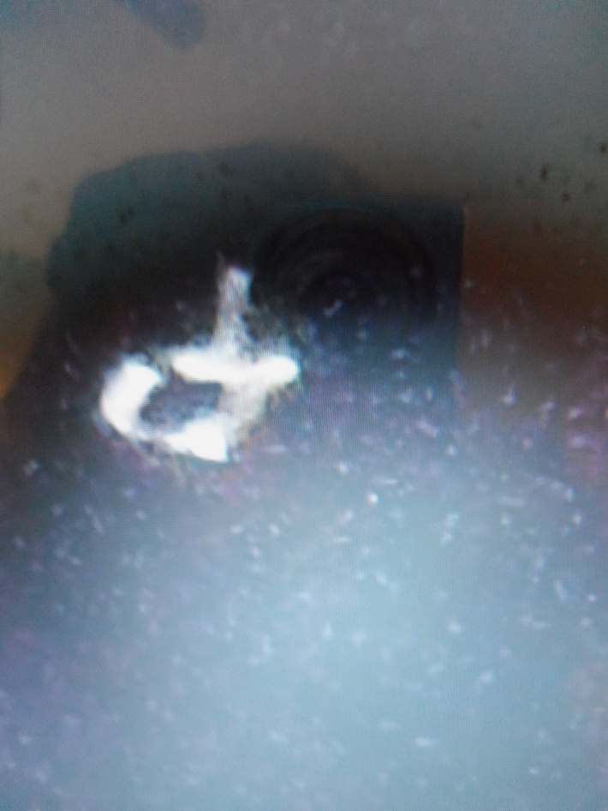

The “helicopter” Blue orb with flying object Multi-colored orb with “ship”

(Notice camera image reflected, left…)

I had seen many fast-speed flying discs over the lake from various apartments with balconies. But, this surprised me.
February 2, 2016: I was sitting outside of a home near Orosi, Costa Rica, at sunset, about 20 miles from the Terrialba Volcano, which has been semi-active for over a year. I saw a fast-moving white light in the sky coming towards the area of the volcano opening, and quickly took two pictures. The object was elongated, but looked very similar to pictures that Dr. Santilli took over Tampa Bay with his new conclave-lens telescope that aids one to see objects/entities that are invisible to the human eye and invisible to the eye looking through a convex telescope lens, like the Galileo telescopes. [Santilli Conclave Telescope Lens Can Site Entities Not Visible to the Human Eye (2-9-16 Steve Quayle Website]

In November of 2015, I was teaching a series of meetings at Rousseau Camp Ground in Manitoba, Canada. When my hostess and I were traveling back to their house, I looked over into a field to my right and saw a large disc-shaped object hovering in the sky. She saw it too! I took two pictures of it. When I enlarged them, they were definitely a UFO/flying saucer. My son, Derek, put them at maximum magnification, and yip – that’s what’s they were.

But, the most spectacular sighing in Israel was a sighting that happened as I sat at the window of my apartment one night to praise Yahuwah. It was 2013, about 9:30 PM. I saw the moon was very high in the sky. It was a totally clear sky. Under the moon something large and gold-colored moved swiftly from left to right. I knew it was too high for an airplane, and moving way too fast for an airplane. About ten minutes later, a huge triangular shaped craft appeared over the lake not far from the shore near me. It was bright gold, with golden lights proceeding forth from it all around. It hovered over the lake. Then it disappeared. My camera was in the bedroom, so I didn’t get any pictures (sad). About 7 minutes later, it appeared again to my right, the tip pointing towards the water, as before. It was absolutely

gorgeous! I told my dear Messianic Jewish friend about it. She lived about two miles from me. She had an apartment with a balcony. She was actually blasé about it. She said that she and her daughter saw those crafts all the time while they sat on their balcony looking at the lake at night.

Directly across from us is the Golan Heights, and on the Golan Heights in Gilgal Rephaim (circle of the Giants) Here is a picture of it.

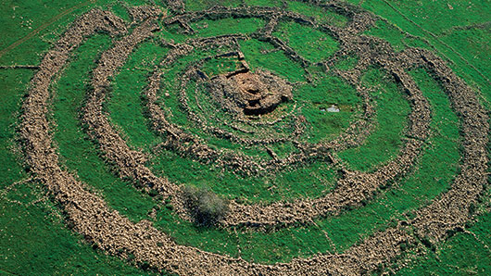
'Stonehenge' of the Golan Heights Fuels Ancient Mystery

Ari Rabinowitz - November 11, 2015 - Image: ​Hebrew Wikipedia

Israel archeologists are working on it. They say it was built by Og, and was a Nephilim structure. They believe Og may have been buried in the center chamber. In the water of the Lake directly in line with it they found sunken monuments that they believe are related …so here we are.

I also refer you to L.A. Marzulli’s On the Trail of the Nephilim Volumes I and II. In volume II, he writes about the connection of America’s Stonehenge in New Hampshire, and Stonehenge in England, and the Stonehenge of Gilgal Rephaim. I had his book sent to me while I lived in Costa Rica – it was so exciting to read it.

As Marzulli so often says, “UFOs are real, burgeoning, and not going away.”

Barry Chamesh wrote an article around 2003 giving reports from Israelis on the Golan Heights and on the Mediterranean Coast telling of seeing saucers landing, and even giant beings coming out from them.

I know for those who are not familiar with the literal realities of the Word, these things may sound crazy, but they’re not. Apostle Sha’ul/Paul speaks of our battle not with “flesh and blood,” but with principalities and powers, rulers of darkness in high places. He speaks of Satan being “the god of this world,” and “the prince of the powers of the air.” The Word as a whole is an extra-dimensional “Book,” filled with extra-dimensional reality. Just the story of Philip in Gaza as an example: One minute he’s there, and the next minute he’s in Samaria. The Red Sea crossing, the crossing of the Jordan, the raising of the children by Elijah, and later Elisha, the raising of Lazarus, and the miracles happening today in places where there is faith, show us that the power of Yahuwah is far greater than the power of “THEM.” As with what I saw over Lake Kinneret (Sea of Galilee), “THEY” are returning to where They were in ancient times.

Moses and Joshua killed Og (Deuteronomy 2-3). “They” are real beings – hybrids of the Canaanite Nephilim (Numbers 13:30-33 for example, the Anakim), and in Joshua 12:4.

“They” are returning worldwide and being seen, in saucers and out of saucers – giants, mutates, hybrids, monsters. The account of David and Goliath and other references, prove the Philistines to be giants.

I refer you to a 2004 article of mine: “The Vatican and Extraterrestrials.” This gives some amazing information about Vatican involvement – which is HUGE.

But, then, it’s all about what Isaiah 13 (Septuagint Version) tells us. These returnees are using man to terraform (change earth) earth so that it will accommodate their invasion and takeover. They want us out, and them in.
“Moving Toward OFFICIAL DISCLOSURE? Respected Investigative Journalist Leslie Kean Says, `Something Extraordinary Is About To Be Revealed’ (Involving Inside Knowledge of UFO-ALIEN Phenomena) `That Could Be World-Changing’ ” –
October 12, 2017
“Something extraordinary is about to be revealed. Former high-level officials and scientists with deep black experience who have always remained in the shadows are now stepping into the light. These insiders have long-standing connections to government agencies which may have programs investigating unidentified aerial phenomena (UAP). They intend to move into the private sector and to make all declassified information, and any future knowledge, available for all to see.
The team includes a 25-year veteran of the CIA’s Directorate of Operations; a Lockheed Martin Program Director for Advanced Systems at `Skunk Works,’ a former deputy Assistant Secretary of Defense for Intelligence, a DoD Senior Intelligence officer who, among other sensitive responsibilities, ran a Pentagon aerospace `threat identification’ program focusing on unidentified aerial technologies. And well placed and experienced professionals, from Intelligence and high academic positions, are also on board. What is going on here? […] The Science division will conduct the research, which will also include consciousness, engineering space-time, brain-computer interface, genomics, and creating a database of supranormal experiences…”
“Black Budget Anti-Gravity Craft You’re Not Supposed to Know About!”
“In this world of cloak-and dagger behind the scenes activity, the `Black Budget’ has grown exponentially. Having little congressional oversight, and virtually no public scrutiny, programs developed within this black world enjoy almost unlimited access to financial backing regardless of their probability of success.” from UFOsigtingsHotspot - November 16, 2017
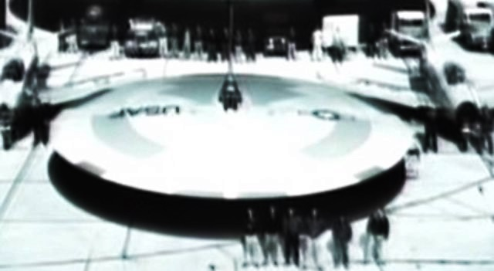
“According to Ben Rich (Lockheed Skunk Works director 1975-1991), keeping programs secret can add anywhere from 10 to 15% to the overall cost. This includes the construction of fortified buildings, extra guards, security clearance logistics, and shuttling works to and from classified facilities… Tom Keller, an aerospace engineer who has worked as a computer systems analyst for NASA’s Jet Propulsion Laboratory told the following facts, quoting Ben Rich: `Inside the Skunk Works (Lockheed’s secret research and development entity), we were a small, intensely cohesive group consisting of about fifty veteran engineers and designers and a hundred or so expert machinists and shop workers. Our forte was building a small number of very technologically advanced airplanes for highly secret missions.’
`We already have the means to travel among the stars, but these technologies are locked up in black projects. Anything you can imagine, we already know how to do and we have know have the technology to take ET home.’
“The NASA-Government UFO Cover-Up”
February 16, 2013, UFOsightings Hotspot
“…Ben Rich’s Lockheed Skunk Works CEO had admitted in his deathbed confession extraterrestrial UFO visitors are real and U.S. Military travel to stars. His statements help give credence to reports that the U.S. military has flying vehicles that mimic alien craft…”
A quote from Nazi SS Officer Werner von Braun, brought into the U.S. and immediately given reign to develop our space program, head of NASA, made this
comment: “There are 2 types of UFOs -- the ones we build and ones 'they' build.” Tom Keller: “We learned from both crash retrievals and actual `hand-me-downs.’ Another Lockheed Skunkworks Engineer USAF, and CIA Contractor, Don Phillips, `These UFOs were huge and they would just come to a stop and do a 60 degree, 45 degree, 10 degree turn, and then immediately reverse this action.’ … And of course Gary McKinnon, he found evidence of the Solar Warden secret program. According to McKinnon, he claimed to have found photographs, film, and other evidence of alien spacecraft secretly held by various U.S. government agencies. He found a list of officers' names under the heading 'Non-Terrestrial Officers,’ a list of 'fleet-to-fleet transfers', and a list of ship names. They weren't US Navy ships. What he saw made him believe they have some kind of spaceship, off-planet…The space fleet, hidden and unknown to the public... operates under the US Naval Network and Space Operations Command (NNSOC) (formerly Naval Space Command). There are approximately 300 personnel involved at that facility. `Solar Warden’ is said to be made up from U.S. aerospace Black Projects contractors, but with some contributions of parts and systems by Canada, United Kingdom, Italy, Austria, Russia, and Australia.”
My input: Joseph Farrell, in his book The Reich of the Black Sun, tells how the Roswell craft was mostly of non-terrestrial origin, but a few things were. The U.S. military in New Mexico called on the German scientists like Von Braun for ID of the vehicle – since they’d been making anti-gravity crafts since the 1930s. Read all about the findings in a special chapter in Farrell’s book.
From my notes on The Albertino Analysis (You Tube) on the D.U.M.B.S. bases, I report on the interview with Phil Schneider, former military man stationed at Area 51, Los Alamos, and the Dulce Base, who risked his life to tell about what he saw “underground.” He said all the stealth bombers and planes, and other crafts of our secret arsenal, has “alien metals” used in them. Where did we get the metals? He said we got them from other planets, of course via Nephilim, or via our own space ships built from Nazi technology. You might want to watch Tim’s analysis!
Continuing with the above article from 2013: “Witness of secret spacecraft:
A professional hiker 'witness' was deep in the Utah desert, 25 miles from the nearest road in a high inaccessible area. Suddenly, he saw an arrowhead-shaped craft 600 feet long appear and hover, a giant camouflaged sliding door opened in the desert floor, and the craft disappeared into what was a concealed underground base. The hiker was rubbing his eyes wondering what on earth he just saw.
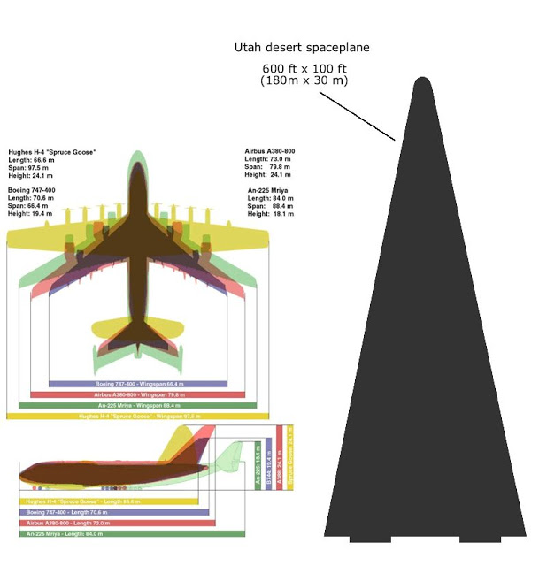
Further evidence of the existence of UFOs are the many global reports of unexplained objects and the many sightings of objects near the sun.
John Andrews and Tom Keller said, actually adding to the quote by von Braun: `There are 2 types of UFOs -- the ones we build and ones they build with a very technologically advanced system, which make it possible to travel to stars, planets, and even to the sun.’ ” The arrow head shaped craft is similar to the golden one I saw over Lake Kinneret in 2013.
SkywatchTV.com had an excellent interview on December 11th with Derek and Sharon Gilbert, Michael Heiser, and Josh Peck, about these very things. They gave excellent advice as to how to challenge our youth to see these things as real – and that our Messiah is bigger, stronger, more powerful, than any of them, and that He has given us power over them (Luke 10:19 for just one example). I hope you will watch this interview. They talk about the soon “disclosure” that has been pending for years. It is now in the forefront of daily conversation.

NASA keeps talking about finding “exo-planets” that we might colonize. But, Yahushua spoke our planet into existence (Genesis 1:1; Genesis 1:3) as a unique life support system just for us special human beings. Genesis 1:2 and Jeremiah 4:21-28 is what the fallen ones did to it in their rebellion against Yahuwah.

We are definitely without question “in the days of Noah.” We are in a time preceding judgment--the Final Judgment by fire. Topics like AI (Artificial Intelligence) and “Human Enhancement,” “Trans-genics,” “Transhumanism,” and “Eugencis,” are BIG. For understanding these topics, I recommend the award-winning DVD produced by Tom Horn and Skywatch entitled: “Inhuman: The Next and Final Phase of Man is Here”

The end of the human race is the goal, and the creation of hybrids, cyborgs, robots, and all types of bodies for the creatures of darkness to inhabit, without having to look at the “image and likeness” of Yahuwah!

People by the billions will fall for the “Ancient Alien” lie, believing these beings are our “parents,” good, and have come to help us. Yet, as in the movie “The Day the Earth Stood Still,” and the TV series “V,” the truth comes out--these beings are evil.

The truth is that they are already using their technology, whether through Nazi humans or Americans, Russians, Chinese, etc., to turn us into something we’re not – our DNA is being changed slowly but surely by the aerosol spraying of chem.-trails, the pollution of water, food, materials, use of aluminums in so many products, medicines, vaccines, and mind-programming using drugs and alpha waves (off TV) and other waves to make our minds dull and compliant to their wishes.

In the coming days, these subjects will be put in our face more and more. Let’s find out the truth about them, so that the lying propaganda, the fear propaganda, of the news media, and Hollywood included, don’t turn us from a strong stand in our faith. The Vatican is talking about how Christians will have to adjust their faith to fit into the alien agenda. Well, Yahuwah and Yahushua are not in any religion – They are set-apart Persons! Our faith is rooted in our personal relationship with THEM. Be in touch with THE ALMIGHTY! Stand strong “in the power of His might.”

If you are not prioritizing your life to flood your mind with the Word and in prayer and praise, you will be caught up in the frenzy of what is coming. If you are not actively sharing life in Messiah, the blood that makes atonement for sin, sharing your testimony with others, giving them the opportunity to receive eternal life, your eternal future is bleak. Yet, recent surveys show that only 12% of those in America who say they are “Christian” feel any responsibility to share their faith. I’m not talking about being an “evangelist” like Billy Graham, or a pushy big mouth religious nut. I’m talking about daily walking and praying for your neighbors, those in the stores, at your job, and asking Abba to open doors for you to share with them. I encourage you to listen to the wisdom of the first four podcasts under Audio Messages on comeenterthemikvah.com. I tell how to be a natural witness, and even share the Torah rightly with Christians. No one can enter the kingdom without the blood of the Lamb of Yahuwah applied to their life, I don’t care how religious and nice they appear. Without Him they are hell-found sinners. First salvation of the spirit, then of the soul, then of the body!!! I detailed that in my last article: “Cocoon – A Special Message for Hanukkah.”

Please share the website with others--especially refer them to the 1st Mivah in which I wrote about the true new birth. Modern Western Christianity has no idea what the true new birth really is. It is so watered down that it is a miracle if anyone is saved. Give people the true new birth which demands for total submission to the Master, or else… it’s not real.

Tonight begins the celebration of Hanukkah by the Creator’s calendar of the sighting of the new moon from Jerusalem/Israel the eve of November 20th.

Love and Shalom, Chag Sameach! Happy Hanukkah!

Yedidah

December 14, 2017

