TRUMP DECLARES:
“WE’RE GOING TO MARS”

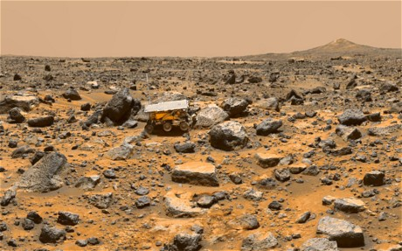
Left: Mars Right: Surface of Mars. Notice the landing craft. This
photo is from the U.K. Telegraph article: “Plans for
Manned Mission to Mars Drawn Up By British team:
Plans on how to land humans on the surface of Mars
have been drawn up by British scientists.”
March 13, 2018

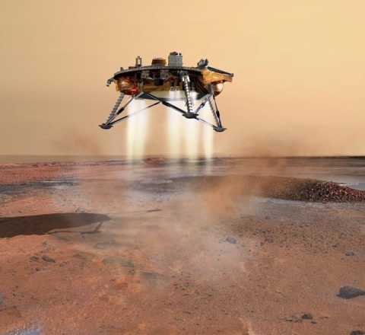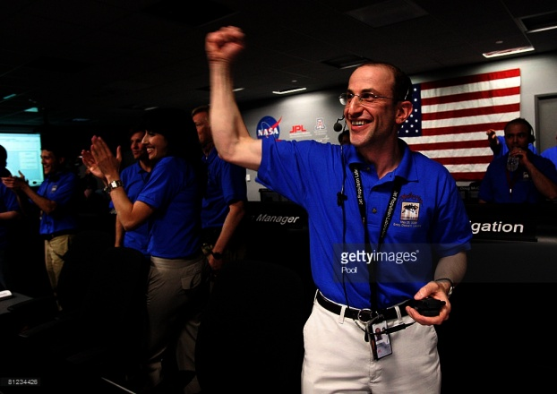
Left: Phoenix Mars Lander Dr. Richard P. Kornfeld, Sr. Engineer of the Phoenix
Softly approaching Lander Project and associates celebrate the historic
landing on Mars on May 25, 2008

***Please read, or re-read, the foundation article for this article, in order to understand what I say here: “Trump Declares: First the Moon, Then It’s Mars…”/Mikvah of the Great Adventure

Online information: “May 25, 2008: NASA's Phoenix spacecraft landed in the northern polar region of Mars Sunday to begin three months of examining a site chosen for its likelihood of having frozen water within reach of the lander's robotic arm…”
That achievement made the U.S. news report on how it was one of the most successful missions to Mars. On that date, that Lander actually landed for the first time gently on Mars. U.S. rovers had been having a problem with crashing onto the surface during the final set-down.
I was excited when I heard of this achievement and I went to tell my son-in-law, Justin, about it. He just smiled. My daughter had her back to me as she was getting something out of oven and said something I didn’t understand. She turned around and repeated that Justin had the patent on the technology that made it possible for the Lander to land softly. He had quite a few patents with NASA and other aerospace contractors in those days. She said they’d be out at night and he’d point to a satellite that he had a patent associated with.
All my life I’ve been fascinated with Yahuwah’s creation. First in the Kingdom of Messiah and 1,000 years later in the Kingdom of Yahushua on earth, we’ll be able to travel into the cosmos and see it all close up. How awesome!
As you can read in detail in The Lost World of the Cloud Eaters by Tom Horn and Steve Quayle, Quayle goes into detail about how the planet between Mars and Jupiter was destroyed and how debris has been found on Mars and some on Earth to this day. The destroyed planet is called “Rahab.” The debris from its destruction is now floating out there in what is called the “Asteroid Belt.” Those comets and asteroids that still threaten Mars and Earth are very real. Revelation 8 may refer to a hit by an asteroid or a comet from that “Belt.”
No I do not believe in Nubiru, Planet X. At least at this point, I believe it’s mycological propaganda hype. It’s a story that keeps people stirred up. However, most myths and legends have some truth to them, so we’ll wait and see.
You might also like to hear the interview of Steve Quayle with Henry Gruver regarding the time when Gruver was in a car accident and radically died. As a small child, looking up at the stars at night, Henry had asked “God” if he could travel in the planets and star before He made a new heaven and a new earth. Much later in life, after he died in that car accident, he tells how Abba answered his childhood prayer. Upon death, he immediately began ascending above the Earth into the second heaven among planets. He told what he saw in detail. In fact, after he came back to life, he was interviewed by a famous astronomer who told Henry that his observations of certain planets up close had answered questions that he and other astronomers had wondered about for a long time.
Two links for the Quayle-Gruver interview: https://www.youtube.com/watch?v=efJ7H_r3S6c
https://www.youtube.com/watch?v=efJ7H_r3S6c (January 25, 2017)
From online info: “The name of the capital of Egypt, Cairo, is derived from "al Qahir”--the Arabic name of the planet Mars.” “Mars, the red planet, was named after the Roman god of war. According to Roman myth, Mars rode on a chariot pulled by two horses named Phobos and Deimos (meaning fear and panic). The two small moons of Mars are named after these two mythical horses.”
As Steve Quayle points out, Mars is very similar to Earth in many ways. Yet, as I wrote recently in “Terraforming the Earth,” the goal of the Nephilim is to turn Earth into a similar planet to Mars, which is to their liking. It is interesting that the spirit of desert-ing the earth is also a spirit of Islam. Wherever they go, slowly but surely the earth turns into a dry desert.
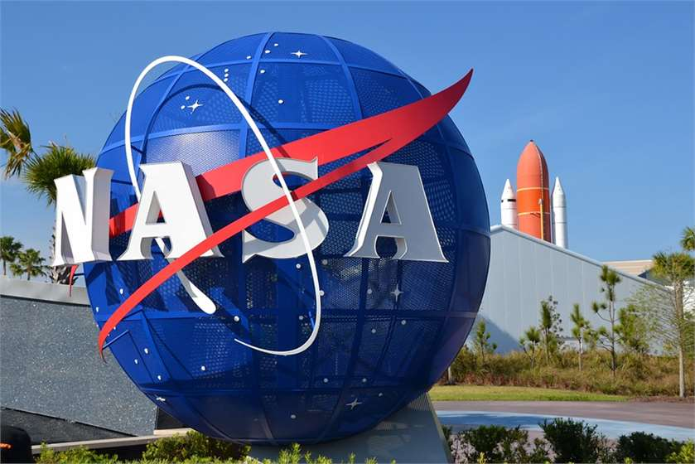
Left: NASA Headquarters Right: Planet Earth – Beautiful!

NASA (National Aeronautics and Space Administration) was a U.S. creation, linked to post World War II Nazis. The original head of NASA was a rocket scientist and former Nazi SS officer with Jewish and Christian blood on his hands from the concentration camps of Nazi Germany: Werner Von Braun.
Research honestly! Never go by what a man says unless you first go to Yahuwah and find out what He says! Do your own research led by the Spirit! Truth must always align to the plumb line of the Source of Truth!
The Hebrew word “nasa” does not mean “to deceive,” as a few say. I checked this out for myself. From Jeff Benner, 20+ years teaching Biblical Hebrew and Bible interpretation: “There are several Hebrew words that can mean `deceive,’ but נסא (Strong’s Hebrew Concordance #5375, “nasa”), which means `to lift up,’ is not one of them.” From The KJV Hebrew Lexicon: Phonetic spelling “naw-saw.” Definition: “to lift up, bear up, carry, take up...to exalt, support, or assist.”
In “Trump Declares: First the Moon, Then It’s Mars” I quoted David Hodges’ words about his father who was in Special Operations for the U.S. government military, who brought Nazis into America beginning in 1945 under “Operation Paperclip.” Hodges’ father, from his own experience with Nazi scientists, said that they were 100-300 years ahead of us in technology, and that they told him they received their technology from fallen angels/Nephilim, aka “aliens.” Von Braun admitted to that fact. Be sure to read Hodges’ article at the end of this article!
As Dave Hodges points out in the article below, “Trump is bringing control of the Secret Space Program under the control of the Elected Government.” This is the Globalist’s nightmare. They’ve worked so hard to keep it all a secret, and now Trump wants to bring what was is the darkness out into the light for all to see. His life may be in danger over this. It is mind-boggling to me that what has been underground since 1945 may be coming to the surface. In doing this, Trump may also play into the Globalist plans for taking over the minds of the world’s people! Exposing what has been hidden for 70 years may be more dramatic than anyone knows!
The work of the Nazi scientists on space exploration continued in America in underground laboratories. To this day these projects are called “Black-Op,” -- Black Operation Projects. America’s Military Industrial Complex has poured billions of dollars into the exploration of space. NASA, which Von Braun first oversaw, was created to be a “front-man” for the public eye to keep the masses ignorant and mind-controlled to facilitate the Globalist agenda.
While NASA did launch some important things, it has never revealed to us the depths of real space exploration that had been going on already.
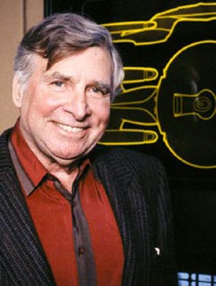
When Star Trek, created by Gene Rodenberry, came on the scene in 1966, those fascinating “sci-fi” things they did up in space via the “Star Ship Enterprise” were already things being done in deep space by man from Earth!
Working with Vice Admiral Leslie Stevens, Rodenberry and Stevens actually tapped into Nazi saucer technology that was really real, and produced a series that reflected reality in many ways! Star Trek’s “beam me up Scottie,” for example, has been for reality for decades. Anti-gravity technology has been round for at least 50 years. Yes! There are real “Star War” going on. If you want to read about this, refer to this article below in the picture. The author talks about the Nazi connection:
There is a real war going on in the cosmos. Mankind has been up there and is up there. We know about the very real war in Revelation 12:7-9, 12. Years ago, Gary Stearman, then with Prophecy in the News, reported on what people were telling him about hearing the sounds of war in the heavenlies, i.e. swords clashing, trumpet sounds, and moaning. Many local news channels around the world have also been reporting on these strange sounds. I’ve actually watched evidence of this fighting in heaven, whether it was between Yahuwah’s angels and fallen angels as in Revelation 12, or between nations vying for power in space. I have a copy of the U.N. Space Treaty, in which they divided up different areas for different nations. That was written years ago. So, what the public is not told has left billions totally ignorant, but left many smug and arrogant in their ignorance.
The world’s people as a whole have been kept horribly ignorant of hard-core reality, while they view a lot of reality in fantasy-form via TV, movies, books, etc., and are also baptized into fantasy, lies, and deceptions, via schools and churches.
Perhaps Americans have been mind-programmed more than any other people, simply because America is the originator of so much deception. We’re the nation with Hollywood and Disneyworld. We see all the time that if Truth is exposed outside the circle of believers in it, truth-tellers are so often considered crazy--someone to be mocked and scorned.
Oh yea! By the way: It was the CIA who coined the expression “conspiracy theory” to keep the public laughing at, and mocking, the Truth. To know absolute Truth, we must know the Source of Truth personally – Yahuwah and Yahushua! Do honest Research! Know the whole Word for yourself! Psalm 119:142 and John 17:17: “Your Word is Truth!”
I was fascinated as I listened to a conversation between Steve Quayle and renowned field researcher Klaus Dona. Dona was telling of giants being seen in the Philippines. They shared stories of how they were mocked and scorned as crazy men for teaching on giants. They both just laughed about it. What can you do when you tell the truth and people laugh at you? Ignorance often hides in pride.
YOU can have discernment from the Spirit through being filled with the Spirit of Yahuwah (I Corinthians 12:1-11). I’m sure many of you operate in this gift. It is one of Abba’s gifts to His children. YOU have the Luke 10:19 authority too, if you are filled with the Spirit. No religion can do what the Spirit can do in us, and through us! Oftentimes, like with the Biblical prophets, Yahuwah gives the final bottom line very early – years early, centuries early, millennium early. He has given me prophetic understanding decades early, but now – all His prophets, Watchmen, and messengers are seeing the same things that they say 2,500 years ago.
Repeating what I wrote in “Trump Declares: First the Moon, Then It’s Mars” my daughter and I heard George Bush give a speech in 2004 about colonizing the Moon and Mars. But, when I told a former friendly Messianic home-group leader in Texas, where I have spoken several times, she twisted what I said and blackballing me to her group, saying I had said we’re going to Mars, and they should have nothing to do with me because I was crazy. Well folks: Now President Trump is saying “we’re going to Mars.” He’s just carrying the 1945 agenda forward.
Here is a link to the transcript of the speech from the White House:
President Bush Announces New Vision for Space Exploration Program
https://history.nasa.gov/Bush%20SEP.htm
Steve Quayle mentioned Bush’s speech in his book Weather Warfare. Now you can read the speech, or listen to it, for yourself--online.
Now because of the study of “Quantum Physics,” we can see that the entire Word is filled with extra-dimensional reality. It is possible that there are at least twelve different dimensions. They were all available to Adam and Eve as long as they were in the Garden. These dimensions will be available to us in eternity. Through the study of Quantum Physics, we learn that the Word speaks of portals, star gates, and doorways that link the kingdom of darkness and the Kingdom of Light to our 3-dimensional world. These things expand our adoration of Elohim!
March 14, 2018: Physicist Steven Hawking died at age 76 in Cambridge, England. I was very sorry to hear about his passing!
Hawking was an honest man with what he knew and believed, and a genius in his field. He often warned CERN about the dangers they were incurring with the LHC. Here was a man totally crippled and confined to a wheelchair, yet he continued to learn and speak about his beliefs. He defied doctors. From The Sun article “Hawking Dies…”: “Described as the greatest scientific brain since Albert Einstein, the physicist was considered a medical marvel, having lived for more than half a century with the devastating condition motor neurone disease.”
Do not be deceived! We are in a war to the death. Get Yahuwah’s opinions on everything – know Him! Know Yahushua personally! Earth is being destroyed to make it a planet for the fallen angels and their offspring. No! There are NO “aliens” from way out in outer space. They are here on earth, some are still near us in another dimension, some may still be on nearby planets like Mars, but they all are here to deceive mankind. They are working with the elite bloodlines of this earth, i.e. “Illuminati bloodlines,” to restore the fallen ones to power over the earth. They really believe in Atlantis rising and a “Golden Age.” Like the Nazis and Hitler, they really believe The Secret Doctrine of Madam Helena P. Blavatsky. The Nazis perpetuated belief in these “sky gods,” saying they are a superior race that have come to help us, and we need to bring them forth to rule the earth. They perpetuated the idea of “ascended masters” like in Shangri-La/Shambhala/
Hyperborea. This is the goal of Luciferic Globalists--to return the fallen ones to power over the earth with hybrid humans as their slaves.
We are beginning to see the last attempts of the kingdom of darkness to take over. We stand in opposition as we praise Yahuwah and call for Yahushua to come! Let your mouth be filled with praise for our Elohim!
Tragically, most of the world’s people will join the deception, either out of fear, out of awe and wonder, or through being drugged. They will worship the hybrid “Beast.” They will, like him, become non-human by taking his “mark.” (Revelation 14:9-11; and Revelation chapter 9)
Yes, Americans have been to the moon! Don’t poopoo NASA totally! Their work is based on long-known facts. Their job has been to hide what they know and what they’ve learned. Remember man-controlled space fight has been going on at least from the 1930s, using the guidelines that the fallen ones gave to the Nazis as early as 1922 via the Vril séances. So, NASA, controlled initially by Nazi science, has done some amazing advanced things. However, as we know, for the most part it has also has done a fabulous job of hiding things from the public. In an article below, you’ll see that hiding shocking reality has been their main virtue!
NASA via Hubble has pictures of the colonizing done by pre-Flood/Antediluvian Nephilim on both the moon and Mars. They just aren’t showing us all they have. As a public mind-programmer, they have been setting up the world’s people to believe aliens are coming from outer space, preparing mankind for “Disclosure.” Yes, they have their incredible dark side in the occult. But, what can you expect from a Nazi-based bunch? [Please refer to the article: “Opening the Door for Official Disclosure/Mikvah of the Great Adventure]
The late David Flynn, in his awesome book Cydonia: The Secret Chronicles of Mars tells us about the colonizing of Mars by the ancient Nephilim. He shows pictures of the face on Mars in the area of Cydonia.
In Richard C. Hoagland and Mike Bara’s book Dark Mission - The Secret History of NASA, they include pictures that were supposed to be all destroyed by an Apollo mission, but were rescued from the trash heap. The book has lots of pictures, even the face and structures on Mars. Hoagland and Bara tell about Operation Paperclip, von Braun, and the Nazi foundation of our space program. They talk about the astrology connected to moon launchings--star alignments necessary for launchings. They include photos of Bean and Mitchell under glass houses on the moon. They expose a lot! Quoting from the back of their book, “For most Americans, the name NASA suggests a squeaky-clean image of technological infallibility. Few people are aware of the hard evidence that secret brotherhoods quietly dominate NASA, with policies far more aligned with ancient religious and occult mystery schools than the façade of rational science the government agency has successfully promoted to the world for almost fifty years.”
As Nick Pope discovered, and wrote about in his documented book The Search for Zero Point, on-earth American scientists are way behind today in what the Nazis had given to them in the 1920s, and many know it. Top-earth American scientists are still working on finding things like anti-gravity technology, when it was given to Nazi scientists in the very early 1900s by returned Nephilim. It’s the under-earth scientists that are going forward from Operation Paperclip days with the help of the fallen ones. Thus, they are so far ahead of the top-earth-surface scientists that it is tragic. Many of the secrets of the Nazis were given to the Russians, especially in the areas of weaponry and space exploration.
So, stating it again, while NASA has been a façade in many ways, there has been a secret underground space program that is far more advanced than anyone on the surface of earth can possibly imagine.
There has been advanced technology found on the moon. Going to the moon was no problem--the Nephilim had colonized it thousands of years ago. Many researchers have dug deeper to find the truth that has been hidden from us. Astronaut Jim Armstrong made this statement upon landing on the moon: “…they’re here; they’re parked on the side of the crater; they’re watching us.”
Yes! NASA has steered public opinion to a great degree to prepare Earth for disclosure of an alien agenda. NASA has been a protection-shield to keep anyone from finding out the truth about what the Nephilim have revealed to select men! So poopoo NASA’s propaganda, but keep digging for the underground reality!
Mind-programming is what’s been done to dummy-up the world. There is also the spewing of lies like “Panspermia,” along with the “Ancient Alien” long-running series on the History Channel, giving the lying theories of men like Zecharia Sitchen, and Erich Van Daniken in his Chariots of the Gods. We know their theories of ancient aliens from outer space are lies by the Word of Elohim! But, what is being done underground by man and Nephilim is very true.
We know THERE ARE NO “ALIENS” as in little green men or gray men either. “Grays” and “black eyed kids,” are two examples of created hybrids. We know that no aliens from outer space seeded us on this planet, making them our “parents.” We refute Panspermia! There’s also the idea that we evolved from space garbage. Crazy! Learn what the Word says about these things!
Don’t let your mind be fascinated with intellectual foolishness. REMEMBER! ANYTHING that takes you away from your one main assignment on earth--spreading the Good News of the salvation of Yahushua and the Spirit’s power to transform a person into a truly new creation, taking them out of the kingdom of darkness into the Kingdom of Light--is of SATAN! Stop listening to man’s arguments that appeal to the mind! These shysters always quote Bible verses, but the wise go to Yahuwah for Truth. Know Elohim! He speaks to your eternal spirit within the midst of you, in your belly-reproductive area--area of your spirit-temple!
We know that Yahuwah and the Living Word, Yahushua Messiah, created the heavens and the earth by sound waves! Yahushua spoke and it came to be, both in Genesis 1:1 and Genesis 1:3. Genesis 1:2 is the result of what the fallen angels did to “terraform” earth back then to suit them, and Yahuwah’s punishment. Well, they’re attempting to terraform it again! Yahuwah’s answer is: II Peter 3:8-14 and Revelation 21-22. The Highest of Intelligence designed everything for us perfectly.
In “Terraforming the Earth,”/Mikvah of the Heart of Elohim, pages 2-4, I quote from Tom Horn’s Exo Vaticana. The article is worth reading or re-reading just for that quote. Earth is unique in that its life-support systems support all life that was created upon it. There’s no home like our blue planet! The whole Word tells us that His people will live forever on earth--not on Mars, not Alpha Centauri, or on any “exo-planets” that NASA keeps coming up with. Earth is Abba’s gift to His children!
Proverbs 2:21-22: “For the straight shall dwell in the earth and the perfect be left in it. But the wicked shall be cut off from the earth and the treacherous ones plucked out of it.” Psalm 37:29: “The righteous shall inherit the earth, and dwell in it forever.”
Is there an international space station? Are there space fight going on right now? Is Trump serious about visiting Mars? Oh come on now: Yes! Lion-faced men, the face on Mars: Is that too weird? The face is of a lion-man: Go to I Chronicles 11:22-23 and David’s “mighty men” who fought to protect David. “Benayah was the son of Yehoyada, the son of a brave man from Qabtse’el who had done many deeds. He smote two lion-like Moabites. He also went down and smote a lion in the midst of a pit on a snowy day. And he smote an Egyptian man of great height, five cubits tall (8’ 3”). And in the Egyptian’s hand was a spear like a weaver’s beam, and he went down to him with a staff and wrenched the spear out of his hand and slew him with his own spear.” Hey, Goliath was an 11-foot giant. It’s all in the Word folks! These big guys, hybrids, fallen angels, have been around for thousands of years. The pre-flood Nephilim built bases as close as they could get to Earth, on the moon and Mars. That’s probably how some survived the Flood and then afterwards returned to Earth. Mars has water; Mars can sustain life. Mars has many similarities to Earth. Check out David Flynn’s Cydonia, and Hoagland’s Dark Mission.
Here’s a link to a super article on Cydonia, including Viking and Surveyor Photos:
www.greatdreams.com/cydonia.htm
Why are the petroglyphs around Tiahuanaco, Bolivia, like the petroglyphs on Mars? - Language perhaps? David Flynn has amazing photographs of them. Refer to: “The Geoglyphs of Tiahuanaco” by David E. Flynn, February 24, 2008 - Discovery of Vast Prehistoric Works Built by Giants from raidersnewsnetwork website. It’s loaded with awesome pictures.
Link: https://www.bibliotecapleyades.net/arqueologia/esp_tiahuanaco8.htm
NASA article: “Is There Morse Code on Mars?” July 8, 2016. Tim Alberino discussed this on SkywatchTV. NASA presented a possible code on Mars but tried to get out of its connection to codes on earth, like around Tiahuanaco. 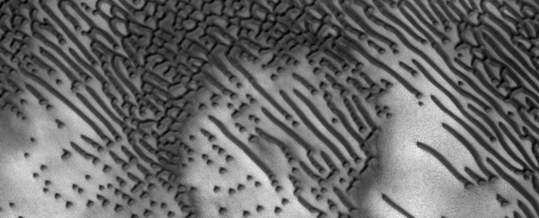
NASA photo Sputnik News, Russia
Why do ancient rock carvings, cave painting, figurines, statues, in many parts of our world clearly show men in space suits and helmets? It wasn’t humans back then who traveled to planets--it was fallen ones and Nephilim. The native people recorded pictures of giants, giants with space helmets, with huge six toed feet running after little 5-toed feet, like in these pictures of Newspaper Rock in Utah.
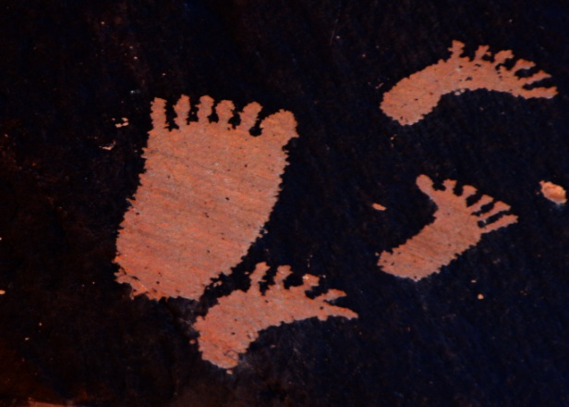
Left: Five toes running from six toes - Right: Who are the big guys with horns?
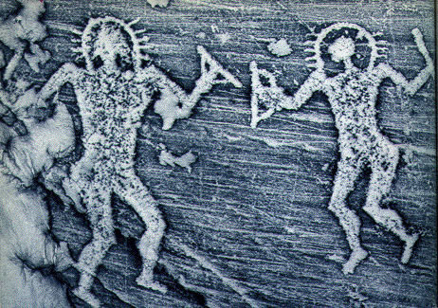
Who’s the wired dude? Cave painting in Italy
There are worldwide Cyclopian Megaliths that defy technology even today, like Ba’albek (Lebanon) and on Easter Island. I visited two such sites in Bolivia – Tiahuanaco and Puma Punku. The two I was at are at 13,000 feet in the Andes Mountains. The mega-ton stones used in this city were carved at a quarry 200 miles away. Figure that! -- Anti-gravity technology? -- The use of sound waves?
In India’s ancient past, the descriptions of the Vimāna are not mythical at all, but very up to date. Wikipedia: “Vimāna is a term used to describe mythological flying palaces or chariots described in Hindu texts and Sanskrit epics.” By their description, they were like space craft today. Why does every ancient civilization have stories of flying discs with unusual creatures manning them? Of course there was Eliyahu/Elijah in II Kings 2, who went up into a flying chariot manned by Yahuwah’s Angels. Like I said, mankind today is hundreds of years behind the pre-Flood world. The Nazis began the race to catch up, and they brought it to America.
So, yes, men have gone to the space station and NASA has photographed a lot, even UFO sightings near the station. But, then, as Hoagland and Bara prove, they have also tried to hide or destroy photos showing what they don’t want the public to know. Hubble is taking some good pictures!
Yes, American astronauts have died from radiation poisoning because of being beyond Earth’s “Van Allen belts,”--shields around Earth to protect us from the sun’s radiation. [Refer to: “Shield’s of the Earth.”] Some astronauts have reported feeling the radiation on the space station. But, going beyond our Van Allen belts, which have been greatly weakened by America’s horrors, is reality. In 1953, America exploded three nuclear bombs in the Van Allen belts – blowing holes in it. That is mind-bogglingly horrible! So, manned rockets to the moon or to the space station going through the Van Allen belts has posed no technical problems.
During the Cold War with Russia, as I have reported recently, the Nazi scientists in the US gave Russia space technology that the “aliens” had given them. Thus Russia was first into space. There was NO space race! That was for the public’s entertainment. I loved the entertainment--Yeah America! Russia is ahead of us again with “Neph-tech” super weapons. The Russians beat America into space, then supposedly we caught up and passed them. Not true! We let them take the lead. Nazi scientists in America during the “Cold War” with Russia, another façade, gave the Russians advanced technology for space flight.
I have truthful material from an insider Naval Intelligence officer exposing how Russia shot down America’s space station on the moon. He exposes also that Russia shot down one of our manned space flights to the moon, too, and the men who returned were clones. I know, it sounds weird, sounds sci-fi. But, we’re been kept so dummied down, we can’t image what we’ve missed.
I refer you to British journalist Joseph Farrell’s book The Reich of the Black Sun, where you’ll read the truth about Roswell 1947. Steve Quayle tells the same truth in his book Empire Beneath the Ice. Hey, as Quayle says, the Nazis did win World War II, and went on to spread their occult Nephilim doctrines and technology worldwide from America, from Britain, from Russia, Antarctica, and etc.
Roswell was about combined German and Nephilim technology that wasn’t supposed to crash. Yes, a government thing, a CIA thing! The CIA came out of the Nazis, too. Why else were the Nazi scientists called in to assess the damage of the Roswell crash? Joseph Farrell’s book tells so much that it reads like a thriller. I really recommend that you read it for one shocker after another of truthful reporting. I’ve read around 20 books so far on these subjects, and they all say approximately the same things--all authors are expert researchers for truth.
I recently wrote an article about my own UFO sightings, in America, Tiberias, Israel, Canada, and Costa Rica. Those reports are in “Trump Declares First the Moon, Then It’s Mars.” One evening, a medium-sized silver saucer paralleled my husband and I for about a mile as we were traveling down the Blairsville highway in North Georgia. I felt no fear. It felt in my spirit that it was human-piloted. It shot across the highway in front of our car and into the field to our right. Read that article for the whole scoop.
Is this important for you to know to help you in your spiritual life? OH YES!
If you do not discern correctly when all of this hits the surface for the public to be “blown away” and “mind-boggled,” you’ll join their fear. Don’t worry about NASA! They’re not your enemy! Satan and the fallen ones are your enemy! Don’t do spiritual warfare against NASA – do it against those attackers from the kingdom of darkness! Is Yahuwah in control! Focus on the day you face the Master Yahushua. Make sure you’ll hear: “Well done good and faithful servant.” If you know that all is under the control of Yahuwah, you’ll retain peace no matter what the enemy does!
Men’s hearts will fail them for fear of what is coming on the earth, or as the text in Luke matches others like it: “coming up onto the earth.” The underground labyrinths are opening, and Nephilim who have been long in stases will surface. Yes, all of them will be with us. So what really matters in light of eternity? Don’t worry about NASA and Trump.
Psalm 91:1 is our daily hiding place! If they want to take people to Mars, let them go. We are soon to receive a new heaven and a new earth!

THREE IMPORTANT ARTICLES
1) “Black Budget Anti-Gravity Craft You’re Not Supposed to Know About!”
Link: www.oom2.com › ... › UFO DISCLOSURE, ISS, MUFON, SETI & NASA
“In this world of cloak-and dagger, behind the scenes activity, and the `Black Budget’ have grown exponentially. Having little congressional oversight, and virtually no public scrutiny, programs developed within this black world enjoy almost unlimited access to financial backing regardless of their probability of success.” by UFOsigtingsHotspot - November 16, 2017
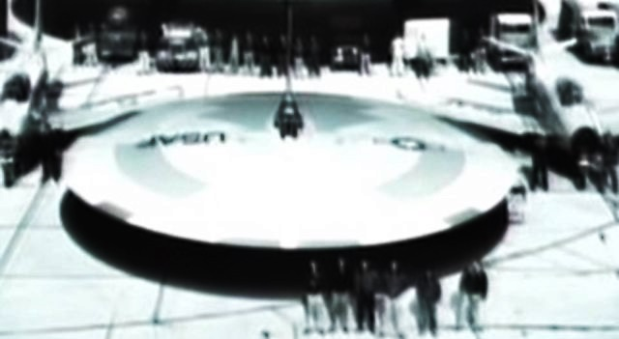
“…According to Ben Rich (Lockheed Skunk Works director 1975-1991), keeping programs secret can add anywhere from 10 to 15% to the overall cost. … Ben Rich: `Inside the Skunk Works (Lockheed’s secret research and development entity), we were a small, intensely cohesive group consisting of about fifty veteran engineers and designers and a hundred or so expert machinists and shop workers. Our forte was building a small number of very technologically advanced airplanes for highly secret missions…We already have the means to travel among the stars, but these technologies are locked up in black projects. Anything you can imagine, we already know how to do it, and we have known the technology to take ET home.’ ” [They’ve been doing “star wars” up there from the 70s at least, maybe earlier]
2) “Trump: `U.S. Is Going to Mars Very Soon’ The President signed a directive ordering NASA to plan a Mars mission” The Hill - March 14, 2018:
“President Trump told troops in California on Tuesday that the U.S. would be going to Mars in the very near future…`Very soon we’re going to Mars. You wouldn’t be going to Mars if my opponent won, that I can tell you. You wouldn’t even be thinking about it,’ Trump said.
Trump signed a directive in December aiming to send Americans to the moon, and eventually Mars.” [Refer to the first article “Trump Declares…”/Mikvah of the Great Adventure, to view a photo of his signing of the directive]
Trump is in danger! He is bringing to light what has been hidden underground!
3) “US Trump is Bringing Control of the Secret Space Program Under the Control of the Elected Government” – March 14, 2018 - Dave Hodges – The Common Sense Show [The complete article]
“For the past 3 years I have been writing about how the secret space program was the dominant program and it had its origin in the 1950’s and the technology behind it was light years ahead of anything NASA was doing. The technology was obtained from captured German scientists. In 1983, my father, who had worked with captured German scientists from 1957 to 1965, told me that he was convinced that NASA was a fraud, used to secretly funnel money to the secret space program. He told me that the technology that he was reverse engineering, from 1957 and on, was hundreds of years beyond anything NASA was working on and as he watched NASA unfold, the technological development of the agency, covering nearly three decades was stagnant and did not reflect the level of sophistication that he would have seen in NASA. NASA was, and is, an unmitigated fraud.
In previous articles, I revealed how my father stated that we were already conducting military operations in space and now, this program is coming out of the shadows through President Trump’s actions.
President Trump is going to bring the secret space program (militarized) out of the shadows of secrecy. He also plans to eliminate its black budget funding and make the program a line item with Presidential and congressional oversight.
I was told this was coming, I just did not believe it. As I have previously published, I knew about the secret space program since 1983 when my father told me of it when his health began to fail. However, I could not reveal anything publicly until my mother’s passing in 2011 because she was receiving his two pensions and would have lost them if it was revealed that my father disclosed secret and classified information.
I did have some private conversations about this situation with the late Jim Marr’s who flew to Phoenix to meet me in secret so we could compare notes. Also, the late Bill Pawelec (CIA), a close friend, and Vance Davis, another close friend, knew what I knew. After my mother’s passing, I began to open up and I first revealed all on Doug Hagmann’s show and then here on The Common Sense Show.
It is clear to me that Trump is transferring the control of the secret space program from Deep State to elected government. However, he is doing so under the ruse that the program is one under development instead of the truth that this a direct transfer of oversight. Make no mistake about it, this is a direct stab at the Deep State who has controlled this program for its own purposes and profit. Personally, I am surprised that Trump has gotten this far with this bold move without JFK type of consequences.
An Amazing Revelation
This is an amazing time in American history. Trump fires Deep State Tillerson and his rogue aide. He is set to fire Sessions and replace him with Trey Gowdy. Trump has taken over the peace process with North Korea, he is controlling trade through tariffs and he has stimulated employment and is keeping American corporations home through his tax policies. America is changing right before our eyes! Yet, there will be nothing as stunning as what Trump is going to do with the `secret space program.’ Trump is making the program public. He is pretending to be creating a space program. However, this program has been around since the 1950’s. The spin-off technologies will revitalize our economy and the innovations, which will now transfer to the public sector will firmly put America on top of the world, once again.
When I saw the following on Fox News, I instantly recognized this for what it was. From Fox News: `…while touting successes around the globe, and even suggesting the creation of a new military branch — the “Space Force.’ ”
The president spoke to thousands of military men and women at Marine Corps Air Station Miramar in San Diego, Calif., Tuesday, following his visit to review border wall prototypes.
…`We are finally going to lead again. Very soon, we’re going to Mars —you wouldn’t be going to Mars if my opponent won. You wouldn’t even be thinking of it,’ Trump said, in a swipe at Hillary Clinton. That’s when the president went on to introduce his `new national strategy for space.’
`Space is a war-fighting domain, just like the land, air and sea,’ Trump said. `We may even have a Space Force — we have the Air Force, we’ll have the Space Force, you know, the Army, the Navy.’
He added: `I said, maybe we need a new force, I was not really serious, but now I’m thinking that’s a great idea. We’re making a Space Force. Tremendous.’…
Mr. President, you are a very bad actor. You did not just come up with this idea. This has been out there for a very long time. However, Mr. President, you are a great American and my father is looking down from heaven with a huge smile on his face.
Where is the Proof?
People might be wondering, where is the proof for the existence of this program? I attended an invitation only meeting at the home of Bill Pawelec (see Steven Greer Disclosure Project). The meeting was held in the foothills of the Sandia Mountains, north of Albuquerque, New Mexico, in 1997.
It was at this meeting, and 12 years after the passing of my father, that I witnessed the manifestation of his work in Operation Paper Clip.
I had privately revealed to Bill what I knew about the secret space program. Bill was fully aware, as a CIA contract agent he worked with my father in his last duty assignment in Westminster, CO., at Sundstrand Electric. Bill knew my father.
Bill Pawelec played video clips that had been captured from the space shuttle automatic camera. What I saw at this meeting is why NASA no longer plays live feeds from space.
I witnessed two craft firing on each other with what appeared to tracer, light-beam type of weapons. Those of you who are familiar with various STS missions which have aired on network TV in UFO documentaries, will have a vague idea of what I was shown. I further saw a large pulse beam of light fired from South America and watched as it passed by the Space Shuttle’s camera.
The year was 1997 and this the stuff of science fiction. And please remember, the Internet was just getting started and there was no YouTube. There were a dozen participants in Bill’s conference in 1997. We all had our related stories to tell. It was there that I realized that all of use shared commonalities. We all had reasons to not speak publicly.
From that conference, I made some life-long friends that I am still in contact with today. I also came to realize from this group that the world is being massively lied to about the technology that exists. There is the Newtonian science that our children are taught and which underlies our primitive technology. And there is the hyper-dimensional physics technology that the elite control. It is the technology that the black-ops military space program utilizes to explore the solar system. No, you do not have to rub your eyes, I have spoken with men who have worked in this program. I know a man who was a conduit for my father’s work to the operation side of things in the black ops military space program.
In the 1950’s and 1960’s, science bifurcated. The result was that we see a primitive NASA based upon the old paradigm of science including booster rockets and three dimensional physics. Behind the scenes, we have a space program based upon developments, arising from a brand of physics that is reserved for the science fiction realm, yet, it is real. In short, you are paying for this technology and related applications, while deriving no benefit from the process, until now.
Conclusion: Everyone must pray for Trump’s safety. This activity represents the crown jewel of the Deep State. They are not going to go down quietly. I know that public has no idea of any of this. But I have been involved in the dissemination of this material for over 30 years, first covertly, and now publicly by the President.
When I read the Fox News report, I knew instantly what Trump was doing. This is an indirect disclosure. It also speaks to how close he is to indicting Deep State operatives. For those that want to know more about the secret space program, you may use the search engine on The Common Sense Show and use the term `secret space program.’ There is a wealth of articles and interviews on the subject.”
Learn all you can. These are things you need to know to keep from being mind-programmed and ignorant.
Love and Shalom,
Yedidah
March 16, 2018

