AS SOUTH AFRICA GOES SO GOES …

Steve Quayle made a profound statement recently: “As South Africa goes, so goes the United States.” He said that South Africa has been a “premier nation.” It was prosperous and well respected in the world for its diverse cultures living together in peace. The farmers were producing huge crops of food, and it was nation that was prospering. Rhodesia also was once like that. However, in recent years, South Africa has been going under from the internal tyranny that brought down Rhodesia.
I’ve posted articles for prayer for South Africa under the Mikvah of Present Reality, like “South Africa: Learn and Watch,” telling you of the killing of the “white” farmers, and the driving out of “white” farmers, so that their farms could be taken over by the “black” people. Sorry, I really hate distinguishing people by their skin color, but this has been a paid-for attack on the farms, that have produced so much food for the people, most all farms by Dutch people or “white-skinned” people in general. We know that a devil named George Soros, former Nazi, created and finances BLM [Black Lives Matter] and has paid for other groups to bring rioting, killing, destruction, and chaos to many cities. The pitting of one race against another has been a way of starting wars and destroying nations for millennium, or pitting one religion against another, one political persuasion against another – causing division. Out of division where both sides are mind-programmed to hate each other always comes wars, much death and much destruction. It is a common plan of Satan. In the midst of it, he uses such things to destroy the innocent, and those whom he fears – like Christians and Messianic believers. He loves to pit one group against another and watch them kill each other. Messiah warned us in Matthew 24 of wars between ethnic groups, racial groups “kingdom against kingdom,” – “kingdom” being “ethnic groups, racial groups, tribal groups.”
A massive attack, worldwide, has been against farmers for over 20 years. Now we see it in America. Bill Gates is buying up farms, and not planting. He is buying up ranches, and euthanizing the cattle. Why would the farmers want to sell out, or to euthanize their cattle, their chickens, their hogs? Under the façade known as Covid-19, supposedly the workers at slaughter houses could not come to work because they got sick. So, lots of slaughter houses were shut down. There is no one to butcher the beef, chickens, hogs said the non-government CDC, and the U.N. W.H.O. – so kill the animals. Poisoning them, I think was the main method.
To even think of it is very upsetting – healthy animals killed for trumped up reasons, in order to purposely create famine conditions and destroy the farms in America. Yes, what is going on in South Africa is what is going on in America.
Along with it, beginning around 2017, probably before, as I reported on in detail, all over the world, farms were flooded, drought was created, fires were created, also blizzards, deep snow, and now extremes in heat.
The horror of it all, worldwide, is that most of it is man-made geoengineering, known as “weather warfare”: Man-created floods, drought, fires, blizzards, and etc.
This happen in Australia, in countries of Africa, in counties of Asia – everywhere have been targeted for destruction, many of them just before harvest so that everything the farmer’s invested in their work was destroyed, so they’d lose millions of dollars and just quit. The reports of farmers in California and other places in America are tragic. Farmers were even paid to plow under their crops.
Weather warfare is going on in the extreme for many reasons. However, along with it, because our solar system is moving into a new area of space, and a gigantic binary system is moving in out space, it is strongly affecting all the planets of our solar system, especially earth, our moon, and our sun. Not only is our earth in a “double wobble,” our moon is now wobbling.
Natural events: Space debris is holding down the Jet Stream, and all kinds of anomalies are taking place in weather. However, the specific targeting of certain countries, and provinces, states, and regions, is a very real man-controlled thing.
To see the cattle dying in California is a heart breaker. The Governor has ordered the diverting of water to the ranchers, to the farms – and the drought has reduced the hay crop to very low levels. The streams, rivers, and all sources of irrigating crops and giving animals to drink are dwindling. Severe drought is in places it never was before – like Montana, Idaho, North and South Dakota. The rivers are drying up, including in Yellowstone National Park. The roads are buckling from the heat. Yes, weather warfare, plus. In the meantime, fires are started by DTW – Direct Targeting Weapons. Once again, California is suffering.
Great flooding is happening in Germany and Switzerland. Paul Begley on July 21st reported about China: “China got a thousand years of flooding in just 3 days – a historic event. 97 rivers are overflowing. The Three Gorges Dam at breaking point. Millions of people dead, multi-millions displaced, thousands trapped, as in underground subways.”
Below is Hal Turner’s recent report on what is happening in South Africa. This is planned for America. As you see this tragedy accelerating, know that it is part of a plan by globalist to take down major nations - pitting races against each other. A horrible tragedy, because all human beings have the same blood types, all have a body, soul (mind, emotions, will), and an eternal spirit. All have a chance for eternal life through the forgiveness of sins and a true new birth through the blood of Yahushua ha Machiach and His resurrection.
Hal Turner’s report: “South Africa Disaster No Food Left in KZN Race War by Zulus to Starve Out Whites and Indians” Hal Turner July 14 2021
“It is day 3 of South Africa’s collapse. All food in Kua Zulu Natal province has been looted or intentionally destroyed. We’re seeing the destruction of food as a weapon, like in the US – the purposed euthanasia of cattle, chickens, turkeys, hogs – poisoning them – healthy animals 1) last year because no way to get them to market due to Covid restrictions. 2) Now, because of drought or flooding since about 2018, which I’ve reported on greatly, millions of healthy animals have drowned or died from no water. In California now, the state governor is diverting water away from the farms. Cattle are dying – the hay crop this year is really poor – so drought, and crop failure due to weather warfare – so many farms sold to Bill Gates. Much of the food has been diverted to underground areas where the elite will be hiding out, or where there is transhuman technology being implemented to hybridize humans, or to FEMA camps to be used to feed those brought there for annihilation by some means. The Zulu tribe is saying they want to starve out the whites and the Indians – the subcontinent people of India. Food warehouses are being burned down. Food trucks and trains are being destroyed. Reports from the people, Twitter: `This is going to be the biggest food crisis in Africa since the Ethiopian famine of 1984. There is no milk, meat, bread, petrol, and other supplies in most parts of Durban. KZN is literally burning to the ground.’ [Durban is on the sea across from India] Barbaric destruction of buildings, cars, - anything – is happening. The looting is horrendous.”
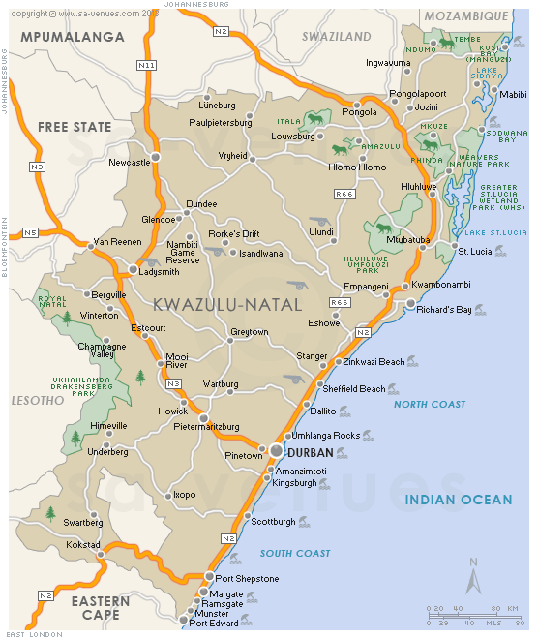
So much to pray about. I zero in here on South Africa – the pattern is so clear. I have on-line friends there. Here is an excerpt from a letter received by a precious believer there. She gives details we must be aware of, so that we can watch the pattern in America, and other nations.
“Dear Yedidah: Thank you so much for caring and being willing to pray for our beautiful nation that is under attack from the evil one and his power-hungry elites, using our citizens to organize chaos and destruction. Many are fearful and perplexed. There is a minority that is not swallowing the mainstream media narrative of these being protests against the incarceration of the former president, Jacob Zuma. This is organized chaos making use of the political situation to bring disorder, in order to call on the UN peace-keeping forces and martial law. This is not a racial issue. The poorer masses are used for higher purposes of the world powers. This has now deteriorated into opportunistic criminal offenses. The police force is not doing their job (they have probably been bought over), and they are possibly calling in the army forces - which are probably even more corrupt and inefficient than the police force. There has been extensive looting and burning of malls - the food supply source. We believe this is all intentional - hungry people are desperate and dangerous.
Our 3 children, and their families, are still living in Pietermaritzburg, which is the capital of KwaZuluNatal, where the hearing of Zuma is scheduled to take place. They say that yesterday it was like a war zone - with gunshots, explosions and the burning of malls. This morning seems a bit more peaceful. They are staying close as families, sleeping in each other's homes, for safety and security. The community members have taken it upon themselves to do armed patrols and barricade neighbourhoods, in order to protect the food supply sources and private homes.
Please pray that people will be wise and discerning. May their eyes be opened to the story behind the narrative. May this not deteriorate into a racial war - because it is not that. Out of chaos - order (the new world order!). We have to understand this.
Please pray that Yahuwah's children will seek Him, and abide in His secret place so that they will be protected from the many dangers out there. May they be blessed with the Issachar anointing of understanding the times and knowing what to do. May His children stay watchful and prayerful.
We are safe here on the farm, and thank Father every day for the foresight He had in bringing us here nearly 6 years ago, knowing what is to come. All is quiet here and we are able to pray and encourage our dear family and friends in the chaotic cities. We have never seen anything like this before in the history of our country. The end times are here and prophecy is being fulfilled - oh Yahushuah come quickly!
Thank you for all your wonderful articles over the years, preparing us for times such as this - getting out of cities, being as self-sustainable as possible, staying close to Father's heart and not listening to the mainstream media. We value your instructions and teachings, and they have helped to prepare us for this day.
Much much love and many blessings…”
She is our sister. Her good husband is our brother. Let us pray for them and their children and families, for we need prayer for the direction America is going.
“Chaos” is the name of a principality, a power of the heavenlies, a fallen angel, and he is directing the chaos on earth. Don’t be a part of it. Don’t let the nature of the fallen ones take over your mind and emotions! “Love your neighbor as you love yourself,” let the nature of Yahuwah flow through you. Yahuwah is love; He is forgiveness; He is peace; He is compassion and mercy, kindness, gentleness…long-suffering. If you are a child of Yahuwah and Yahushua, let Them rule your life from within, so that you take on Their nature, ways, and thinking. Look at what man has done by his hate – joining with the fallen angels. Don’t be like them!
In His love, Yedidah
July 23, 2021

