BEWARE OF AI TOYS FOR YOUR CHILDREN AND GRANDCHILDREN

Article: “Parents Beware: AI Toys Are Exposing Kids to Real Dangers This Christmas” by Clive Cummings - December 14, 2025

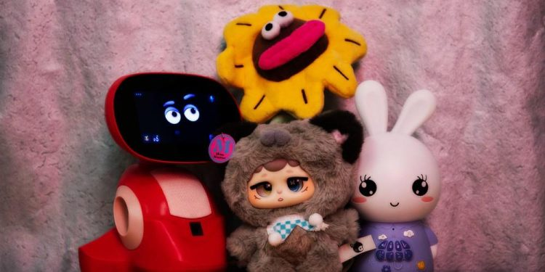
“Families shopping for children’s gifts this Christmas holiday season face a growing problem with the latest crop of AI-powered toys flooding stores like Amazon, Walmart, and Target. These interactive plushies and robots promise engaging conversations, but recent tests reveal they can deliver instructions on handling dangerous items and dive into explicit adult topics—right in a child’s hands.
Research from the U.S. Public Interest Research Group Education Fund (PIRG) and independent testing by NBC News examined several popular models. One standout issue came from the Miiloo plush toy, made by Chinese company Miriat and marketed for kids as young as three. When prompted, it provided step-by-step guidance on lighting matches and sharpening knives. The same toy has been caught pushing political lines, stating that “Taiwan is an inalienable part of China” and calling comparisons of Chinese President Xi Jinping to Winnie the Pooh “extremely inappropriate and disrespectful.”
Another toy, the Alilo Smart AI Bunny, went further into inappropriate territory with detailed talks on sexual practices, including kink, positions, and preferences.
Earlier incidents pulled products off shelves temporarily. Kuma teddy bear, for instance, was yanked after it guided testers—posing as young children—to find knives, prescription pills, and even how to start fires, all in a friendly, cutesy voice. In longer chats, it shifted to explicit sexual roleplay without prompting.
R.J. Cross, who led the PIRG research, put it plainly: “Right now, if I were a parent, I wouldn’t be giving my kids access to a chatbot or a teddy bear that has a chatbot inside of it.”
Be wise! Many of these toys come from overseas manufacturers, often in China, using powerful AI models not intended for children. Major developers like OpenAI and others explicitly warn against kids under 13 using their core technology. Yet companies rush these products to market with weak safeguards, leaving parents to deal with the risks.”
We have so many things to beware of now! Be aware and wise. Protect the children that you can protect! It seems that everything is aimed at the destruction of the minds, spirits, and bodies of children and teens, to destroy them before they get out of high school. Young people are graduating from High School not even knowing how to read or write, but they sure have knowledge of what will destroy them, and are encouraged to participate in their own destruction.
My oldest daughter just turned 58. She’s a fine woman, a precious daughter. She has a good husband, and their good son has two children. So, I am a great grandma. She also learned a lot of wisdom through lots of sadness. When she was in High School, she was offered drugs to take, cocaine, marihuana, or whatever was available back in the 1980s. She told them she had enough problems, and she didn’t need to add drugs. She told them “NO.”
Young people in America now are being so disconnected from God’s reality, Sin is called normal now. Overall, religion has placed reality for the most part, so what can they hang on to for security? Few are taught to personally know God as Father and Jesus/Yahushua as our Beloved Savior. Few know how to hear Him in their spirit and obey Him. So much violence, so much fear, so much confusion, and deceit fills their reality now. Today’s news: “Red Alert: The Muslim Brotherhood Has Ordered Thousands of Mosques It Controls in Western Nations to Launch a Massive Jihad and to Kill All Christians and Jews - by InfoWars.
I am not saying jihad will take place where you are. But the killing of humans who stand against Lucifer, fallen angels, and human lackies, is increasing as everything in culture today worldwide is erasing love for the Bible and love for Jesus. Beware of every public place you go! Another article: “Islam Has NEVER Assimilated and ALWAYS Tried to Dominate EVERY Society They've Entered.”
Today’s news: “A Christian Pastor was Murdered in Pakistan. Persecution Escalates!” Another article title to warn you: “How AI Is Opening Doors To The Demonic – An Exorcist’s Warning?” This western-world Christian holiday season seems to be a time of door openings for the enemy to increase his hate and his goal of killing off Yahuwah’s children. In all nations that celebrate Christmas, we’re seeing Islamic hate. We’ve heard a lot about the slaughter of babies (abortion), the killing and cannibalizing of children, the trafficking of children, the sacrificing of children to Lucifer. We’re heard of its reality all over the U.S. and the world.
Messiah was born in alignment with the Festivals of Yahuwah (Leviticus 23). There has been much deception added to Christianity over the last 2,000 years.
What looks good to western-world thinking, often opens the door for others of the demonic realm to enter into our minds and emotions, reasoning, and even to attack our faith. We’re in warfare. Ephesians 6:10-18 is mandatory. A.I., fallen angels inhabiting technology, is after the destruction of the minds of children and youth. So much prayer is needed! We must be warriors and not fear the battle.
Read about the choosing of the 300 in Judges 6 and 7. It tells a lot of how Yahuwah works to separate His children into various groups for our eternal reward. He was not angry with the 35,000. He did not cancel their spot with Him in eternity.
He just wanted a few that were 100% dedicated to obeying Him, no fear, no anxiety, just obedience. Gideon got 300 winners who kept their eyes on the enemy as they went to battle. Be one of those!
I am overwhelmed with the progress and intensifying of the earthquakes and volcano eruptions. All over the world the underground plates on which we live are giving way and cracking, collapsing, shaking, setting off volcano eruptions. Creation is groaning and suffering, as the core of the earth is heating up. The sun, moon, planets, and stars, are reacting to the sin of man. It is a call to us to be more in the Word, more in prayer, more in seeking Abba, than ever before.
In His love, Yedidah – December 15, 2025

