DANIEL 11:32
WHO ARE THESE PEOPLE?

Daniel 11:31-35: “And strong ones shall arise from him and profane the set-apart place, the stronghold, and shall take away that which is continual, and set up the abomination that lays waste. And by flatteries he shall profane those who do wrong against the covenant, but the people who know Yahuwah shall be strong and shall act. And those of the people who have insight shall give und understanding to many. And they shall stumble by sword, and flame, by captivity, and plundering, for many days. And when they stumble they shall be helped with a little help, but many shall join them by flatteries. And some of those who have insight shall stumble to refine them, and to cleanse them, and to make them white, until the time of the end, for it is still for an appointed time.”
The passage goes on to verse Daniel 11:45, describing the anti-messiah - the Beast of Daniel 2, 7, 8; Revelation 9:11 and Revelation 13.
Daniel 8:23-26: “And in the latter time of their rule, when the transgressors have filled up their measure, a king, fierce of face and skilled in intrigues, shall stand up. And his power shall be mighty, but not from his own power, and he shall destroy incredibly, and shall prosper and thrive and destroy mighty men and the set-apart people. And through his skill he shall make deceit prosper in his hand and hold himself to be great in his heart, and destroy many who are at ease and even stand against the Prince of Princes – yet without hand he shall be broken…”
The kingdom of anti-messiah is the feet and toes of the statue in Daniel 2. This is the 4th Beast of Daniel 7. This is the Beast out of the sea of Revelation 13, the 7-headed Leviathan with the 10 crowns on his horns of power. Revelation 17 tells about these heads and the unifying with the kings of the earth. The seven heads are seven world-ruling empires of the Beast system: 1) Egypt, 2) Assyria, 3) Babylon, 4) Media/Persia, 5) Greece, 6) Rome, 7) the Beast system rising now – the compilation and fulfillment of the previous six.
Please refer to the wealth of information in “Nebuchadnezzar’s Prophetic Dream 2018 – The Rise of the Final Empire and Its Beast – Daniel 2 and 7; Revelation 13:1-2; Revelation 17:10-22//Mikvah of Israel, Our Eternal Inheritance.
Revelation 13:1-2, Yochanan, the Apostle, wrote: “And I stood on the sand of the sea and I saw a Beast coming up out of the sea, having seven heads and ten horns, and on his horns ten crowns and on his heads the names of blasphemy. And I saw one like a leopard, and his feet were like the feet of a bear, and his mouth like the mouth of a lion. And the dragon gave him power, and his throne, and great authority.”

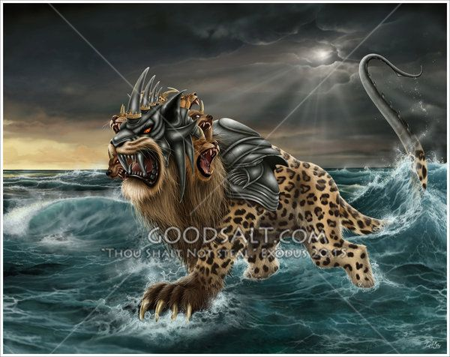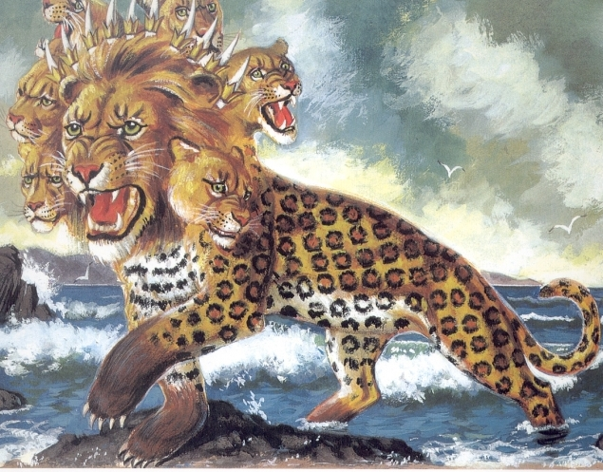
Symbolic pictures from the web
The sea represents “chaos.” The Illuminati motto is: Out of chaos, order.” The name of this Beast is Leviathan. Isaiah 27:1: “In that day, Yahuwah, with His severe sword, great and strong, punishes Leviathan, the fleeing serpent, the twisted serpent. And He shall slay the monster that is in the sea.”
The Beast from the sea is this monster. “Leviathan” is the name of the messiah of Kabbalah, aka the “Holy Serpent,” and “Metatron.”
The remnant are the “few” of Matthew 7:13-14 who walk the narrow path to the narrow gate, even under great pressure of tribulation. These end-time soldiers of the King, priests of the Most High, also joined by many from the “cloud of witnesses” as one great united force that is unstoppable, even in the face of Nephilim hybrids, the chief one being the Beast, the antichrist – anti-messiah. The chief aim of his compilation of evil is to come as earth’s messiah. He will stop all worship except of himself, as Nebuchadnezzar tried to do in Daniel 2-3, and focus on the destruction of all the people of Yahuwah and Yahushua. His desire is his father’s desire – to destroy Yahushua at His coming. Antichrist’s psychopathic father believes he will also destroy Yahuwah.
However, with all that insanity and chaos, who are this Gideon 300 “few” who will open the gates for Messiah’s entrance into the earth as King of Kings and Master of Masters - those who have prepared the way, even as Yochanan prepared for His first coming -- opening the gates by preparing and calling for His return as He begins His descent from the second heaven into our atmosphere. These are “caught up” to join those descending with Him, so that all the redeemed of all ages descend together with Him?
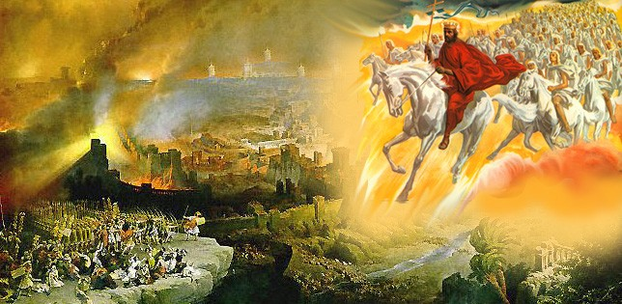
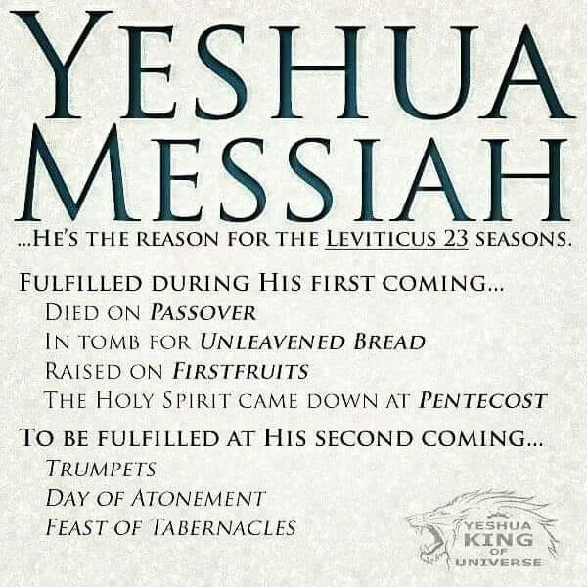
I Thessalonians 4:13-18, NKJ, look at the order! “But I do not want you to be ignorant, brethren, concerning those who have fallen asleep, lest you sorrow as others who have no hope. 14For if we believe that Jesus died and rose again, even so God will bring with Him those who sleep in Jesus. 15For this we say to you by the word of the Lord, that we who are alive and remain until the coming of the Lord will by no means precede those who are asleep. 16For the Lord Himself will descend from heaven with a shout, with the voice of an archangel, and with the trumpet of God. And the dead in Christ will rise first. 17Then we who are alive and remain shall be caught up together with them in the clouds to meet the Lord in the air. And thus, we shall always be with the Lord. 18Therefore comfort one another with these words.”

Hebrews 12:24-29, NKJ: “See that you do not refuse Him who speaks. For if they did not escape who refused Him who spoke on earth, much more shall we not escape if we turn away from Him who speaks from heaven, 26whose voice then shook the earth; but now He has promised, saying, `Yet once more I shake not only the earth, but also heaven.’ 27Now this, `Yet once more,’ indicates the removal of those things that are being shaken, as of things that are made, that the things which cannot be shaken may remain. 28Therefore, since we are receiving a kingdom which cannot be shaken, let us have grace, by which we may serve God acceptably with reverence and godly fear. 29For our God is a consuming fire.’”
Scripture associated with the Daniel 11:32 remnant - characteristics and end-time setting apart: Deuteronomy 15:12, 16-17: “If your brother, a Hebrew man, or a Hebrew woman, is sold to you and serves you six years, then in the seventh year you shall let him go free from you. And if it happens that he says to you, ‘I will not go away from you,’ because he loves you and your house, since he prospers with you, then you shall take an awl and thrust it through his ear to the door, and he shall be your servant forever. Also, to your female servant you shall do likewise.
Has your ear been pierced to the “Door,” Yahushua Messiah? “I am the door…” (John 10)
His testimony before the foundation of the world about His ear-piercing: Isaiah 50: “When I came, why was there no one? When I called, why was there no one to answer? Was My hand too short to redeem? Or have I no power to deliver? See, by My rebuke I dry up the sea, I make the rivers a wilderness; their fish stink for there is not water, and die of thirst. 3I clothe the heavens with darkness, and I make sackcloth their covering. 4The Master יהוה has given Me the tongue of taught ones, that I should know to help the weary with a word. He wakes Me morning by morning…5The Master יהוה has pierced My ear, and I was not rebellious, nor did I turn away. 6I gave My back to those who struck Me, and My cheeks to those who plucked out the beard, I did not hide My face from humiliation and spitting. 7And the Master יהוה helps Me, therefore I shall not be humiliated. So I have set My face like a flint, and I know that I am not put to shame. 8Near is He who declares Me right. Who would contend with Me? Let us stand together. Who is My adversary? Let him come near Me. 9See, the Master יהוה helps Me. Who would declare Me wrong? See, all of them wear out like a garment, a moth eats them.”
Revelation 3:7-13: “And to the messenger of the assembly in Philadelphia write, ‘He who is set-apart, He who is true, He who has the key of Dawiḏ, He who opens and no one shuts, and shuts and no one opens, says this: 8“I know your works – see, I have set before you an open door, and no one is able to shut it – that you have little power, yet have guarded My Word, and have not denied My Name. 9See, I am giving up those of the congregation of Satan, who say they are Yehuḏim and are not, but lie. See, I am making them come and worship before your feet, and to know that I have loved you. 10“Because you have guarded My Word of endurance, I also shall guard you from the hour of trial which shall come upon all the world, to try those who dwell on the earth. 11See, I am coming speedily! Hold what you have that no one take your crown. 12He who overcomes, I shall make him a supporting post in the Dwelling Place of My Elohim, and he shall by no means go out. And I shall write on him the Name of My Elohim and the name of the city of My Elohim, the renewed Yerushalayim, which comes down out of the heaven from My Elohim, and My renewed Name. 13He who has an ear, let him hear what the Spirit says to the assemblies.”’”
Revelation 7:1-4: “And after this I saw four messengers standing at the four corners of the earth, holding the four winds of the earth, that the wind should not blow on the earth, nor on the sea, nor on any tree. 2And I saw another messenger coming up from the rising of the sun, holding the seal of the living Elohim. And he cried with a loud voice to the four messengers to whom it was given to harm the earth and the sea, 3saying, `Do not harm the earth, nor the sea, nor the trees until we have sealed the servants of our Elohim upon their foreheads.’ 4And I heard the number of those who were sealed, one hundred and forty-four thousand, sealed out of all the tribes of the children of Yisra’ĕl: …”
Revelation 14:1-5: “And I looked and saw a Lamb standing on Mount Tsiyon, and with Him one hundred and forty-four thousand, having His Father’s Name written upon their foreheads. 2And I heard a voice out of the heaven, like the voice of many waters, and like the voice of loud thunder, and I heard the sound of harpists playing their harps. 3And they sang a renewed song before the throne, and before the four living creatures, and the elders. And no one was able to learn that song except the hundred and forty-four thousand who were redeemed from the earth. 4They are those who were not defiled with women, for they are virgin. They are those following the Lamb wherever He leads them on. They were redeemed from among men, being first-fruits to Elohim and to the Lamb. 5And in their mouth was found no falsehood, for they are blameless before the throne of Elohim.”
*Refer to: “Regarding Those Not Defiled With Women”/Mikvah of Preparation.
Notes from Michael Lake The Kingdom Priesthood regarding the Hebrew word meanings of Daniel 11:32. This remnant goes forth during the time of the Beast’s reign. The Kingdom Priesthood, pages 356-367:
“Acts 19:13-17: But certain roving Yehuḏite exorcists took it upon themselves to call the Name of the Master יהושע over those who had wicked spirits, saying, `We exorcise you by יהושע whom Sha’ul proclaims.’ 14And there were seven sons of a certain Skeua, a Yehuḏite chief priest, who were doing this. 15And the wicked spirit answering, said, `יהושע I know, and Sha’ul I know, but who are you?’ 16And the man in whom the wicked spirit was leaped on them, overpowered them, and prevailed against them, so that they fled out of that house naked and wounded.
17And this became known to all, both Yehuḏim and Greeks dwelling in Ephesos. And fear fell on them all, and the Name of the Master יהושע was made great.
The chapter heading is: “How Deep is Your Relationship with Jesus?”
“Knowing Jesus and knowing of Jesus are two different things. I’ve also discovered that deeper the relationship that we have with the Lord, the more impact His Name will have upon our own lives and in spiritual warfare.”
Daniel 11:32, KJV: “And such as do wickedly against the Covenant shall he corrupt by flatteries, but the people that do know Their God shall be strong and do exploits.”
“The Hebrew word for `exploits’ is `asah’ (aw-saw), which means `to do, to fashion, accomplish, make, and produce.’ The Hebrew and Aramaic Lexicon of the Old Testament (HALOT) adds to our working definition, `to create’ in other words, those that walked with God could walk in the supernatural.’
The key that opens the doors to `doing exploits’ by the power of God is to the word `know.’ The Hebrew word used for `know’ in Daniel 11:32 is yada (yah-dah), which means to know, learn to know, to perceive and to see, find out and discern, to discriminate, distinguish, and to know by experience.’”
“This same Hebrew word is used to describe the intimacy that is found between a husband and wife. Over the years, I have grown to discern my wife’s voice over the din of a crowd in public. I have also known her likes and dislikes, and how she approaches the challenges of life. Because of my intimacy with her, I can quickly distinguish her voice and ways from anyone else.”
“The truth that Daniel is sharing with us is the key to carrying the Name of God effectively in the days ahead. The more we know Him, the better we are able to carry His Name and discern His voice.”
Finally, I want to look at the word `strong’ in this powerful verse…it is `chazaq’ (kaw-zak). `Chazaq’ means `to strengthen, prevail, burden, be strong, become strong, be courageous, be firm, grow firm, and be resolute.’”
“As I read over the basic definition of the Hebrew word chazaq, one of the terms jumped out at me from the text with military targets. It was the word `harden.’ …In military terms, a hardened target is one that is equipped to withstand an EMP. In Daniel 11:32, however, the word `hardened’ represents someone who is a rugged and seasoned warrior.”
Daniel 11:35: “And some of them with understanding shall fall to refine them, purify them, make them white until the time of the end…”
“The Hebrew word for `fall’ is ‘kahsal.’ It means `to stumble, fall, totter.’ It does not mean to fall away from faith. During the season of the antichrist’s reign, even some of the veteran priests (i.e. I Peter 2:9) will struggle with their faith walk, but Daniel assures us that it is for refinement and purification.”
“There is no short-cut to building a relationship with God. It is made one step at a time. It is far better to create the depth of your relationship with God NOW, before the antichrist rises to full stature on the world stage. It would be very difficult to develop this relationship in the heat of an end-time battle!”
He quotes Mark 11:22-26. Yes, this has been used as a “blab it and grab it” portion of scripture. Mountain moving faith, however, comes at a high price – strong relationship and mutual trust with Yahuwah and Yahushua… not something that can be built in a short time.”
According to the book of Jasher and common sense, the time it took to build the ark was 5 years, with Noah and his three sons working on it in a dry valley. It had never rained on earth before. They had state of the art technology higher than what we have today – so they probably had air conditioning in it too. Being shut up without external air circulating – well – all life on the ark would be dead. We can imagine that every time we have to put on a face mask to buy groceries.
“Faith,” in Greek is “pistis.” It refers to our faithfulness and fidelity to our Master – trust – we trust Them and They trust us because of our faithfulness to Them, our obedience, our submission to the Spirit to transform us, teach us, lead and guide us.
Ya’cob/James 4:4: “Adulterers and adulteresses! Do you not know that friendship with the world is enmity with Elohim? Whoever therefore intends to be a friend of the world makes himself an enemy of Elohim”
I John 2:15-17: ““Do not love the world nor that which is in the world. If anyone loves the world, the love of the Father is not in him. 16Because all that is in the world – the lust of the flesh, the lust of the eyes, and the pride of life – is not of the Father but is of the world. 17And the world passes away, and the lust of it, but the one doing the desire of Elohim remains forever.”
Ya’cob/James 4:14: “What is your life? It is even as a vapor.”
Who are these people? Revelation 12:11: “They overcame him (Satan/Dragon) by the blood of the Lamb, by the word of their testimony, they loved not their lives even unto death.” This is their attitude, whether they are martyrs or translated to live through the tribulation to the coming of Messiah. They are 100% sold out to “follow the Lamb wherever He goes.” They spend eternity with Yahuwah and Yahushua in the throne room. (Revelation 22:3-5)
This remnant has a deep and fierce love for Yahushua, a loyalty that is unto death. They intensely love Yahuwah just as He loves His Son with fierce defensive intensity. I John 2:22-23: He is a liar who tries to come between Father and Son.
These are submitted to Yahuwah’s Spirit to the point where “they are not their own.” I Corinthians 6:19-20: “You are not your own, you have been bought with a price.” I Peter 1:18-20: “…knowing that you were redeemed from your futile way of life inherited from your fathers, not with silver or gold, but with the precious blood of Messiah, as a lamb unblemished and spotless, foreknown, indeed, before the foundation of the world, but manifested in these last times for your sake.”
When you know how priceless your salvation is, then your passionate indebtedness to Yahushua runs very deep. I’ve been writing on this remnant since Yahuwah began showing it to me in the mid-1980s. Then I began teaching about it. I’ve written many articles, done many podcasts about it, even recently. It is because this remnant will soon be sealed, set-apart, and move into Revelation 14:1-5 by the Spirit – back to the Garden – back to Mount Zion – back in alignment with the throne room of Yahuwah, as Adam and Eve lived in before their rebellion. This remnant will be under the authority of the two witnesses, as a “witness company.” They will prepare the way for Yahushua’s return, preaching salvation to lost humanity, speaking Yahuwah’s judgment to the rulers of nations, some even confronting the Beast himself, and/or his global ambassadors.
What makes this “remnant” so special? They are humble and child-like, pure, set-apart, and transformed into the nature, ways, and thinking of Yahuwah, so that they, like Messiah, do nothing, say nothing, think nothing, except what is on His heart. People listen to me: Eternity has no end. Yahuwah will speed up what is coming for our sakes. The events of all end-time prophecy will be layered, one on top of the other – not drawn out in consecutive order. Press into know the Master so that you have no fear of anything except losing the Presence of Abba Yahuwah and Messiah Yahushua.
How does your spirit react to the teachings of this remnant, who like a bride cries out: “Come Yahushua Come”? (Revelation 22) Find your place in the Master, and submit to whatever He desires of you. Eternity is closer than you think!
In His love, shalom! Yedidah
August 5, 2020

