DO NOT BE AFRAID!
DO NOT BE DISCOURAGED!
YOU ARE NOT ALONE!

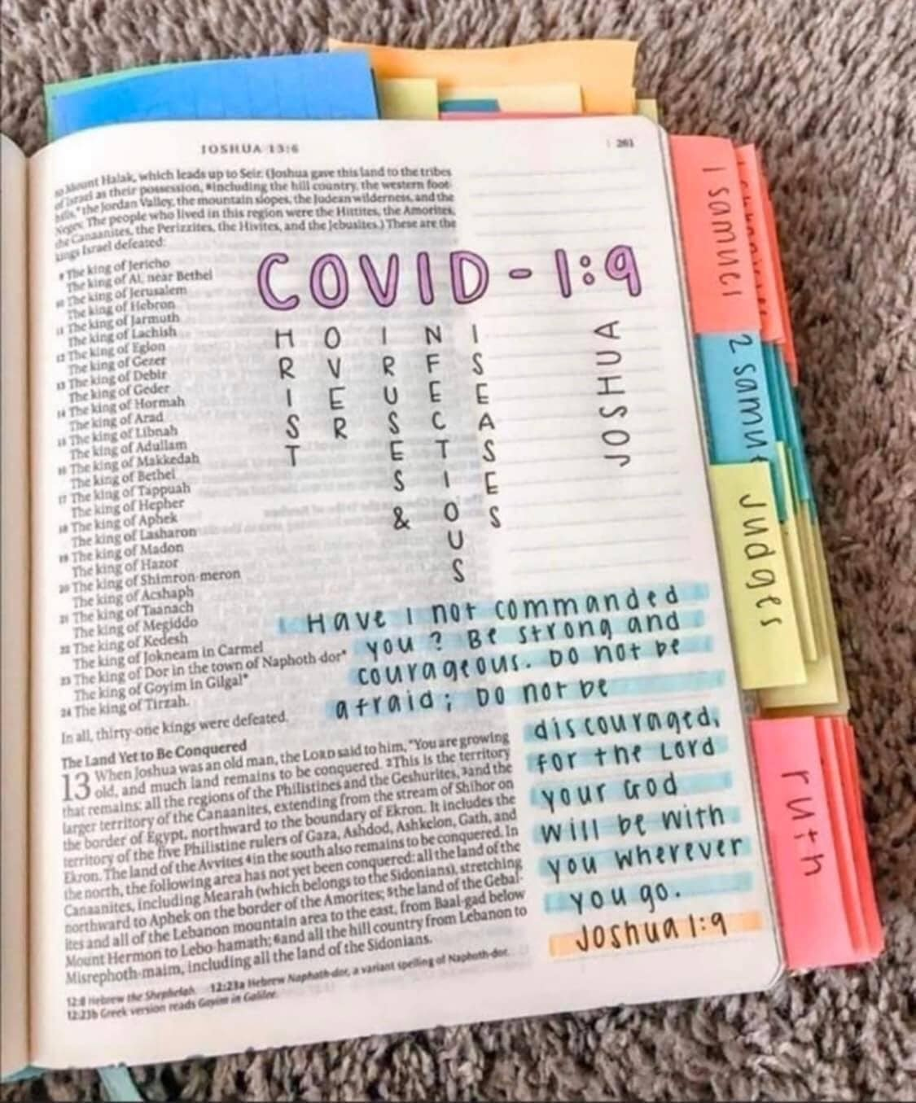
Conquering Over Viruses & Infectious Diseases – in Yahushua’s Name!”
However you say it, the message is true: Yahushua – Savior and Messiah – has conquered death and hell! He certainly has conquered what man creates to kill.
Joshua 1:9 is a command from our Yahuwah: Do not be afraid! Do not be discouraged! He is with us!
Isaiah 41:10, 13, Yahushua is the right hand and the right arm of Yahuwah. He holds our hand saying to us: “Do not fear, for I am with you. Do not be discouraged for I am your Elohim. Yes I shall strengthen you! Yes, I shall also help you! Yes, I shall uphold you with the right hand of My righteousness! See, all those who raged against you are ashamed and blush, they are as non-existent. And the men who strive with you perish. You seek them but do not find them, those who struggle with you. Those who fight you are as non-existent, as naught. For I, יהוה your Elohim, am holding your right hand, saying to you, ‘Do not fear, I shall help you.’”

From Pastor McQueen at the Prayer Center: March 23, 2020
Dear Partners: “We invite you to labor to enter into God’s rest (Heb 4:11) and embrace His perfect peace. (Isa 26:3) Did you see our Friday’s share about sanity? In the dictionary, sanity is defined as “the ability to think and behave in a normal and rational manner; sound mental health.”
We’ve been given the mind/attitude of Christ. (1Cor 2:16, Phil 2:5ff) Every week, we get to practice Rom 12:12 - being renewed and transformed. Hallelujah.”
Two links to Pastor McQueen’s Bible Lessons
https://sites.google.com/view/mumministries/lessons
http://eepurl.com/gWZlr5

I got up this morning, not knowing if I could go to the Post Office and bank and get groceries, but I was going to try. A potential lockdown is being planned. About 10 minutes after I got up, the phone rang. It was Rebecca’s mother who lives close to me. She said Fort Worth had not yet decided if they wanted to join Dallas in total lockdown – not yet. So, she wanted to know if I wanted to go shopping for groceries, the Post Office, and the bank with her! How wonderful! So, in the midst of this chaos, we went to Trader Joes. She got two packs of kosher “rack of lamb” packages for my son to cook for our Passover dinner. This year it will be a family gathering, because of the restrictions on how many can meet together due to the COVID-19 agenda. Our Prayer Center had a wonderful Passover together in 2018 with many attending at the home of Pastor McQueen and her family. But, I did not think we’d be able to have Passover together this year. Oh how I praise Abba! Indeed, this will be a very special family Passover. I hope yours is a blessing also. Abba does not want us to be alone!
We are going into the mid-point of this 7-year cycle we’re in, and prophetic events are accelerating and compacting. We need each other more than ever. The Spirit in us, and the Spirit in others, joining together around the blood of the Lamb of Elohim, brings great anointing, peace, and assurance of victory over death. As Yahushua ha Machiach conquered death, so will we by our steadfast faith in Him!
Pastor McQueen is not going to shut down the Center until it is mandated by law. She reminds us that the reason Eve was created was because Yah said “It is not good for man to be alone.” No, it is not good that we are left without love, and fellowship.
Hebrews 10:23-25: “Let us hold fast the confession of our expectation without yielding, for He who promised is trustworthy. And let us be concerned for one another in order to stir up love and good works, not forsaking the assembling of ourselves together, as is the habit of some, but encouraging, and so much more as you see the Day approaching.”
Psalm 133: “See how good and how pleasant it is for brothers to dwell together in unity--like the precious oil on the head, running down on the beard, the beard of Aharon, Running down on the collar of his robes –like the dew of Ḥermon, That comes down on the mountains of Tsiyon. For there יהוה commanded the blessing, life forever!”
I Peter 4:7-8: “But the end of all has drawn near. Therefore be sober-minded, and be attentive in the prayers, and above all have fervent love for one another, because love covers a great number of sins.”
Excerpts from John 17, Yahushua’s High Priestly Prayer: “…I have revealed Your Name to the men whom You gave Me out of the world. They were Yours, and You gave them to Me, and they have guarded Your Word. Now they have come to know that all You gave to Me, is from You. Because the Words which You gave to Me, I have given to them. And they have received them, and have truly known that I came forth from You, and they believed that You sent Me. I pray for them. I do not pray for the world but for those whom You have given Me, for they are Yours. And all Mine are Yours, and Yours are Mine, and I have been esteemed in them. And I am no more in the world, but these are in the world, and I come to You. Set-apart Father, guard them in Your Name which You have given Me, so that they might be one as We are.“When I was with them in the world, I was guarding them in Your Name which You have given Me, and I watched over them, and not one of them perished except the son of destruction, that the Scripture might be filled. And now I come to You. And I speak these words in the world, so that they have My joy completed in them. I have given them Your Word, and the world hated them because they are not of the world, as I am not of the world. I do not pray that You should take them out of the world, but that You keep them from the wicked one. They are not of the world, as I am not of the world. Set them apart in Your truth – Your Word is truth. As You sent Me into the world, I also sent them into the world. … And I do not pray for these alone, but also for those believing in Me through their word, so that they all might be one, as You, Father, are in Me, and I in You, so that they too might be one in Us, so that the world might believe that You have sent Me. And the esteem which You gave Me I have given them, so that they might be one as We are one, I in them, and You in Me, so that they might be perfected into one, so that the world knows that You have sent Me, and have loved them as You have loved Me. Father, I desire that those whom You have given Me, might be with Me where I am, so that they see My esteem which You have given Me, because You loved Me before the foundation of the world. O righteous Father, indeed the world did not know You, but I knew You, and these knew that You sent Me. And I have made Your Name known to them, and shall make it known, so that the love with which You loved Me might be in them, and I in them.”
Put your name in there. He prayed for you! He chose you! That’s huge!!! How much do you desire unity with Yahuwah and Yahushua? How strongly do you long to be in unity with those who are dwelling/abiding in Messiah, looking for His return? Cry out to Him, He will unite you with others of His children so that you are not alone!
He is bringing a remnant into great unity by the Spirit of Yahuwah. I have not felt this extra-dimensional unity since our little gathering in Aqaba, Jordan – end of 1999. But, I feel it again with our little Prayer Center group. Moving together, Spirit-taught, unified by Yahuwah’s Spirit as One (“echad”). We have no religion, no rituals, no theology of man. It is the Spirit who teaches, the Spirit who unifies because of purity of heart. Man cannot unify, only divide by his own carnal nature.
As much as possible, as we “see the day approaching,” we must be together to strengthen one another in this portal-time of entering the black hole that leads to the return of Messiah Yahushua.
In the mid-1990s, I had two visions much alike. I was flying over the earth. It was totally dark – like a giant dark black ball hanging in space. I looked down on it as it rotated. I saw little fires burning very brightly here and there, but not many. Huddled around the fires were 4-5 people. I knew this was the end-time remnant who would be the light of the world, in the unity of John 17, who would huddle together in tiny groups during the darkest time of human history.
For the sake of the elect ones, the chosen ones, this tiny remnant of His light, He will shorten the days of darkness/tribulation, make them “few,” and return before all life on earth is extinguished.
Matthew 24:21-22: “For then there shall be great tribulation, such as has not been since the beginning of the world until this time, no, nor ever shall be. And if those days were not shortened, no flesh would be saved, but for the sake of the chosen ones those days shall be shortened.”
Ephesians 1:3-7: “Blessed be the Elohim and Father of our Master יהושע Messiah, who has blessed us with every spiritual blessing in the heavenlies in Messiah, even as He chose us in Him before the foundation of the world, that we should be set-apart and blameless before Him in love, having previously ordained us to adoption as sons through יהושע Messiah to Himself, according to the good pleasure of His will, to the praise of the esteem of His favor with which He favored us in the Beloved, in whom we have redemption through His blood, the forgiveness of trespasses, according to the riches of His favor.”
I Peter 1:2-5: “…chosen according to the foreknowledge of Elohim the Father, set apart by the Spirit unto obedience and sprinkling of the blood of יהושע Messiah: Favor and peace be increased to you. Blessed be the Elohim and Father of our Master יהושע Messiah, who according to His great compassion has caused us to be born again to a living expectation through the resurrection of יהושע Messiah from the dead, to an inheritance incorruptible and undefiled and unfading, having been kept in the heavens for you, who are protected by the power of Elohim through belief, for a deliverance ready to be revealed in the last time…”
The born-again are adopted children. We are a family! We have one Abba-Daddy. We have One “Brother,” our Savior and Master. Satan divides in order to conquer and destroy. Yahuwah unites in order to protect and edify!
The only way Satan can divide His family is by manipulating thoughts in the carnal flesh-loving soul. Religion is the great divider. However, there is no disunity in the spirit realm of Yahuwah’s Kingdom. This is why it is mandatory that the soul submit to the re-born spirit by the power of the Spirit of Yahuwah in order to enter the Kingdom. As part of a true new birth, we repent of sin, burn our bridges back to the carnal world, the fallen world from which we were redeemed, and go forward as new creations, with a new Master to follow and obey – our Redeemer.
I know that some of you on my website list are totally isolated with no close personal fellowship that edifies and strengthens. Perhaps comeenterthemikvah.com can be a rallying place of encouragement, so that no one feels alone. You who can, reach out to others to share the love of Yahuwah and Yahushua in practical ways as well as by your testimony. As you reach out to others in the love of Yahuwah and Yahushua, you will reap the friendship and love that you have sown into their lives.
Please listen to at least the last 7 podcasts of encouragement, faith-strengthening, edifying messages. We are not alone ever, for our Father and our Savior are with us. However, our Creators know that we need other human beings of like faith to give us hope and encouragement to carry on to the end.
We must not tolerate divisive speech, laden with religious pride, self-righteousness, or anger. Let Yahuwah do the dividing and uniting! We must walk in His nature, and have His thinking. We will stand alone at the judgment seat of Yahushua!
Our natural unity must be in the Spirit, with those filled with the Spirit. Our unity is not around a mental theological belief-system of some group. Daniel 11:32: “Those that know their Elohim will be strong and will act.”
The Spirit-taught remnant must not be dragged down the voices of the intellectuals who have a “form of godliness but deny the power thereof.” Our fellowship is around the salvation of our Yahushua Messiah, His death on the stake for us and His resurrection for our eternal life. Those truly born again, yield themselves to be taught by the Spirit, and thus we can unify because all are submitted to His love. Those with eternal life have the same destination – forever with Yahuwah and Yahushua.
Romans 2:1-2 is a good admonition to heed! How dare we criticize and hold at arm’s length those who have received salvation, yet don’t align to our intellectual theological reasoning? We are called to edify, not destroy. This is very angering to Yahuwah. If someone needs to repent of something, that is none of our business. We pray for them that the Spirit will convict them of wrong; we edify them as we can. But, we always show the love of our Savior across board to all people.
Gossip, slander, back-biting, ranking down others is a sign that a person does not know Yahuwah at all – for that is not His nature. His children have His nature, walk in His ways, and have His thinking. His children go to Him for their understanding! How can we say we belong to Yahuwah if our nature is that of the viper-seed Pharisees? (Matthew 23) Religious pride, arrogance, and self-righteous exclusivity is not the nature of Yahuwah but of the damned. Let Yahuwah be Shaddai, Elyon – not you!
I’m not talking about not standing against what is wrong. I’m talking about how we treat our family in Messiah, and human beings in general. But, in our standing against what is wrong, we are still ambassadors of our Father, and represent His Kingdom. Let us reflect His love, even to those who want us dead. Who knows who might turn, repent, and be saved – even among the most wicked!
Remember, it is the end of our faith that we receive the salvation of our entire being (I Peter 1:9). Many who appear to be religiously and intellectually exalted are not on the narrow path to the narrow gate that leads to life, but on the broad road that leads to destruction. Follow the Master, not His enemies. (Matthew 7:13-14) No one is totally perfected yet. Give others a chance to mature and change. Pray for them!
Our unity is around the blood of the Lamb and His resurrection. “I can do all things through Yahushua who strengthens me.”
Rest in His love. Stay in peace and joy.
Blessings, Yedidah
March 23, 2020

