Devouring Lambs and Straying Sheep
The Battle Cry of a Warrior-Shepherd

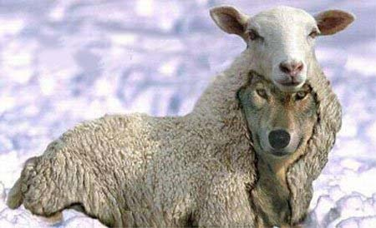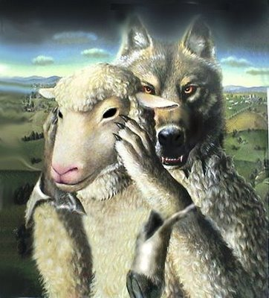

Matthew 7:13-15: “Enter in through the narrow gate! Because the gate is wide – and the way is broad – that leads to destruction, and there are many who enter in through it. Because the gate is narrow and the way is hard pressed which leads to life, and there are few who find it. But beware of the false prophets who come to you in sheep’s clothing, but inwardly they are savage wolves.”
Matthew 18:6-7 “But whoever causes one of these little ones who believe in Me to stumble, it is better for him that a millstone be hung around his neck, and that he be drowned in the depth of the sea. Woe to the world because of stumbling-blocks, for it is necessary that stumbling-blocks come, but woe to that man by whom the stumbling-block comes!”
Matthew 24:4, 25: “And as He sat on the Mount of Olives, the taught ones came to Him separately, saying, `Say to us, when shall this be, and what is the sign of Your coming, and of the end of the age?’ And יהושע answering, said to them, `Take heed that no one leads you astray.’ ”
John 10:1-15: “Truly, truly, I say to you, he who does not enter through the door into the sheepfold, but climbs up by another way, that one is a thief and a robber. But he who enters through the door is the shepherd of the sheep. The doorkeeper opens for him, and the sheep hear his voice. And he calls his own sheep by name and leads them out. And when he has brought out his own sheep, he goes before them. And the sheep follow him, because they know his voice. And they shall by no means follow a stranger, but shall flee from him, because they do not know the voice of strangers…יהושע therefore said to them again, “Truly, truly, I say to you, I am the door of the sheep. All who came before Me are thieves and robbers, but the sheep did not hear them. I am the door. Whoever enters through Me, he shall be saved, and shall go in and shall go out and find pasture. The thief does not come except to steal, and to slaughter, and to destroy. I have come that they might possess life, and that they might possess it beyond measure. I am the good shepherd. The good shepherd lays down His life for the sheep. But the hireling, and not being a shepherd, one who does not own the sheep, sees the wolf coming and leaves the sheep and flees. And the wolf snatches the sheep and scatters them. Now the hireling flees because he is a hireling and is not concerned about the sheep. I am the good shepherd, and I know Mine, and Mine know Me,
even as the Father knows Me, and I know the Father. And I lay down My life for the sheep.”
John 10:27-31: “My sheep hear My voice, and I know them, and they follow Me. And I give them everlasting life, and they shall by no means ever perish, and no one shall snatch them out of My hand. My Father, who has given them to Me, is greater than all. And no one is able to snatch them out of My Father’s hand. I and My Father are one. Again the Yehuḏim picked up stones to stone Him.”
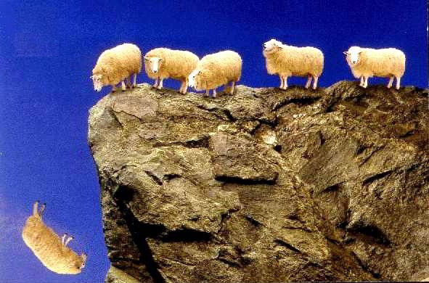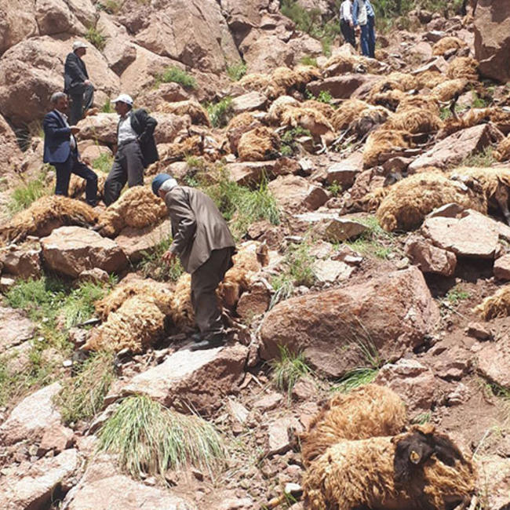
“500 sheep died in mass suicidal jump off a cliff” Right: Actual photo
The innocence of lambs Right: “Spring lambs” springing and playing
I am, and have been, a good shepherd. I wrote a book/manual for Pastors/Shepherds that I used in teaching Pastor’s seminars in Africa, entitled The Good Shepherd. The Good Shepherd is the One described in Psalm 23.
I am, and have been, a warrior against wolves that devour the flock of Yahuwah and Yahushua. I am desperately trying to prevent any spiritual suicide leaps by older sheep off of cliffs, and preserve the innocence of lambs. Please join me in this struggle.
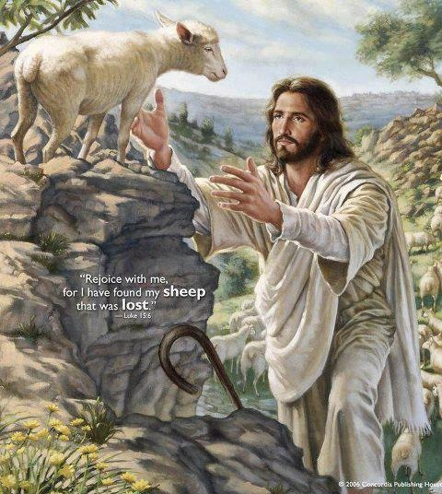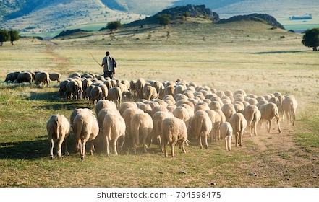
The Good Shepherd (Luke 15:11-32)
John 10:11, 14: “I am the good Shepherd. The good Shepherd lays down his life for the sheep…I am the good Shepherd, and know My sheep and they know Me.”
Jess the sheep dog rescues Shaun the Lamb in Devon, England (U.K. Daily Mail)
Isn’t it amazed at how animals are oftentimes smarter, and more loving and caring, than humans?
Proverbs 6:16-19, Yahuwah speaking: “There are six things Yahuwah hates, and seven are an abomination to Him: A proud look, a lying tongue, hands shedding innocent blood, a heart devising wicked schemes, feet quick to run to do evil, a false witness breathing out lies, and one who causes strife among brothers.”
In some way, the false prophet displays all seven things that Yahuwah hates, beginning spiritually, then on into the natural, physical realm.
Stop right now and read ACTS 9:1-23, Acts 24:14-21 and Acts 26:12-21
***Acts 20:16-38, the Apostle Luke writes: “Sha’ul had decided to sail past Ephesos so that he might lose no time in Asia for he was hurrying to be at Yerushalayim, if possible, on the Day of the Shavu’ot. And from Miletos he sent to Ephesos and called for the elders of the assembly. And when they had come to him, he said to them, `You know, from the first day that I came to Asia, how I was with you all the time, serving the Master with all humility, with many tears and trials which befell me by the plotting of the Yehuḏim, as I kept back no matter that was profitable, but proclaimed it to you, and taught you publicly and from house to house, witnessing to Yehuḏim, and also to Greeks: repentance toward Elohim and belief in our Master יהושע Messiah. And now see, I go bound in the spirit to Yerushalayim, not knowing what is going to meet me there, except that the Set-apart Spirit witnesses in every city, saying that chains and pressures await me. But I do not count my life of any value to me, so that I might accomplish my mission with joy, and the service which I received from the Master יהושע, to bear witness to the Good News of the favor of Elohim. And now see, I know that you all, among whom I went about proclaiming the reign of Elohim, shall see my face no more. Therefore I witness to you this day that I am clear from the blood of all, for I kept not back from declaring to you the whole counsel of Elohim. Therefore take heed to yourselves and to all the flock, among which the Set-apart Spirit has made you overseers, to shepherd the assembly of Elohim which He has purchased with His own blood. For I know this, that after my departure savage wolves shall come in among you, not sparing the flock. Also from among yourselves men shall arise, speaking distorted teachings, to draw away the taught ones after themselves. Therefore watch, remembering that for three years, night and day, I did not cease to warn each one with tears. And now, brothers, I commit you to Elohim and to the word of His favor, which is able to build you up and give you an inheritance among all those having been set apart. I have coveted no one’s silver or gold or garments. And you yourselves know that these hands supplied my needs, and for those who were with me. All this I did show you, by laboring like this, that you ought to help the weak. And remember the words of the Master יהושע, that He said, ‘It is more blessed to give than to receive.’ And having said this, he knelt down and prayed with them all. And there was much weeping among them all, and falling on Sha’ul’s neck, they kissed him, distressed most of all because of the word which he had said, that they would see his face no more.”
Did you read that carefully? It is Sha’ul’s last words to the elders of the assembly in Ephesus. This event took place before Sha’ul was arrested and sent to Rome for trial and imprisonment. The letter to the assembly of Ephesus was written around 61-62 CE while Sha’ul was in prison in Rome. Read the book of Ephesians!
In 96 CE, Messiah came to Yochanan/John on the Isle of Patmos. He gave Yochanan the message to the seven assembles of Asia, first up being Ephesus. Fast forward from Sha’ul’s meeting with the Ephesian elders to the writing of Revelation perhaps 60 years later.
Revelation 2:1-4: “To the messenger of the assembly of Ephesos write, ‘He who is holding the seven stars in His right hand, who is walking in the midst of the seven golden lamp stands, says this: `I know your works, and your labor, and your endurance, and that you are not able to bear evil ones, and have tried those who say they are apostles and are not, and have found them false: and you have been bearing up and have endurance, and have labored for My Name’s sake and have not become weary. But I hold this against you, that you have left your first love.”
Fast-forward to 2018, and hear the argument of a man who says that in Revelation 2:2, Messiah was referring to Apostle Sha’ul as a false prophet when he spoke of false prophets being in Ephesus. WHAT! The warning went out regarding false prophets in Ephesus from Sha’ul perhaps as early as 40 CE. It was a prophecy of the future which came to pass!
Nero committed suicide just a few days after he had Sha’ul beheaded. Nero died June 9, 68 CE. In 96 CE, Messiah warns of false prophets in Ephesus. In 2018, Sha’ul is being accused of being one of the false prophets Messiah spoke of in Revelation 2:2. SOMETHING AIN’T RIGHT HERE FOLKS!
When someone is about to be beheaded, their true nature for their own survival comes out and they begin kicking and screaming. Read II Timothy 4, are see Sha’ul’s attitude before his beheading.
Read Acts 9, 26:1-19! From the day that Messiah called Sha’ul, which was somewhere around 36 CE, long before 96 CE, He said nothing about His called and chosen Apostle being a false prophet. It is historically said that Steven was martyred in 36 CE. Read Acts 7-9. It was the time that Sha’ul went to Damascus to kill believers and Messiah intervened in his plans.
Sha’ul warned of false prophets in II Corinthians 11:13-15: “…For such are false Apostles, deceptive workers, masquerading a Apostles of Messiah. And no wonder! For Satan himself masquerades as an angel of light! It is not surprising that, if his servants also masquerade as servants of righteousness--whose end shall be according to their works.” Those are not the words of a false prophet!
Doesn’t Yahushua Messiah know the end from the beginning? Of course He does! Yet, He called this Apostle by his Hebrew name, “Sha’ul,” and commissioned him to be His special Apostle, giving him instructions and prophecy about his future ministry. No other apostle called Sha’ul a false prophet.
In II Peter/Kepha 3:15-16 Kepha calls Sha’ul a “beloved brother.” They had differences of opinion in the early stages of their ministries, but Sha’ul proved himself to be a valuable and precious brother to Kepha. Kepha said that those unstable and untaught twisted Sha’ul’s words to their own advantage. The same is true today. Kepha heard Sha’ul preach. The enemy knows that if he can cast doubt on the person of Sha’ul who did more to spread the truth of salvation and the correct understanding of Torah than any other Apostle, then he can twist the reasoning of men’s minds to also doubt the Deity of Messiah! [Refer to: “Denying the Deity of Messiah”/Mikvah of Present Reality]
Those in Ephesus that Messiah speaks of in 96 CE had already “tried” those apostles who were false and dealt with them. It says so in Revelation 2:2.
This ridiculous and flimsy questioning of Sha’ul by modern western-thinking religious intellectuals who have no clue as to the cultural context of the writings of Sha’ul, also shed question on Messiah’s credibility. Should Messiah apologize to us for selecting Sha’ul, a man who would become a false prophet, a divider of His Kingdom? Messiah appeared to Sha’ul, called him by name in Hebrew, sent Ananias to pray for his healing and to lay hands on him to receive the Set-Apart Spirit, then he was baptized and became a herald of the Good News.
However, in 2018, he’s a dubbed a false prophet by a group of the intellectually deceived. This is a direct slap in Messiah’s face! I ask: Why don’t they ask Abba His opinion of Sha’ul? Is that an unreasonable request? No! They do not know Yahuwah or Yahushua. They are not filled with the Spirit of Yahuwah. They are not taught by His Spirit. Therefore, all they have is their bitterness and hate and twisted reasoning that goes with it, all in the name of trying to find Truth. Truth is a Person – Yahushua, the Word. Why don’t they go to Him? Why not ask Messiah what He thinks of Sha’ul? – Because they only have a religious head belief in Someone they do not know personally.
Truly, this is Satan’s work! It brings doubt, division, destroys faith, and removes from us 2/3 of the Messianic Scriptures, or more, that lay for us the foundation of our faith, and backs up the whole of the Tenach. This is why if the Spirit who is the Author of the Word does not teach us, we fall into a pit of deceit, lies, and falsehood, filled with spiritual barracuda and piranha, alligators and crocodiles.
No, this particular deceived one that I wrote about in “Paul,”/Mikvah of the Heart of Elohim, whose flimsy arguments I address in this article, has not denied Messiah that I know of--yet. He is saying that we should only read the Gospels. However, by erasing not only Sha’ul’s letters, Acts, Revelation, and the other books by Apostles, he leaves believers with no clear understanding of our salvation, our walk in the Spirit, our gifts of the Spirit, the fruit of the Spirit, our authority to do spiritual warfare, or details of the return of Messiah. Thus the enemy can clearly move in to deceive and lead us to damnation.
We desperately need the history in the book of Acts. Acts is our manual for what is normal in following Messiah. We need to learn spiritual warfare. Who wants us ignorant of how to do spiritual warfare? We need to know about the Torah-guarding followers of the Way, the followers of the Nazarene. We need Revelation! We need to know our glorious forever in eternity. We need to return to normalcy.
Once of my most important writings is Putting Torah in Its Proper Place/Mikvah of the Covenant, which you can buy on Amazon Kindle, or get it on comeenterthemikvah.com under the Mivkah of the Covenant. Read it! It is a defense of Sha’ul’s love of the Torah and his astuteness to guard it. Be sure to read the current article “Paul” under the Mivkah of the Heart of Elohim, which was written specifically to expose this new doubter, a man on a rampage to destroy the faith of lambs and of weak and straying sheep--those not solid in the Word.
There is nothing Sha’ul ever said that was disparaging of the Torah of Yahuwah! He warned of the “takin’ot” of the Pharisees, those rules of rabbis that were added to the Torah against the warning of Deuteronomy 4:2, etc. Sha’ul was fighting a Pharisaical group known as “the Circumcision,” who came into the assemblies, saying that unless a person is circumcised they cannot be forgiven of their sins. It takes educated understanding of what the Apostles were fight against in the 1st century--i.e. the beginnings of Pharisaical Rabbinic Judaism, and the early stages of Gnostic Greek Christianity.
READ JUDE 1: It gives the judgment on those who come into congregations and turn the lambs, and weak sheep, away from the truth to denying the deity of Messiah, and denying Him altogether. There is a pattern. It begins with doubting Hebrew man named Sha’ul, who was called “Pallu” – a Hebrew word for a set-apart one, NOT the Englishized name “PAUL.” Messiah called him the Hebrew “Sha’ul.”
This deceived man, who says he wants truth, goes as far as to compare Sha’ul’s name with the Hebrew word “she’ol”/grave. He goes so far as to say that because he was of the tribe of Benjamin whose symbol is the wolf, that Sha’ul was a spiritual wolf. These arguments are so flimsy and silly they really don’t deserve attention, yet they fool the weak in faith and the ignorant.
I Peter 5:8: “Be sober, watch, because your adversary the devil walks about like a roaring lion, seeking someone to devour.”
Abba Yahuwah warns over and over throughout the Word against false prophets. My article “The True Prophet, the False Prophet, and the Speculators,” under the Mikvah of Present Reality gives you clear guidelines as to how to tell the true from the false. According to the whole of the Word, we must expose false prophets! According to Sha’ul in Ephesians 5:11-12, we must reprove false prophets and wicked ones.
II Peter 2:18-22: “These are fountains without water, clouds driven by a storm, to whom the blackest darkness is kept forever. For speaking arrogant nonsense, they entice – through the lusts of the flesh, through indecencies – the ones who have indeed escaped from those living in delusion, promising them freedom, though themselves being slaves of corruption – for one is a slave to whatever overcomes him, for if after they have escaped the defilements of the world through the knowledge of the Master and Savior יהושע Messiah, they are again entangled in them and overcome, the latter end is worse for them than the first. For it would have been better for them not to have known the way of righteousness, than having known it, to turn from the set-apart command delivered unto them. For them the proverb has proved true, `a dog returns to his own vomit,’ and, `A washed sow returns to her rolling in the mud.’ ”
No, I have not named this deceived man or given his website address. I believe he is a humble and good man. I do not judge him. But, I do have to expose what he is saying because he has already caused some sheep and lambs to go close to the cliff edge, and perhaps some to jump off to their spiritual death. He will have to face the Judge of the universe, like us all. These intellectuals who are played for fools by Satan and his fallen angels do not stop to think that they may be causing someone to be harmed.
I have had a couple of people on my website list tell me that they subscribed to this man’s website because I innocently recommended it to encourage a brother in Messiah. So, evidently they know who I’m talking about. I don’t want others to go to his site, read his articles, or read the articles in the many links that he gives.
Why doesn’t he give this link: Psalm 91:1? Then all questions would be answered. It is a crime to send men to men, to get one’s opinions spread far and wide, when our Teacher is Yahuwah’s Spirit. It is blasphemy, rejection of Yahuwah as Sovereign. It is wicked to be so obsessed with what one believes in their mind, not taught by the Spirit, that they lead others to embrace their damning doctrines of demons.
I did not know that this man was concealing his articles from me about “Paul” being a false prophet, or that we should throw out the “New Testament” except for Gospels. I have known him, and his wife, for several years, and nothing I read indicated he was off center, until a lady on my list brought it to my attention. He hid under “sheep’s clothing.” I have good discernment, but this was a hurtful shock. I had to make a choice: Stay friends and overlook the harming of the lambs and sheep, or expose him and save lambs and sheep. I chose to save lambs and sheep.
He says he seeks truth. I’ve had other ministers tell me that they sought truth too, but ended up denying Messiah. These men had Truth since they were born again! Truth is the whole of the Word as taught by the Spirit. Truth is a Person who said: “I am the Way, the Truth, and the Life…”
The arguments of this man, and all others like him, did not originate with him. These twisted arguments come from someone else’s reasoning, someone else using the deceit of the Nachash, that puts doubt into the mind. So, they build on their doubts with the help of the demonic world. It is a club of deceivers joined together to be one loud false prophet voice. Sadly, these deceived ones become deceivers--missionaries of their deceptions. They evidently have no concept of being taught by the Spirit. I confronted the man I speak of, urging him to ask Yahuwah and Yahushua what His opinions of Sha’ul are. I do not argue from the mind, but speak in His anointing from my spirit. Head to head conversion is useless. Only by the Spirit is one truly born again in their spirit. But, this man has bypassed asking Yahuwah His opinion, or Yahushua’ opinion. Instead, he sent me back another useless argument.
I’ve been through losing many friends, some very close friends, since 2005 because they get off against “Paul,” or demote Messiah to just a created being, or deny Him altogether. I’ve written, preached, counseled, and prayed – sending warning after warning – telling people not to fall for deception. I’ve lost sleep over it too. I’ve lost precious friends to deceptions--all were “Messianic” folk who turned from Messiah in some way, even converting to Pharisaical Judaism. And not one of them has repented. Not one! They proceeded on to their destination in the lake of fire thinking they’ve done the right thing.
The enemy is making fools out of Yahuwah’s people! His once-sheep are running off cliffs, chasing after some new opinion, some new religious fad. There are so many crazy things luring His sheep off a cliff now. It is the great “falling away!” And always, the first to be sacrificed to a new fad is love for sharing the Good News!
In Revelation 2:4, Messiah warns us not to lose our first love, otherwise He will have to come and remove our light. Our first love is sharing our testimony of what Messiah’s salvation has done in our life. That’s how we overcome Satan – Revelation 12:11. So, of course, the enemy wants to take that testimony out of our mouths, so that we hide it under the preverbal bushel basket. He is terrified of the “blood of the Lamb.” Look at the words of Revelation 6:12-17!
This morning my son, Derek, wrote me an e-mail after reading this man’s latest article, in which he compared the Hebrew word for She’ol (grave) with the Hebrew word for Sha’ul (a common name in Hebrew). (Derek’s website is: thewelltroddenroad.org.) He is a good shepherd. He loves the sheep and the lambs. But, after reading several things that this man has written, his and my anger level rose. I can say to you without hesitation that Yahuwah’s and Yahushua’s anger level has also risen against this man, and against those who are feeding him flimsy silly arguments. Just know that all false prophets use Bible verses, all out of context, and ignore ones that refute what they say.
Derek wrote: “I went on his website to make sure he wasn’t saying anything bad about Yedidah and found this latest article. You don’t have to read it, but know that he is using the Hebrew to compare Sheol with Sha’ul. I’m very angry right now. This blasphemy will lead people away from Messiah.”
I read this man’s latest article, and that’s why I’m writing this warning.
Yes, the tribal symbol of Benjamin is that of a wolf. Yes, Sha’ul said he was of the tribe of Benjamin in Philippians 3. But, come on! Does this mean that all born into the tribe of Benjamin are wolves? Do you see the flimsy arguments--silly stuff. Yet, sadly, lambs and doubting sheep gravitate to this kind of silly stuff.
This man asks: “So, why are Paul's epistles in the Bible? - For the same reason the Serpent was in the Garden.” That’s a no-brainer folks!
People are going to hell. The earth’s people are being taken over by demonic forces. If we are not obeying our “Great Commission,” the natural reaction of our “first love,” then what good are we in this world?
If you’re not sick enough, he concludes with: “Then Saul, `Paul’, shows up with a different message of salvation, one that sees no need for the keeping of the commandments of Elohim. Paul teaches that it's all mental, in the head, believing and faith. Yahuwah's commandments are missing from the Ark, the heart, of the average Christian today. Instead there is a covenant with Sha'ul (She'ol), a covenant with death.Genesis 49:27: “Benjamin shall ravin as a wolf: in the morning he shall devour the prey, and at night he shall divide the spoil.’ The teachings of Sha'ul have divided the end time `Church’ into thousands of denominations,…”
Folks, Sha’ul never taught a mental belief system! He guarded the Torah. He was true to Messiah, and to us. No, Sha’ul’s teachings did not divide the church into thousands of denominations. Man did that, misusing his teachings.
The Greeks and the Roman Emperor Constantine hated anything Hebrew. They passed that hatred on to western believers! The Bible translation from Latin uses a word for Roman judicial law, not the Greek “nomos” which is equivalent to “Torah,” teachings and instructions for right standing in the Kingdom of Light. Yes, we grieve that the “law” was presented as something undesirable.
We are sad that those who love our Savior/Messiah, yet are cut off from the Commandments that He spoke on Mount Sinai, that He gave to Moses, as in Leviticus 23, all because religious teachers do not know Yahuwah as a Father.
Please note: This disassociation of Messiah from His Father’s Torah did not come from Sha’ul! It came from the creators of Christianity--a religion of the Greeks to counter the spread of the Torah-guarding Messiah. Please read the true history of the “church,” in The Foundation of Deception, on Amazon Kindle or comeenterthemikvah.com/Present Reality.
Don’t blame Sha’ul for the fragmentation of the Truth! It was religious people through the centuries who did this evil--“tares among the wheat!” As I said before, we cannot understand what the Apostles were contending with from a western world view. This is why so many do not understand the nature, ways, and thinking of Yahuwah, because they try to analyze Him from a Western world view, from a pagan Greco-Roman mindset. So, if they can’t even understand Elohim, how can they understand His servants!
Read II Timothy 4! Does this sound like a false prophet!
How do people get so far off course that, in their arrogance, they lose their ability to repent, and thus lose their eternal life? It all starts with one thing:
*Revelation 2:4: “But I hold this against you, that you have lost your first love.”
Revelation 3:1-6: “And to the messenger of the assembly in Sardis write, ‘He who has the seven Spirits of Elohim and the seven stars, says this, I know your works, that you have a name that you are alive, but you are dead. Wake up, and strengthen what remains and is about to die, for I have not found your works complete before Elohim. Remember, then, how you have received, and heard. And watch and repent. If, then, you do not wake up, I shall come upon you as a thief, and you shall not know at all what hour I come upon you. Nevertheless, you have a few names in Sardis who have not defiled their garments. And they shall walk with Me in white, because they are worthy. He who overcomes shall be dressed in white robes, and I shall by no means blot out his name from the Book of Life, but I shall confess his name before My Father and before His messengers. He who has an ear, let him hear what the Spirit says to the assemblies.”
Without repentance there can be no salvation. How many in Revelation 9:20-21 and in 16:9 once had their name in the Book of Life?
We all sin because of our carnal flesh. We all need forgiveness as long as we’re in this flesh. But, to turn from one’s first love--the excitement of the true new birth, the joy in knowing that we’ve been taken out of the kingdom of darkness into the Kingdom of light, the realization that we were helpless sinners and the love of Elohim has been extended to us--causes us to want to tell everyone we can about His great salvation. If we ever lose that initial first love of our Savior, and draw back from telling the joy of it to others, we are wide open to the enemy to begin to work on the intellect with subtle deceit, and turn the mind towards doubt. This man, once a minister of salvation, began intellectualizing in his writings to the point where the good news of salvation was nearly non-existent. Once a person loses their first child-like purity of love for Yahushua, they turn to intellectualism to fill the void, and so open their minds to the deceptions of the enemy.
This is exactly what the Nachash did with Adam and Eve in the Garden – opened their minds by doubt as to the goodness of Elohim, and then made promises that were enticing. This is what is happening to so many in the Messianic movement – leaving the simplicity of salvation by faith and love of Messiah for intellectual wrangling over Torah verses. Thus the arrogant pride of ancient Pharisees enter, and so many end up in their godlike haughtiness denying the Deity of Messiah and/or Messiah Himself, even converting to the pagan religion of rabbinic Judaism which has roots in the Satanic Cabala.
Stay in the whole of the Word. If the Spirit is not your Teacher in the inner court of your spirit within you, then you are in error at some point, and vulnerable to hearing and receiving error. The great falling away is happening. Stay away from mind-tantalizing fads. Ask Yahuwah what He thinks about things. Get His opinions. Learn His nature, ways, and thinking, through the Word and through inner action with Him. If that sounds bizarre to you, then you are in a very dangerous place.
WE DO NOT FIGHT FLESH AND BLOOD; we do fight against the principalities and powers, the rulers of darkness in the second heaven. However, when a good Shepherd sees something that is leading lambs and weak or straying sheep astray to their sure death, he goes into fight-mode to protect the flock, which often includes exposing the evil and the person behind it. When you love His people, no matter what your assignment is for the Master, you are a spiritual Shepherd. As a spiritual Shepherd, you watch, and if you see something that is going to harm one of the “little ones” of the flock, you go into fight mode because that’s the Heart of Elohim! Being protective of those He loves, makes you a partner with Him, like a good sheep dog if nothing else – you do all you can to keep the weaker ones from going off the cliff, or being devoured by wolves.
We must not judge, or be haughty. We must band together to pray for this man, and all those like him, asking Abba to show him his dangerous position on the cliff edge. He is on a cliff edge as far as his own salvation goes, for as he stands on the cliff edge, he is assisting lambs and sheep to commit spiritual suicide along with him by jumping off the cliff. Let us pray until Abba says to stop, or the man repents. I pray he repents!
Please, listen to Derek’s podcast “Find Rest in Knowing You Are Loved” on his website: thewelltroddenroad.org. His words are profound! He addresses some of the things I’ve written here in the Light of Abba’s love. People fall into deception because they do not know the love of Abba, or the love that drove His Son, Yahushua, to choose to die in our place.
Blessings to you mature sheep, and to you lambs who are maturing in the Word, taught to you and fed to you by the Good Shepherd!
Shalom,
Yedidah
August 14, 2018

